# Python-Flask – Login, Logout, Contact handler webpage.

This is an example to show how we can use Flask framework for creating a webpage.

## Getting Started

These instructions will get you a copy of the project up and running on your local machine for development and testing purposes. See deployment for notes on how to deploy the project on a live system. This is a simple Login page designed using Python, flask, HTML, and MySQL database where HTML works in frontend and Python and Flask works at backend and mySQL is a database connected to the website.

### Prerequisites

* Python 2.7 or later

* Flask 0.11.1 or later (You can install using (pip install flask)).

* MySQLdb 1.2.5 or later

* Flask_MySQLDB (You can install using (pip install flask-mysqldb)).

```

import re

import MySQLdb.cursors

from flask import Flask, render_template, request, redirect, url_for, session

from flask_mysqldb import MySQL

```

### Installing

Need to Install Python and pip.

```

for window users

1. From <https://www.python.org/downloads/> download appropriate Python 2.7.10 Windows Installer.

Run the file

2. Select install for all users or install just for me, click Next

3. You'll see it installs under the download folder, click Next

4 .Click Next again for the 'Customize Python' step

5. Click Finish

6. Open Control Panel, then System

7. Click 'Advanced system settings' on the left

8. Click the 'Environment Variables' button

9. Under 'System variables' click the variable called 'Path' then the 'Edit...' button. (This will set it for all users, you could instead choose to edit the User variables to just set python as a command prompt command for the current user)

10. Without deleting any other text, add location of your python installation to the beginning of the 'Variable value' and click OK.

11. Click OK on the 'Environment Variables' window.

12. Open a new command prompt window type python, you will have python running in the command prompt. Note: command prompt windows open prior to setting the Environment Variable will not have the python command available.

The below instruction will start your web server (Windows):

1. Open Command Prompt and navigate to your project directory.

2. Run command: set FLASK_APP=flask_app.py

3. Run command: set FLASK_DEBUG=1

4. Run command: python -m flask run

## Running the webpage

Run the main python file to start.

or

* Running on <https://aftabmulani.pythonanywhere.com/aftabmulani%24pythonlogin/>

## snapshots of the webpage

Step 1. Register Yourself

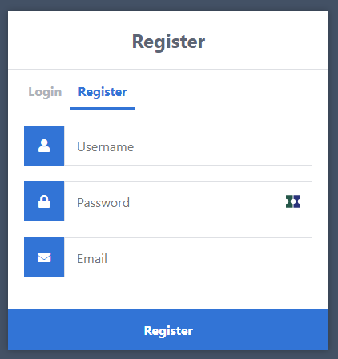

Enter username, password and email-id to register(make sure you are entering the right format of email id)

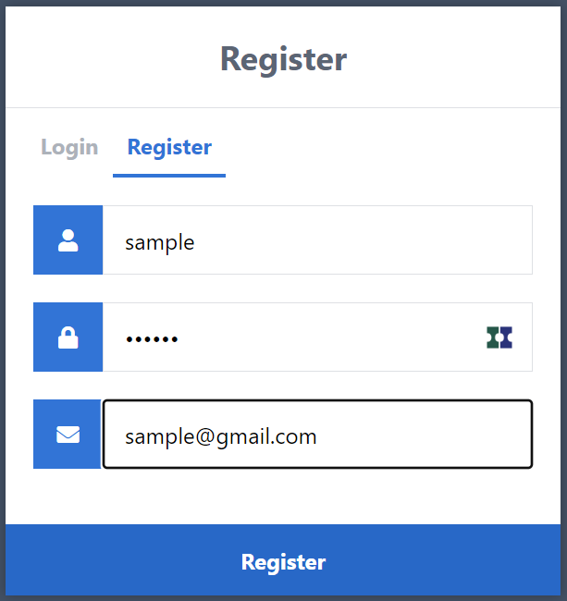

After entering all details click on register

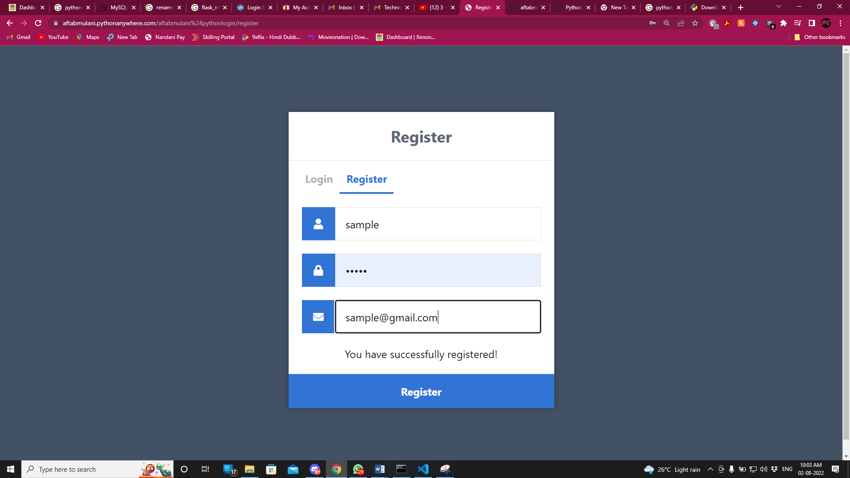

After click on register you will prompt as you have successfully registered!

Step 2. Go to login page and enter all details and click on login

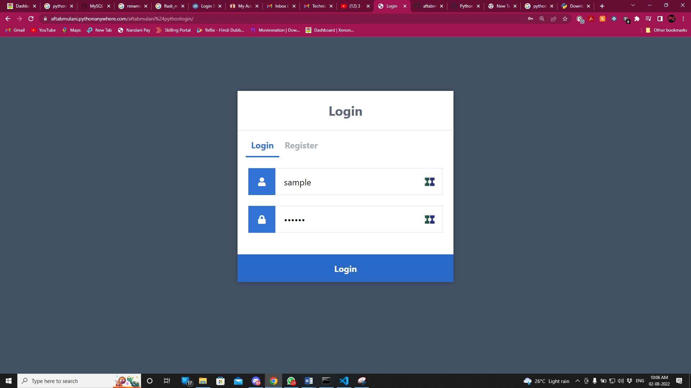

Step 3. After click on login you will directed to home page.

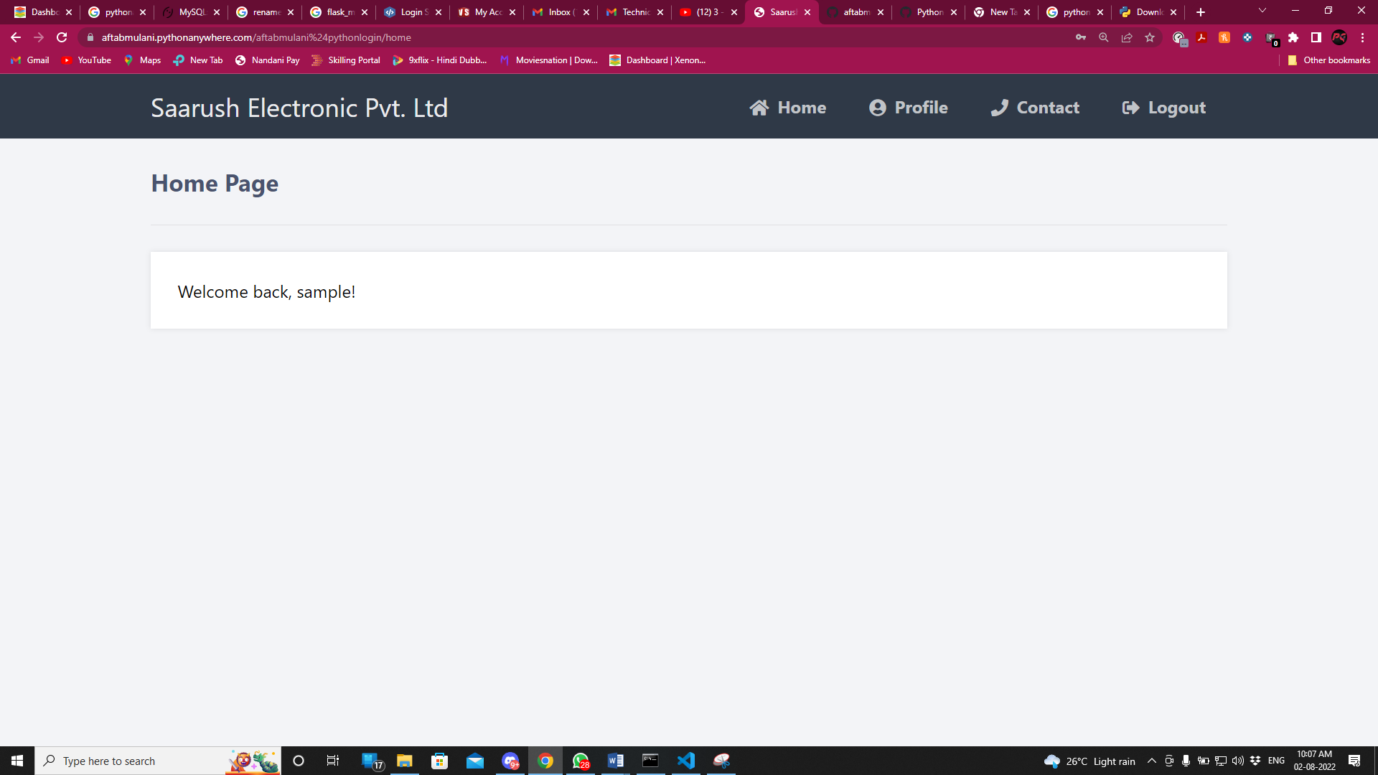

Step 4. Click on contact to give feedback or any error report

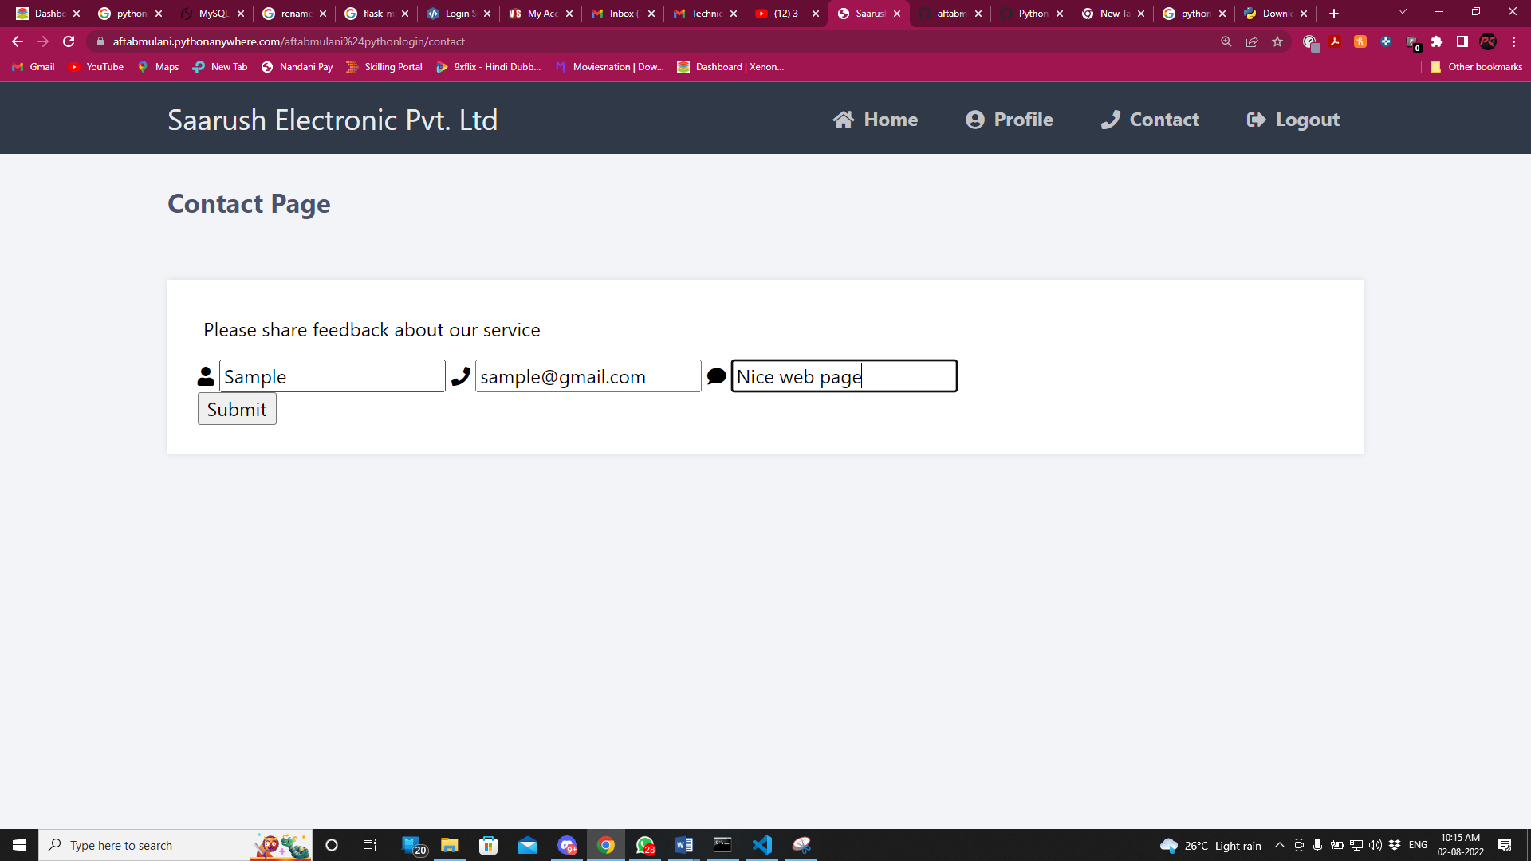

Click on submit

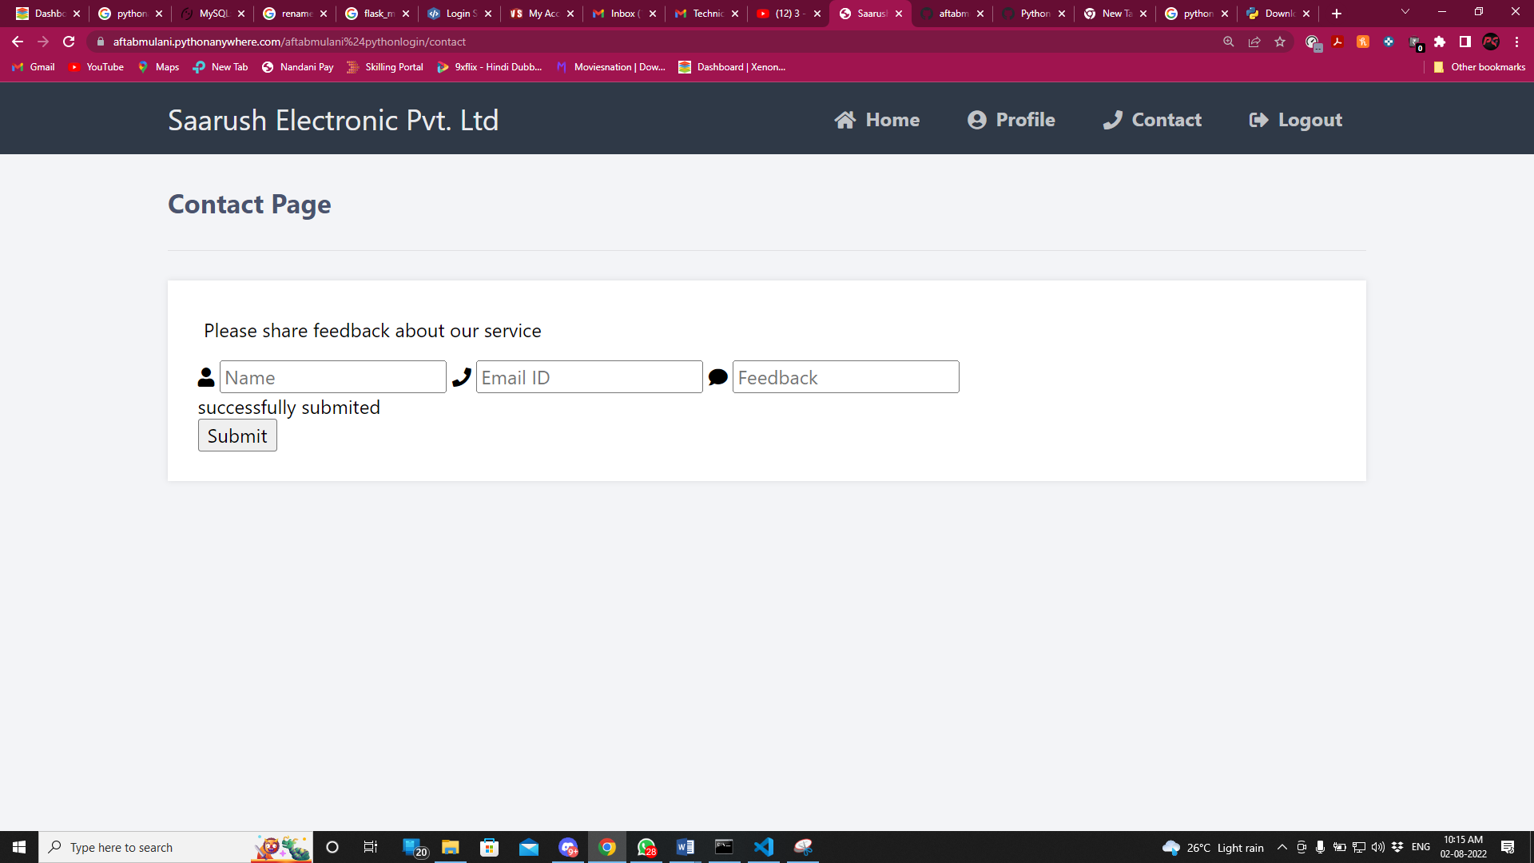

Step 5. Click on logout

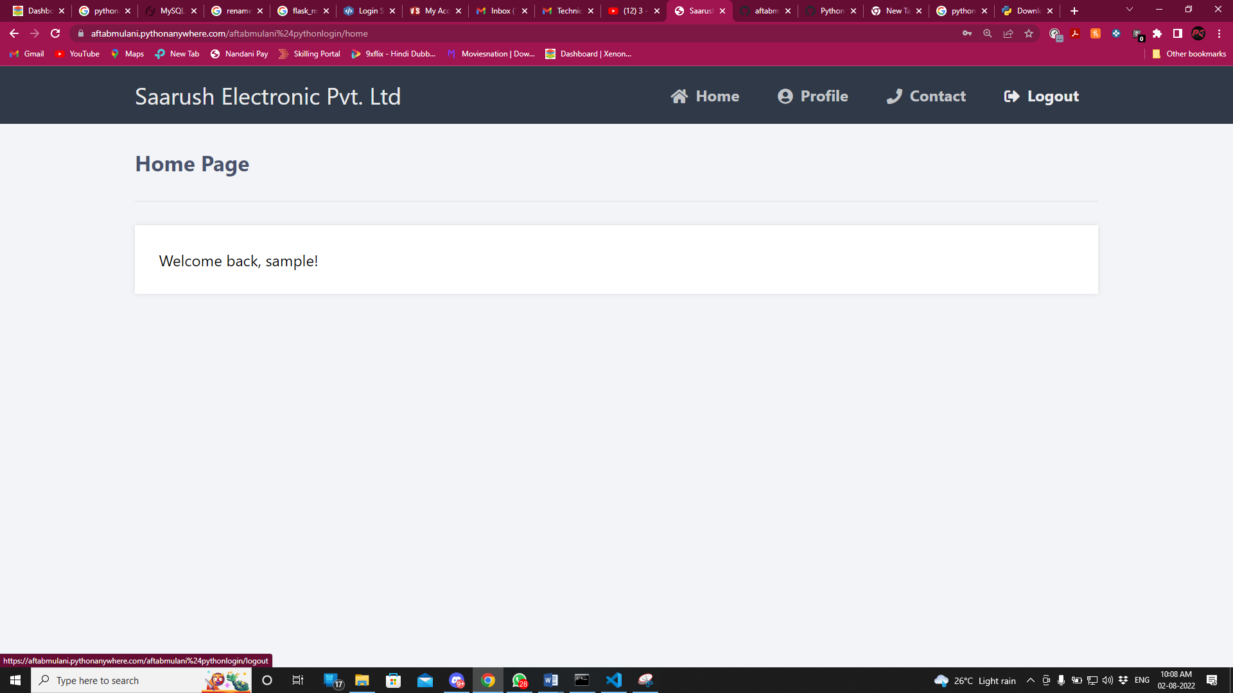

Then you will directed to the login page again

