|  |  |  |  |  |  |
| --- | --- | --- | --- | --- | --- |
| AIUB | | **American International University- Bangladesh (AIUB)**  **Faculty of Engineering (EEE)** | | | |
|  | | |  |  |  |
| **Course Name:** | | | Microprocessor and Embedded Systems | **Course Code:** | EEE 4103 |
| **Semester:** | | | Fall 2022-2023 | **Section:** | I |
| **Faculty Name:** | | | Mr. Nirjhor Rouf | | |
|  | | |  |  |  |
| **Capstone Project Title:** | | | IoT Based Smart Poultry & Fish Farm | | |
| **Project Group No.** | | | 02 | | |
|  | | |  |  |  |
|  | **Student ID** | | | **Student Name:** | |
| **1.** | **20-42017-1** | | | **SULTANUL ARIFEEN HAMIM (Author)** | |
| **2.** | **20-41991-1** | | | **RAKIN SAD AFTAB (Author)** | |
| **3.** | **20-41943-1** | | | **RIJOAN FARDOUS** | |
| **4.** | **20-41905-1** | | | **SABIHA KHAIR OHI** | |
| **5.** | **20-43173-1** | | | **SHAHARIYER SHAMS JIM** | |
| **6.** | **20-42763-1** | | | **TAUSIFUR RAHMAN** | |
| **7.** | **20-42008-1** | | | **EASHITA ISLAM** | |

**Assessment Materials and Marks Allocation:**

|  |  |  |  |
| --- | --- | --- | --- |
| **Cos** | **Assessment Materials** | **POIs** | **Marks** |
| CO3 | Course Project report ***(Demonstrate a course project using microcontrollers, sensors, actuators, switches, display devices, etc. that can solve a complex engineering problem in the electrical and electronic engineering discipline through appropriate research)*** | **P.d.1.P3** | **5** |

|  |  |  |  |  |  |  |
| --- | --- | --- | --- | --- | --- | --- |
| **CO** | Excellent to proficient  [5- 4] | Good  [3] | Acceptable  [2] | Unacceptable  [1] | No response  [0] | Secured marks |
| **CO3**  **P.d.1.P3** | The outcome of the project demonstrates a course project using microcontrollers, sensors, actuators, switches, display devices, etc. that can solve a complex engineering problem in the electrical and electronic engineering discipline through appropriate research. | The outcome of the project somewhat demonstrates a course project using microcontrollers, sensors, actuators, switches, display devices, etc., and also somewhat solves a complex engineering problem in the electrical and electronic engineering discipline through appropriate research. | The outcome of the project demonstrates a course project using microcontrollers, sensors, actuators, switches, display devices, etc. but cannot solve a complex engineering problem in the electrical and electronic engineering discipline through appropriate research. | The outcome of the project does not demonstrate a course project using microcontrollers, sensors, actuators, switches, display devices, etc. also cannot solve a complex engineering problem in the electrical and electronic engineering discipline through appropriate research. | No Response |  |
| **Comments** |  |  |  |  | Total marks (5) |  |

## Abstract

The consumption of fish and poultry products is rising along with the global population. Increased housing and better management of chicken and fish are two potential techniques to boost production to fulfil this need. However, such a technique makes it very difficult for farmers to keep track of the production, health, and welfare conditions of all their poultry and fish properly, in addition to staffing issues. The project aims to create an Internet of Things (IoT)-based smart poultry and fish farm system that can control and monitor both poultry and fish farms simultaneously. In this project, automatic feeding and monitoring of water level, room temperature, water ph., and turbidity using the internet of things and a smartphone application called Blynk that will allow for the simultaneous cultivation of fish and chicken.

***Keywords: Potential benefits, efficiency, Cost reduction, Automation, Revolutionizing***

## Introduction

### **Background of Study and Motivation**

The farming of fish and poultry is one of the largest industries in our country. However, it is seriously concerning that Bangladeshis continue to engage in conventional farming. Some students also want to start farming, but they need longer opportunities to do so because they don't have vast knowledge about conventional farming, or for other reasons. We will therefore build a farming assistance system based on the Internet of Things using an Arduino Uno. With this project, farming will require a great deal less time and work. The goal of this project is to apply contemporary technologies in poultry and fish farming to track and manage environmental variables that are crucial to a farm's operations. Here, we have categorized the issue under K5, K6, and K8 characteristics based on the knowledge profile. Additionally, it fits into P1, P4, and P7 of the Complex Engineering Problem Solving Characteristics

### **Project Objectives**

The main objectives of this project are:

* To automate the watering and feeding of the fish and poultry farms.
* To develop an automated system that can simultaneously run several fish and poultry farms.
* To monitor and maintain a healthy environment for poultry birds and fish on the farm.
* Temperature, ph. and turbidity monitoring on an OLED display and control by app.

### **A brief outline of the report**

* Develop a business plan that outlines the goals and objectives of the fish and poultry farm.
* The project's planned operating model.
* Components' descriptions and implementation: using an OLED display, LEDs, a servo and water motor, an ultrasonic sensor, a temperature, a pH sensor, a turbidity sensor, a water level sensor, and a moisture sensor.
* Establish a Production Process: Create an effective, economical, and customer-satisfying production process.
* Setup for the experiment and numerical analysis.
* Measured response and research findings.
* Evaluation of numerical and experimental outcomes.
* Limitations in the project.
* Monitor Performance: Monitor the performance of the poultry firm and make adjustments as needed.

## Literature Review

In the agriculturally prosperous nation of Bangladesh, where fish and chicken meat and eggs are vital sources of protein, vitamins, and minerals, new methods of artificial control are being created daily. Rich natural excrement is produced by chickens, which is also a significant source of income and employment for many farmers and other people involved in related activities in the poultry industry. In Bangladesh, chicken is the meat that is most widely recognized. Because poultry meat is high in protein, low in calories, and low in cholesterol, it is becoming increasingly popular in most nations. The authors provide a low-cost Internet of Things-based remote poultry management system that small- to medium-sized farmers can adopt. The authors use a range of sensors that can measure and regulate temperature, humidity, water level, and lighting. The authors' proposed study aims to help achieve some of the UNSDGs, such as infrastructure improvement, business innovation, and the abolition of hunger [1].

The author wants to develop an intelligent system for chicken farms. The recommended system collects sensor data from the farm, such as moisture, temperature, and humidity. After that, the developed method will automatically manage and maintain the prevailing circumstances properly [2].

This article aims to describe how to build an automated Environment Controlled Poultry Management System (ECPMS) utilizing readily available minimum resources. The system has been rigorously studied for temperature, humidity, air quality, and other physical characteristics essential for effectively maintaining chickens. It was found that in addition to monitoring specific features, the system also successfully modifies them. The framework was proven to be very beneficial for farmers because they could access and control the system remotely using their portable mobile devices [3]. The author of the study discusses the use of intelligent sensing technologies in the poultry industry to keep track of critical environmental factors necessary for chicken production, such as air temperature, relative humidity, light, and air quality. Regarding the measurement of these indicators and their effects on bird welfare, the state of industry practice is currently addressed. As a result, they looked into how intelligent sensing technology is used in the poultry sector [4].

## Methodology

### **Introduction**

The chicken house, fish pond, smart feeder, automatic watering system, temperature monitoring system, ph. monitor, and turbidity meter on an OLED display are the main components of this project. The intelligent feeder is the first feature. A sensor installed in the farm's door will detect any hens entering. The food will start to flow if it sees the birds. Ten seconds will pass before the sensor detects anything. A system for automatic irrigation is the second feature. The motor will automatically turn on and begin pouring water for the chicken once the water level falls below the desired level. The temperature monitoring system is then displayed on an OLED screen. A temperature sensor detects whenever the farm's temperature rises too high for the chickens, turning on a red light and saying the temperature is Celsius. The green light will turn on once the temperature is at an average level. The blink app also controls automatic feeding for fish, and you can see the pH and turbidity levels on display.

### **Working principle of the proposed project:**

|  |  |  |  |  |  |
| --- | --- | --- | --- | --- | --- |
| SensorName | Sense (if the distanceis <=10 cm) | Pump | Temp<=29 0C | Temp>29 0C | Status |
| Ultrasonic sensor | Yes | - | - | - | Smart feeder open |
| Temperature sensor | - | - | Yes |  | Green Light ON |
| Temperature sensor | - | - | - | Yes | Red Light ON |
| Moisture sensor | - | Yes | - | - | Automatically Watering for Chicken |
| Water level  sensor | - | Yes | - | - | Automatically Watering for Fish |
| PH sensor | - | - | - | - | Monitor Ph in the water |
| Turbidity Sensor | - | - | - | - | Monitor Turbidity in the water |

Table: 1

* 1. **Process of Work**

Here, we'll be able to monitor and run farms digitally, and the fish and poultry will develop in a controlled environment to boost output. We create systems that automatically feed and check water levels, room temperature, water PH, and turbidity. We used an ultrasonic sensor to provide the chickens and distribute water automatically, and we used a water pump and a soil moisture sensor. A soil moisture sensor is used to measure the water level in the container. When the water level becomes too low, the soil moisture sensor instructs the pump to start. When the water entered the container, the pump automatically stopped using the temperature sensor LM35. When the temperature is hot or regular, two lights show it. The red light will illuminate, and the cooling fan will turn on if the temperature is high. The temperature is indicated by a green light when it is normal. We work to develop automatic fish feeding with servo motors that the Blynk app can manage. We also utilize a turbidity sensor and a ph sensor to determine the turbidity of the water. The Blynk app can monitor and manage all of these systems.

### **Description of the components**

#### **Arduino UNO R3**

Arduino UNO is a microcontroller board based on the ATmega328P.It contains everything needed to support the microcontroller; connect it to a computer with a USB cable or power it with an AC-to-DC adapter or battery to get started.

Memory: 1. AVR CPU at up to 16 MHz

2. 32KB Flash

3.2KB SRAM

4.1KB EEPROM

Power: 2.7-5.5 volts

|  |
| --- |
|  |

Fig 1: Arduino UNO

#### **Soil moisture sensor**

The soil moisture sensor consists of two probes used to measure water's volumetric content. The two probes allow the current to pass through the soil, and then it gets the resistance value to measure the moisture value.

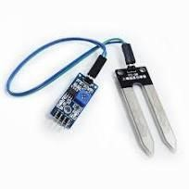

Fig 2: Soil moisture sensor

#### **Ultrasonic module HC-SR04**

Ultrasonic ranging module HC-SR04 provides a 2cm – 400cm non-contact measurement function, and the ranging accuracy can reach 3mm. It uses Ian O trigger for at least 10us high-level signal. The Module automatically sends eight 40 kHz and detects whether there is a pulse signal back.

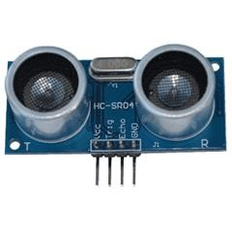

Fig 3: Ultrasonic module HC-SR04

#### **LM35 temperature sensor**

The LM35 device is rated to operate over a −55°C to 150°C temperature range, while the LM35C device is rated for a −40°C to 110°C degree. Operates From 4 V to 30 V. 0.5°C Ensured Accuracy (at 25°C).

|  |
| --- |
|  |

Fig 4: LM35 temperature sensor

#### **Servo Motor**

Dimension: 39.5mm x 20.5mm x 40.7mm.

Stall Torque: 9.4kg/cm (4.8v); 11kg/cm (6v)

Op. speed: 0.20sec/60degree (4.8v); 0.16sec/60degree (6.0v) Operating voltage: 4.8~ 6.6v.

Gear Type: Metal gear.

Temperature range: 0- 55deg.

Servo wire length: 30cm

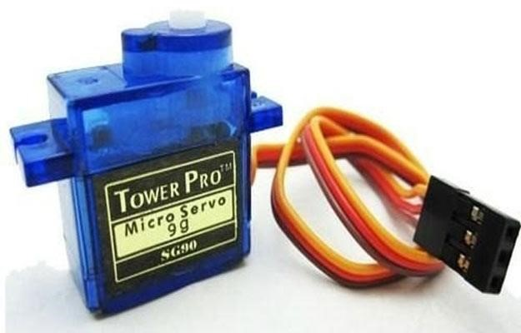

Fig 5: Servo Motor

#### **OLED Display**

High-resolution at 128x64 pixels.

160 degrees viewing angle.

Lower power consumption: only 0.06W with normal use.

Power supply AC3V-5V, working very well with Arduino.

Working temperature: -30 degrees to 70 degrees Celsius.

Dimensions: L27. 8 x W27. ...

Compatible 3.3v and 5.0v chip I/O level.

Driver IC SSD1306

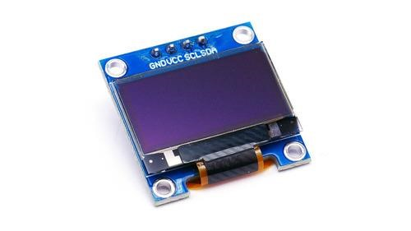

Fig 6: OLED Display

#### **Water pump**

Technical Specification. Input Voltage: DC 3V – 5V. Flow Rate: 1.2 – 1.6 L/min. Operating Current: 0.1 – 0.2A. Maximum Suction Distance: 0.8m.

Application. Controlled Gardening Systems. Controlled Fountain Water flow. Additional Information. Weight: 26g. Dimensions: 45 × 30 × 25mm.

|  |
| --- |
|  |

Fig 7: Water pump

#### **Turbidity Sensor**

It has an Operating Voltage of 5V DC

Response Time: <500MS

Insulation Resistance: 100M (Min)

Analog Output: 0-4.5V

Digital Output: High/Low-level signal

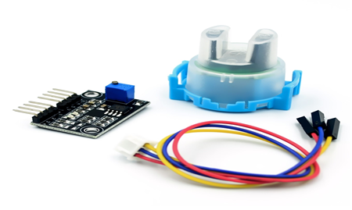

Fig 8: Turbidity Sensor

#### **Water Level Sensor:**

Voltage: 5V-24V DC

Maximum Current: 15 mA

Sensor Weight: 43 gm

Water discharge: 1-80 Liter/minute

Operating temperature: 0 C – 80 C

Pressure: <1.75 MPa

Humidity: 35% - 90% RH

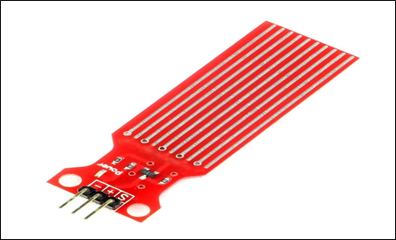

Fig 9: Water Level Sensor

#### **Ph sensor**

A number between 0 and 14 represents the normal pH range. The chemical is described as balanced when its pH value is 7. Higher alkalinity is indicated by pH values above 7, whilst more acidic compounds are those with pH values below 7.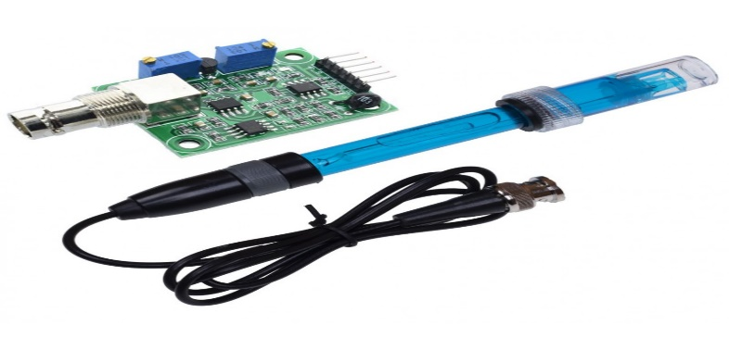

Fig 10: Ph sensor

#### **Breadboard**

The purpose of the breadboard is to make quick electrical connections between components- like resistors, LEDs, capacitors, Etc. so that user can test their circuit before permanently soldering it together. Height / Thickness: 0.5118 inch.

Length: 7.87 to 47.24 inch.

Units: Metric.

Width: 7.87 to 47.24 inch

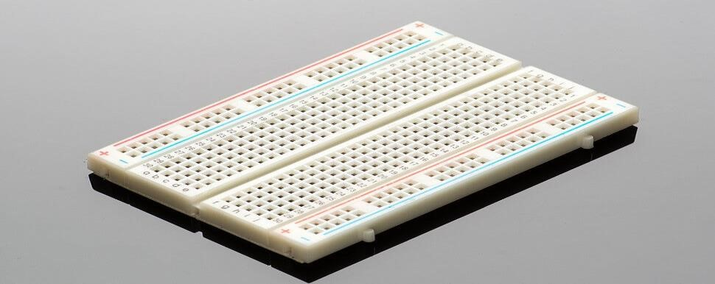

Fig 11: Breadboard

#### **Other Components**

LED Lights

Jumper wires

Resistors

Pipe

Plastic bottle

### **Implementation**

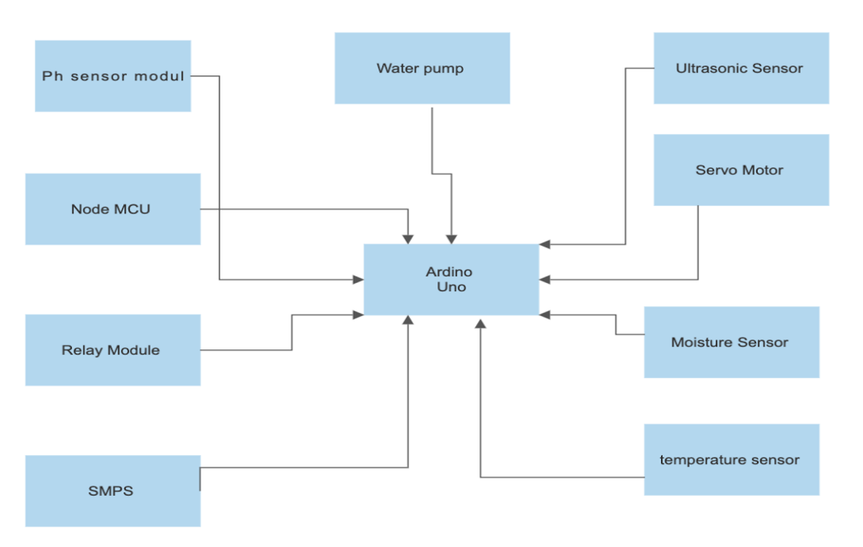

Fig 12: PROJECT DIAGRAM

### **Experimental Setup**

|  |  |
| --- | --- |
|  |  |
|  |  |
|  |  |

## Cost analysis

OLED Display (Will display Temperature and water Ph level = 400 taka

Water Level Sensor Depth of Detection Water Sensor for Arduino = 300 taka

Ph sensor module = 3.4 taka

Arduino Nano/UNO = 1000 taka

SMPS (For DC power supply AC 220V to DC 5V) = 1000 taka

Water pump (Poultry farm water supply) = 200 taka

Ultrasonic Sensor SR04 – measure of distance. (Feeding pot) = 100 taka

Servo Motor SG90 (Automatic Feeding procedure) = 200 taka

Moisture Sensor (Poultry farm water monitoring) = 250 taka

Light and Cooling Fan = 200 taka

LM35 Temperature Sensor = 35 taka

Buzzer = 20 taka

Male to Female Jumper Wires 40 Pin 30cm5v Power = 200 taka

## Graph Representation

## Results and Discussion

### **Numerical analysis**

#### **The Summary of the Working Principle of temperature and lights for poultry birds**

|  |  |  |  |  |
| --- | --- | --- | --- | --- |
| Week | Temperature(0C) | Status | RED LIGHT | GREEN LIGHT |
| 1 | 32≤T≤35 | HOT | ON | OFF |
| T≥35 | HOT | ON | OFF |
| T≥32 | HOT | ON | OFF |
| 2 | 27≤T≤29 | NORMAL | OFF | ON |
| T≥32 | HOT | ON | OFF |
| T≤29 | NORMAL | OFF | ON |
| 3 | 24≤T≤29 | NORMAL | OFF | ON |
|  | T≥30 | HOT | ON | OFF |
| T≤24 | NORMAL | OFF | ON |
| 4 | 21≤T≤26 | NORMAL | OFF | ON |
| T≤26 | NORMAL | OFF | ON |
| T≤21 | NORMAL | OFF | ON |
| 5 | 18≤T≤21 | NORMAL | OFF | ON |
| T≥30 | HOT | ON | OFF |
| T≥35 | HOT | ON | OFF |

Table: 2

#### **The Summary of the Working Principle of smart feeder for poultry birds**

|  |  |  |  |
| --- | --- | --- | --- |
| Week | Ultrasonic sensor  (Distance, D= maximum10 cm) | Status | Smart Feeder |
| 1 | D<10cm | Sensor sense | OPEN |
| D<6cm | Sensor sense | OPEN |
| D>10cm | Sensor does not sense | NOT OPEN |
| 2 | D<9cm | Sensor sense | OPEN |
| D<5cm | Sensor sense | OPEN |
| D>13cm | Sensor does not sense | NOT OPEN |
| 3 | D<3cm | Sensor sense | OPEN |
| D<8cm | Sensor sense | OPEN |
| D>15cm | Sensor does not sense | NOT OPEN |
| 4 | D<11cm | Sensor sense | OPEN |
| D<5cm | Sensor sense | OPEN |
| D>11cm | Sensor does not sense | NOT OPEN |
| 5 | D<4cm | Sensor sense | OPEN |
| D<6cm | Sensor sense | OPEN |
| D>10cm | Sensor does not sense | NOT OPEN |

Table: 3

## Experimental results

The ultrasonic sensor should be no closer than 10 cm when the chicken enters; if it is, the sensor will detect the fowl, and the intelligent feeder will begin to flow automatically. The lights are temperature-dependent; if the temperature is above 29 °C, the heating light (red light) will automatically turn on and appear on display; if the temperature is below 30 °C, the usual green light will turn on. The user can alter this threshold value.

#### **The Summary of Experimental value of the temperature and lights for poultry**

#### **birds**

|  |  |  |  |  |
| --- | --- | --- | --- | --- |
| Week | Temperature(0C) | Status | RED  LIGHT | GREEN  LIGHT |
| 1 | T=25.4 | NORMAL | OFF | ON |
| T=29.2 | HOT | ON | OFF |
| T=30.33 | HOT | ON | OFF |
| 2 | T=22.1 | NORMAL | OFF | ON |
| T=43.2 | HOT | ON | OFF |
| T=25.7 | NORMAL | OFF | ON |
| 3 | T=21.5 | NORMAL | OFF | ON |
| T=23.5 | NORMAL | OFF | ON |
| T=31.3 | HOT | ON | OFF |
| 4 | T=33.5 | HOT | ON | OFF |
| T=28.9 | NORMAL | OFF | ON |
| T=22.2 | NORMAL | OFF | ON |
| 5 | T=21.3 | NORMAL | OFF | ON |
| T=20.2 | NORMAL | OFF | ON |
| T=27.9 | NORMAL | OFF | ON |

Table 4

#### **The Summary of Experimental value of the chicken distance from the sensor and smart feeder status for poultry birds**

|  |  |  |  |
| --- | --- | --- | --- |
| Week | Ultrasonic sensor (Chicken Distance, D= maximum 10 cm) | Status | Smart Feeder |
| 1 | D=9.8cm | Sensor sense | OPEN |
| D=6.5cm | Sensor sense | OPEN |
|  | D=10.3cm | Sensor does not sense | NOT OPEN |
| 2 | D=7.9cm | Sensor sense | OPEN |
| D=6.6cm | Sensor sense | OPEN |
| D=13.1cm | Sensor does not sense | NOT OPEN |
| 3 | D=5.5cm | Sensor sense | OPEN |
| D=6.3cm | Sensor sense | OPEN |
| D=11.1cm | Sensor does not sense | NOT OPEN |
| 4 | D=4.4cm | Sensor sense | OPEN |
| D=8.9cm | Sensor sense | OPEN |
| D=10.1cm | Sensor does not sense | NOT OPEN |
| 5 | D=8.78cm | Sensor sense | OPEN |
| D=6.9cm | Sensor sense | OPEN |
| D=19.5cm | Sensor does not sense | NOT OPEN |

Table 5

#### **The Summary of the Working Principle of pH sensor**

|  |  |  |
| --- | --- | --- |
| Week | pH sensor  (pH rate, pH range = 0-14) | Status |
| 1 | pH=8 | Water weakly Alkaline |
| 2 | pH=9 | Water weakly Alkaline |
| 3 | pH=8 | Water weakly Alkaline |
| 4 | pH=7 | Water Normal |
| 5 | pH=6.5 | Water weakly Acidic |

Table 6

#### **The Summary of Working Principle of Turbidity sensor**

|  |  |  |  |
| --- | --- | --- | --- |
| Week | Turbidity sensor  (NTU rate) | Status | Water Pump  (For water filter) |
| 1 | NTU<30 | Water normal | Off |
| NTU<32 | Water normal | Off |
| NTU=40 | Water murky | On |
| 2 | NTU<32 | Water normal | Off |
| NTU<32 | Water normal | Off |
| NTU<30 | Water normal | Off |
| 3 | NTU<34 | Water normal | Off |
| NTU=45 | Water murky | On |
| NTU=40 | Water murky | On |
| 4 | NTU<30 | Water normal | Off |
| NTU<30 | Water normal | Off |
| NTU=38 | Water murky | On |
| 5 | NTU<30 | Water normal | Off |
| NTU=40 | Water Murky | On |
| NTU<30 | Water normal | Off |

Table 7

## Comparison between numerical and experimental results

### **Temperature sensor**

#### **Comparison between numerical and experimental results of Temperature sensor**

|  |  |  |
| --- | --- | --- |
| Week | The numerical value of the Temperature sensor | The experimental value  of Temperature sensor |
| 1 | 32≤T≤35 | T=25.4 |
| T≥35 | T=29.2 |
| T≥32 | T=30.33 |
| 2 | 27≤T≤29 | T=22.1 |
| T≥32 | T=43.2 |
| T≤29 | T=25.7 |
| 3 | 24≤T≤29 | T=21.5 |
| T≥30 | T=23.5 |
| T≤24 | T=31.3 |
| 4 | 21≤T≤26 | T=33.5 |
| T≤26 | T=28.9 |
| T≤21 | T=22.2 |
| 5 | 18≤T≤21 | T=21.3 |
| T≥30 | T=20.2 |
| T≥35 | T=27.9 |

Table 8

### **Ultrasonic sensor**

#### **Comparison between numerical and experimental results of Ultrasonic sensor**

|  |  |  |
| --- | --- | --- |
| Week | Numerical value of Ultrasonic sensor | Experimental value of Ultrasonic sensor |
| 1 | D<10cm | D=9.8cm |
| D<6cm | D=6.5cm |
| D>10cm | D=10.3cm |
| 2 | D<9cm | D=7.9cm |
| D<5cm | D=6.6cm |
| D>13cm | D=13.1cm |
| 3 | D<3cm | D=5.5cm |
| D<8cm | D=6.3cm |
| D>15cm | D=11.1cm |
| 4 | D<11cm | D=4.4cm |
| D<5cm | D=8.9cm |
| D>11cm | D=10.1cm |
| 5 | D<4cm | D=8.78cm |
| D<6cm | D=6.9cm |
| D>10cm | D=19.5cm |

Table 9

### **pH sensor**

#### **Comparison between numerical and experimental results of pH sensor**

|  |  |  |
| --- | --- | --- |
| Week | Numerical value of pH sensor | Experimental value of pH sensor |
| 1 | pH=8 | pH=8.4 |
| 2 | pH=9 | pH=9.5 |
| 3 | pH=8 | pH=7.8 |
| 4 | pH=7 | pH=7.2 |
| 5 | pH=6.5 | pH=5.8 |

Table 10

### **Turbidity sensor**

#### **Comparison between numerical and experimental results of a Turbidity sensor**

|  |  |  |
| --- | --- | --- |
| Week | The experimental value of Turbidity sensor | The experimental value of Turbidity sensor |
| 1 | NTU<30 | NTU=30 |
| NTU<32 | NTU=35 |
| NTU=40 | NTU=32 |
| 2 | NTU<32 | NTU=32 |
| NTU<32 | NTU=30 |
| NTU<30 | NTU=28 |
| 3 | NTU<34 | NTU=32 |
| NTU=45 | NTU=42 |
| NTU=40 | NTU=40 |
| 4 | NTU<30 | NTU=30 |
| NTU<30 | NTU=30 |
| NTU=38 | NTU=35 |
| 5 | NTU<30 | NTU=30 |
| NTU=40 | NTU=39 |
| NTU<30 | NTU=30 |

Table 11

We obtained the greatest floating value in the experimental data, according to a comparison between the numerical and experimental results. Regarding measuring temperatures, there are modest differences between the numerical and experimental data. If we look at week 5 of the experimental results, we can observe that the temperature stays normal, however in the numerical analysis, the temperature fluctuates between normal and heated. Only when the requirement is met in both the numerical and experimental findings does the smart feeder open. We utilize pH sensors in the fish ponds to monitor and maintain the right pH for the fish. We are aware that pond water pH should be as similar as possible to fish blood for optimal results (i.e., 7.0 to 8.0). If the pH of the water falls below 5 (due to acidic runoff, for example) or goes over 10 fish could become stressed and perish (e.g., alkaline runoff). So, we simultaneously check and regulate the pH level of our pond. It displays an average value between 6 and 8, which is suitable for a fish pond. A turbidity sensor was also present, which can measure the clarity of pond water. The value is displayed in NTU. Nephelometric Turbidity Unit is the abbreviation. The pond has a typical NTU of 30. A value was obtained between 28 and 45 NTU. Our water pump automatically starts filtering the water and maintaining water clarity once the NTU value exceeds the standard

## Limitations of the project

* Manual setups, which are necessary for Controlling sheds and call for expert labor,
* Another concern to take into account with chicken production is the usage of antibiotics.
* Some environmental circumstances do not favor some birds & fish.
* Poultry illness has the potential to cause the loss of an entire batch of chicks.
* some faulty sensors (Turbidity and pH sensor) and we faced some technical errors for that problem.

## Conclusion and future endeavors

IoT-based systems A revolutionary initiative called Smart Poultry and Fish Farm has the potential to transform the poultry industry. Many businesses may provide farmers with a profitable and inexpensive way to manage their poultry business by leveraging technology. Investors and industry experts will be interested in the farm's novel approach to poultry farming, and the farm will be in a good position to take the lead in the sector.

Smart Poultry and Fish Farm will keep improving its technology and growing its offerings in the future. The accurate recognition of chicken noises can be utilized to analyze and anticipate information about fish and chicken diseases, behavior, weight, age, happiness, and well-being through the application of sound recognition technology and reliable algorithms. It is possible to utilize IoT to investigate how vocalization affects chickens' levels of stress. It is possible to hear when chickens are plucking their feathers by listening to their sounds. As a result, the animal may suffer harm or perhaps perish. Fish are the same way. The farm intends to provide new goods and services that will aid farmers in boosting their output and profits. The farm will also be looking into new markets and collaborations that would help it reach more consumers. The smart Poultry Farm will undoubtedly grow to be a significant player in the poultry business thanks to its creative approach and dedication to customer care.

## References

1. J. Chigwada, F. Mazunga, C. Nyamhere, V. Mazheke, and N. Taruvinga, “Remote Poultry Management System for small to medium scale producers using IOT,” Scientific African, vol. 18, 2022.
2. T. M. Akhund, S. R. Snigdha, M. S. Reza, N. T. Newaz, M. Saifuzzaman, and M. R. Rashel, “Self-powered IOT-based design for Multi-purpose Smart Poultry Farm,” Information and Communication Technology for Intelligent Systems, pp. 43–51, 2020.
3. L. S. Handigolkar, M. L. Kavya, and P. D. Veena, “IOT based smart poultry farming using commodity hardware and software,” Bonfring International Journal of Software Engineering and Soft Computing, vol. 6, no. Special Issue, pp. 171–175, 2016.
4. G. Corkery, S. Ward, C. Kenny and P. Hemmingway, “Monitoring environmental parameters in poultry production facilities," Computer Aided Process Engineering - CAPE Forum, 2013.
5. William A. Wurts and Robert M. Durborow (1992) "Interactions of pH, Carbon Dioxide,Alkalinity and Hardness in Fish Ponds"
6. Anita Bhatnagar, Pooja Devi (2013) "Water quality guidelines for the management of pond fish culture"
7. Anggara Trisna Nugraha, Dadang Priyambodo (2020) "Design of Pond Water Turbidity Monitoring System in Arduino-based Catfish Cultivation to Support Sustainable Development Goals 2030 No.9 Industry, Innovation, and Infrastructure"