6. System Sequence Diagrams
A system sequence diagram (SSD) shows, for one use case, the events the actor sends to the system (treated as a black box) and how the system responds. The diagrams below cover the main success scenario and the main alternate flow of each use case.

6.1 UC1: Login
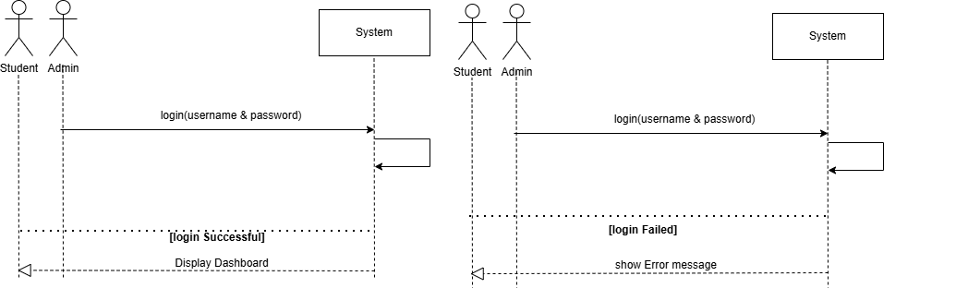
Figure 4: System Sequence Diagram for UC1

6.2 UC2: Logout
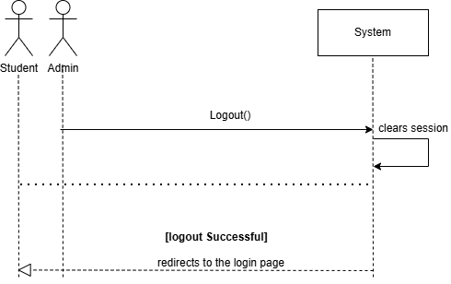
Figure 5: System Sequence Diagram for UC2

6.3 UC3: Manage Courses
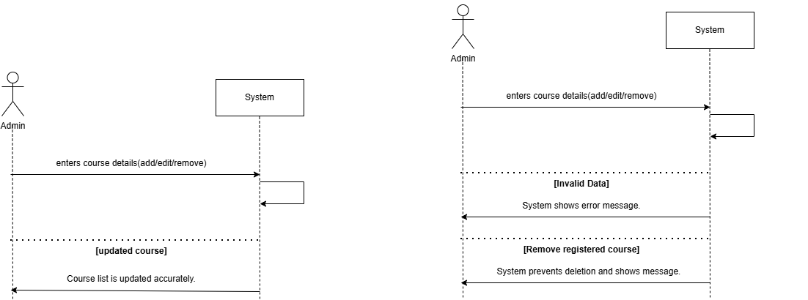
Figure 6: System Sequence Diagram for UC3

6.4 UC4: Register Courses
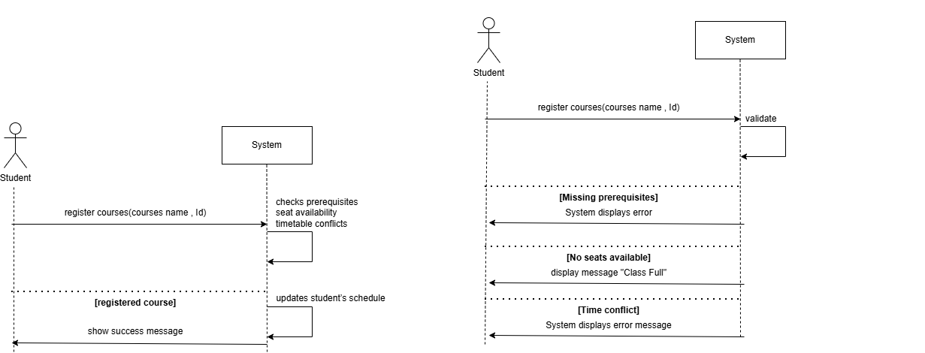
Figure 7: System Sequence Diagram for UC4

6.5 UC5: Drop Course
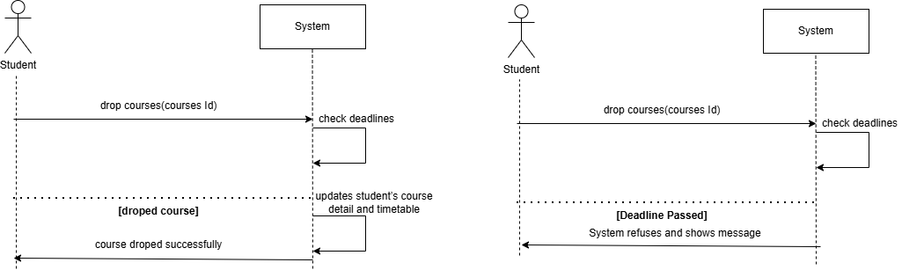
Figure 8: System Sequence Diagram for UC5

6.6 UC6: Generate Timetable
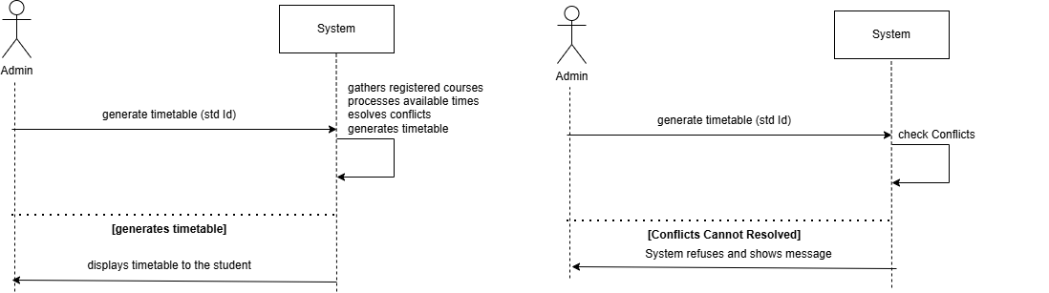
Figure 9: System Sequence Diagram for UC6

6.7 UC7: View Timetable
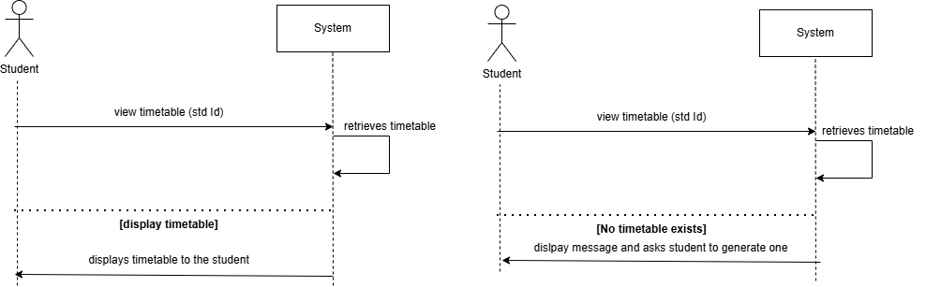
Figure 10: System Sequence Diagram for UC7

6.8 UC8: Generate Reports
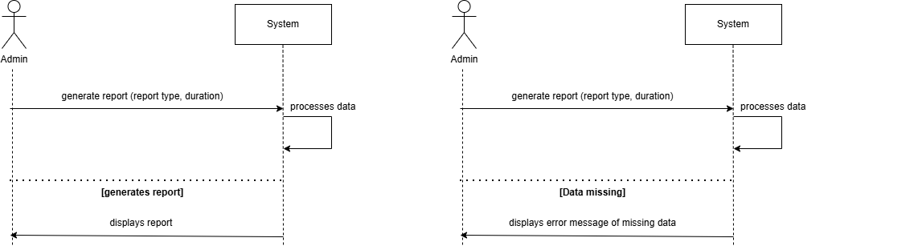
Figure 11: System Sequence Diagram for UC8
UC9 (Manage Student Accounts) was added during analysis and has no SSD yet. It follows the same pattern as UC3 and will be drawn in the design phase, together with its entry in Figure 3.

