
Course Registration and Timetable Scheduler

Software Construction Project

Group Members:
Aftab Shaban
04072312046

Submitted to: Dr. Umar Rashid

Table of Contents
Part I: Project Planning Phase 5
P1. Project Overview 5
P1.1 Background and Problem Statement 5
P1.2 Project Objectives 5
P1.3 Project Scope 5
P1.4 Project Deliverables 6
P1.5 Assumptions, Dependencies and Constraints 6
P2. Feasibility Study 6
P3. Project Organisation 7
P3.1 Process Model 7
P3.2 Stakeholders 7
P3.3 Team Roles and Responsibilities 7
P3.4 Communication and Reporting 8
P4. Managerial Process Plan 8
P4.1 Work Breakdown Structure and Effort 8
P4.2 Schedule and Milestones 9
P4.3 Resource Plan 10

Part I: Project Planning Phase
This part is the project management plan for the Course Registration and Timetable Scheduler (CRTS). It explains what we are building, why, who is building it, when it will be done, and how we will keep risk and quality under control. It follows IEEE Std 1058-1998. Part II picks up from here with the detailed requirements.

P1. Project Overview

P1.1 Background and Problem Statement
Right now, course registration at the university is done by hand. Students fill in forms, staff check seat availability and timetable clashes themselves, and records sit in separate lists. This is slow and error-prone. Classes end up over-enrolled, clashes go unnoticed, student records drift out of sync, and staff lose a lot of time at the start of every semester.

P1.2 Project Objectives
Table 1: Project objectives and success measures
ID | Objective | Measure of success
O1 | Let students register for and drop courses online through a desktop application. | All 8 core use cases (UC1–UC8) pass system tests.
O2 | Prevent invalid registrations automatically (prerequisites, seat capacity, credit limit, time clash). | 0 invalid registrations accepted in acceptance testing.
O3 | Generate a conflict-free weekly timetable for a student. | Timetable produced in 3 seconds or less (NFR-3).
O4 | Give administrators central control of courses, sections and student accounts. | Admin can complete add, edit, archive and import tasks without database access.
O5 | Provide registration, occupancy and timetable reports. | Reports export to PDF and Excel.
O6 | Protect data and access with role-based security. | Passwords stored as salted hashes; no SQL-injection findings in security review.
O7 | Deliver within one semester with the planned effort. | All milestones M1–M5 met; actual effort within 15% of the 462-hour baseline.

P1.3 Project Scope
In scope
- Secure login and logout for students and administrators with role-based dashboards.
- Administrator management of courses, sections (capacity, instructor, room, weekly time slots), prerequisites and student accounts.
- Student registration and dropping of course sections with automatic validation.
- Timetable generation, clash detection and grid display of a student's weekly timetable.
- Registration, occupancy and timetable reports with PDF and Excel export.
- Database design and scripts (MySQL 8.0), in-app help and a PDF user manual.
Out of scope for this release
- Web or mobile clients (a REST API is a future option only).
- Fee payment, refunds, grading, transcripts and instructor portals.
- Two-factor or biometric authentication and e-mail notifications.
- University-wide timetable optimisation (room and instructor allocation). CRTS only checks and shows the time slots that administrators set for each section.

P1.4 Project Deliverables
Table 2: Deliverables
# | Deliverable | Phase | Due
D1 | Project Management Plan (Part I of this document) | Planning | M1 (W2)
D2 | Software Requirements Specification (Part II), use case model, SSDs, domain model | Analysis | M2 (W4)
D3 | Architecture, database schema (ERD + DDL), class and sequence design, UI prototypes | Design | M3 (W6)
D4 | Source code (Java Swing application), SQL install and seed scripts | Implementation | M4 (W11)
D5 | Test plan, test cases and test report | Testing | M4–M5
D6 | PDF user manual and in-app help | Deployment | M5 (W14)
D7 | Final release package and presentation | Deployment | M5 (W14)

P1.5 Assumptions, Dependencies and Constraints
- Constraint: the product has to use Java Swing for the interface and MySQL for the database, and follow the MVC pattern.
- Constraint: the project has to follow the university guidelines for the CS322 Software Construction course.
- Constraint: the team is fixed at two members and the semester is fixed at 14 weeks.
- Assumption: a MySQL 8.0 server is available on every development machine and in the demo environment.
- Assumption: the supervisor and some sample users (one administrator and a few students) are available for reviews and acceptance testing.
- Dependency: the university provides the drop deadlines, credit-hour limits and a sample course catalogue (see Part II, Appendix C).

P2. Feasibility Study
Before starting the requirements work, we looked at feasibility from five angles.
Table 3: Feasibility assessment
Dimension | Assessment | Verdict
Technical | Java Swing, JDBC and MySQL are mature, well documented and already part of the course. No new technology is needed. Clash detection reduces to interval-overlap checks on (day, start, end), and seat control to transactional updates. | Feasible
Economic | All tools are free or open source (see P4.3), so there are no licence costs. The only cost is team effort of about 462 person-hours. Benefits are less manual work, fewer errors and centralised data. | Feasible
Operational | Users are administrators and students with basic computer skills. The desktop application runs on standard Windows machines and follows familiar form-and-table patterns. A user manual and in-app help support adoption. | Feasible
Schedule | 462 hours over 14 weeks is about 16.5 hours per member per week. This is achievable with three increments, a prioritised scope (High requirements first) and a 15% reserve. | Feasible with risk (see R5)
Legal and ethical | The system stores student personal data. It must follow the university data policy, store passwords only as hashes, restrict access by role and log administrative changes. | Feasible

Conclusion: the project is feasible within our constraints, so we can move on to requirements analysis.

P3. Project Organisation

P3.1 Process Model
The project follows an iterative-incremental model. Planning, requirements and design are done up front, because the registration rules are stable and well understood. Implementation is then delivered in three increments, each ending in a tested build we can demonstrate: Increment 1 (login and course management), Increment 2 (registration and drop) and Increment 3 (timetable generation and reports). This way the supervisor sees progress early and late changes cost less.

P3.2 Stakeholders
Table 4: Stakeholders
Stakeholder | Role in the project | Main interest
Students | End users of registration and timetable functions | Fast, conflict-free registration; clear timetable
Administrators / registrar staff | End users; maintain courses, sections and accounts | Accurate catalogue, less manual work, reliable reports
Course supervisor / reviewer | Reviews and approves deliverables at milestones | Compliance with course guidelines, traceability, quality
University | Owner of rules and data (credit limits, deadlines) | Accurate enrolment records, policy compliance
Development team | Muzaffar Ali and Aftab Shaban | On-time delivery of a working, well-documented product

P3.3 Team Roles and Responsibilities
Table 5: Roles
Role | Responsibilities
Project manager | Plan, schedule, status reporting, risk register, change control
Requirements analyst | Elicitation, SRS, use cases, domain model, traceability
Designer / architect | Architecture, database schema, class and sequence design, UI prototypes
Developer | Implementation of modules, unit tests, code reviews
Tester / QA | Test plan, test cases, system and acceptance testing, defect tracking
Configuration manager | Repository, baselines, build and release packages

P3.4 Communication and Reporting
- A 30-minute team meeting every week to go over progress, risks and decisions.
- A review with the supervisor at each milestone (M1 to M5). Comments are logged and followed up until they are closed.
- A shared Git repository holds the code, documents and SQL scripts, and a task board tracks the work packages from the WBS.
- Decisions and requirement clarifications are recorded in the open-issues list (Part II, Appendix C).

P4. Managerial Process Plan

P4.1 Work Breakdown Structure and Effort
The work is split into six main packages. Effort is the team's own bottom-up estimate in person-hours.
Table 6: Work breakdown structure with effort estimate
WBS | Work package | Effort (h)
1 | Project Management | 44
1.1 | Project planning, feasibility study, plan baseline | 16
1.2 | Monitoring, weekly status meetings, reporting | 20
1.3 | Risk management and change control | 8
2 | Requirements Analysis | 74
2.1 | Elicitation and stakeholder analysis | 12
2.2 | SRS authoring (IEEE 830 / 29148 structure) | 24
2.3 | Use case modelling and system sequence diagrams | 20
2.4 | Domain model and data dictionary | 10
2.5 | SRS inspection and baseline | 8
3 | Design | 48
3.1 | Architecture (two-tier, MVC) | 8
3.2 | Database schema (ERD, DDL scripts) | 12
3.3 | Class and sequence design | 14
3.4 | UI prototypes (Login, Admin Dashboard, Student Panel) | 14
4 | Implementation | 168
4.1 | Database creation and DAO layer (JDBC) | 24
4.2 | Authentication and account management | 16
4.3 | Course, section and prerequisite management | 24
4.4 | Registration and drop module | 32
4.5 | Timetable generation and clash detection | 28
4.6 | Reports and export (PDF / Excel) | 20
4.7 | UI integration and validation | 24
5 | Testing | 92
5.1 | Test plan and test case design | 14
5.2 | Unit testing (JUnit) | 24
5.3 | Integration and system testing | 24
5.4 | User acceptance testing | 10
5.5 | Defect fixing and regression | 20
6 | Deployment and Documentation | 36
6.1 | PDF user manual | 14
6.2 | In-app help | 6
6.3 | Packaging, DB install script, backup script | 8
6.4 | Final presentation and handover | 8
 | Total baseline effort | 462

We keep a 15% management reserve (about 69 hours) outside the baseline for rework and risk response.

P4.2 Schedule and Milestones
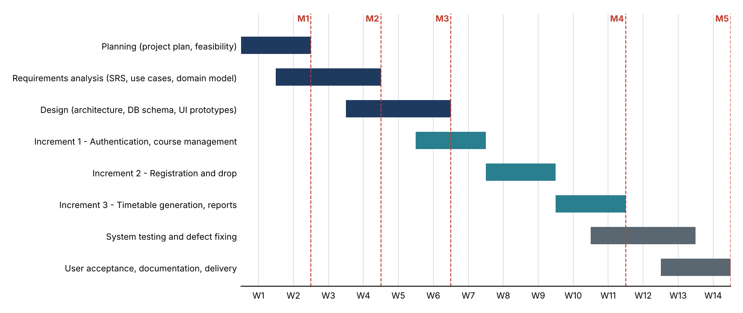
Figure 1: Baseline project schedule (weeks W1 to W14, milestones M1 to M5)
Table 7: Milestones
Milestone | Week | Exit criterion
M1: Plan approved | W2 | Project plan, feasibility and risk register reviewed by the supervisor
M2: Requirements baseline | W4 | SRS inspected; no open critical defects; traceability matrix complete
M3: Design review | W6 | Architecture, ERD, class design and UI prototypes approved
M4: Feature complete | W11 | Increments 1–3 integrated; all High-priority requirements implemented
M5: Release | W14 | System and acceptance tests passed; manual delivered; final presentation

P4.3 Resource Plan
Table 8: Tools and resources
Resource | Use
Java JDK 17+, Eclipse IDE | Development of the Swing application
MySQL 8.0 server and MySQL Workbench | Database, schema design, test data
mysql-connector-j 9.5.0 (JDBC) | Database access
JUnit 5 | Unit tests of business logic (clash detection, credit limit, seat control)
Git and a hosted repository | Version control, baselines, backup of work
UML tool (for example draw.io or StarUML) | Use case, sequence, domain and class diagrams
Two development computers (4 GB RAM minimum, 8 GB recommended) | Development and testing, Windows 10 or later

