
Course Registration and Timetable Scheduler

Software Construction Project

Group Members:
Aftab Shaban
04072312046

Submitted to: Dr. Umar Rashid

Table of Contents
Part I: Project Planning Phase 5
P1. Project Overview 5
P1.1 Background and Problem Statement 5
P1.2 Project Objectives 5
P1.3 Project Scope 5
P1.4 Project Deliverables 6
P1.5 Assumptions, Dependencies and Constraints 6
P2. Feasibility Study 6
P3. Project Organisation 7
P3.1 Process Model 7
P3.2 Stakeholders 7
P3.3 Team Roles and Responsibilities 7
P3.4 Communication and Reporting 8
P4. Managerial Process Plan 8
P4.1 Work Breakdown Structure and Effort 8
P4.2 Schedule and Milestones 9
P4.3 Resource Plan 10
P5. Risk Management Plan 10
P6. Technical and Supporting Processes 11
P6.1 Methods, Standards and Tools 11
P6.2 Quality Assurance and Verification Plan 11
P6.3 Configuration Management 11
P6.4 Requirements Change Control 11
P6.5 Acceptance Criteria for the Release 12
Part II: Requirements Analysis Phase (Software Requirements Specification) 13
1. Introduction 13
1.1 Purpose 13
1.2 Document Conventions 13
1.3 Product Scope 13
1.4 Definitions, Acronyms and References 13
2. Overall Description 13
2.1 Product Perspective 13
2.2 Product Functions 14
2.3 User Classes and Characteristics 14
2.4 Operating Environment 14
2.5 Design and Implementation Constraints 15
2.6 User Documentation 15
2.7 Assumptions and Dependencies 15
2.8 Future Enhancements (Apportioning of Requirements) 15
3. External Interface Requirements 15
3.1 User Interfaces 15
3.2 Hardware Interfaces 16
3.3 Software Interfaces 16
3.4 Communications Interfaces 16
4. System Features (Functional Requirements) 16
4.1 User Authentication 16
4.2 Student Account Management 17
4.3 Course Management 17
4.4 Course Registration and Drop 18
4.5 Timetable Generation and Display 18
4.6 Reports and Administration 19
5. Use Case Model 19
5.1 Actors 19
5.2 Use Case Diagram 19
5.3 Use Case Summary 20
5.4 Use Case Descriptions 20
6. System Sequence Diagrams 26
6.1 UC1: Login 26
6.2 UC2: Logout 27
6.3 UC3: Manage Courses 27
6.4 UC4: Register Courses 27
6.5 UC5: Drop Course 28
6.6 UC6: Generate Timetable 28
6.7 UC7: View Timetable 28
6.8 UC8: Generate Reports 28
7. Domain Model 29
7.1 Domain Concepts and Data Dictionary 29
7.2 Relationships 30
8. Preliminary Design Models (Informative) 30
8.1 Sequence Diagram 31
8.2 Design Class Diagram 32
9. Other Non-functional Requirements 32
9.1 Performance Requirements 32
9.2 Safety Requirements 33
9.3 Security Requirements 33
9.4 Software Quality Attributes 33
9.5 Business Rules 34
10. Other Requirements 34
11. Requirements Traceability and Verification 34
Appendix A: Glossary 35
Appendix B: References 35
Appendix C: Open Issues, Decisions and TBD List 36

Part I: Project Planning Phase
This part is the project management plan for the Course Registration and Timetable Scheduler (CRTS). It explains what we are building, why, who is building it, when it will be done, and how we will keep risk and quality under control. It follows IEEE Std 1058-1998. Part II picks up from here with the detailed requirements.

P1. Project Overview

P1.1 Background and Problem Statement
Right now, course registration at the university is done by hand. Students fill in forms, staff check seat availability and timetable clashes themselves, and records sit in separate lists. This is slow and error-prone. Classes end up over-enrolled, clashes go unnoticed, student records drift out of sync, and staff lose a lot of time at the start of every semester.

P1.2 Project Objectives
Table 1: Project objectives and success measures
ID | Objective | Measure of success
O1 | Let students register for and drop courses online through a desktop application. | All 8 core use cases (UC1–UC8) pass system tests.
O2 | Prevent invalid registrations automatically (prerequisites, seat capacity, credit limit, time clash). | 0 invalid registrations accepted in acceptance testing.
O3 | Generate a conflict-free weekly timetable for a student. | Timetable produced in 3 seconds or less (NFR-3).
O4 | Give administrators central control of courses, sections and student accounts. | Admin can complete add, edit, archive and import tasks without database access.
O5 | Provide registration, occupancy and timetable reports. | Reports export to PDF and Excel.
O6 | Protect data and access with role-based security. | Passwords stored as salted hashes; no SQL-injection findings in security review.
O7 | Deliver within one semester with the planned effort. | All milestones M1–M5 met; actual effort within 15% of the 462-hour baseline.

P1.3 Project Scope
In scope
- Secure login and logout for students and administrators with role-based dashboards.
- Administrator management of courses, sections (capacity, instructor, room, weekly time slots), prerequisites and student accounts.
- Student registration and dropping of course sections with automatic validation.
- Timetable generation, clash detection and grid display of a student's weekly timetable.
- Registration, occupancy and timetable reports with PDF and Excel export.
- Database design and scripts (MySQL 8.0), in-app help and a PDF user manual.
Out of scope for this release
- Web or mobile clients (a REST API is a future option only).
- Fee payment, refunds, grading, transcripts and instructor portals.
- Two-factor or biometric authentication and e-mail notifications.
- University-wide timetable optimisation (room and instructor allocation). CRTS only checks and shows the time slots that administrators set for each section.

P1.4 Project Deliverables
Table 2: Deliverables
# | Deliverable | Phase | Due
D1 | Project Management Plan (Part I of this document) | Planning | M1 (W2)
D2 | Software Requirements Specification (Part II), use case model, SSDs, domain model | Analysis | M2 (W4)
D3 | Architecture, database schema (ERD + DDL), class and sequence design, UI prototypes | Design | M3 (W6)
D4 | Source code (Java Swing application), SQL install and seed scripts | Implementation | M4 (W11)
D5 | Test plan, test cases and test report | Testing | M4–M5
D6 | PDF user manual and in-app help | Deployment | M5 (W14)
D7 | Final release package and presentation | Deployment | M5 (W14)

P1.5 Assumptions, Dependencies and Constraints
- Constraint: the product has to use Java Swing for the interface and MySQL for the database, and follow the MVC pattern.
- Constraint: the project has to follow the university guidelines for the CS322 Software Construction course.
- Constraint: the team is fixed at two members and the semester is fixed at 14 weeks.
- Assumption: a MySQL 8.0 server is available on every development machine and in the demo environment.
- Assumption: the supervisor and some sample users (one administrator and a few students) are available for reviews and acceptance testing.
- Dependency: the university provides the drop deadlines, credit-hour limits and a sample course catalogue (see Part II, Appendix C).

P2. Feasibility Study
Before starting the requirements work, we looked at feasibility from five angles.
Table 3: Feasibility assessment
Dimension | Assessment | Verdict
Technical | Java Swing, JDBC and MySQL are mature, well documented and already part of the course. No new technology is needed. Clash detection reduces to interval-overlap checks on (day, start, end), and seat control to transactional updates. | Feasible
Economic | All tools are free or open source (see P4.3), so there are no licence costs. The only cost is team effort of about 462 person-hours. Benefits are less manual work, fewer errors and centralised data. | Feasible
Operational | Users are administrators and students with basic computer skills. The desktop application runs on standard Windows machines and follows familiar form-and-table patterns. A user manual and in-app help support adoption. | Feasible
Schedule | 462 hours over 14 weeks is about 16.5 hours per member per week. This is achievable with three increments, a prioritised scope (High requirements first) and a 15% reserve. | Feasible with risk (see R5)
Legal and ethical | The system stores student personal data. It must follow the university data policy, store passwords only as hashes, restrict access by role and log administrative changes. | Feasible

Conclusion: the project is feasible within our constraints, so we can move on to requirements analysis.

P3. Project Organisation

P3.1 Process Model
The project follows an iterative-incremental model. Planning, requirements and design are done up front, because the registration rules are stable and well understood. Implementation is then delivered in three increments, each ending in a tested build we can demonstrate: Increment 1 (login and course management), Increment 2 (registration and drop) and Increment 3 (timetable generation and reports). This way the supervisor sees progress early and late changes cost less.

P3.2 Stakeholders
Table 4: Stakeholders
Stakeholder | Role in the project | Main interest
Students | End users of registration and timetable functions | Fast, conflict-free registration; clear timetable
Administrators / registrar staff | End users; maintain courses, sections and accounts | Accurate catalogue, less manual work, reliable reports
Course supervisor / reviewer | Reviews and approves deliverables at milestones | Compliance with course guidelines, traceability, quality
University | Owner of rules and data (credit limits, deadlines) | Accurate enrolment records, policy compliance
Development team | Muzaffar Ali and Aftab Shaban | On-time delivery of a working, well-documented product

P3.3 Team Roles and Responsibilities
Table 5: Roles
Role | Responsibilities
Project manager | Plan, schedule, status reporting, risk register, change control
Requirements analyst | Elicitation, SRS, use cases, domain model, traceability
Designer / architect | Architecture, database schema, class and sequence design, UI prototypes
Developer | Implementation of modules, unit tests, code reviews
Tester / QA | Test plan, test cases, system and acceptance testing, defect tracking
Configuration manager | Repository, baselines, build and release packages

P3.4 Communication and Reporting
- A 30-minute team meeting every week to go over progress, risks and decisions.
- A review with the supervisor at each milestone (M1 to M5). Comments are logged and followed up until they are closed.
- A shared Git repository holds the code, documents and SQL scripts, and a task board tracks the work packages from the WBS.
- Decisions and requirement clarifications are recorded in the open-issues list (Part II, Appendix C).

P4. Managerial Process Plan

P4.1 Work Breakdown Structure and Effort
The work is split into six main packages. Effort is the team's own bottom-up estimate in person-hours.
Table 6: Work breakdown structure with effort estimate
WBS | Work package | Effort (h)
1 | Project Management | 44
1.1 | Project planning, feasibility study, plan baseline | 16
1.2 | Monitoring, weekly status meetings, reporting | 20
1.3 | Risk management and change control | 8
2 | Requirements Analysis | 74
2.1 | Elicitation and stakeholder analysis | 12
2.2 | SRS authoring (IEEE 830 / 29148 structure) | 24
2.3 | Use case modelling and system sequence diagrams | 20
2.4 | Domain model and data dictionary | 10
2.5 | SRS inspection and baseline | 8
3 | Design | 48
3.1 | Architecture (two-tier, MVC) | 8
3.2 | Database schema (ERD, DDL scripts) | 12
3.3 | Class and sequence design | 14
3.4 | UI prototypes (Login, Admin Dashboard, Student Panel) | 14
4 | Implementation | 168
4.1 | Database creation and DAO layer (JDBC) | 24
4.2 | Authentication and account management | 16
4.3 | Course, section and prerequisite management | 24
4.4 | Registration and drop module | 32
4.5 | Timetable generation and clash detection | 28
4.6 | Reports and export (PDF / Excel) | 20
4.7 | UI integration and validation | 24
5 | Testing | 92
5.1 | Test plan and test case design | 14
5.2 | Unit testing (JUnit) | 24
5.3 | Integration and system testing | 24
5.4 | User acceptance testing | 10
5.5 | Defect fixing and regression | 20
6 | Deployment and Documentation | 36
6.1 | PDF user manual | 14
6.2 | In-app help | 6
6.3 | Packaging, DB install script, backup script | 8
6.4 | Final presentation and handover | 8
 | Total baseline effort | 462

We keep a 15% management reserve (about 69 hours) outside the baseline for rework and risk response.

P4.2 Schedule and Milestones
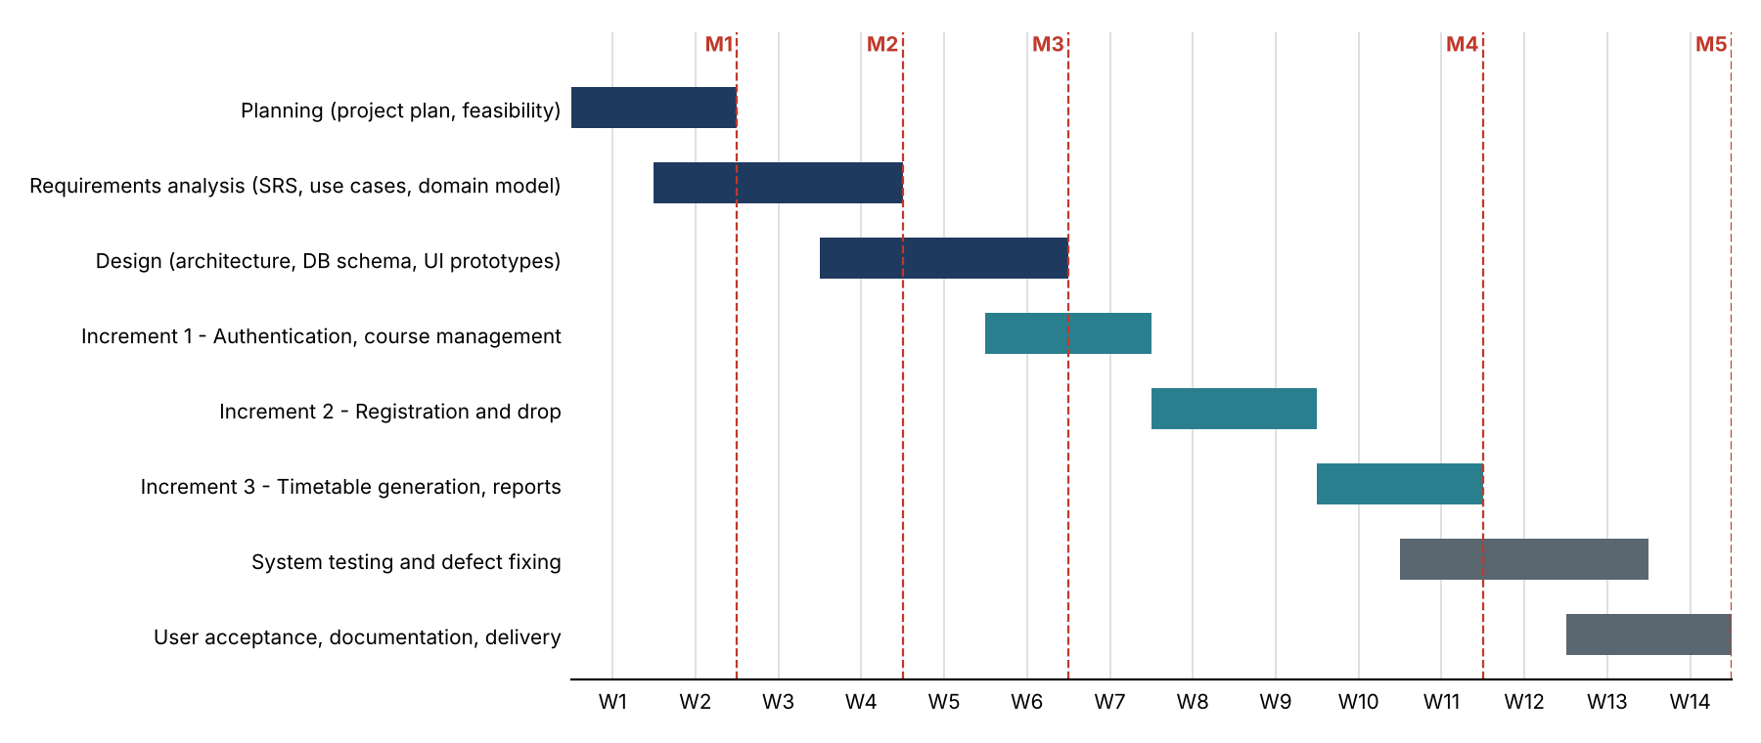
Figure 1: Baseline project schedule (weeks W1 to W14, milestones M1 to M5)
Table 7: Milestones
Milestone | Week | Exit criterion
M1: Plan approved | W2 | Project plan, feasibility and risk register reviewed by the supervisor
M2: Requirements baseline | W4 | SRS inspected; no open critical defects; traceability matrix complete
M3: Design review | W6 | Architecture, ERD, class design and UI prototypes approved
M4: Feature complete | W11 | Increments 1–3 integrated; all High-priority requirements implemented
M5: Release | W14 | System and acceptance tests passed; manual delivered; final presentation

P4.3 Resource Plan
Table 8: Tools and resources
Resource | Use
Java JDK 17+, Eclipse IDE | Development of the Swing application
MySQL 8.0 server and MySQL Workbench | Database, schema design, test data
mysql-connector-j 9.5.0 (JDBC) | Database access
JUnit 5 | Unit tests of business logic (clash detection, credit limit, seat control)
Git and a hosted repository | Version control, baselines, backup of work
UML tool (for example draw.io or StarUML) | Use case, sequence, domain and class diagrams
Two development computers (4 GB RAM minimum, 8 GB recommended) | Development and testing, Windows 10 or later

P5. Risk Management Plan
We identify risks while planning and review them at each weekly meeting. Probability (P) and impact (I) are rated from 1 (low) to 5 (high), and exposure is P × I. Any risk with an exposure of 12 or more gets a named owner and a contingency plan.
Table 9: Risk register
ID | Risk | P | I | Exp. | Mitigation / contingency
R1 | Scope creep (web or mobile clients, extra features) | 4 | 3 | 12 | Baseline the SRS; process every change through P6.4; park extras in the future-enhancements list.
R2 | Clash-detection edge cases (several slots per section, back-to-back classes) | 3 | 4 | 12 | Prototype the algorithm in Increment 2; unit tests with boundary cases.
R3 | Two students registering for the last seat at the same time | 3 | 4 | 12 | Check and update seats in one transaction with row locking; concurrency test.
R4 | Team member unavailable (illness, exams) | 2 | 4 | 8 | Backup owner per role; documentation kept current; reserve hours.
R5 | Implementation slips past W11 | 3 | 3 | 9 | Deliver High-priority requirements first; defer Low-priority ones (CSV import, printing).
R6 | JDBC or MySQL set-up problems on different machines | 2 | 3 | 6 | Scripted install; setup instructions in the manual; same versions on all machines.
R7 | Ambiguous or inconsistent requirements | 3 | 3 | 9 | Formal SRS inspection at M2; open-issues log with decisions.
R8 | Data loss or corruption | 2 | 5 | 10 | Daily backup (NFR-6), transactions, restore test before release.
R9 | Security weakness (SQL injection, weak password storage) | 2 | 5 | 10 | Prepared statements only; salted hashing; security checklist in code review.
R10 | Poor usability | 2 | 3 | 6 | UI prototypes at M3; trial with sample users during UAT.
R11 | Performance below target with 200 concurrent users | 2 | 3 | 6 | Index key columns; connection pooling; load test in system testing.

P6. Technical and Supporting Processes

P6.1 Methods, Standards and Tools
- Requirements: we use the IEEE Std 830-1998 structure, with the requirement attributes from ISO/IEC/IEEE 29148 (ID, priority, source, verification).
- Modelling: UML 2 for use case, sequence, domain and class diagrams; use cases are written in the fully dressed format.
- Coding: Java 17 with MVC and a DAO layer, CamelCase names for variables, classes and methods, and Javadoc on public methods.
- Database: MySQL 8.0 with lower-case snake_case table and column names; foreign keys and unique constraints are defined in the DDL scripts.

P6.2 Quality Assurance and Verification Plan
Quality is built in through reviews and checked by testing at four levels. A teammate inspects each document, following the walkthrough and inspection practice of IEEE Std 1028.
Table 10: Test levels
Level | Scope | Entry criterion | Exit criterion
Unit | Business rules: clash detection, credit limit, seat control, password hashing, validation | Module coded and compiled | All unit tests pass; business logic coverage of 80% or more
Integration | Controller to DAO to database for each use case | Unit tests pass | No open critical or high defects in the increment
System | All use cases and non-functional requirements (performance, security) | M4 build | Every High requirement verified; traceability matrix complete
Acceptance (UAT) | Scenarios run by the supervisor and sample users | System tests passed | Supervisor sign-off

Defect severity: Critical means data loss, a security breach or an unusable system. High means a use case cannot be completed. Medium means there is a workaround. Low means cosmetic. We do not release with any open Critical or High defects.

P6.3 Configuration Management
- One Git repository with a main branch for released baselines and a develop branch, plus one feature branch per work package.
- Baselines are tagged: SRS v1.3 at M2, the design baseline at M3, v0.1 to v0.3 for each increment and v1.0 at M5.
- SQL schema and seed scripts are versioned with the code. Every document carries a version number and a revision history.
- Commit messages name the work package or requirement ID, for example “FR-24: check seat availability”.

P6.4 Requirements Change Control
- Anyone can raise a change request, stating what the change is, why it is needed and which requirement IDs it affects.
- The team assesses the impact on scope, effort, schedule, risk and tests. Changes costing more than 8 hours need the supervisor's approval.
- Approved changes update the SRS version, the traceability matrix and this plan. Rejected requests are logged with the reason.

P6.5 Acceptance Criteria for the Release
- All High-priority functional requirements are implemented and pass system tests. Medium requirements are either implemented or formally deferred.
- The non-functional targets in Part II, Section 9 are met, or any exceptions are approved.
- No Critical or High defects are open, and the user manual, in-app help, database install script and backup script are delivered.

Part II: Requirements Analysis Phase (Software Requirements Specification)
This part is the Software Requirements Specification (SRS) for the Course Registration and Timetable Scheduler (CRTS). It follows the section structure of IEEE Std 830-1998 and adds the requirement attributes from ISO/IEC/IEEE 29148:2018 (unique ID, priority, source and verification method). It is the baseline for design, implementation and testing.

1. Introduction

1.1 Purpose
This document sets out what the Course Registration and Timetable Scheduler must do. The system lets students register for courses and builds clash-free timetables for them automatically. It is written for developers, testers and supervisors, and it is the baseline for design, implementation and verification.

1.2 Document Conventions
- The structure follows IEEE Std 830-1998. That standard has been replaced by ISO/IEC/IEEE 29148:2018, so we also use its requirement attributes.
- Identifiers: FR-n is a functional requirement, NFR-n a non-functional requirement, BR-n a business rule, UCn a use case and A-n an assumption.
- “Must” marks a mandatory requirement and “should” a recommendation. Anything not yet decided is marked TBD and listed in Appendix C.
- Priority: High (must have; the release fails without it), Medium (should have), Low (nice to have; the first to be deferred).
- Verification method: T = test, D = demonstration, I = inspection, A = analysis.
- CamelCase is used for variables, classes and methods in models and code.

1.3 Product Scope
CRTS lets students register for classes online and lets administrators manage course data and check for scheduling problems. The system keeps data consistent, validates the rules and builds timetables automatically. The main benefits are central course data, fewer human errors and less work for staff. The objectives, scope and exclusions are in Part I (P1.2 and P1.3).

1.4 Definitions, Acronyms and References
Terms and abbreviations are explained in Appendix A, and the documents we refer to are listed in Appendix B.

2. Overall Description

2.1 Product Perspective
CRTS is a new, self-contained desktop application with two tiers. The client tier is written in Java Swing and holds the user interface and the application logic (MVC). The data tier is a MySQL database that the client reaches through JDBC. It replaces the manual registration process and does not connect to any other university system in this release.
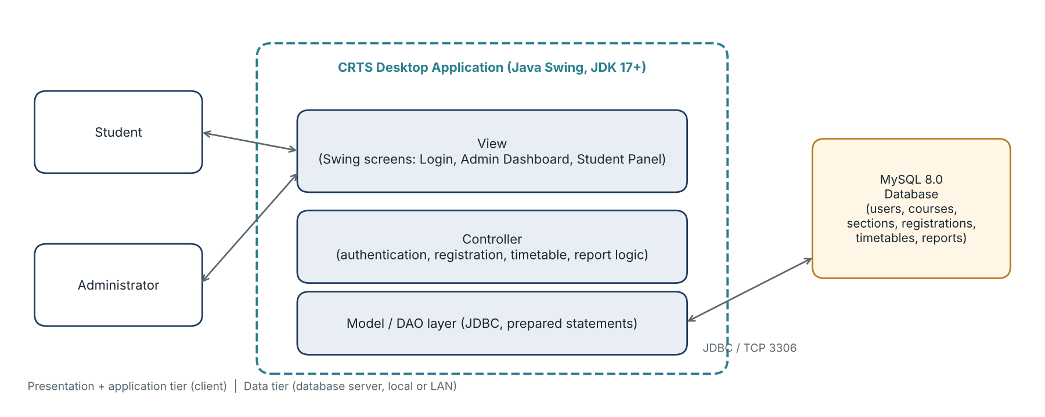
Figure 2: System context and two-tier architecture of CRTS

2.2 Product Functions
Table 11: Product functions
Function group | Summary | Users
Authentication | Secure login and logout, role-based dashboards, session timeout, account lock | Student, Administrator
Account management | Create, edit, deactivate student accounts; reset passwords | Administrator
Course management | Maintain courses, sections, time slots, capacities and prerequisites; CSV import | Administrator
Registration | View available sections, register and drop with automatic checks of prerequisites, seats, credit limit and clashes | Student
Timetable | Generate a conflict-free timetable, view it in a grid, print or export it | Administrator, Student
Reports | Registration summary, course occupancy and timetable statistics with PDF and Excel export | Administrator

2.3 User Classes and Characteristics
Table 12: User classes
User class | Description | Privileges | Expertise
Student | Registers, drops, views the timetable and account information. Uses the system mostly at registration time. | Own registrations and timetable only; read-only course catalogue | Basic computer skills
Administrator | Manages courses, sections, student accounts and timetables; generates reports. Uses the system throughout the semester. | All administrative functions; no access to other users' passwords | Knowledge of academic scheduling

2.4 Operating Environment
- Operating system: Windows 10 or later is the main target. Since the application is built in Java it should also run on Linux and macOS, but we do not formally test those in this release.
- Software: Java JDK 17 or later and MySQL 8.0, developed in the Eclipse IDE.
- Hardware (minimum): 4 GB RAM, 1 GHz CPU and a 1024 × 768 display; 8 GB RAM is recommended for the database server.
- Network: the database runs on the same machine or on a local network the client can reach.

2.5 Design and Implementation Constraints
- The interface must be built in Java Swing and the data stored in MySQL (course requirement).
- The architecture must follow the MVC pattern, with database access kept in a DAO layer.
- All SQL must use prepared statements (NFR-11).
- The project must follow the university guidelines for the course and the schedule in Part I.

2.6 User Documentation
- In-app help menu.
- A PDF user manual with instructions and screenshots, with separate guides for students and administrators.

2.7 Assumptions and Dependencies
Table 13: Assumptions and dependencies
ID | Assumption or dependency
A-1 | The MySQL server is installed, running and reachable (locally or on the LAN) whenever the application is used.
A-2 | Every student has a unique registration number issued by the university.
A-3 | Administrators define the weekly time slots of every section; CRTS does not allocate rooms or instructors.
A-4 | The university provides the credit-hour limits, the drop deadline and the registration period (see Appendix C, TBD-1 to TBD-3).
A-5 | Course prerequisites are course-level (a required course must be completed beforehand); the system holds each student's completed courses (TBD-4).
A-6 | One application instance is used per user at a time; many instances may use the same database.

2.8 Future Enhancements (Apportioning of Requirements)
These items came up in version 1.2 but are not requirements for this release. We note them here so the design does not rule them out later.
- Web or mobile access. Version 1.2 mentioned it in UC5 and UC7, but this is a desktop application. An optional REST API may be added later.
- Two-factor or biometric authentication.
- Automatic suggestion of alternate courses, student timetable preferences, scheduled report e-mails and fee or refund handling.

3. External Interface Requirements

3.1 User Interfaces
All screens share one look and keep buttons in consistent places. Every screen has a menu bar, a help entry and a status bar.
Table 14: Main screens
Screen | Users | Main elements | Use cases
Login window | All | Username, password, role selection, Login button, error message area | UC1
Admin Dashboard | Administrator | Buttons for course management, student accounts, timetable generation, reports; logout | UC2, UC3, UC6, UC8, UC9
Student Panel | Student | Tabs for registration, registered courses and drop, timetable view, account information; logout | UC2, UC4, UC5, UC7
Course and section form | Administrator | Course fields, section list, time-slot editor, prerequisite selector, CSV import | UC3
Report window | Administrator | Report type and filters, preview table or chart, PDF/Excel export | UC8

Interface standards:
- Mandatory fields are marked, and invalid input is explained in plain language next to the field.
- Destructive actions (delete, drop) ask for confirmation (NFR-8).
- Screens can be used with the keyboard (tab order, Enter to submit) and work at 1024 × 768 or larger.
- The interface is in English. Dates use DD-MMM-YYYY and times use the 24-hour clock.

3.2 Hardware Interfaces
- Standard desktop or laptop computer with keyboard, mouse and display.
- An optional printer for timetable printouts, through the operating system's print service.

3.3 Software Interfaces
Table 15: Software interfaces
Item | Specification
Database | MySQL 8.0
Connector | JDBC driver mysql-connector-j 9.5.0, accessed through java.sql
Operating system | Windows 10 or later (primary); Linux and macOS (not formally tested)
Libraries | Java Swing, AWT, java.sql; a PDF and an Excel export library (to be chosen in design)

3.4 Communications Interfaces
- The client talks to MySQL over TCP/IP (default port 3306) through JDBC.
- If the database is on a different machine, the connection must use TLS and a dedicated database account with only the privileges it needs (NFR-12).
- There is no other network communication in this release.

4. System Features (Functional Requirements)
Each feature below has a description, the stimulus and response sequence, and its functional requirements. FR-1 to FR-10 keep their IDs from version 1.2; FR-11 to FR-36 were added during analysis to complete the specification.

4.1 User Authentication
Description and priority: users log in securely and are sent to the right screen for their role (High). Stimulus/response: the user enters credentials, the system checks them and opens the matching dashboard; on logout or inactivity the session is cleared and the login window appears.
Table 16: Authentication requirements
ID | Requirement | Priority | Source
FR-1 | The system must allow students and administrators to log in with username (or email) and password. | High | UC1
FR-2 | The system must store passwords only as salted cryptographic hashes (SHA-256 or stronger) and must never display or log them. | High | UC1
FR-11 | The system must validate the credentials against the database and redirect the user to the dashboard that matches the stored role. | High | UC1
FR-12 | The system must let a logged-in user log out, then clear the session and show the login window. | High | UC2
FR-13 | The system must log a user out automatically after 15 minutes of inactivity. | Medium | UC2
FR-14 | The system must lock an account for 15 minutes after 5 consecutive failed login attempts. | Medium | UC1

4.2 Student Account Management
Description and priority: administrators look after student accounts (High). Stimulus/response: the administrator opens Manage Students and enters or edits details, and the system validates and saves them.
Table 17: Account management requirements
ID | Requirement | Priority | Source
FR-15 | The administrator must be able to create, edit and deactivate student accounts (username, registration number, name, program, semester, section, maximum credit hours). | High | UC9
FR-16 | The system must enforce a unique registration number and a unique username for every user. | High | UC9
FR-17 | The administrator must be able to reset a user's password; the user must be forced to change it at next login. | Medium | UC9

4.3 Course Management
Description and priority: the administrator manages the course catalogue (High). Stimulus/response: the administrator chooses “Add Course” and enters the details, and the system validates them and stores them in the database.
Table 18: Course management requirements
ID | Requirement | Priority | Source
FR-3 | The administrator must be able to add, edit and delete (archive) courses. | High | UC3
FR-4 | Course codes must be unique. | High | UC3
FR-5 | Changes to courses and sections must update the related timetables immediately. | High | UC3, UC6
FR-18 | The administrator must be able to define course sections with section number, instructor, room, capacity and weekly time slots (day, start time, end time). | High | UC3
FR-19 | The administrator must be able to define the prerequisite courses of a course. | High | UC3
FR-20 | The system must prevent deletion of a course or section that has active registrations and must offer to archive it instead. | High | UC3
FR-21 | The administrator may import course data from a CSV file; the system must validate every row and report rejected rows. | Low | UC3

4.4 Course Registration and Drop
Description and priority: the core function for students (High). Stimulus/response: the student picks an available section; the system checks prerequisites, seats, credit limit and clashes, then registers the student if everything passes or shows the reason if not.
Table 19: Registration requirements
ID | Requirement | Priority | Source
FR-6 | Students must be able to register for and drop courses. | High | UC4, UC5
FR-7 | The system must detect and prevent timetable clashes (two sections of the student overlapping on the same day and time). | High | UC4
FR-22 | The system must list the active sections offered in the current semester together with the seats remaining. | High | UC4
FR-23 | The system must check that the student has met the prerequisites before registering. | High | UC4
FR-24 | The system must refuse registration for a full section and must show “Class Full”. | High | UC4
FR-25 | The system must refuse registration that would take the student above the maximum credit hours. | High | UC4
FR-26 | The system must register or drop a course and update the enrolled count in one atomic transaction. | High | UC4, UC5
FR-27 | The system must allow a drop only before the drop deadline, ask for confirmation, and record the drop. | High | UC5
FR-28 | The student must be able to view the list of the courses currently registered. | Medium | UC4, UC5

4.5 Timetable Generation and Display
Description and priority: the system builds and shows a conflict-free weekly timetable (High). Stimulus/response: the administrator selects a student and clicks Generate; the system gathers the sections and time slots, checks for clashes, then stores and displays the timetable or lists the clashes it could not resolve. Registration already blocks clashes (FR-7), so generation pulls the student's registered sections into one validated weekly timetable and re-checks it when administrators change section times (FR-5).
Table 20: Timetable requirements
ID | Requirement | Priority | Source
FR-8 | The system must display the generated timetable in a grid format (days × time). | High | UC6, UC7
FR-29 | The administrator must be able to generate the timetable of a selected student from that student's registered sections. | High | UC6
FR-30 | If clashes cannot be resolved the system must list them, must not store a timetable, and must show a message. | High | UC6
FR-31 | The student must be able to view his or her own timetable. | High | UC7
FR-32 | If no timetable exists the system must tell the student and suggest registering for courses or contacting the administrator. | Medium | UC7
FR-33 | The system should allow a timetable to be printed or exported to PDF. | Low | UC7

4.6 Reports and Administration
Description and priority: the administrator generates and exports reports (Medium). Stimulus/response: the administrator chooses Generate Reports and a report type, and the system shows the report and offers to export it.
Table 21: Reporting requirements
ID | Requirement | Priority | Source
FR-9 | The system must generate registration summary reports. | Medium | UC8
FR-10 | Reports must include total seats, occupancy and timetable statistics. | Medium | UC8
FR-34 | The administrator must be able to select the report type (registration summary, course occupancy, timetable statistics, student enrolment list) and filter by semester and course. | Medium | UC8
FR-35 | Reports must be exportable to PDF and Excel. | Medium | UC8
FR-36 | The system must warn the administrator when the data needed for a report is missing or incomplete. | Low | UC8

5. Use Case Model

5.1 Actors
Table 22: Actors
Actor | Role
Student | Registers for and drops courses and views the timetable. Needs basic computer skills.
Administrator | Manages courses, sections and student accounts, generates timetables and reports. Needs knowledge of academic scheduling.

5.2 Use Case Diagram
Figure 3 shows how the Student and the Administrator use CRTS.
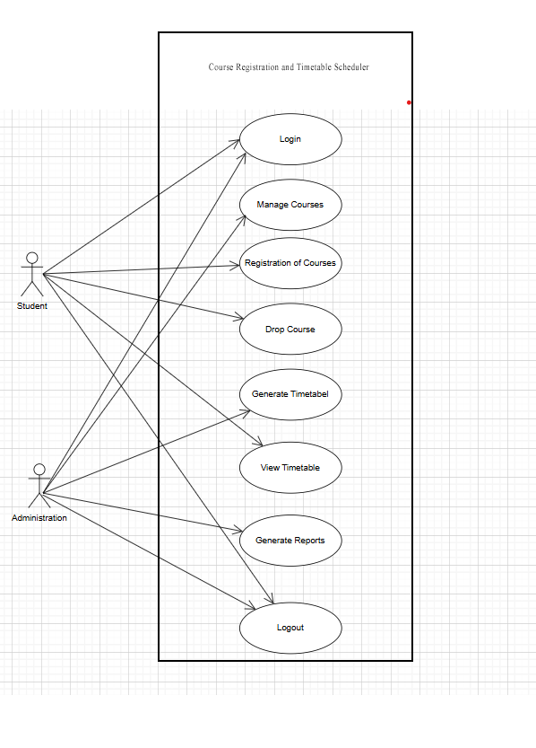
Figure 3: Use Case Diagram: Course Registration and Timetable Scheduler (UC9 is not shown)

5.3 Use Case Summary
Table 23: Use case summary
ID | Use case | Primary actor | Level | Includes | Priority
UC1 | Login | Student, Administrator | User-goal | – | High
UC2 | Logout | Student, Administrator | User-goal | UC1 (precondition) | High
UC3 | Manage Courses | Administrator | User-goal | UC1 | High
UC4 | Register Courses | Student | User-goal | UC1 | High
UC5 | Drop Course | Student | User-goal | UC1 | High
UC6 | Generate Timetable | Administrator | Summary | UC1 | High
UC7 | View Timetable | Student | User-goal | UC1 | High
UC8 | Generate Reports | Administrator | Summary | UC1 | Medium
UC9 | Manage Student Accounts | Administrator | User-goal | UC1 | High

5.4 Use Case Descriptions
Each use case is written in the fully dressed format. In the extensions, a step number followed by “a” or “b” (for example 3a) points to the step of the main scenario where the alternative happens.
UC1: Login
Scope / Level | Course Registration and Timetable Scheduler | User-goal
Primary actor | Student, Administrator
Stakeholders and interests | - Student / Administrator: wants quick and secure access to the system.  - System owner: only valid users enter; accounts remain secure.
Preconditions | - The user has an active registered account.  - The database is reachable.
Postconditions (success guarantee) | Success: the user is authenticated, a session is created and the dashboard for the user's role is shown.  Failure: no session is created and the failed attempt is logged.
Main success scenario | 1. User opens the login window.  2. User enters username (or email) and password.  3. System validates the credentials against the stored salted hash.  4. System grants access and creates a session.  5. System redirects the user to the Admin Dashboard or Student Panel according to role.
Extensions (alternate flows) | 2a. Missing fields: system prompts the user to fill the required fields.  3a. Invalid credentials: system shows “Invalid username/password”, increments the failed-attempt counter; user re-enters credentials.  3b. Account locked (5 failed attempts, BR-9): system shows the lock message and the time remaining.  3c. Account deactivated: system denies access and advises contacting the administrator.  3d. Database unavailable: system shows “Service unavailable, try again later”.
Special requirements | - Passwords are never stored or logged in plain text and are protected in transit (NFR-9, NFR-12).  - Login completes within 2 seconds (NFR-1).
Technology and data variations | - Users may log in with email or username.
Frequency of occurrence | Many times daily.
Related requirements | FR-1, FR-2, FR-11, FR-14; NFR-1, NFR-9, NFR-10, NFR-11, NFR-12, NFR-14; BR-9
Open issues and decisions | - Biometric login: out of scope for this release (Appendix C).  - Account lock after repeated failures: adopted (FR-14, BR-9).  - Two-factor authentication: out of scope; listed as a future enhancement.

UC2: Logout
Scope / Level | Course Registration and Timetable Scheduler | User-goal
Primary actor | Student, Administrator
Stakeholders and interests | - User: wants to exit securely.  - System owner: sessions are fully terminated.
Preconditions | - The user is logged in.
Postconditions (success guarantee) | Success: the session is cleared, cached user data is released and the login window is shown.
Main success scenario | 1. User chooses Logout.  2. System clears the session and cached data.  3. System shows the login window.
Extensions (alternate flows) | 1a. Inactivity timeout: after 15 minutes without activity the system performs steps 2 and 3 on its own (FR-13).  1b. Unsaved changes: system asks the user to confirm before logging out.
Special requirements | - The application session state is destroyed completely; no screen is reachable without logging in again.
Technology and data variations | - Automatic logout after inactivity.
Frequency of occurrence | Several times daily.
Related requirements | FR-12, FR-13; NFR-13
Open issues and decisions | - “Remember me”: not provided, because it weakens session security (Appendix C).

UC3: Manage Courses
Scope / Level | Course Registration and Timetable Scheduler | User-goal
Primary actor | Administrator
Stakeholders and interests | - Administrator: wants to maintain course offerings efficiently.  - Students: want accurate course listings.  - University: wants a consistent catalogue.
Preconditions | - The administrator is logged in.
Postconditions (success guarantee) | Success: the course, section and prerequisite data is validated, stored, and shown in the updated course list; affected timetables are refreshed.
Main success scenario | 1. Administrator opens Manage Courses.  2. Administrator selects add, edit or delete (archive).  3. Administrator enters course, section (capacity, instructor, room, time slots) and prerequisite details.  4. System validates the data.  5. System saves the changes.  6. System updates the course list and refreshes affected timetables.
Extensions (alternate flows) | 4a. Invalid data (missing fields, duplicate course code, end time before start time): system shows an error message and keeps the form open.  2a. Course has registered students: system blocks deletion, shows a message and offers to archive the course (BR-7).  5a. Database error: system rolls back the change and informs the administrator.
Special requirements | - Course code must be unique (FR-4, BR-5).  - Time changes must update related timetables immediately (FR-5).
Technology and data variations | - Administrator may import course details from a CSV file (FR-21).
Frequency of occurrence | Weekly, and intensively at semester start.
Related requirements | FR-3, FR-4, FR-5, FR-18, FR-19, FR-20, FR-21; NFR-2, NFR-8, NFR-11; BR-5, BR-7
Open issues and decisions | - Archive instead of delete: adopted; archived courses stay in history but cannot be registered.

UC4: Register Courses
Scope / Level | Course Registration and Timetable Scheduler | User-goal
Primary actor | Student
Stakeholders and interests | - Student: wants to register for courses without conflicts.  - System owner: seat limits and academic rules are enforced.
Preconditions | - The student is logged in.  - Active course sections are offered for the current semester.
Postconditions (success guarantee) | Success: the student is registered for each selected section, the enrolled count is incremented and the student's schedule is updated, all in one transaction.
Main success scenario | 1. Student opens the Registration page.  2. System lists available sections with seats remaining.  3. Student selects courses.  4. System checks prerequisites.  5. System checks seat availability.  6. System checks the credit-hour limit and timetable conflicts.  7. System registers the student and updates the enrolled count.  8. System updates the student's schedule and confirms.
Extensions (alternate flows) | 4a. Missing prerequisites: system displays an error naming the prerequisite.  5a. No seats available: system shows “Class Full”.  6a. Time conflict: system warns the user and names the conflicting course.  6b. Credit-hour limit exceeded: system refuses and shows the limit (BR-1).  7a. Transaction fails: system rolls back, shows an error and leaves registrations unchanged.
Special requirements | - Seat availability is checked and updated inside the same transaction (NFR-5).  - Real-time seat availability is shown on the list.
Technology and data variations | - Courses may be displayed in list or calendar format.
Frequency of occurrence | Once or twice per semester (intensive in registration week).
Related requirements | FR-6, FR-7, FR-22, FR-23, FR-24, FR-25, FR-26, FR-28; NFR-2, NFR-5, NFR-16; BR-1, BR-2, BR-4, BR-6, BR-8, BR-10
Open issues and decisions | - Auto-suggest alternate courses: deferred to a future release.

UC5: Drop Course
Scope / Level | Course Registration and Timetable Scheduler | User-goal
Primary actor | Student
Stakeholders and interests | - Student: wants flexibility to adjust the schedule.  - System owner: registration counts stay accurate.
Preconditions | - The student is logged in.  - The student is registered for the course.
Postconditions (success guarantee) | Success: the registration is removed, the enrolled count is decremented, the timetable is updated and the drop is recorded.
Main success scenario | 1. Student opens Registered Courses.  2. Student selects a course to drop.  3. System asks for confirmation.  4. Student confirms.  5. System removes the registration and decrements the enrolled count.  6. System records the drop and updates the timetable.
Extensions (alternate flows) | 2a. Deadline passed: system refuses and shows the deadline (BR-3).  4a. Student cancels: system keeps the registration unchanged.  5a. Transaction fails: system rolls back and shows an error.
Special requirements | - The system enforces drop deadlines (FR-27).
Technology and data variations | - Desktop application only; web or mobile access is a future enhancement.
Frequency of occurrence | Rare (1–2 times per semester).
Related requirements | FR-6, FR-26, FR-27, FR-28; NFR-8, NFR-16; BR-3
Open issues and decisions | - Refund policy: out of scope (no fee handling in this release).

UC6: Generate Timetable
Scope / Level | Course Registration and Timetable Scheduler | Summary
Primary actor | Administrator
Stakeholders and interests | - Student: wants a conflict-free schedule.  - Administrator: wants to (re)generate timetables for students reliably.
Preconditions | - The administrator is logged in.  - The selected student is registered for at least one course section.
Postconditions (success guarantee) | Success: a valid, conflict-free timetable is generated, stored and available to the administrator and (through UC7) the student.
Main success scenario | 1. Administrator selects a student and chooses Generate Timetable.  2. System gathers the student's registered sections.  3. System retrieves their weekly time slots.  4. System checks and resolves conflicts.  5. System generates the timetable.  6. System displays the timetable to the administrator.
Extensions (alternate flows) | 2a. Student has no registrations: system shows a message and stops.  4a. Conflicts cannot be resolved: system lists the unresolved clashes, refuses and does not store a timetable.
Special requirements | - Processing completes within 3 seconds (NFR-3).
Technology and data variations | - Result shown in grid, calendar or list view.
Frequency of occurrence | Several times during registration week.
Related requirements | FR-5, FR-29, FR-30; NFR-3; BR-2
Open issues and decisions | - Customised preferences (preferred days or times): deferred.

UC7: View Timetable
Scope / Level | Course Registration and Timetable Scheduler | User-goal
Primary actor | Student
Stakeholders and interests | - Student: wants easy access to the weekly schedule.
Preconditions | - The student is logged in.  - A timetable exists for the student.
Postconditions (success guarantee) | Success: the student's timetable is displayed.
Main success scenario | 1. Student opens View Timetable.  2. System retrieves the timetable.  3. System displays it in grid format.
Extensions (alternate flows) | 2a. No timetable exists: system tells the student that no timetable is available yet and suggests registering for courses or contacting the administrator.  3a. Student chooses Print / Export: system produces a printout or PDF of the timetable (FR-33).
Special requirements | - Readable at a minimum window size of 1024 × 768.
Technology and data variations | - Display in grid, table or calendar form.
Frequency of occurrence | Daily.
Related requirements | FR-8, FR-31, FR-32, FR-33; NFR-2, NFR-15
Open issues and decisions | - PDF export: adopted with Low priority (FR-33).

UC8: Generate Reports
Scope / Level | Course Registration and Timetable Scheduler | Summary
Primary actor | Administrator
Stakeholders and interests | - Administrator: needs analytics for decisions.  - University: wants accurate enrolment records.
Preconditions | - The administrator is logged in.
Postconditions (success guarantee) | Success: the selected report is generated and displayed or exported.
Main success scenario | 1. Administrator selects Generate Reports.  2. Administrator selects the report type and filters (semester, course).  3. System processes the data.  4. System generates the report.  5. System presents the report.
Extensions (alternate flows) | 3a. Data missing: system warns the administrator (FR-36).  4a. Report too large: system offers a download option.  5a. Export fails: system shows an error and keeps the on-screen report.
Special requirements | - Reports can be downloaded as PDF and Excel (FR-35).
Technology and data variations | - Chart-based or table-based formats.
Frequency of occurrence | Monthly, and at end of semester.
Related requirements | FR-9, FR-10, FR-34, FR-35, FR-36; NFR-2
Open issues and decisions | - Scheduled e-mailing of reports: deferred.

UC9: Manage Student Accounts
Scope / Level | Course Registration and Timetable Scheduler | User-goal
Primary actor | Administrator
Stakeholders and interests | - Administrator: wants to create and maintain student accounts.  - Student: needs a working account to log in.
Preconditions | - The administrator is logged in.
Postconditions (success guarantee) | Success: the student account is created, updated, deactivated or its password reset, and the change is stored and logged.
Main success scenario | 1. Administrator opens Manage Students.  2. Administrator selects add, edit, deactivate or reset password.  3. Administrator enters or changes the student details (registration number, name, program, semester, section, credit limit).  4. System validates the data.  5. System saves the change and confirms.
Extensions (alternate flows) | 4a. Duplicate registration number or username: system shows an error.  2a. Reset password: system generates a temporary password and forces a change at next login (FR-17).
Special requirements | - Registration number is unique (FR-16, A-2).
Technology and data variations | - None.
Frequency of occurrence | At semester start and when students join or leave.
Related requirements | FR-15, FR-16, FR-17; NFR-9, NFR-10
Open issues and decisions | - Added during analysis. v1.2 listed “student records” as a function but had no use case for it. A diagram entry (Figure 3) and an SSD are still to be drawn (Section 6).

6. System Sequence Diagrams
A system sequence diagram (SSD) shows, for one use case, the events the actor sends to the system (treated as a black box) and how the system responds. The diagrams below cover the main success scenario and the main alternate flow of each use case.

6.1 UC1: Login
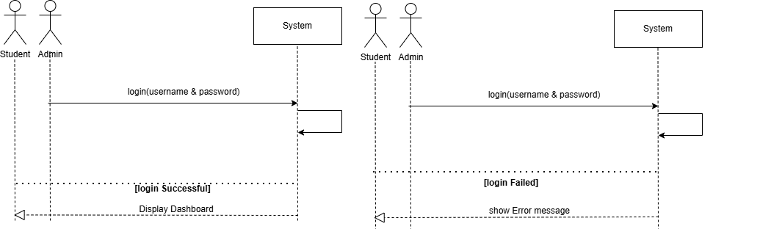
Figure 4: System Sequence Diagram for UC1

6.2 UC2: Logout
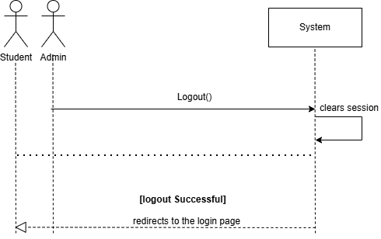
Figure 5: System Sequence Diagram for UC2

6.3 UC3: Manage Courses
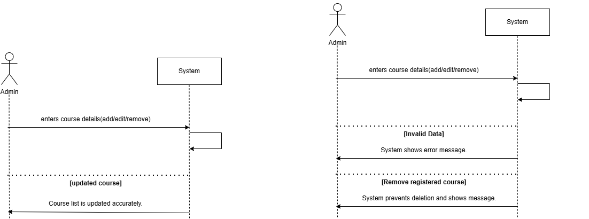
Figure 6: System Sequence Diagram for UC3

6.4 UC4: Register Courses
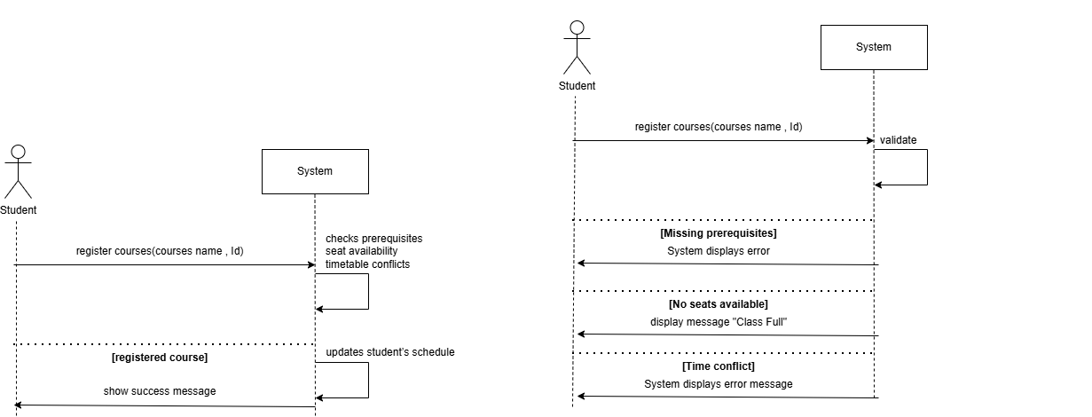
Figure 7: System Sequence Diagram for UC4

6.5 UC5: Drop Course
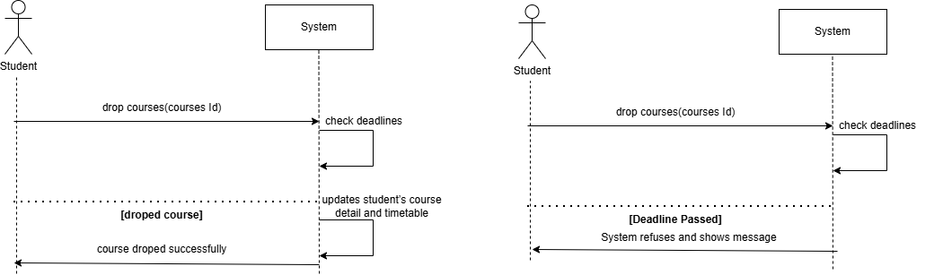
Figure 8: System Sequence Diagram for UC5

6.6 UC6: Generate Timetable
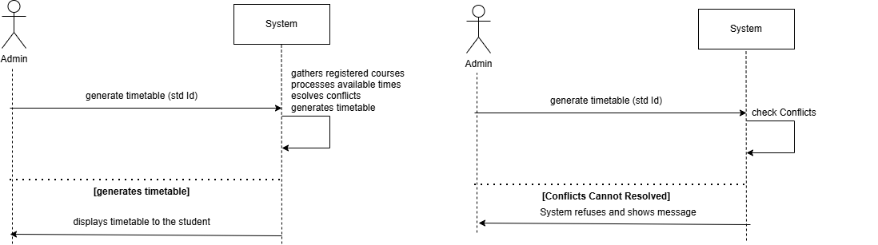
Figure 9: System Sequence Diagram for UC6

6.7 UC7: View Timetable
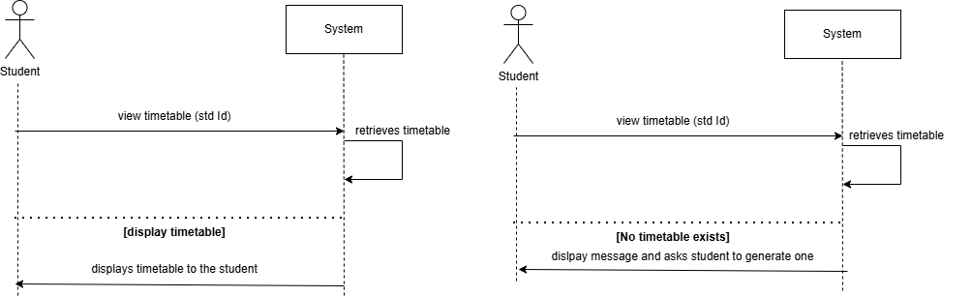
Figure 10: System Sequence Diagram for UC7

6.8 UC8: Generate Reports
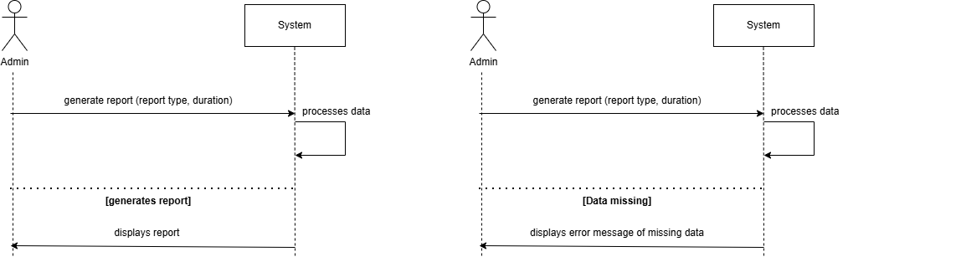
Figure 11: System Sequence Diagram for UC8
UC9 (Manage Student Accounts) was added during analysis and has no SSD yet. It follows the same pattern as UC3 and will be drawn in the design phase, together with its entry in Figure 3.

7. Domain Model
The domain model shows the real-world concepts in the problem, their attributes and how they relate. It is the starting point for the database schema and the class design.
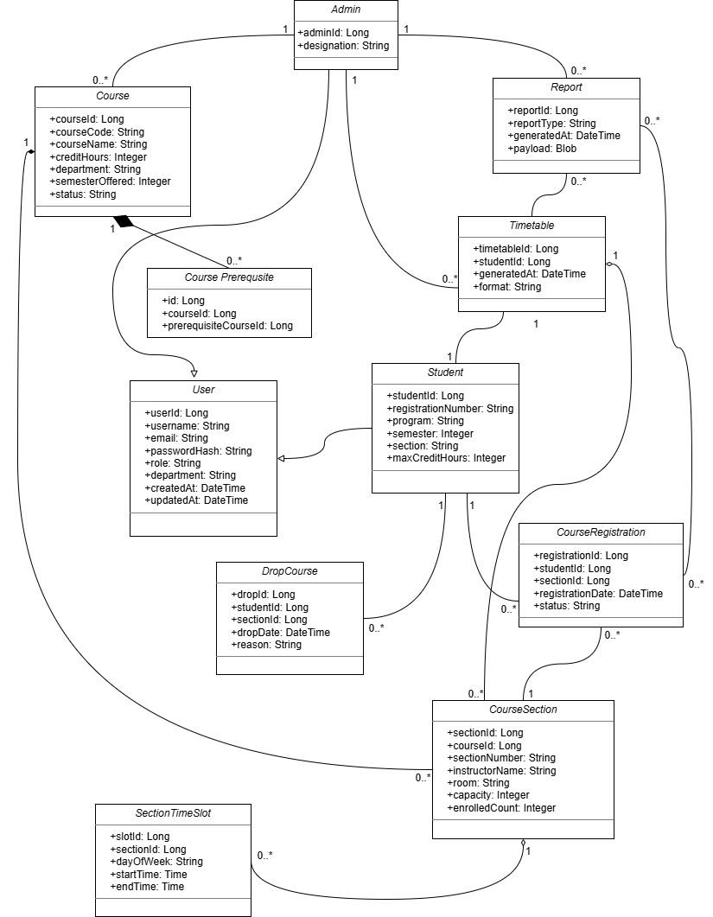
Figure 12: Domain Model for the Course Registration and Timetable Scheduler

7.1 Domain Concepts and Data Dictionary
Table 24: Domain concepts and data dictionary
Concept | Key attributes | Description and constraints
User | userId, username, email, passwordHash, role, department, createdAt, updatedAt | Generalisation of Student and Admin. Username and email are unique; role is Student or Admin; only the hash of the password is stored.
Student | studentId, registrationNumber, program, semester, section, maxCreditHours | Specialisation of User. Registration number is unique (A-2). maxCreditHours is the credit limit used by BR-1.
Admin | adminId, designation | Specialisation of User. Manages courses, generates timetables and reports.
Course | courseId, courseCode, courseName, creditHours, department, semesterOffered, status | Course code is unique (BR-5). Status is Active or Archived.
CoursePrerequisite | id, courseId, prerequisiteCourseId | A course may have 0..* prerequisites; deleted with the course.
CourseSection | sectionId, courseId, sectionNumber, instructorName, room, capacity, enrolledCount | A section of a course. 0 ≤ enrolledCount ≤ capacity (BR-6).
SectionTimeSlot | slotId, sectionId, dayOfWeek, startTime, endTime | Weekly meeting of a section. startTime < endTime; used for clash detection.
CourseRegistration | registrationId, studentId, sectionId, registrationDate, status | A student's enrolment in a section. At most one active registration per student and course (BR-8).
DropCourse | dropId, studentId, sectionId, dropDate, reason | History record of a dropped registration (FR-27).
Timetable | timetableId, studentId, generatedAt, format | Weekly schedule generated for one student (FR-29).
Report | reportId, reportType, generatedAt, payload | Report produced by an administrator (FR-34).

7.2 Relationships
- Student and Admin are specialisations of User.
- A Course has 0..* CoursePrerequisite and 0..* CourseSection; a CourseSection has 0..* SectionTimeSlot.
- A Student has 0..* CourseRegistration and 0..* DropCourse records; a CourseSection has 0..* CourseRegistration.
- A Student has a Timetable generated by an Admin; an Admin creates 0..* Report and manages 0..* Course.
In the design class diagram (Section 8) the same concepts are called CourseOffering, Registration and TimetableEntry. Those names should be aligned with this domain model (CourseSection, CourseRegistration, SectionTimeSlot) before the schema is created.

8. Preliminary Design Models (Informative)
The sequence diagram and design class diagram below come from the analysis models in version 1.2. They are kept as input for the design phase and are not requirements.

8.1 Sequence Diagram
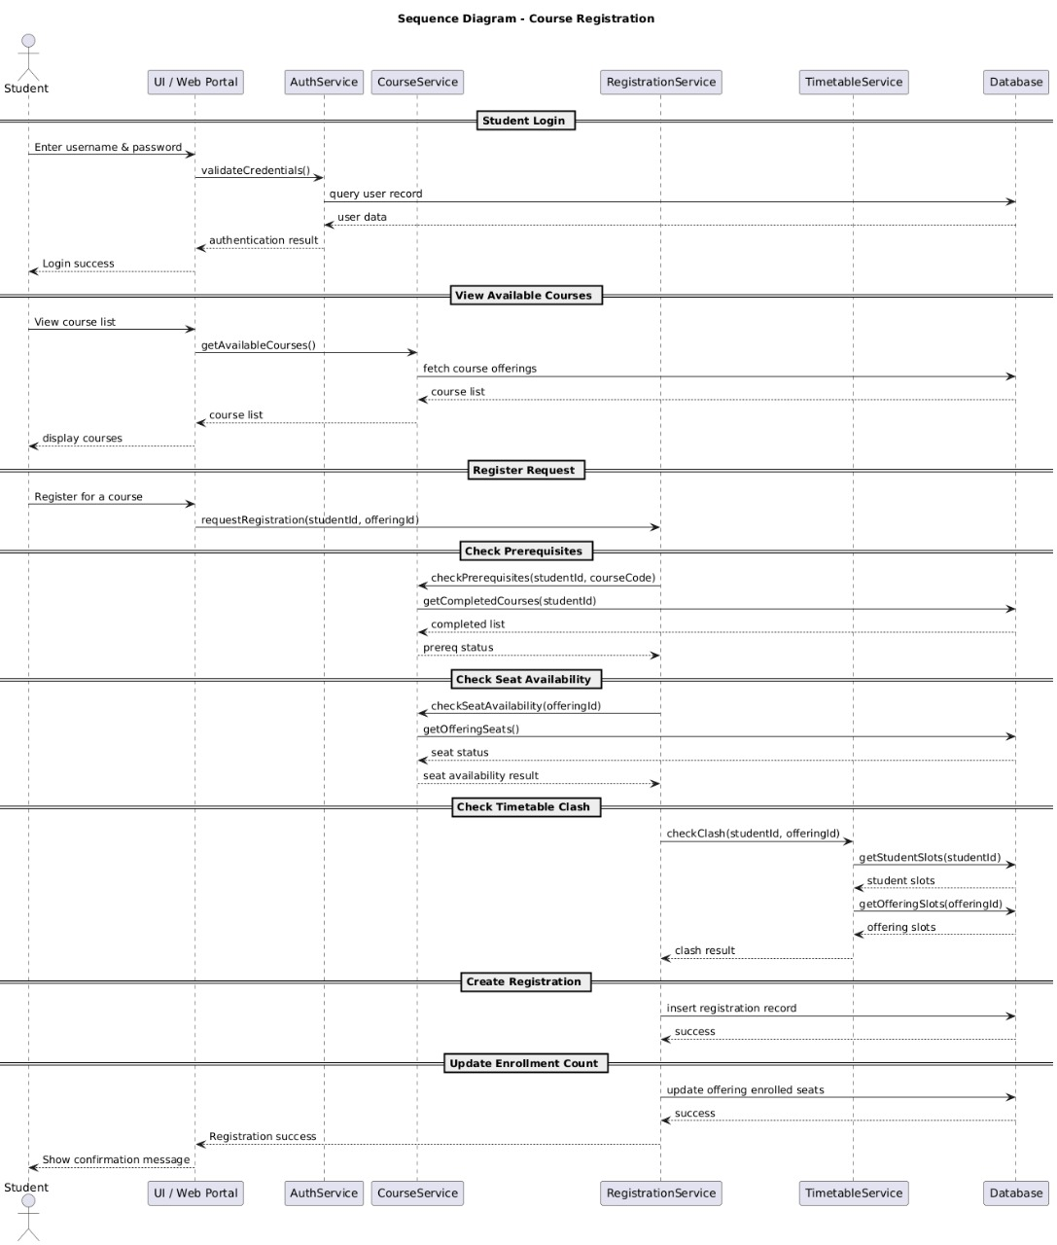
Figure 13: Sequence Diagram for the Course Registration and Timetable Scheduler

8.2 Design Class Diagram
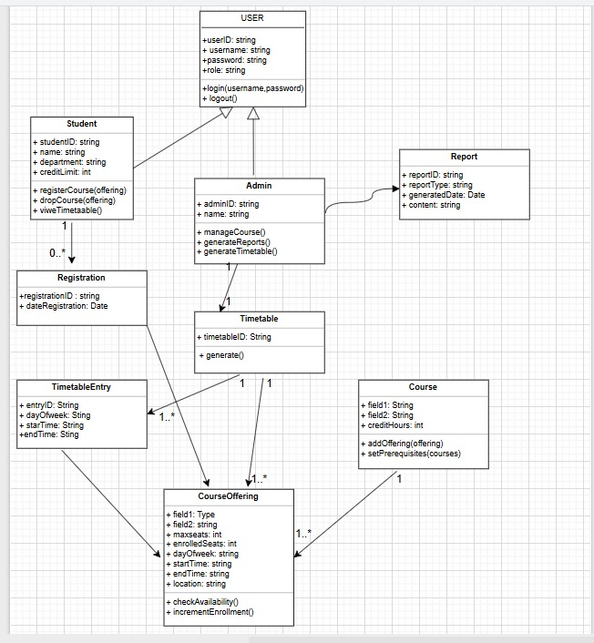
Figure 14: Design Class Diagram for the Course Registration and Timetable Scheduler

9. Other Non-functional Requirements

9.1 Performance Requirements
Table 25: Performance requirements
ID | Requirement | Priority | Verif.
NFR-1 | Login must complete within 2 seconds under normal load. | High | T
NFR-2 | Query responses and screen refreshes must complete within 2 seconds for 95% of requests. | High | T
NFR-3 | Timetable generation must complete within 3 seconds. | High | T
NFR-4 | The system must support at least 200 concurrent users. | Medium | T
NFR-5 | Seat availability must be checked and updated inside the registration transaction, so two students can never take the last seat. | High | T

9.2 Safety Requirements
Table 26: Safety requirements
ID | Requirement | Priority | Verif.
NFR-6 | The database must be backed up daily at 00:00 and the last 7 backups must be kept. | High | I, D
NFR-7 | Incomplete transactions must be rolled back so that the database stays consistent after an error or crash. | High | T
NFR-8 | The system must ask for confirmation before deleting or dropping data. | Medium | D

9.3 Security Requirements
Table 27: Security requirements
ID | Requirement | Priority | Verif.
NFR-9 | Passwords must be stored as salted hashes using SHA-256 or stronger (bcrypt or PBKDF2 recommended). | High | I
NFR-10 | Access must be role-based: students cannot reach administrator functions or other students' data; the check is enforced in the controller layer, not only in the UI. | High | T
NFR-11 | All database access must use prepared statements and all input must be validated to prevent SQL injection. | High | I, T
NFR-12 | Credentials must not be sent in clear text; connections to a remote database must use TLS with a least-privilege account. | High | I
NFR-13 | Sessions must end on logout and after 15 minutes of inactivity. | Medium | T
NFR-14 | The system must log logins, failed logins, registrations, drops, administrative changes and errors with time and user. | Medium | I, D

9.4 Software Quality Attributes
Table 28: Quality attributes
ID | Requirement | Priority | Verif.
NFR-15 | Usability: a first-time student must be able to register for a course within 5 minutes without training. | Medium | D
NFR-16 | Reliability: data consistency must be kept through atomic transactions. | High | T
NFR-17 | Availability: the system must be available at least 99% of the time during the registration period. | Medium | A
NFR-18 | Maintainability: the code must follow MVC with a DAO layer and documented public methods. | Medium | I
NFR-19 | Portability: the application must run on Windows 10 or later with JDK 17+; other operating systems are best effort. | Medium | T
NFR-20 | Scalability (design target, TBD-5): at least 5,000 students and 1,000 sections without loss of the performance targets. | Low | A

9.5 Business Rules
Table 29: Business rules
ID | Rule | Source
BR-1 | A student cannot exceed the maximum credit hours (TBD-1). | University policy
BR-2 | A time clash automatically blocks registration. | v1.2
BR-3 | Dropping is allowed only until the drop deadline set by the university (TBD-2). | University policy
BR-4 | A student must have completed the prerequisites of a course before registering. | v1.2 (UC4)
BR-5 | Course codes are unique. | v1.2 (FR-4)
BR-6 | The enrolled count of a section never exceeds its capacity. | v1.2 (UC4)
BR-7 | A course or section with active registrations cannot be deleted; it can be archived. | v1.2 (UC3)
BR-8 | A student can hold at most one active registration per course. | Analysis
BR-9 | An account is locked for 15 minutes after 5 consecutive failed logins. | Analysis
BR-10 | Only active students can register, and only for active courses offered in the current semester within the registration period (TBD-3). | Analysis

10. Other Requirements
- Backup: the database is backed up automatically every day at 00:00 (NFR-6), with a documented restore procedure.
- Logging: all transactions and errors are logged (NFR-14); the retention period follows university policy (TBD-6).
- Installation: the product ships with SQL scripts that create the schema and load sample data, plus installation instructions.
- Legal: student personal data is handled according to the university data policy.
- Future: an optional REST API for a later web version (Section 2.8); it is not part of this release.

11. Requirements Traceability and Verification
The matrix links every use case to its requirements, rules, SSD and system tests. Every FR appears in at least one use case, and every High-priority requirement has at least one planned test (T) or demonstration (D).
Table 30: Traceability matrix
Use case | Functional requirements | NFR and business rules | SSD | System tests
UC1 Login | FR-1, 2, 11, 14 | NFR-1, 9, 10, 11, 12, 14; BR-9 | Fig. 4 | TC-UC1-01…
UC2 Logout | FR-12, 13 | NFR-13 | Fig. 5 | TC-UC2-01…
UC3 Manage Courses | FR-3, 4, 5, 18, 19, 20, 21 | NFR-2, 8, 11; BR-5, 7 | Fig. 6 | TC-UC3-01…
UC4 Register Courses | FR-6, 7, 22–26, 28 | NFR-2, 5, 16; BR-1, 2, 4, 6, 8, 10 | Fig. 7 | TC-UC4-01…
UC5 Drop Course | FR-6, 26, 27, 28 | NFR-8, 16; BR-3 | Fig. 8 | TC-UC5-01…
UC6 Generate Timetable | FR-5, 8, 29, 30 | NFR-3; BR-2 | Fig. 9 | TC-UC6-01…
UC7 View Timetable | FR-8, 31, 32, 33 | NFR-2, 15 | Fig. 10 | TC-UC7-01…
UC8 Generate Reports | FR-9, 10, 34, 35, 36 | NFR-2 | Fig. 11 | TC-UC8-01…
UC9 Manage Student Accounts | FR-15, 16, 17 | NFR-9, 10 | to be drawn | TC-UC9-01…

The test case IDs are placeholders. The real test cases are written in the testing phase (Part I, WBS 5.1) and added to this matrix.

Appendix A: Glossary
Table 31: Glossary
Term | Definition
CRTS | Course Registration and Timetable Scheduler (this product)
Course | A subject offered by a department with a code, name and credit hours
Section | A scheduled offering of a course with an instructor, room, capacity and weekly time slots
Registration | A student's enrolment in a section
Timetable | The weekly schedule of a student built from the registered sections
Clash (conflict) | Two sections of the same student that overlap in day and time
Prerequisite | A course that must be completed before another course may be taken
Credit hours | The weight of a course; the sum for a student is limited per semester
Seat / capacity | The maximum number of students allowed in a section
GUI | Graphical User Interface
DBMS | Database Management System
JDBC | Java Database Connectivity
DAO | Data Access Object, a class that isolates database access
MVC | Model-View-Controller design pattern
FR / NFR / BR | Functional requirement / Non-functional requirement / Business rule
SRS / SPMP | Software Requirements Specification / Software Project Management Plan
SSD | System Sequence Diagram
WBS | Work Breakdown Structure
UAT | User Acceptance Testing
RBAC | Role-Based Access Control
SHA | Secure Hash Algorithm
CSV | Comma-separated values file
TBD | To be determined: a value or decision not yet confirmed

Appendix B: References
- IEEE Std 830-1998, IEEE Recommended Practice for Software Requirements Specifications. IEEE, 1998.
- ISO/IEC/IEEE 29148:2018, Systems and software engineering: Life cycle processes: Requirements engineering.
- IEEE Std 1058-1998, IEEE Standard for Software Project Management Plans. IEEE, 1998.
- IEEE Std 1028-2008, IEEE Standard for Software Reviews and Audits.
- IEEE Std 829-2008, IEEE Standard for Software and System Test Documentation.
- Cockburn, A. Writing Effective Use Cases. Addison-Wesley, 2001.
- Oracle. Java Swing API Documentation. Oracle Corporation.
- MySQL. MySQL 8.0 Reference Manual. Oracle Corporation.
- Quaid-i-Azam University. CS322: Software Construction, Course Manual.

Appendix C: Open Issues, Decisions and TBD List
Table 32: Open issues and TBD list
Issue (from v1.2) | Decision in v1.3 | Status
UC1: biometric login? | Out of scope | Closed
UC1: lock accounts after repeated failures? | Yes: 5 attempts, 15 minutes (FR-14, BR-9) | Closed
UC2: “Remember me”? | Not provided (security) | Closed
UC3: archive instead of delete? | Yes (FR-3, FR-20, BR-7) | Closed
UC4: auto-suggest alternate courses? | Deferred to a future release | Deferred
UC5: refund policy? | Out of scope (no fees) | Closed
UC6: customised timetable preferences? | Deferred to a future release | Deferred
UC7: PDF export of the timetable? | Yes, Low priority (FR-33) | Closed
UC8: scheduled report e-mails? | Deferred to a future release | Deferred
TBD-1: maximum credit hours per semester | Value per student is held in maxCreditHours; default to be given by the university | Open
TBD-2: drop deadline | To be provided by the university; stored as a setting | Open
TBD-3: registration period dates | To be provided by the university; stored as a setting | Open
TBD-4: source of completed-course history for prerequisite checks | To be agreed: admin-maintained records or imported history | Open
TBD-5: expected maximum number of students and sections | Design target in NFR-20 to be confirmed | Open
TBD-6: log retention period | Per university policy | Open

