Realm of Legends
ASP.NET Core MVC Role-Playing Game

Complete Technical Documentation

Version 1.0
Generated: June 06, 2026

Table of Contents
1. Executive Summary
2. Project Overview
3. Technology Stack
4. Application Architecture
5. Database Design
6. Authentication System
7. Dashboard and Game Hub
8. Shop System
9. Inventory Management
10. Arena Combat System
11. Quest System
12. Achievement System
13. Application Screenshots
14. Code Implementation
15. Security and Best Practices
16. Testing and Quality Assurance
17. Conclusion

1. Executive Summary
Realm of Legends is a comprehensive browser-based role-playing game built using ASP.NET Core MVC and SQL Server. The application demonstrates modern web development practices, secure authentication, and engaging gameplay mechanics.

Key Features:
• Character creation with 4 unique classes
• Dynamic turn-based combat system with 10 arena levels
• Item marketplace with 40+ items across 5 rarity tiers
• Quest system with interactive objectives
• Achievement tracking and progression
• Real-time statistics and leaderboards

2. Project Overview
Realm of Legends provides players with an immersive fantasy RPG experience entirely within their web browser. The game features a complete gameplay loop: character progression, equipment management, combat, questing, and achievement hunting.

3. Technology Stack

Backend Technologies
• Framework: ASP.NET Core 8.0 (LTS)
• Language: C# 12
• ORM: Entity Framework Core 8.0
• Database: SQL Server 2022 / LocalDB
• Authentication: ASP.NET Core Identity

Frontend Technologies
• View Engine: Razor Pages
• JavaScript: Vanilla ES2022
• CSS: Custom styles with CSS variables
• Graphics: HTML5 Canvas for arena battles

4. Application Architecture
The solution follows a layered architecture pattern with four main projects:

• RealmOfLegends.Web - Presentation layer with MVC controllers and views
• RealmOfLegends.Core - Domain layer with business entities
• RealmOfLegends.Data - Data access layer with EF Core context
• RealmOfLegends.Tests - Testing project with unit and integration tests

5. Database Design
The database consists of 12 core entities:
• AspNetUsers - Authentication and user accounts
• Players - Game character data
• Items - Master catalog of all items
• Inventory - Player-owned items
• PurchaseHistory - Transaction audit log
• Quests - Quest definitions
• PlayerQuests - Player quest progress
• ArenaProgress - Arena level and statistics
• FightLog - Combat history
• Achievements - Achievement definitions
• PlayerAchievements - Unlocked achievements
• News - Admin announcements

13. Application Screenshots
This section provides visual documentation of all application pages.

01 Home
Landing page
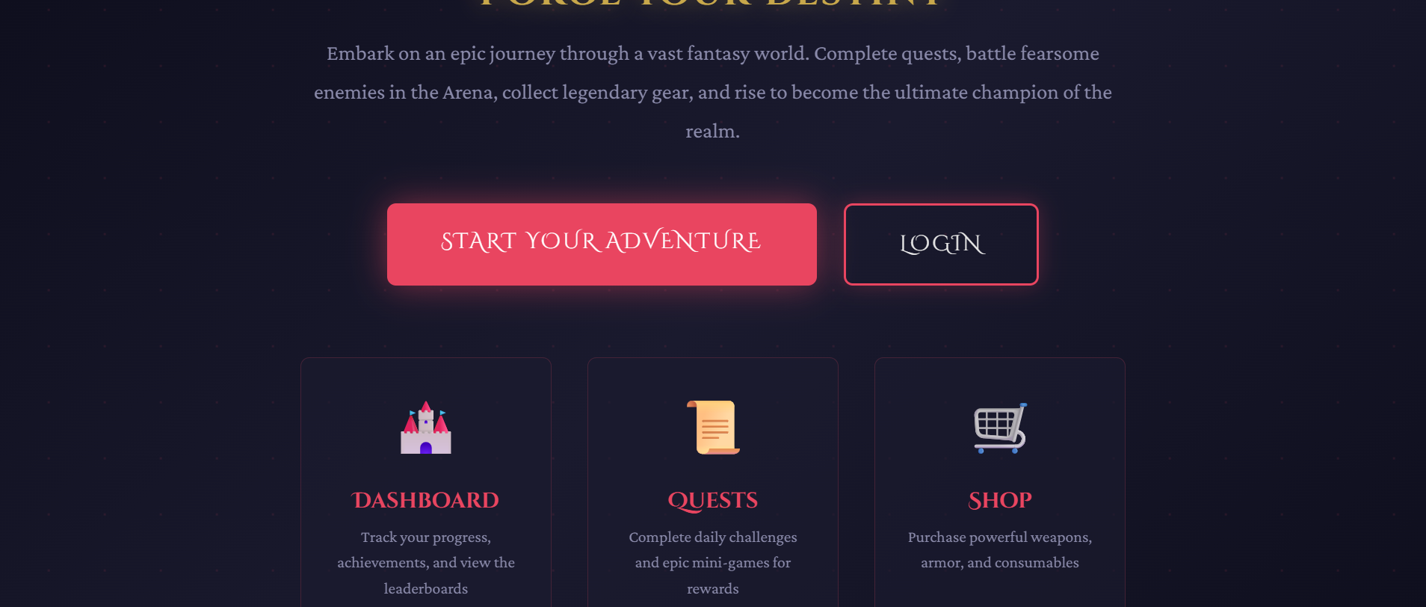
Figure: Landing page

02 Login
Login page
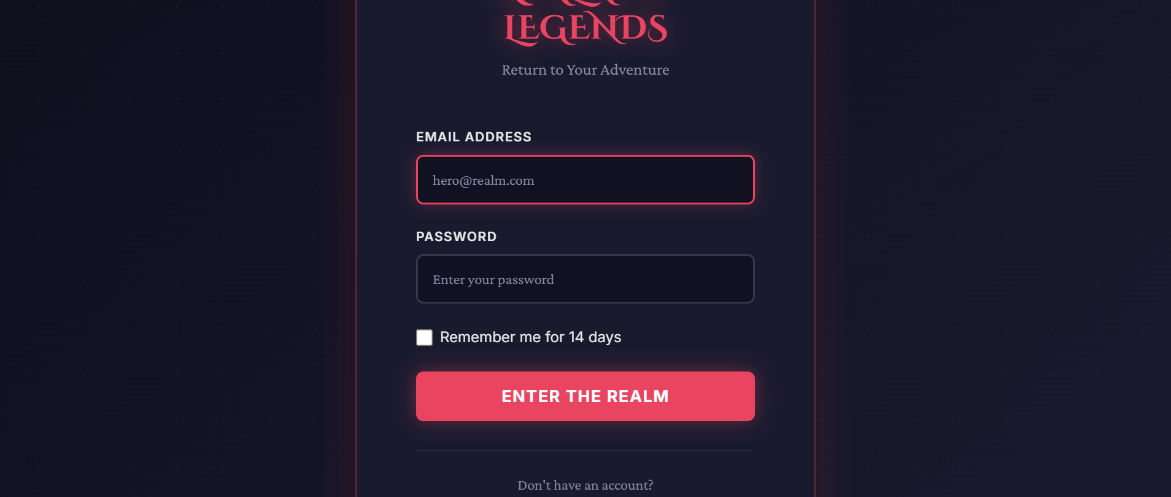
Figure: Login page

03 Register
Registration page
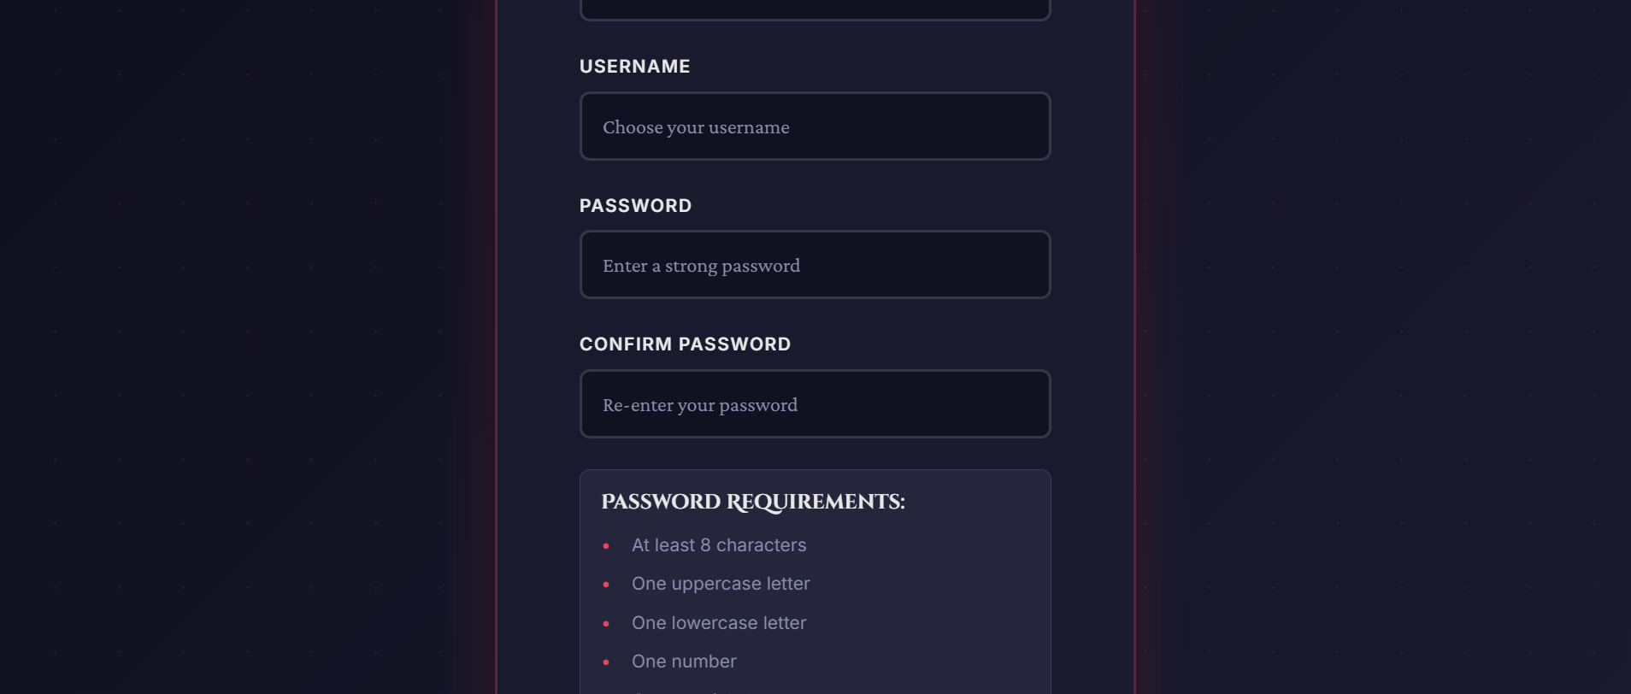
Figure: Registration page

04 Character Creation
Character creation page
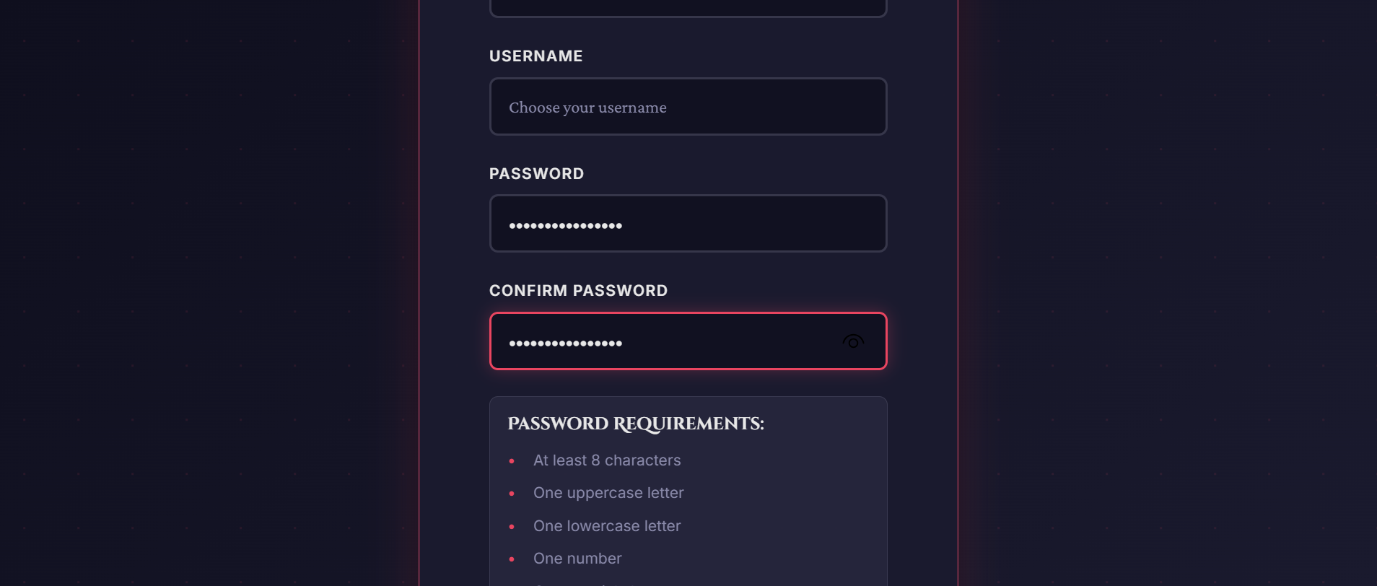
Figure: Character creation page

05 Dashboard
Main dashboard
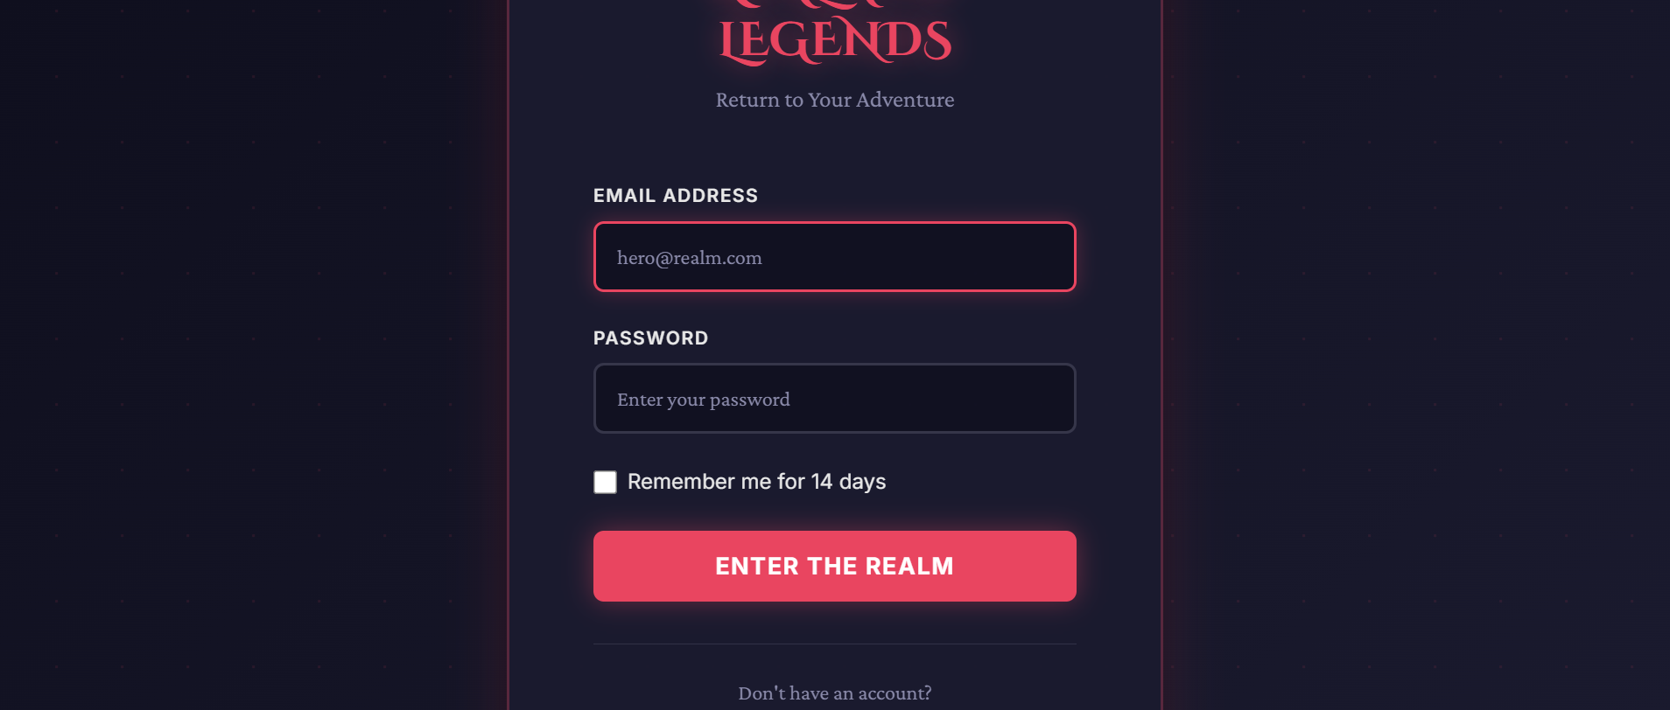
Figure: Main dashboard

06 Shop
Shop page

Figure: Shop page

07 Shop After Purchase
Shop after purchases
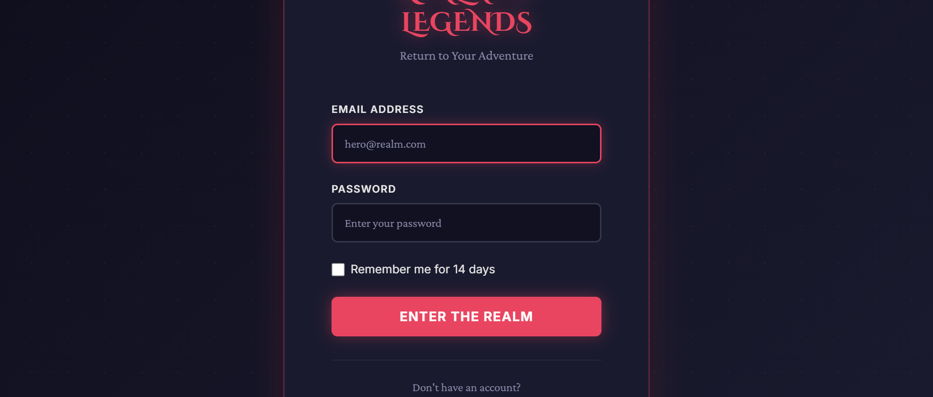
Figure: Shop after purchases

08 Inventory Empty
Inventory before equipping
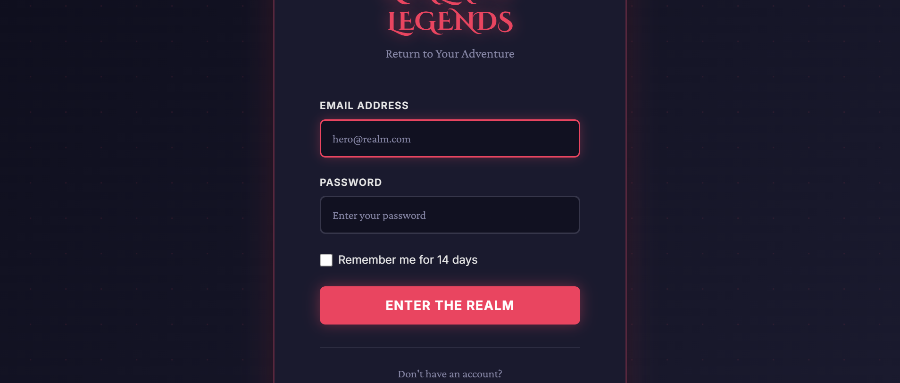
Figure: Inventory before equipping

09 Inventory Equipped
Inventory with equipped items

Figure: Inventory with equipped items

10 Quests
Quests page
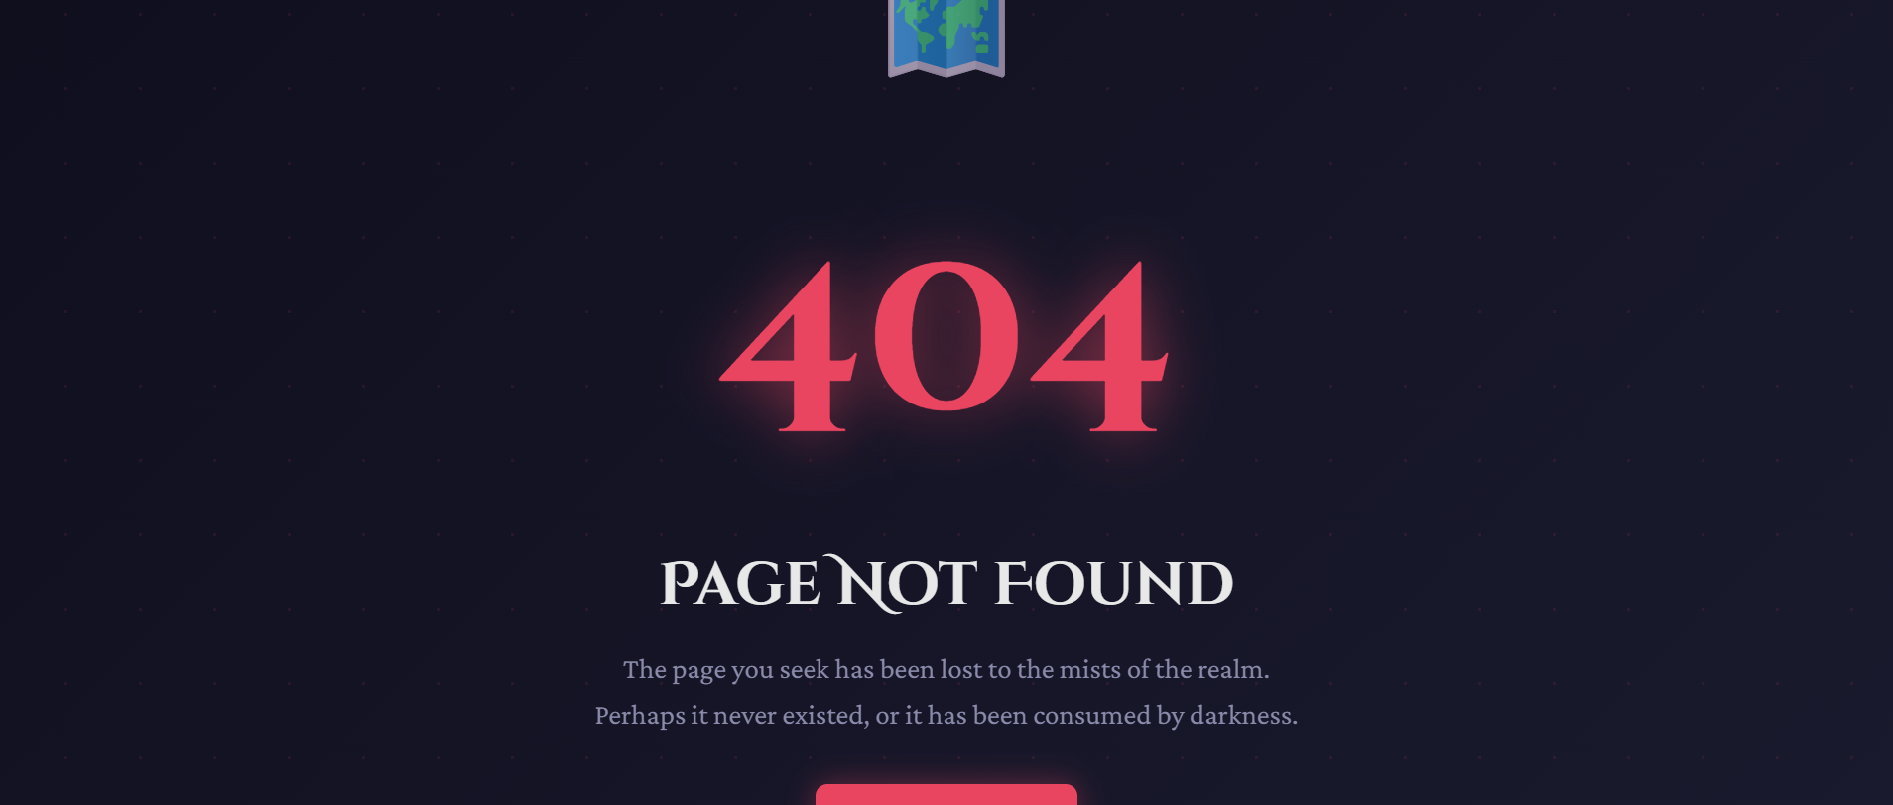
Figure: Quests page

11 Achievements
Achievements page
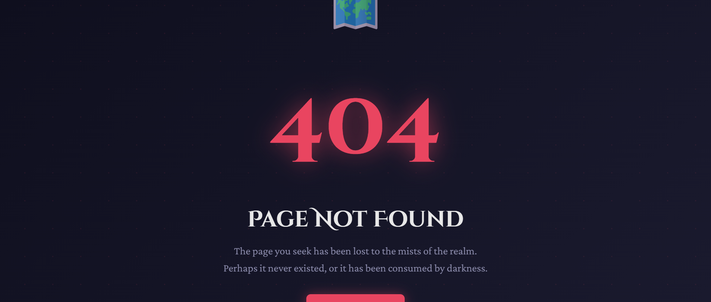
Figure: Achievements page

12 Profile
Profile page
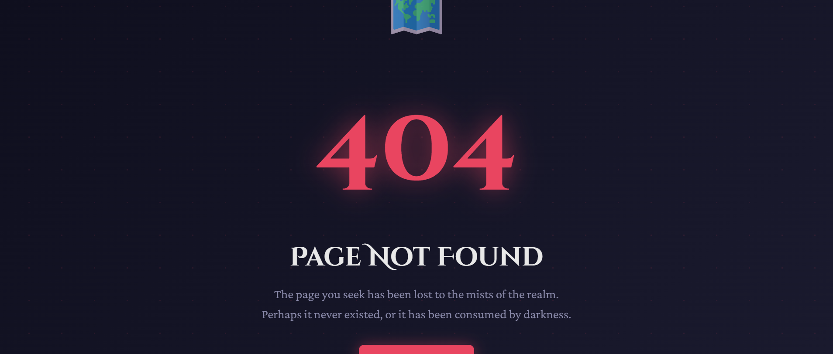
Figure: Profile page

13 Arena Hub
Arena hub
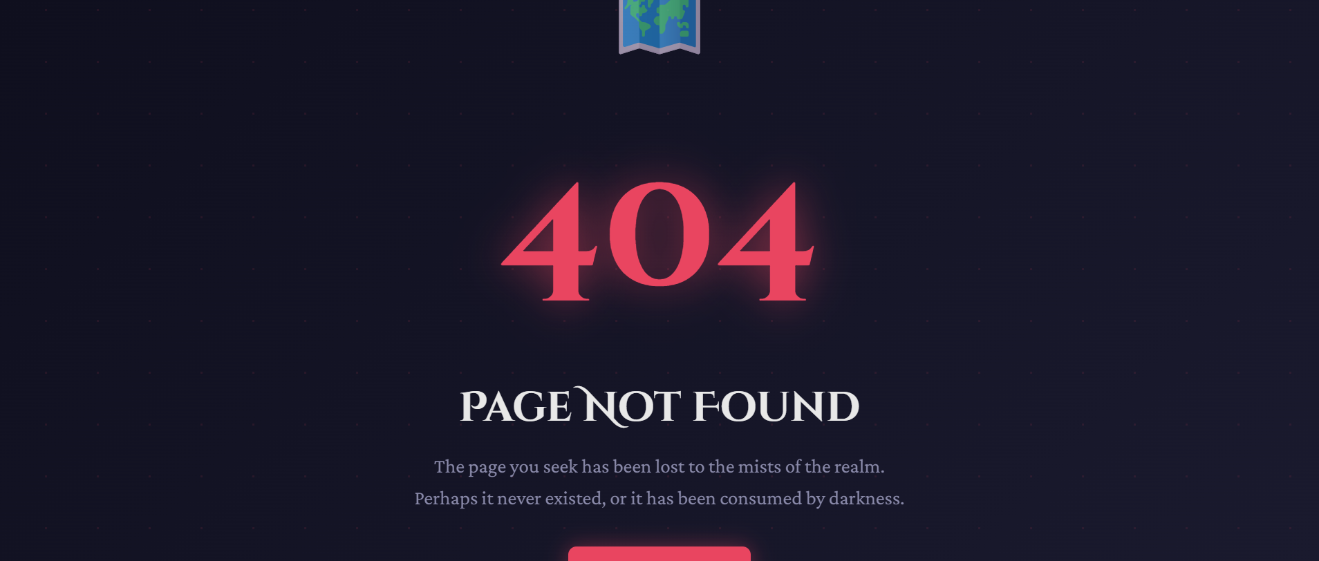
Figure: Arena hub

10. Arena Combat System
The Arena is the core gameplay feature, providing turn-based combat against increasingly difficult enemies. The system features 10 progressive levels with two boss encounters.

Combat Mechanics
Turn-Based Battle System:
• Initiative: Player always attacks first
• Damage Calculation: Attack - Defense (minimum 1)
• Critical Hits: Based on character class
• Victory: Enemy HP reaches 0
• Rewards: Gold, XP, and possible item drops

17. Conclusion
Realm of Legends demonstrates a complete full-stack web application built with modern .NET technologies. The project showcases technical excellence in clean architecture, secure authentication, efficient database design, and engaging user interface design.

