Project Report on

**AUREATE FOOD DEVILERY**

at

**Aimdek Technologies Pvt. Ltd.**



|  |  |
| --- | --- |
| **External Guide :** | **Prepared By:** |
| Mr. Jay Virsodiya | Mr. Aftab Sipahi (19012012005) |
| **Internal Guide :** |  |
| Prof. Chirag Gami |  |

**B.Tech Semester VIII (Computer Engineering)** May 2022

Submitted to,

Department of Computer Engineering

U.V. Patel College of Engineering Ganpat University, Kherva - 384 012

U.V. PATEL COLLEGE OF

ENGINEERING



**21/05/2022**

**C E R T I F I C A T E**

**T O W H O M S O E V E R I T M A Y C O N C E R N**

This is to certify that Mr. **Aftab Sipahi** student of **B.Tech. Semester VIII (Computer Engineering)** has completed his/her full semester on site project work titled “**Aureate Food Delivery**” satisfactorily in partial fulfillment of the requirement of Bachelor of Technology degree of Computer Engineering of Ganpat University, Kherva, Mehsana in the year 2021-2022.

**College Project Guide**

Sign **Dr. Paresh M. Solanki,**

**HOD, Computer Engineering**

Prof. Chirag Gami



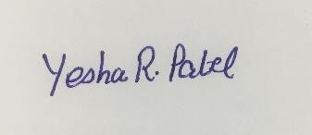

Date: 11th May 2022

**TO WHOMSOEVER IT MAY CONCERN**

This is to certify that Mr. Aftab Sipahi (Er. No. 19012012005), 8th semester student at Ganpat University, Mehsana Gojariya Highway, from Computer Engineering branch is undergoing his training period in Salesforce with AIMDek Technologies Private Limited, starting from 5 Jan 2022 till Present Date.

Regards,

Authorized Person

For, AIMDek Technologies Pvt. Ltd.

AIMDek confidential

# ACKNOWLEDGEMENT

I owe a debt of gratitude to several individuals who in one way or another contributed and extended their valuable assistance in the preparation and completion of this project during the 8th semester of B. Tech industrial project training.

First of all, I would thank the institute, U. V. Patel College of Engineering, Ganpat University. for giving me such a wonderful opportunity to get a full semester industrial training in Aimdek technology, which gave me an insight into how an industry works.

I would like to express my heartfelt gratitude towards my internal guide Prof. Chirag Gami for his invaluable help, critical suggestions and key directions throughout the course of the project. His in-depth knowledge and experience have always been a constant source of inspiration. I would also thank our Head of Computer Engineering, Prof. Paresh Solanki who helped me a lot to get placement and his constant help in every phase of college life was irreplaceable.

# ABSTRACT

The purpose of the **Aureate** is to automate the existing manual system with the help of computerised equipment and full-fledged computer software, fulfilling their requirements, so that their valuable data/information can be stored for a longer period with easy accessing and manipulation of the same. The required software and hardware are easily available and easy to work with. **Aureate**, as described above, can lead to an error-free, secure, reliable, and fast management system. It can assist the user to concentrate on their other activities rather than concentrate on the record-keeping. g. Thus, it will help the organisation in better utilisation of resources. The organisation can maintain computerised records without redundant entries. That means that one need not be distracted by information that is not relevant while being able to reach the information. The aim is to automate its existing manual system while being able to reach the information. The aim is to automate its existing manual system by the help of computerised equipment and full-fledged computer software, fulfilling their requirements, so that their valuable data/information can be stored for a longer period with easy access and manipulation of the same.

# INDEX

ACKNOWLEDGEMENT……………………………………………………..1

ABSTRACT 2

List of Figure…………………………………………………………………...5

Introduction 6

Problem Definition **6**

Project Description .**6**

Project Scope. …………………………………………………………… **7**

Feasibility Analysis 8

Economical Feasibility **8**

Technical Feasibility **8**

Operational Feasibility **8**

Software and Hardware requirement 9

Process Model 10

Integrated model **10**

Project Plan 11

System Design 13

Use Case Diagram **13**

Class Diagram **14**

Sequence Diagram **15**

Activity Diagram **16**

DFD Diagram **17**

PERD Chart **18**

Implementation Detail 19

Testing 22

Snap sorts 25

Conclusion 31

Future Work 32

Limitation of Project 33

Reference 34

**List of Figure**

|  |  |  |
| --- | --- | --- |
| **Figure Number** | **Figure Name** | **Page Number** |
| **1** | Use Case Diagram | 13 |
| **2** | Class Diagram | 14 |
| **3** | Sequence Diagram | 15 |
| **4** | Activity Diagram | 16 |
| **5** | DFD Diagram | 17 |
| **6** | PERD Chart | 18 |

# INTRODUCTION

**Project Definition**

* Aureate is Online Food Ordering for daily food requirements.

# Project Description

* The "**Aureate**" has been developed to override the problems prevailing in the practising manual system. This software is supported to eliminate and, in some cases, reduce the hardships faced by this existing system. Moreover, this system is designed for the particular need of the company to carry out operations in a smooth and effective manner. The application is reduced as much as possible to avoid errors while entering the data. It also provides an error message while entering invalid data. No formal knowledge is needed for the user to use this system. Thus, by this all it proves it is user-friendly.
* Aureate, as described above, can lead to error free, secure, reliable and fast management systems. It can assist the user to concentrate on their other activities rather than concentrating on the record keeping. Thus, it will help organisations in better utilisation of resources. Every organisation, whether big or small, has challenges to overcome and manage the information of Category, Food Item, Order, Payment, Confirm Order.
* Every Online Food Ordering App has different Food Item needs; therefore, we design exclusive employee management systems that are adapted to your managerial requirements. This is designed to assist in strategic planning and will help you ensure that your organisation is equipped with the right level of information and details for your future goals. Also, for those busy executives who are always on the go, our systems come with remote access features, which will allow you to manage your workforce anytime, at all times. These systems will ultimately allow you to better manage resources.

# Project Scope

* Scope of the project Aureate, It may help collecting perfect management in detail. In a very short time, the collection will be obvious, simple and sensible. It will help a person to know the management of the past year perfectly and vividly. It also helps in current work relative to the Online Food Ordering System. It will also reduce the cost of collecting the management & collection procedure will go on smoothly. Our project aims at Business process automation, i.e. we have tried to computerise various processes of Online Food Ordering System.
* In computer system the person has to fill the various forms & number of copies of the forms can be easily generated at a time.
* In computer systems, it is not necessary to create the manifest but we can directly print it, which saves our time.
* To assist the staff in capturing the effort spent on their respective working areas.
* To utilise resources in an efficient manner by increasing their productivity through automation.
* The system generates types of information that can be used for various purposes.
* It satisfies the user requirement
* Be easy to understand by the user and operator
* Be easy to operate
* Have a good user interface
* Be expandable
* Delivered on schedule within the budget.

# Feasibility Analysis

After doing the project Aureate, study and analyse all the existing or required functionalities of the system, the next task is to do the feasibility study for the project. All projects are feasible - given unlimited resources and infinite time. Feasibility study includes consideration of all the possible ways to provide a solution to the given problem. The proposed solution should satisfy all the user requirements and should be flexible enough so that future changes can be easily done based on the future upcoming requirements.

1. **Economical Feasibility**: This is a very important aspect to be considered while developing a project. We decided on the technology based on the minimum possible cost factor.
   * All hardware and software cost has to be borne by the organisation.
   * Overall we have estimated that the benefits the organisation is going to receive from the proposed system will surely overcome the initial costs and the later on running cost for the system.
2. **Technical Feasibility**: This included the study of function, performance and constraints that may affect the ability to achieve an acceptable system. For this feasibility study, we studied complete functionality to be provided in the system, as described in the System Requirement Specification (SRS), and checked if everything was possible using different types of frontend and backend platforms.
3. **Operational Feasibility:** No doubt the proposed system is fully GUI based that is very user friendly and all inputs to be taken all self-explanatory even to a layman. Besides, proper training has been conducted to let them know the essence of the system so that they feel comfortable with the new system. As far as our study is concerned the clients are comfortable and happy as the system has cut down their loads and doing.

# Software and Hardware requirement

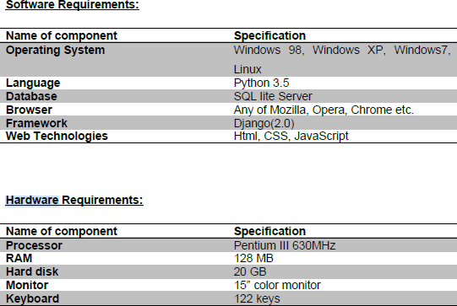

# Process Model

# Integrated model

The integrated food delivery model is flexible and the most sought after business model in the industry. In this model, delivery can be managed by both admin and restaurants.

Many restaurants have their own pool of delivery agents and all they want is a platform to bring their offerings online. Online food ordering platforms functioning in accordance with the integrated model can easily cater to such restaurants.

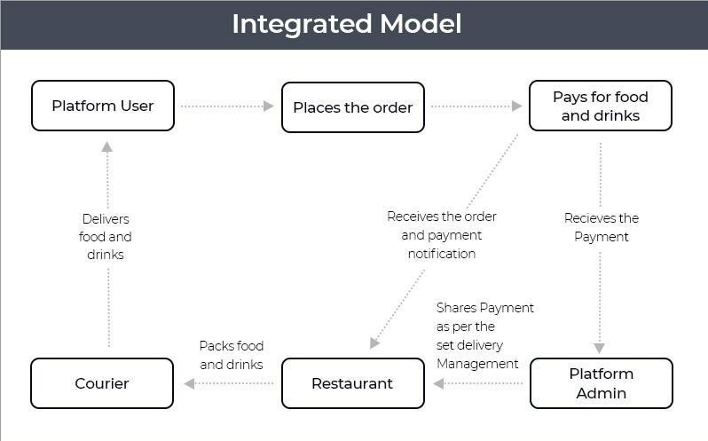

Make sure that the food delivery solution you choose has functionality for restaurants to seek approval from admin to activate delivery services to “Self” so that the admin can easily see it on the dashboard whether the delivery is managed by the restaurant or admin himself. When a customer places an order from a restaurant, the admin checks if that restaurant has enabled the self- delivery option or avails the platform’s delivery services and then accordingly manages the delivery.

# Project Plan

Software project plan can be viewed as the following:

1. **Within the organisation:** How is the project to be implemented?

What are various constraints (time, cost, staff)? What is market strategy?

1. **With respect to the customer:** Weekly or timely meetings with the customer with presentation on status reports. Customer feedback is also taken and further modification and developments are done. Project milestones and deliverables are also presented to the customer.

For a successful software project, the following steps can be followed:

* + Select a project
    - Identifying project’s aims and objectives
    - Understanding requirements and specification
    - Methods of analysis, design and implementation
    - Testing techniques
    - Documentation
  + Project milestones and deliverables
  + Budget allocation
    - Exceeding limits within control
  + Project Estimates
    - Cost
    - Time
  + Resource Allocation
    - Hardware
    - Software
    - Previous relevant project information
    - Digital Library
  + Risk Management
    - Risk avoidance
    - Risk detection

# System Design

# Use Case Diagram :

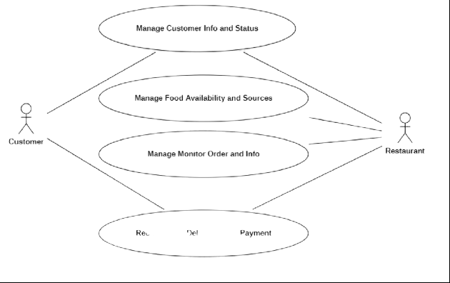

*Figure 1 Use Case Diagram*

# Class Diagram :

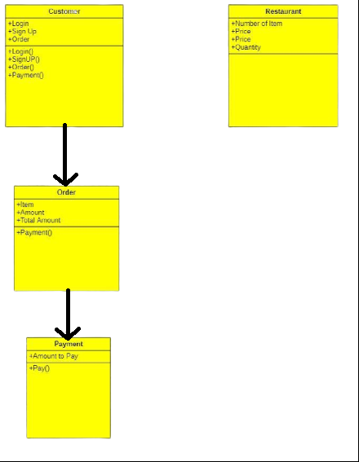

*Figure 2 Class Diagram*

# Sequence Diagram :

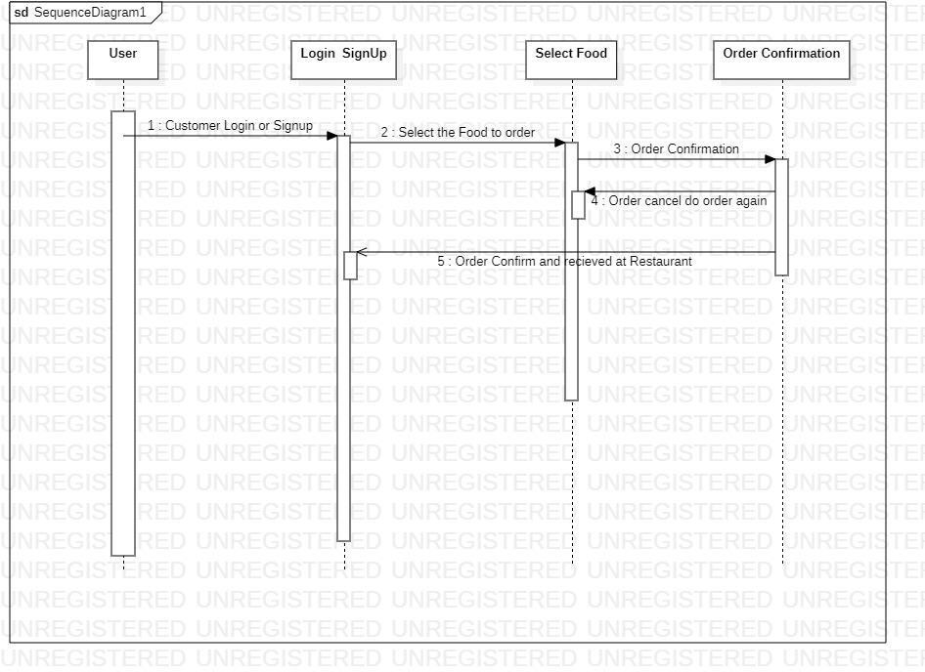

*Figure 3 Sequence Diagram*

# Activity Diagram :

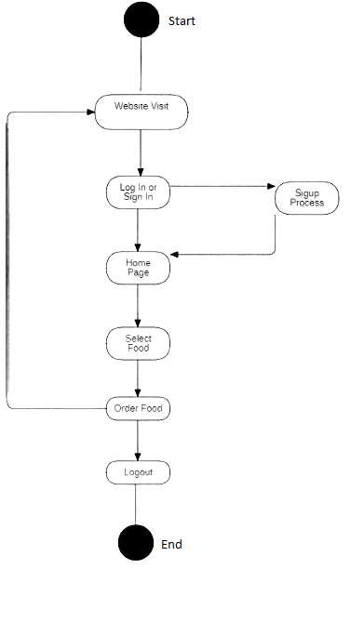

*Figure 4 Activity Diagram*

# DFD Diagram (level 1):

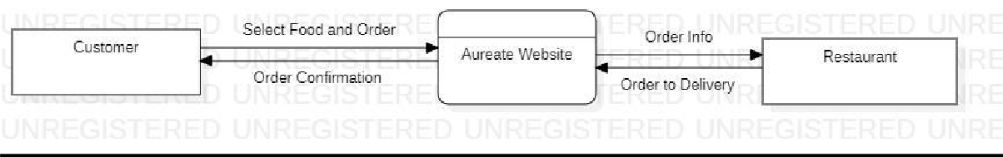

*Figure 5 DFD Diagram level 1*

# DFD Diagram (level 2):

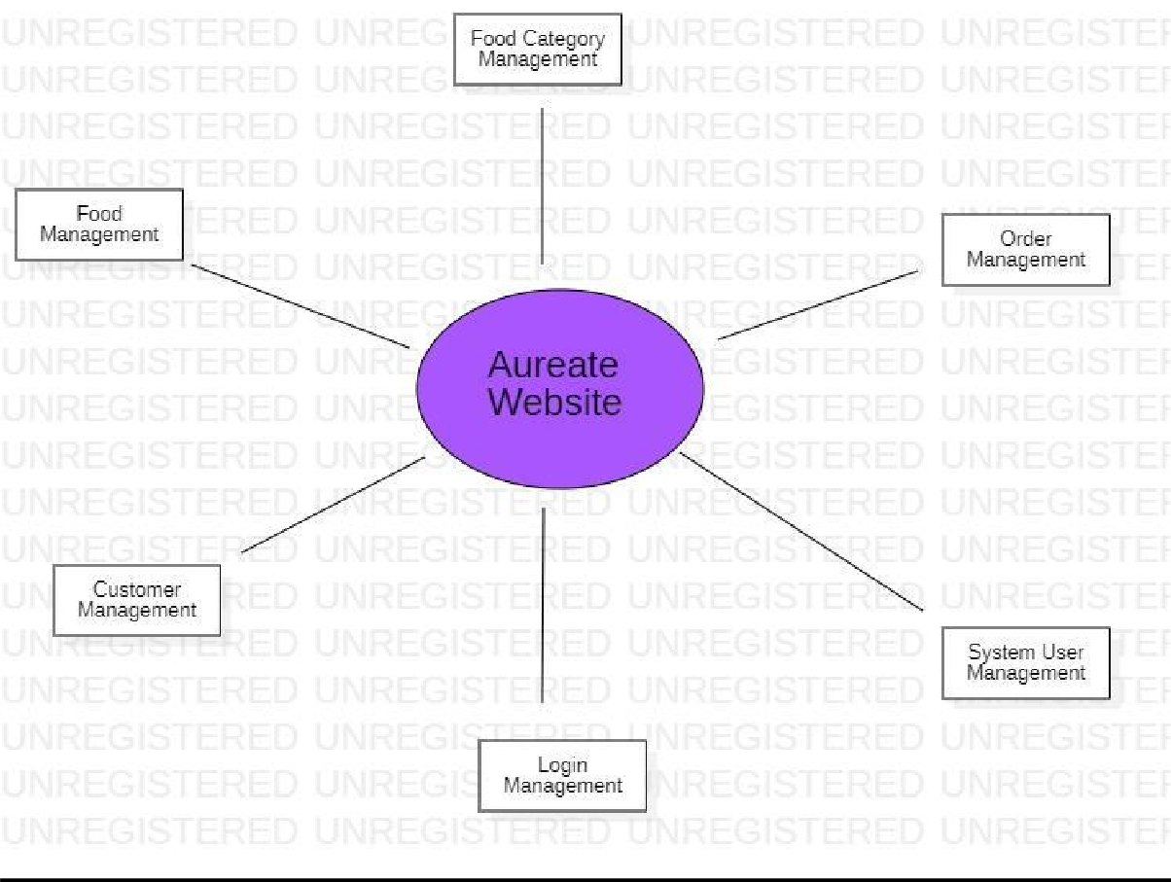

*Figure 6 DFD Diagram level 2*

# PERT CHART :

(Program Evaluation Review Technique) PERT chart is organised for events, activities or tasks. It is a scheduling device that shows graphically the order of the tasks to be performed. It enables the calculation of the critical path. The time and cost associated along a path is calculated and the path requires the greatest amount of elapsed time in the critical path.

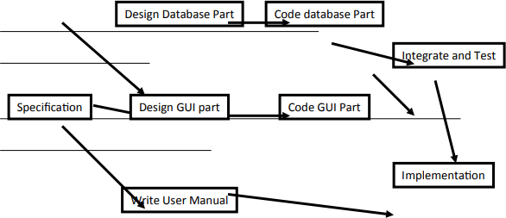

*Figure 7 PERT Chart Representations*

# Implementation Detail

**Detailed Design of Implementation**

* + This phase of the systems development life cycle refines hardware and software specifications, establishes programming plans, trains users and implements extensive testing procedures, to evaluate design and operating specifications and/or provide the basis for further modification.

**Technical Design**

* + This activity builds upon specifications produced during new system design, adding detailed technical specifications and documentation.

**Test Specifications and Planning**

* + This activity prepares detailed test specifications for individual modules and programs, job streams, subsystems, and for the system as a whole.

**Programming and Testing**

* + This activity encompasses actual development, writing, and testing of program units or modules.

**User Training**

* + This activity encompasses writing user procedure manuals, preparation of user training materials, conducting training programs, and testing procedures.

**Acceptance Test**

* + A final procedural review to demonstrate a system and secure user approval before a system becomes operational.

**Installation Phase**

* + In this phase the new Computerised system is installed, the conversion to new procedures is fully implemented, and the potential of the new system is explored.

**System Installation**

* + The process of starting the actual use of a system and training user personnel in its operation.

**Review Phase**

* + This phase evaluates the successes and failures during a systems development project, and to measure the results of a new Computerised Transystem in terms of benefits and savings projected at the start of the project.

**Development Recap**

* + A review of a project immediately after completion to find successes and potential problems in future work.

**Post-Implementation Review**

* + A review, conducted after a new system has been in operation for some time, to evaluate actual system performance against original expectations and projections for cost-benefit improvements. Also identifies maintenance projects to enhance or improve the system.

**THE STEPS IN THE SOFTWARE TESTING**

The steps involved during Unit testing are as follows:

1. Preparation of the test cases.
2. Preparation of the possible test data with all the validation checks.
3. Complete code review of the module.
4. Actual testing done manually.
5. Modifications done for the errors found during testing.
6. Prepared the test result scripts.

**The unit testing done included the testing of the following items:**

1. Functionality of the entire module/forms.
2. Validations for user input.
3. Checking of the Coding standards to be maintained during coding.
4. Testing the module with all the possible test data.
5. Testing of the functionality involving all type of calculations etc.
6. Commenting standard in the source files.

After completing the Unit testing of all the modules, the whole system is integrated with all its dependencies in that module. While System Integration, We integrated the modules one by one and tested the system at each step. This helped in reduction of errors at the time of the system testing.

**The steps involved during System testing are as follows:**

* + Integration of all the modules/forms in the system.
  + Preparation of the test cases.
  + Preparation of the possible test data with all the validation checks.
  + Actual testing done manually.
  + Recording of all the reproduced errors.
  + Modifications done for the errors found during testing.
  + Prepared the test result scripts after rectification of the errors.

**The System Testing done included the testing of the following items:**

1. Functionality of the entire system as a whole.
2. User Interface of the system.
3. Testing the dependent modules together with all the possible test data scripts.
4. Verification and Validation testing.
5. Testing the reports with all its functionality.

After the completion of system testing, the next following phase was the Acceptance Testing. Clients at their end did this and accepted the system with appreciation. Thus, we reached the final phase of the project delivery.

**There are other six tests, which fall under special category. They are described below:**

* + Peak Load Test: It determines whether the system will handle the volume of activities that occur when the system is at the peak of its processing demand. For example, test the system by activating all terminals at the same time.
  + Storage Testing: It determines the capacity of the system to store transaction data on a disk or in other files.
  + Performance Time Testing: it determines the length of time system used by the system to process transaction data. This test is conducted prior to implementation to determine how long it takes to get a response to an inquiry, make a backup copy of a file, or send a transmission and get a response.
  + Recovery Testing: This testing determines the ability of user to recover data or re-start system after failure. For example, load backup copy of data and resume processing without data or integrity loss.
  + Procedure Testing: It determines the clarity of documentation on operation and uses of system by having users do exactly what manuals request. For example, powering down system at the end of week or responding to paper-out light on printer.
  + Human Factors Testing: It determines how users will use the system when processing data or preparing reports.

# Testing

Testing is vital for the success of any software. no system design is ever perfect. Testing is also carried in two phases. the first phase is during the software engineering that is during the module creation. the second phase is after the completion of software. This is system testing which verifies that the whole set of programs hangs together.

**White Box Testing:**

In this technique, the close examination of the logical parts through the software are tested by cases that exercise specific sets of conditions or loops. all logical parts of the software checked once. errors that can be corrected using this technique are typographical errors, logical expressions which should be executed once may be getting executed more than once and errors resulting from using wrong controls and loops. When the box testing tests all the independent parts within a module a logical decisions on their true and the false side are exercised , all loops and bounds within their operational bounds were exercised and internal data structure to ensure their validity were exercised once.

**Black Box Testing:**

This method enables the software engineer to devise sets of input techniques that fully exercise all functional requirements for a program. black box testing tests the input, the output and the external data. it checks whether the input data is correct and whether we are getting the desired output.

**Alpha Testing:**

Acceptance testing is also sometimes called alpha testing. Be spoke systems are developed for a single customer. The alpha testing proceeds until the system developer and the customer agree that the provided system is an acceptable implementation of the system requirements.

**Beta Testing:**

On the other hand, when a system is to be marked as a software product, another process called beta testing is often conducted. During beta testing, a system is delivered among a number of potential users who agree to use it. The customers then report problems to the developers. This provides the product for real use and detects errors which may not have been anticipated by the system developers.

**Unit Testing:**

Each module is considered independently. it focuses on each unit of software as implemented in the source code. It is white box testing.

**Integration Testing:**

Integration testing aims at constructing the program structure while at the same time constructing tests to uncover errors associated with interfacing the modules. Modules are integrated by using the top down approach.

**Validation Testing:**

Validation testing was performed to ensure that all the functional and performance requirements are met.

**System Testing:**

It is executing programs to check logical changes made in it with the intention of finding errors. a system is tested for online response, volume of transaction, recovery from failure etc. System testing is done to ensure that the system satisfies all the user requirements.

# Existing System of Online Food Ordering

In the existing system the exams are done only manually but in the proposed system we have to computerise the exams using this application.

* + Lack of security of data.
  + More man power.
  + Time consuming.
  + Consumes a large volume of spare work.
  + Needs manual calculations.
  + No direct role for the higher officials

# Snap Sorts



This is the first page of Aureate website. That shows the feature, products, category, review and blog. This page includes all the functionality of this page. By scrolling down the page and work on it.

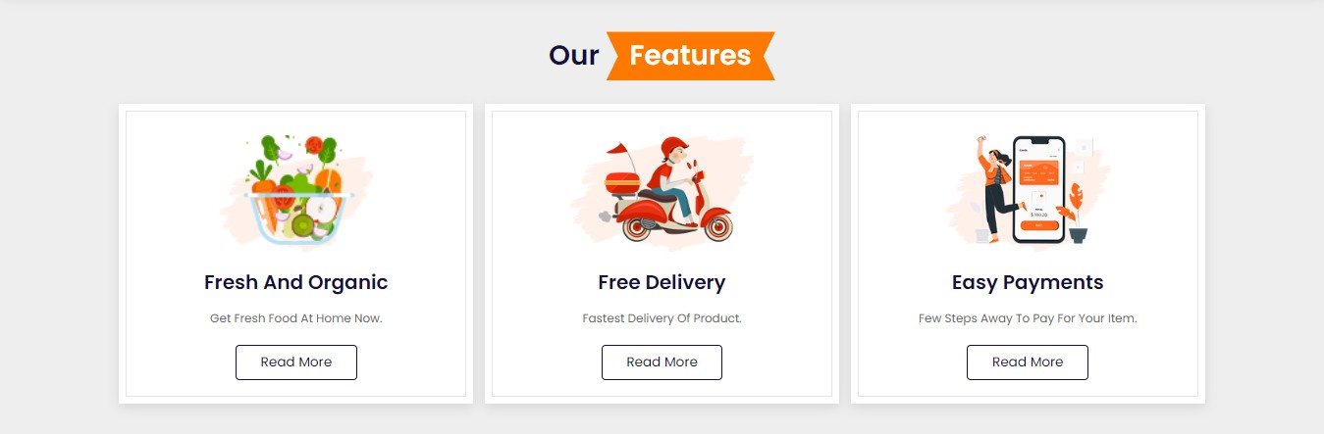

This page section shows the Freshness of Food that deliver by Aureate and hygienic of good. Aureate provide free delivery to 3 km around the Aureate restaurant, with fast way to deliver. And website has putted easy way of payment to go fast.

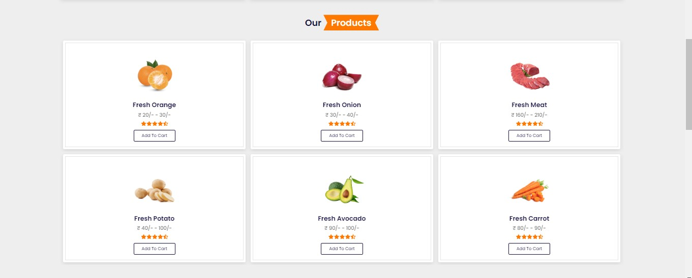

This page section contains Fresh food that would be deliver to Aureate customer. And this food will be add to cart and then it will redirect to payment page.

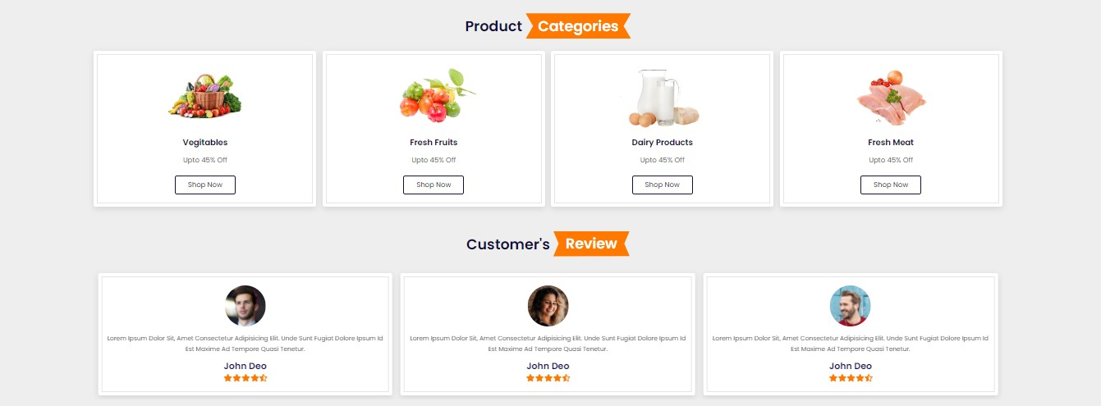

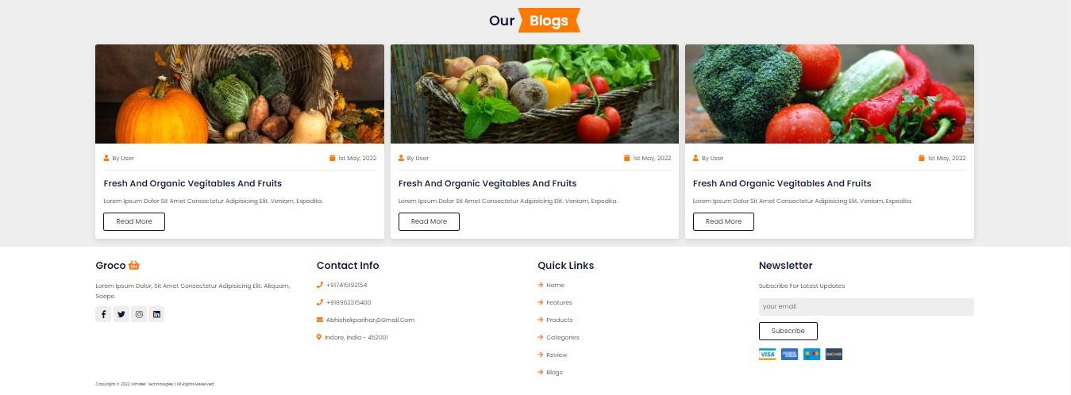

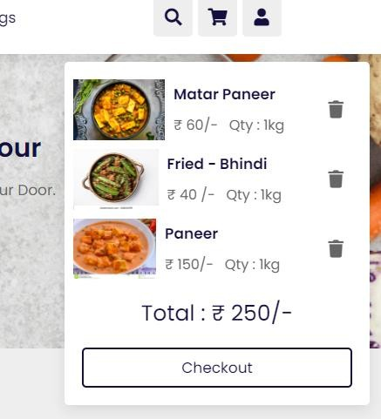

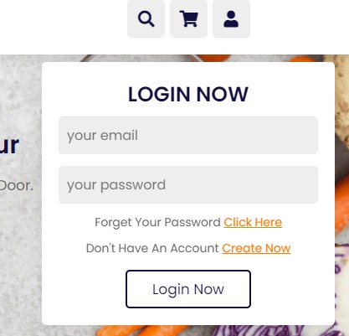

# Conclusion

Our project is only a humble venture to satisfy the needs to manage their project work. Several user friendly coding have also adopted. This package shall prove to be a powerful package in satisfying all the requirements of the school. The objective of software planning is to provide a frame work that enables the manger to make reasonable estimates made within a limited time frame at the beginning of the software project and should be updated regularly as the project progresses.

**At the end it is concluded that we have made effort on following points…**

* + A description of the background and context of the project and its relation to work already done in the area.
  + Made statement of the aims and objectives of the project.
  + The description of Purpose, Scope, and applicability.
  + We define the problem on which we are working in the project.
  + We describe the requirement Specifications of the system and the actions that can be done on these things.
  + We understand the problem domain and produce a model of the system, which describes operations that can be performed on the system.
  + We included features and operations in detail, including screen layouts.
  + We designed user interface and security issues related to system.
  + Finally the system is implemented and tested according to test cases.

# Future Work

In a nutshell, it can be summarised that the future scope of the project revolves around maintaining information regarding:

* + We can add printers in future.
  + We can give more advance software for Online Food Ordering System including more facilities
  + We will host the platform on online servers to make it accessible worldwide
  + Integrate multiple load balancers to distribute the loads of the system
  + Create the master and slave database structure to reduce the overload of the database queries
  + Implement the backup mechanism for taking backup of codebase and database on regular basis on different servers

The above-mentioned points are the enhancements which can be done to increase the applicability and usage of this project. Here we can maintain the records of Food Items and Categories. Also, as it can be seen that now-a-days the players are versatile, i.e. so there is a scope for introducing a method to maintain the Online Food Ordering System. Enhancements can be done to maintain all the Food Item, Category, Customer, Order, Confirm Order.

We have left all the options open so that if there is any other future requirement in the system by the user for the enhancement of the system then it is possible to implement them. In the end we would like to thank all the persons involved in the development of the system directly or indirectly. We hope that the project will serve its purpose for which it is developed by underlining the success of the process.

# Limitation of Project

Although I have put my best efforts to make the software flexible, easy to operate but limitations cannot be ruled out even by me. Though the software presents a broad range of options to its users some intricate options could not be covered into it; partly because of logistic and partly due to lack of sophistication. Paucity of time was also major constraint, thus it was not possible to make the software foolproof and dynamic. Lack of time also compelled me to ignore some part such as storing old result of the candidate etc.

Considerable efforts have made the software easy to operate even for the people not related to the field of computers but it is acknowledged that a layman may find it a bit problematic at the first instance. The user is provided help at each step for his convenience in working with the software.

# List of limitations which are available in the Online Food Ordering System:

* + Excel export has not been developed for Food Item, Category due to some criticality.
  + The transactions are executed in off-line mode, hence on-line data for Customer, Order capture and modification is not possible.
  + Off-line reports of Food Item, Confirm Order, Customer cannot be generated due to batch mode execution.

# References and Bibliography:

Google for problem solving https://docs.python.org/3/reference/

https://[www.sqlite.org/index.html](http://www.sqlite.org/index.html) https://[www.tutorialspoint.com/django/index.html](http://www.tutorialspoint.com/django/index.html) https://[www.w3schools.com/python/python_classes.asp/](http://www.w3schools.com/python/python_classes.asp/) https://[www.w3schools.com/html/](http://www.w3schools.com/html/) https://[www.w3schools.com/tags/tag_object.asp](http://www.w3schools.com/tags/tag_object.asp) https://[www.w3schools.com/w3css/default.asp](http://www.w3schools.com/w3css/default.asp) https://[www.python.org/about/gettingstarted/](http://www.python.org/about/gettingstarted/) https://[www.tutorialspoint.com/python/index.htm](http://www.tutorialspoint.com/python/index.htm)

**About the Organization ( Company Information ):**

Founded in 2014, AIMDek Technologies is a team of professionals; with engineering excellence commonly believing in the disruptive power of the technology. We are unified by our commitment to quality and innovation, where we ideate and meticulously craft value-based IT solutions for several businesses across the globe to power digital transformation across all major platforms and tech stacks with improved efficiency, productivity, and agility.

Our extensive knowledge expertise comprises but is not confined to service-oriented architecture, open source portal consulting, business intelligence, Enterprise Portals, Enterprise Content Management, PLM and ERP solutions to a varied industry including healthcare, sports, and fitness, education, manufacturing, insurance, and eCommerce.

**About College (UVPCE):**

Our dedicated efforts are directed towards leading our student community to the acme of technical excellence so that they can meet the requirements of the industry, the nation and the world at large. We aim to create a generation of students that possess technical expertise and are adept at utilizing the technical 'know-hows' in the service of mankind.