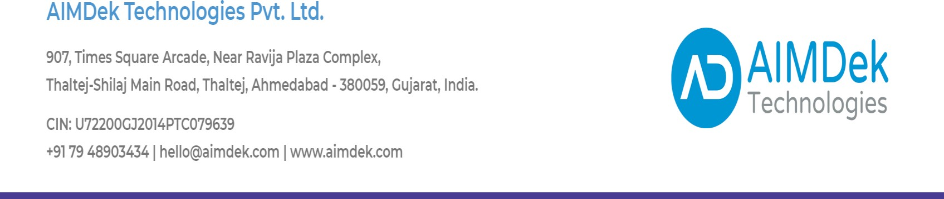

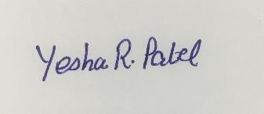

Date: 11th May 2022

**TO WHOMSOEVER IT MAY CONCERN**

This is to certify that Mr. Aftab Sipahi (Er. No. 19012012005), 8th semester student at Ganpat University, Mehsana Gojariya Highway, from Computer Engineering branch is undergoing his training period in Salesforce with AIMDek Technologies Private Limited, starting from 5 Jan 2022 till Present Date.

Regards,

Authorized Person

For, AIMDek Technologies Pvt. Ltd.

AIMDek confidential