Project Report on

# AUREATE FOOD DEVILERY

at

# Aimdek Technologies Pvt. Ltd.

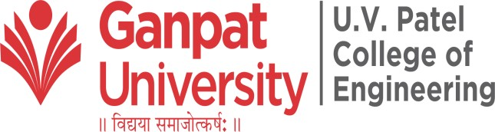

|  |  |
| --- | --- |
| **External Guide :** | **Prepared By:** |
| Mr. Jay Virsodiya | Mr. Aftab Sipahi (19012012005) |
| **Internal Guide :** |  |
| Prof. Chirag Gami |  |

B.Tech Semester VIII (Computer Engineering) May 2022

Submitted to,

Department of Computer Engineering

U.V. Patel College of Engineering Ganpat University, Kherva - 384 012

**U.V. PATEL COLLEGE** **OF**

**ENGINEERING**



DD/MM/YY

# C E R T I F I C A T E

**T O W H O M S O E V E R I T M A Y C O N C E R N**

This is to certify that Mr. **Aftab Sipahi** student of **B.Tech. Semester VIII (Computer Engineering)** has completed his/her full semester on site project work titled “**Aureate Food Delivery**” satisfactorily in partial fulfillment of the requirement of Bachelor of Technology degree of Computer Engineering of Ganpat University, Kherva, Mehsana in the year 2021-2022.

College Project Guide

Sign Dr. Paresh M. Solanki,

HOD, Computer Engineering

Prof. Chirag Gami

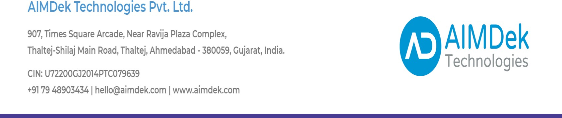

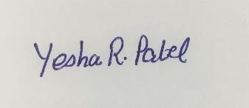

Date: 11th May 2022

**TO WHOMSOEVER IT MAY CONCERN**

This is to certify that Mr. Aftab Sipahi (Er. No. 19012012005), 8th semester student at Ganpat University, Mehsana Gojariya Highway, from Computer Engineering branch is undergoing his training period in Salesforce with AIMDek Technologies Private Limited, starting from 5 Jan 2022 till Present Date.

Regards,

Authorized Person

For, AIMDek Technologies Pvt. Ltd.

AIMDek confidential