Software Requirements Specification
for
Timar
Version 1.1
Prepared by Aftab Ahmed Samoo and Haseeb Mudasir
SZABIST University, Karachi Campus
4 November 2026
Table of Contents
1. Introduction 4
1.1 Purpose 4
1.2 Document Conventions 4
1.3 Intended Audience and Reading Suggestions 4
1.4 Product Scope 5
1.5 References 6
2. Overall Description 8
2.1 Product Perspective 8
2.2 Product Functions 8
2.3 User Classes and Characteristics 9
2.4 Operating Environment 11
2.5 Design and Implementation Constraints 11
2.6 User Documentation 13
2.7 Assumptions and Dependencies 13
3. External Interface Requirements 15
3.1 User Interfaces 15
3.2 Hardware Interfaces 43
3.3 Software Interfaces 43
3.4 Communications Interfaces 44
4. System Features 45
4.1 Sign Up (SU) 45
4.2 Sign In (SI) 47
4.3 Plot Management (PLM-C) 48
4.4 Plot Management (PLM-R) 50
4.5 Plot Management (PLM-U) 51
4.6 Plot Management (PLM-D) 52
4.7 Growth Monitoring (GRM) 54
4.8 Trip Booking (TRB) 56
4.9 Mangrove Adoption (SPN) 57
4.10 Adoption Tracking (SPT) 59
4.11 Volunteer Management (VLM) 60
4.12 Field Task Assignment (FTA) 62
4.13 Awareness Content (AWC) 63
4.14 Cutting Complaint (CMP) 65
4.15 Public Impact Dashboard (PID) 67
4.16 Company Portfolio and Impact Reports (CPR) 68
4.17 Administrative Portal (ADM) 70
4.18 Community Feed (CMF) 71
4.19 Media and Interview Requests (MDR) 73
4.20 Plant Health Assessment and Seedling Counting (PHA) 74
4.21 Site Recommendation (SRC) 76
4.22 Satellite Change Detection (SCD) 77
4.23 Use Case Diagrams 79
5. Other Nonfunctional Requirements 89
5.1 Performance Requirements 89
5.2 Safety Requirements 89
5.3 Security Requirements 89
5.4 Software Quality Attributes 90
5.5 Business Rules 90
6. Other Requirements 92
Appendix A: Glossary 93
Appendix B: Analysis Models 95
Appendix C: To Be Determined List 101

Revision History
Name | Date | Reason For Changes | Version
Aftab Ahmed Samoo, Haseeb Mudasir | 26 Oct 2026 | First complete version of the SRS | 1.0
Aftab Ahmed Samoo, Haseeb Mudasir | 4 Nov 2026 | Field surveys changed from hand counts to stake photographs. Sponsorship renamed adoption. Email codes, profile setup, Journal and admin screens added. Sites, prices and hosting updated. FYP-I and FYP-II phases and requirement status recorded. Use case diagrams and UI screens added. | 1.1

1. Introduction
1.1 Purpose
This Software Requirements Specification describes what the Timar platform must do, who will use it, and the conditions it has to work under. It covers the complete first release of the system, including the public website, the field monitoring tools used by Saltwater Marina, the adoption and volunteer features, the administrative portal, and the five machine learning components that support them. The document is written so that a developer can build from it, a tester can write test cases from it, and the partner organisation can check that what we are building is what they actually need.
1.2 Document Conventions
This document follows the general shape of a software requirements specification. The conventions below are used throughout.
• Font: Times New Roman is used throughout this document.
• Bold text marks field names, table labels and requirement identifiers.
• Every requirement carries a unique identifier, for example PLM-3, so that it can be traced through design, code and testing.
• Functional requirements carry a priority of High, Medium or Low, and a status. Done means the requirement works in the current build, In Progress means part of it works, and Pending means it has not been built yet.
• Machine learning components are numbered M1 to M5 and are referred to by those identifiers wherever they appear.
• The document is arranged from general to specific. Early sections describe the product as a whole, later sections break it into individual features.
1.3 Intended Audience and Reading Suggestions
The document is written for the following readers.
• Developers: to understand exactly what has to be built, how the pieces fit together, and what each feature is expected to do.
• Project supervisor and evaluators: to judge whether the scope is complete, realistic and properly defined.
• Testers: to write test cases directly from the numbered requirements.
• Saltwater Marina, the partner organisation: to confirm that the system matches how they actually work in the field.
• Future maintainers: to understand the system without having to read the code first.
Suggested reading order:
• The supervisor and the partner organisation will find Section 1 (Introduction) and Section 2 (Overall Description) most useful, as these explain the purpose, the users and the scope in plain language.
• Developers and testers should focus on Section 3 (External Interface Requirements), Section 4 (System Features) and Section 5 (Other Nonfunctional Requirements), where the detailed behaviour is defined.
• Anyone interested only in the machine learning work should read Sections 4.20 to 4.22, which cover the plant health models, the site recommendation model and the satellite change detection model.
1.4 Product Scope
Timar gives mangrove restoration a record. Today a plantation drive happens, photographs are taken on personal phones, and six months later nobody can say which seedlings survived or why. The platform replaces that with a mapped plot for every planting event, marked stakes photographed at fixed intervals, and a photograph timeline taken from the same position each time. On top of that record it builds the things the record makes possible: honest reports for adopters, a public page anyone can check, alerts when satellite imagery shows green cover disappearing, and recommendations for where to plant next.
The goals of the product are the following.
• Record every plantation site as a mapped plot with its species, date, count and responsible person, so that no planting event is lost.
• Follow survival through scheduled photo surveys rather than assuming it, and show the result, an estimate checked by a person, where anyone can look it up.
• Let a person or a company who funded seedlings see the plot they funded, its coordinates, its estimated survival and dated photographs of it.
• Give volunteers a clear way to join, receive field work and keep a record of what they contributed.
• Make loss visible by letting anyone report cutting with a location and a photograph, and by flagging suspected loss from free satellite imagery.
• Reduce manual field effort using machine learning that reads photographs, estimates visible seedlings, scores candidate sites and detects change over time.
• Give Saltwater Marina one administrative portal for trips, volunteers, plots, content and reporting, with an audit trail behind every change.
• Raise public awareness of what mangroves do for Karachi, through readable content and an open impact dashboard.
The product fits a wider shift in environmental work towards measured, verifiable impact. Funding for restoration increasingly depends on proof rather than photographs, and small community organisations are the ones least able to produce that proof. Timar is aimed squarely at that gap.
The work is delivered in two phases, and this version of the document records where each requirement stands.
• FYP-I: accounts and roles, the public website and awareness content, trip booking, volunteer management, photo surveys and the photograph timeline, mangrove adoption and tracking, the administrative dashboard and content management, and the public impact dashboard.
• FYP-II: the machine learning components M1 to M5, satellite change detection, cutting complaints and the public threat map, company portfolios and impact reports, geospatial planting recommendations, the community feed, media requests, and audit logs with administrative reporting.
• Current iteration, up to the mid evaluation: the database, the role based dashboards, and create, read, update and delete for drive records and articles in the administrative portal. Features not built yet appear in the dashboards with sample data so that the full scope can be shown, and their requirements stay marked Pending.
1.5 References
• Karl E. Wiegers, Software Requirements Specification template, used as the structure for this document.
• Timar Final Year Project Proposal, SZABIST University, 2026. The proposal defines the project objectives, scope and schedule that this SRS expands into requirements.
• European Union Copernicus Programme, Sentinel-2 mission and open data access. https://dataspace.copernicus.eu/
• Global Mangrove Watch, global mangrove extent and change maps. https://www.globalmangrovewatch.org/
• Mongabay, Pakistan bucks global trend with 30 year mangrove expansion, February 2024. https://news.mongabay.com/2024/02/pakistan-bucks-global-trend-with-30-year-mangrove-expansion/
• The News International, Urbanisation and deforestation endanger Karachi's mangrove cover. https://www.thenews.com.pk/latest/1213951-urbanisation-deforestation-endanger-karachis-mangrove-cover
• Dawn, Agriculture: the slow death of the Indus Delta. https://www.dawn.com/news/1895480/agriculture-the-slow-death-of-the-indus-delta
• The Blue Carbon Initiative, About blue carbon. https://www.thebluecarboninitiative.org/about-blue-carbon
• PostGIS documentation, spatial extension for PostgreSQL. https://postgis.net/documentation/

2. Overall Description
2.1 Product Perspective
Timar is a new product. It is not part of any existing family of software and it does not replace an earlier system, because Saltwater Marina currently has no system at all. Field records today live in personal phone galleries and chat groups.
The platform is a web application that works on both phone and desktop. It has four parts: a browser front end used by the public, volunteers and administrators; a backend service that handles accounts, roles, plots, bookings and reporting; a separate Python service that runs the machine learning models and the satellite processing; and a spatial database that stores everything, including map geometry.
The satellite side depends on an outside source, the European Union Copernicus programme, which publishes Sentinel-2 imagery free of charge. Timar reads that imagery, it does not produce any imagery of its own.
2.2 Product Functions
The main functions of the platform are the following.
• Public website: a home page with field photographs and a satellite map of the sites, the Journal of past drives and articles, and an About page covering the project, the partnership with Saltwater Marina and the team.
• Accounts and roles: registration with an emailed code, sign in with a password or an emailed code, profile setup, and role based access for visitors, volunteers, companies, field coordinators and administrators. A visitor counts as an adopter once they have paid for at least one mangrove.
• Plot management: recording a plantation site as a mapped boundary with species, planting date, seedling count and the person responsible.
• Growth monitoring: scheduled photo surveys in which a volunteer photographs a plot from its marked stakes and notes anything unusual, with a GPS position. Plants are not counted by hand.
• Trip booking: browsing and booking plantation drives and Mangrove Safaris, with capacity limits and attendance marking.
• Mangrove adoption: paying for one or more mangroves, which are assigned to a specific plot, and then following that plot over time.
• Adoption tracking: a page per adoption showing the plot location, the current survival estimate and dated photographs, with the option to request a fresh photograph.
• Volunteer management: applications, approval, assignment of field tasks by area, and a personal record of hours and plots worked.
• Awareness content: articles and a species guide explaining what mangroves do and which species grow in the Indus Delta, published in the Journal alongside the records of past plantation drives.
• Complaint reporting: a located, photographed report of cutting or encroachment, compiled into a formal document and tracked by status.
• Public impact dashboard: open totals for seedlings planted, estimated survival, area covered and alerts raised, visible without logging in.
• Company portfolio: a private area where a company sees its own plots, survival estimates and downloadable impact reports.
• Administrative portal: the partner organisation's console for adoptions, users and roles, trips, volunteers, plots, content, media requests, reporting and the audit log.
• Machine learning support: plant health assessment and seedling counting from field photographs, site suitability scoring, satellite change detection and survival risk prediction.
2.3 User Classes and Characteristics
Timar serves several groups with very different needs, from a first time visitor who has never heard of mangroves to a field coordinator who uses the system every day.
Citizens and Visitors
• Description: members of the public who want to learn about mangroves, book a trip, adopt a mangrove or report cutting they have seen. Most will arrive with no prior knowledge of the subject.
• Frequency of use: occasional. Many will visit once, read, and either book or adopt.
• Technical expertise: low. The public pages must work without instruction.
• Key functions used: awareness content, public dashboard, trip booking, mangrove adoption, complaint reporting.
• Importance: high. Public participation is the main source of adoption money and volunteers.
Volunteers
• Description: students and residents who want to take part in plantation drives and field surveys. They are the people who physically collect the data the whole system depends on.
• Frequency of use: regular during the planting season, lighter in between.
• Technical expertise: low to medium. They will mostly use the system on a phone, outdoors, in poor light.
• Key functions used: volunteer registration, task assignment, growth monitoring entry, photograph upload.
• Importance: high. Without volunteers recording surveys, there is no record of how a plot is doing.
Adopters and Companies
• Description: individuals who pay to adopt mangroves, and companies that adopt in bulk or run a carbon project with Saltwater Marina as part of their environmental commitments. A public user counts as an adopter only after paying for at least one mangrove, so adopter is not a separate account type.
• Frequency of use: low but repeated. They return to check on the plot they funded.
• Technical expertise: medium.
• Key functions used: adoption, adoption tracking, photograph requests, company portfolio, impact reports.
• Importance: high. This group is the main source of funding and the reason verifiable reporting matters.
Field Coordinators
• Description: Saltwater Marina staff who plan plantation drives, assign work to volunteers, verify survey records and confirm satellite alerts on the ground.
• Frequency of use: daily during active periods.
• Technical expertise: medium.
• Key functions used: plot management, task assignment, survey verification, alert verification, trip management.
• Importance: high. They are the quality gate between raw field entries and published numbers.
Administrators
• Description: the Saltwater Marina account holders who run the organisation side of the platform, manage users and content, generate reports and oversee the machine learning model versions in use.
• Frequency of use: regular.
• Technical expertise: medium.
• Key functions used: the full administrative portal, user management, content publishing, reporting, audit log, model management.
• Importance: high. The platform exists to serve this organisation.
2.4 Operating Environment
The platform runs in the following environment.
• Client: a web application running in modern browsers on Android phones, iPhones, laptops and desktops. Chrome, Firefox, Safari and Edge in their current versions are supported. The layout adapts to phone screens, which is where field use happens.
• Frontend technology: React with Tailwind CSS, and Leaflet for maps, plot boundaries, alerts and the threat map.
• Backend: Node.js with Express, exposing a REST API. Authentication uses signed tokens held in an httpOnly cookie, and access to every endpoint is checked against the user's role.
• AI services: a separate Python service built with FastAPI. Image models use PyTorch, tabular models use scikit-learn or a gradient boosting library, and satellite rasters are processed with rasterio.
• Database: PostgreSQL hosted on Neon, with the PostGIS extension available so that plot boundaries, survey points and detected change areas can be stored as real geometry and queried by location. The current build uses six tables (users, otp_codes, volunteer_applications, drives, articles and adoptions) defined in one schema file. Further tables and geometry are added as each feature is built. Without a database address, development falls back to a local copy of the same engine.
• Satellite data: Sentinel-2 imagery from the European Union Copernicus programme, which is published openly at ten metre resolution with a revisit of a few days.
• Storage: uploaded photographs are kept on the backend server during development and move to object storage before release.
• Hosting: a cloud environment with a free or low cost tier during development. Model training is done separately on free GPU services such as Google Colab or Kaggle, and only the trained model files are deployed.
2.5 Design and Implementation Constraints
The following limits shape what the system can be and must be respected during design.
Hardware Limitations
• Field devices: surveys are recorded on ordinary phones in the creeks. The interface has to work on mid range devices with weak signal and a camera that is good but not professional.
• Satellite resolution: Sentinel-2 pixels cover about ten metres of ground. A cleared patch is visible, an individual seedling is not. This limits what the satellite models can ever claim.
• Training hardware: we have no dedicated GPU. All model training must fit inside free cloud GPU sessions, which means small models, transfer learning and short training runs.
Interfaces to Other Applications
• Copernicus Sentinel-2: the satellite imagery source. If it is unavailable or clouded over, change detection for that month is delayed rather than wrong.
• Global Mangrove Watch: used as a reference layer for existing mangrove extent.
• Payment provider: a single simple provider for adoption payments. Card details are never stored on our servers.
• Email service: Gmail SMTP during development, used for verification codes, booking confirmations and alert notifications.
Specific Tools and Technology
• Spatial database: PostGIS is required once plots are built, not optional. Almost every question the system then answers is a question about location.
• Image models: the plant health and counting models depend on photographs collected by us with the partner organisation, because no public dataset of Karachi mangrove seedlings exists.
• Satellite processing: the monthly job that downloads imagery, computes the vegetation index and compares months runs on a schedule and must complete without a person watching it.
Data Limitations
• Cold start: at the beginning of the project there is no training data at all. Field photograph collection must start in the first weeks, and the survival risk model cannot be fully trained within the project period because it needs a year of survey history.
• Small datasets: the image models will be trained on a few thousand photographs at most, so transfer learning and heavy image augmentation are required rather than optional.
Legal and Ethical Constraints
• The platform produces evidence that a carbon verification body could use. It does not issue carbon credits and must never present itself as doing so.
• A photograph assessment states plant health with a confidence value. It is not a guarantee of survival and is always labelled as an assessment.
• Complaints are compiled and forwarded by the organisation. The system does not file directly into any government system and does not claim to.
• Volunteer location data is collected only while recording a survey, and exact home locations are never shown publicly.
2.6 User Documentation
Documentation is kept short on purpose, because most users are either members of the public or volunteers standing in a creek. The following material will be delivered with the system.
• In app guidance: short tooltips and first use hints on the screens that matter most, particularly the survey entry form used in the field.
• A one page field guide, printable and usable offline, explaining how to take a survey photograph from the same position each time.
• A short administrator guide for Saltwater Marina covering plot creation, task assignment, verification and report generation.
• A help and contact section on the public site for anyone who gets stuck.
2.7 Assumptions and Dependencies
Assumptions made in developing this platform:
• Saltwater Marina will continue to run plantation drives and field visits during the project, which is how training photographs and survey data are collected.
• Volunteers will have an ordinary smartphone with a camera and location enabled.
• Copernicus will continue to publish Sentinel-2 imagery free of charge and without registration limits that block academic use.
• Internet access is available when a user opens the platform. Field entries are made where signal exists or shortly after returning from a site.
• The field team is willing to label photographs with us, since they are the ones who can tell a stressed seedling from a healthy one.
• Adoption amounts are small and handled by one payment provider, so no complex financial handling is required.
Dependencies of the platform:
• Copernicus Sentinel-2 imagery, for the change detection and site recommendation models.
• Global Mangrove Watch extent maps, used as a reference layer.
• Free cloud GPU services for model training.
• The payment provider for adoption transactions.
• The email service for verification and notifications.
• PostgreSQL with the PostGIS extension, and object storage for photographs.
• The partner organisation's continued participation, which is the single largest dependency in the project.

3. External Interface Requirements
3.1 User Interfaces
Timar follows no imposed style guide. The interface is built to be clear to a first time visitor and quick to use for a volunteer working outdoors.
• Screen support: the platform is responsive and works on phone, tablet and desktop. The field survey screens are designed phone first, because that is where they are used.
• Navigation: a top navigation bar on the public site with How it works, Sites, Take part, Journal and About. Signed in users get a role based dashboard with a side menu on desktop and a bottom bar on phones.
• Map views: plots, alerts and complaints are shown on an interactive map with zoom, pan and a layer switch. Tapping a plot opens its detail page.
• Forms: all input forms validate as the user types and show clear messages next to the field that is wrong, not as a general error at the top.
• Photograph capture: the survey form opens the device camera directly, goes through the marked stakes of the plot one by one, and shows a faint outline of the previous photograph from that stake, so the new one is taken from the same position.
• Error handling: errors are shown as inline messages or a small banner. The system never shows a raw technical error to a user.
• Themes: a single light theme built on a forest green palette. A dark theme is future work. The map keeps its own colours.
• Language: English at launch, with the text held separately so that Urdu can be added without changing the code.
• Accessibility: readable font sizes, sufficient colour contrast, and no information conveyed by colour alone.
The figures below show the screens of the current build, at desktop size unless stated. Panels for features that are not built yet show sample data, as explained in Section 1.4. Long pages are split at the gaps between panels so that they stay readable. The full set of images is in the ui-snapshots folder supplied with this document.
Public website
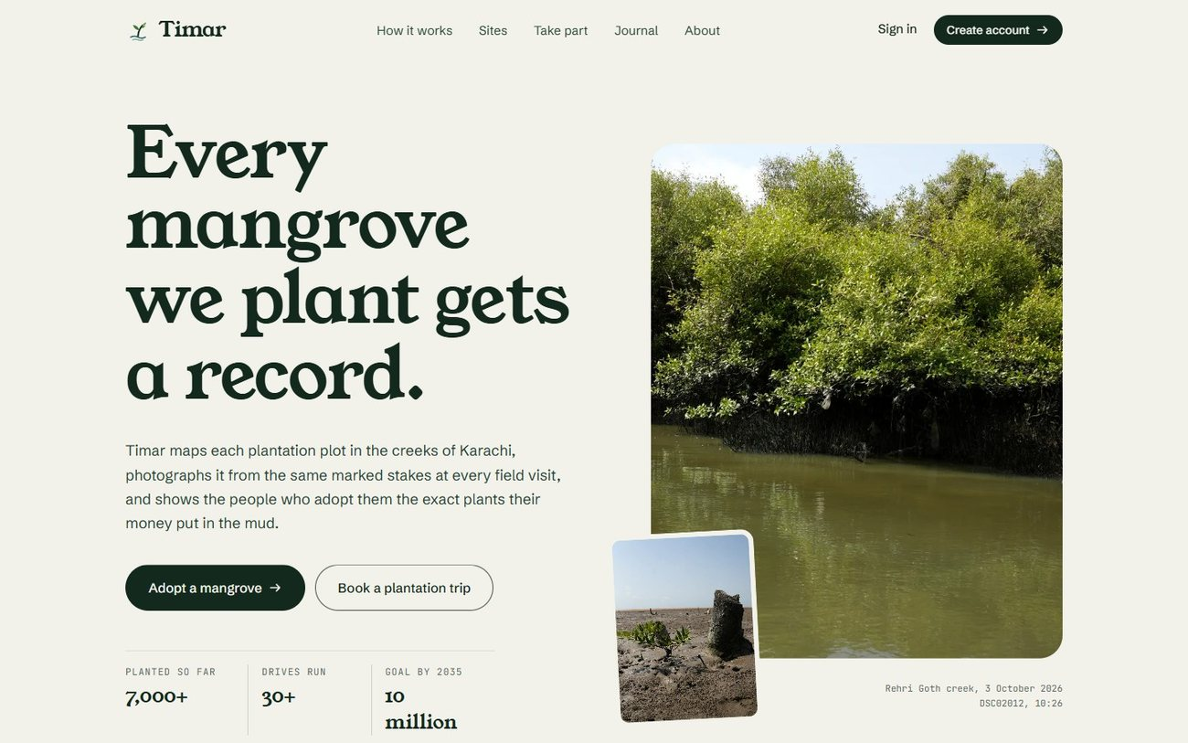
Figure 1. Home page, opening section
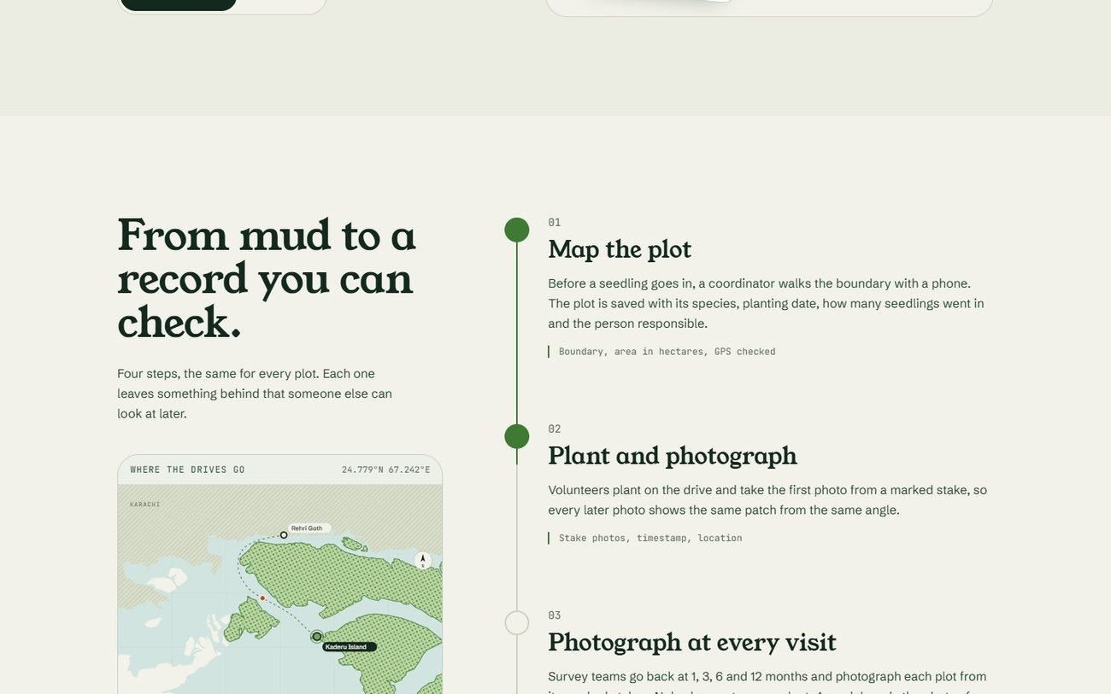
Figure 2. Home page, how it works
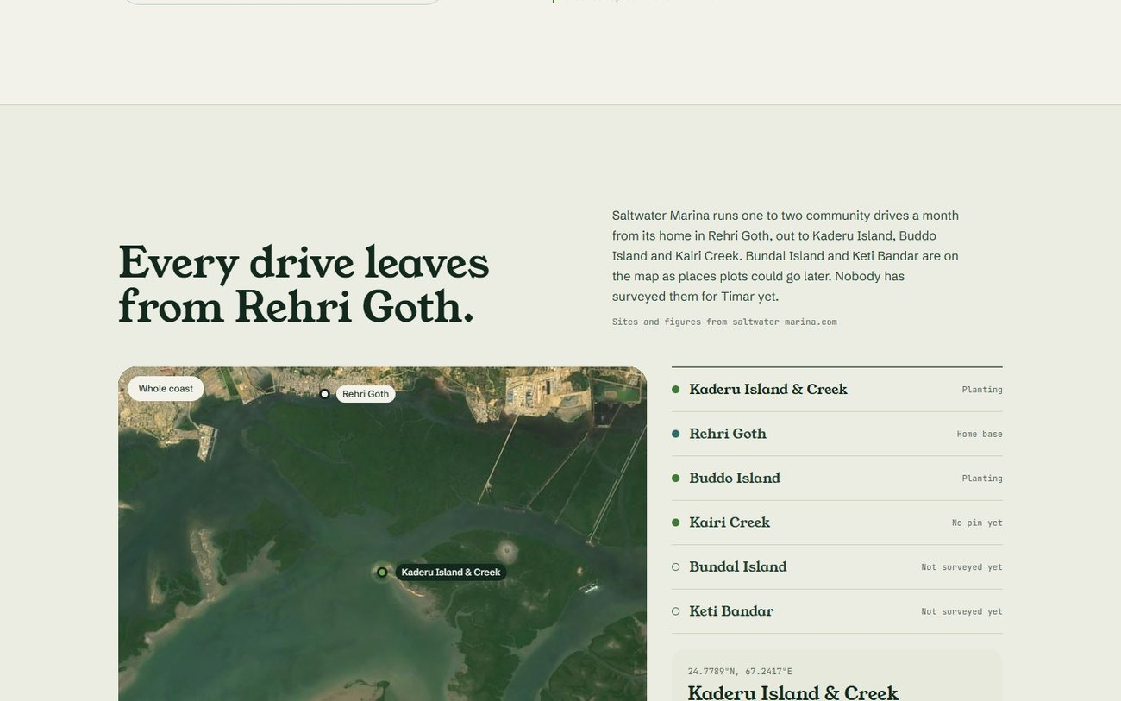
Figure 3. Home page, satellite map of the sites
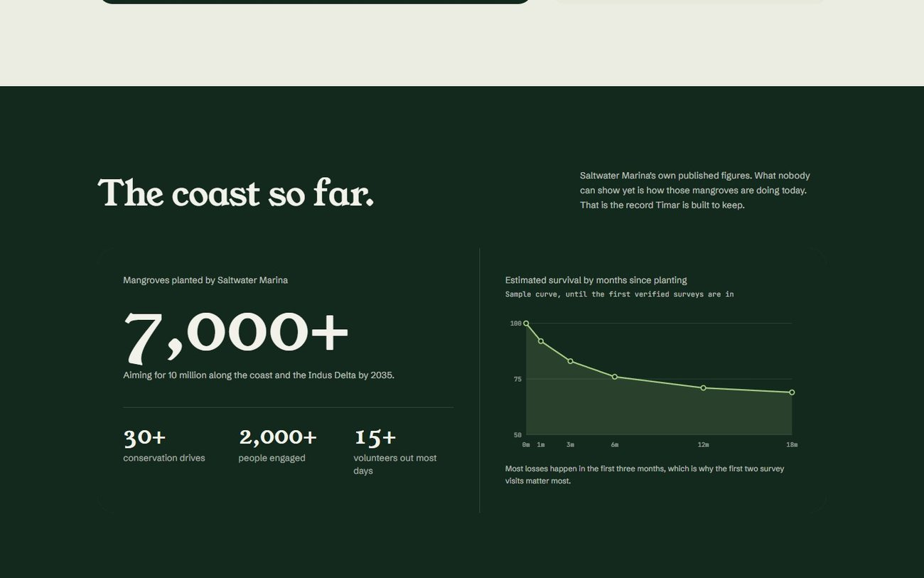
Figure 4. Home page, impact figures
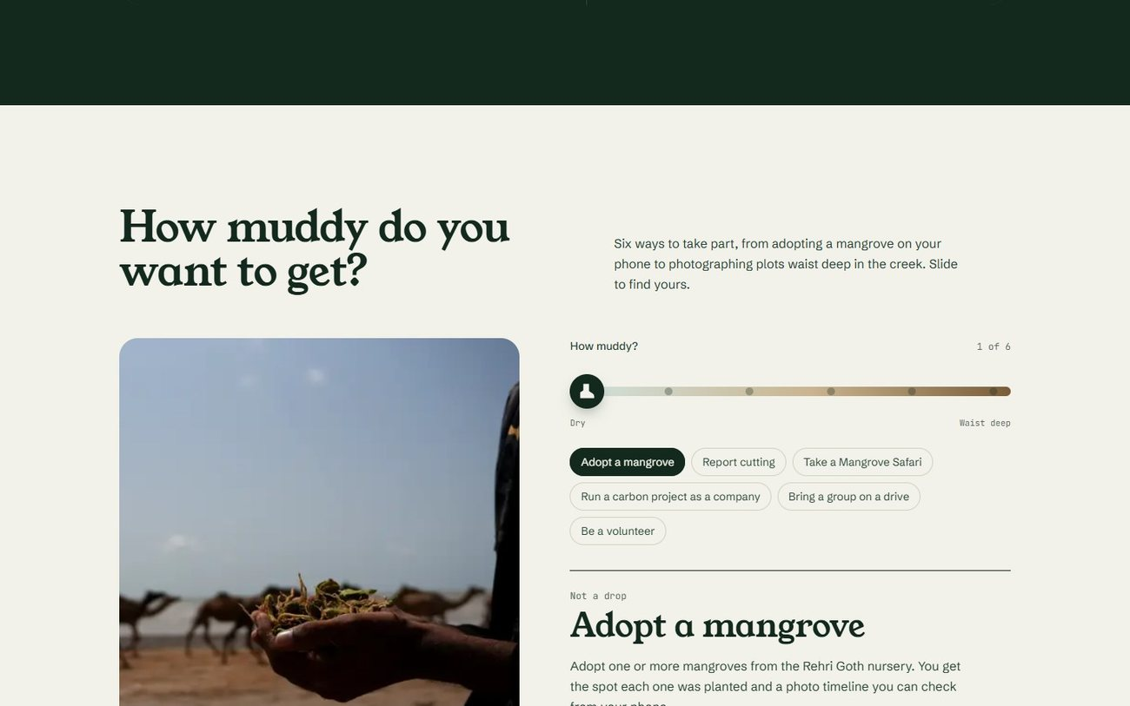
Figure 5. Home page, ways to take part
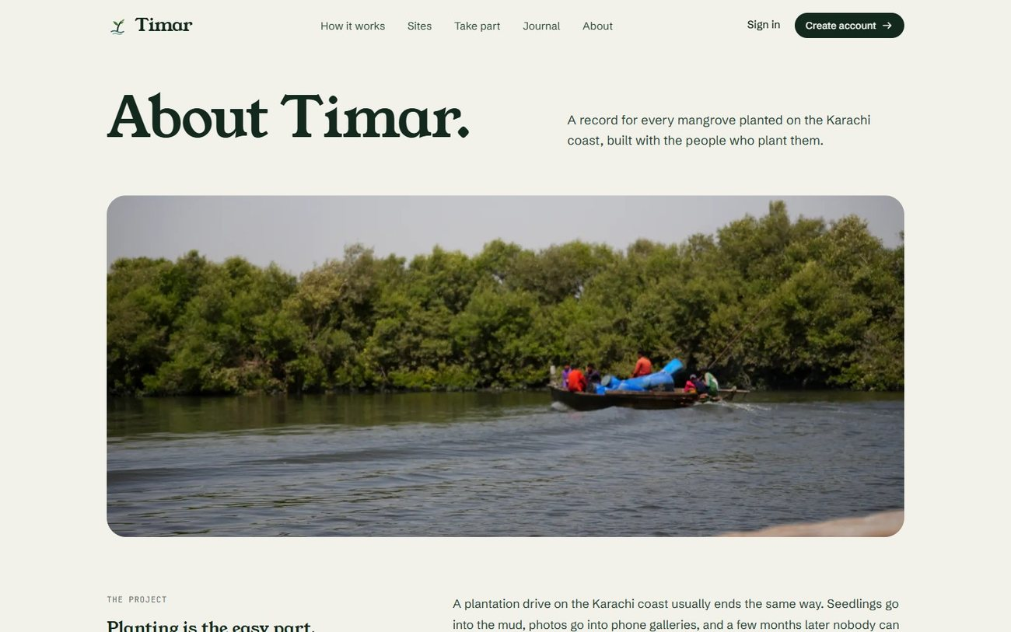
Figure 6. About page, the project
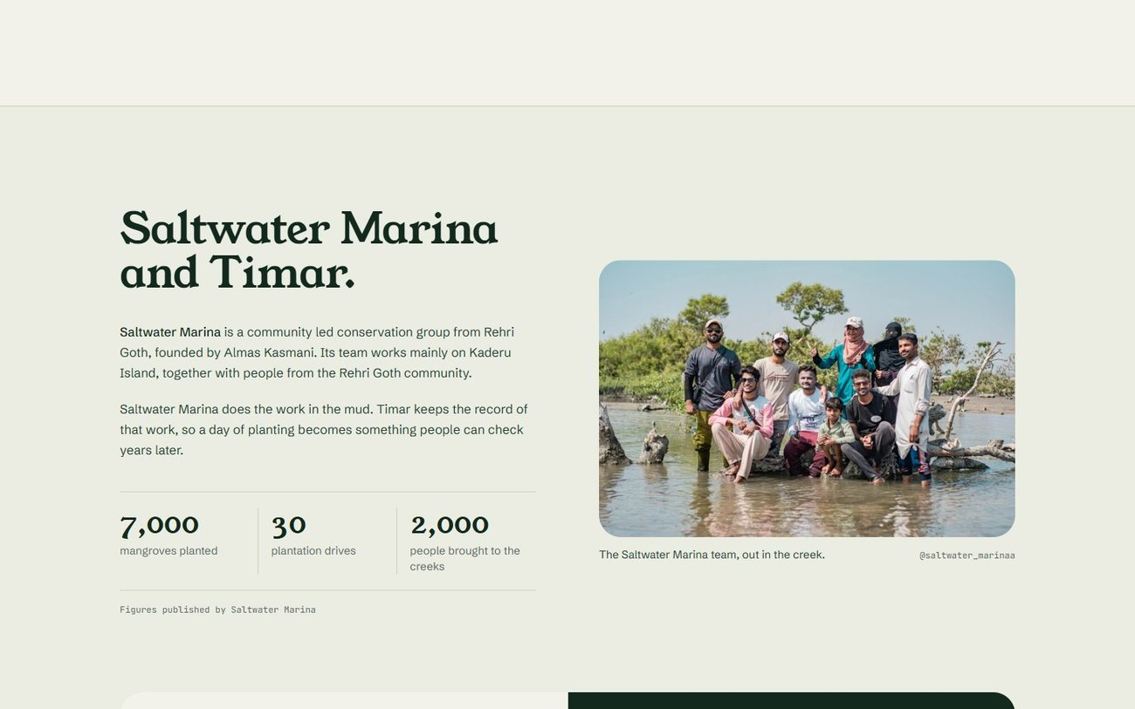
Figure 7. About page, Saltwater Marina and Timar

Figure 8. About page, vision, mission and goal
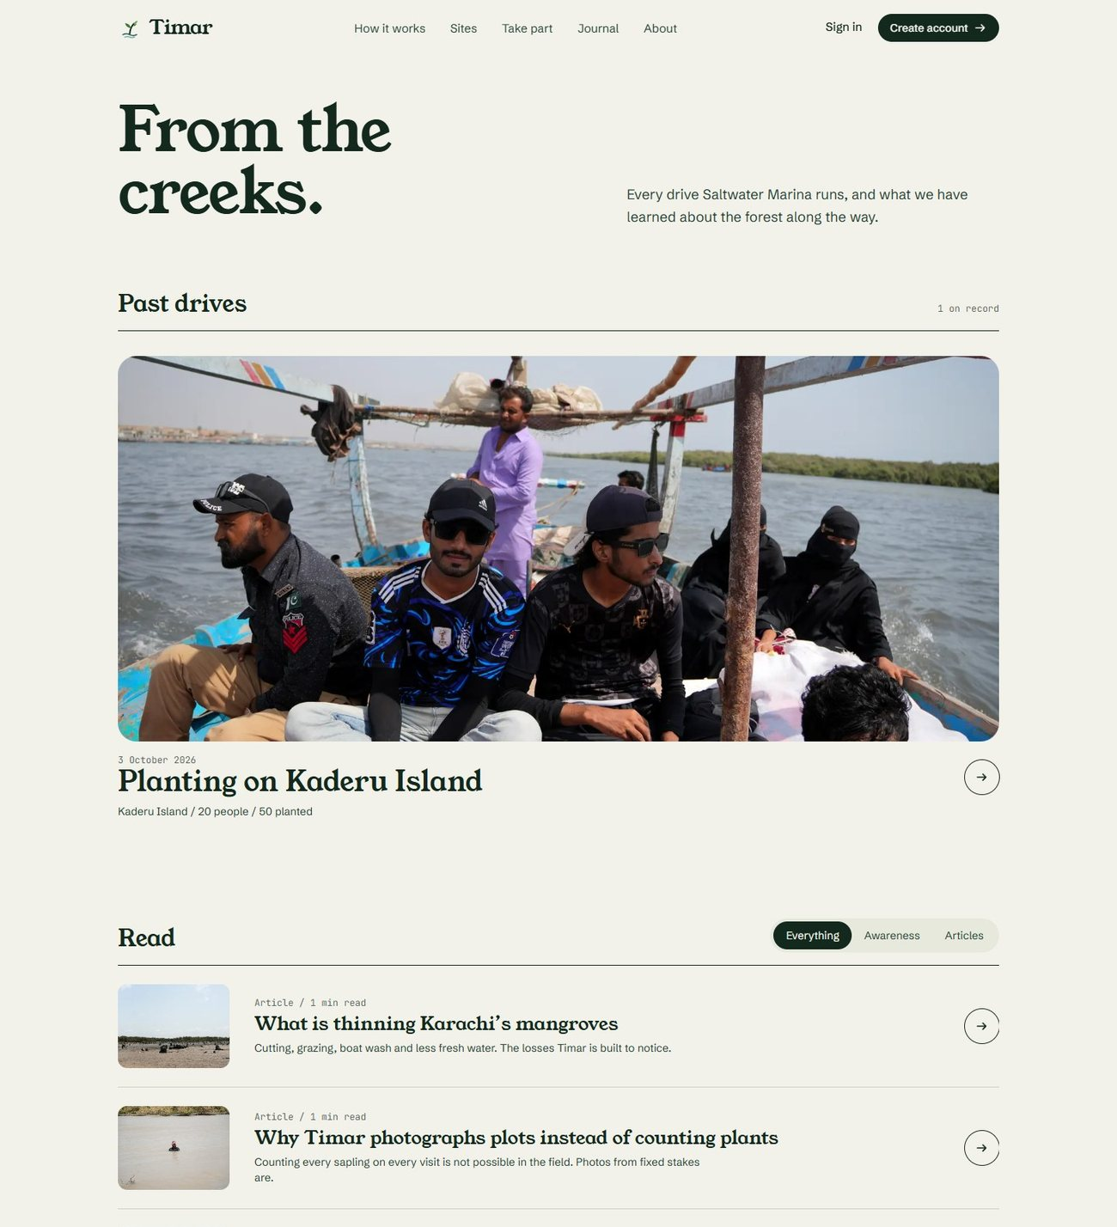
Figure 9. Journal, past drives and articles
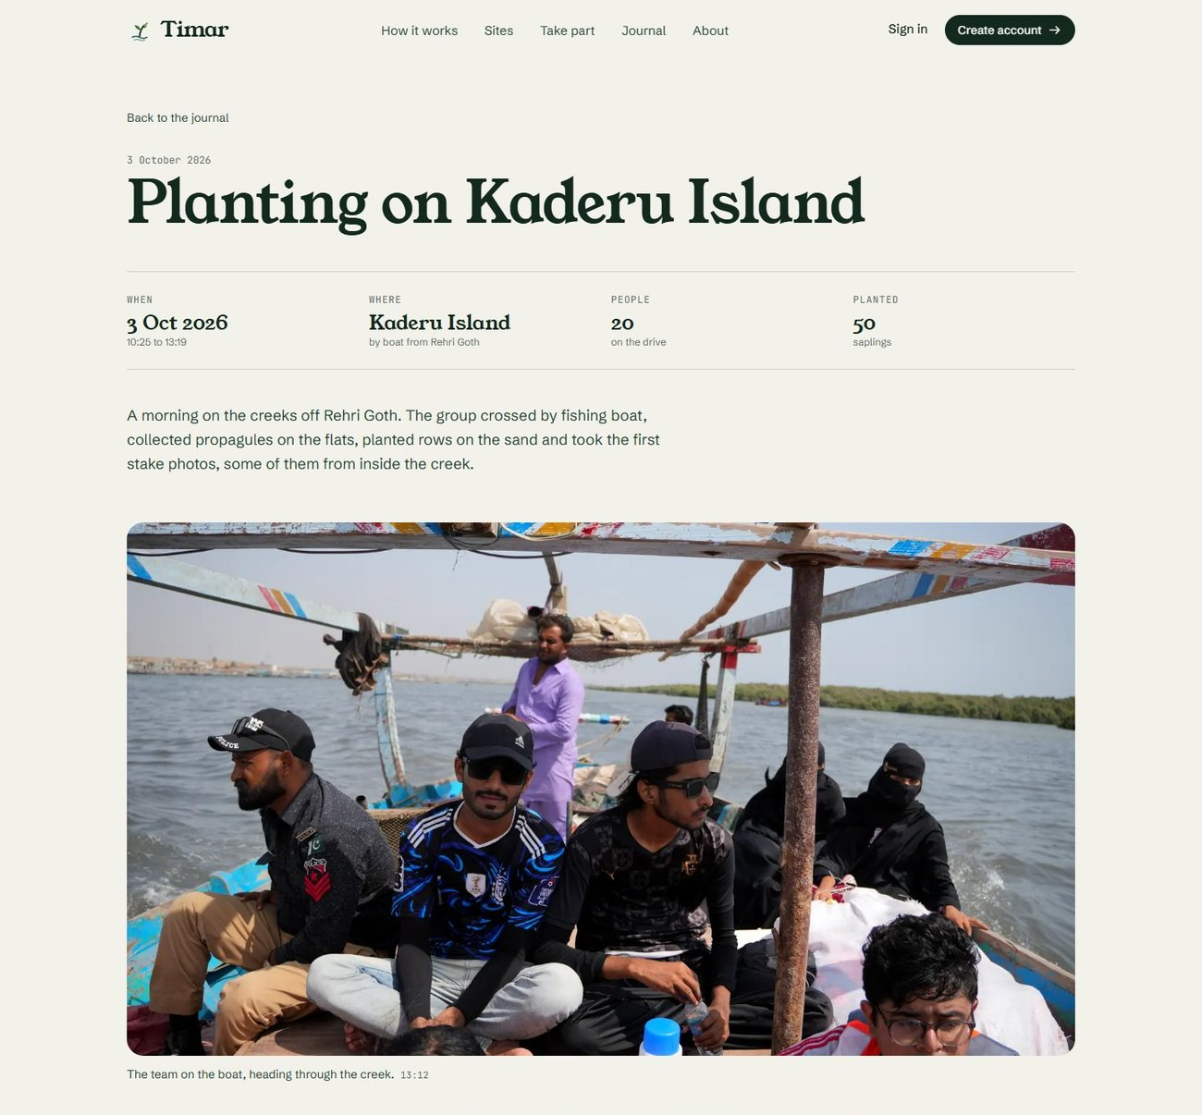
Figure 10. Journal, record of a past drive
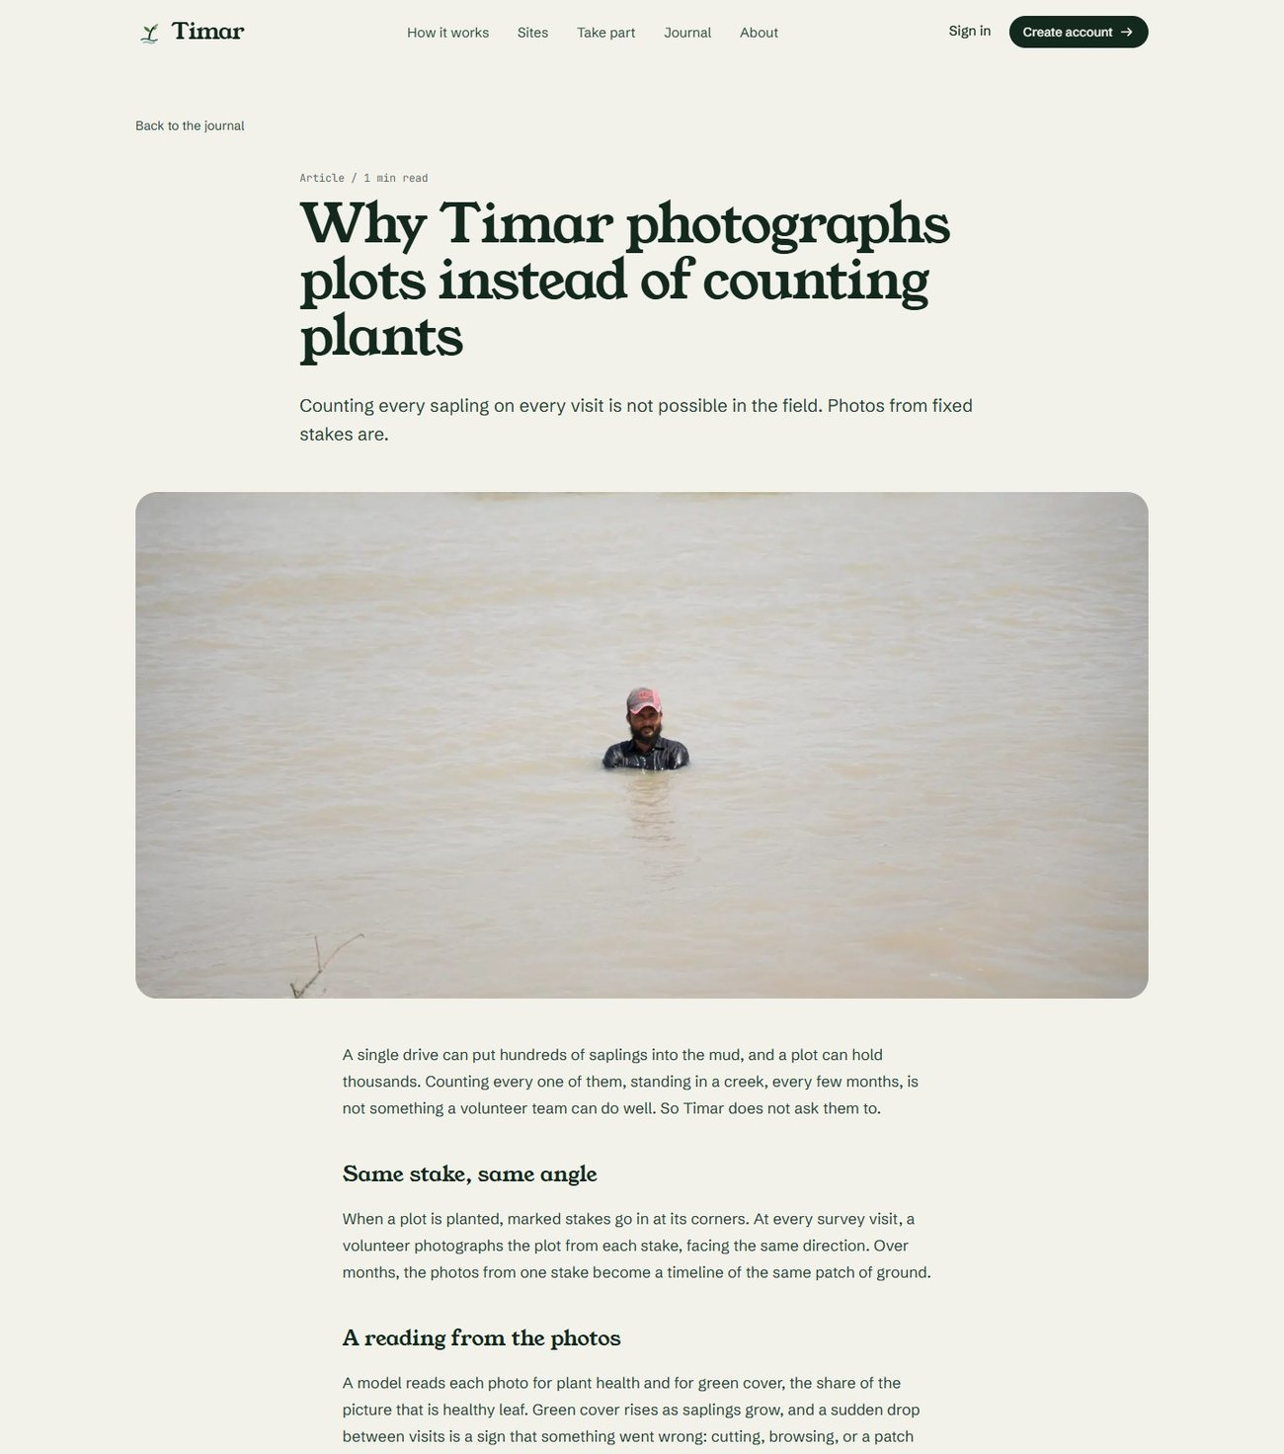
Figure 11. Journal, an awareness article
Sign in and sign up
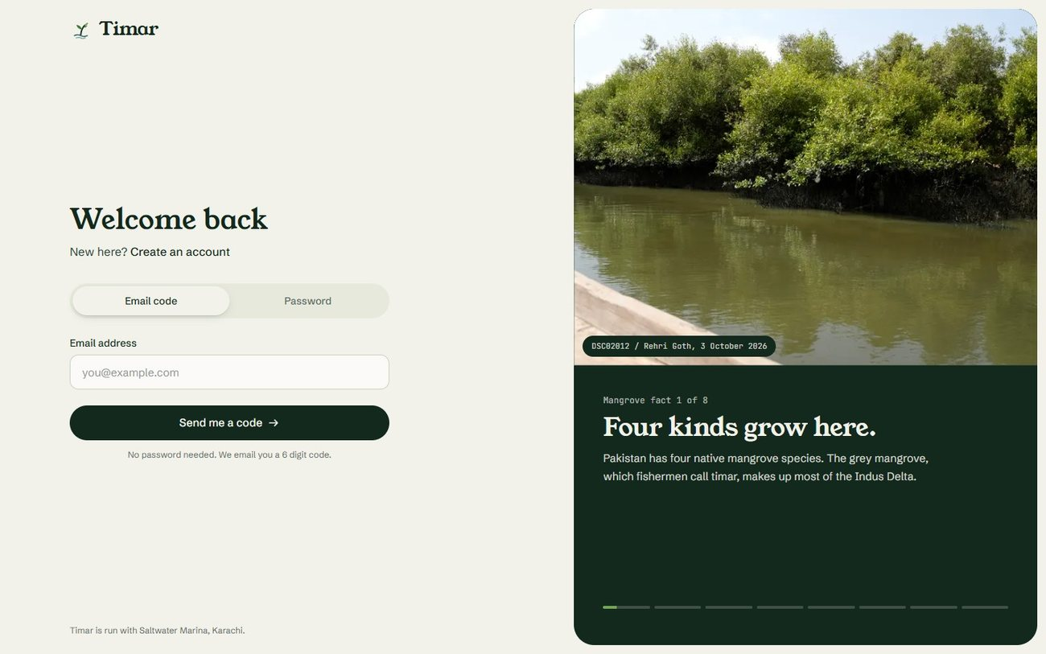
Figure 12. Sign in with an email code
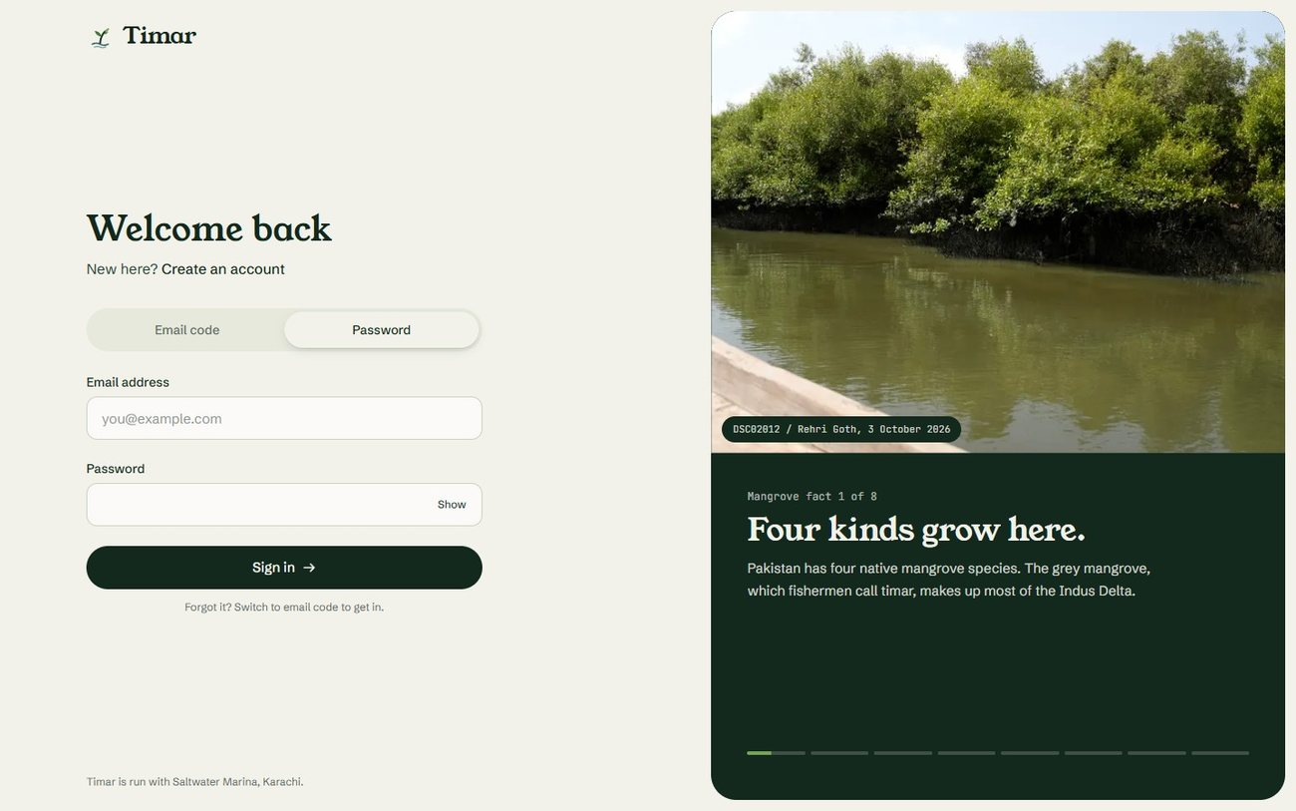
Figure 13. Sign in with a password
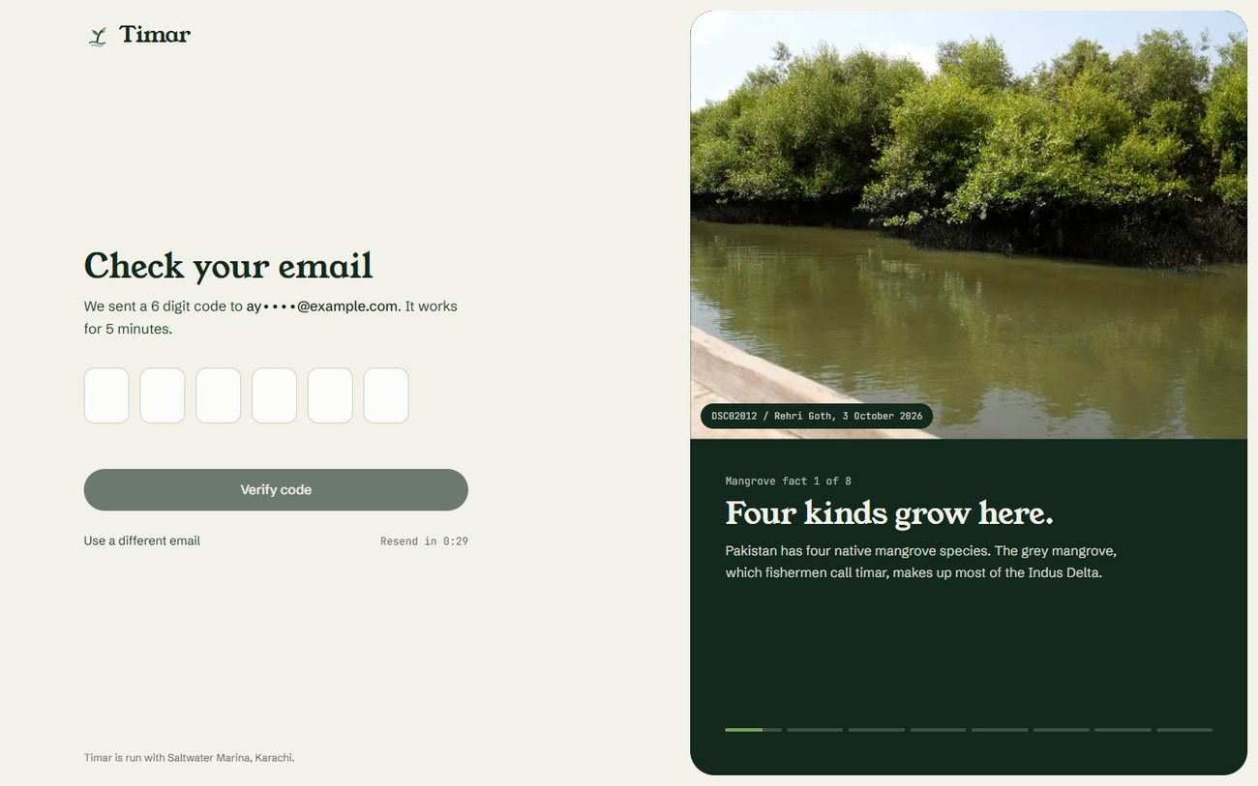
Figure 14. Entering the emailed code
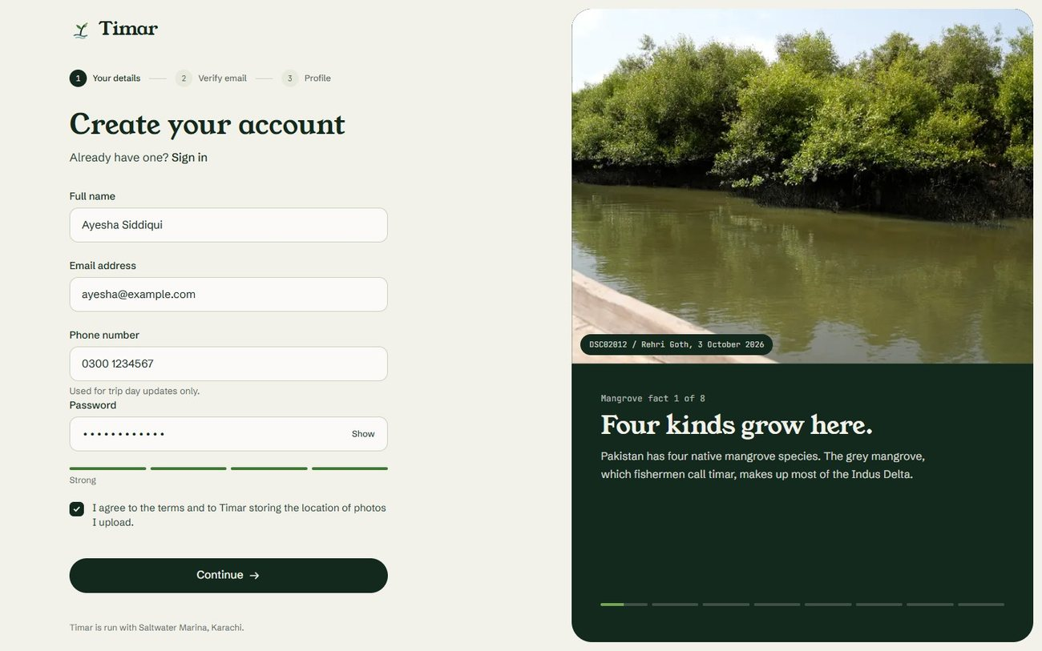
Figure 15. Sign up form
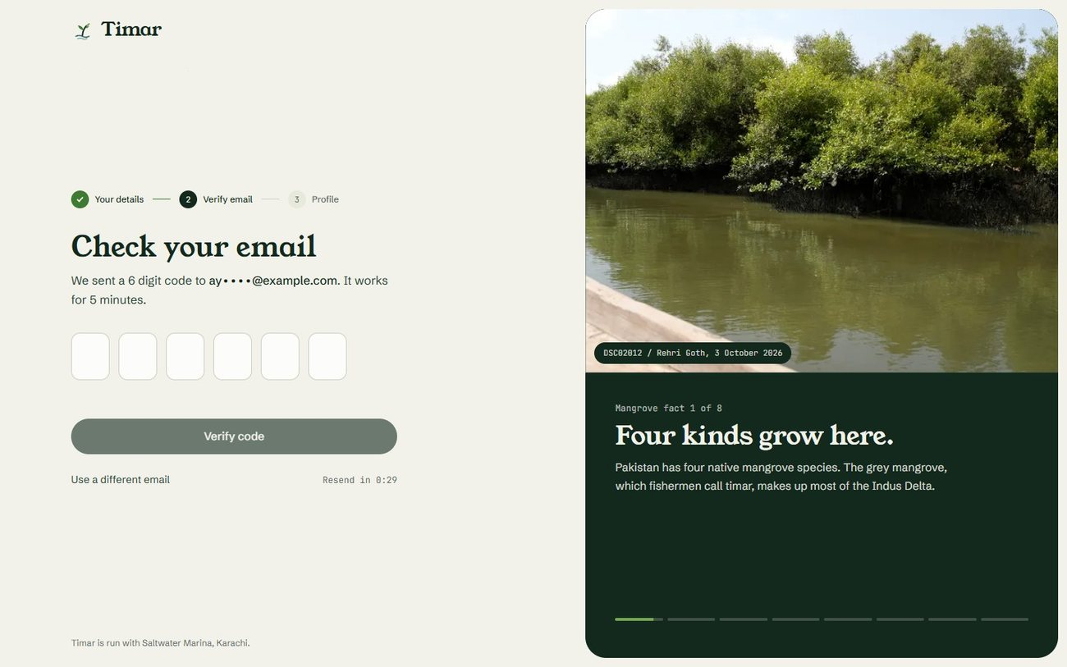
Figure 16. Verifying the email address
Profile setup
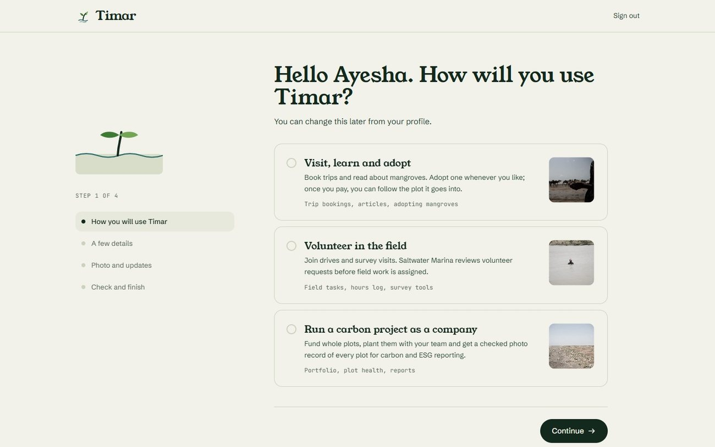
Figure 17. Profile setup, choosing the account type
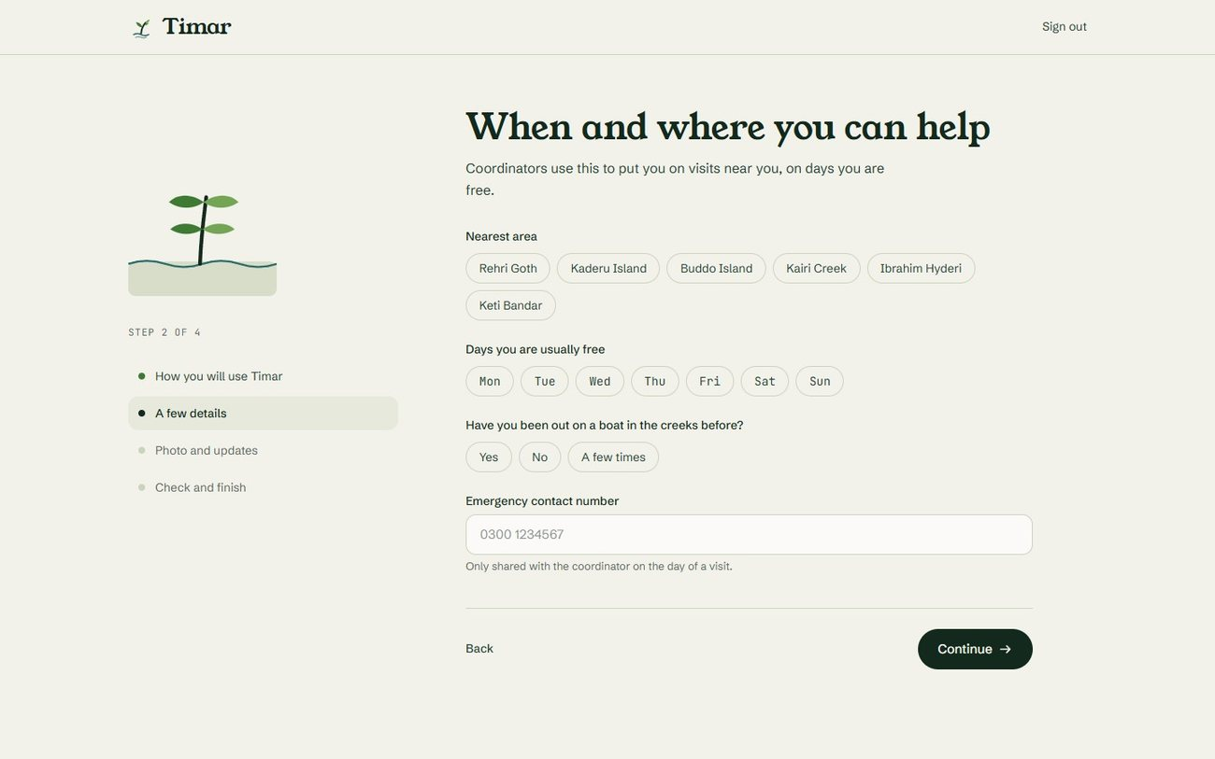
Figure 18. Profile setup, volunteer details
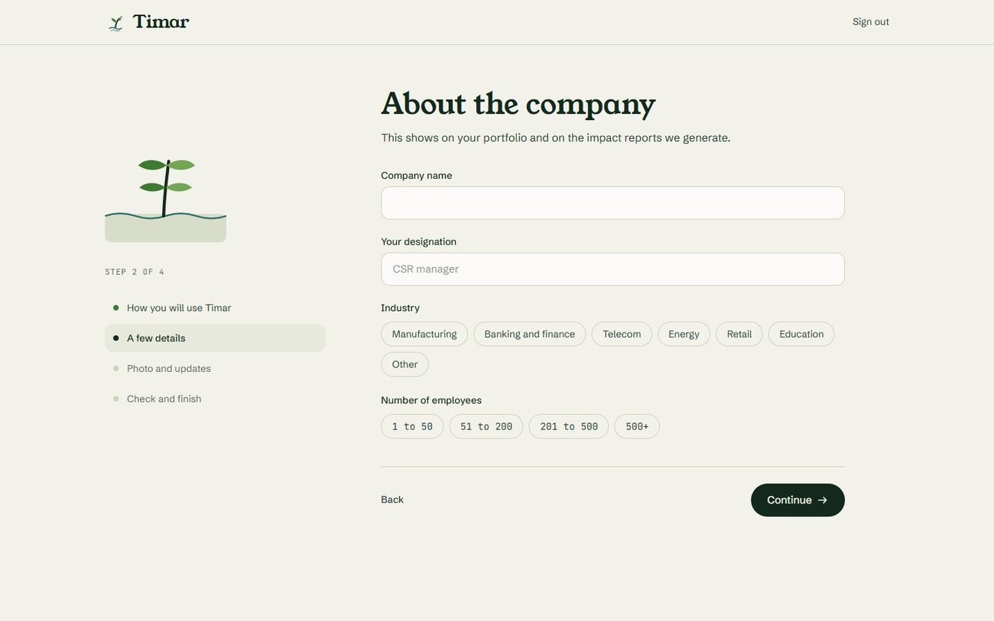
Figure 19. Profile setup, company details
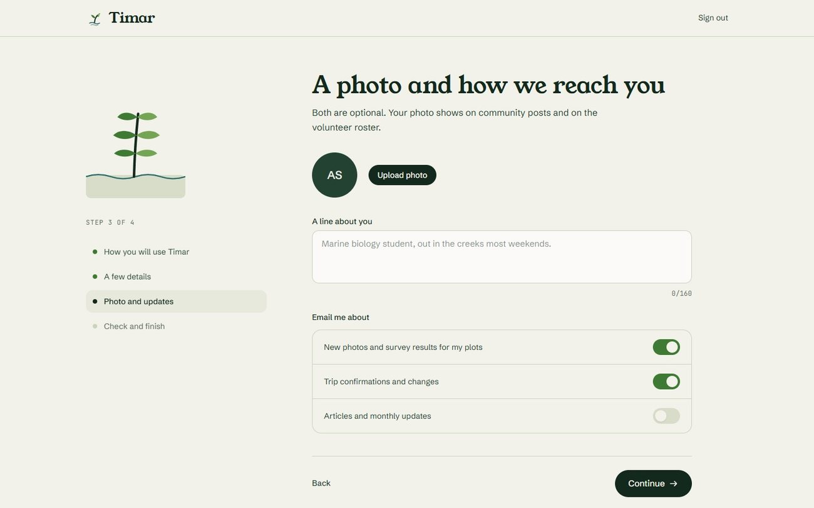
Figure 20. Profile setup, photo and updates
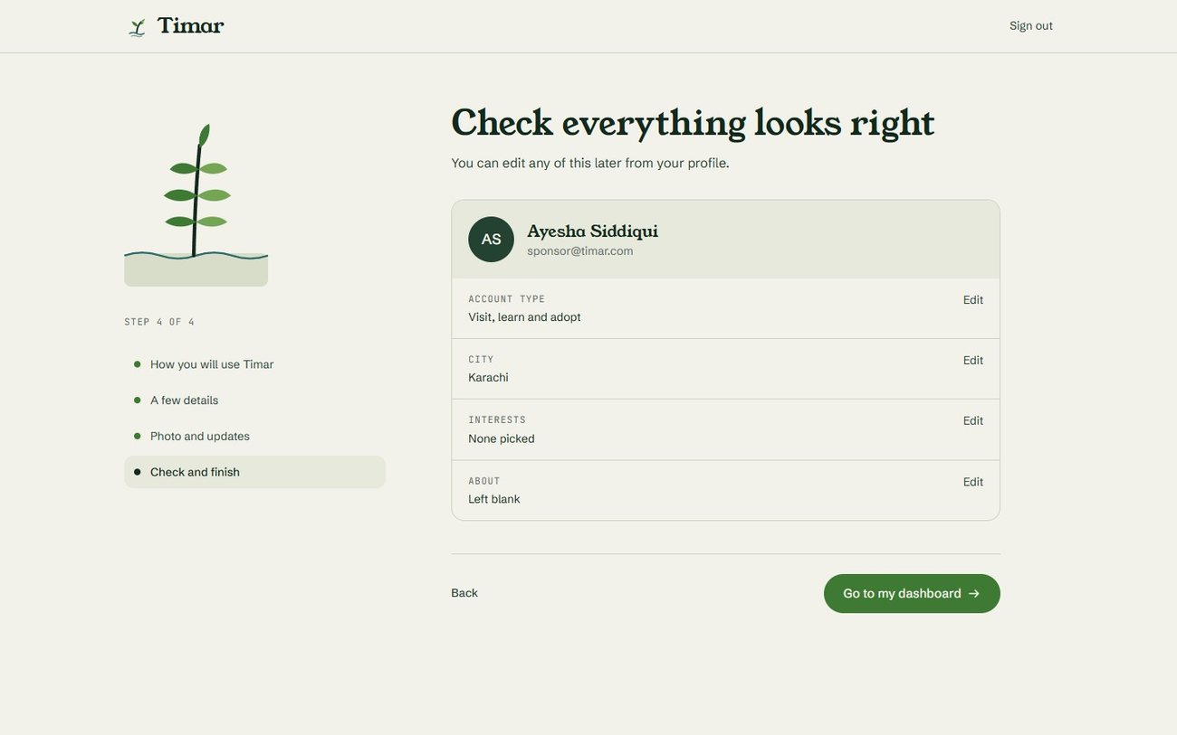
Figure 21. Profile setup, final review
Dashboards
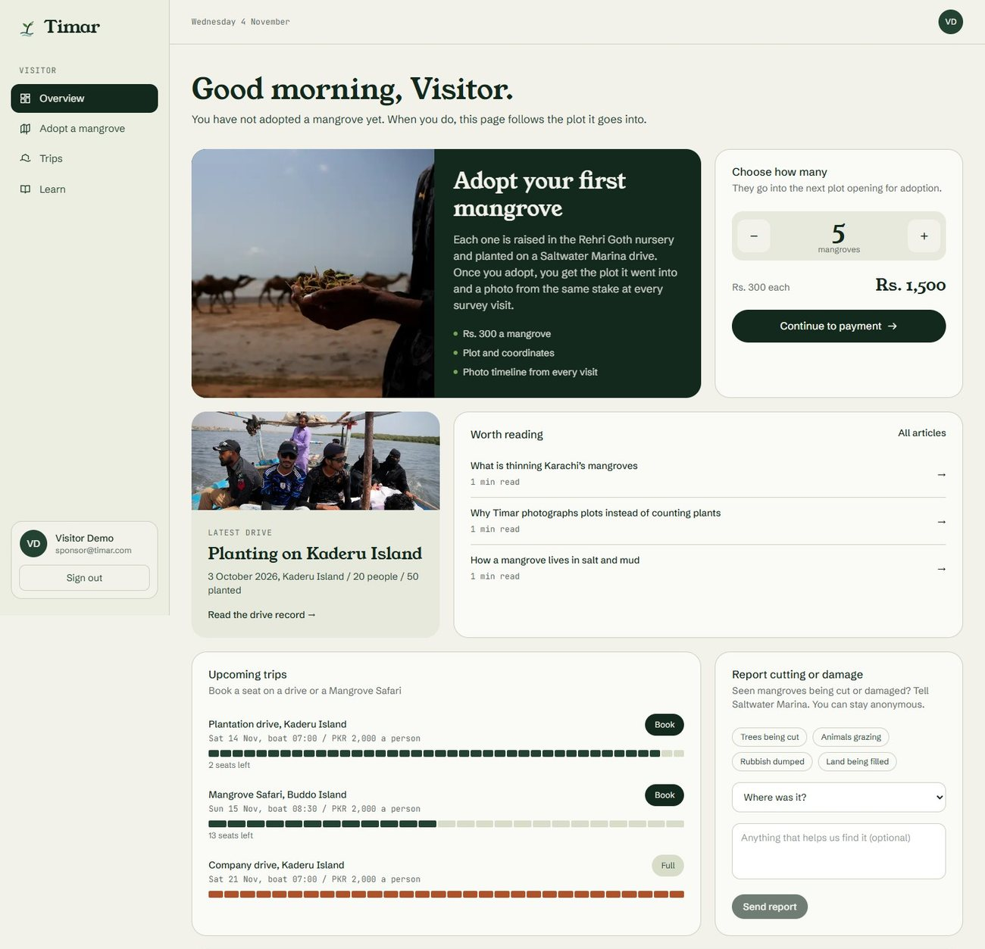
Figure 22. Visitor dashboard, part 1 of 2
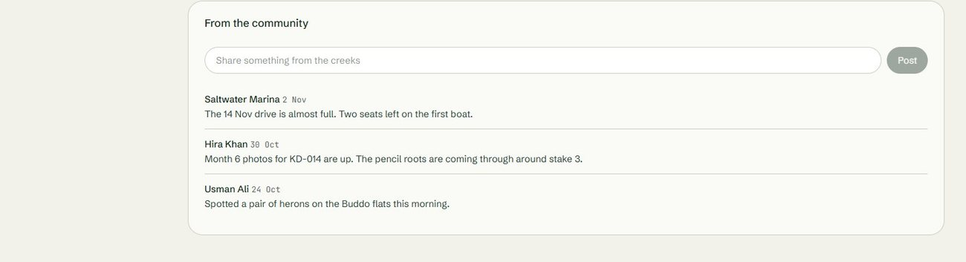
Figure 23. Visitor dashboard, part 2 of 2
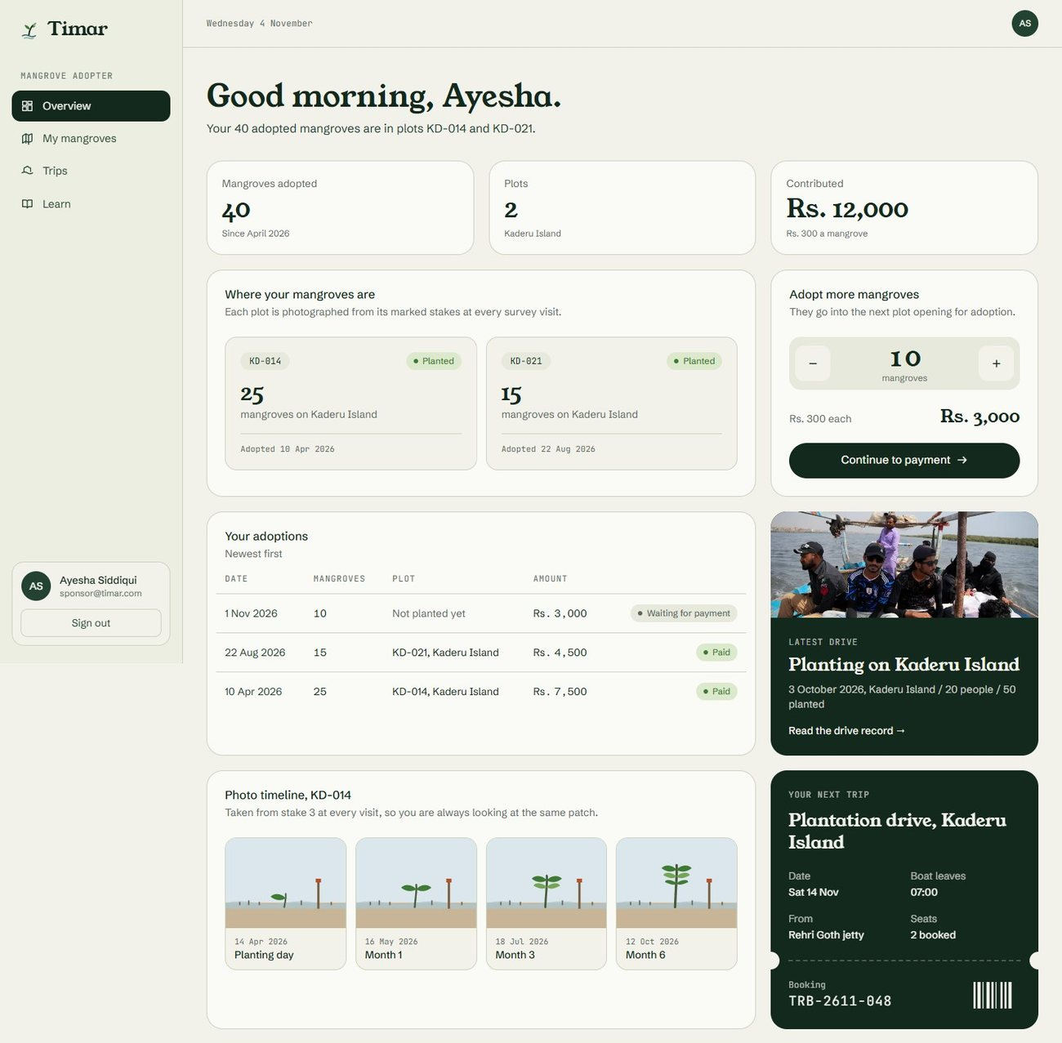
Figure 24. Adopter dashboard, part 1 of 2
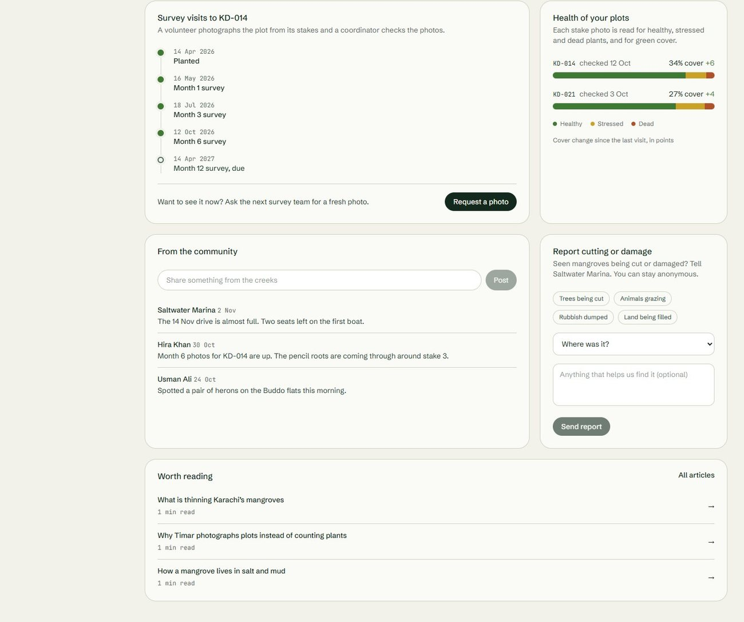
Figure 25. Adopter dashboard, part 2 of 2
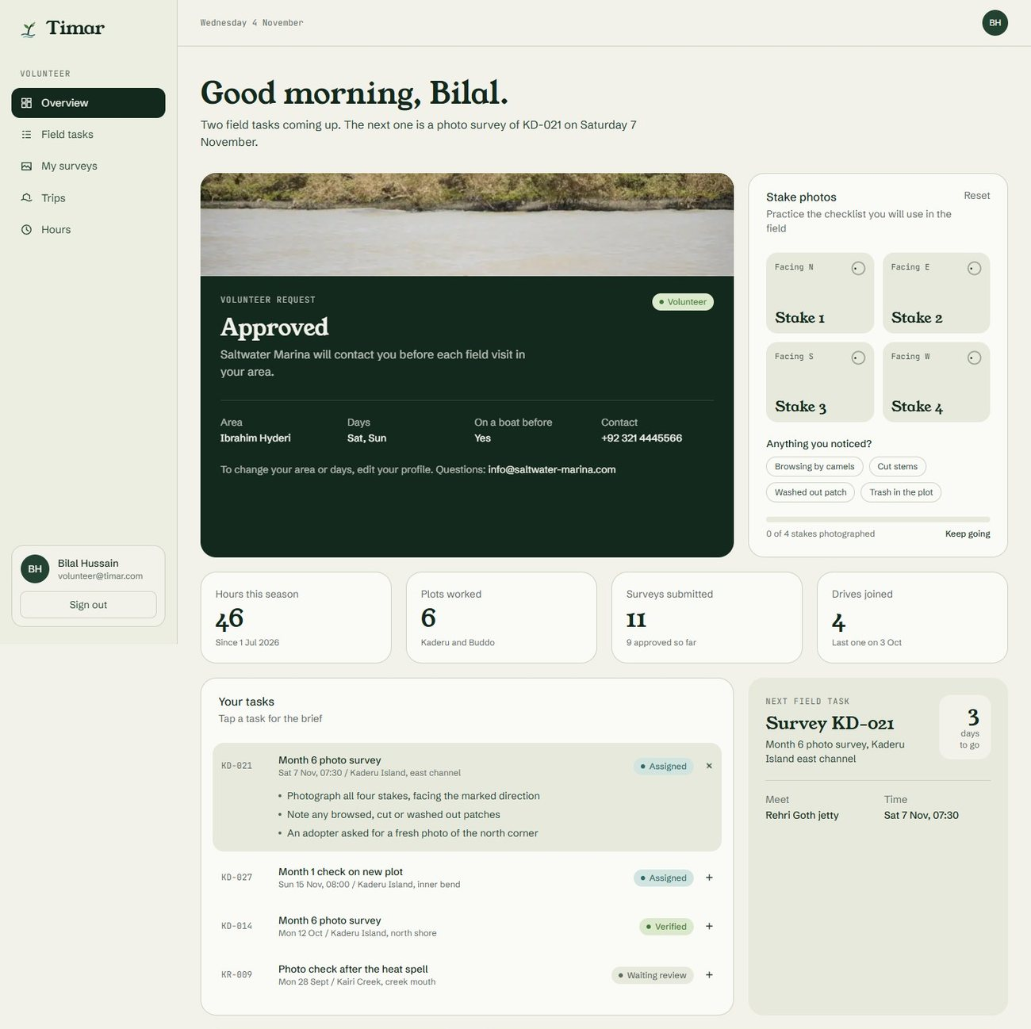
Figure 26. Volunteer dashboard, part 1 of 2
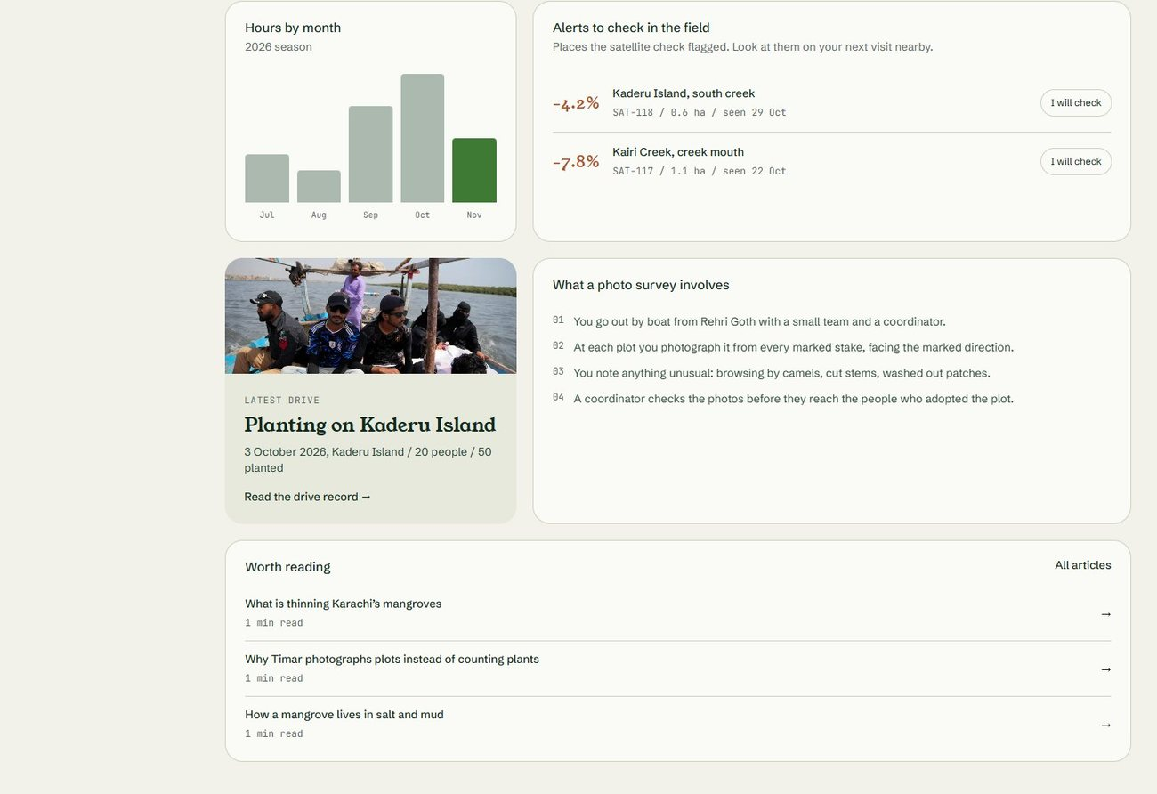
Figure 27. Volunteer dashboard, part 2 of 2
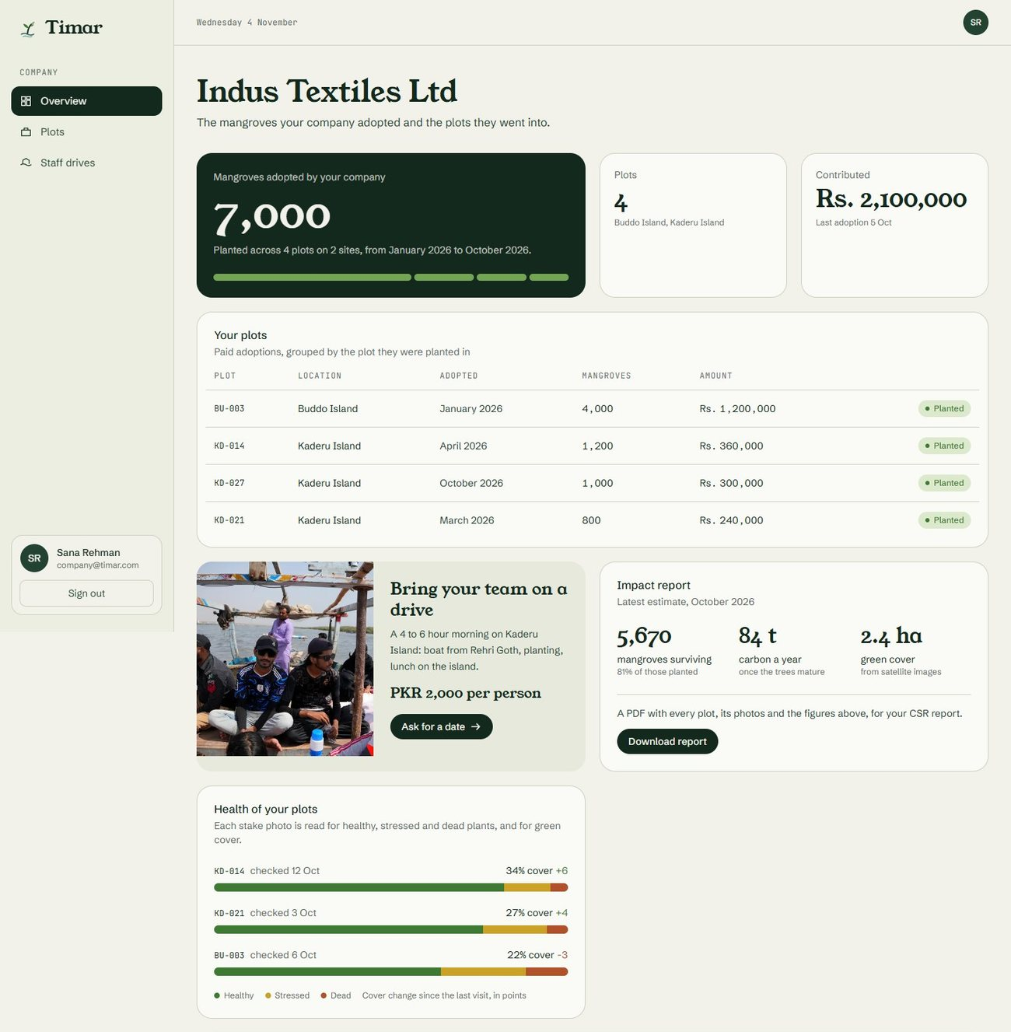
Figure 28. Company dashboard, part 1 of 2
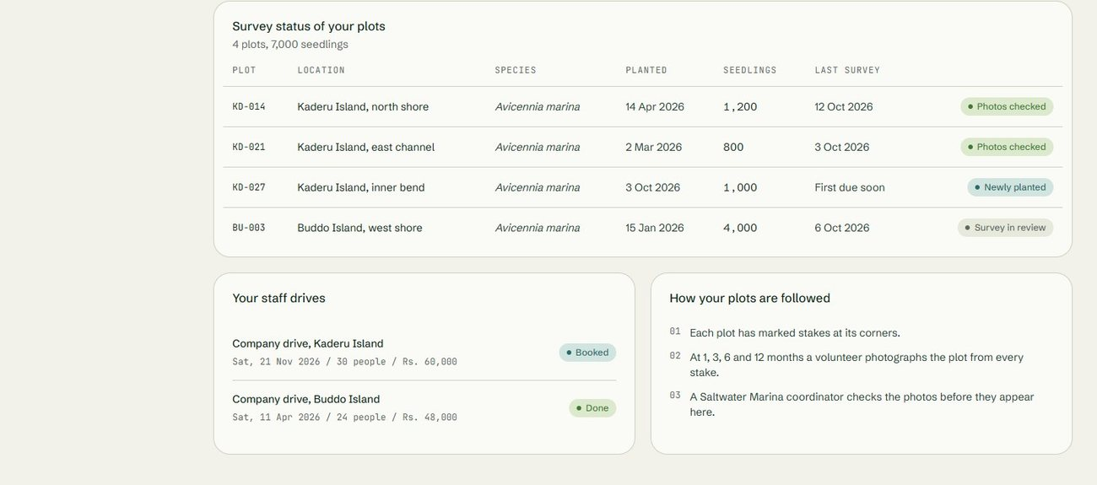
Figure 29. Company dashboard, part 2 of 2
Administrative portal
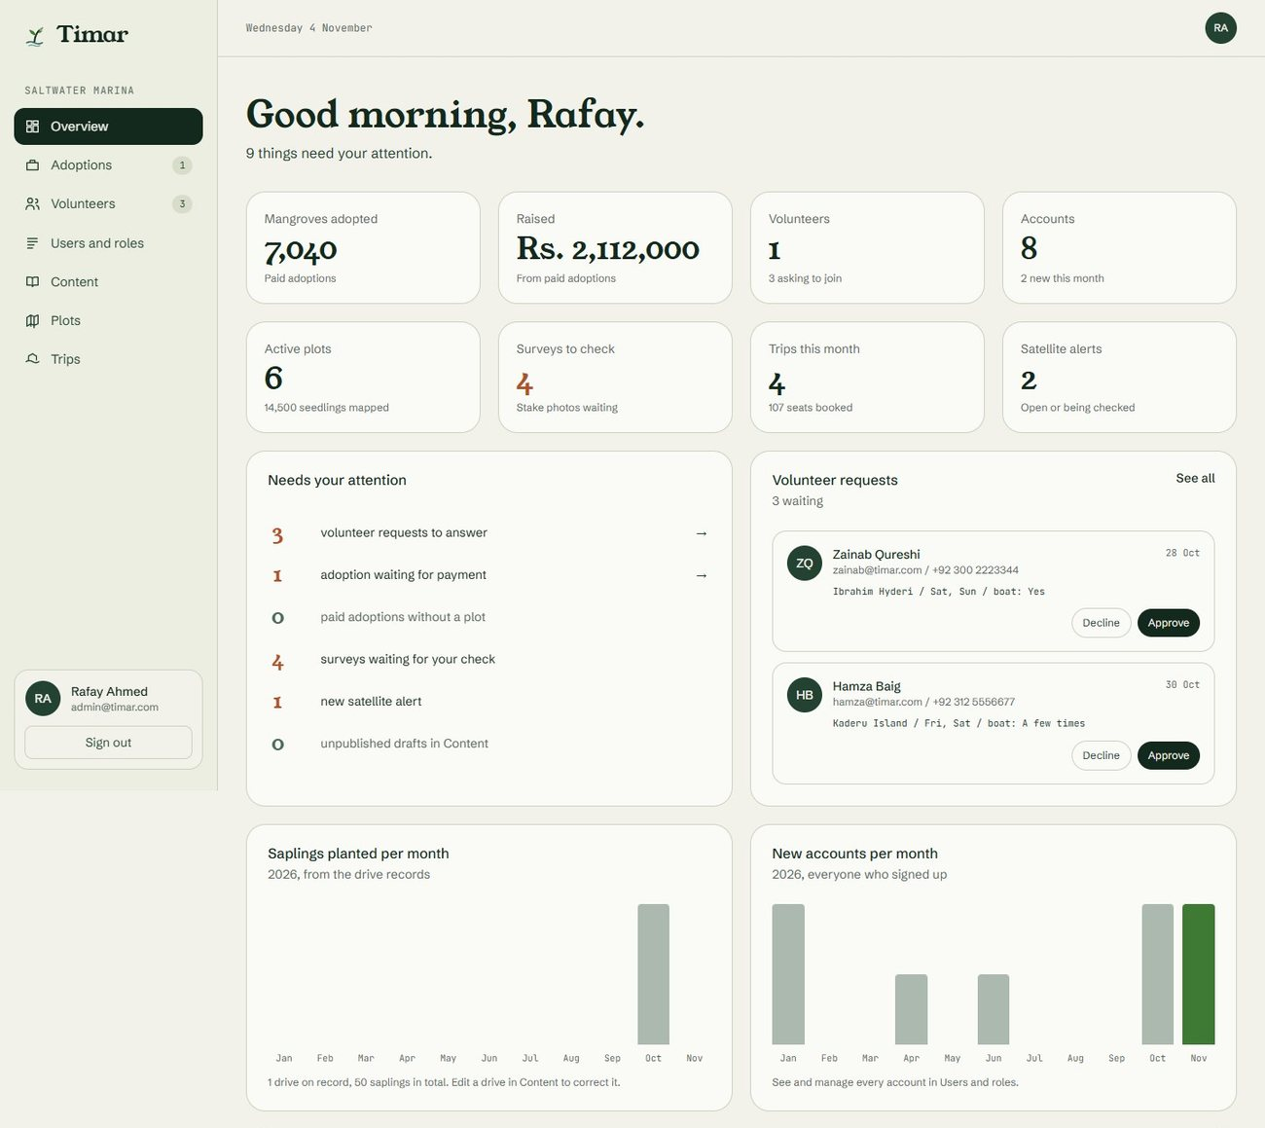
Figure 30. Administrative dashboard, overview, part 1 of 3
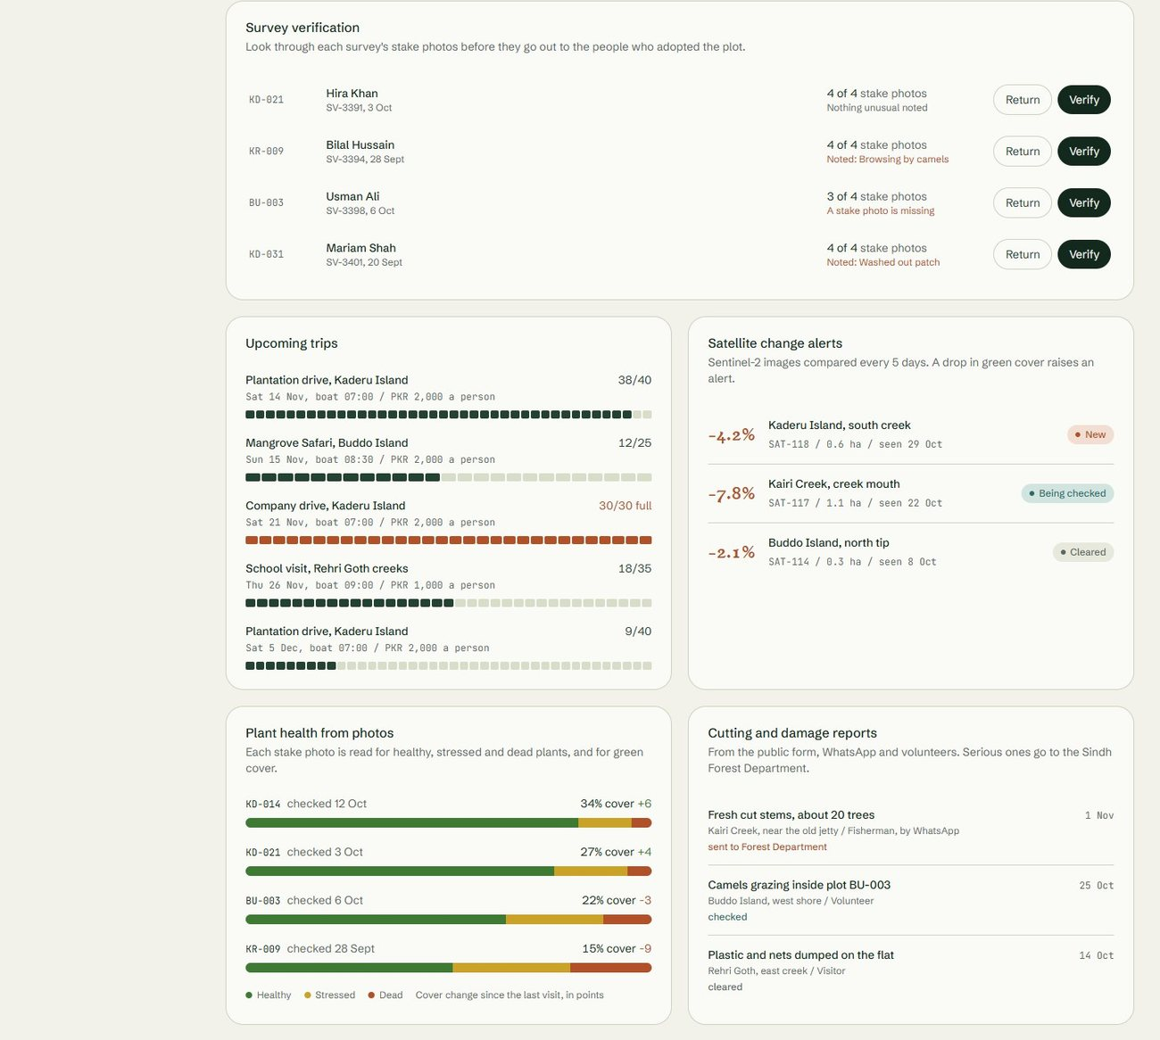
Figure 31. Administrative dashboard, overview, part 2 of 3
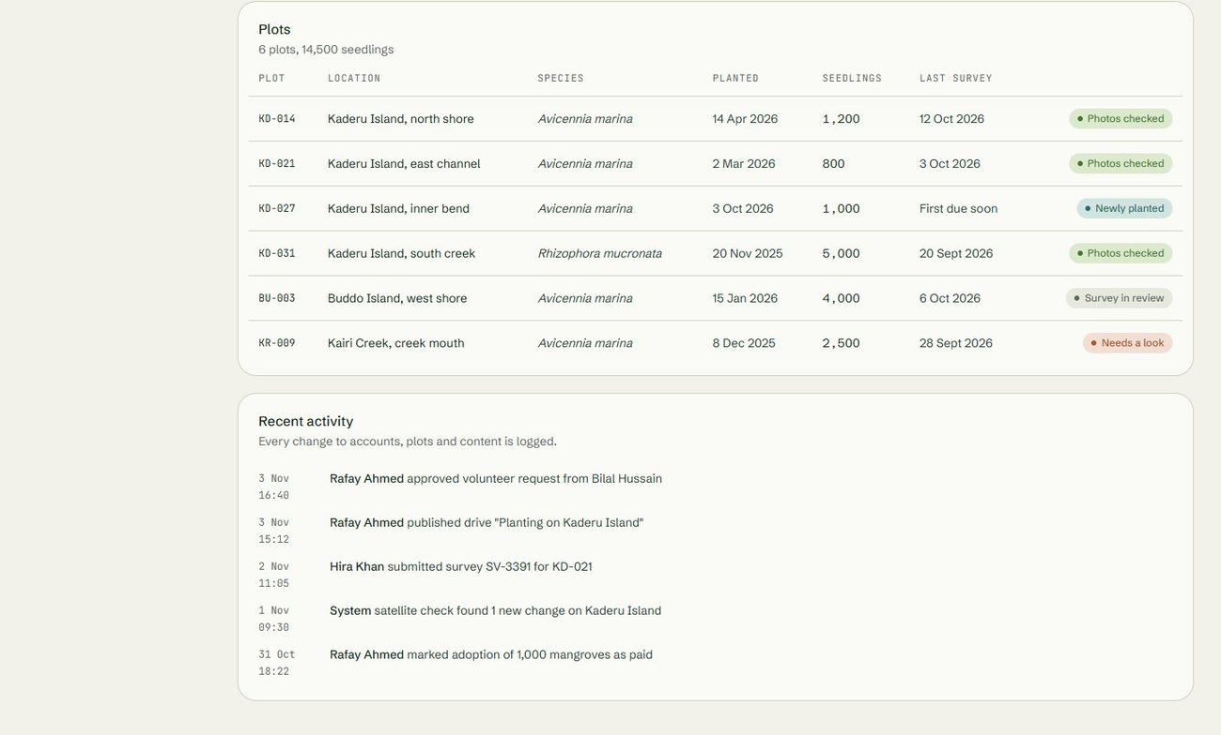
Figure 32. Administrative dashboard, overview, part 3 of 3
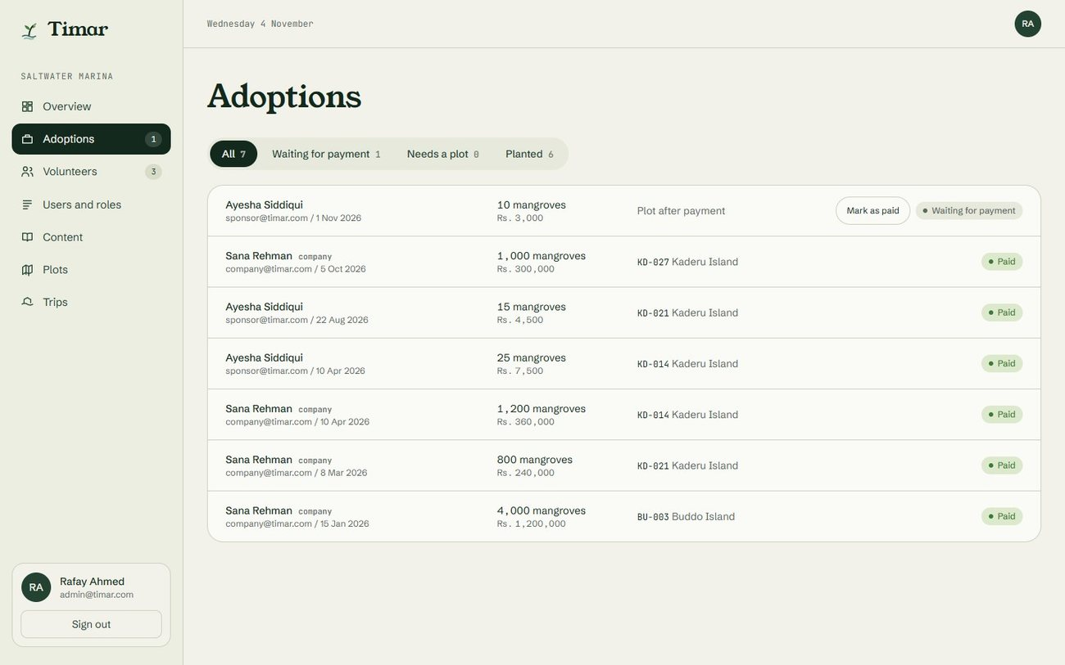
Figure 33. Administrative portal, adoptions
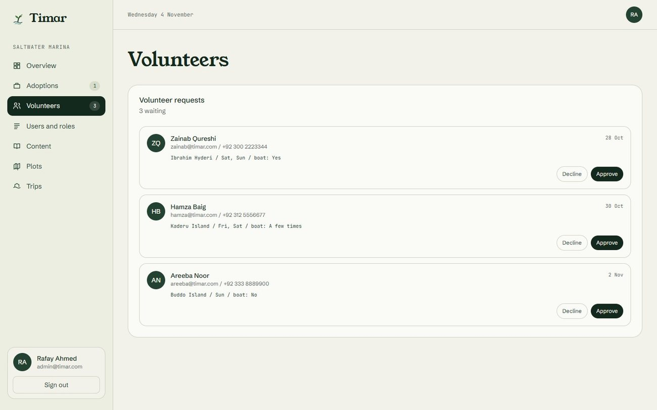
Figure 34. Administrative portal, volunteer requests
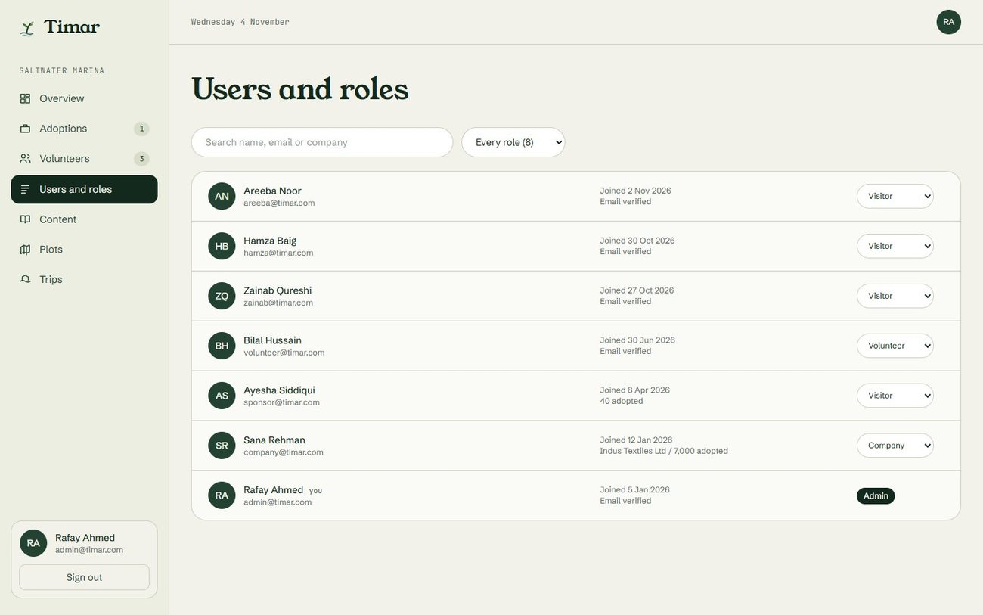
Figure 35. Administrative portal, users and roles
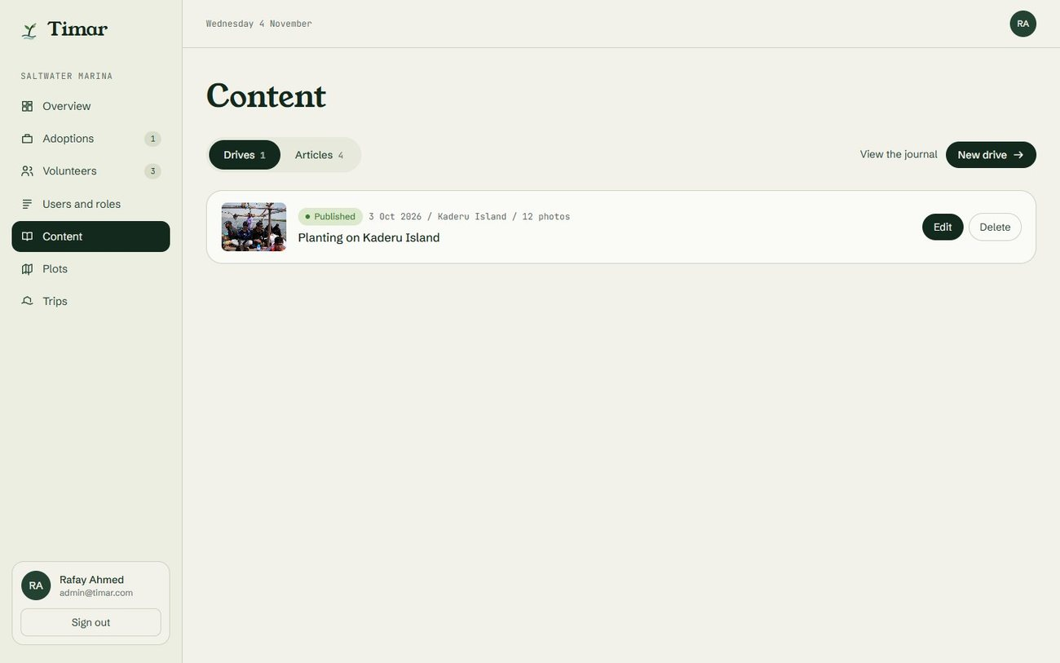
Figure 36. Administrative portal, content
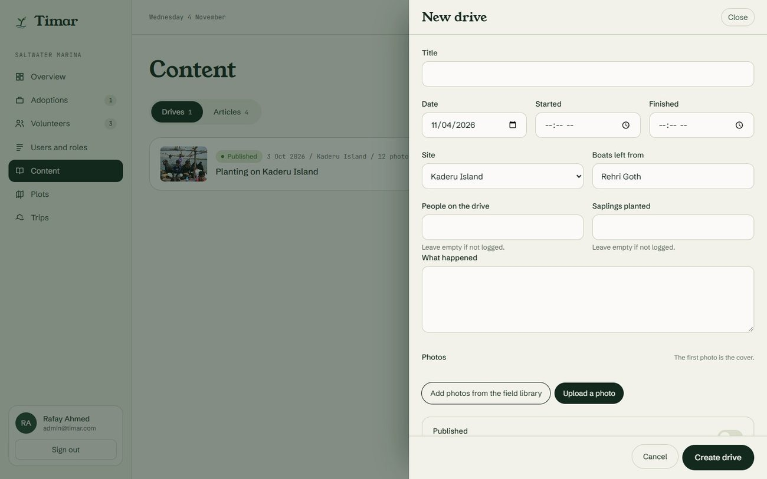
Figure 37. Administrative portal, new drive form
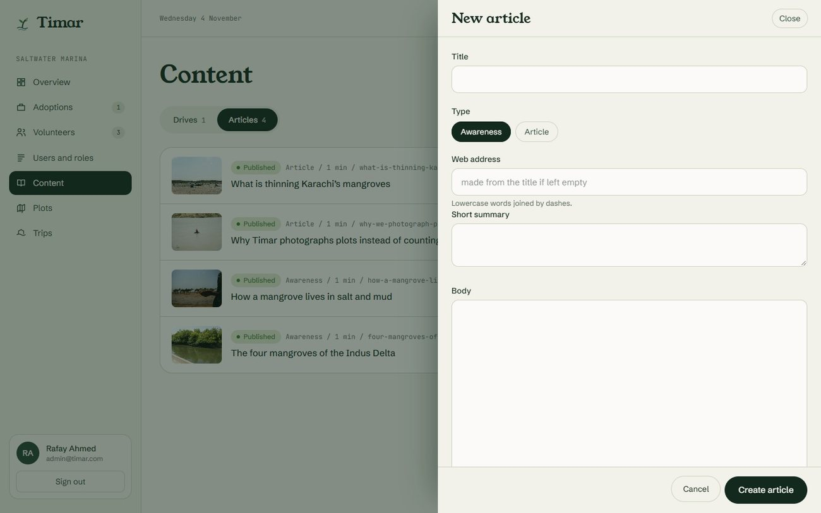
Figure 38. Administrative portal, new article form
Phone size
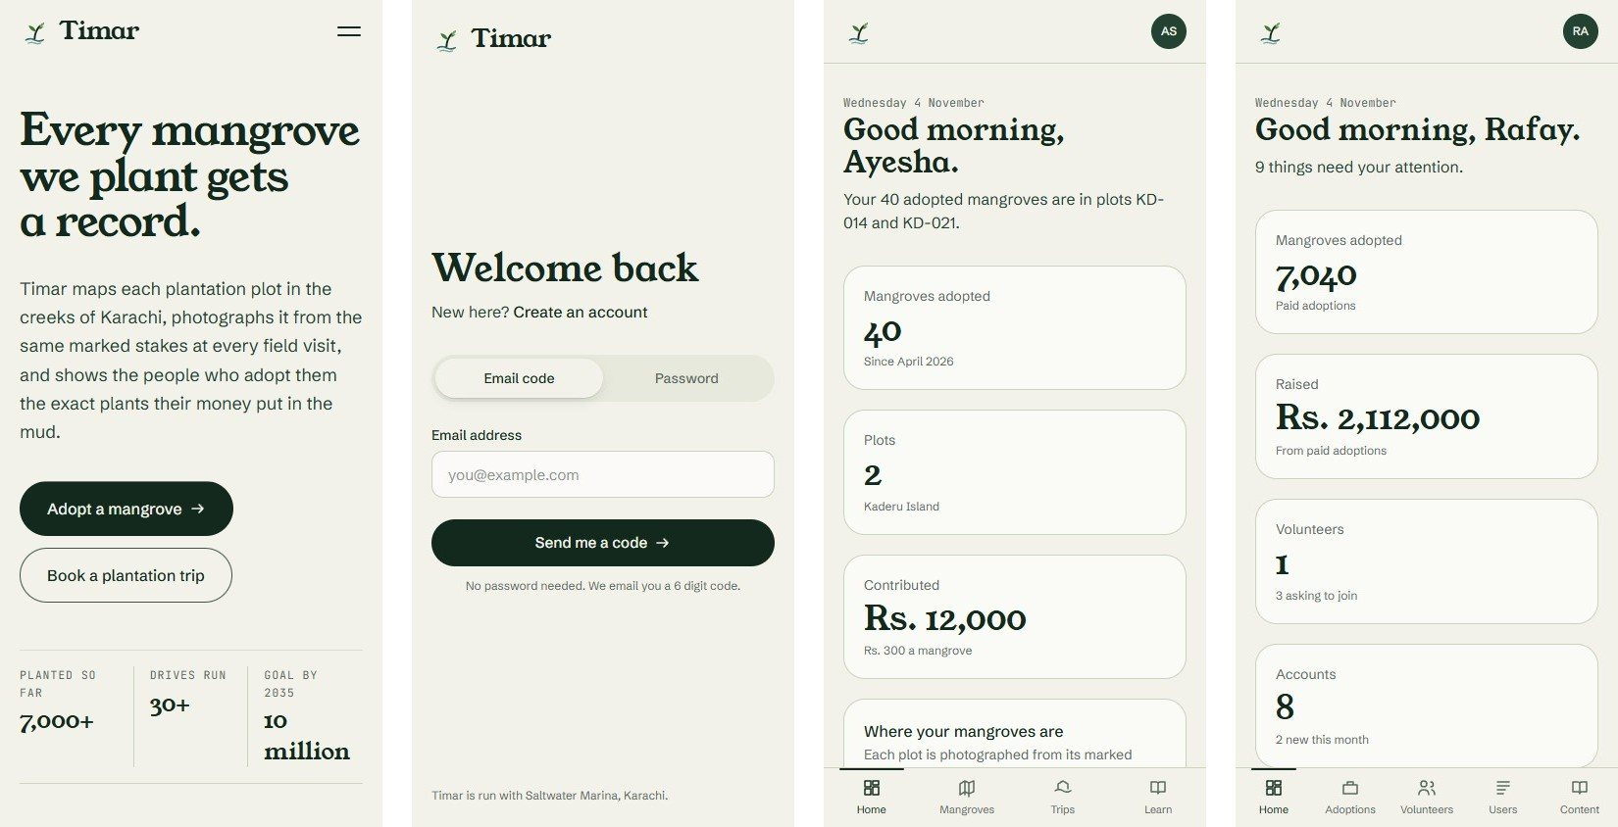
Figure 39. Home page, sign in, adopter dashboard and administrative dashboard at phone size
3.2 Hardware Interfaces
The platform uses only the hardware an ordinary phone or computer already has.
• Camera: used to capture survey photographs, complaint evidence and community posts.
• GPS: used to record where a survey was taken and where a complaint was reported. The accuracy figure reported by the device is stored with the point, so a weak reading can be judged later.
• Touchscreen: the main input method on phones, including map pan, pinch zoom and swipe.
• Notifications: the browser notification system is used to tell a coordinator that a new alert or complaint has arrived.
• No special hardware is required. No drone, no sensor and no survey equipment is part of this system.
3.3 Software Interfaces
The platform communicates with the following software components.
• Browser and operating system: the application runs in current versions of Chrome, Firefox, Safari and Edge on Android, iOS, Windows and macOS.
• Backend API: the frontend communicates with the Node.js service over a REST API using JSON.
• AI service: the backend calls the Python service over an internal REST interface for health assessment, seedling estimates, site scoring and change detection. Each response includes the model version that produced it.
• Database: PostgreSQL with PostGIS stores users, plots, surveys, adoptions, complaints and alerts, including all geometry.
• Object storage: field photographs are stored outside the database, with only their references held in it.
• Copernicus data access: the satellite job retrieves Sentinel-2 imagery for the Karachi coastal area on a monthly schedule.
• Payment provider: used for adoption payments through a hosted checkout, so card data never reaches our servers.
• Email service: used for verification codes, booking confirmations, adoption receipts and alert notifications.
3.4 Communications Interfaces
The following communication methods are used between the browser, the backend, the AI service and outside systems.
• Network: all traffic between the browser and the backend uses HTTPS. Plain HTTP is not accepted.
• API format: requests and responses use JSON, with standard HTTP status codes to indicate success or failure.
• Authentication: a signed token is issued at login and kept in an httpOnly cookie, so it is sent with every request. It is valid for seven days, after which the user signs in again.
• Email: verification codes, booking confirmations and notification messages are sent through the email service.
• File upload: photographs are uploaded directly to object storage using a short lived upload link, so large images do not pass through the application server.
• Scheduled jobs: the monthly satellite job and the survey reminder job run on the server without any user action.
• Security of transfer: passwords are never transmitted or stored in readable form, and photographs carry no personal data beyond the location of the plot itself.

4. System Features
This section describes each feature of the system as a use case. For every feature there is a description with its priority, a use case table giving the actors, goal, pre-conditions, the main flow with its alternate and exception flows, and the post conditions, followed by a table of numbered functional requirements. Features that depend on machine learning carry additional tables covering the models, the data, the training and evaluation plan, and how the models are deployed and monitored.
4.1 Sign Up (SU)
4.1.1 Description and Priority
A new visitor creates an account on the platform. The same form is used by everyone. After verifying their email the user completes a short profile setup and chooses how they will use Timar: as a visitor, a volunteer or a company. Choosing volunteer files an application, and the person stays a visitor until it is approved. Coordinator and administrator roles are set by an administrator.
Priority: High
4.1.2 Stimulus/Response Sequences
Use Case Name: Sign Up
Description: A new user creates an account on the Timar platform.
Actors: Citizens, volunteers, adopters
Goal: Create a verified account that can book trips, adopt mangroves and report cutting
Pre-Conditions: The user must not already have an account with the same email address
Basic Course of Events / Main Flow
User Action (Step 1):
the user opens the sign up page and enters name, email, phone and password.
System Response:
the system checks the format of each field, confirms the email is not already registered, creates the account in a pending state and emails a six digit verification code.
User Action (Step 2):
the user enters the code.
System Response:
the account is marked verified, the user is signed in and taken to profile setup, and then to their dashboard.
Alternate Flow (invalid input)
If any field is empty, badly formatted, or the password is too weak, the system shows a message next to the field concerned and does not submit the form. If the email is already registered, the system says so and offers a link to sign in instead.
Exception Flow (system errors)
If the database or the email service is unavailable, the system shows a short message asking the user to try again shortly, keeps the entered values in the form, and records the failure in the server log.
Post Conditions: A new verified user account exists and the user is signed in and shown their dashboard.
Table 1. Sign Up Stimulus/Response Sequences
4.1.3 Functional Requirements
Req.ID | Description | Priority | Status
Req 1 | The system shall provide a sign up form with fields for full name, email address, phone number and password. | High | Done
Req 2 | The system shall validate the format of the email address and require a password of at least eight characters containing letters and numbers. | High | Done
Req 3 | The system shall reject a sign up attempt if the email address is already registered. | High | Done
Req 4 | The system shall store the password only as a one way hash and never in readable form. | High | Done
Req 5 | The system shall email a six digit verification code and keep the account unverified until the code is entered. A code expires after five minutes and locks after five wrong tries, and a new one can be requested after thirty seconds. | High | Done
Req 6 | The system shall assign the role of Visitor to every newly created account. | High | Done
Req 7 | The system shall record the account creation in the audit log. | Medium | Pending
Req 8 | The system shall ask a verified user to complete a profile setup, choosing visitor, volunteer or company, before showing the dashboard. | High | Done
Table 2. Sign Up Functional Requirements
4.2 Sign In (SI)
4.2.1 Description and Priority
An existing user signs in and is taken to the dashboard that matches their role: visitor or adopter, volunteer, company, or the administrative dashboard for coordinators and administrators.
Priority: High
4.2.2 Stimulus/Response Sequences
Use Case Name: Sign In
Description: An existing user authenticates and enters the platform.
Actors: All registered users
Goal: Give the user access to the features their role allows
Pre-Conditions: The user must have a verified account
Basic Course of Events / Main Flow
User Action (Step 1):
the user enters email and password, or asks for a six digit code by email and enters it.
System Response:
the system checks the credentials, issues a signed session token, and redirects the user to the landing area for their role.
Alternate Flow (invalid input)
If the credentials do not match, the system shows a single message saying the email or password is incorrect, without revealing which one. After five failed attempts from the same address the system adds a short delay before further attempts. If the account is not verified, the system sends a new verification code.
Exception Flow (system errors)
If the authentication service or database is unavailable, the system shows a general failure message and logs the error. No partial session is created.
Post Conditions: The user holds an active session and is shown the landing area for their role.
Table 3. Sign In Stimulus/Response Sequences
4.2.3 Functional Requirements
Req.ID | Description | Priority | Status
Req 1 | The system shall allow a verified user to sign in with email address and password, or with a code sent to that address. | High | Done
Req 2 | The system shall issue a signed session token on successful sign in and require that token on every later request. | High | Done
Req 3 | The system shall redirect the user after sign in to the area that matches their role. | High | Done
Req 4 | The system shall not reveal whether a failed sign in was caused by an unknown email or a wrong password. | High | Done
Req 5 | The system shall delay further attempts after five consecutive failures from the same source. | Medium | Done
Req 6 | The system shall provide a password reset flow that sends a time limited code to the registered email address. | High | Done
Req 7 | The system shall expire a session token after seven days, after which the user signs in again. | Medium | Done
Table 4. Sign In Functional Requirements
4.3 Plot Management (PLM-C)
4.3.1 Description and Priority
A field coordinator records a new plantation site as a plot. This is the single most important record in the system, because every survey, adoption, report and alert is linked back to a plot.
Priority: High
4.3.2 Stimulus/Response Sequences
Use Case Name: Plot Management (Create)
Description: A coordinator records a new plantation site on the map.
Actors: Field coordinators, administrators
Goal: Create a mapped plot with its species, planting date, count and responsible person
Pre-Conditions: The user must be signed in with the role of coordinator or administrator
Basic Course of Events / Main Flow
User Action (Step 1):
the coordinator opens the new plot form, draws the boundary on the map or uploads it, then enters the creek name, planting date, species and the number of seedlings planted.
System Response:
the system calculates the area from the boundary, saves the plot, assigns it an identifier and shows it on the plot map.
Alternate Flow (invalid input)
If the boundary is missing, self intersecting, or falls outside the coastal area covered by the project, the system refuses to save and explains the problem. If the planting date is in the future, the system asks the user to confirm that the plot is planned rather than planted.
Exception Flow (system errors)
If the map service fails to load, the coordinator may still enter the plot using coordinates and add the boundary later. The plot is then marked as incomplete until a boundary exists.
Post Conditions: A new plot exists with its boundary, species and planting details, and is visible on the plot map.
Table 5. Plot Management (Create) Stimulus/Response Sequences
4.3.3 Functional Requirements
Req.ID | Description | Priority | Status
Req 1 | The system shall allow a coordinator to create a plot by drawing its boundary on a map or uploading a boundary file. | High | Pending
Req 2 | The system shall store the plot boundary as geographic geometry and shall calculate its area in hectares automatically. | High | Pending
Req 3 | The system shall require a creek or site name, a planting date, at least one species and an initial seedling count. | High | Pending
Req 4 | The system shall allow more than one species to be recorded against a plot, each with its own planted count. | Medium | Pending
Req 5 | The system shall reject a boundary that is self intersecting or that lies outside the project area. | High | Pending
Req 6 | The system shall record the creating user and the creation time against the plot. | High | Pending
Req 7 | The system shall write the creation of a plot to the audit log. | Medium | Pending
Req 8 | The system shall record the marked stakes of a plot and the direction each one faces, so that every survey photographs the same views. | High | Pending
Table 6. Plot Management (Create) Functional Requirements
4.4 Plot Management (PLM-R)
4.4.1 Description and Priority
Any user views plots, with the level of detail depending on their role. The public sees location, species and estimated survival. Coordinators additionally see unverified entries, assigned tasks and alert history.
Priority: High
4.4.2 Stimulus/Response Sequences
Use Case Name: Plot Management (Read)
Description: A user views the plot map and the detail page of a plot.
Actors: All users, including visitors who are not signed in
Goal: Let anyone see where planting has happened and how it is doing
Pre-Conditions: None for public information. Internal detail requires a coordinator or administrator role
Basic Course of Events / Main Flow
User Action (Step 1):
the user opens the map and taps a plot.
System Response:
the system shows the plot detail page with its boundary, species, planting date, latest estimated survival, area and photograph timeline.
Alternate Flow (filtered view)
The user filters the map by creek, species, planting year or survival band. The system updates the map and the list to match, and shows a message when no plot meets the filter.
Exception Flow (system errors)
If plot geometry cannot be loaded, the system shows the plot as a list entry with its details and a notice that the map is unavailable.
Post Conditions: The user has seen the plot information their role allows. No data is changed.
Table 7. Plot Management (Read) Stimulus/Response Sequences
4.4.3 Functional Requirements
Req.ID | Description | Priority | Status
Req 1 | The system shall display all plots on an interactive map with zoom, pan and layer selection. | High | Pending
Req 2 | The system shall provide a detail page per plot showing boundary, creek, species, planting date, area, initial count and latest estimated survival. | High | Pending
Req 3 | The system shall display the photograph timeline of a plot in date order. | High | Pending
Req 4 | The system shall allow filtering of plots by creek, species, planting year and survival band. | Medium | Pending
Req 5 | The system shall show unverified survey entries and internal notes only to coordinators and administrators. | High | Pending
Req 6 | The system shall allow public viewing of plot information without signing in. | Medium | Pending
Table 8. Plot Management (Read) Functional Requirements
4.5 Plot Management (PLM-U)
4.5.1 Description and Priority
A coordinator corrects or updates a plot, for example after a replanting or a boundary correction. Because published figures depend on plot data, every change is recorded.
Priority: High
4.5.2 Stimulus/Response Sequences
Use Case Name: Plot Management (Update)
Description: A coordinator edits an existing plot record.
Actors: Field coordinators, administrators
Goal: Keep plot records accurate as conditions change
Pre-Conditions: The plot must exist and the user must have the coordinator or administrator role
Basic Course of Events / Main Flow
User Action (Step 1):
the coordinator opens the plot, changes a field such as species, count or boundary, and saves.
System Response:
the system validates the change, saves the new values, recalculates area if the boundary changed, and writes the old and new values to the audit log.
Alternate Flow (replanting)
If the change is a replanting, the coordinator records it as an additional planting event with its own date and count rather than overwriting the original figure, so the history of the plot stays intact.
Exception Flow (system errors)
If the save fails, the system keeps the entered values on screen and reports the failure. The stored record is left unchanged.
Post Conditions: The plot record reflects the new values, the area is recalculated, and the change is recorded in the audit log.
Table 9. Plot Management (Update) Stimulus/Response Sequences
4.5.3 Functional Requirements
Req.ID | Description | Priority | Status
Req 1 | The system shall allow a coordinator to edit the species, counts, boundary, site name and status of a plot. | High | Pending
Req 2 | The system shall record a replanting as a new planting event against the plot rather than as a change to the original count. | High | Pending
Req 3 | The system shall recalculate the plot area whenever its boundary changes. | High | Pending
Req 4 | The system shall write the previous and new values of every changed field to the audit log. | High | Pending
Req 5 | The system shall update any published survival estimate affected by the change. | High | Pending
Table 10. Plot Management (Update) Functional Requirements
4.6 Plot Management (PLM-D)
4.6.1 Description and Priority
A plot is retired rather than erased. Because adoptions, surveys and reports point at plots, deleting one outright would damage records that other people rely on.
Priority: Medium
4.6.2 Stimulus/Response Sequences
Use Case Name: Plot Management (Archive)
Description: An administrator retires a plot that was entered in error or no longer exists.
Actors: Administrators
Goal: Remove a plot from active use without destroying its history
Pre-Conditions: The plot must exist and the user must have the administrator role
Basic Course of Events / Main Flow
User Action (Step 1):
the administrator selects a plot and chooses to archive it, giving a reason.
System Response:
the system asks for confirmation, marks the plot as archived, hides it from the public map, keeps all its surveys and photographs, and records the action with the reason.
Alternate Flow (plot has adoptions)
If the plot has active adoptions, the system refuses to archive it until those adoptions have been moved to another plot, and tells the administrator how many are affected.
Exception Flow (system errors)
If the operation fails part way, no change is applied. The plot stays active and the failure is logged.
Post Conditions: The plot is archived, hidden from public figures, and all of its surveys and photographs are retained.
Table 11. Plot Management (Archive) Stimulus/Response Sequences
4.6.3 Functional Requirements
Req.ID | Description | Priority | Status
Req 1 | The system shall allow an administrator to archive a plot, and shall not provide any permanent delete. | High | Pending
Req 2 | The system shall require a written reason before archiving a plot. | Medium | Pending
Req 3 | The system shall prevent archiving of a plot that has active adoptions attached to it. | High | Pending
Req 4 | The system shall retain all surveys, photographs and reports belonging to an archived plot. | High | Pending
Req 5 | The system shall exclude archived plots from public figures while keeping them visible to administrators. | High | Pending
Req 6 | The system shall write archiving to the audit log with the user, time and reason. | High | Pending
Table 12. Plot Management (Archive) Functional Requirements
4.7 Growth Monitoring (GRM)
4.7.1 Description and Priority
The heart of the platform. A volunteer or coordinator visits a plot on a scheduled round, photographs it from its marked stakes facing the marked direction, and notes anything unusual such as browsing, cut stems or washed out patches. Plants are not counted by hand, because counting every sapling in a plot on every visit is not possible in the field. The photographs from one stake form a timeline of the same patch of ground, and a coordinator checks them before anything is published. Every survival estimate the platform publishes comes from here.
Priority: High
4.7.2 Stimulus/Response Sequences
Use Case Name: Growth Monitoring
Description: A field visit records the current condition of a plot.
Actors: Volunteers, field coordinators
Goal: Produce a dated, located and photographed record of how a plot is doing
Pre-Conditions: The plot must exist, and the user must be signed in with the volunteer or coordinator role
Basic Course of Events / Main Flow
User Action (Step 1):
the volunteer opens an assigned survey task at the site, photographs the plot from each marked stake using the faint outline of the previous photograph as a guide, and notes anything unusual.
System Response:
the system captures the GPS position and its accuracy, checks that the point falls inside the plot boundary, saves the record as unverified and notifies a coordinator that it is waiting for review. From FYP-II the photographs also go to the plant health and seedling counting models.
Alternate Flow (position outside the plot)
If the GPS point falls outside the plot boundary or the accuracy is poor, the system still saves the record but flags it, and the coordinator must confirm it manually before it counts towards any published figure.
Exception Flow (upload failure)
If the photograph fails to upload, the system saves the rest of the record, keeps the photograph queued on the device and retries. The record remains unverified until the photograph arrives.
Post Conditions: A survey record exists against the plot with a position and a photograph from each stake, awaiting coordinator verification.
Table 13. Growth Monitoring Stimulus/Response Sequences
4.7.3 Functional Requirements
Req.ID | Description | Priority | Status
Req 1 | The system shall allow a volunteer to record a survey against a plot with one photograph from each marked stake, notes and a GPS position, and shall not ask for a hand count of plants. | High | Pending
Req 2 | The system shall capture the GPS accuracy reported by the device and store it with the survey record. | High | Pending
Req 3 | The system shall flag any survey whose GPS point falls outside the plot boundary. | High | Pending
Req 4 | The system shall show a faint outline of the previous photograph when a new one is taken, so the series stays comparable. | Medium | Pending
Req 5 | The system shall send every survey photograph to the plant health and seedling counting models and store the result with its model version. | High | Pending
Req 6 | The system shall mark every new survey as unverified until a coordinator confirms it. | High | Pending
Req 7 | The system shall show the estimated survival of a plot, set by a coordinator from the verified stake photographs and supported by the model readings once they exist. | High | Pending
Req 8 | The system shall schedule survey rounds at one, three, six and twelve months after planting and remind the assigned volunteer. | Medium | Pending
Req 9 | The system shall present all photographs of a plot as a timeline in date order. | High | Pending
Table 14. Growth Monitoring Functional Requirements
4.8 Trip Booking (TRB)
4.8.1 Description and Priority
A visitor browses upcoming plantation drives and Mangrove Safaris and books a place. Trips are how most people first meet the organisation, and how many of them become volunteers or adopters.
Priority: High
4.8.2 Stimulus/Response Sequences
Use Case Name: Trip Booking
Description: A user books a place on a plantation drive or a Mangrove Safari.
Actors: Citizens, volunteers, school and company groups
Goal: Secure a confirmed place on a trip and receive the joining details
Pre-Conditions: The user must be signed in and the trip must have places remaining
Basic Course of Events / Main Flow
User Action (Step 1):
the user opens the trips page, selects a trip, chooses the number of places and acknowledges the safety briefing.
System Response:
the system checks remaining capacity, reserves the places, takes payment if the trip has a fee, confirms the booking, emails the joining details and reduces the remaining capacity.
Alternate Flow (trip full)
If the trip has no places left, the system offers to add the user to a waiting list and notifies them automatically if a place is released.
Exception Flow (payment failure)
If payment fails, the reservation is released after a short hold period and the user is told the booking was not completed. No partial booking is kept.
Post Conditions: A confirmed booking exists, the remaining capacity of the trip is reduced, and the user has received the joining details by email.
Table 15. Trip Booking Stimulus/Response Sequences
4.8.3 Functional Requirements
Req.ID | Description | Priority | Status
Req 1 | The system shall list upcoming trips with date, meeting point, type, capacity, remaining places and fee. | High | Pending
Req 2 | The system shall require the user to acknowledge a safety briefing before a booking is confirmed. | High | Pending
Req 3 | The system shall prevent bookings beyond the capacity of a trip. | High | Pending
Req 4 | The system shall offer a waiting list when a trip is full and notify waiting users when a place is released. | Medium | Pending
Req 5 | The system shall send a confirmation email containing the joining details after a successful booking. | High | Pending
Req 6 | The system shall allow a coordinator to mark attendance against each booking on the day of the trip. | High | Pending
Req 7 | The system shall allow a user to cancel a booking up to a set period before the trip. | Medium | Pending
Req 8 | The system shall charge trips per person, with a standard plantation drive at PKR 2,000 per person, and shall describe a Mangrove Safari as including both planting and a boat ride. | Medium | Pending
Table 16. Trip Booking Functional Requirements
4.9 Mangrove Adoption (SPN)
4.9.1 Description and Priority
A person or company pays for a number of mangroves, at Rs. 300 each. The adopted mangroves are assigned to a specific plot, which is what makes later tracking possible and honest. A public user becomes an adopter only after paying for at least one mangrove.
Priority: High
4.9.2 Stimulus/Response Sequences
Use Case Name: Mangrove Adoption
Description: A user pays for mangroves and they are assigned to a plot.
Actors: Individual adopters, companies
Goal: Fund planting and receive a traceable link to a real plot
Pre-Conditions: The user must be signed in and at least one plot must be open for adoption
Basic Course of Events / Main Flow
User Action (Step 1):
the user chooses a number of mangroves, optionally picks a creek, adds a dedication message and pays.
System Response:
the system assigns the seedlings to an open plot, records the adoption, issues a receipt and a certificate, and creates the tracking page for that adoption.
Alternate Flow (no open plot)
If no plot is currently open for adoption, the system records the adoption as pending assignment, tells the adopter this clearly, and assigns it to the next plot created, notifying the adopter when that happens.
Exception Flow (payment failure)
If payment fails, no adoption record is created and the user is invited to try again. Nothing is assigned to a plot.
Post Conditions: An adoption record exists, assigned to a plot, with a receipt and certificate issued to the adopter.
Table 17. Mangrove Adoption Stimulus/Response Sequences
4.9.3 Functional Requirements
Req.ID | Description | Priority | Status
Req 1 | The system shall allow a user to adopt one or more mangroves and to pay through the hosted checkout of the payment provider. | High | Pending
Req 2 | The system shall assign every adoption to a specific plot and shall never present adoption as tracking an individual plant. | High | In Progress
Req 3 | The system shall allow an adopter to add a dedication message shown on their certificate. | Low | Pending
Req 4 | The system shall issue a receipt and a downloadable certificate after a successful adoption. | Medium | Pending
Req 5 | The system shall record an adoption as pending assignment when no plot is currently open, and notify the adopter once it is assigned. | Medium | Pending
Req 6 | The system shall not store card details on any server belonging to the platform. | High | Pending
Req 7 | The system shall link a company adoption to that company's portfolio. | High | In Progress
Req 8 | The system shall treat a user as an adopter only when at least one of their adoptions is paid, without a separate role. | High | Done
Table 18. Mangrove Adoption Functional Requirements
4.10 Adoption Tracking (SPT)
4.10.1 Description and Priority
The page an adopter returns to. It shows the plot they funded, its coordinates, the current estimated survival, the photograph timeline, and a button to request a fresh photograph on the next field visit.
Priority: High
4.10.2 Stimulus/Response Sequences
Use Case Name: Adoption Tracking
Description: An adopter follows the plot their seedlings were assigned to.
Actors: Individual adopters, companies
Goal: Show the adopter what actually happened to the planting they funded
Pre-Conditions: The user must be signed in and must have at least one adoption
Basic Course of Events / Main Flow
User Action (Step 1):
the adopter opens their tracking page.
System Response:
the system shows the plot on a map with its coordinates, the number of seedlings adopted, the latest estimated survival, the date of the last survey and the photograph timeline.
Alternate Flow (photograph request)
The adopter requests a fresh photograph. The system creates a request against the plot, shows it to the coordinator as part of the next field task, and notifies the adopter when a new photograph is uploaded.
Exception Flow (no survey yet)
If the plot has not yet been surveyed, the system says so plainly, shows the planting date and the date of the first scheduled survey, and does not display a survival estimate.
Post Conditions: The adopter has seen the current state of the plot they funded. Any photograph request they made is queued against the next field task.
Table 19. Adoption Tracking Stimulus/Response Sequences
4.10.3 Functional Requirements
Req.ID | Description | Priority | Status
Req 1 | The system shall provide a tracking page per adoption showing the plot location, coordinates, adopted count and latest estimated survival. | High | In Progress
Req 2 | The system shall display the date of the last survey alongside every survival estimate shown to an adopter. | High | Pending
Req 3 | The system shall display the photograph timeline of the adopted plot. | High | Pending
Req 4 | The system shall allow an adopter to request a follow up photograph, and shall attach that request to the next field task for the plot. | Medium | Pending
Req 5 | The system shall notify an adopter when a new photograph or survey result is added to their plot. | Medium | Pending
Req 6 | The system shall state clearly that tracking is at plot level and that individual seedlings cannot be identified. | High | Pending
Req 7 | The system shall display an area level green cover trend for the plot taken from satellite analysis where available. | Low | Pending
Table 20. Adoption Tracking Functional Requirements
4.11 Volunteer Management (VLM)
4.11.1 Description and Priority
A visitor applies to become a volunteer, a coordinator approves or rejects the application, and the approved volunteer gets a profile that records what they have contributed.
Priority: High
4.11.2 Stimulus/Response Sequences
Use Case Name: Volunteer Management
Description: A user applies to volunteer and is reviewed by the organisation.
Actors: Citizens applying to volunteer, field coordinators, administrators
Goal: Build a managed pool of volunteers who can be given real field work
Pre-Conditions: The applicant must have a verified account
Basic Course of Events / Main Flow
User Action (Step 1):
the user picks volunteer during profile setup and gives their preferred area, available days, boat experience and an emergency contact.
System Response:
the system records the application as pending and notifies the coordinators.
User Action (Step 2):
a coordinator reviews and approves it.
System Response:
the system changes the user's role to Volunteer, creates a volunteer profile and emails the applicant.
Alternate Flow (rejection)
A coordinator may reject an application with a reason. The system notifies the applicant politely and keeps the record, so the person may apply again later.
Exception Flow (duplicate application)
If an application from the same user is already pending, the system blocks a second one and shows the status of the existing application.
Post Conditions: The application has been approved or rejected. On approval the user holds the Volunteer role and has a volunteer profile.
Table 21. Volunteer Management Stimulus/Response Sequences
4.11.3 Functional Requirements
Req.ID | Description | Priority | Status
Req 1 | The system shall allow a signed in user to submit a volunteer application with preferred area, available days, boat experience and an emergency contact. | High | Done
Req 2 | The system shall notify coordinators when a new application is received. | Medium | Pending
Req 3 | The system shall allow a coordinator to approve or reject an application, with a reason recorded for a rejection. | High | In Progress
Req 4 | The system shall change the user's role to Volunteer on approval and notify the applicant by email. | High | In Progress
Req 5 | The system shall maintain a volunteer profile showing trips attended, surveys recorded, plots worked and total hours. | High | Pending
Req 6 | The system shall prevent a user from submitting more than one pending application. | Medium | Done
Req 7 | The system shall allow an administrator to deactivate a volunteer without deleting their contribution record. | Medium | Pending
Table 22. Volunteer Management Functional Requirements
4.12 Field Task Assignment (FTA)
4.12.1 Description and Priority
A coordinator assigns field work to a volunteer: survey this plot, verify this alert, take a photograph for this adopter. Tasks are what turn a pool of willing people into a dataset.
Priority: High
4.12.2 Stimulus/Response Sequences
Use Case Name: Field Task Assignment
Description: A coordinator assigns a field task to a volunteer and tracks it to completion.
Actors: Field coordinators, volunteers
Goal: Make sure every plot is surveyed on time and every alert is checked
Pre-Conditions: The user must be a coordinator, and at least one approved volunteer must exist
Basic Course of Events / Main Flow
User Action (Step 1):
the coordinator creates a task, choosing the type, the plot, the due date and the volunteer.
System Response:
the system saves the task, notifies the volunteer and shows it in their task list with the tide condition for the planned date.
User Action (Step 2):
the volunteer completes the work and submits the matching record.
System Response:
the system marks the task complete and updates the volunteer's contribution record.
Alternate Flow (task declined or overdue)
A volunteer may decline a task with a reason, and the system returns it to the unassigned list. If a task passes its due date it is marked overdue and the coordinator is notified.
Exception Flow (volunteer deactivated)
If the assigned volunteer is deactivated, their open tasks return to the unassigned list automatically and the coordinator is told.
Post Conditions: A field task exists with an owner and a due date, or has been marked complete and added to the volunteer's contribution record.
Table 23. Field Task Assignment Stimulus/Response Sequences
4.12.3 Functional Requirements
Req.ID | Description | Priority | Status
Req 1 | The system shall allow a coordinator to create a field task of type survey, alert verification or photograph request, linked to a plot. | High | Pending
Req 2 | The system shall allow a task to be assigned to a specific volunteer or left in an open pool. | High | Pending
Req 3 | The system shall notify a volunteer when a task is assigned to them. | High | Pending
Req 4 | The system shall display the tide condition for the planned date alongside every field task. | Medium | Pending
Req 5 | The system shall allow a volunteer to accept or decline a task, returning a declined task to the open pool. | Medium | Pending
Req 6 | The system shall mark a task complete automatically when the matching record is submitted. | High | Pending
Req 7 | The system shall mark a task overdue after its due date and notify the coordinator. | Medium | Pending
Table 24. Field Task Assignment Functional Requirements
4.13 Awareness Content (AWC)
4.13.1 Description and Priority
Articles and a species guide that explain what mangroves do for Karachi, and a public record of past plantation drives, all published in the Journal. This exists because the project found that public awareness is close to zero, and awareness is an objective in its own right.
Priority: Medium
4.13.2 Stimulus/Response Sequences
Use Case Name: Awareness Content
Description: Staff publish articles, the species guide and past drive records, and the public reads them.
Actors: Administrators and coordinators as authors, the general public as readers
Goal: Explain why mangroves matter in language anyone can follow
Pre-Conditions: Publishing requires the administrator or coordinator role. Reading requires nothing
Basic Course of Events / Main Flow
User Action (Step 1):
an administrator writes an article or records a past drive, adds images and publishes it.
System Response:
the system saves it, lists it in the public Journal and makes it shareable.
User Action (Step 2):
a visitor opens and reads it.
Alternate Flow (draft and edit)
An article may be saved as a draft, which is visible only to administrators, and published later. An edit to a published item takes effect immediately.
Exception Flow (image failure)
If an image fails to upload, the article still saves with its text and the missing image is reported to the author for a retry.
Post Conditions: The article or guide is published and readable by the public, or saved as a draft visible only to administrators.
Table 25. Awareness Content Stimulus/Response Sequences
4.13.3 Functional Requirements
Req.ID | Description | Priority | Status
Req 1 | The system shall allow an administrator or coordinator to create, edit, publish, unpublish and delete articles with text and images. | High | Done
Req 2 | The system shall support draft articles visible only to administrators. | Medium | Done
Req 3 | The system shall provide a species guide with the mangrove species of the Indus Delta, including local names and where each one grows. | High | Done
Req 4 | The system shall allow the public to read all published content without signing in. | High | Done
Req 5 | The system shall allow content to be grouped by category and shared by link. | Low | Done
Req 6 | The system shall keep text content separate from the interface code so that another language can be added later. | Medium | In Progress
Req 7 | The system shall allow an administrator or coordinator to create, edit, publish, unpublish and delete records of past plantation drives, with date, site, people, saplings planted, summary and photographs. | High | Done
Req 8 | The system shall show published drives and articles in a public Journal that can be read without signing in. | High | Done
Req 9 | The system shall accept uploaded images only after checking their contents, as JPG, PNG or WebP files under 2 MB. | High | Done
Table 26. Awareness Content Functional Requirements
4.14 Cutting Complaint (CMP)
4.14.1 Description and Priority
Anyone can report mangrove cutting or encroachment with a location and photographs. The platform compiles a formal complaint document which the organisation forwards to the relevant department, and tracks the status afterwards. The system does not file directly into any government system.
Priority: High
4.14.2 Stimulus/Response Sequences
Use Case Name: Cutting Complaint
Description: A member of the public reports mangrove cutting or encroachment.
Actors: Citizens, volunteers, field coordinators, administrators
Goal: Create a located, evidenced record of loss and get it in front of the right people
Pre-Conditions: The reporter must be signed in
Basic Course of Events / Main Flow
User Action (Step 1):
the reporter opens the complaint form, allows the location to be captured, chooses a category, writes a short description and attaches photographs.
System Response:
the system saves the complaint with the location, notifies the coordinators, shows it on the internal threat map and sets its status to Submitted.
Alternate Flow (forwarding)
An administrator reviews the complaint, compiles it into a formal document with the location, photographs and description, sends it to the relevant department, and updates the status to Forwarded with a reference number. Later status changes are entered by hand as replies arrive.
Exception Flow (location unavailable)
If device location is not available, the reporter may place a marker on the map manually. The system records that the location was entered by hand rather than measured.
Post Conditions: A complaint record exists with its location and evidence, visible to coordinators and tracked by status.
Table 27. Cutting Complaint Stimulus/Response Sequences
4.14.3 Functional Requirements
Req.ID | Description | Priority | Status
Req 1 | The system shall allow a signed in user to submit a complaint with a location, category, description and at least one photograph. | High | Pending
Req 2 | The system shall capture the device location where available and allow manual placement where it is not, recording which method was used. | High | Pending
Req 3 | The system shall notify coordinators when a new complaint is submitted. | Medium | Pending
Req 4 | The system shall compile a complaint into a formal document for forwarding by the organisation. | High | Pending
Req 5 | The system shall track complaint status through Submitted, Under Review, Forwarded, Responded and Closed. | High | Pending
Req 6 | The system shall display complaints on a public threat map at reduced location precision, and shall allow the reporter's name to be withheld. | High | Pending
Req 7 | The system shall link a complaint to any nearby plot or satellite alert automatically. | Medium | Pending
Req 8 | The system shall not claim to file complaints directly into any government system. | High | Pending
Table 28. Cutting Complaint Functional Requirements
4.15 Public Impact Dashboard (PID)
4.15.1 Description and Priority
A single page, open to everyone with no login, showing the real totals. This is how the project turns record keeping into accountability.
Priority: High
4.15.2 Stimulus/Response Sequences
Use Case Name: Public Impact Dashboard
Description: Anyone views the live totals for the restoration work.
Actors: The general public, donors, journalists, researchers
Goal: Make the state of the work checkable by anyone at any time
Pre-Conditions: None. The page is open
Basic Course of Events / Main Flow
User Action (Step 1):
a visitor opens the dashboard.
System Response:
the system shows total seedlings planted, overall estimated survival, number of plots, hectares covered, alerts raised and verified this month, and a map of all active plots.
Alternate Flow (drill down)
The visitor filters by creek or by year. The system recalculates the figures shown and updates the map.
Exception Flow (calculation unavailable)
If live calculation fails, the system shows the last successfully calculated figures with the time they were produced, rather than showing nothing or showing a wrong number.
Post Conditions: The visitor has seen the current published figures together with the date they were last updated.
Table 29. Public Impact Dashboard Stimulus/Response Sequences
4.15.3 Functional Requirements
Req.ID | Description | Priority | Status
Req 1 | The system shall provide a public dashboard accessible without signing in. | High | Pending
Req 2 | The system shall calculate published figures from verified survey records only. | High | Pending
Req 3 | The system shall display total seedlings planted, estimated survival, plot count, area covered and alert counts. | High | Pending
Req 4 | The system shall show the date on which each published figure was last updated. | High | Pending
Req 5 | The system shall allow the figures to be filtered by creek and by year. | Medium | Pending
Req 6 | The system shall display a map of active plots on the dashboard. | Medium | Pending
Req 7 | The system shall show the last known good figures with their timestamp if live calculation is unavailable. | Medium | Pending
Table 30. Public Impact Dashboard Functional Requirements
4.16 Company Portfolio and Impact Reports (CPR)
4.16.1 Description and Priority
A private area for a company showing only its own plots, with downloadable reports. The report states its method and the date of the last survey, and describes itself as carbon evidence rather than carbon credits.
Priority: High
4.16.2 Stimulus/Response Sequences
Use Case Name: Company Portfolio
Description: A company reviews the plots it funded and downloads an impact report.
Actors: Companies, administrators
Goal: Give a funder verifiable evidence of what their money produced
Pre-Conditions: The company account must exist and have at least one adoption
Basic Course of Events / Main Flow
User Action (Step 1):
the company signs in and opens its portfolio.
System Response:
the system shows the plots it funded, seedlings adopted, estimated survival per plot, total area and an estimated carbon figure with its method stated.
User Action (Step 2):
the company downloads a report.
System Response:
the system generates a dated report document and records the download.
Alternate Flow (no recent survey)
If a plot has no survey within the reporting period, the report shows the date of the last available survey and marks the figure as out of date rather than estimating one.
Exception Flow (report generation failure)
If report generation fails, the system tells the user and logs the failure. No partial or unlabelled report is ever produced.
Post Conditions: The company has seen its portfolio, and any generated report has been produced with its method and survey dates stated, and recorded in the audit log.
Table 31. Company Portfolio Stimulus/Response Sequences
4.16.3 Functional Requirements
Req.ID | Description | Priority | Status
Req 1 | The system shall provide each company account with a private portfolio of the plots it has funded. | High | Pending
Req 2 | The system shall display adopted count, estimated survival and area for every plot in the portfolio. | High | Pending
Req 3 | The system shall generate a downloadable impact report that states its method and the date of the last survey for each plot. | High | Pending
Req 4 | The system shall present carbon figures as estimates for verification purposes and shall state that the platform does not issue carbon credits. | High | Pending
Req 5 | The system shall mark any figure as out of date when no survey exists within the reporting period. | High | Pending
Req 6 | The system shall record every report generation in the audit log. | Medium | Pending
Req 7 | The system shall restrict portfolio access to the owning company and to administrators. | High | Pending
Table 32. Company Portfolio Functional Requirements
4.17 Administrative Portal (ADM)
4.17.1 Description and Priority
The console Saltwater Marina runs the organisation from. It brings together users, plots, trips, tasks, content, complaints, reporting, the audit log and the machine learning model versions in use.
Priority: High
4.17.2 Stimulus/Response Sequences
Use Case Name: Administrative Portal
Description: An administrator runs the day to day operation of the platform.
Actors: Administrators, field coordinators with limited access
Goal: Give the partner organisation one place to manage everything
Pre-Conditions: The user must hold the administrator or coordinator role
Basic Course of Events / Main Flow
User Action (Step 1):
the administrator signs in and opens the portal.
System Response:
the system shows a summary of pending verifications, open alerts, new complaints, upcoming trips and recent adoptions, with links into each area.
Alternate Flow (model management)
An administrator views the machine learning models in use, their versions and their last measured scores, and may promote a newer version or roll back to a previous one. The change is recorded and applies to future results only.
Exception Flow (permission denied)
If a coordinator opens an area reserved for administrators, the system refuses the request, explains that the role does not allow it, and records the attempt.
Post Conditions: The administrative action has been applied and written to the audit log.
Table 33. Administrative Portal Stimulus/Response Sequences
4.17.3 Functional Requirements
Req.ID | Description | Priority | Status
Req 1 | The system shall provide an administrative portal summarising pending verifications, open alerts, new complaints, upcoming trips and recent adoptions. | High | In Progress
Req 2 | The system shall allow administrators to manage users and roles, including approving volunteers and changing a person's role. An administrator cannot change their own role, and coordinators can view users but not change roles. | High | Done
Req 3 | The system shall allow administrators to create, edit and cancel trips and to view their bookings and attendance. | High | Pending
Req 4 | The system shall allow coordinators to verify or reject submitted survey records with a reason. | High | Pending
Req 5 | The system shall allow administrators to view machine learning model versions with their last measured scores and to promote or roll back a version. | Medium | Pending
Req 6 | The system shall apply a model version change to future results only and shall never alter stored results. | High | Pending
Req 7 | The system shall provide an audit log, searchable by user, action, entity and date. | High | Pending
Req 8 | The system shall enforce role based access on every administrative function and record refused attempts. | High | In Progress
Req 9 | The system shall allow export of plot and survey data in a spreadsheet and a standard geographic format. | Medium | Pending
Req 10 | The system shall list every adoption and allow staff to mark a pending adoption as paid and to assign a paid adoption to a plot. | High | Done
Req 11 | The system shall show what is waiting for staff, such as volunteer requests, pending payments and adoptions without a plot, with a link to each. | Medium | Done
Table 34. Administrative Portal Functional Requirements
4.18 Community Feed (CMF)
4.18.1 Description and Priority
A space where people interested in the coast and the climate share photographs and short posts. It exists to keep volunteers connected between plantation drives.
Priority: Medium
4.18.2 Stimulus/Response Sequences
Use Case Name: Community Feed
Description: Users post and discuss within the platform.
Actors: Volunteers, adopters, citizens, administrators as moderators
Goal: Keep the community engaged between field activities
Pre-Conditions: The user must be signed in to post, and may read without signing in
Basic Course of Events / Main Flow
User Action (Step 1):
a signed in user writes a post, optionally attaching a photograph, and submits it.
System Response:
the system saves the post and shows it in the feed newest first. Other users may comment.
Alternate Flow (reporting a post)
Any user may report a post. The system flags it for moderation and notifies administrators, who may remove it with a reason recorded in the audit log.
Exception Flow (upload failure)
If an attached image fails to upload, the text post is still published and the user is offered a retry for the image.
Post Conditions: The post or comment is published to the feed, or has been removed by an administrator with the reason recorded.
Table 35. Community Feed Stimulus/Response Sequences
4.18.3 Functional Requirements
Req.ID | Description | Priority | Status
Req 1 | The system shall allow a signed in user to publish a post with text and an optional photograph. | Medium | Pending
Req 2 | The system shall display the feed in reverse date order with paging. | Medium | Pending
Req 3 | The system shall allow comments on a post. | Medium | Pending
Req 4 | The system shall allow any user to report a post for moderation. | High | Pending
Req 5 | The system shall allow an administrator to remove a post or comment, with the reason written to the audit log. | High | Pending
Req 6 | The system shall allow reading of the feed without signing in. | Low | Pending
Table 36. Community Feed Functional Requirements
4.19 Media and Interview Requests (MDR)
4.19.1 Description and Priority
Journalists, students and researchers can request an interview or information from the Saltwater Marina team through the platform instead of chasing a phone number, and the organisation can see every request in one queue.
Priority: Low
4.19.2 Stimulus/Response Sequences
Use Case Name: Media and Interview Requests
Description: An outside party requests an interview or information.
Actors: Journalists, students, researchers, administrators
Goal: Collect and track outside requests in one place
Pre-Conditions: The requester must provide contact details. An account is not required
Basic Course of Events / Main Flow
User Action (Step 1):
the requester fills in the form with their name, organisation, topic and preferred dates.
System Response:
the system saves the request, sets its status to New, notifies the administrators and sends the requester an acknowledgement.
Alternate Flow (scheduling)
An administrator accepts the request, sets a date and adds notes. The system updates the status and emails the requester with the agreed details.
Exception Flow (spam)
Repeated submissions from the same address within a short period are rate limited, and the requester is told to wait before submitting again.
Post Conditions: A media request record exists with a status, and the requester has received an acknowledgement.
Table 37. Media and Interview Requests Stimulus/Response Sequences
4.19.3 Functional Requirements
Req.ID | Description | Priority | Status
Req 1 | The system shall provide a form for interview and information requests with name, organisation, topic, contact details and preferred dates. | Medium | Pending
Req 2 | The system shall track request status through New, Accepted, Scheduled, Completed and Declined. | Medium | Pending
Req 3 | The system shall notify administrators of new requests and send the requester an acknowledgement. | Medium | Pending
Req 4 | The system shall allow an administrator to schedule a request and notify the requester of the agreed details. | Medium | Pending
Req 5 | The system shall rate limit repeated submissions from the same email address. | Low | Pending
Table 38. Media and Interview Requests Functional Requirements
4.20 Plant Health Assessment and Seedling Counting (PHA)
4.20.1 Description and Priority
Two machine learning components, M1 and M2, that read a field photograph. M1 classifies the condition of the plants shown as healthy, stressed or dead, and M2 estimates how many seedlings are visible. Together they turn a photograph from a picture into a measurement and give a coordinator a consistent reading, so nobody has to count plants by hand.
Priority: High
4.20.2 Stimulus/Response Sequences
Use Case Name: Plant Health Assessment and Seedling Counting
Description: A survey photograph is analysed to assess plant condition and count visible seedlings.
Actors: Primary: volunteers and coordinators. Secondary: adopters who see the result
Goal: Support field survey records with a consistent, repeatable assessment
Pre-Conditions: A survey photograph must have been uploaded, and a trained model version must be deployed
Basic Course of Events / Main Flow
User Action (Step 1):
a volunteer submits a survey with a photograph.
System Response:
the backend sends the photograph to the AI service, which returns a health class with a confidence value and a seedling estimate. The system stores both with the model version, and shows them to the coordinator next to the stake photographs during verification.
Alternate Flow (low confidence or disagreement)
If the model confidence is below the set threshold, or the model estimate changes sharply from the previous visit, the system marks the survey for closer review rather than accepting the reading. The coordinator's decision is final.
Exception Flow (AI service unavailable)
If the AI service does not respond, the survey is still saved with its photographs and notes and is queued for analysis later. The absence of a model result never blocks a field record.
Post Conditions: The photograph carries a stored health class, confidence value, predicted count and model version, shown to the coordinator during verification.
Table 39. Plant Health Assessment and Seedling Counting Stimulus/Response Sequences
4.20.3 Functional Requirements
Req.ID | Description | Priority | Status
Req 1 | The system shall send every uploaded survey photograph to the plant health model and the seedling counting model. | High | Pending
Req 2 | The system shall store the predicted health class, the confidence value, the predicted count and the model version against the photograph. | High | Pending
Req 3 | The system shall display the model result beside the stake photographs when a coordinator verifies a survey. | High | Pending
Req 4 | The system shall mark a survey for closer review when model confidence falls below the configured threshold. | High | Pending
Req 5 | The system shall mark a survey for closer review when the model estimate changes by more than the configured margin since the previous visit. | Medium | Pending
Req 6 | The system shall treat the coordinator's verified figure as final, not the model output. | High | Pending
Req 7 | The system shall save a survey record and queue the analysis if the AI service is unavailable. | High | Pending
Req 8 | The system shall present every model output as an assessment with a confidence value and never as a guarantee of survival. | High | Pending
Table 40. Plant Health Assessment and Seedling Counting Functional Requirements
4.21 Site Recommendation (SRC)
4.21.1 Description and Priority
Machine learning component M3. It scores candidate locations along the coast for how likely a planting there is to survive, using satellite derived features and the organisation's own record of what worked and what failed. The output is a ranked shortlist for the field team, not an instruction.
Priority: High
4.21.2 Stimulus/Response Sequences
Use Case Name: Site Recommendation
Description: The system scores candidate planting locations and presents a ranked shortlist.
Actors: Primary: field coordinators. Secondary: administrators planning a season
Goal: Help the organisation plant where seedlings are most likely to survive
Pre-Conditions: Satellite imagery for the area must be available and the model must be trained
Basic Course of Events / Main Flow
User Action (Step 1):
a coordinator opens the site recommendation view and selects an area of coast.
System Response:
the system samples candidate locations in that area, builds the feature values for each, scores them with the model, and shows the highest scoring locations on the map with their scores and the main reasons behind them.
Alternate Flow (coordinator feedback)
The coordinator accepts or rejects a suggested location, optionally giving a reason. The system records the decision, which becomes additional training data for the next version of the model.
Exception Flow (insufficient data)
If too few past outcomes exist to train a reliable model, the system presents the underlying features and a simple rule based score instead, and states clearly that the learned model is not yet available.
Post Conditions: A ranked list of candidate planting locations has been produced and stored, and any coordinator decision on it has been recorded for future training.
Table 41. Site Recommendation Stimulus/Response Sequences
4.21.3 Functional Requirements
Req.ID | Description | Priority | Status
Req 1 | The system shall allow a coordinator to select a coastal area and request site recommendations for it. | High | Pending
Req 2 | The system shall sample candidate locations in the selected area and build the feature values required by the model. | High | Pending
Req 3 | The system shall display recommended locations on the map ranked by suitability score. | High | Pending
Req 4 | The system shall show the main features behind each score so that the recommendation can be judged by a person. | High | Pending
Req 5 | The system shall allow a coordinator to accept or reject a recommendation with a reason, and shall store that decision for future training. | High | Pending
Req 6 | The system shall fall back to a rule based score and state so clearly when the learned model has insufficient training data. | High | Pending
Req 7 | The system shall store every recommendation with its score, feature values and model version. | Medium | Pending
Table 42. Site Recommendation Functional Requirements
4.22 Satellite Change Detection (SCD)
4.22.1 Description and Priority
Machine learning component M4. Each month the system compares new satellite imagery of the Karachi coast against the previous month, finds areas where green cover has dropped, and decides whether each drop looks like real clearing or a false alarm such as tide, haze or season. Confirmed alerts appear on the threat map.
Priority: High
4.22.2 Stimulus/Response Sequences
Use Case Name: Satellite Change Detection
Description: The system detects possible mangrove loss from satellite imagery and raises alerts.
Actors: Primary: the system itself, running on a schedule. Secondary: coordinators and volunteers who verify alerts
Goal: Make loss visible within weeks instead of years, across a whole coastline
Pre-Conditions: Sentinel-2 imagery for the area must be available and reasonably free of cloud
Basic Course of Events / Main Flow
System action: the monthly job downloads the newest usable imagery for the Karachi coastal area, computes the vegetation index for every pixel, and subtracts the previous month. Pixels with a sharp drop are grouped into patches, and the classifier decides whether each patch is likely to be real loss.
System Response:
qualifying patches are saved as alerts with their area, location and confidence, linked to any plot they fall inside, and coordinators are notified.
Alternate Flow (ground verification)
A coordinator assigns an alert to a volunteer for ground checking. The volunteer confirms or rejects it with photographs. Only confirmed alerts appear on the public threat map, and the decision becomes training data.
Exception Flow (cloud cover or missing imagery)
If no usable image is available for the month because of cloud, the job uses the most recent usable image instead and records the actual dates compared, so the gap is visible rather than hidden.
Post Conditions: Any detected loss is stored as an alert polygon linked to its plot, and coordinators have been notified for ground verification.
Table 43. Satellite Change Detection Stimulus/Response Sequences
4.22.3 Functional Requirements
Req.ID | Description | Priority | Status
Req 1 | The system shall retrieve Sentinel-2 imagery for the Karachi coastal area on a monthly schedule. | High | Pending
Req 2 | The system shall compute a vegetation index for the area and compare it against the previous usable image. | High | Pending
Req 3 | The system shall group significant drops into patches and store each as a polygon with its area and average drop. | High | Pending
Req 4 | The system shall classify each patch as likely loss or likely false alarm and store the result with a confidence value. | High | Pending
Req 5 | The system shall link an alert automatically to any plot whose boundary contains it. | High | Pending
Req 6 | The system shall notify coordinators of new alerts and allow an alert to be assigned for ground verification. | High | Pending
Req 7 | The system shall publish an alert on the public threat map only after ground verification. | High | Pending
Req 8 | The system shall record the dates of the two images compared with every alert, including when cloud forced an older image to be used. | Medium | Pending
Req 9 | The system shall store ground verification results as labelled training data for later retraining. | Medium | Pending
Table 44. Satellite Change Detection Functional Requirements
4.23 Use Case Diagrams
The diagrams below bring the use cases of this section together. Figures 40 to 47 give one diagram per person actor, Figure 48 covers the external systems, and Figure 49 combines every actor on one page. A solid white ellipse is a use case in FYP-I and a dashed grey ellipse is planned for FYP-II. Full size copies are in the use-case-diagrams folder supplied with this document.
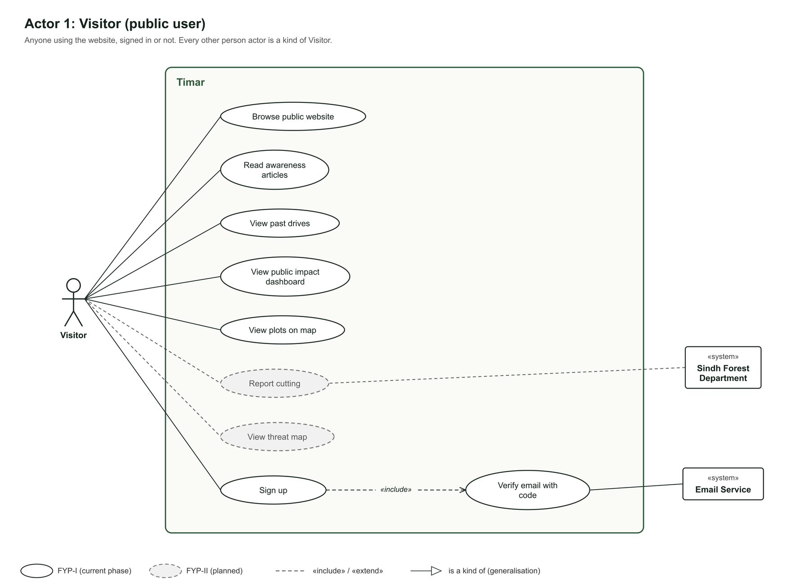
Figure 40. Use case diagram, Visitor
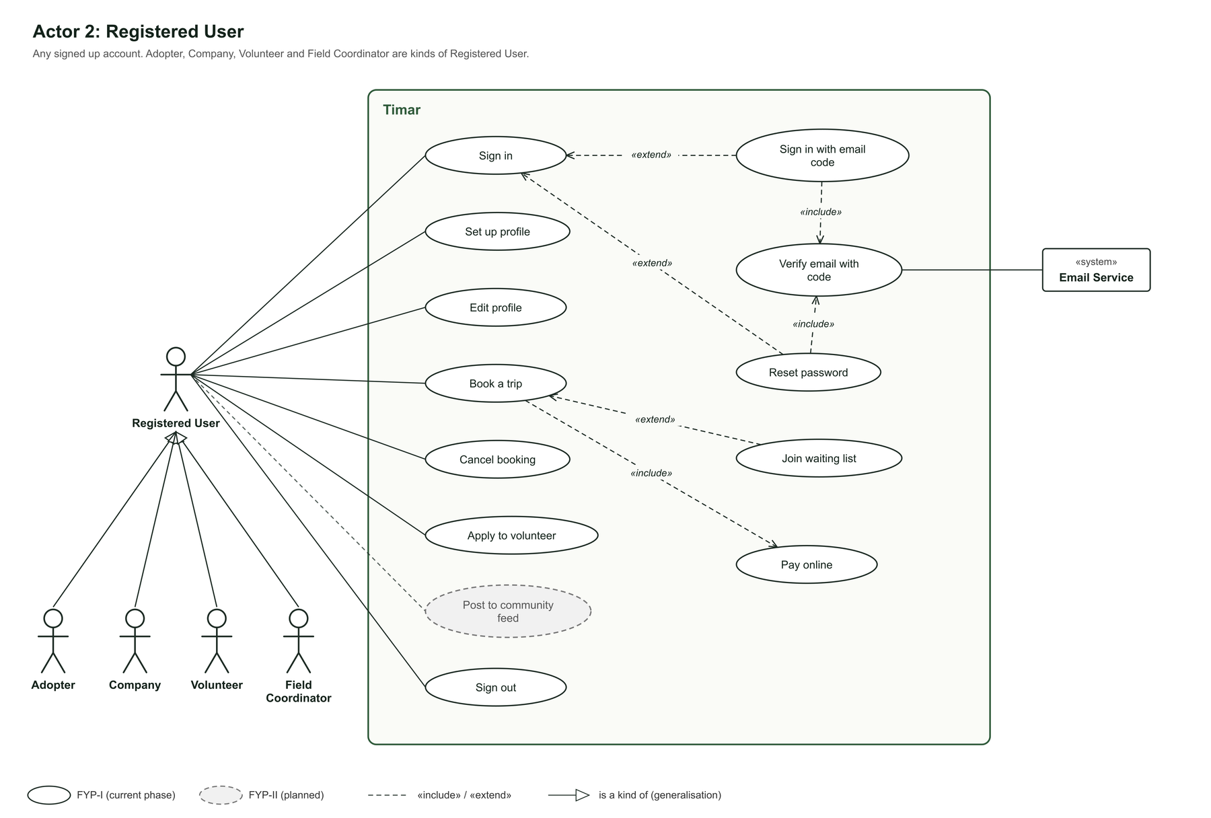
Figure 41. Use case diagram, Registered User
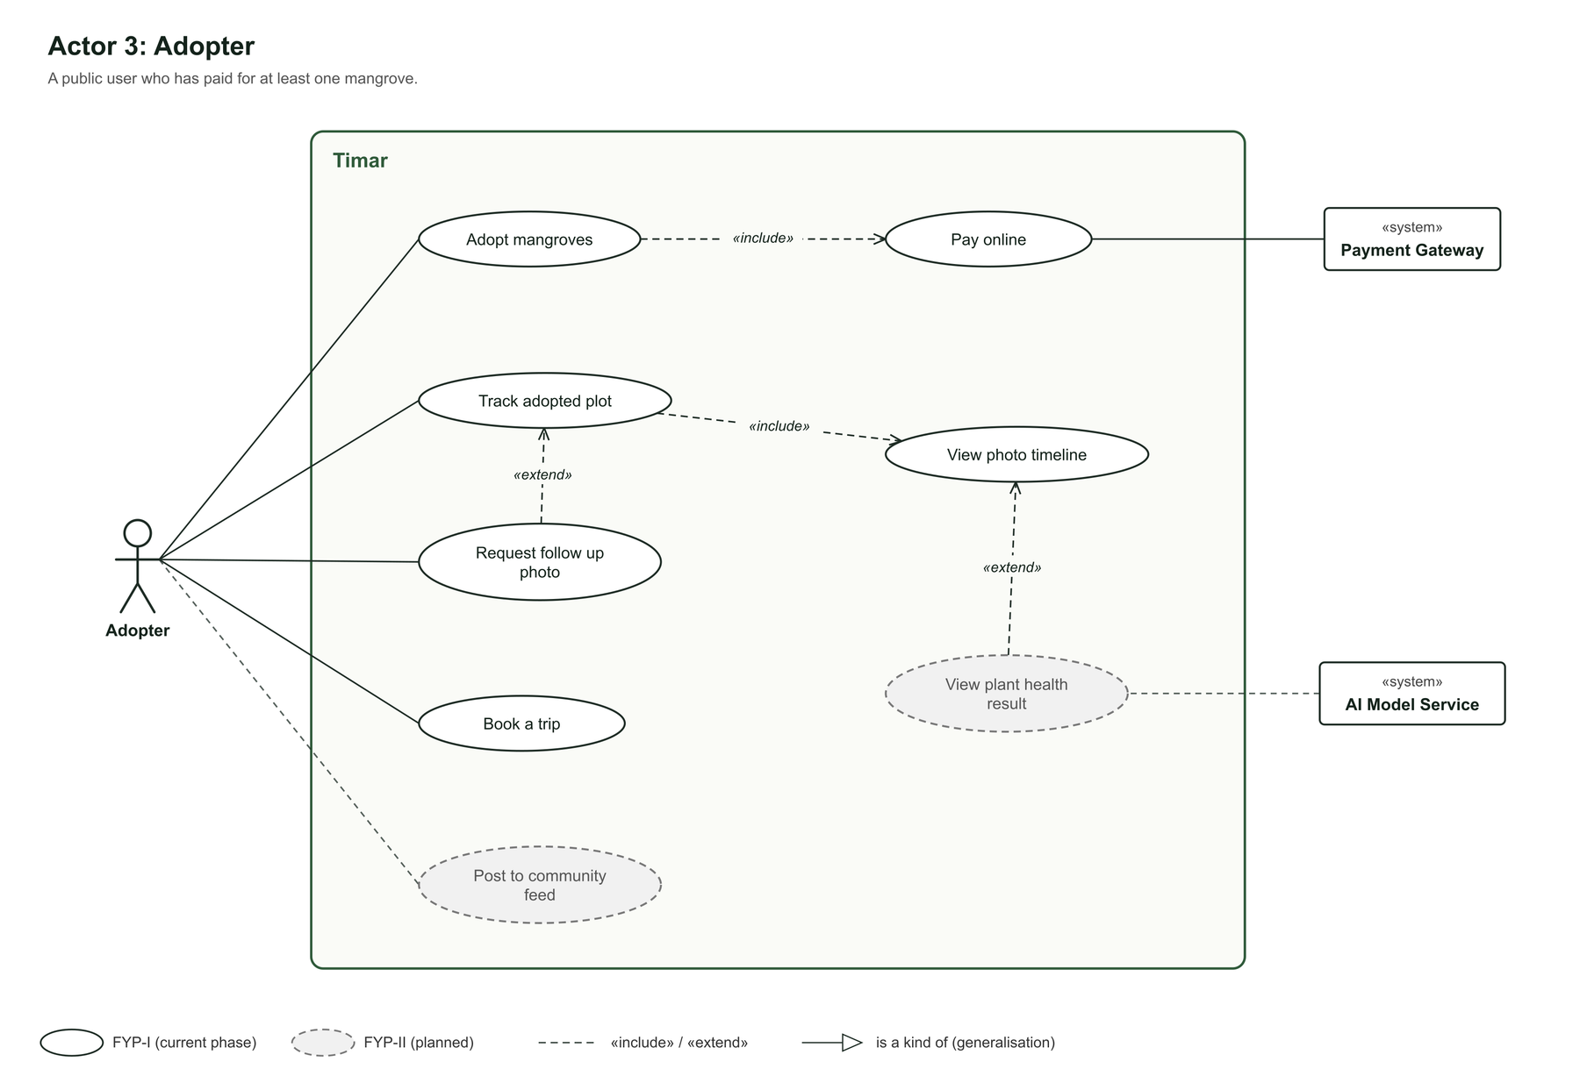
Figure 42. Use case diagram, Adopter
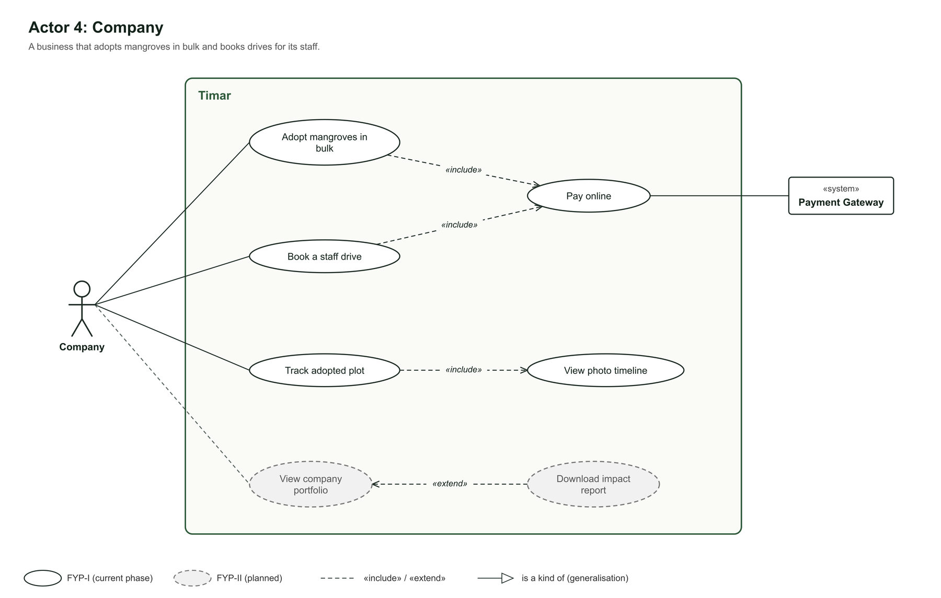
Figure 43. Use case diagram, Company
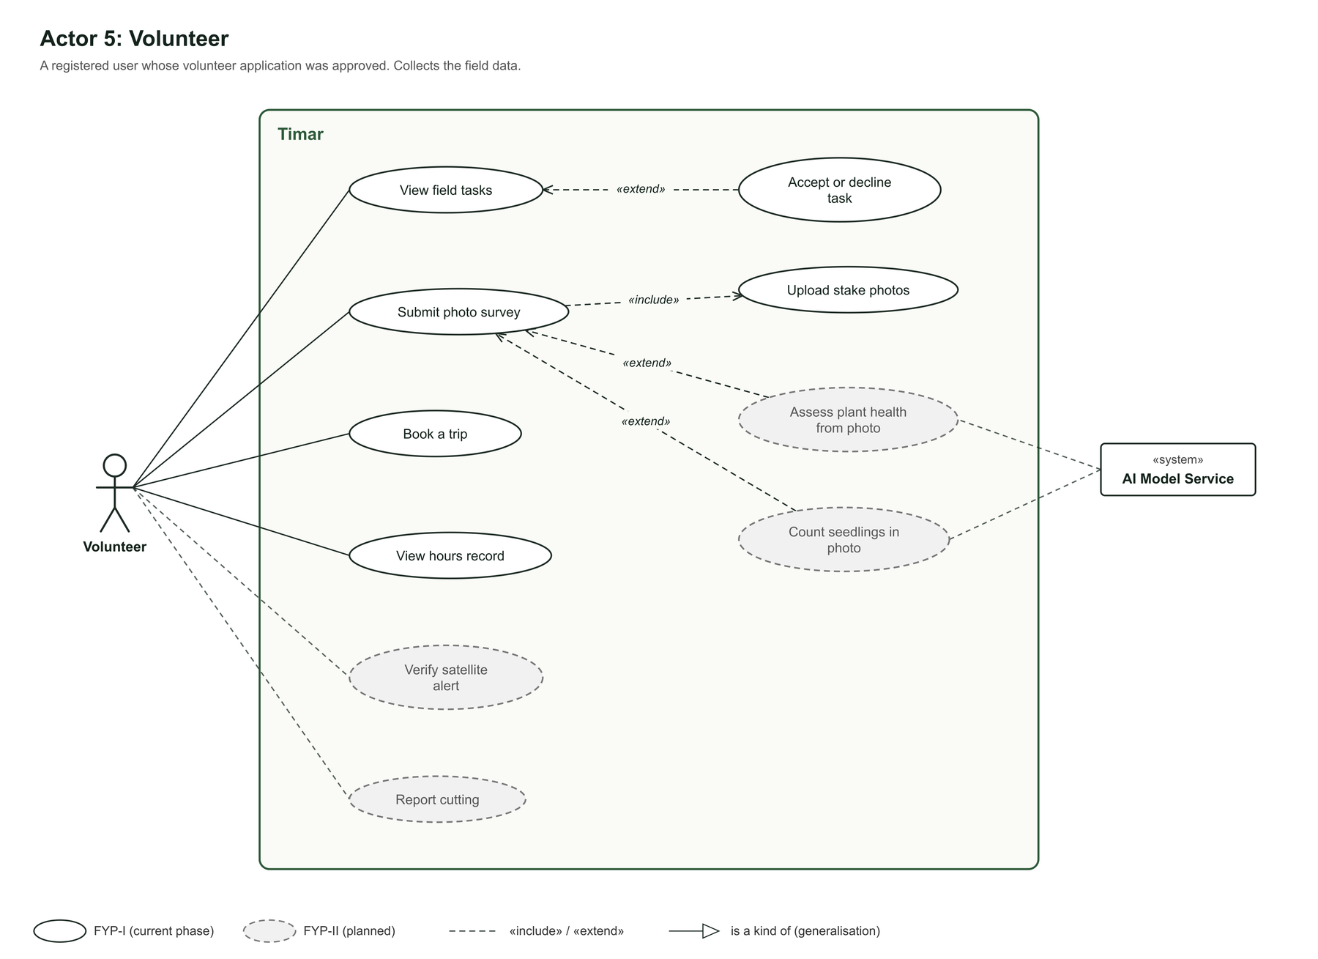
Figure 44. Use case diagram, Volunteer
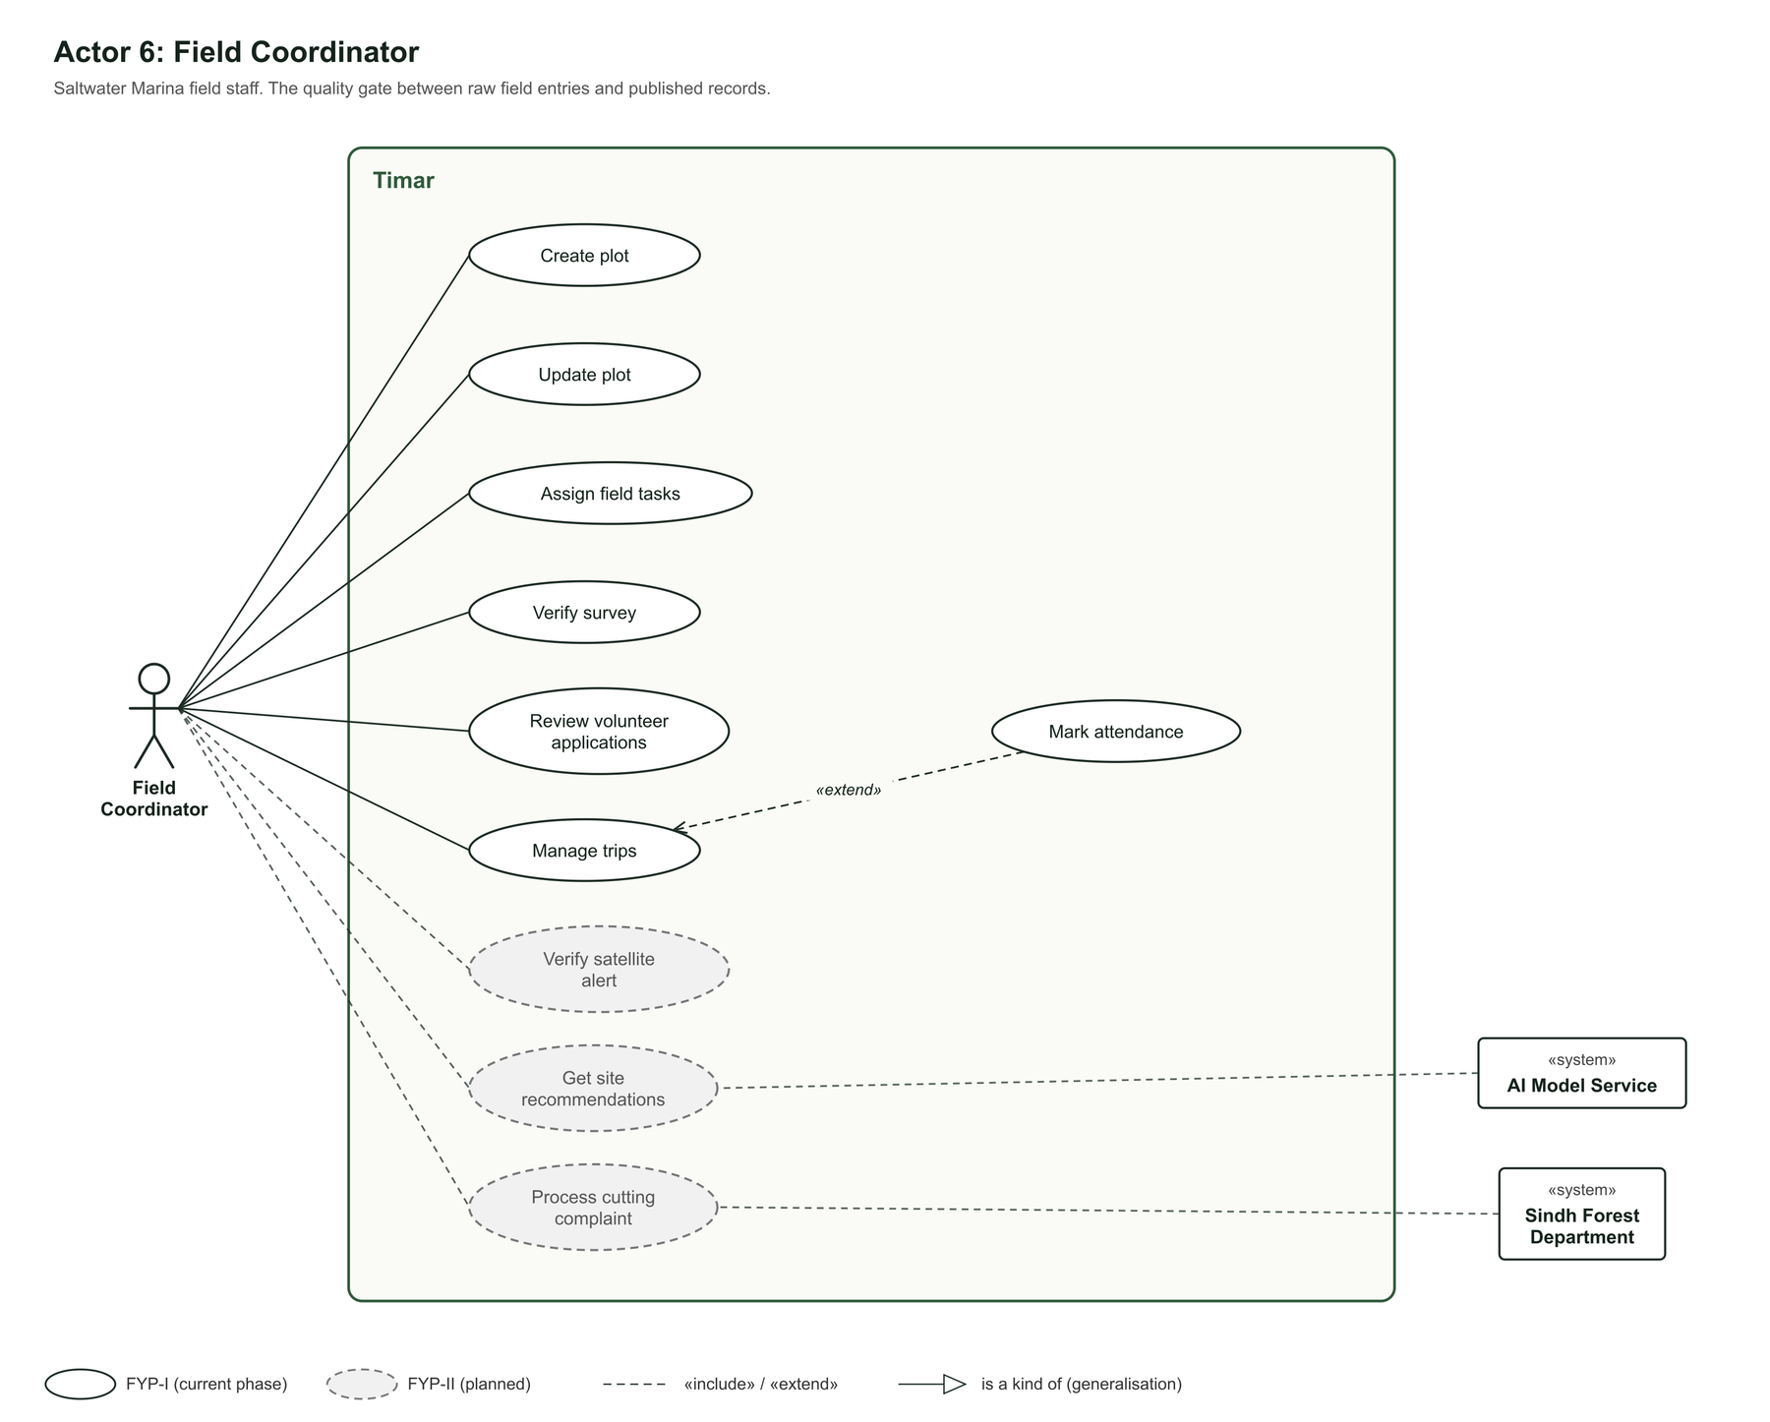
Figure 45. Use case diagram, Field Coordinator
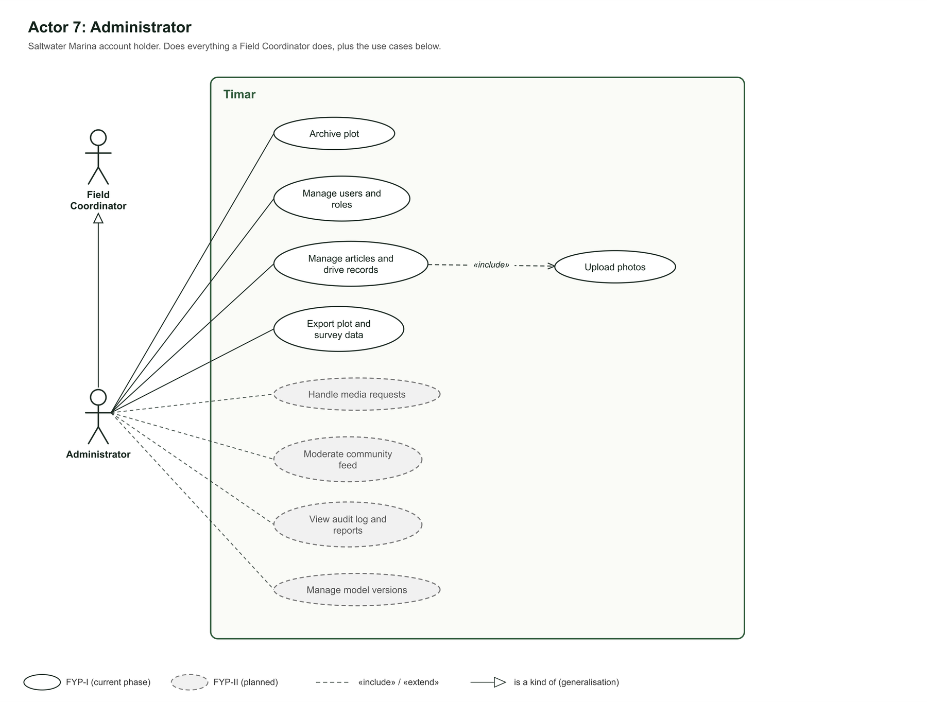
Figure 46. Use case diagram, Administrator
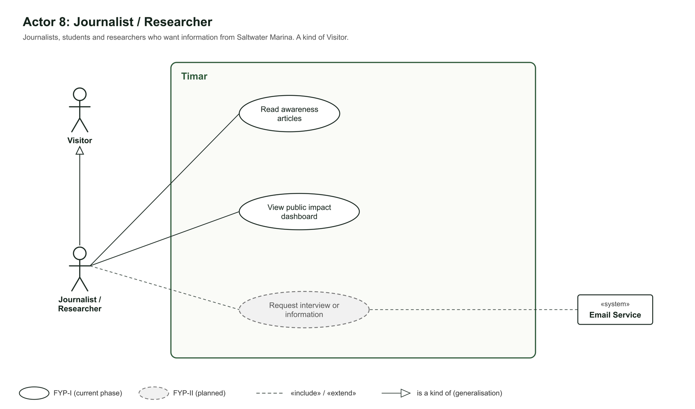
Figure 47. Use case diagram, Journalist or Researcher
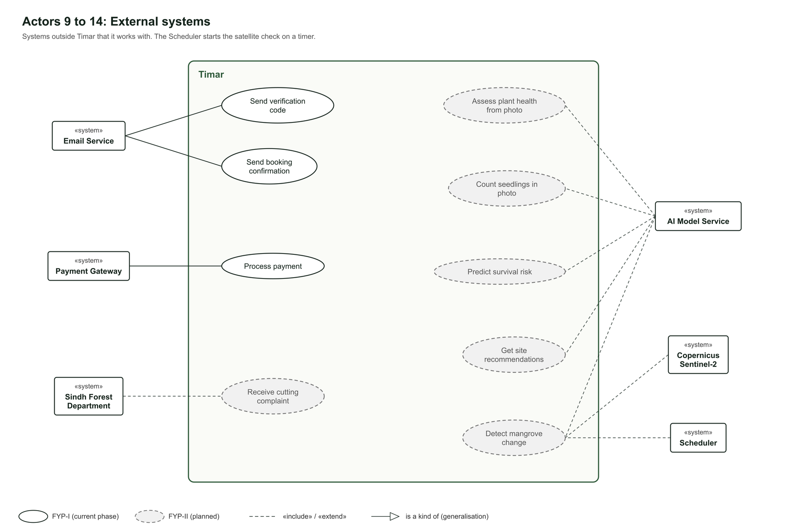
Figure 48. Use case diagram, external systems
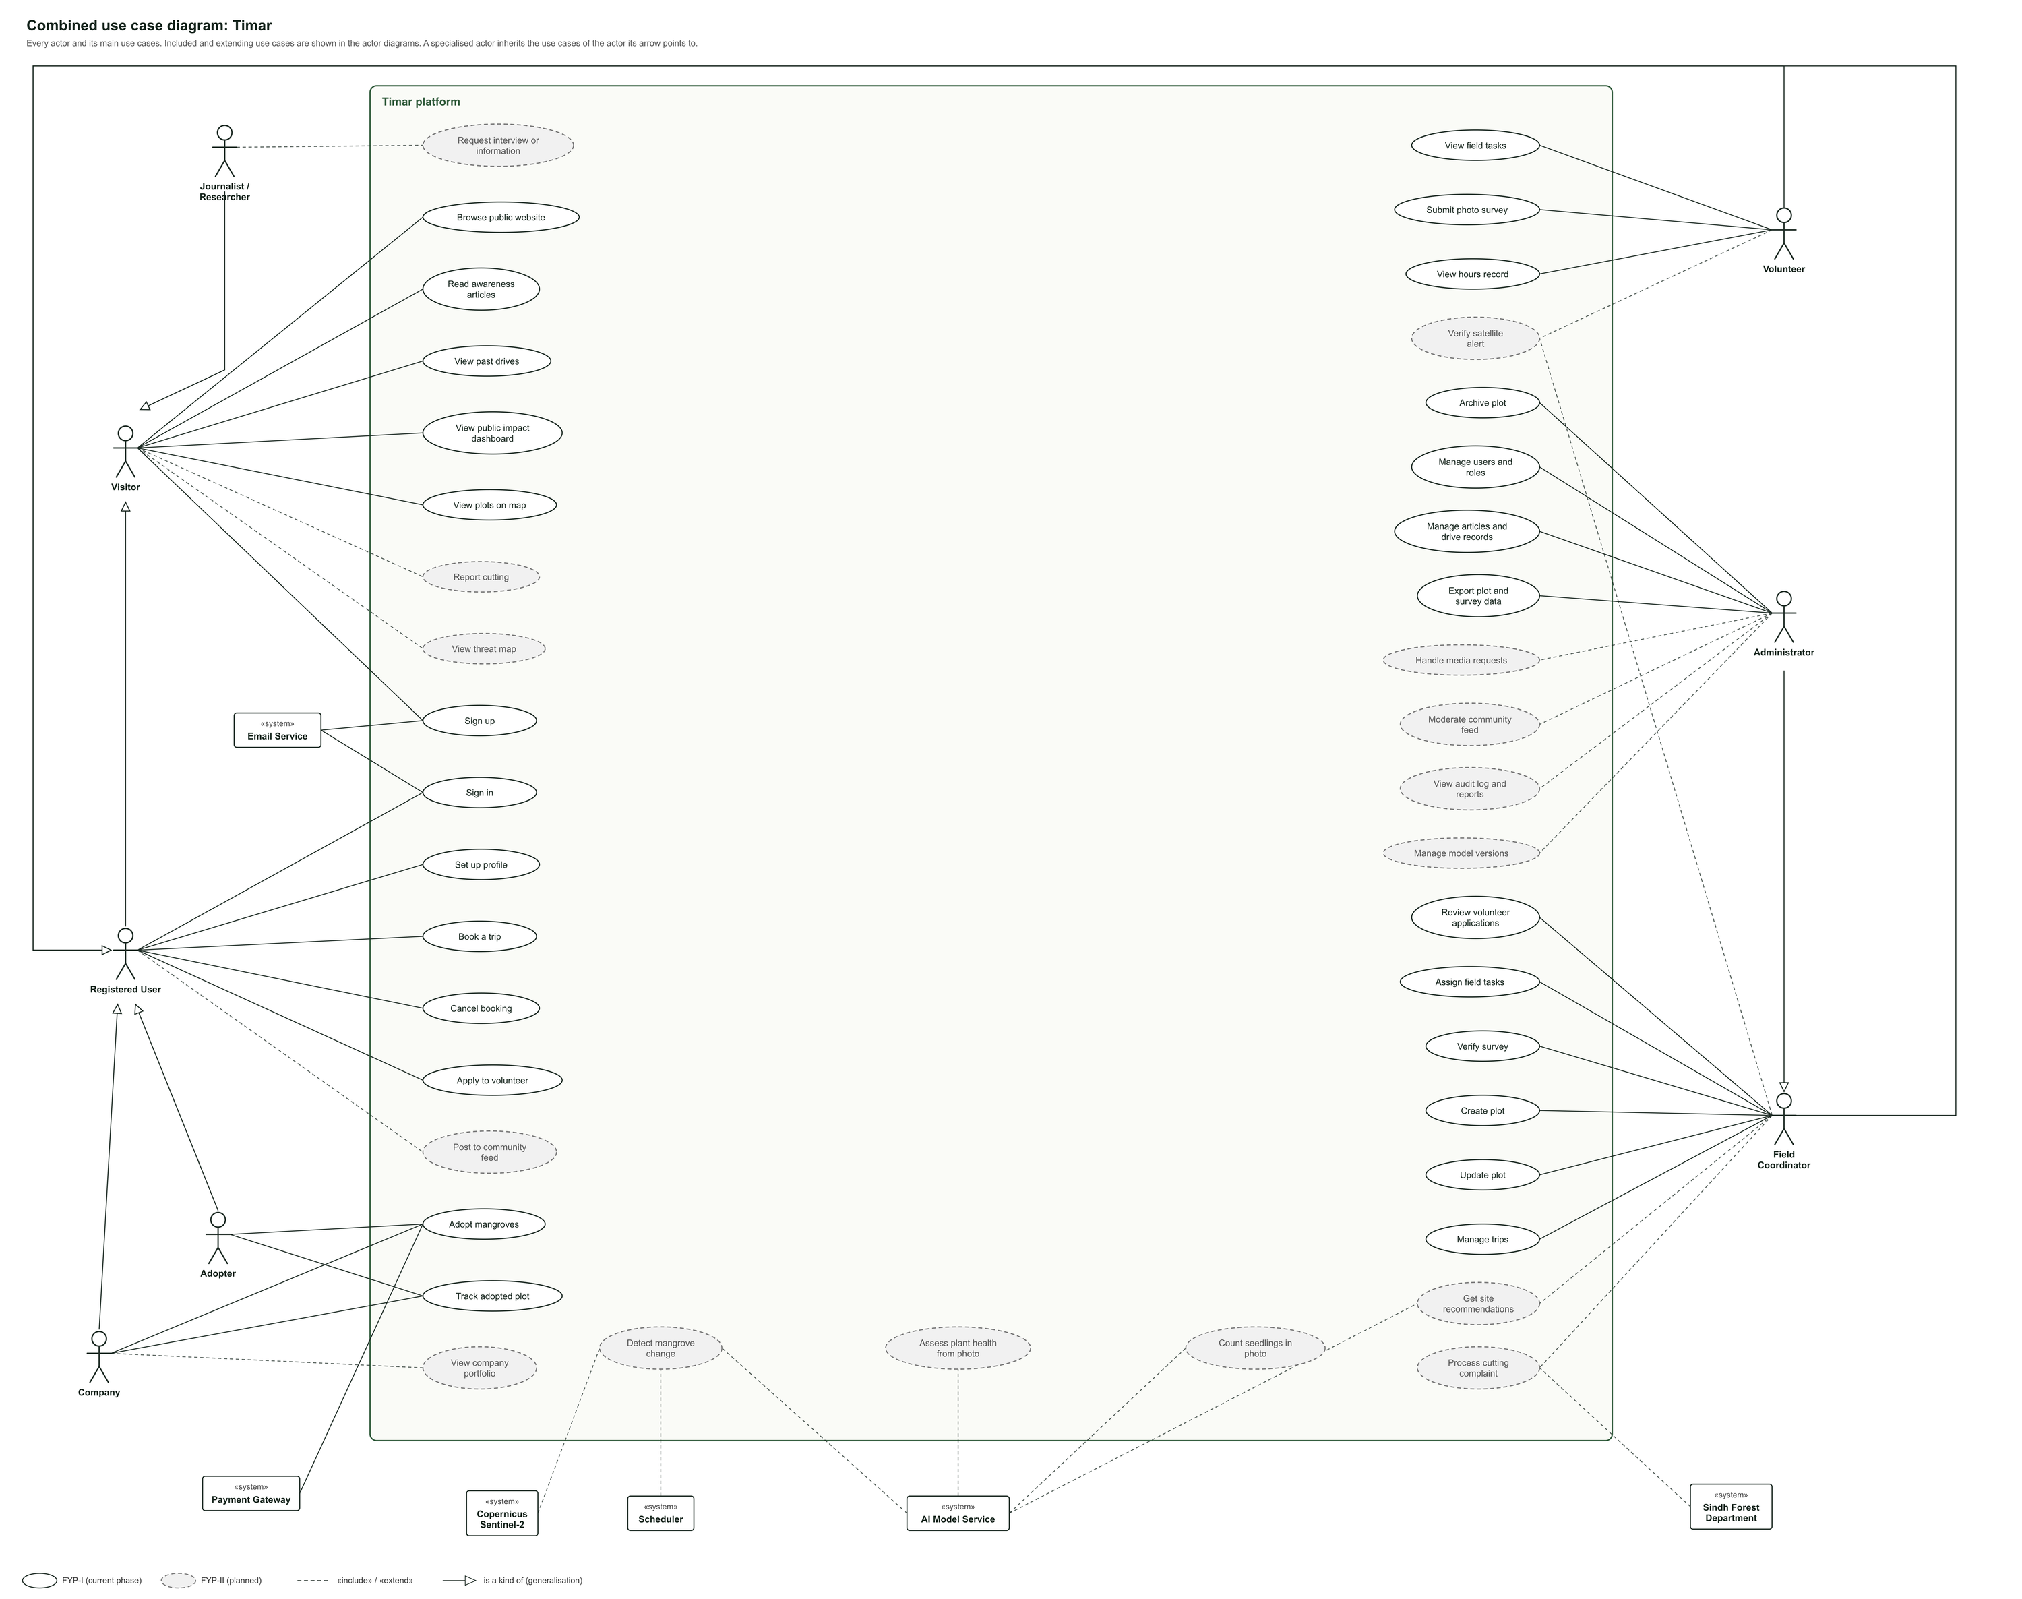
Figure 49. Combined use case diagram of all actors

5. Other Nonfunctional Requirements
5.1 Performance Requirements
The platform is used by the public on ordinary mobile connections and by volunteers in the field, so responsiveness matters more than raw capacity. The following targets apply.
• Page response: normal pages should load within three seconds on a mobile connection.
• Map performance: the plot map should display and remain usable with at least five hundred plots in view.
• Photograph upload: a single survey photograph should upload within ten seconds on a mobile connection, and the form should allow the user to continue while the upload finishes.
• Model response: plant health assessment and seedling counting on one photograph should return within five seconds.
• Satellite job: the monthly change detection run for the full Karachi coastal area should complete within two hours, and it runs unattended.
• Concurrent users: the system should handle at least two hundred users at the same time without noticeable slowdown, which is well above expected load.
• Availability: the public site should be available at least ninety five percent of the time.
5.2 Safety Requirements
Unlike most software projects, this one sends people into tidal creeks and asks them to report illegal activity, so safety is a real concern rather than a formality.
• Field safety: trip booking includes a safety briefing that a participant must acknowledge before the booking is confirmed, because creek sites involve tides, mud and boats.
• Tide awareness: survey tasks show the tide condition for the planned date, so volunteers are not sent into a site at the wrong time.
• No lone working: field tasks are assigned to a drive or a group rather than to a single volunteer sent alone.
• Honest output: the system never states that a plant will survive. It reports an assessment with a confidence value, and the wording on screen says so.
• Reporter protection: a person reporting illegal cutting may choose to have their name withheld from the public threat map, since land disputes in these areas can be sensitive.
5.3 Security Requirements
The platform holds personal data, payment related records and figures that may later be used in funding claims. The following measures apply.
• Passwords are stored using a strong one way hash and are never readable, including by administrators.
• Emailed verification codes are stored only as a keyed hash, expire after five minutes and lock after five wrong tries. Sign in tokens are kept in an httpOnly cookie that page scripts cannot read.
• Access to every endpoint is checked against the user's role. A volunteer cannot reach administrative functions by guessing a web address.
• All traffic uses HTTPS.
• Payments are handled by a hosted checkout provided by the payment provider. No card details touch our servers.
• From FYP-II, every change to a plot, survey, user or published figure is written to an audit log with the user, the action and the time. This matters because these numbers may later be used in funding claims.
• Uploaded files are checked by type and size, and image files are stripped of unnecessary metadata before storage.
• Exact locations of reported complaints may be shown to the public at reduced precision, so that reporting does not put anyone at risk.
5.4 Software Quality Attributes
• Maintainability: the code is organised in modules that follow the features in this document, so a change to growth monitoring does not require touching adoption.
• Reliability: a failed photograph upload or a failed satellite job never loses a user's entered data. The entry is kept and the job is retried.
• Usability: the survey form is the most important screen in the system and is designed to be completed in under two minutes, outdoors, one handed.
• Testability: every numbered requirement in Section 4 can be turned directly into a test case.
• Traceability: every machine learning output stores the model version that produced it, so a result can always be explained later.
• Portability: the platform is built for a browser, so it runs on any modern device without a separate application for each operating system.
• Scalability: the design allows a second organisation on another coastline to be added without rewriting the system.
5.5 Business Rules
The following rules govern how the system behaves regardless of who is using it.
• Only a field coordinator or an administrator may create or edit a plot. Volunteers record surveys against existing plots.
• A survey record counts as verified only when it includes a photograph from each marked stake and a GPS point that falls inside the plot boundary, and a coordinator has confirmed it. Plants are never counted by hand.
• Public figures on the impact dashboard are calculated from verified survey records only. Unverified entries are visible internally but are never published.
• A satellite alert is a suspicion, not a finding. It is published only after a volunteer or coordinator confirms it on the ground.
• Adoption is tracked at plot level, never at individual plant level, because no technology in this system can identify a single seedling. The wording shown to adopters reflects this.
• Impact reports state the method and the date of the last survey. A report is never issued without one.
• Community posts may be removed by an administrator, and a removal is recorded in the audit log.
• The platform prepares carbon evidence. It does not issue carbon credits, and no report may state otherwise.
• A public user becomes an adopter only after paying for at least one mangrove. Adopter is a state of the account, not a separate role.
• A standard plantation drive costs PKR 2,000 per person, and adopting one mangrove costs Rs. 300.

6. Other Requirements
• Data retention: survey records and their photographs are kept for the life of the plot, since the value of this system is the long record it builds. Nothing is deleted automatically.
• Backups: the database is backed up daily and the object storage keeps previous versions, because a lost survey cannot be recreated.
• Licence compliance: the licence and usage conditions of every external dataset, including Sentinel-2 imagery and Global Mangrove Watch layers, are recorded in the project repository before the data is used.
• Export: all plot and survey data can be exported as a spreadsheet or a standard geographic file, so that Saltwater Marina is never locked into this platform.
• Future work: an offline field mode, an Urdu interface and a mobile application are recognised as valuable but are outside the scope of this release.

Appendix A: Glossary
Term | Meaning
Adoption | A payment that funds a number of mangroves, assigned to a specific plot and tracked at plot level. A public user who has paid for at least one is called an adopter.
Alert | A record created by the system when satellite imagery shows a drop in green cover that may indicate cutting. An alert is a suspicion until a person confirms it on the ground.
Blue carbon | Carbon captured and stored by coastal ecosystems such as mangroves, salt marshes and seagrass.
Coordinator | A member of the Saltwater Marina team who plans field work, assigns tasks to volunteers and verifies the records they submit.
Creek | A tidal channel along the Karachi coast. Kaderu Island and the creeks around Rehri Goth are the main working areas of the partner organisation.
Estimated survival | A coordinator's estimate of the share of planted seedlings in a plot still alive, made from the verified stake photographs and supported by model readings once they exist. It is never a hand count.
Growth monitoring | A scheduled field visit in which a plot is photographed from its marked stakes and anything unusual is noted. Plants are not counted by hand.
Journal | The public page of the website that lists past plantation drives and awareness articles.
M1 to M5 | The five machine learning components of the system: plant health classifier, seedling counter, site suitability model, satellite change detection and survival risk prediction.
Mangrove | A salt tolerant tree that grows where land meets the sea. Known locally as timar.
Mangrove Safari | A guided trip from Rehri Goth that includes both planting and a boat ride through the creeks.
NDVI | Normalised Difference Vegetation Index. A number calculated from red and near infrared light that shows how much living plant material is present in an area.
Plot | A mapped plantation site with a boundary, species, planting date, seedling count and a responsible person. The central record of the system.
PostGIS | An extension that allows a PostgreSQL database to store and query geographic shapes rather than plain numbers.
Sentinel-2 | A pair of European Union satellites that photograph the earth at ten metre resolution every few days, free of charge.
Stake | A marker fixed at a plot when it is planted. At every survey visit the plot is photographed from each stake, facing the same direction, so the photographs line up over time.
Timar | The local name for the grey mangrove, Avicennia marina, and the name of this platform.
Verified record | A survey or alert that has been reviewed and confirmed by a coordinator. Only verified records are used in published figures.

Appendix B: Analysis Models
The following models support this specification and are supplied alongside it.
• Entity Relationship Diagram: the full data model of the platform, covering twenty one entities built around the PLOT record, including growth monitoring, adoption, complaints, the machine learning outputs and the audit log. Supplied as a separate diagram file with this document. The current build uses six simplified tables, listed in Section 2.4, and grows towards this model as features are built.
• System Architecture Diagram: the four layers of the system, which are the browser client, the Node.js backend service, the Python machine learning and satellite service, and the PostgreSQL with PostGIS database.
• Use Case Diagrams: one diagram per actor and one combined diagram, covering Visitor, Registered User, Adopter, Company, Volunteer, Field Coordinator, Administrator, Journalist or Researcher and the external systems, mapped against the features described in Section 4. Shown in Section 4.23 and supplied in the use-case-diagrams folder.
• Data Flow Diagram for satellite change detection: the monthly path from Sentinel-2 imagery, through vegetation index calculation and month on month comparison, to stored alert polygons and ground verification.
• Sequence Diagram for growth monitoring: the path a field survey takes from a volunteer's phone through photograph upload, model analysis and coordinator verification to the published survival estimate.
The three features that depend on machine learning are specified further below. For each one the tables give the model used, the data it learns from, how it is trained and evaluated, and how it is deployed and monitored.
Plant Health Assessment and Seedling Counting
Machine Learning Modules:
Module | Description
M1 Plant Health Classifier | A convolutional image model fine tuned by transfer learning to classify a seedling or plot photograph as healthy, stressed or dead, returning a confidence value with every result.
M2 Seedling Counter | An object detection model fine tuned to locate individual seedlings in a photograph and return a count. Where plants overlap heavily, a density estimation approach is used instead of individual boxes.
Table 45. Plant Health Assessment and Seedling Counting Machine Learning Modules
Data Collection and Preprocessing:
Aspect | Description
Data Sources | Field photographs taken on ordinary phones during plantation drives and survey visits with Saltwater Marina. No public dataset of Karachi mangrove seedlings exists, so this dataset is created by the project.
Target Volume | Two to three thousand labelled photographs for M1, and five hundred to one thousand photographs with marked seedlings for M2.
Labelling | Health classes are labelled by the project team with guidance from the Saltwater Marina field team, who can tell a stressed seedling from a healthy one. Seedlings for M2 are marked using a free annotation tool.
Preprocessing | Resizing, normalisation, removal of blurred or unusable images, and removal of location metadata before storage. Heavy augmentation is applied during training, including flips, rotations, brightness and crop variation, because the dataset is small.
Cold Start Approach | Collection begins in the first weeks of the project, before the platform is complete. Until a trained model exists, surveys rely on the coordinator's review of the photographs alone, and the photographs are stored for later training.
Table 46. Plant Health Assessment and Seedling Counting Data Collection and Preprocessing
Model Training and Evaluation:
Aspect | Description
Training Process | Transfer learning from a model pretrained on general images. Most layers are frozen and only the final layers are retrained on the project dataset, which keeps training inside free cloud GPU sessions.
 | Data is split into training, validation and test sets of roughly seventy, fifteen and fifteen percent. The test set is held back and used once.
 | Training stops when performance on the validation set stops improving, to avoid memorising a small dataset.
Evaluation Metrics | M1 is measured on accuracy and F1 score across its three classes, with a confusion matrix to show which classes are confused.
 | M2 is measured on mean absolute error against hand counted photographs.
Baselines | M1 must beat always predicting the most common class. M2 must beat a human eyeball estimate. A model that does not beat its baseline is not deployed.
Compute Budget | Under ten GPU hours in total for both models, on free Google Colab or Kaggle sessions.
Table 47. Plant Health Assessment and Seedling Counting Model Training and Evaluation
Model Deployment and Monitoring:
Aspect | Description
Deployment | Trained models are exported and served from the Python AI service behind an internal REST interface. The backend calls that interface when a survey photograph is uploaded.
Versioning | Every result is stored with the model version that produced it, so an old result can always be explained. Administrators may promote a new version or roll back, and the change applies only to results produced afterwards.
Monitoring | Prediction confidence distribution is tracked over time. Disagreements between the model estimate and the coordinator's verified estimate are logged and reviewed.
Retraining | Verified surveys add new labelled photographs continuously, so the models are retrained periodically on the larger dataset.
Stated Limits | The output is an assessment with a confidence value. It is never presented as a guarantee that a plant will survive, and the interface wording reflects this.
Table 48. Plant Health Assessment and Seedling Counting Model Deployment and Monitoring
Site Recommendation
Machine Learning Modules:
Module | Description
M3 Site Suitability Model | A gradient boosted model over tabular features that predicts the likelihood of survival at a candidate location. Gradient boosting is chosen because it performs well on small tabular datasets and can report which feature influenced a score.
Rule Based Fallback | A simple weighted score over the same features, used when there are too few outcomes to train the learned model. It keeps the feature useful from the first day.
Table 49. Site Recommendation Machine Learning Modules
Data Collection and Preprocessing:
Aspect | Description
Data Sources | Sentinel-2 imagery from Copernicus, existing mangrove extent layers from Global Mangrove Watch, and the project's own plot and survey records.
Features | Vegetation index of the area, distance to the nearest creek channel, elevation and tidal exposure, distance from the nearest settlement or industrial outfall, and the historical survival of nearby plots.
Labels | Locations where the organisation planted and the plants survived are positive examples. Locations where they planted and the plants failed are negative examples, taken from Saltwater Marina's historical records and from the platform's own growth monitoring.
Preprocessing | Imagery is clipped to the Karachi coastal area, the vegetation index is computed per pixel, and features are sampled at each candidate point to produce one row per location.
Cold Start Approach | Historical outcomes shared by the partner organisation provide the first training rows. The dataset then grows with every survey round the platform records.
Table 50. Site Recommendation Data Collection and Preprocessing
Model Training and Evaluation:
Aspect | Description
Training Process | A gradient boosted classifier is trained on the sampled rows with cross validation, since the dataset is small. Feature importance is examined so the field team can see what is driving a score.
 | Training runs on an ordinary laptop in minutes and requires no GPU.
Evaluation Metrics | Area under the ROC curve and accuracy on held out locations, together with agreement between the model ranking and an independent ranking produced by the Saltwater Marina field team.
Baselines | The model must outperform choosing sites at random and must at least match the rule based score. Expert agreement is treated as the most meaningful measure.
Compute Budget | Negligible. No GPU time is required.
Table 51. Site Recommendation Model Training and Evaluation
Model Deployment and Monitoring:
Aspect | Description
Deployment | The model is served from the Python AI service. Scores are recalculated when new imagery arrives or when new survey outcomes are added.
Versioning | Every recommendation is stored with its score, its feature values and the model version, so an old recommendation can be explained later.
Monitoring | Acceptance rate by the field team is tracked. Survival at recommended sites is compared against survival at sites chosen without the model.
Retraining | The model is retrained whenever a meaningful number of new survey outcomes has been recorded.
Stated Limits | A score is a suggestion based on past patterns. The field team makes the final choice, and their rejections are recorded as training data rather than ignored.
Table 52. Site Recommendation Model Deployment and Monitoring
Satellite Change Detection
Machine Learning Modules:
Module | Description
Vegetation Index Computation | A deterministic calculation, not a learned model. The normalised difference vegetation index is computed from the red and near infrared bands of each image. Living vegetation reflects infrared strongly, dead or cleared ground does not.
M4 Change Classifier | A classifier applied to each patch of detected drop, deciding whether it is likely real clearing or a false alarm. It uses patch size, shape, edge sharpness, magnitude of the drop, season and whether the drop persists in the following month.
Table 53. Satellite Change Detection Machine Learning Modules
Data Collection and Preprocessing:
Aspect | Description
Data Sources | Sentinel-2 imagery from the European Union Copernicus programme, published openly at ten metre resolution with a revisit of a few days, together with Global Mangrove Watch extent layers as a reference.
Preprocessing | Only the red and near infrared bands for the Karachi coastal window are retrieved, rather than whole tiles. Cloud affected pixels are masked, the vegetation index is computed, and two dates are compared to produce a change raster.
Patch Extraction | Neighbouring pixels showing a significant drop are grouped into patches. Each patch is converted into a polygon with its area and average drop recorded, which is what is stored in the database.
Labels | Patches are labelled as real loss or false alarm using known past clearing events, published change layers, and ground verification by volunteers on current alerts.
Data Volume | Only a small coastal window is retrieved each month, a few megabytes rather than a full tile of about one gigabyte. Rasters are processed and discarded, and only the resulting polygons are stored.
Table 54. Satellite Change Detection Data Collection and Preprocessing
Model Training and Evaluation:
Aspect | Description
Training Process | The index comparison requires no training. The classifier is trained on labelled patches using a gradient boosted model over the patch features described above.
 | Training data grows over the life of the project, because every alert verified or rejected in the field adds a labelled example.
Evaluation Metrics | Precision and recall against manually checked patches. Recall matters because a missed clearing is worse than a wasted field visit, so the operating threshold is set to favour recall.
Baselines | The classifier must outperform a plain threshold on the index drop alone. If it does not, the plain threshold is used instead and this is stated honestly.
Compute Budget | Light. The processing cost is in handling the imagery rather than in training the model.
Table 55. Satellite Change Detection Model Training and Evaluation
Model Deployment and Monitoring:
Aspect | Description
Deployment | A scheduled monthly job in the Python service. It runs unattended and writes its results into the spatial database as alert records.
Versioning | Each alert stores the model version, the dates of the two images compared and the measured drop, so any alert can be re-examined later.
Monitoring | The proportion of alerts confirmed on the ground is tracked over time. A falling confirmation rate indicates the model needs retraining or the threshold needs adjusting.
Retraining | Ground verification results are fed back as labels and the classifier is retrained periodically.
Stated Limits | At ten metre resolution the system can detect a cleared patch but not an individual plant. An alert is treated as a suspicion requiring ground confirmation, never as a finding on its own.
Table 56. Satellite Change Detection Model Deployment and Monitoring
Appendix C: To Be Determined List
The following points remain open at the time of writing and will be closed before implementation of the feature concerned.
• TBD-1: The exact payment provider for mangrove adoption has not been selected. The requirement that no card data reaches our servers is fixed, the provider is not.
• TBD-2: The confidence threshold below which a plant health assessment is marked for closer review will be set after the first model is trained and measured.
• TBD-3: The change in the model seedling estimate between visits, before a survey is flagged, will be set from the first evaluation results.
• TBD-4: The schedule of growth monitoring rounds is planned as one, three, six and twelve months after planting. This may change once Saltwater Marina confirms their field calendar.
• TBD-5: The exact department and contact route for forwarding cutting complaints is to be confirmed with the partner organisation.
• TBD-6: The method used to estimate carbon for company reports will be chosen from published mangrove carbon factors and recorded here once agreed with the supervisor.
• TBD-7: The hosting provider for the website and backend is to be decided before the second semester begins. The database is hosted on Neon.

