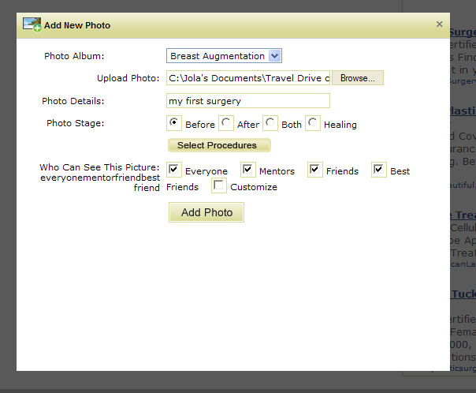 | 1. Add New Photo light box  Before>After>Both>Healing should be:  - Before Surgery  - After Surgery  - Before&After  - Healing  Please align them vertically as shown below.  2. There is text showing up under Who Can See This Picture:  Please remove it  3. All the text on the right should be Right Justified. See below
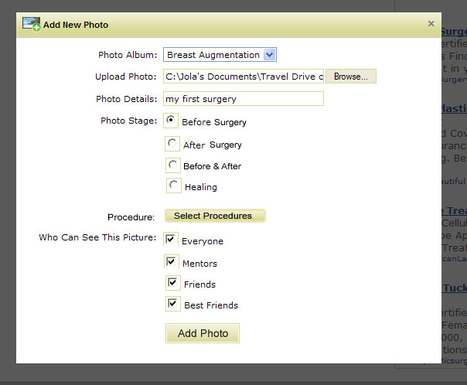 | 4. Please remove Customize for now from privacy.  5. Please align privacy options vertically  - Everyone  - Mentors  - Friends  - Best Friends  We have the space and there is no reason to crowd everything. Clarity is more important.

