T18-Update WORK PACKAGE 3 (WP3):

Deriving/cataloguing the kinematic properties of STEREO/HI CMEs based on geometrical and forward modelling

WP3 ACTIVITY TYPE: RTD

WP3 DURATION: MONTHS 1 – 36

WP3 LEAD BENEFITIARY: UGOE (4)

WP3 LEADER: Dr. Volker Bothmer

WP3 CONTRIBUTORS: UGOE (4); TCD (9); STFC (1); UNIGRAZ (2)

WP3 OVERVIEW: The key objectives of WP3 are deriving and cataloguing the kinematic properties of the STEREO/HI CMEs identified and catalogued in WP2, based on geometrical and forward modelling. For these purposes the recently established geometrical, forward (and prototype) inverse CME-modelling methods are applied. The CME parameters will be added to the catalogue, including back- and forward-projections to ‘predict’ CME launch and arrivals at various solar system locations. Comparisons will be made between the parameters yielded by the different models.

WP3 TASK 3.1: Geometrical modelling of STEREO/HI CMEs (TASK LEAD: STFC)

The STFC contribution to WP3 is principally through Task 3.1, the geometrical modelling of STEREO/HI CMEs. This task involves the derivation of the kinematic properties of those CMEs visually identified in WP2.1. This is achieved by manually identifying the track made by each CME in a time-elongation map (J-map) and applying the assumptions about its geometry and dynamics summarized in Davies et al. (2012, *Astrophys. J*., 750, 23). This makes use of three established geometrical approaches, assuming that the CME can be modelled (i) as a point-like feature propagating outwards, or *Fixed-Phi* (FP) method, (ii) as an expanding circle whose diameter is defined by the CME apex and Sun-centre, the *Harmonic Mean* (HM) method, and (iii) as a self similarly expanding circle of 30° half-width, propagating outward between two fixed position angles, the *Self Similar Expansion* (SSE) method.

The CMEs are assumed to travel at a constant speed in a fixed direction away from the Sun. The three different fitting methods are applied to each CME (see Davies et al., for details). For a given CME, the path of its (apparent) leading edge through a J-map is manually tracked at a position angle close to its apex and each of the three fitting procedures is applied to estimate its 3D speed and propagation direction. These values are, in turn, used to derive launch times for each event, which are then applicable to WP4.1, and to generate arrival times at various locations in the heliosphere for comparison with in-situ measurements (WP4.2).

To date, events occurring between the beginning of the science phase and the beginning of reduced science operations (April ’07 to August ‘14) for both STEREO-A and -B have been analysed in this way. Events identified as poor in WP2.1 are excluded, as are those which are directed at position angles far from the ecliptic, due to the limited number of HI frames in which they appear. A number of small CMEs occur, which quickly become subsumed by subsequent, larger events; these events are also excluded. This process has been completed for a total of 1210 events; 635 for STEREO-A and 575 for STEREO-B. A comparison between the speeds and propagation angles resulting from each of the three fitting methods is shown in figure 3.1.

The catalogue of geometrically modelled STEREO/HI CMEs generated in task 3.1 is used by UNIGRAZ to derive a catalogue of CME arrival time estimates at Mercury, Venus, Earth, Mars and Saturn, providing support to European-funded space missions around these planets. Predicted arrivals at the Ulysses spacecraft location are also made. Using initial speeds and directions from the geometrically modelled CME catalogue provided by STFC, UNIGRAZ has applied the Self-Similar Expansion Model results with the correction formulae of Möstl

& Davies (2013, *Solar Phys.* 285, 411), which takes into account the angle between geometrically fitted CME

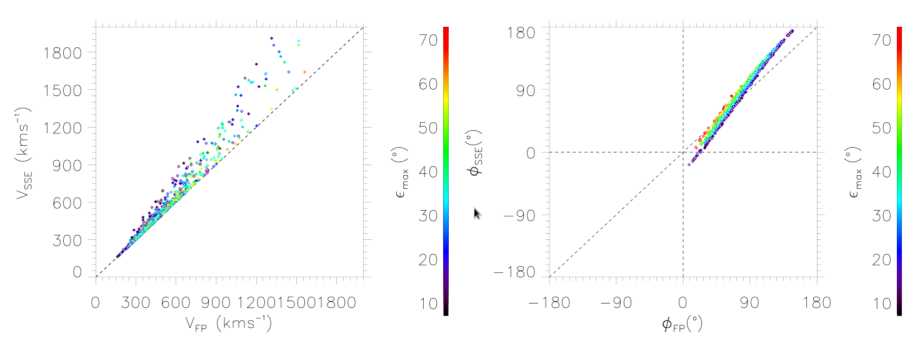

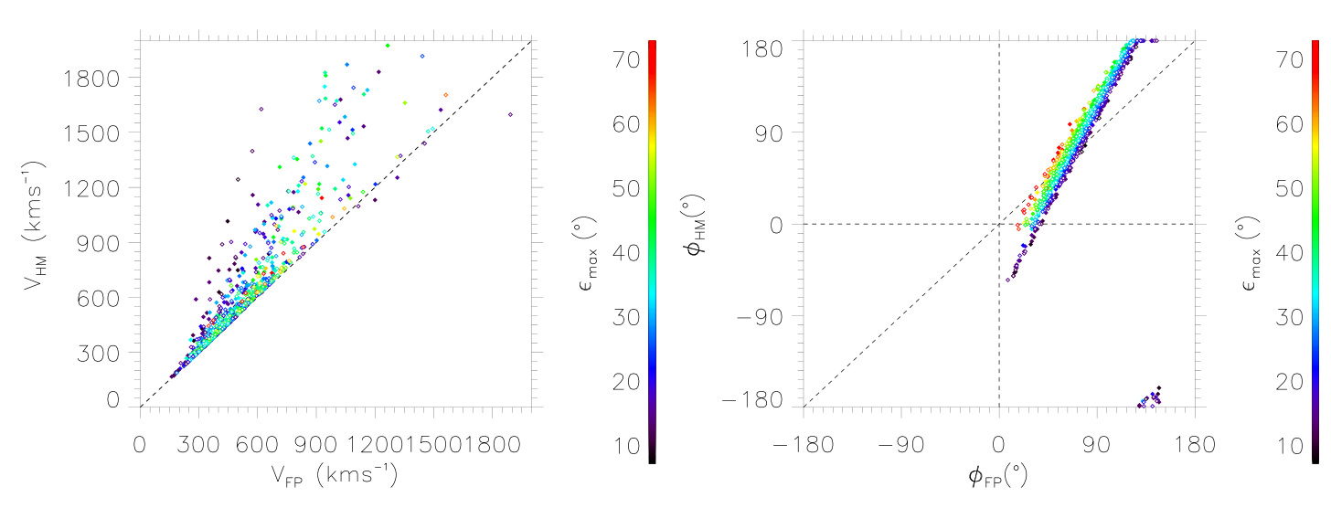

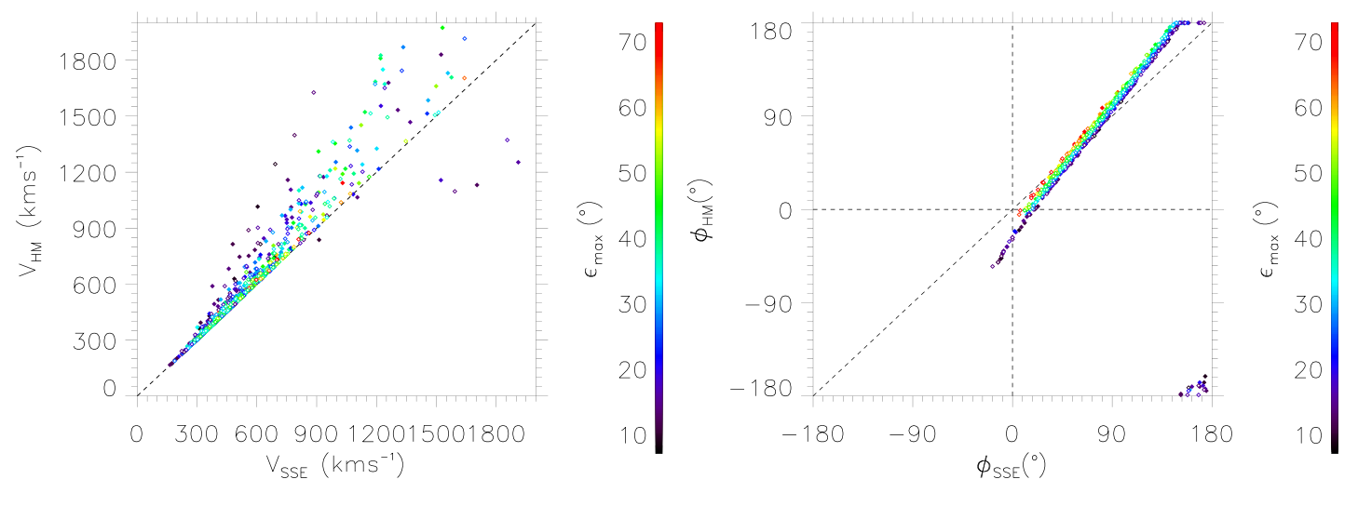

*Figure 3.1: A comparison between the speeds and propagation directions obtained from each of the three fitting methods. The scatter plots in the left column show the difference in velocity between the FP and SSE models (top), FP and HM models (middle) and SSE and HM models. The right hand column shows the differences between the propagation angles,* φ*, for the same methods. The colour of each data point represents the maximum elongation angle to which the CME was tracked. Filled and open dots correspond to CMEs observed by STEREO-A and B, respectively.*

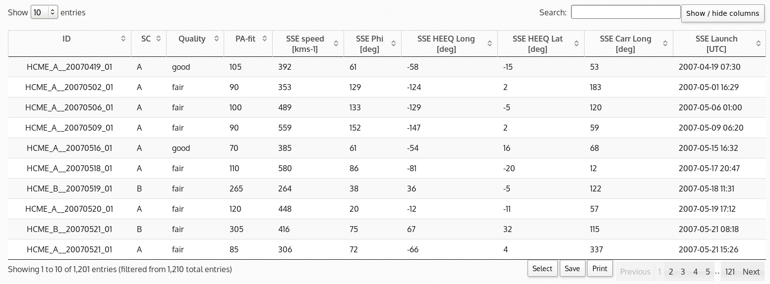

*Figure 3.2: Example of CME catalogue available on the HELCATS website. The kinematic properties (from SSE fitting) of the first ten CMEs are displayed.*

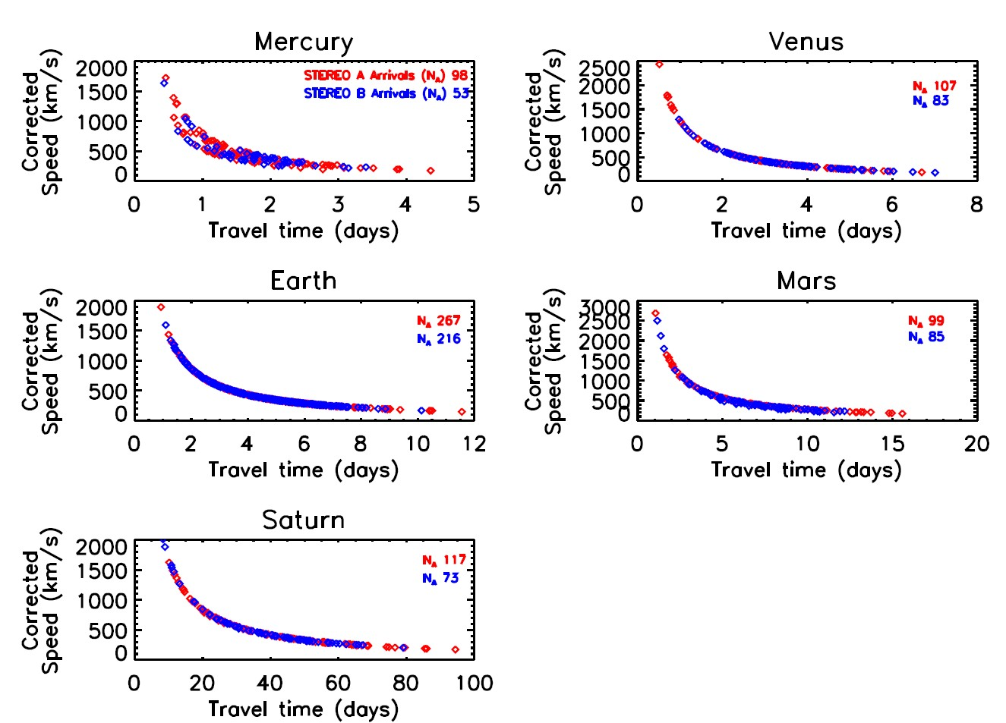

*Fig. 3.3: SSEF ICME speed vs. Transit time to different planetary locations.*

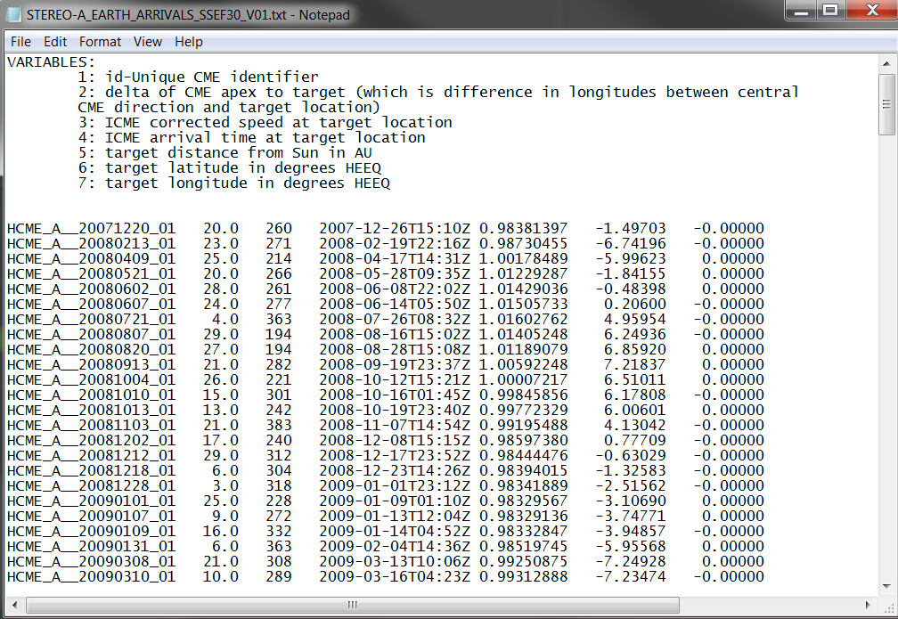

This model also allows one to estimate whether, and to what degree, each CME will ‘hit’ any in-situ location, and this is provided as a parameter in the catalogue, along with speeds and arrival times. A user friendly package in the IDL programming language has been created to read in the geometrically modelled CME catalogue files and output the predicted arrival time files (Figure 3.4) for any of the in situ locations. The initial catalogue contains over 400 predicted arrivals at Earth, and over 100 for Mercury-, Venus-, Mars- and Saturn- directed CMEs. The arrival times will be compared to other model results and in situ data in WP4.

*Fig. 3.3 Sample Arrival Time File.*

WP3 TASK 3.2: Forward modelling of STEREO/HI CMEs (TASK LEAD: UGOE)

The HI-COR2 event list established in WP2 contains 109 events. Out of these, 96 have been modelled with the GCS-method. Self-similar expanding modelling of the CMEs was performed with the GCS-method to determine directional propagation velocities and source region positions and also to derive estimates of their total masses. The data analysis methods were developed in collaboration with the STEREO/SECCHI PI institution at the Naval Research Laboratory, Washington, DC, USA (A. Vourlidas, R. Howard, A Thernisien, N. Savani). The results will be made available through an online database catalogue under development. Results for a sample CME event are shown in Figure 3.5.

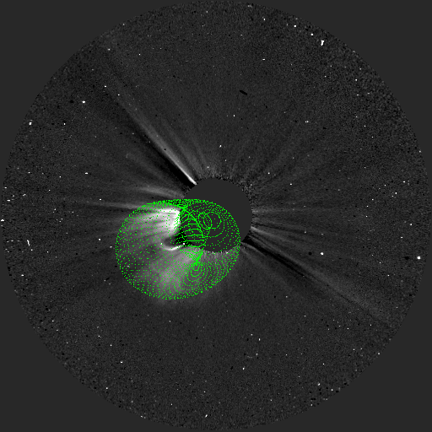 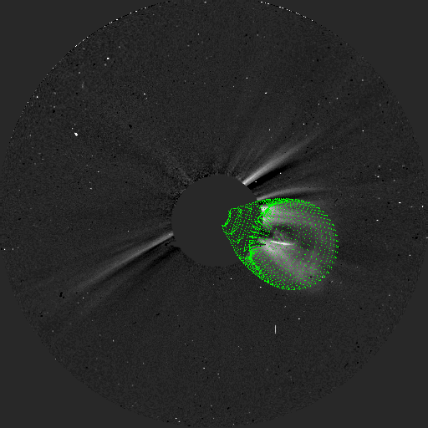

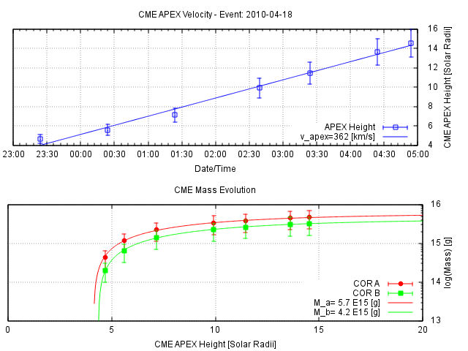

Fig. 3.5 Sample mass and velocity determination for a CME observed on 19 April 2010. Forward Modelling fits are shown superimposed on the STEREO-A and B COR images (top).

WP3 TASK 3.3: Inverse modelling of STEREO/HI CMEs (TASK LEAD: UGOE)

UGOE has established an “Inverse Modelling List“ (Figure 3.6), based on inspection of STEREO coronagraph and EUV data, which has been used by TCD to provide a “Low Coronal Event Catalogue“ available online at <http://grian.phy.tcd.ie/helcats/> (Figure 3.7), aimed at establishing structure and activity in the solar atmosphere associated with the CMEs listed. It contains information on CME source region magnetic field configurations and various activity parameters, such as EUV wave properties and Alvén speeds.

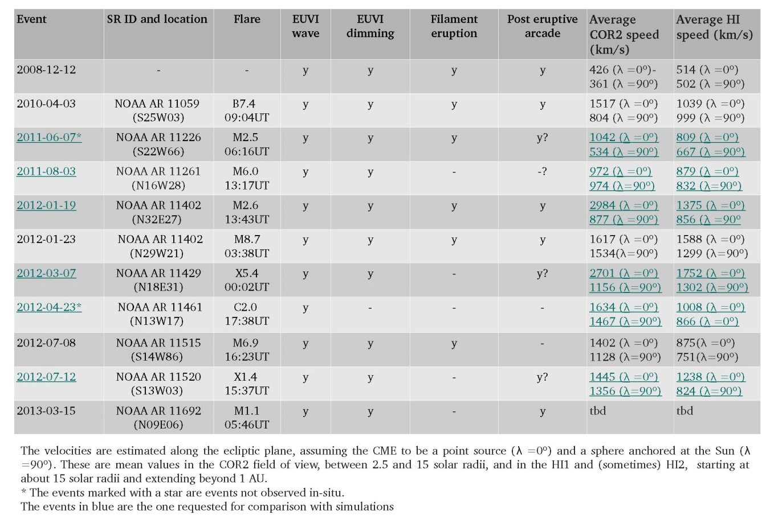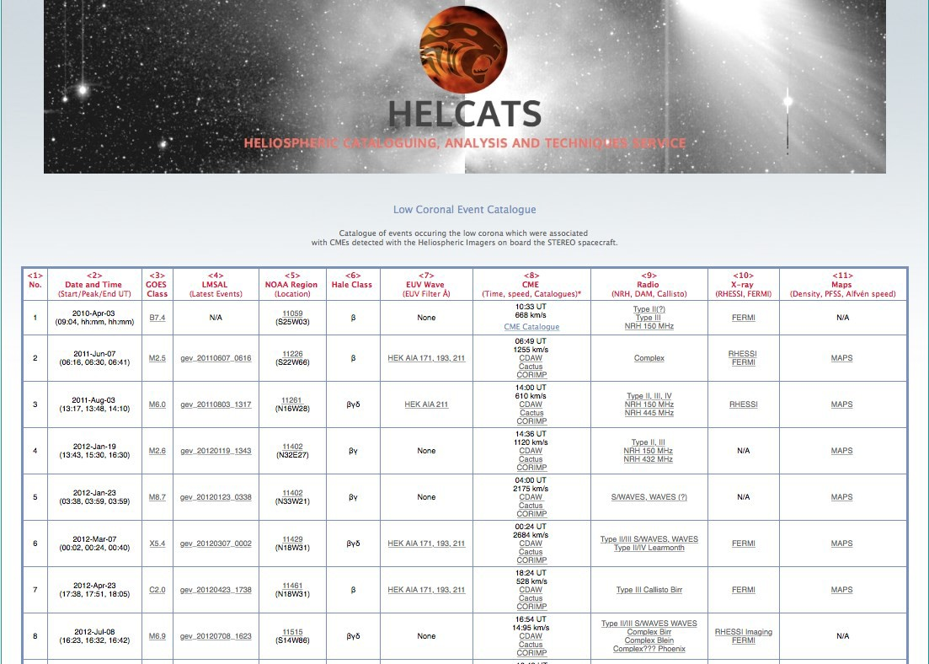

*Fig. 3.6 Prototype “Inverse Modelling List”.*

*Fig. 3.7 Prototype “Low Coronal Event Catalogue”.*

WP3 TASK 3.4: Comparison of modelling results (TASK LEAD: UGOE)

The results of the COR2 CME speed determinations derived under WP3 task 3.2 are being compared with the speeds derived with the HI results derived from geometrical modelling under WP3 task 3.1. Furthermore the determined COR2 CME source region positions will be compared with the positions derived from HI modelling. This is on-going work that will mature as the cataloguing and kinematic fit activities progress.

WP3 SUMMARY/NEXT STEPS:

In the next steps we will establish access to the online COR2 database providing speed and mass results to which further processed additional events from WP 2.3 will be added. The results from the COR2-HI comparisons will be analysed statistically. TCD will analyse the photospheric magnetic field properties of the identified CME source regions and coronal activity features such as EUV wave propagation directions and speeds. In terms of deliverables, WP3 has three major deliverables that will be completed at the end of the project (month 36), namely (deliverable D3.2) completing the incorporation of the forward modelling results into the catalogues (although this is an on-going activity), (D3.3) reporting on the model results and (D3.4) reporting on the prototype inverse model activities. However, a major deliverable is D3.1, which is provision of the time-elongation maps and incorporating the fits for the geometrical modelling into the HI CME catalogue (from WP2). This is due month on 12 but would also be updated as events are detected with the on-going STEREO mission.