Catalogue of the Corotating Interaction Regions (WP 5)

The large-scale structure of the solar wind measured in the ecliptic plane at solar minimum is to a large extent set by the recurring compression/rarefaction regions formed by the radial alignment of fast and slow solar wind. The compression regions are called Stream Interaction Regions (SIRs) when measured once in situ or Corotating Interaction Regions (CIRs) when measured over consecutive solar rotations (Jian et al. 2006). The advent of high-resolution heliospheric imaging allows us to track continuously the solar wind outflow between the Sun and 1AU and to study the origin of the variable plasma output released from the Sun. Imaging from STEREO has shown that, contrary to the standard picture of a smooth spiral of density increase, SIR/CIRs have significant longitudinal variability associated with the continual release and subsequent compression of small-scale transients in the slow solar wind. STEREO has been monitoring the variable plasma output of the Sun systematically for the last 8 years, thereby offering just under a solar cycle of insightful observations.

It is possible to track the Corotating Density Structures (CDS) in the Heliospheric Images by using J-maps constructed from running-difference images. In J-maps made with SECCH-A, patterns of converging tracks appear at nearly every solar rotation and are most clearly visible during solar minimum years. As previously shown by Rouillard et al 2008 and Davies et al. 2008, each track in this pattern is the white-light signature of a strong density inhomogeneity (or so-called `density blob') moving radially outward. Beyond about 0.3 AU (situated roughly between HI-1 and HI-2), these inhomogeneities become entrained ahead of corotating high-speed streams. Because these density structures are emitted by a spatially limited source region at the Sun they rapidly form a spiral of density inhomogeneities in the interplanetary medium. This spiral is analogous to the Parker spiral formed by the interplanetary magnetic field, both trace approximately the locus of plasma emitted by a single source region at the Sun.

As part of the FP7 Heliospheric Cataloguing, Analysis and Techniques Service (HELCATS) project, we derived a catalogue listing the properties of 190 corotating structures well-observed by the heliospheric images taken by ST-A (from April 2007 to Augus 2014). The time-dependent evolution of the 3-D trajectory of each SIR, the characteristic tracks left by these SIRs in the J-maps were fitted manually by clicking on J-maps produced with HI-1 and HI-2 images from STEREO-A (and in the future STEREO-B). For each SIR, we fitted first the clearest tracks associated with individual density irregularities entrained by the SIR. We then used the fact a SIR corotates during its passage in the heliospheric imagers, thereby leaving a characteristic pattern in the J-map. This pattern was then computed theoretically and superposed onto the real J-map. The algorithm to trace this SIR pattern folds in a correction for the orbital motion of the spacecraft. This orbital motion changes the location of the viewpoint of the probe (STEREO-A) and can have an important effect when the SIR pattern is considered over a 180 degrees of corotation in the HI field of view lasting up to 18 days. To validate a fitting we use two criteria (1) we require that the correspondence between the simulated and measured SIR patterns are satisfactory, (2) we require that the fitting technique (‘fixed-point technique’) of the trajectory of individual small-scale transients entrained by the SIR gives small errors in both speed (<40 km/s) and direction (<20o). Both of these criteria usually impose that the SIR be well observed by the heliospheric imagers over a large range of elongations (>40 degrees). SIRs that are poorly observed because (1) the white-light signature is too weak, (2) too many CMEs passed in the field of view are not fitted. We found that HI detects all S/CIRs passing in its field of view as CDSs at solar minimum but at solar maximum the many CMEs passing in the field of view ‘hide’ up to half of the passing S/CIRs.

The catalogue currently extends from April 2007 to August 2014, it lists:

— a unique SIR identifier*, e.g. HSIR_A__20070419_191210

— the spacecraft making the white-light observations (STEREO-A or STEREO-B),

— The ‘reference launch time’ of the most clearly observed density irregularity embedded in the SIR along the ecliptic plane: Format: YYYY-MM-DDTHH:MM:SS,

— Rotation period of the SIR assumed fixed at 25,38 days,

— The radial velocity (in km/s) of the SIR along the ecliptic plane,

— The error in radial velocity (in km/s) of the SIR along the ecliptic plane,

— The longitudinal separation (called ‘beta’, in degrees) between the observer and the most easily tracked density feature embedded in the SIR along the ecliptic plane,

— The error in the longitudinal separation (in degrees) between the observer and the most easily tracked density feature embedded in the SIR along the ecliptic plane,

— The Carrington longitude (in degrees) of the SIR source (tracked along the ecliptic plane),

— The HAE longitude (in degrees) of the SIR source (tracked along the ecliptic plane),

— The Carrington longitude (in degrees) of the coronal hole in EUI identified near the source region of the SIR in Carrington coordinates,

— The Carrington rotation number of the identified source.

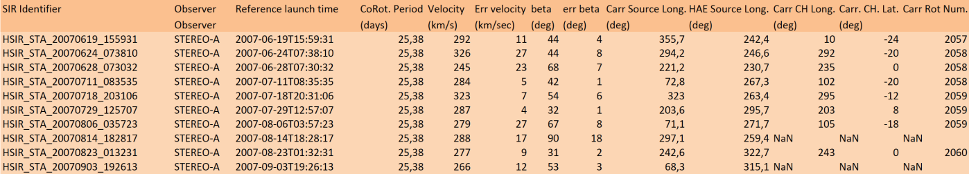An extract of the catalogue is given here:

The mean radial propagation speed of the corotating structures was found to be 310 km/s. Such low mean value correspond to the terminal speed of the slow solar wind rather than the speed of stream interfaces typically situated between the slow and fast solar wind speed (400 km/s). Using our fitting technique, we could predict the arrival time of each corotating structure at different probes in the inner heliosphere.

Additionally, by backtracing the source point of each corotating event seen in Heliospheric images on the Sun we studied the link between CDSs and the Heliospheric Current Sheet (HCS). Half of the 190 events have a separation less <10 degrees with the closest HCS position. We conclude that there is an overall strong tendency for CDSs source regions to occur near the coronal neutral line.