Afterpay LINK Integration SFRA

Version 20.1.0


int_afterpay_sfra

Contents
1. Summary 2
2. Component Overview 3
2.1 Functional Overview 3
2.2 Use Cases 4
2.3 Limitations, Constraints 4
2.4 Compatibility 5
2.5 Privacy, Payment 5
3. Integration Guide 5
3.1 Activating the Cartridges in Business Manager 5
3.2 Configuration 5
3.2.1 Importing Meta Data 6
3.2.2 Setting Afterpay Custom Site Preferences 6
3.2.3 Setting Afterpay Payment Method : 8
3.2.4 Setting Afterpay Payment Processors: 8
3.2.5 Setting SFCC Service 8
3.2.6 Adding Afterpay image to Payment method 9
3.2.7 Modifying Content 10
3.2.8 Setting up Job Schedule 10
4. Operations, Maintenance 10
4.1 Data Storage 10
4.2 Availability 12
4.3 Support 12
5. User Guide 12
5.1 Roles, Responsibilities 12
5.2 Business Manager Refund Transaction 12
5. Testing 13
6. Known Issues 18
7. Release History 18

1. Summary

This implementation guide describes how to integrate Afterpay Payment Processor (int_afterpay_sfra) into SFCC reference application SFRA site v4.4.1.

This cartridge provides the ability to use Afterpay as a Payment Method for during checkout of the SFCC storefront.

- Afterpay 101
  - Afterpay is a service that offers an order to be paid in 4 fixed instalments at a fixed frequency of 2 weeks each.
  - The Afterpay – Salesforce cartridge enables Afterpay to be offered as a Payment Method.
i. This cartridge displays the Afterpay ‘Payment Breakdown’ on the Product, Cart and Checkout Pages.
ii. This cartridge enables the Consumers to select Afterpay as a Payment method on the Checkout page.
  - Consumers can use Afterpay if it is offered in their country of residency.
  - Purchases are split in to 25% increments, and this cannot be adjusted.
  - Repayment is made every 2 weeks, and this cannot be adjusted.
  - Repayments are made via a Credit or Debit Card (Visa and Mastercard).
  - Merchant refunds will always apply any amount to the last ‘repayment’ to the first.
i. In a scenario where $100 has been purchased, and the 1st instalment of $25 has been paid; but a ‘full’ refund is requested.
ii. A refund of $100 is requested via the Afterpay Merchant Portal
iii. $75 is nullified (the 4th, 3rd,2nd instalments) as they have not yet been paid.
iv. $25 (1st instalment) is refunded back to the consumer.
  - Merchants must register on to gain access to use Afterpay
i. AU Registration URL: https://www.afterpay.com/en-AU/merchant-enquiry
ii. NZ Registration URL: https://www.afterpay.com/en-NZ/merchant-enquiry
iii. US Registration URL: https://www.afterpay.com/merchant-enquiry

- Regionality
  - The Afterpay Cartridge can be used for purchases from Australia, New Zealand and United States regions (assuming relevant commercial agreements are in place).
- Consumer Orders can be delivered to addresses anywhere in the world.
- AUD, NZD and USD are the only currencies serviced by Afterpay, transactions not made in other currencies are not valid.

- Payment Value Modifiers
  - Afterpay can be used when Split Payment is offered, as long as Afterpay is the last payment method used with a transaction.
  - Afterpay can be used with Discount Codes, Loyalty Points or other order value modifying methods.
- Transactions / Refunds / Settlements Information
  - Afterpay an ‘Merchant’ Portal, which Merchants can access their transactions, organise refunds or review settlement information.

2. Component Overview

2.1 Functional Overview

Afterpay provides a payment processing gateway. Afterpay’s payment gateway connects your storefront to process transactions that allow customers to purchase products.

When the service is unavailable, Afterpay API will provide the industry wide and expected HTTP 500 response error.

Afterpay’s current system operational status can be seen: https://status.afterpay.com/.

2.2 Use Cases

Allows checkout using Afterpay payment method.

2.3 Limitations, Constraints

The following Afterpay APIs are not supported,

- Void Payment
- Authorise Payment
- Update Shipping Courier

The following Afterpay APIs are supported,

- Direct Capture Payment
- Get Payments
- Create Refund
- Create Orders
- Get Orders
- Get configuration

2.4 Compatibility

Available since SFCC 16.4
Compatibility mode version this was tested against is 19.10.

2.5 Privacy, Payment

This integration requires access to the following customer data elements: Billing Address, Shipping Address, Order Details and Customer Profile.

No credit card details are stored within SFCC using this integration.

3. Integration Guide

The cartridge can first be downloaded from Commerce Cloud’s Xchange marketplace:
https://xchange.Commerce Cloud.com/community/marketplace

Once downloaded, please import the cartridge into your UX studio. Please refer following article on how to install UX studio:

- Getting started >> Installing or updating UX studio in Commerce Cloud’s documentation portal.

Please refer to following articles if you need assistance with how to connect UX studio with your sandbox and registering (installing) cartridge to sandbox:

- Getting started >> connection to a server >> in Commerce Cloud’s documentation portal.

- Getting started >> Registering your cartridge >> in Commerce Cloud’s documentation portal.

3.1 Activating the Cartridges in Business Manager

Before the Afterpay functionality can become available to SFRA, the cartridge names have to be added to the cartridge path of the Site’s settings. In order to do this, follow the below instructions:

1. Log into Business Manager
2. Navigate to Administration > Sites > Manage Sites.
3. Click on the target site name and Click on Settings tab.
4. In the Cartridges prepend the cartridge name int_afterpay_sfra separated by a colon (:)

3.2 Configuration

This chapter will describe how to configure the cartridge in Business Manager for SFRA.

3.2.1 Importing Meta Data

For the AfterPay integration to work, the following object structures (metadata) needs to be imported and configured in the Business manager. Follow the below steps:
- In the cartridge bundle find metadata/afterpay-meta-import folder.
- Find the sites folder and inside it find RefArch folder.
- Rename this RefARch folder to the ID of your site. If you have multiple site to which these meta has to be imported, then copy and paste this RefArch folder to replicate for other sites. Renames those folders with ID of corresponding sites.
- Open the specific site folder and find library folder. Inside library folder find library.xml.
- Edit the library.xml file to change the library-id mentioned in it. If your site uses private library, then remove the library-id attribute and its value. If your site uses shared library, then replace the existing library-id RefArchSharedLibrary in xml by your actual shared library id. Save the library.xml file.
- In the cartridge bundle, inside metadata folder compress afterpay-meta-import folder to generate afterpay-meta-import.zip file.
- Go to Business Manager Menu > Administration > Site Development > Site Import & Export
- Under Import: Upload Archive : Ensure that the radio button with label Local is enabled (Else click on the radio button to enable it)
- Click on Choose File input field, select the afterpay-meta-import.zip file from open dialog box and click on upload button
- After finishing the upload, from the Archives list click the radio button corresponding to afterpay-meta-import.zip and click on Import button
- Click on OK button of the confirmation box asking “Are you sure that you want to import the selected archive?”

3.2.2 Setting Afterpay Custom Site Preferences

In Business Manager, navigate to the Site > Site Preferences > Custom Preferences. A custom site preference group with the ID Integration_Afterpay is available. Please select it and edit the attributes according to your Afterpay account data and the data shown below.

Site Preference | Description |  | Default Values
apDelayRetry | The field is required to set delay time for the
 | unavailable service.
CapturePayment | The field is used to set timeout for the Direct
Timeout | Capture payments.
UserAgent | The field is used to send the UserAgent details
 | to Afterpay.
Enable Afterpay | The field determines if the Afterpay is |  | False
 | enabled / disabled in the cartridge.
Afterpay Display | The field determines if the Afterpay messaging |  | true
Product Details | is displayed on the Product Details Page.
Page Information
Afterpay Display | The field determines if the Afterpay messaging |  | False
Product List | is displayed on the Product List Page (category
Page Information | pages).

Afterpay Learn More URL | The URL that links to more information about Afterpay that users can click to view. | https://www.afterpay.com.au/terms/
Afterpay Payment Mode | This field determines if the payment should be Authorised only or if a Direct Capture is to be used. | Merchant Specific – Select the ones to be supported.
Afterpay Service Name | This field is used to identify the service with Afterpay. This only needs to be changed if you are using multiple sites where those sites are using additional Afterpay accounts as the accounts are stored in the service | afterpay.http.defaultendpoint  (for AUS site )  afterpay.http.defaultendpoint.NZ  (for NZsite)  afterpay.http.ddefaultendpoint.US  (for US site)
Afterpay Javascript URL | The endpoint where the javascript library is obtained from – Use  Sandbox - https://portal.sandbox.afterpay.com/afterpay.js  Production - https://portal.afterpay.com/afterpay.js
Afterpay Minimum Threshold Amount | Afterpay minimum threshold amount
Afterpay Maximum Threshold Amount | Afterpay maximum threshold amount

3.2.3 Setting Afterpay Payment Method :

Confirm that a payment method with the name AFTERPAY_PBI is available that was imported.

3.2.4 Setting Afterpay Payment Processors:

Confirm that a payment processor with the name AFTERPAY_CREDIT is available that was imported.

3.2.5 Setting SFCC Service

Three services for US, AUS and NZ locale are available. Select the Credentials tab and select required service and enter the account details

Attribute | Description
URL | This is the Afterpay API endpoints for:  Australia & New Zealand :  Sandbox  https://api-sandbox.afterpay.com/v1/  Production  https://api.afterpay.com/v1/  United States :  Sandbox  https://api.us-sandbox.afterpay.com/v1/  Production  https://api.us.afterpay.com/v1/
User | Enter the Account ID provided by Afterpay
Password | Enter the Key provided by Afterpay

3.2.6 Adding Afterpay image to Payment method

In order to display the Afterpay image on the site the image needs to be added to your site.

- Merchant Tools > Ordering > Payment Methods

- Select the payment method with ID AFTERPAY_PBI and locate the image attribute and upload the image included in the cartridge (int_afterpay_sfra/cartridge/static/default/images/afterpay-logo.png).

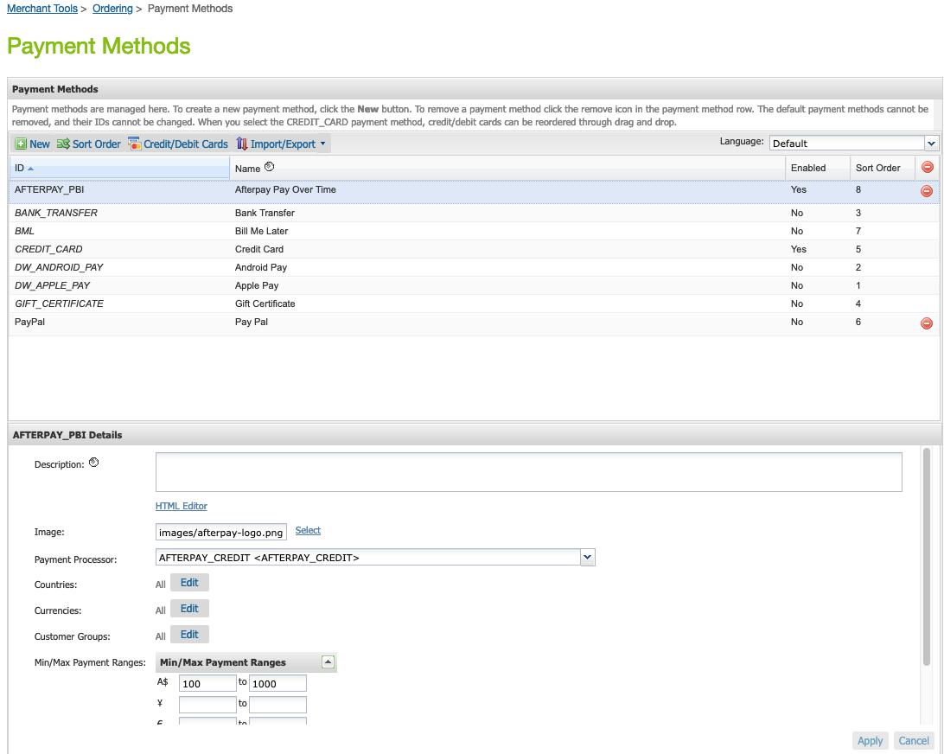

3.2.7 Modifying Content

There is a content asset (afterpay-checkout-pbi) and content slot (afterpay-checkout-pbi) those are used in the checkout and are displayed when selecting Afterpay payment method. The content asset (afterpay-checkout-pbi) can be modified as required to suit your site.

3.2.8 Setting up Job Schedule

This cartridge supports an Afterpay order status of PENDING by running a Job Schedule against all Afterpay Orders that are in a PENDING state. This is not required at this point as Aferpay will only respond with APPROVED or DECLINED and if the order is DECLINED the checkout cannot complete.
By default Job Step is set for SiteGenesis site. You may change this to your site.

4. Operations, Maintenance

4.1 Data Storage

Some additional custom attributes are stored against system objects. The following table lists these attributes and their uses , other than Site Preferences (which are listed under section 3.2.2).

Object | Attribute | Type | Description
OrganizationPreferences | flowIPAddresses  (flowIPAddresses) | Text | IP addresses
PaymentTransaction | Afterpay Refund ID  (apRefundID) | String | Refund ID
Order | Afterpay Order ID  (apPaymentD) | Boolean | Flags the order as an Afterpay order
PaymentTransaction | Afterpay Token  (apToken) | String | The token used to place order in Afterpay
PaymentTransaction | Afterpay Initial Status  (apInitialStatus) | String | The pre-approval status first returned
PaymentTransaction | Afterpay Payment Mode  (apPaymentMode) | String | The payment mode used
PaymentTransaction | Afterpay Direct Payment  (apDirectPaymentStatus) | String | The status of Direct Payment, if this payment mode is used
PaymentTransaction | Afterpay Authorise Status  (apAuthoriseStatus) | String | The status of Authorise, if this payment mode is used
PaymentTransaction | Afterpay Order ID  (apPaymentD) | String | The Payment ID generated by Afterpay

4.2 Availability

If the Afterpay service is unavailable the user will not be able to checkout using this payment method.

The service availability can be tracked in SFCC using the Service Status.

4.3 Support

For support please contact support@afterpay.com.au

5. User Guide

5.1 Roles, Responsibilities

Integration of this cartridge will typically be done by a SFCC developer.
Afterpay will provide access keys for be used with the API.

5.2 Business Manager Refund Transaction

For the Afterpay integration to work, the following needs to be configured in the Business manager.

- Upload the cartridge bm_afterpay and int_afterpay_core into server.

- Go to Business Manager Menu > Administration > Manage Sites > Business Manager > Settings > Cartridges input field add cartridge name “bm_afterpay: int_afterpay_core.

- Administration > Organization > Roles > Adminstrator > Business manager modules > Select context (select your site) > enable the Afterpay transactions management

5. Testing

Checkout Flow :

Once the cartridge is installed and integrated based on instructions, please try to place an order on your sandbox to test the functionality.

- On billing page, you should see following option of Afterpay:

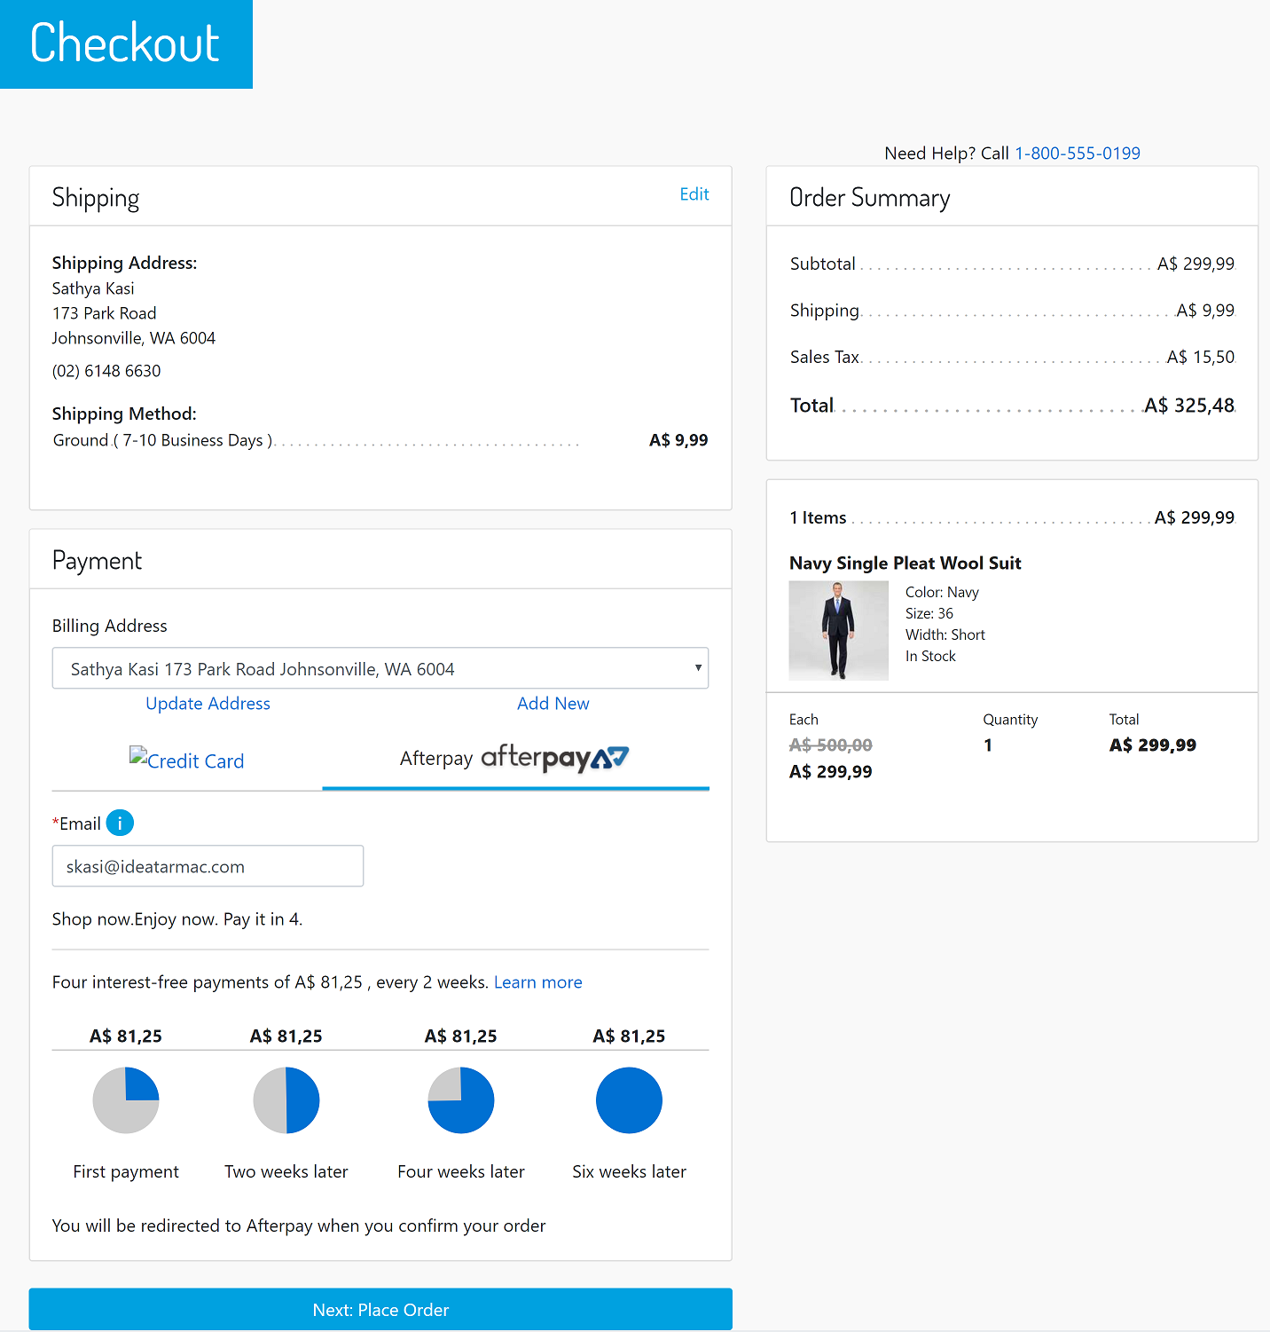

- After you click on Place order then you should be redirected to Afterpay Payment Page. If you are not registered then you will be asked for creating an account otherwise you see the following login page:
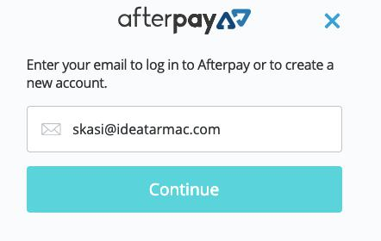

- Once you logged in successfully, you will be asked to enter payment details. After payment you will be redirected to Commerce Cloud storefront confirmation page like one below:

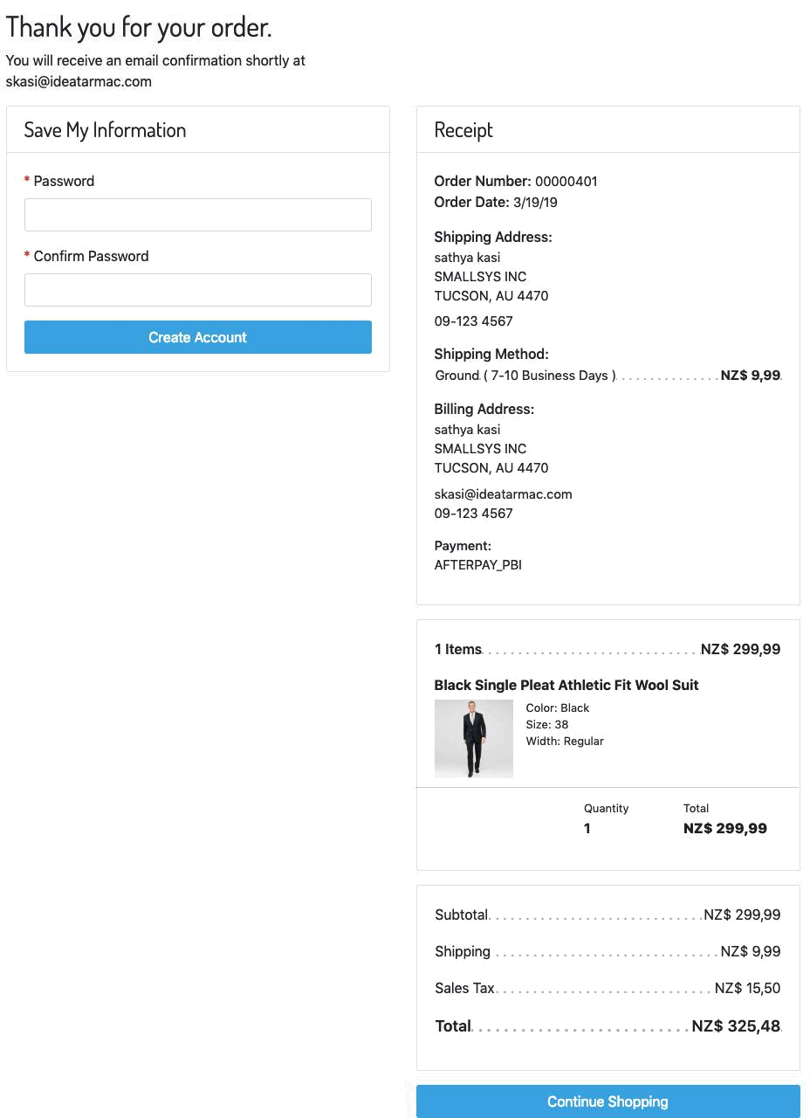

Refund Transaction

Merchant tools > Afterpay > Transactions Management > Click on the “APPROVED “ Order ID for which you want to refund the transaction.

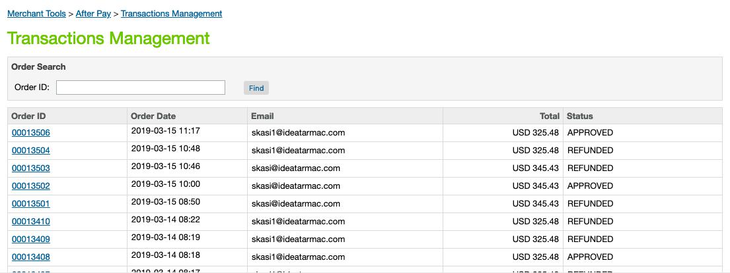

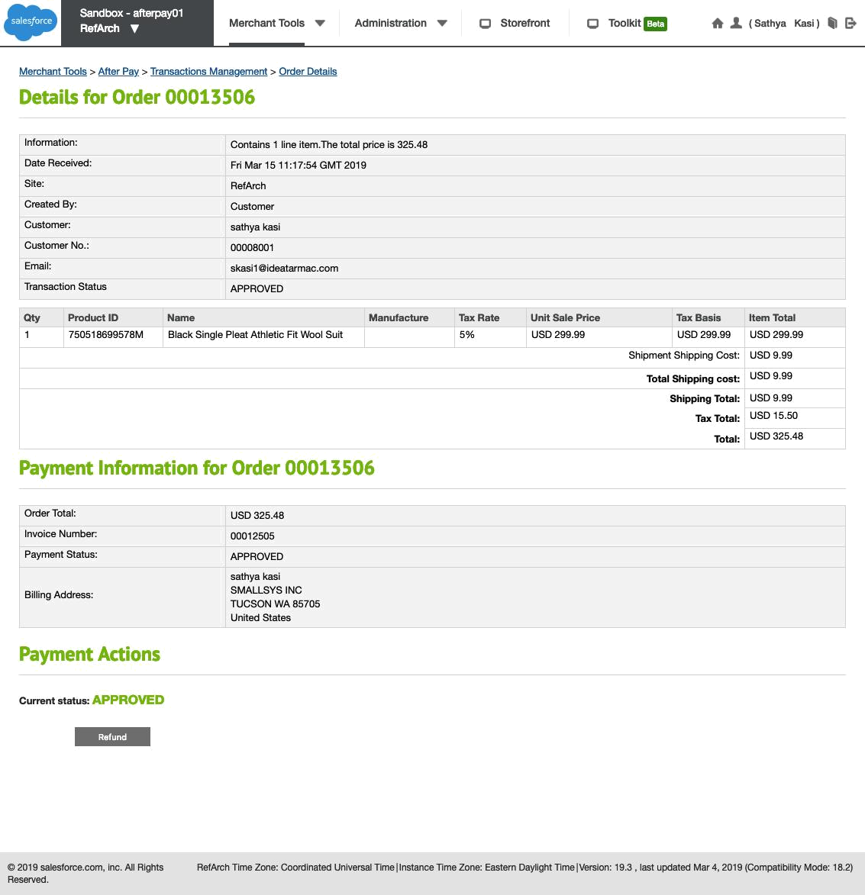

Sample Widgets :
- Product Details Page Widget :
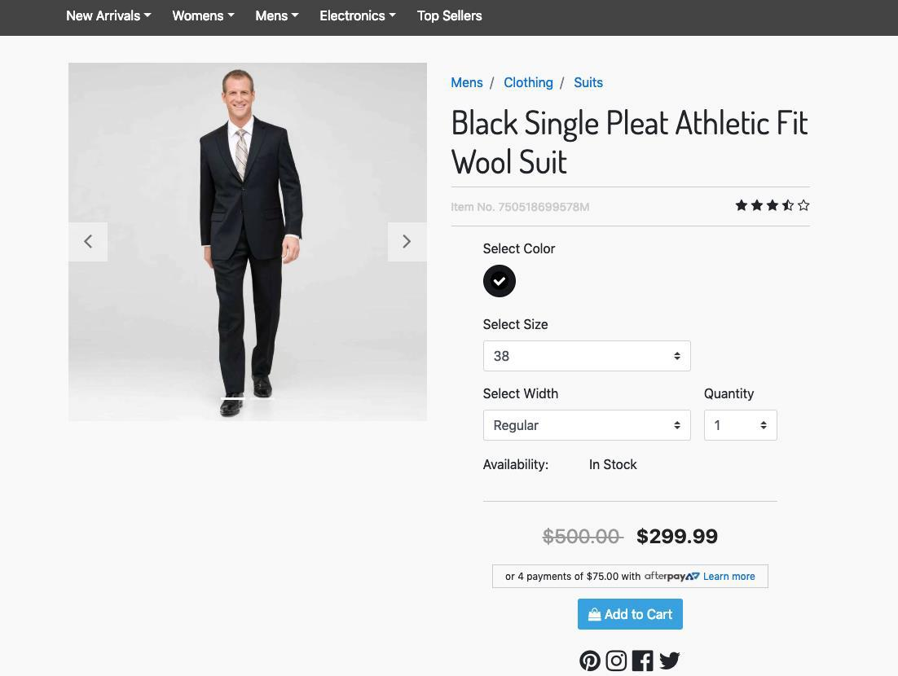

- Product Listing Page Widget :

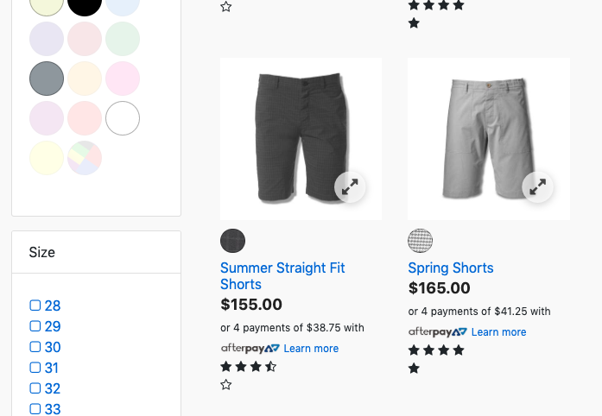

- Cart Page Widget :

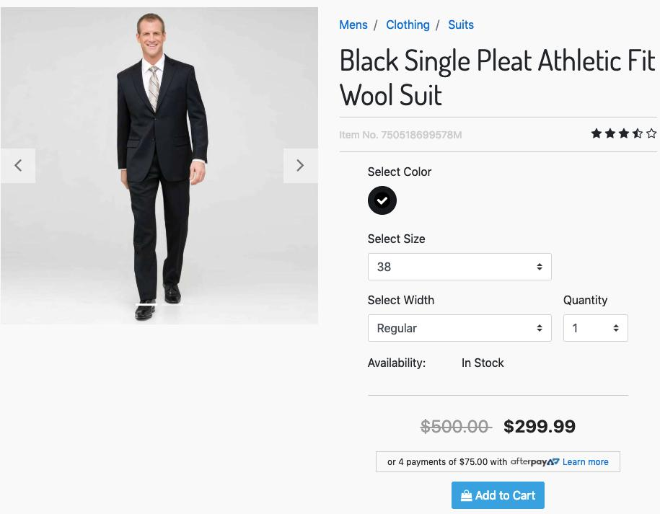

6. Known Issues
No known issues at the time

7. Release History

Version | Date | Changes
20.1.0 | 10 Jan 2020 | Initial release

