Afterpay LINK Integration

Version 20.1.0


Table of Contents
1. Summary 3
2. Component Overview 3
2.1 Functional Overview 3
2.2 Use Cases 4
2.3 Limitations, Constraints 4
2.4 Compatibility 5
2.5 Privacy, Payment 5
3. Implementation Guide 5
3.1 Activating the Cartridges in Business Manager 5
3.2 Configuration 5
3.2.1 Importing Meta Data 6
3.2.2 Setting Afterpay Custom Site Preferences 6
3.3 Custom Code 9
3.5 Testing 21
4. Operations, Maintenance 24
4.1 Data Storage 24
4.2 Availability 25
4.3 Support 25
5. User Guide 25
5.1 Roles, Responsibilities 25
5.2 Business Manager 25
5.3 Storefront Functionality 27
6. Known Issues 27
7. Release History 27

1. Summary

This implemetation guide describes how to integrate Afterpay Payment Processor (int_afterpay) in to SFCC(B2C Commerce) reference application SiteGenesis v2.

This cartridge provides the ability to use Afterpay as a Payment Method for during checkout of the SFCC(B2C Commerce) storefront.

To integrate you will need to modify SiteGenesis storefront cartridge.

2. Component Overview

2.1 Functional Overview

Afterpay provides a payment processing gateway. Afterpay‟s payment gateway connects your storefront to process transactions that allow customers to purchase products.

When the service is unavailable, Afterpay API will provide the industry wide and expected HTTP 500 response error.

Afterpay’s current system operational status can be seen: https://status.afterpay.com/.
This cartridge provides the ability to use Afterpay as a Payment Method for during checkout of the SFCC storefront.

- Afterpay 101
  - Afterpay is a service that offers an order to be paid in 4 fixed instalments at a fixed frequency of 2 weeks each.
  - The Afterpay – Salesforce cartridge enables Afterpay to be offered as a Payment Method.
i. This cartridge displays the Afterpay ‘Payment Breakdown’ on the Product, Cart and Checkout Pages.
ii. This cartridge enables the Consumers to select Afterpay as a Payment method on the Checkout page.
  - Consumers can use Afterpay if it is offered in their country of residency.
  - Purchases are split in to 25% increments, and this cannot be adjusted.
  - Repayment is made every 2 weeks, and this cannot be adjusted.
  - Repayments are made via a Credit or Debit Card (Visa and Mastercard).
  - Merchant refunds will always apply any amount to the last ‘repayment’ to the first.
i. In a scenario where $100 has been purchased, and the 1st instalment of $25 has been paid; but a ‘full’ refund is requested.
ii. A refund of $100 is requested via the Afterpay Merchant Portal
iii. $75 is nullified (the 4th, 3rd,2nd instalments) as they have not yet been paid.
iv. $25 (1st instalment) is refunded back to the consumer.
  - Merchants must register on to gain access to use Afterpay
i. AU Registration URL: https://www.afterpay.com/en-AU/merchant-enquiry
ii. NZ Registration URL: https://www.afterpay.com/en-NZ/merchant-enquiry
iii. US Registration URL: https://www.afterpay.com/merchant-enquiry

- Regionality
  - The Afterpay Cartridge can be used for purchases from Australia, New Zealand and United States regions (assuming relevant commercial agreements are in place).
- Consumer Orders can be delivered to addresses anywhere in the world.
- AUD, NZD and USD are the only currencies serviced by Afterpay, transactions not made in other currencies are not valid.

- Payment Value Modifiers
  - Afterpay can be used when Split Payment is offered, as long as Afterpay is the last payment method used with a transaction.
  - Afterpay can be used with Discount Codes, Loyalty Points or other order value modifying methods.
- Transactions / Refunds / Settlements Information
  - Afterpay an ‘Merchant’ Portal, which Merchants can access their transactions, organise refunds or review settlement information.

2.2 Use Cases

Allows checkout using Afterpay payment method

2.3 Limitations, Constraints

The following Afterpay API‟s are not supported

- Void Payment

- Authorise Payment

- Update Shipping Courier

The following Afterpay API‟s are supported

- Direct Capture Payment

- Get Payments

- Create Refund

- Create Orders

- Get Orders

- Get configuration

2.4 Compatibility

Available since SFCC(B2C Commerce)16.4

Compatibility mode version this was tested against is 19.10.

2.5 Privacy, Payment

This integration requires access to the following customer data elements: Billing Address, Shipping Address, Order Details and Customer Profile.

No credit card details are stored within SFCC(B2C Commerce) using this integration.

3. Implementation Guide

The cartridge can first be downloaded from Commerce Cloud’s Xchange marketplace: https://xchange.Commerce Cloud.com/community/marketplace
Once downloaded, please import the cartridge into your UX studio. Please refer following article on how to install UX studio: Getting started >> Installing or updating UX studio in Commerce Cloud’s documentation portal.
Please refer to following articles if you need assistance with how to connect UX studio with your sandbox and registering(installing) cartridge to sandbox:

• Getting started >> connection to a server >> in Commerce Cloud’s documentation portal.
Getting started >> Registering your cartridge >> in Commerce Cloud’s documentation portal.

3.1 Activating the Cartridges in Business Manager

Before the Afterpay functionality can become available to SiteGenesis, the cartridges have to be added to the cartridge path of the Site in question. In order to do this, follow the following instructions:

- Log into Business Manager
- Navigate to Administration > Sites > Manage Sites.
- Click on the site name and on the next page go to the Settings tab.

- In the textbox Cartridges add

“:int_afterpay_controllers:int_afterpay_core” after sitegenesis cartridge.

- Click Apply.

- Repeat steps 3 to 6 for each site that is to use Afterpay.

- Go to “Manage the Business Manager site””

- In the textbox Cartridges add “:bm_afterpay: int_afterpay_core”.

3.2 Configuration

This chapter will describe how to configure the cartridge in Business Manager for SiteGenesis.

3.2.1 Importing Meta Data

For the AfterPay integration to work, the following object structures (metadata) needs to be imported and configured in the Business manager. Follow the below steps:
- In the cartridge bundle find metadata/afterpay-meta-import folder.
- Find the sites folder and inside it find RefArch folder.
- Rename this RefARch folder to the ID of your site. If you have multiple site to which these meta has to be imported, then copy and paste this RefArch folder to replicate for other sites. Renames those folders with ID of corresponding sites.
- Open the specific site folder and find library folder. Inside library folder find library.xml.
- Edit the library.xml file to change the library-id mentioned in it. If your site uses private library, then remove the library-id attribute and its value. If your site uses shared library, then replace the existing library-id RefArchSharedLibrary in xml by your actual shared library id. Save the library.xml file.
- In the cartridge bundle, inside metadata folder compress afterpay-meta-import folder to generate afterpay-meta-import.zip file.
- Go to Business Manager Menu > Administration > Site Development > Site Import & Export
- Under Import: Upload Archive : Ensure that the radio button with label Local is enabled (Else click on the radio button to enable it)
- Click on Choose File input field, select the afterpay-meta-import.zip file from open dialog box and click on upload button
- After finishing the upload, from the Archives list click the radio button corresponding to afterpay-meta-import.zip and click on Import button
- Click on OK button of the confirmation box asking “Are you sure that you want to import the selected archive?”

3.2.2 Setting Afterpay Custom Site Preferences

In Business Manager, navigate to the SiteGenesis Site > Site Preferences > Custom Preferences. A custom site preference group with the ID Integration_Afterpay is

available. Please select it and edit the attributes according to your Afterpay account data and the data shown below.

Site Preference | Description | Default Values
apDelayRetry | The field is required to set delay time for the unavailable service.
CapturePayment | The field is used to set timeout for the Direct Timeout Capture payments.
UserAgent | The field is used to send the UserAgent details to Afterpay.
Enable Afterpay | The field determines if the Afterpay is enabled / disabled in the cartridge. | False
Afterpay Display Product Details Page Information | The field determines if the Afterpay messaging is displayed on the Product Details Page. | true
Afterpay Display Product List Page Information | The field determines if the Afterpay messaging is displayed on the Product List Page. | False
Afterpay Learn More URL | The URL that links to more information about Afterpay that users can click to view. | https://www.afterpay.com.au/terms/
Afterpay Payment Mode | This field determines if the payment should be Authorised only or if a Direct Capture is to be used. | Merchant Specific – Select the ones to be supported.
Afterpay Service Name | This field is used to identify the service with Afterpay. This only needs to be changed if you are using multiple sites where those sites are using additional Afterpay accounts as the accounts are stored in the service | afterpay.http.defaultendpoint  (for AUS site )  afterpay.http.defaultendpoint.NZ  (for NZsite)  afterpay.http.ddefaultendpoint.US  (for US site)
Afterpay JavaScript URL | The endpoint where the javascript library is obtained from – Use  Sandbox - https://portal.sandbox.afterpay.com/afterpay.js  Production - https://portal.afterpay.com/afterpay.js
Default Controller Cartridge Name | Name of default storefront controller cartridge | app_storefront_controllers
Default Core Cartridge | Name of default storefront core cartridge
Afterpay Minimum Threshold Amount | Afterpay minimum threshold amount
Afterpay Maximum Threshold Amount | Afterpay maximum threshold amount

Afterpay Payment Methods:

Check that a payment method with the name AFTERPAY_PBI is available that was imported.

Afterpay Payment Processors:

Check that a payment processor with the name AFTERPAY_CREDIT is available that was imported.

Setting SFCC(B2C Commerce) Service

Three services for US, AUS and NZ locale are available. Select the Credentials tab and select required service and enter the account details.

Attribute | Description
URL | This is the Afterpay API endpoints for:  Australia & New Zealand :  Sandbox  https://api-sandbox.afterpay.com/v1/  Production  https://api.afterpay.com/v1/  United States :  Sandbox  https://api.us-sandbox.afterpay.com/v1/  Production  https://api.us.afterpay.com/v1/
User | Enter the Account ID provided by Afterpay
Password | Enter the Key provided by Afterpay

Adding the Afterpay image to Payment method

In order to display the Afterpay image on the site the image needs to be added to your site.

Select Site > Ordering > Payment Methods

Select the payment method with ID AFTERPAY_PBI and locate the image attribute

and upload the image included in the cartridge

(int_afterpay_core\cartridge\static\default\images\ afterpay-logo.png)
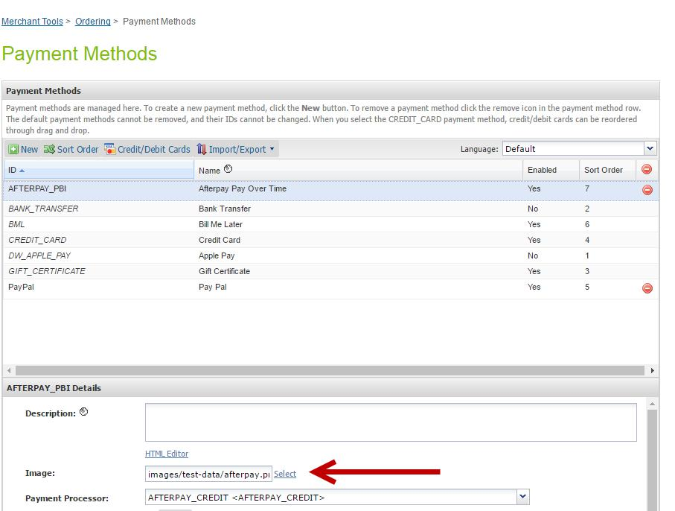

Modifying Content

There is a content asset (afterpay-checkout-pbi) and content slot (afterpay-checkout-pbi) those are used in the checkout and are displayed when selecting Afterpay payment method. The content asset (afterpay-checkout-pbi) can be modified as required to suit your site.

Job

This cartridge supports an Afterpay order status of PENDING by running a Job Schedule against all Afterpay Orders that are in a PENDING state. This is not required at this point as Aferpay will only respond with APPROVED or DECLINED and if the order is DECLINED the checkout cannot complete.
By default Job Step is set for SiteGenesis site. You may change this to your site.

3.3 Custom Code

In order to make this Afterpay cartridge work, a few modifications to SiteGenesis are required

- In app_storefront_controllers/cartridge/controllers/COBilling.js ,add the below mentioned code snippet:

In the method resetPaymentForms(), add the command for the three conditions:

cart.removePaymentInstruments(cart.getPaymentInstruments('AFTERPAY_PBI'));

function resetPaymentForms() {

var cart = app.getModel('Cart').get();


var status = Transaction.wrap(function () {

if

(app.getForm('billing').object.paymentMethods.selectedPaymentMethodID.val ue.equals('PayPal')) {

app.getForm('billing').object.paymentMethods.creditCard.clearFormElement();

app.getForm('billing').object.paymentMethods.bml.clearFormElement();

cart.removePaymentInstruments(cart.getPaymentInstruments(PaymentInstru ment.METHOD_CREDIT_CARD));

cart.removePaymentInstruments(cart.getPaymentInstruments(PaymentInstru ment.METHOD_BML));
// remove Afterpay PaymentInstrument

cart.removePaymentInstruments(cart.getPaymentInstruments('AFTERPAY_P BI'));

} else if

(app.getForm('billing').object.paymentMethods.selectedPaymentMethodID.val ue.equals(PaymentInstrument.METHOD_CREDIT_CARD)) {

app.getForm('billing').object.paymentMethods.bml.clearFormElement();

cart.removePaymentInstruments(cart.getPaymentInstruments(PaymentInstru ment.METHOD_BML));

cart.removePaymentInstruments(cart.getPaymentInstruments('PayPal')); // remove Afterpay PaymentInstrument

cart.removePaymentInstruments(cart.getPaymentInstruments('AFTERPAY_P BI'));
} else if

(app.getForm('billing').object.paymentMethods.selectedPaymentMethodID.val ue.equals(PaymentInstrument.METHOD_BML)) {

app.getForm('billing').object.paymentMethods.creditCard.clearFormElement();


if (!app.getForm('billing').object.paymentMethods.bml.ssn.valid) { return false;

}

cart.removePaymentInstruments(cart.getPaymentInstruments(PaymentInstru ment.METHOD_CREDIT_CARD));

cart.removePaymentInstruments(cart.getPaymentInstruments('PayPal')); // remove Afterpay PaymentInstrument

cart.removePaymentInstruments(cart.getPaymentInstruments('AFTERPAY_P BI'));

}

return true;
});


return status;
}

- In app_storefront_controllers/cartridge/controllers/COSummary.js ,add the below mentioned code snippet:

Replace the code block

“app.getView(viewContext).render('checkout/summary/summary');”

With

require("int_afterpay_core/cartridge/scripts/util/AfterpayUtilities.js").disableSummaryForAfterpay(cart, viewContext);

- In app_storefront_controllers/cartridge/controllers/COPlaceOrder.js ,add the below mentioned code snippet:

Replace the code block :

if (authorizationResult.not_supported || authorizationResult.error) {

return {
error: true
};

}

With :

if (authorizationResult.not_supported || authorizationResult.error) { return {

authorizeError : authorizationResult.authorizationResponse,
error: true

};
}

Replace the code block :

if (handlePaymentsResult.error) {
return Transaction.wrap(function () {

OrderMgr.failOrder(order);
return {
error: true,

PlaceOrderError: new Status(Status.ERROR,

'confirm.error.technical')

};
});

With

if (handlePaymentsResult.error) {

return Transaction.wrap(function () {

OrderMgr.failOrder(order);
return {

error: true,

afterpayOrderAuthorizeError :

handlePaymentsResult.authorizeError,
PlaceOrderError: new Status(Status.ERROR,

'confirm.error.technical')

};
});

- In app_storefront_controllers/cartridge/controllers/Product.js ,add the below mentioned code snippet:

Add the below mentioned code snippet in the method show() ,inside the condition -> if (product.isVisible()) { :

var sitePreferences =

require("int_afterpay_core/cartridge/scripts/util/AfterpayUtilities.js").getSitePreferencesUti lities();
var afterpayEnable = sitePreferences.isAfterpayEnabled();

if(afterpayEnable){

require("int_afterpay_core/cartridge/scripts/util/AfterpayCallThreshold.js").SetThre shold();

}

- In app_storefront_controllers/cartridge/scripts/views/CartView.js :

Add the below mentioned code snippet in the method CartView () ,after the transaction wrap for cart.calculate :

var sitePreferences =

require("int_afterpay_core/cartridge/scripts/util/AfterpayUtilities.js").getSitePreferencesUti lities();
var afterpayEnable = sitePreferences.isAfterpayEnabled();

if(afterpayEnable){

require("int_afterpay_core/cartridge/scripts/util/AfterpayCallThreshold.js").SetThre shold();
}

- In app_storefront_controllers/cartridge/controllers/Search.js :

Add the below mentioned code snippet in the method Show () , inside the elseif (productSearchModel.count > 0) { :

var sitePreferences =

require("int_afterpay_core/cartridge/scripts/util/AfterpayUtilities.js").getSitePreferencesUti lities();
var afterpayEnable = sitePreferences.isAfterpayEnabled();

if(afterpayEnable){

require("int_afterpay_core/cartridge/scripts/util/AfterpayCallThreshold.js").SetThre shold();

}

3.4.1 Templates

- Checkout/billing/billing.isml :

Locate the <iscomment> +++++++++++++++++++++billing address</iscomment> and add the below mentioned code after the comment:

<isset name="afterpayError" value="${!empty(pdict.AfterpayApiError) ? pdict.AfterpayApiError : (!empty(request.httpParameterMap.get('afterpay')).stringValue ? request.httpParameterMap.get('afterpay').stringValue : null)}" scope="page"/>

<isif condition="${!empty(afterpayError)}">
<div class="error-form">

<isprint value="${afterpayError}" encoding="off" />

</div>
</isif>

- Checkout/billing/paymentmethods.isml

After the line : <isinclude template="util/modules"/> , add the below mentioned code :

<isscript>

var sitePreferences = require("int_afterpay_core/cartridge/scripts/util/AfterpayUtilities.js").getSitePreferencesUtilities();
var afterpayEnable = sitePreferences.isAfterpayEnabled();
var basketObject = dw.order.BasketMgr.getCurrentBasket();
var orderGrandTotal = basketObject.totalGrossPrice;
var apMessageService = require("int_afterpay_core/cartridge/scripts/product/AfterpayDisplayProductMessage");
var thresholdResponse = apMessageService.getThresholdRange(orderGrandTotal);
var disableAfterpayPaymentMethod = false;

if(thresholdResponse && (thresholdResponse.belowThreshold || thresholdResponse.aboveThreshold)){
disableAfterpayPaymentMethod = true;
}
</isscript>

After the line : <isif

condition="${paymentMethodType.value.equals(dw.order.PaymentInstrument.METH
OD_GIFT_CERTIFICATE)}"><iscontinue/></isif> : , add the below mentioned code :

<iscomment>Ignore the payment method AFTERPAY_PBI if Afterpay payment method is disabled in configuration</iscomment>

<isif
condition="${paymentMethodType.value.equals('AFTERPAY_PBI') && afterpayEnable ==
false}"><iscontinue/></isif>

<isif condition="${paymentMethodType.value.equals('AFTERPAY_PBI') && disableAfterpayPaymentMethod}">
<isset name="disableAfterpay" value="${true}" scope="page" />
<iselse>
<isset name="disableAfterpay" value="${false}" scope="page" />
</isif>

Locate the following div :

<div class="form-row label-inline">
<isset name="radioID" value="${paymentMethodType.value}" scope="page"/>
<div class="field-wrapper">
<input id="is-${radioID}" type="radio" class="input-radio" name="${pdict.CurrentForms.billing.paymentMethods.selectedPaymentMethodID.htmlName}" value="${paymentMethodType.htmlValue}" <isif condition="${paymentMethodType.value == pdict.CurrentForms.billing.paymentMethods.selectedPaymentMethodID.htmlValue}">checked="checked"</isif> />
</div>
<label for="is-${radioID}"><isprint value="${Resource.msg(paymentMethodType.label,'forms',null)}"/></label>
</div>

And replace with:

<isif condition="${!disableAfterpay}">
<div class="form-row label-inline">
<isset name="radioID" value="${paymentMethodType.value}" scope="page"/>
<div class="field-wrapper">
<input id="is-${radioID}" type="radio" class="input-radio" name="${pdict.CurrentForms.billing.paymentMethods.selectedPaymentMethodID.htmlName}" value="${paymentMethodType.htmlValue}" <isif condition="${paymentMethodType.value == pdict.CurrentForms.billing.paymentMethods.selectedPaymentMethodID.htmlValue}">checked="checked"</isif> />
</div>
<label for="is-${radioID}">
<isset name="paymentObject" value="${paymentMethodType.object}" scope="page"/>
<isif condition="${empty(paymentObject.image)}">
<isprint value="${Resource.msg(paymentMethodType.label,'forms',null)}"/>
<iselse>
<img src="${paymentObject.image.URL}" class="payment-image ${radioID.toLowerCase()}-image" alt="${Resource.msg('billing.logo','afterpay',null)}"/>
</isif>
</label>
</div>
</isif>

Locate the following on line 138

<iscomment>
Custom processor
--------------------------------------------------------------

</iscomment>

Add this after:

<iscomment>
Afterpay Pay Over Time
--------------------------------------------------------------

</iscomment>
<isif condition="${afterpayEnable == true}">

<div class="payment-method <isif condition="${!empty(pdict.selectedPaymentID) && pdict.selectedPaymentID=='AFTERPAY_PBI'}">payment-method-expanded</isif>" data-method="AFTERPAY_PBI">

<isslot id="afterpay-checkout-pbi" description="Afterpay checkout PBI content"
context="global" />
</div>

</isif>

- product/components/pricing.isml

Locate this code <isinclude template="product/components/standardprice"/> And add the below mentioned code snippet after this line

<isinclude template="util/modules">

Locate this code on line 160 at very bottom of file:

<isif condition="${!empty(pdict.OrgProduct)}">
<iscomment>Restore current product instance</iscomment>

<isset name="Product" value="${pdict.OrgProduct}" scope="pdict"/>
<isset name="OrgProduct" value="${null}" scope="pdict"/>
</isif>

Add this before:

<isscript>
var sitePreferences =
require("int_afterpay_core/cartridge/scripts/util/AfterpayUtilities.js").getSitePreferencesUtiliti
es();
var afterpayEnable = sitePreferences.isAfterpayEnabled();

</isscript>
<isif condition="${afterpayEnable == true}">
<isafterpaythreshold totalprice="${(SalesPrice ? SalesPrice : StandardPrice)}"
classname="pdp-afterpay-message" />
</isif>

- product/producttile.isml Locate this code at the top of file:

<iscontent type="text/html" charset="UTF-8" compact="true"/> <isif condition="${(pdict.cache != null) ? pdict.cache : true}">

<iscache type="relative" hour="24" varyby="price_promotion"/> </isif>

Add this after:

<isinclude template="util/modules">

Locate this code on line 239:

prices.push(price);

if (extraPrice) {prices.push(extraPrice);}

And replace with:

if (price && price.value) {prices.push(price);}
if (extraPrice && extraPrice.value) {prices.push(extraPrice);}

Locate this comment on line 248: <iscomment>Promotion</iscomment>

Add this before:

<iscomment>Afterpay message</iscomment>
<isscript>
var sitePreferences =

require("int_afterpay_core/cartridge/scripts/util/AfterpayUtilities.js").getSitePreferencesUtiliti
es();

var afterpayEnable = sitePreferences.isAfterpayEnabled(); </isscript>
<isif condition="${afterpayEnable == true}">

<isafterpaythreshold totalprice="${(prices[prices.length-1].value)}" classname="plp-afterpay-message" />
</isif>

- checkout/cart/cart.isml

Locate the div : <div class="cart-actions">
And add the below mentioned code before the div

<isscript>
var sitePreferences =
require("int_afterpay_core/cartridge/scripts/util/AfterpayUtilities.js").getSitePreferencesUtiliti
es();

var afterpayEnable = sitePreferences.isAfterpayEnabled(); </isscript>

<isif condition="${afterpayEnable == true}">
<div class="learn-more">

<isif condition="${pdict.Basket.totalGrossPrice.available}"> <isset name="orderTotalValue"

value="${pdict.Basket.totalGrossPrice}" scope="page"/> <iselse/>

<isset name="orderTotalValue"

value="${pdict.Basket.getAdjustedMerchandizeTotalPrice(true).add(pdict.Basket.giftCertific ateTotalPrice)}" scope="page"/>
</isif>

<iscomment>Afterpay message</iscomment>

<isafterpaythreshold totalprice="${orderTotalValue}"
classname="cart-afterpay-message" />

</div>
</isif>

- util/modules.isml Add this:

<iscomment>
Render the Afterpay modules
</iscomment>
<isinclude template="util/afterpay/modules" />

- app_storefront_core/cartridge/scripts/util/Resource.ds

Find the line ResourceHelper.getPreferences = function(pageContext) {

Add this code inside the method :

AFTERPAY_PORTAL : Site.getCurrent().getCustomPreferenceValue('apJavascriptURL')

3.4.2 Javascript

In app_storefront_core/cartridge/js/app.js

Add the below mentioned code snippet after the method $('.user-account').on('click', function (e) { :

$(document).on('click', '.afterpay-link', function (e) { e.preventDefault();

dialog.open({
url: $(e.target).attr('href')
});
});

In app_storefront_core/cartridge/js/ bonus-products-view.js

function createOrder() {
var url = util.ajaxUrl(Urls.createAfterpayOrder);

ajax.getJson({
url: url,
callback: function (data) {
if (data) {

checkAuthorize(data);
}
}
});

}

function checkAuthorize(data) {
if (window.AfterPay) {

AfterPay.init();
AfterPay.display({token: data.token});
} else {

setTimeout(checkAuthorize.bind(null, data), 3000);

}
}

function initScript() {
var script = document.createElement('script');

script.src = SitePreferences.AFTERPAY_PORTAL;
script.async = true;

document.body.appendChild(script);
}

function initSubmitOrderEvent() {
var $form = $('.checkout-billing');

var $paymentMethods = $form.find('input[name$="_selectedPaymentMethodID"]'); var $btnContinue = $form.find('button[name$="_billing_save"]');

$btnContinue.on('click', function(e) {

if ($paymentMethods.filter(':checked').val() === 'AFTERPAY_PBI') { e.preventDefault();

createOrder();

return false;

}
});
var $declined = $('.ap-declined'),

$form = $('.submit-order');

if ($declined.length > 0) {
$form.on('submit', function (e) {

e.preventDefault();
window.location = window.Urls.billing;
});
} else {

$form.off('submit').on('submit', function (e) {
return true;

});
}
}

exports.init = function () {

initScript();
initEvent();
};

module.exports.initSubmitOrderEvent = function () {

initSubmitOrderEvent();
};

CSS

app_storefront_core/cartridge/scss/default/style.scss

Add the code :

@import "afterpay";

Note: Copy the file ‘_afterpay.scss from the reference folder in the root folder of the cartridge to the path: app_storefront_core/cartridge/scss/default/_afterpay.scss

3.5 Testing

In Business Manager, navigate to the SiteGenesis Site > Site Preferences > Custom Preferences. A custom site preference group with the ID Integration_Afterpay is available. Please select it and add the respective data (obtained from Afterpay). The service credentials also need to be updated with an Account ID and Key provided by Afterpay. The Service URL needs to be set to the relevant region and environment. See 3.3.3

Products Listing Page :

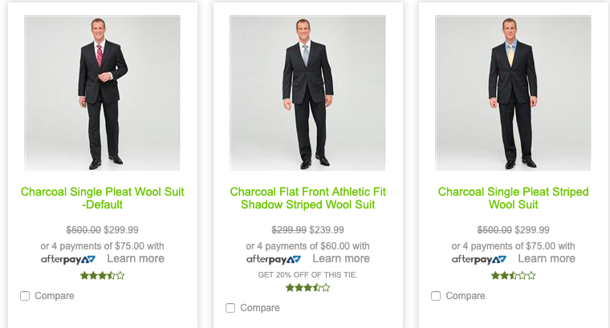

Products Details Page :

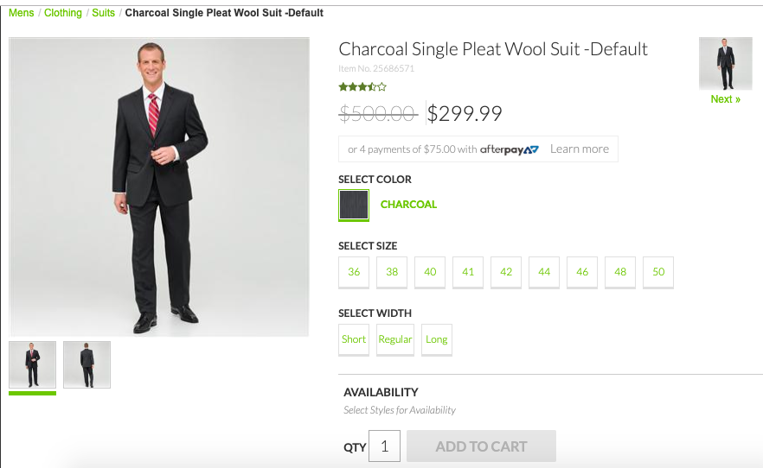

Checkout page :

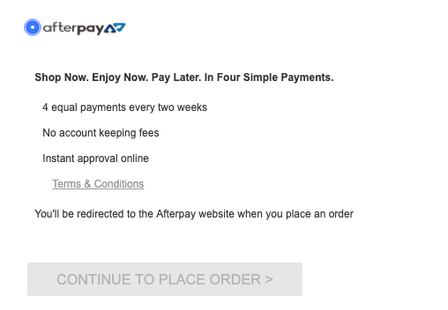

Order Placement:

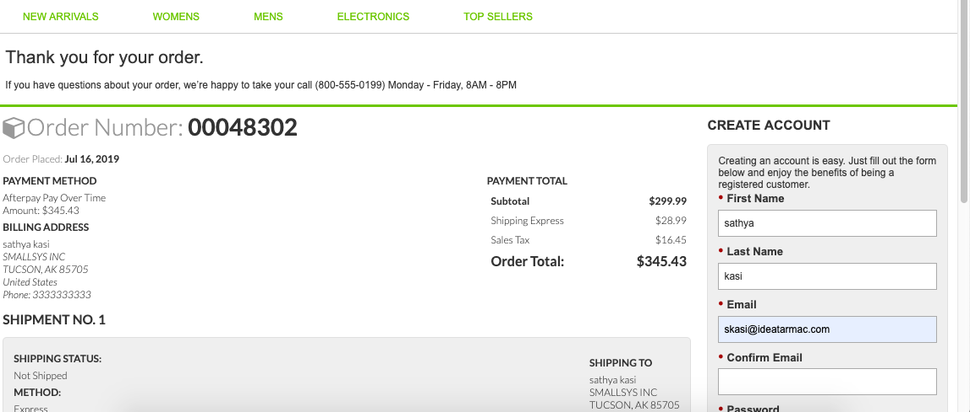

4. Operations, Maintenance

4.1 Data Storage

Some additional custom attributes are stored against system objects. The following table lists these attributes and their uses, other than Site Preferences (which are listed under section 3.3.2).

Object | Attribute | Type | Description
OrganizationPreferences | flowIPAddresses  (flowIPAddresses) | Text | IP addresses
PaymentTransaction | Afterpay Refund ID  (apRefundID) | String | Refund ID
Order | Afterpay Order ID  (apPaymentD) | Boolean | Flags the order as an Afterpay order
PaymentTransaction | Afterpay Token  (apToken) | String | The token used to place order in Afterpay
PaymentTransaction | Afterpay Initial Status  (apInitialStatus) | String | The pre-approval status first returned
PaymentTransaction | Afterpay Payment Mode  (apPaymentMode) | String | The payment mode used
PaymentTransaction | Afterpay Direct Payment  (apDirectPaymentStatus) | String | The status of Direct Payment, if this payment mode is used
PaymentTransaction | Afterpay Authorise Status  (apAuthoriseStatus) | String | The status of Authorise, if this payment mode is used
PaymentTransaction | Afterpay Order ID  (apPaymentD) | String | The Payment ID generated by Afterpay

4.2 Availability

If the Afterpay service is unavailable the user will not be able to checkout using this payment method.

The service availability can be tracked in SFCC(B2C Commerce) using the Service Status.

4.3 Support

For support please contact support@afterpay.com.au

5. User Guide

5.1 Roles, Responsibilities

Integration of this cartridge will typically be done by a SFCC(B2C Commerce) developer.

Afterpay will provide access keys for be used with the API.

5.2 Business Manager

For the Afterpay integration to work, the following needs to be configured in the Business manager.

- Upload the cartridge bm_afterpay and int_afterpay_core into server.

- Go to B2C Commerce > Administration > Manage Sites > Business Manager > Settings

  - Cartridges input field add cartridge name “bm_afterpay: int_afterpay_core ‟.

- Administration > Organization > Roles > Adminstrator > Business manager modules

  - Select context(select your site ) > enable the Afterpay transactions management .

- Merchant tools > Afterpay > transactions Management > Click on the “APPROVED” order ID for which you want to refund the transaction.

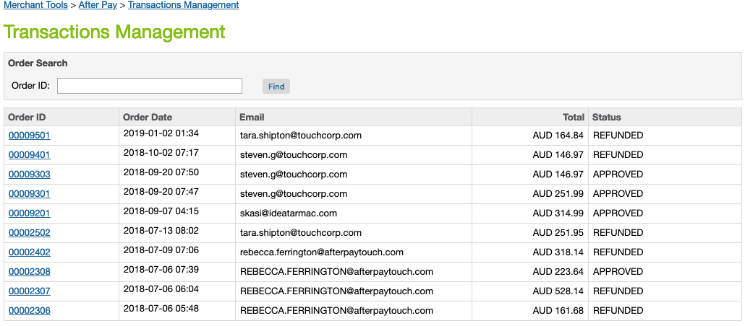

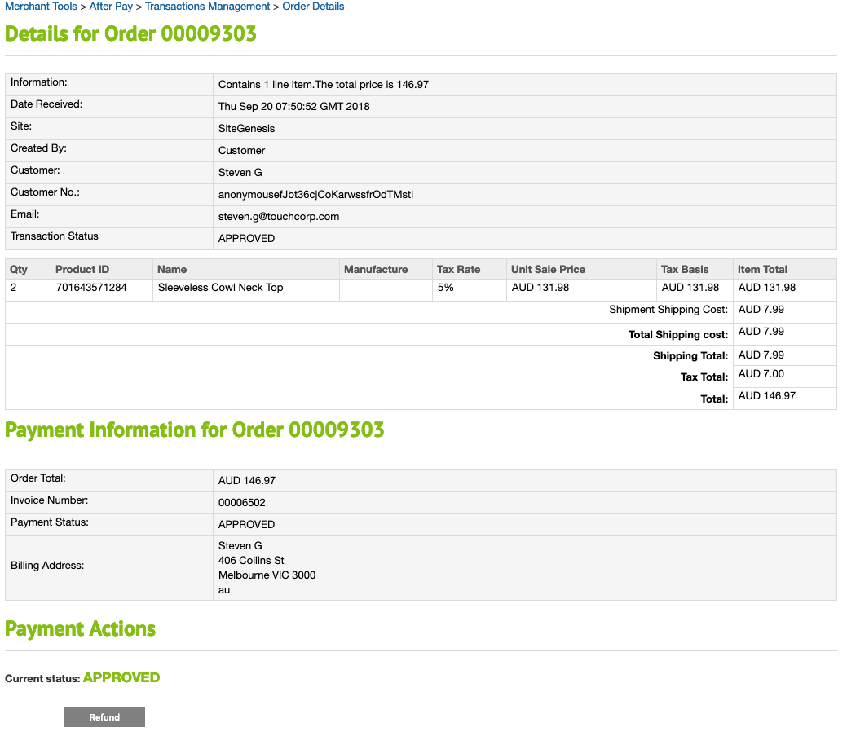

5.3 Storefront Functionality

This cartridge provides an additional payment method during checkout

6. Known Issues

No known issues at the time

7. Release History

Version | Date | Changes
20.1.0 | 10 Jan 2020 | No Changes
18.3 | 07 May 2018 | Controller version
18.3 | 3 September 2016 | Initial release

