

MIDDLESEX UNIVERSITY
DUBAI, U.A.E
B.ENG COMPUTER SYSTEM ENGINEERING

PDE2226
Systems Integration
and
Machine Learning

SAVESENTRA
Smart Family Savings Bank
Project Technical Report

AFTHAB ANTHAS M01033122

Table of Contents

Chapter 1 – Abstract 4
Chapter 2 – Introduction 5
2.1 Problem Definition 5
2.2 Aims and Objectives 5
2.3 Description 6
Chapter 3 – Design Methodology 6
3.1 Deliverables 7
3.2 Requirements Specification 7
3.3 Research Methodology 8
3.4 Development Methodology 8
3.5 Work Breakdown Structure 9
Chapter 4 – Development and Implementation 9
4.1 System Architecture and Workflow 9
4.2 Hardware Development and Firmware Logic 10
4.3 Raspberry Pi Backend Development 12
4.4 The Mobile Application Interface (Blynk) 13
Chapter 5 – Testing and Evaluation 14
5.1 Physical Threshold Calibration 14
5.2 Wi-Fi and Data Preservation 15
5.3 Application Security Testing 15
Chapter 6 – Machine Learning Steps 15
6.0 Data Set Collection 15
6.1 Data Cleaning and Formatting 16
6.2 Exploratory Data Analysis (EDA) 17
6.3 Feature Engineering and Selection 20
6.4 Compare Machine Learning Models on a Performance Metric 21
6.5 Hyperparameter Tuning on the Best Model 22
6.6 Evaluate the Best Model 22
6.7 Interpret the Model Results 22
6.8 Send Conclusions 23
Chapter 7 – Conclusion 23
7.1 Future Development 23
7.2 Conclusion 24
Reference List 24

Chapter 1 – Abstract
The Internet of Things (IoT) is now becoming part of the daily life of consumers and changing how we think about and use common items. This paper presents SaveSentra. SaveSentra is an IoT-based Family Cash Deposit System that encourages the practice of literacy and savings habits within families by offering an innovative solution that offers families a centralized, user-friendly, interactive, and transparent system for physically depositing and tracking their cash.
The architecture of the system utilizes the Arduino Nano ESP32 microcontroller as the main processing unit. It integrates an MFRC522 RFID reader to enable user authentication, a TCRT5000 IR sensing and counting mechanism to detect bills/notes, and a stepper motor mechanism to securely take cash/bills and estimate the cash/bill denomination based on the length of the bill. The system’s real-time data syncs through Wi-Fi on the Blynk IoT platform, which offers a mobile application to provide ease of access to users to view their individual balances, family goals, and transaction history on the system. Additionally, the system is designed with a local Raspberry Pi server that hosts a Flask application to log transactions and run an ML (Machine Learning) predictive pipeline. This pipeline utilizes historical data of deposits to predict the date the family's financial objective will be met and to provide insight on which family members are the most financially active.
SaveSentra combines hardware engineering with cloud computing and machine learning to transform an individual household financial tracking activity into an interactive and collaborative family experience.

Chapter 2 – Introduction

2.1 Problem Definition
As society becomes more cashless, young people increasingly lose the ability to appreciate the solid worth of money. Digital banking apps give consumers a variety of useful tools, but there are no comparable tools for children and teenagers to help them engage and track savings in cash. While classic piggy banks are nostalgic, they are opaque, they do not allow for any real time tracking, they do not foster accountability in shared family settings, and they do not provide any analytical information about saving behavior.
While planning a family vacation or purchasing a new gaming console, family members or several siblings may face disputes about their individual contributions. There is no automated way to confirm who deposited how much, which may cause conflicts and a possible loss of motivation. Cash counting, though, is often tedious and may lead to mistakes. Parents do not have a way to track their children’s financial goals, to set a group family goal, or reward them for positive saving practices. There is no available predictive analytics which pose limitations of planning for families. Without predictive analytics, families find it hard to estimate when their financial goal will be achieved based on their saving patterns.

2.2 Aims and Objectives
The primary aim of the SaveSentra project is to engineer a smart, automated cash deposit system that resolves the challenges associated with traditional savings methods. The project seeks to foster a collaborative financial environment within households by introducing accountability, transparency, and gamification.
The specific objectives of this project are:
- Hardware Integration: To design and assemble a robust hardware setup utilizing an ESP32 microcontroller, an RFID reader for secure user identification, an IR sensor for detecting the insertion of physical bills, and a motorized intake system to pull in and measure the bills.
- Automated Denomination Recognition: To implement an algorithm that estimates the denomination of inserted United Arab Emirates Dirham (AED) bills based on the duration (stepper motor steps) the IR sensor is blocked during bill intake.
- Cloud Synchronization and User Interface: To create a user-friendly mobile dashboard on the Blynk platform that allows users to monitor individual balances, track the family’s progress towards a collective goal in real time, and send push notifications instantaneously when there are transactions.
- Local Data Management: To establish a Raspberry Pi-based local server that acts as a secure data repository, logging all transaction details (Timestamp, UID, Amount, Balance) into a scalable dataset.
- Machine Learning Predictive Analytics: To build a complete machine learning pipeline that processes historical data, creates relevant time features, tests several regression models, and forecasts both the targeted completion date of the family goal and the estimated top contributor.

2.3 Description
SaveSentra operates as a multi-tiered architecture consisting of the edge device (hardware intake unit), the cloud interface (Blynk mobile app), and the local processing server (Raspberry Pi).
User interaction starts when a family member taps their personalized RFID card or tag on the device’s scanner. The ESP32 authenticates the Unique Identifier (UID) with one of its locally stored preferences databases; if registered, the system greets the user through the Blynk app and engages the intake mechanism. The user slides a physical banknote into the slot, breaking the beam of the TCRT5000 IR sensor, which activates the stepper motor to draw the bill into the secured vault.
While the motor is active, the system carefully counts the number of steps needed to pull the complete bill across the sensor. By relating the actual length of the bill (in steps of the motor) to the specific size of AED currency (e.g. 5 AED vs. 10 AED notes), the firmware determines the value of the bill. The value of the bill is updated, and the transaction is sent to the Blynk cloud, updating the user’s internal balance and the family’s progress bar.
At the same time, the ESP32 sends an HTTP POST request to the local Raspberry Pi Flask server along with the transaction info. The server appends this info to the savings_dataset.csv and runs the savesentra_ml.py script. The ML model examines the dataset to predict future deposit trends, analyzes past daily contributions, and updates the Blynk app to let the family know when they will achieve their savings goal.

Chapter 3 – Design Methodology

3.1 Deliverables
The SaveSentra system is designed to provide a comprehensive, end-to-end solution for family financial tracking. To achieve this, the project architecture is divided into several deliverables:
- IoT Edge Device: The physical piggy bank device. This unit is built around the Arduino Nano ESP32 microcontroller. It incorporates a TCRT5000 infrared sensor and a 28BYJ-48 stepper motor driven by a ULN2003 board to handle physical cash intake. For user interaction and security, an MFRC522 RFID module is embedded.
- Embedded Firmware (savesentra_iot.ino): The software that makes the edge device. Written in C++, this handles everything from hardware interrupts and sensor polling to Wi-Fi connectivity and HTTP request generation. It also implements the crucial on-device logic for estimating bill denominations based on stepper motor timing.
- Blynk Cloud Dashboard: The user-facing mobile interface. This deliverable translates raw sensor and database values into an accessible, easy experience. It uses Blynk's virtual pins to display real-time balances, family goals, and administrative controls for parents.
- Local Backend Server (rpi_server.py): Raspberry Pi functions as a local node on the network. Its Python-based Flask web server listens for HTTP POST requests from the ESP32 and extracts transaction metadata to generate a persistent, chronological dataset.
- Machine Learning Pipeline and Analytics (savesentra_ml.py & EDA.ipynb): The analytical core of the project. The exploratory dataset analysis notebook visually confirms saving trends, while the automated Python script handles the end-to-end machine learning process: cleaning data, feature engineering, training regression models, and calculating predictive dates for goal completion.
- Project Report: A fully technical and contextual documentation artifact that lays out the methodologies, testing phases, and underlying code mechanics of the entire SaveSentra ecosystem.

3.2 Requirements Specification
Defining the operational limits in the design phase helps to ensure the system will function reliably in the everyday environment of a typical household.
Functional Requirements:
- Authentication: The system must strictly restrict cash deposits to authenticated users. Anyone attempting to push cash without an authorized RFID tag must be rejected by the hardware.
- Administrative Controls: Parents must possess ultimate control over the database. The system needs an interface to add new children to the system, assign roles, define the family savings goal, and completely wipe the database if necessary.
- Automated Intake and Counting: The hardware must mechanically draw the bill in and calculate the denomination internally, avoiding the need for the user to manually type in how much they are depositing.
- Persistent Memory: Savings balances are critical data. Disconnecting the ESP32 from power must not result in data loss. Balances and user profiles must be stored in non-volatile flash memory.
- Data Logging: Every single valid transaction has to be recorded chronologically.
- Predictive Capability: The system must evaluate historical deposit habits and project a realistic date for when the family goal will be met.
Non-Functional Requirements:
- Durability and Consistency: The motor intake code must account for edge cases, ensuring that a bill is not swallowed without credit being applied.
- Network Latency: Internal network calls between the ESP32 and the Raspberry Pi should add no more than a few seconds of delay so that the user interaction feels responsive.
- Scalability of the ML Model: As the dataset grows daily, the machine learning script needs to run efficiently without timing out the Raspberry Pi's processor.

3.3 Research Methodology
The engineering decisions for SaveSentra were informed by a rigorous review of available technologies.
- Hardware Selection: Although they enjoy significant popularity, standard Arduino Unos do not have built-in internet connectivity. The ESP8266 was an option, but newer Arduino Nano ESP32s were preferred due to their more powerful dual-core processors. The additional overhead is needed because controlling a stepper motor involves intricate timing loops, which must remain unblocked during concurrent Wi-Fi operations. The TCRT5000 IR sensor was selected because reflection-based optical sensing is very effective for capturing the quick motion of a paper bill.
- Cloud and App Interface: Developing a native iOS or Android app from scratch would introduce unnecessary complexity and maintenance overhead. The Blynk IoT platform was selected due to its straightforward C++ library integration and intuitive drag-and-drop mobile UI builder, ensuring a rapid deployment timeline for the dashboard.
- Machine Learning Framework: To perform predictive analytics on time-series behavioral data, classical statistics often fall short because human habits are non-linear. The scikit-learn framework in Python was researched, leading to the selection of Random Forest, Gradient Boosting, and SVR algorithms for robust, regression-based forecasting.

3.4 Development Methodology
An iterative, Agile-inspired methodology guided the development. This allowed for position control for subsystems, without the risk of scope creep, and verification of each subsystem individually prior to complete integration.
- Step 1 – Hardware setup: Connecting the MFRC522 RFID reader to the ESP32's SPI bus and dumping the card serial number data to the Serial Monitor. Also wired up the stepper motor and the IR sensor to make sure they worked under some basic loop command functions.
- Step 2 – The Embedded System: Implementing the Preferences library logic to save UUIDs and balances to the ESP32's flash memory. Connecting the ESP32 to the local Wi-Fi and establishing the Blynk connection.
- Step 3 – Motor Control: Writing the logic to count motor steps while the IR sensor was blocked, followed by physical testing with actual AED bills to determine the motor thresholds for 5 and 10 AED notes.
- Step 4 – The Local Server: Using Python and Flask to create a local API on a Raspberry Pi. Testing HTTP POST requests from the ESP32 to check if the paylaod variables were correctly logged into a CSV file that was just created.
- Step 5 – The ML Part: Developing the savesentra_ml.py script. The script was refined to handle data cleaning, model training, and forecasting, ending with HTTP requests to push the results back to the Blynk app.

3.5 Work Breakdown Structure
To maintain organization, the project tasks were conceptually structured into five pillars:
- Hardware Setup: Circuit design, breadboarding, and final soldering.
- Device Firmware: C++ programming, sensor polling, motor stepping logic, and network communications.
- Cloud Integration: Setting up Blynk DataStreams, designing the UI widgets, and writing the sync functions in the firmware.
- Backend Server Architecture: Writing the Flask framework, handling incoming routes, and managing the CSV database operations.
- Data Science: Feature engineering the dataset, evaluating regression algorithms, and predicting the output values.

Chapter 4 – Development and Implementation

4.1 System Architecture and Workflow
The dataflow initiates when a user taps an RFID tag, making the ESP32 to wake the motor and IR subsystem. When a physical bill blocks the optical gate, the ESP32 determines the denomination, updates the memory, and syncs the result instantly to the Blynk cloud. Simultaneously, the ESP32 forwards the transaction data to the local Raspberry Pi server. The Pi appends this data to the CSV and subsequently launches the Machine Learning script, which computes forecasts based on the updated ledger and pushes those forecasts to the corresponding Blynk widgets.
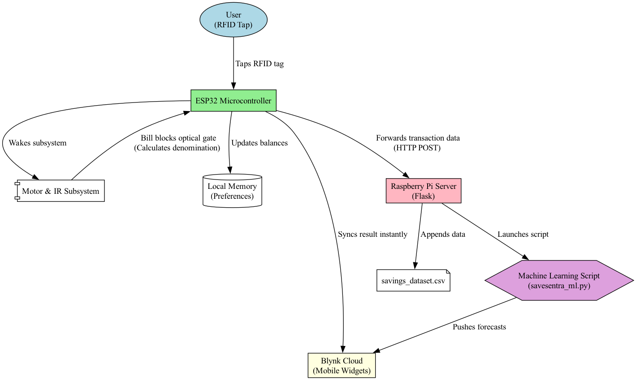

4.2 Hardware Development and Firmware Logic

ESP32 Memory Management
Users' financial information must be protected, particularly to ensure that users will never lose power and will always protect their savings. Standard Arduinos have EEPROM, but the ESP32 uses a more sophisticated flash-based Preferences library, which works like a key-value pair database. While running the loadUsers() function as part of the setup, the firmware rebuilds the active state as follows:
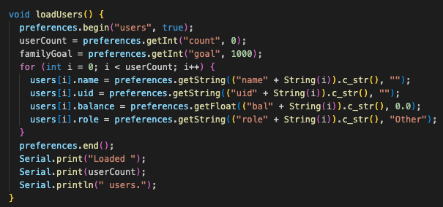

Denomination Identification
Commercial bill acceptors rely on expensive camera modules or magnetic sensors to identify specific ink patterns. To keep SaveSentra cost-effective and strictly IoT-focused, a mechanical estimation was implemented.
The stepper motor drives the bill inward at a constant speed. The TCRT5000 IR sensor sits at the entry. As long as the bill blocks the IR reflection, the firmware increments a step counter. Because AED bills vary in length depending on their denomination, a longer bill naturally occupies the sensor for a slightly greater number of mechanical steps.
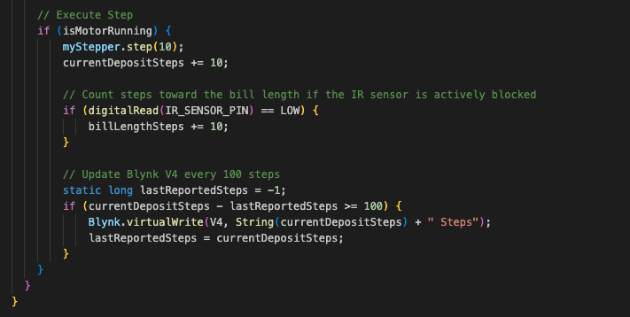
When the sensor clears (indicating completion of the physical bill), the logic block assesses the total billLengthSteps to determine the value of the bill deposited:

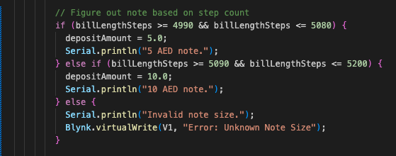

Cloud Synchronization
Once a legitimate deposit is verified, the ESP32 carries out a series of network operations. The first of these is the use of the Blynk.virtualWrite() functions, which updates the mobile app gauges for the individual and family totals. Right after that, it creates an HTTPClient to communicate locally with the Raspberry Pi.
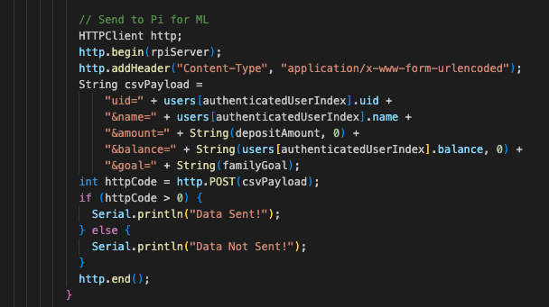

4.3 Raspberry Pi Backend Development
The local server was built with Python using the Flask framework. Its main job is to handle the ESP32 edge device’s HTTP POST requests, process the payload, create a high-fidelity system timestamp, and securely store the data in the primary savings_dataset.csv file.
The server needs to activate the predictive pipeline after the data has been entered onto the ledger. Notably, the Flask server uses the typical subprocess module to start the Python ML script as a separate process. The goal parameter sent from the ESP32 is included as a command line argument.
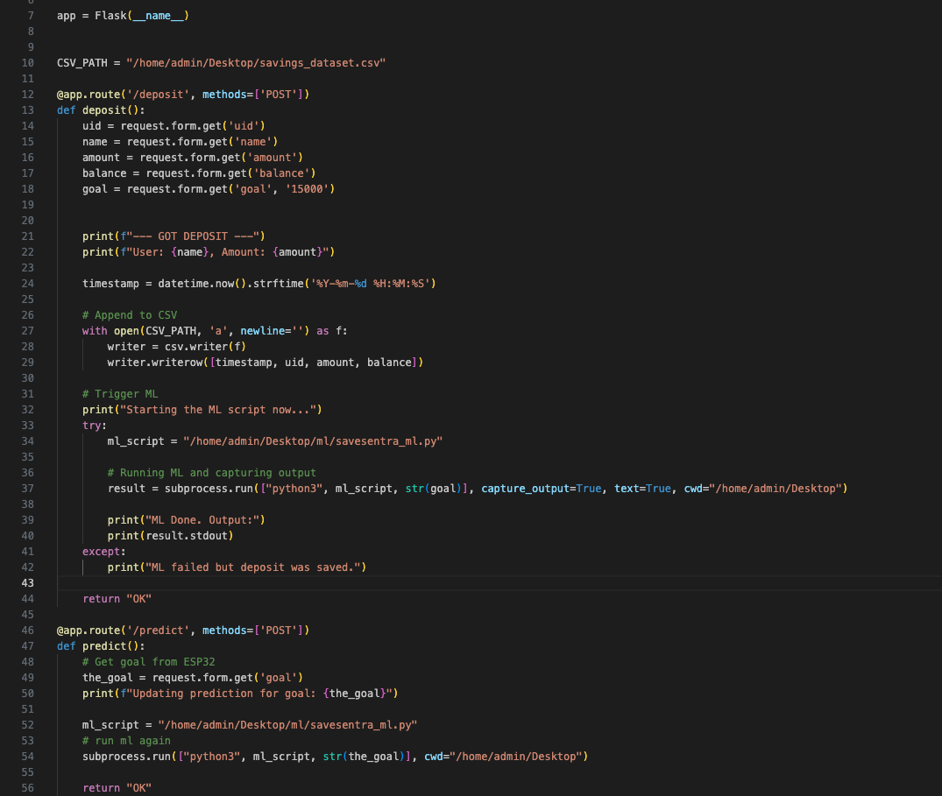

4.4 The Mobile Application Interface (Blynk)
The user-facing element of the SaveSentra ecosystem is hosted entirely on the Blynk IoT platform. This mobile dashboard was designed to provide an intuitive experience for standard users (children) while maintaining a secure, hidden administrative layer for parents.
The integration between the physical ESP32 hardware and the cloud interface is managed through Blynk's Virtual Pins. When a user authenticates via their RFID tag, the firmware pushes variables to the cloud to dynamically build their specific role based view.
For instance, the user's individual balance and the overarching family total are synchronized and/or a dynamic percentage calculation compares the user's current balance against the family goal set by the parent.
Two distinct label widgets, Target Completion Date (V16) and Top Contributor (V17)—are updated directly from the Python backend via HTTPS GET requests, bypassing the ESP32 entirely to deliver real-time prediction to the family's mobile devices.
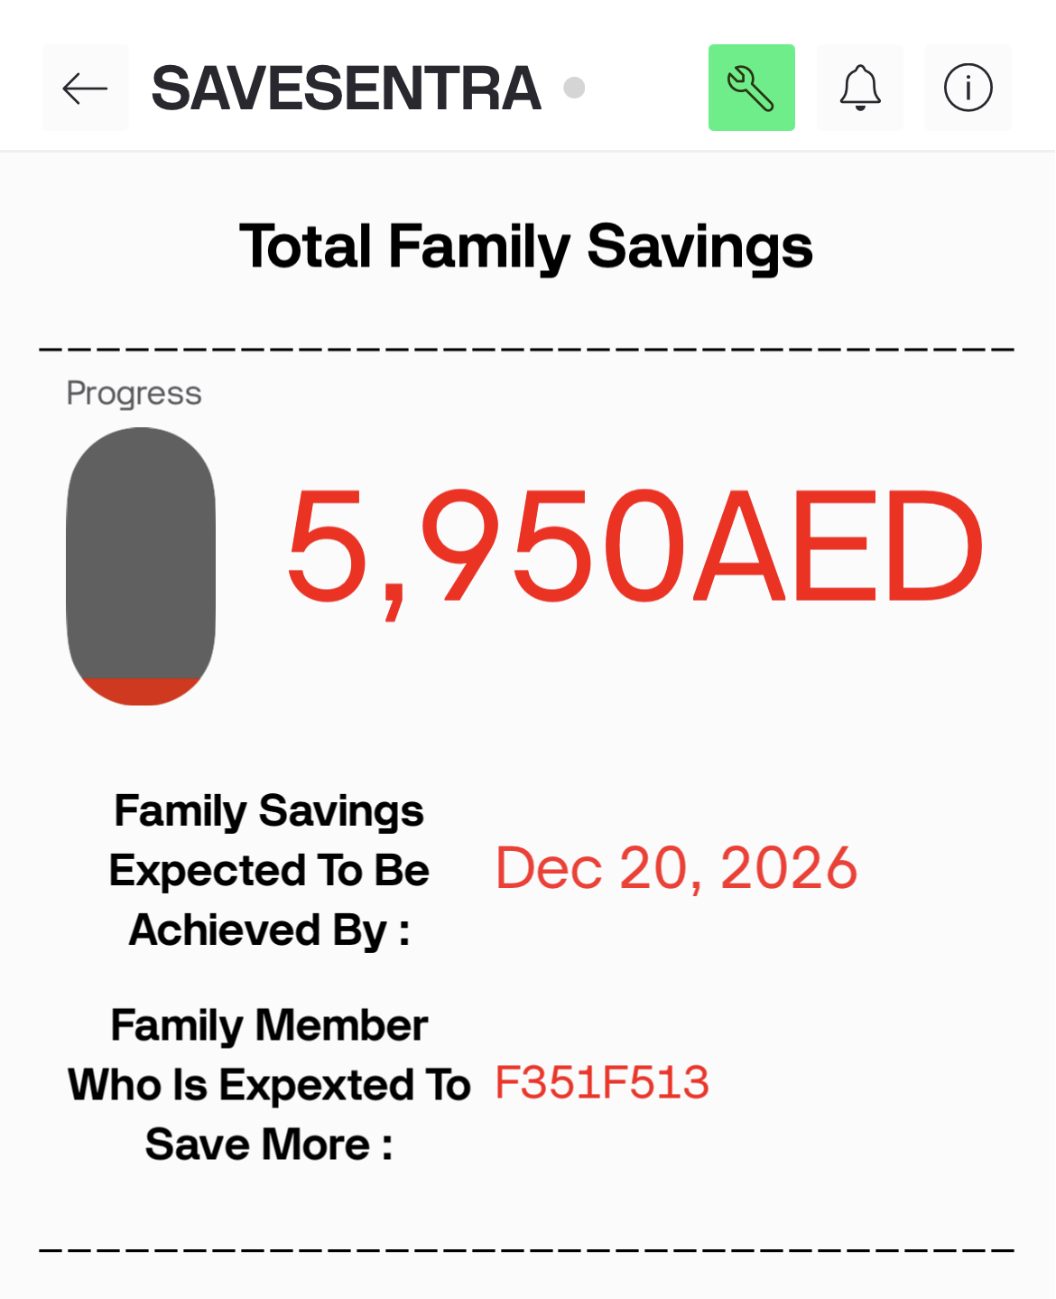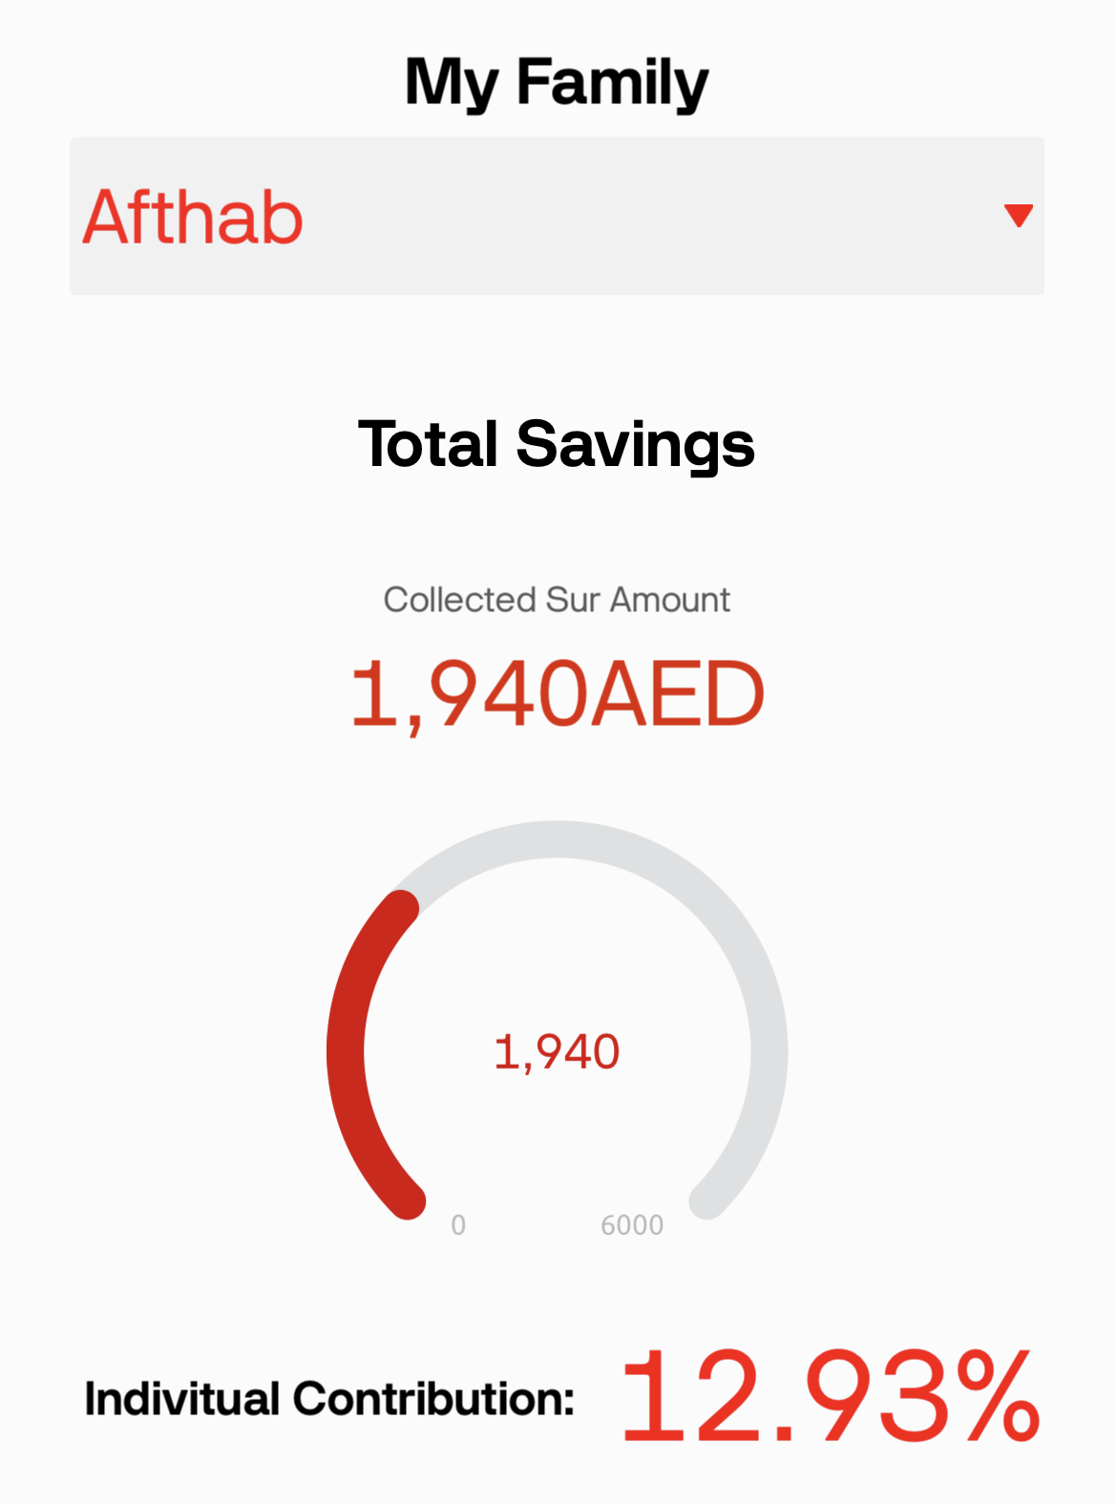
The ESP32 logic also strictly filters which dashboard elements are shown based on the authenticated user's assigned role. Standard users only see their savings metrics.
However, when a user with the "Parent" role taps their RFID card, the firmware actively unhides the administrative toolkit on the dashboard by manipulating the isHidden property of specific widgets
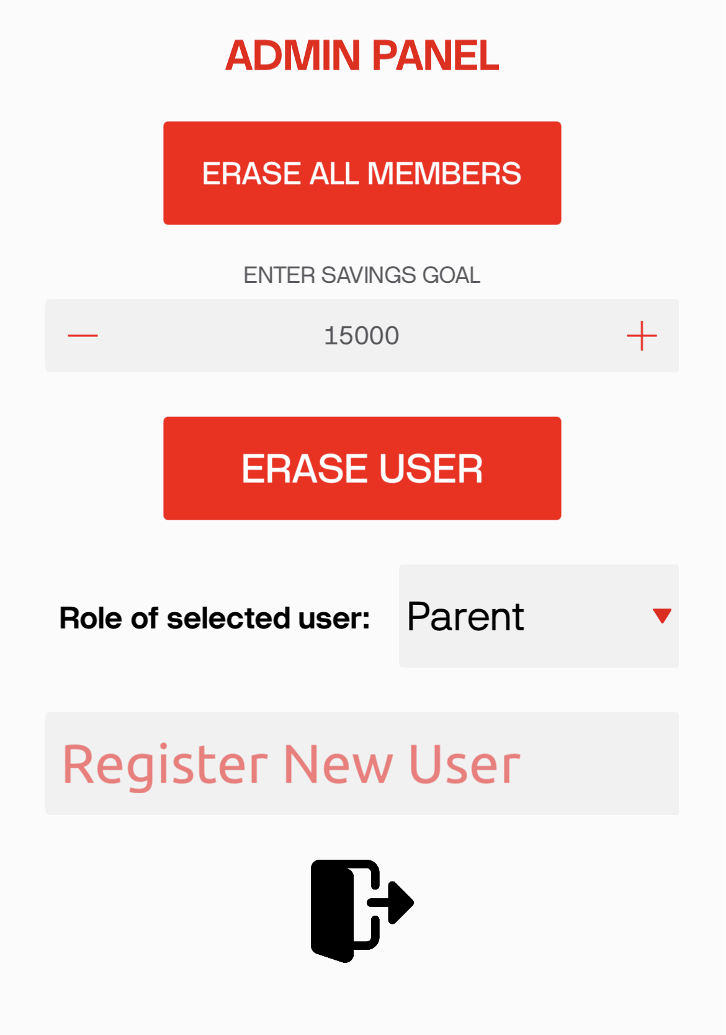
Through this secure layer, parents can dynamically register new RFID tags, adjust the target FAMILY_GOAL (which actively recalculates all ML predictions), erase users and even assign roles.
*App code explanations or screenshots are not included. Please refer code files*

Chapter 5 – Testing and Evaluation

During the entire development lifecycle, strong evaluation methods were put in place to ensure that the system's ability to cope with edge anomalies and reliability in household environment were still effective.

5.1 Physical Threshold Calibration
The motor step-counting denomination technique is based on some statistical assumptions. For the sake of accuracy, one test bank of 5 AED and 10 AED notes in different physical states (crumbled and slightly worn) was used. The script was designed to dump the raw billLengthSteps to the Serial monitor.
After individual insertions:
- 5 AED notes produced an average of 5035 steps.
- 10 AED notes consistently tracked slightly longer length, averaging 5145 steps.

This supported the validity of the method. When other materials such as ripped paper strips or pieces of cardboard were added, the total step counts dropped considerably below or above the hardcoded 4990-5200 range. The firmware appropriately classified these occurrences into the else block, resulting in zero deposits and avoiding false marking.

5.2 Wi-Fi and Data Preservation

Internet connectivity within an IoT ecosystem can be unpredictable. Testing scenarios were introduced where the local Wi-Fi router was forcefully restarted mid-transaction. Due to the nature of the ESP32 code, even if the HTTP POST to the local Raspberry Pi timed out, the internal non-volatile preferences.putFloat() memory block remained intact. When connectivity was restored, the individual’s monetary balance accurately reflected the last bill on the next card tap.

5.3 Application Security Testing
Role-Based Access Control was tested via the Blynk App. The system applies rigid administrative control. Children users had RFID tags assigned and set to the generic “Child” or “Other” role. During authentication, the dashboard's isHidden properties were checked to confirm that standard users could not view or modify the critical controls (V0 entry registration, control V7 parameter setting, control V8 delete button). It was verified that only when a profile with the ‘Parent' role flag was scanned, the ESP32 triggered Blynk.setProperty(V0, “isHidden”, false); to show the hidden management dashboard features; thus, providing a family friendly secure admin layer.

Chapter 6 – Machine Learning Steps
The introduction of Machine Learning (ML) transforms SaveSentra from a static program into a predictive, analytical engine. This section provides a rigorous, step-by-step breakdown of the applied machine learning methodology, starting from raw data collection and ending with actionable, cloud-synchronized predictions. The process rigidly follows an eight-stage pipeline implemented in the savesentra_ml.py script.

6.0 Data Set Collection
Any predictive modeling will depend on underlying data quality and data structure. The main dataset, savings_dataset.csv, is constructed dynamically over time by the Raspberry Pi server. Each row represents one authenticated hardware transaction.
Structurally, the data encompasses four major dimensions:
- Timestamp: The exact local chronological marker (e.g., 2025-09-01 10:47:06), acting as the spine of our time-series analysis.
- NFC_UID: A string identifying the specific family member responsible for the transaction.
- Deposit_Amount: The integer value of the deposited UAE Dirham (AED) banknote, derived mechanically via the stepper motor algorithm.
- Total_Balance: The sequential, continuous summation of the specific user's cumulative savings.
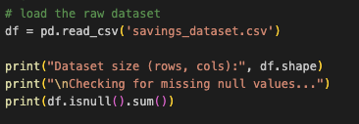

6.1 Data Cleaning and Formatting
The original datasets contain flaws due to noise, redundancy, and inconsistent formatting. Such imperfections can compromise the mathematical accuracy of a machine learning model. The savesentra_ml.py pipeline, however, implements a powerful sanitization protocol at the outset.
First, standard pandas CSV loading reads timestamps as generic Python strings, which strips them of their chronological value.
The script then performs a cleaning for duplicate values. The df.drop_duplicates() function clears the duplicates from the ledger, so a single transaction cannot, for instance, artificially increase the historical trend.

Lastly, a filter actively enforces financial validity. In the UAE, paper currency is issued in specific denominations. A list is defined: allowed_notes = [5, 10, 20, 50, 100, 200]. Any transaction where the Deposit_Amount deviates from these values is instantly flagged as an error and discarded.

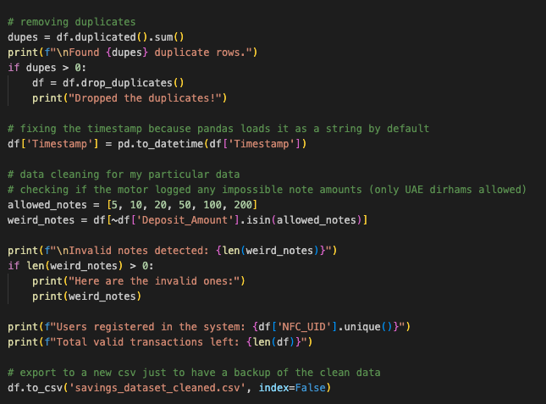

6.2 Exploratory Data Analysis (EDA)
Before writing the ML forecasting functions, it was crucial to visualize and understand the patterns within the data. This visual display occurred within a Jupyter Notebook (EDA.ipynb), utilizing matplotlib and seaborn through various bar charts and heat maps.
The resulting Area Plots and Bar Charts showed distinct information. Some users deposited frequently on weekends, while overall family savings was through mid-week. This confirmed the need of regression models capable of parsing multi-dimensional habits.
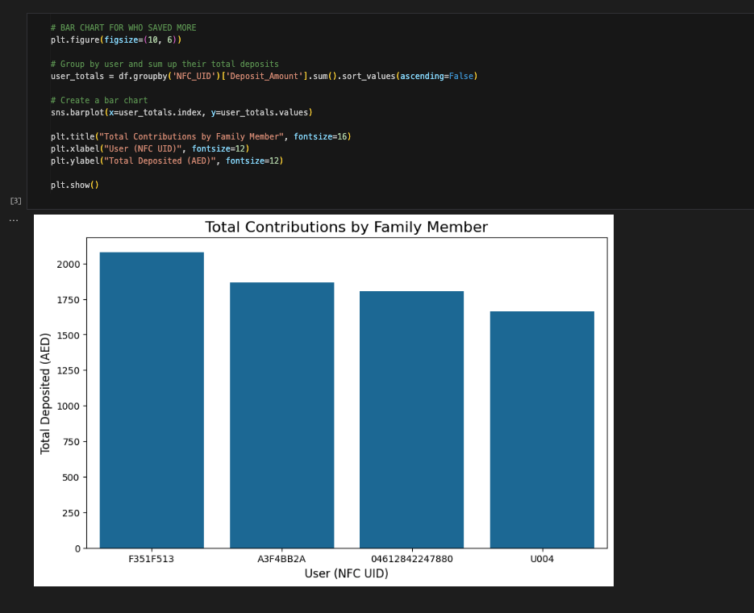
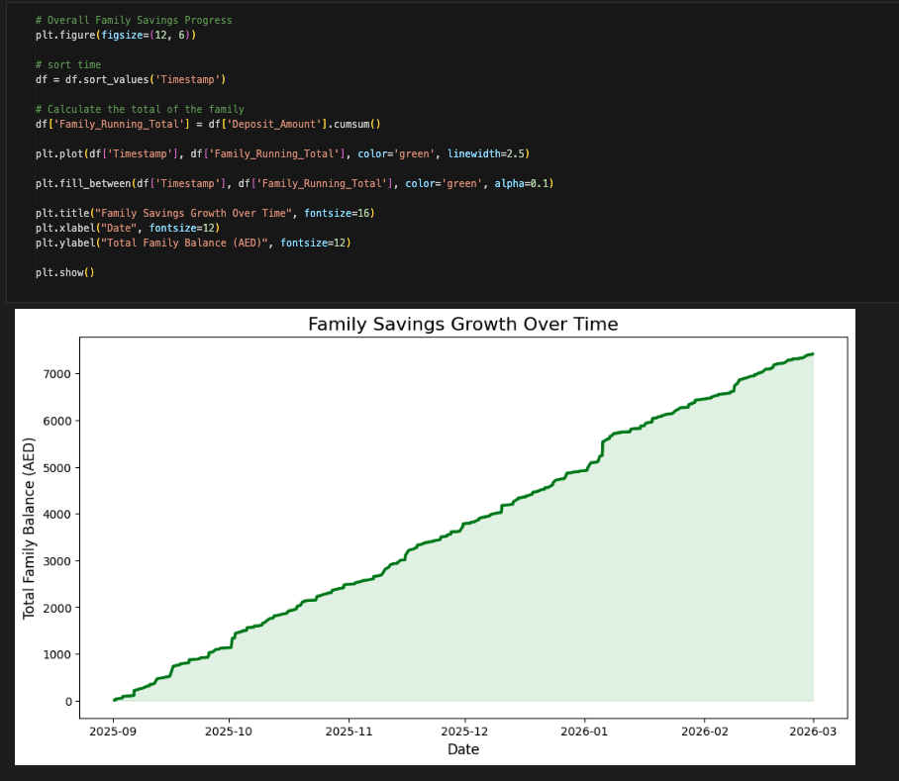
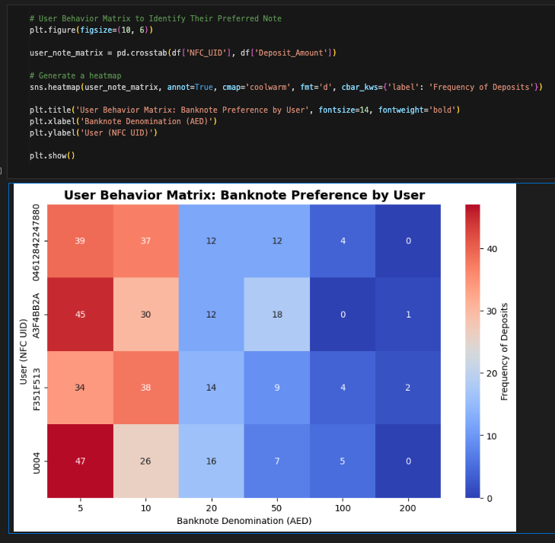
* all EDA features are not displayed here and is attached in the jupyter notbook file*

6.3 Feature Engineering and Selection
Machine learning algorithms interpret only numbers; they do not understand "Tuesdays" or "September." Feature engineering is the process of extracting the underlying data inside that chronological metadata and mapping them to structured numerical columns.
With the data restructured into a day-by-day layout, the script uses pandas functions to seperate four distinct behavioral features out of every specific date
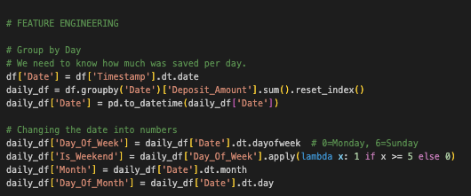

The script trims away the raw strings and IDs, defining ['Day_Of_Week', 'Is_Weekend', 'Month', 'Day_Of_Month'] as the explicit input matrix (X), mapping strictly against the target Deposit_Amount (y).

6.4 Compare Machine Learning Models on a Performance Metric
Considering the goal is forecasting daily amounts (AED) in the form of continuous numerical precision, the system requires a shootout style competition between different regression algorithms to achieve the best possible prediction accuracy. The train_test_split function holds out 20% of the daily historical data as a blind evaluation set.
Three robust algorithms are imported from scikit-learn to represent varied structural approaches
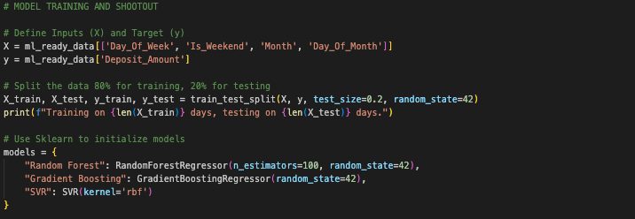
The script independently loops through all three iterations. They all receive extensive training on X_train and are instructed to provide predictions on X_test. To measure and compare their precision, the script provides the Mean Absolute Error (MAE). The MAE captured the absolute difference between the computational prediction and the actual withheld data resulting in an error represented in dirhams (AED). The loop automatically designates the methodically better model to the winning_model variable.
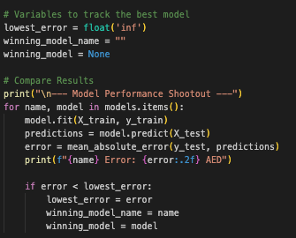

6.5 Hyperparameter Tuning on the Best Model
In the predictive shootout phase, Support Vector Regression (SVR) clearly dominated the competition by achieving a far superior performance than all ensemble-method based predictors. The Random Forest Regressor achieved a Mean Absolute Error (MAE) of 33.39 AED, the Mean Absolute Error for the Gradient Boosting model was 31.65 AED, while SVR minimized the historical error margin even further to 28.10 AED. This demonstration illustrated that for this dataset’s behavior.

6.6 Evaluate the Best Model
Prior to a deep exploration of the simulated future, the savesentra_ml.py script carries out a mandatory "final fit." It instructs the adjusted mathematical model to absorb the last part of the database tracked historically (X and y).
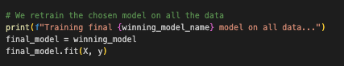
This absolute re-training is essential. It guarantees the SVR model absorbs the up-to-date data rows recorded by the Raspberry Pi, ensuring no recent behavioral momentum is discarded.

6.7 Interpret the Model Results
With a fully reinforced SVR loaded into memory, the script starts a day-by-day continuous simulation algorithm. The program identifies the present chronological date, retrieves the target FAMILY_GOAL sent by the Flask server as an argument, and begins its flow.
With datetime.timedelta(days=days_ahead), the code sequentially activates the features (Month, Is_Weekend, etc.) for tomorrow, the day after tomorrow, and so on into the future.
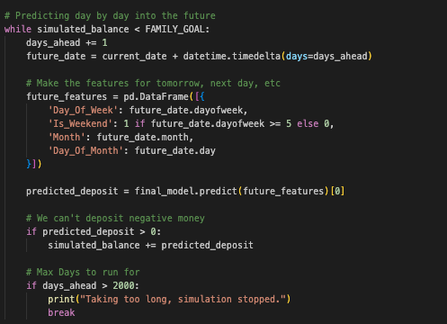
The logic iterates, actively depositing theoretical future cash into the simulated_balance. This loop calculates a final, human-readable target value.

To add further analytics, the system identifies the potential top contributor. Extracting the NFC_UID aggregations, it determines which user commands the strongest statistical trajectory over the upcoming days, assigning the winner to top_user_uid.

6.8 Send Conclusions
The last stage of the machine learning pipeline is cloud storage.
The savesentra_ml.py uses the powerful Python requests library to format standard HTTPS GET requests, sending the predictions immediately across the internet and updating the parameters of the original SaveSentra blynk dashboard.
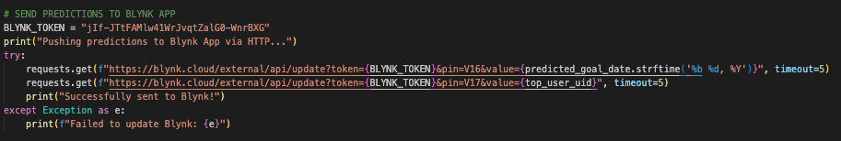
This final step completes the deployment of the pipeline into a smart saving ecosystem.

Chapter 7 – Conclusion

7.1 Future Development
- Security and Fraud Prevention: The existing stepper-motor time-driven denomination calculation is highly accurate for well-maintained currency but vulnerable to perfectly dimensioned counterfeit paper. Integrating an Color Sensor or a UV light sensor at the intake would allow the ESP32 to cross-reference not just the bill's physical length, but the specific color profiles and UV security threads inside UAE banknotes. This would introduce absolute fraud rejection.
- Cloud Migration of the Predictive Pipeline: Currently, the savesentra_ml.py process is bound to the local computational constraints of the Raspberry Pi processor. As the dataset expands over years of use, the local Random Forest retraining time will linearly degrade. Migrating the core Python calculations to an AWS Lambda or Google Cloud Functions endpoint would decentralize the mathematical heavy lifting, allowing the Raspberry Pi to function purely as a secure network gateway rather than a computational workhorse. This shift would also open the door to deploying significantly more demanding deep learning architectures, such as Recurrent Neural Networks (RNNs).
- Enhanced Data Visualization Platform: While the Blynk framework facilitated fast prototype deployment, it does not act as a standalone app. Developing a custom, responsive mobile application via React Native or Flutter, interfaced directly to a dedicated cloud database, would allow the system to render custom, interactive widgets directly within the family's mobile dashboard.
- Expanded Denomination Acceptance and Security: The current hardware is accurate but structurally limited to validating only 5 and 10 AED notes based solely on their physical length using the stepper-motor time-driven calculation. Future iterations must mechanically expand the intake software to recognize the entire line of UAE Dirham denominations (e.g., 20, 50, 100).

7.2 Conclusion
The SaveSentra IoT Family Cash Deposit System successfully re-engineers the traditional way of physical saving into a deeply interactive digital framework. By integrating the versatile functions of an ESP32 microcontroller with a carefully designed stepping motor bill intake mechanism, the systems strategically converts a passive physical act into an active digital one.
The deployment of a localized Raspberry Pi backend ensures that raw family financial interactions are logged securely. The most significant achievement of the project lies within the seamless execution of the applied Machine Learning pipeline. The eight-step algorithm not only autonomously cleans and shapes complex behavioral data but actively predicts goal estimations and user leaderboards to the blynk mobile app.
In summary, SaveSentra modernizes the traditional piggy bank by bridging the gap between physical cash and digital tracking. It creates an engaging, transparent system that goes beyond simply counting money. Instead, it actively uses a Raspberry Pi and machine learning to encourage family accountability, turn saving into a fun game, and teach long-term financial habits.

Reference List
- Blynk Inc., Blynk IoT Platform Documentation. Available at: https://docs.blynk.io
- Arduino, ESP32 Preferences Library Documentation. Available at: https://github.com/vshymanskyy/Preferences
- Pallets Projects, Flask Documentation (2.0.x). Available at: https://flask.palletsprojects.com/
- Espressif Systems, ESP32 Series Datasheet. Version 3.9, 2022. Available at: https://www.espressif.com/

