Name: Afueth Thomas
Roll No: 2
Batch: B
Date: 21/3/2022

NETWORKING & SYSTEM ADMINISTRATION LAB

Experiment No :

Aim
Install Docker on Ubuntu
Procedure
Step 1: Open Terminal on Ubuntu
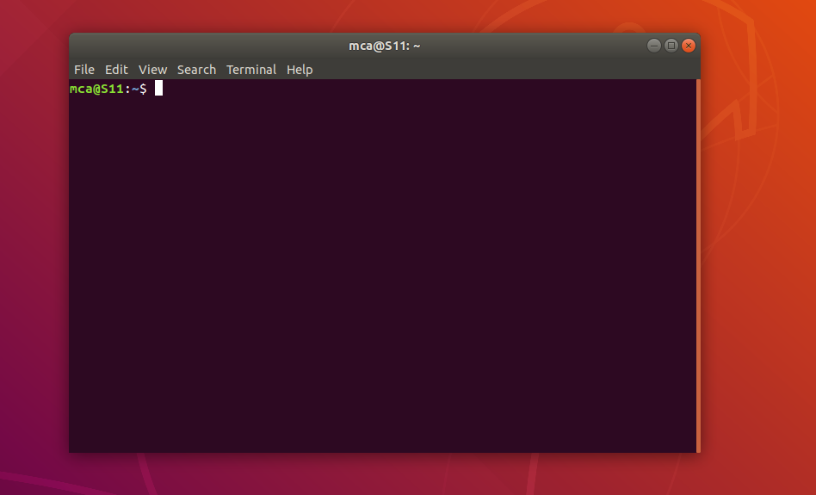

Step 2:
Remove any Docker files that are running in the system, using the following command
$ sudo apt-get remove docker docker-engine docker.io
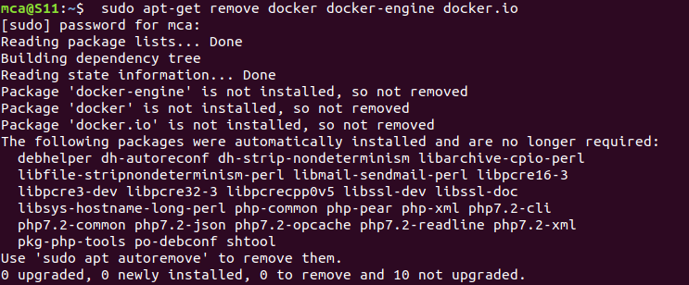

Step 3: Check if the system is up-to-date using the following command:
$ sudo apt-get update

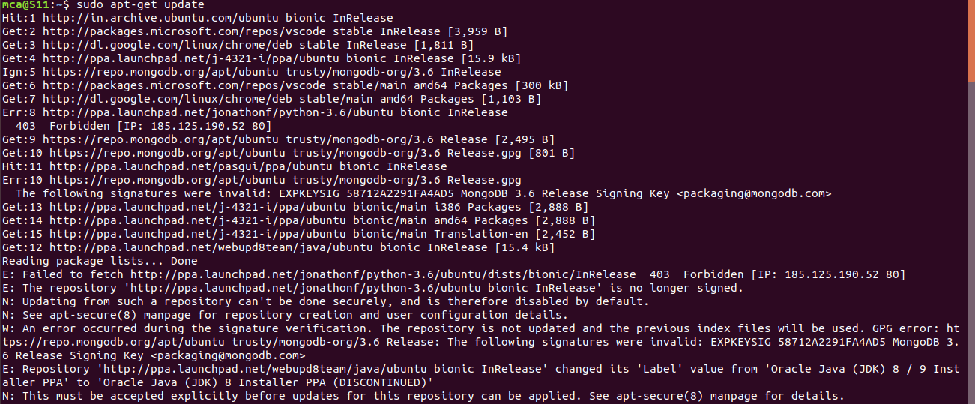

Step 4:
Install Docker using the following command:
$ sudo apt install docker.io
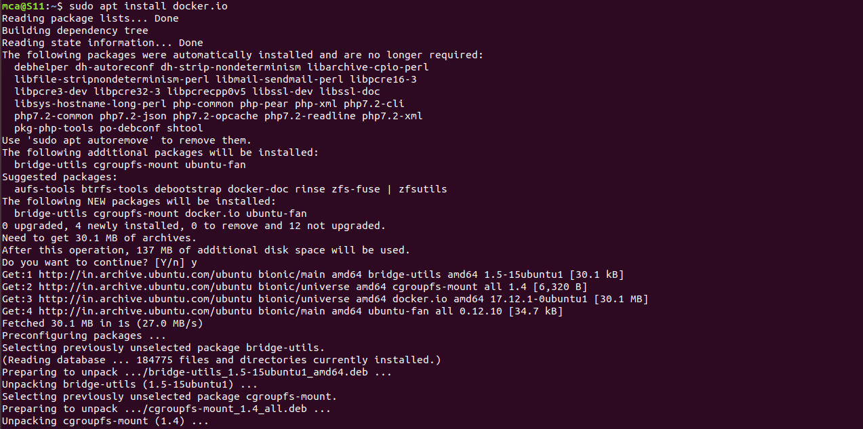

Step 5:
Install all the dependency packages using the following command:
$ sudo snap install docker

Step 6:
Before testing Docker, check the version installed using the following command:
$ docker –version

Step 7:
Pull an image from the Docker hub using the following command:
$ sudo docker run hello-world
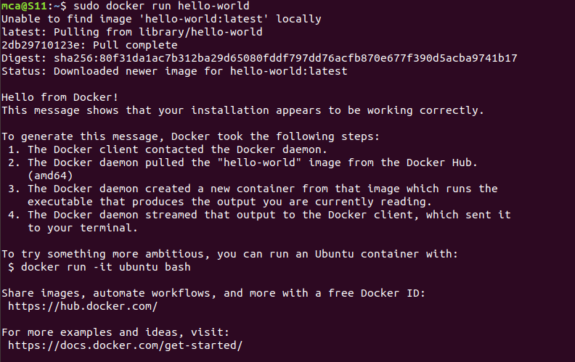
Step 8 :
Check if the docker image has been pulled and is present in your system using the following command:
$ sudo docker images

Step 9 :
To display all the containers pulled, use the following command:
$ sudo docker ps -a

Step 10 :
To check for containers in a running state, use the following command:
$ sudo docker ps

successfully installed Docker on Ubuntu!

