Name: Afueth Thomas
Roll No: 2
Batch: MCA B
Date: 05-05-2022

NETWORKING & SYSTEM ADMINISTRATION LAB

Experiment No: 8

Aim
Basic Shell scripting

Procedure
1. Shell script program for print the basic Details
Syntax:-
#!/bin/bash
echo "Enter the Name: "
read name
echo "Enter your Email: "
read email
echo "Enter you Course: "
read course
echo "Your details are : "
echo $name
echo $email
echo $course
Output:-
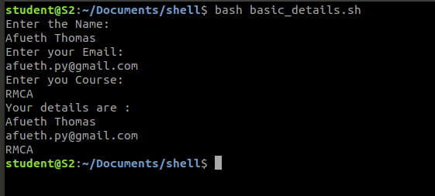

2. Shell script program for find sum of 2 numbers

Syntax:-
#!/bin/bash
echo "enter the first number"
read a
echo "enter the second number"
read b
sum=$(($a+$b))
echo "The sum of "$a "and" $b "is :" $sum
Output:-
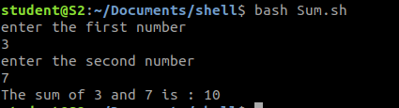

3. Shell script program for find the number is Odd or Even

Syntax:-
#!bin/bash
echo "Enter the number: "
read a
if [ $(($a%2)) -eq 0 ]
then
echo "The number is even"
else
echo "The number is odd"
fi

Output:
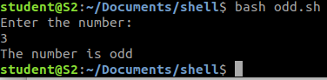

4. Shell script program for find largest among 3 numbers

Syntax:-
#!/bin/bash
read -p "Enter the First number :" a
read -p "Enter the Second number :" b
read -p "Enter the Third number :" c
if [ $a -gt $b -a $a -gt $c ]
then
echo $a "is Greater"
else
if [ $b -gt $a -a $b -gt $c ]
then
echo $b "is Greater"
else
echo $c "is Greater"
fi
fi

Output:
