Name: Afueth Thomas
Roll No: 2
Batch: MCA B
Date: 21-03-2022

NETWORKING & SYSTEM ADMINISTRATION LAB

Experiment No.: 4

Aim
Familiarization of basic Linux commands part 2

Procedure
1. cut -d ‘ ‘ f2
This commands in Linux allows you to select the second part of the content that split by ‘ ‘ delimiter.
Syntax:- $ cut -d ‘ ‘ f2 filename.txt
Output:-
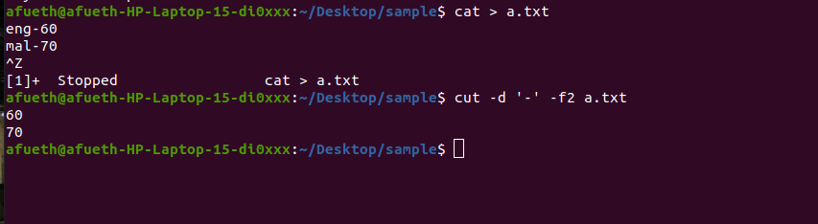

2. cut -b 2
This command in Linux allows to select only these bytes.
Syntax:- $ cut -b 2 filename

Output:-

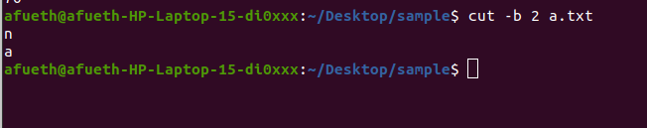

3. cut –complement
This command helps to exclude given bytes.
Syntax:- $ cut –complement -c 1 filename
Output:-

4. paste
This command helps to paste contents to other file
Syntax:- $ paste filename > filename2
Output:-
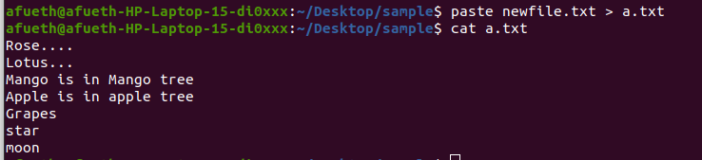

5. paste a b > c
This command helps to paste from multiple files.
Syntax:- $ paste file1 file2 > file3

Output:- 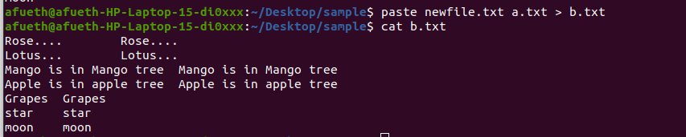
6. paste -d ‘ ‘
This command helps to paste contents with ‘ ‘ delimiter.
Syntax:- $ paste -d ‘ ‘ file1 file 2 > file3
Output:-
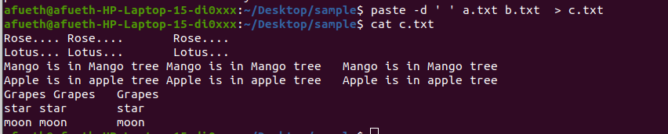

7. paste -d ‘-‘
This command helps to contents from multiple files with ‘-‘ delimiter.
Syntax:- $ paste -d ‘-‘ file1 file2 > file3
Output:-
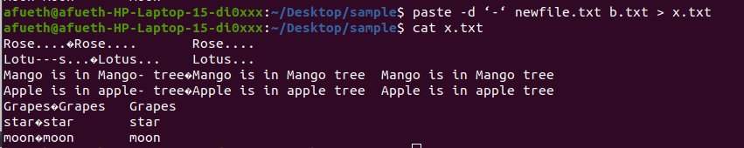

8. paste -s
This command helps to paste on file at a time instead of in parallel.
Syntax:- $ paste -s file1 file2 > file3.
Output:-
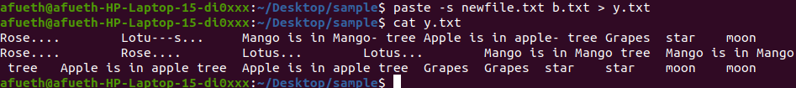

9. more
More command is used to view the text files in the command prompt, displaying one screen at a time in case the file is large.
Syntax:- $ more filename.

Output:-

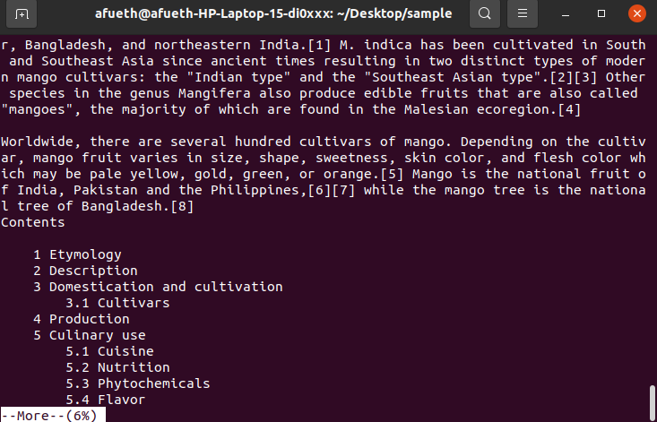

10. more -s
This command is used to squeeze multiple blank lines into one.
Syntax:- $ more -s filename.

Output:-
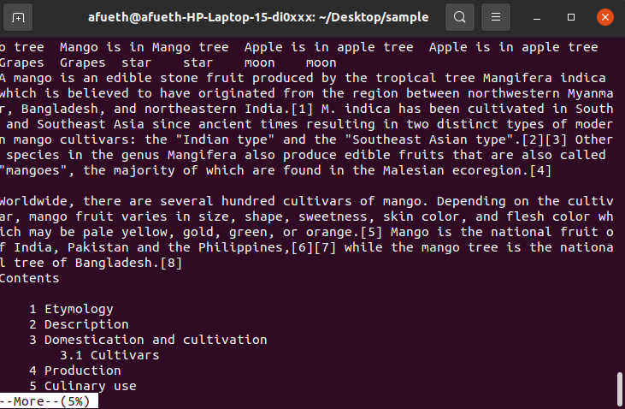
11. more –(no.)
This command helps to view content based on specified number of lines.
Syntax:- $ more -4 filename.
Output:-
