Name: Afueth Thomas
Roll No: 2
Batch: MCA B
Date: 21-04-2022

NETWORKING & SYSTEM ADMINISTRATION LAB

Experiment No.: 5

Aim
Familiarization of basic Linux commands part 4

Procedure
1. read
To read the content of a line to a variable
Syntax:- $ read variable_name
content
echo $variable_name
Output:-
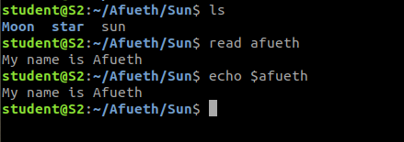

2. locate
Locate a file or Directory from any folder
Syntax:- $ locate filename
Output:-
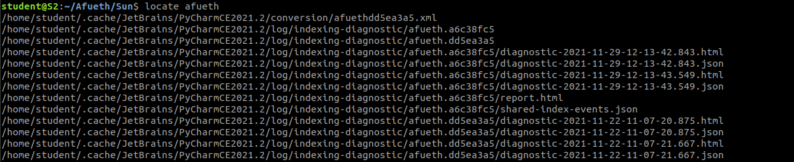
3. Find
Find a file or directory from current working directory
Syntax:- $ find filename
Output:-
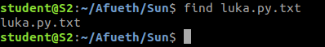

4. grep
Grep command will let you search through all the text in a given file
Syntax:- grep filename
Output:-

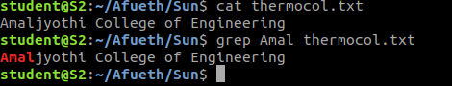

5. grep -i
For an case sensetive search.
Syntax:- $ grep -i word filename
Output:-
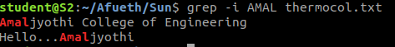

6. grep -v
For an inverted Search.
Syntax:- $ grep -v word filename
Output:-

7. grep |
Highlight the given word.
Syntax:- $ cat filename.txt | grep word
Output:-

8. grep -A1
For a search with next line with the searched word.
Syntax:- $ grep -A1 word
Output:-
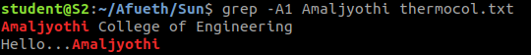

9. grep b1
For a search with before line with the searched word
Syntax:- $ grep -b1 word
Output:-
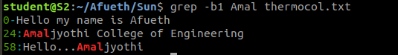

10. df
The command is used for get a report on system disk usage
Syntax:- $ df
Output:-
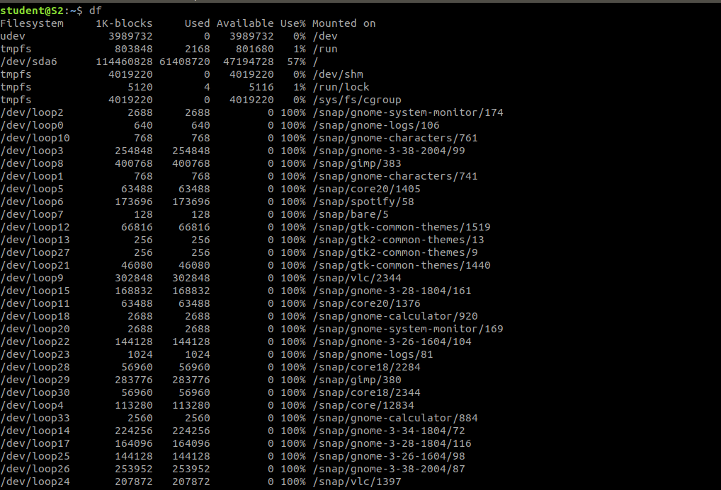

11. df -m
View the set of reports in MB
Syntax:- $ df -m
Output:-
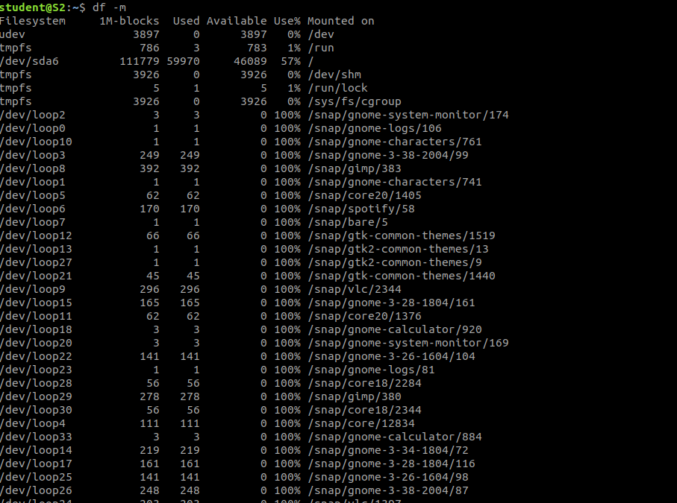

12. du
Find a file or directory used disk space
Syntax:- $ du
Output:-
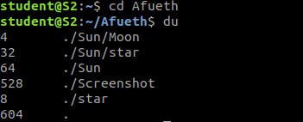

13. wc
Command used for counting the words ,lines, characters,bytes.
Syntax:- $ wc
Output:-

14. wc -l
Command used for counting the lines.
Syntax:- $ wc -l
Output:-

15. wc -w
Command used for counting the words.
Syntax:- $ wc -w
Output:-

16. wc -c
Command used for counting the characters.
Syntax:- $ wc -c
Output:-

17. wc -m
Command used for counting the bytes.
Syntax:- $ wc -m
Output:-

