Name: Afueth Thomas
Roll No: 2
Batch: MCA B
Date:25-03-2022

NETWORKING & SYSTEM ADMINISTRATION LAB

Experiment No.: 3

Aim
Familiarization of basic linux commands
Procedure
1.$ pwd
Shows the present working directory
Syntax: $pwd
Output:
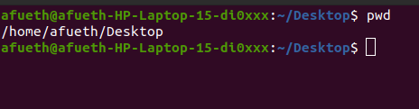

2.$mkdir
Make a directory
Syntax: $mkdir <directory_name>
Output:
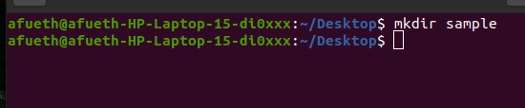

3.$ ls
List the contents of a directory , By default it display all the contents of present working directory.
Syntax: $ls
Output:
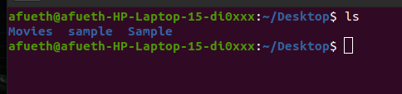

4.$ ls -l
Used for long listing. List all the files in sub-directories as well
Syntax: $ls -l
Output:
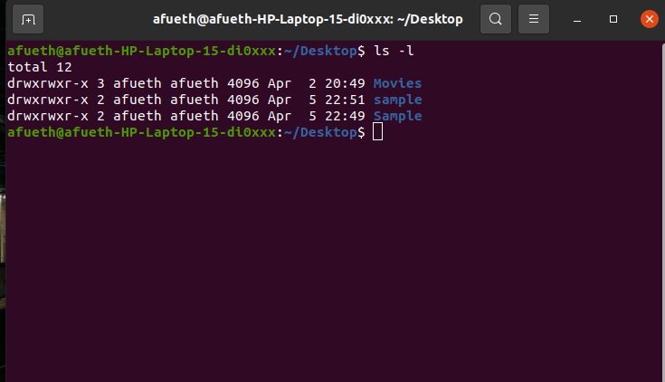

5.$ ls -F
List files and directories with ‘/’ character at the end
Syntax: $ls -F
Output:
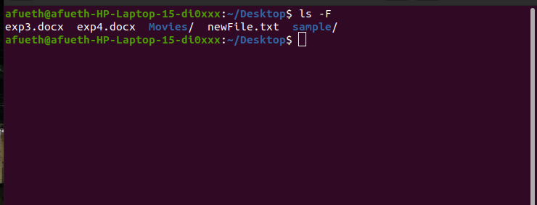

6.$ ls -r
List files in reverse order in linux
Syntax: $ls -r
Output:
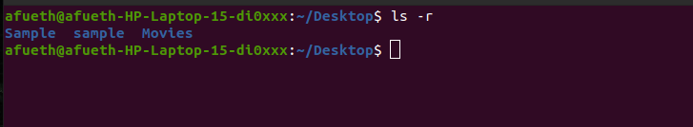

7.$ls -R
Recursively list sub-directories in linux
Syntax: $ls -R
Output:
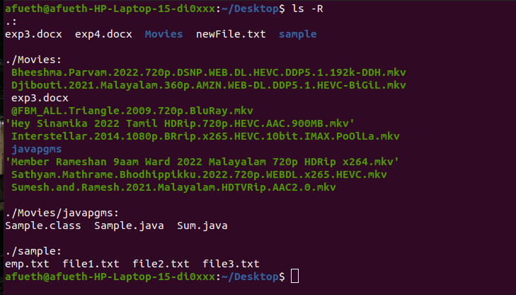

8.$ ls -ltr
List files and directories in reverse order in linux
Syntax: $ls -ltr
Output:
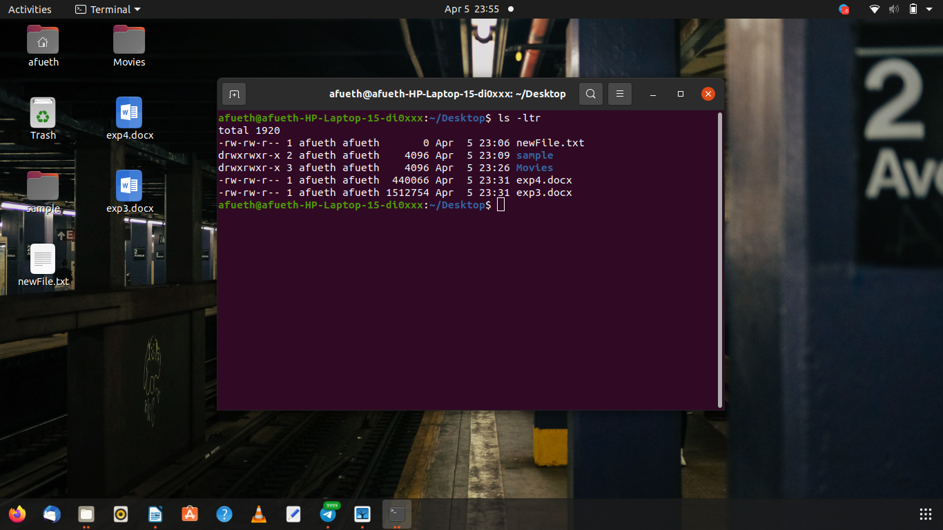

9.$ ls -lS
Sort files by file size in linux
Syntax: $ls -IS
Output:
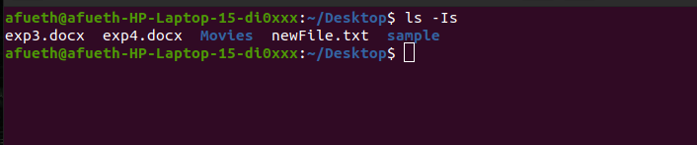

10.$ ls -i
Display inode number of file or directory
Syntax: $ls -i
Output:
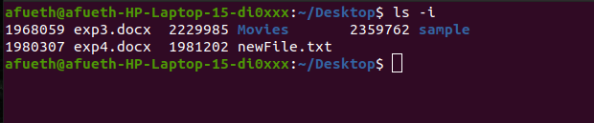

11.$ls -a
This command is used to display all files including hidden files.
Syntax: $ls -a
Output:
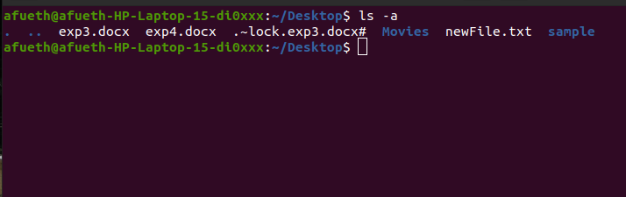

12. $ls -al
This command will list all the files and directories with detailed information like
Permission,size,owner etc.
Syntax: $ls -al
Output:
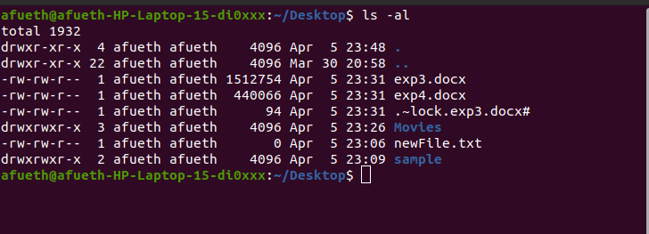

13. $ls -t
The command used to display the files sorted in the order of last modification
Syntax: $ls -t
Output:
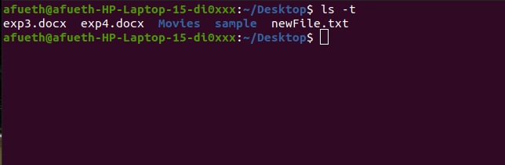

14.$ ls –version
Shows version of ls command
Syntax: $ls –version
Output:
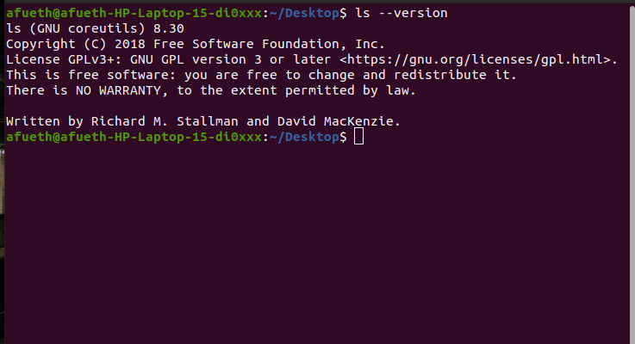

15.$ ls --help
Show ls command help page
Syntax: $ls –help
Output:
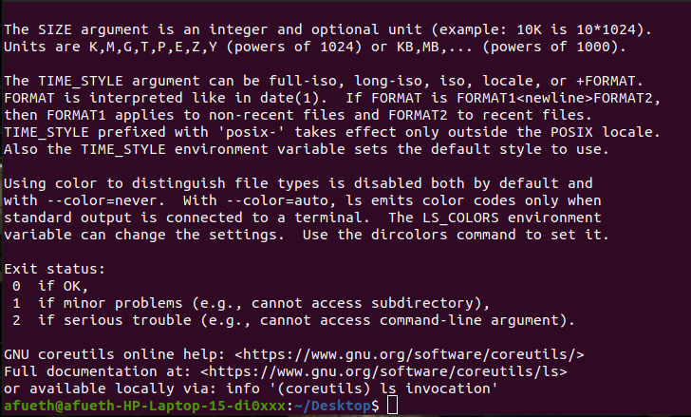

16.$ ls -l /tmp
List directory information in linux
Syntax: $ls -l /tmp
Output:
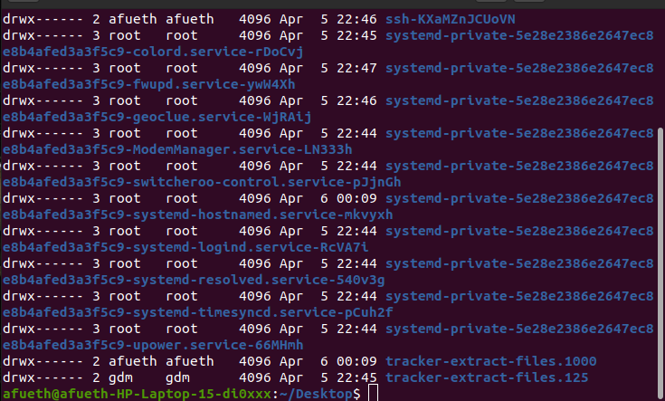

17.$ ls -n
Display UID and GID of files
Syntax: $ls -n
Output:
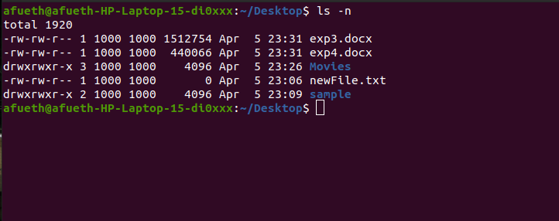

18.$ cd
Change directory
Syntax: $cd <path>
Output:
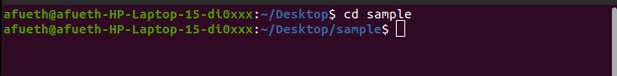
19.$ mkdir <foldername>
To make new directory
Syntax: $mkdir <directoryname>
Output:

20.$ touch <filename>
To create a file in a directory
Syntax: $touch <filename>
Output:
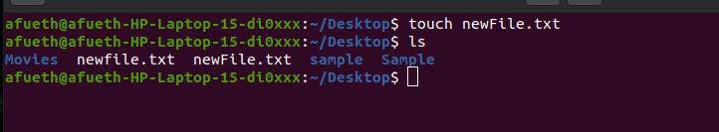

21.$ rm <filename>
To delete a file from the directory
Syntax: $rm <filename>
Output:
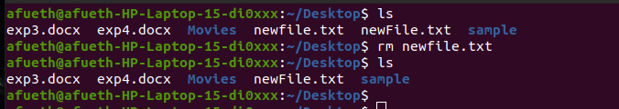

22. $cat > filename
This command is used to create a file and add contents to it if necessary
Syntax: $cat > filename
Output:
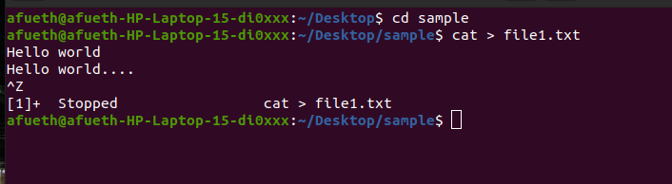

23. $cat >> filename
This command is used to add some contents to an already existing file
Syntax: $cat >> filename
Output:
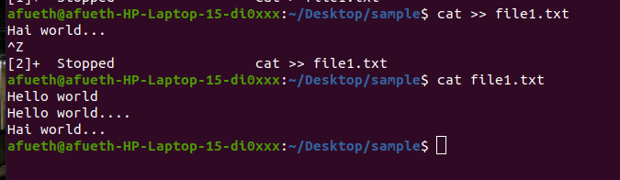

24. $cat filename1 > filename2
This command is used to copy the content of one file to another file
Syntax: $cat filename1 > filename2
Output:
