Deterministic vs. Stochastic Climate Inputs for RHEM-Snow
Does the unrealistic cross-correlation and auto-correlation in daily sequences of weather variables in the stochastic input given by CLIGEN cause bias in RHEM-Snow?
Andrew Fullhart, Patrick Broxton, and Haiyan Wei, 2025

Experiment: Paired sets of 30-year deterministic and stochastic daily climate inputs were tested in the snow model for 10 locations. The deterministic time series have more realistic cross-correlations between variables than the stochastic time series, which are known to have unrealistic cross-correlations. Basic statistics for daily snowmelt and rain-on snow events were checked for consistency between the two sets in order to quantify the degree of similarity or difference between the two sets when operating the model with daily time steps. These factors subsequently impact RHEM output, but the addition of the RHEM model component was not considered because the sub-daily precipitation factors given by CLIGEN cannot be easily determined for both sets of inputs.
Treatment: 30-year time series (1984-2013) were constructed from nearly complete GHCN-d precipitation records and complete PRISM temperature (4km) and DayMet solar radiation (1km) records. The same time series were then used to parameterize CLIGEN and produce 30-year stochastic time series. Both sets of climate inputs took the average daily wind speed time series from stochastic time series given by the existing U.S. CLIGEN ground network because the required CLIGEN wind parameters cannot be easily determined.

Locations:
State | Location | ghcndID | x | y | Pcp Rec % | cligenID
AZ | Flagstaff | USW00003103 | -111.666 | 35.1442 | 99.76044 | AZ023010
ID | Deer Flat | USC00102444 | -116.748 | 43.5764 | 96.20123 | ID102444
MT | Billings | USC00244345 | -108.245 | 45.9228 | 94.74333 | MT244345
ND | Bismark | USC00325479 | -100.91 | 46.8128 | 98.41205 | ND325479
SD | Badlands | USC00394184 | -101.941 | 43.7483 | 96.91992 | SD394184
NE | Ogallala | USC00256200 | -101.721 | 41.1275 | 96.27652 | NE256200
WY | Laramie | USW00024022 | -105.673 | 41.3164 | 100 | WY485415
CO | Greeley | USC00053553 | -104.699 | 40.4022 | 99.52088 | CO053553
NV | Reno | USW00023185 | -119.768 | 39.5078 | 99.99316 | NV266779
UT | Great Salt Lake | USC00423097 | -112.198 | 40.7242 | 95.85216 | UT423097

Summary of Results: Overall, the comparison shows close agreement between deterministic and stochastic outcomes. The snow budgets, the distributions of melt accumulation, and the top 10 largest melt and rain-on-snow events all compare reasonably well. There is some scatter in the relationships that show the stochastic vs. deterministic results, but the relationships generally follow the 1:1 line (Figure 1), indicating that there is not an overall bias that occurs because of the CLIGEN data not preserving the cross-correlation between variables. In fact, any resequencing of weather events (i.e., changing the auto-correlation) is likely to lead to some differences even if there were perfect cross-correlations between variables. The cumulative frequency of snowmelt at different intensities are also generally close and range from being nearly identical to showing some modest differences (Figure 2).
One potential difference that can occur in the RHEM-Snow simulations is that there are differences in how snowpack builds between snowy winters and winters with less snow, because these winters can be characterized by strings of wet months or dry months. For example, Figure 3 shows that during snowy winters, Peak SWE tends to be higher in the deterministic simulations.
Overall, these results suggest that issues with unrealistic cross-correlations between CLIGEN variables have relatively little impact on the distribution of snowmelt in RHEM-Snow, which is the factor that drives the runoff and erosion calculations.

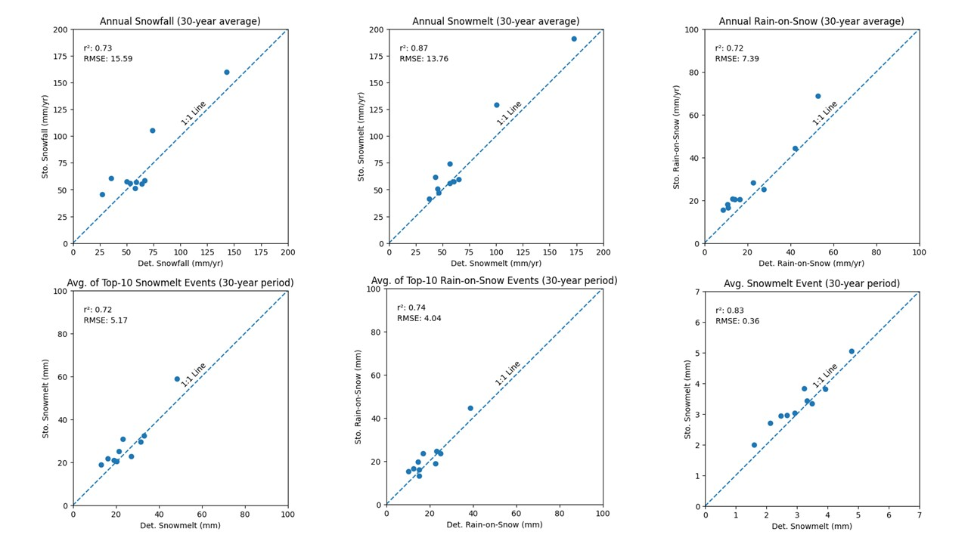

Figure 1: Scatterplots of Stochastic vs. Deterministic snow budget factors. The top row shows annual stochastic vs. deterministic values of snowfall, snowmelt, and rain-on-snow, and the bottom row shows the size of the top 10 snowmelt and rain-on-snow events in the deterministic and stochastic simulations, as well as the average snowmelt event.
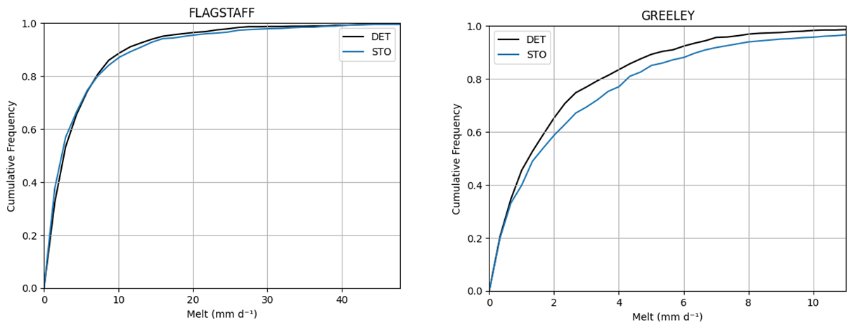
Figure 2: Examples of better (left) and worse (right) agreement between the intensity-frequency distributions of snowmelt for individual stations.

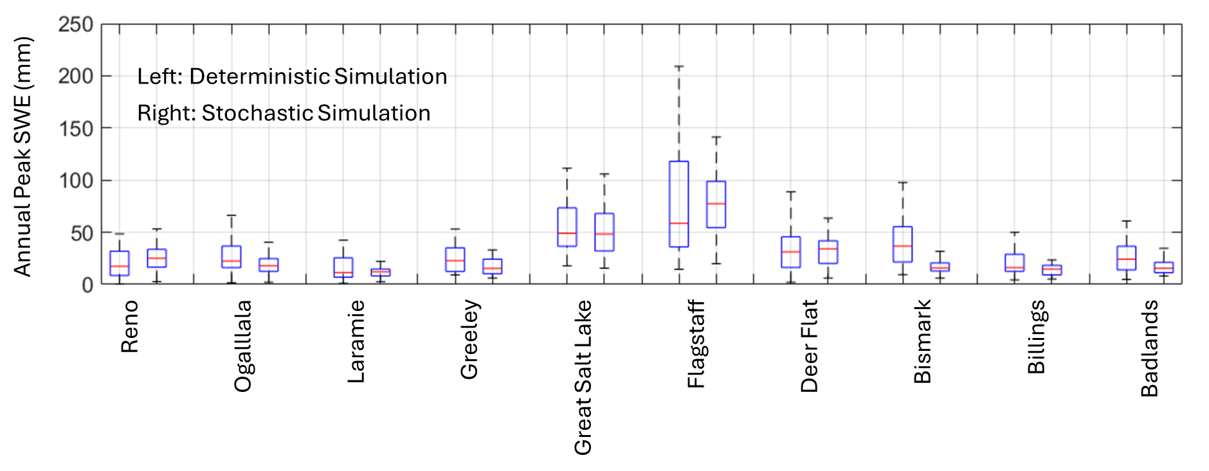
Figure 3: Boxplots showing the distributions of annual peak SWE in the stochastic and deterministic simulations. For each pair of bars at each site, the bar on the left shows the distribution of peak SWE in the deterministic simulation, and the bar on the right shows its distribution in the stochastic simulation.

