Evaluation of 3D Human Pose Estimation with 2D Marginal Heatmaps
Simon Badgett & Alberto Fung

For this project we chose to evaluate the paper “3D Human Pose Estimation with 2D Marginal Heatmaps” by Aiden Nibali, Zhen He, Stuart Morgan, and Luke Prendergast from La Trobe University, Australia. The stated goal of the paper is to generate an accurate human pose, in 3D, from a single 2D RGB image, with no separate depth information. The primary proposed contribution is the use of 2D marginal heatmaps, versus 3D volumetric heatmaps, to reduce the memory requirements for calculation; other contributions in the paper, such as the use of soft-argmax regularization or axis permutation, arguably supplement the 2D marginal heatmaps.
The La Trobe University team provided a repository of their proposed implementation, along with two pretrained models; this implementation is hereafter referred to as MargiPose. To evaluate the proposed methodology, we cloned the publicly available code repository and created a branch. In our branch, we added code to allow for input from a single image, a directory of images, or a video. Output was extended with exporters to Maya, in both Maya ASCII format and ATOM format. The Maya ASCII format contains a posed skeleton; the ATOM format holds animation information for an existing skeleton. These exporters allowed us to view the predicted pose in 3D in an external editor, dynamically changing the view. We also attempted to implement some basic applications for the output, such as step analysis or motion capture, to evaluate the immediate usefulness of MargiPose and its output.
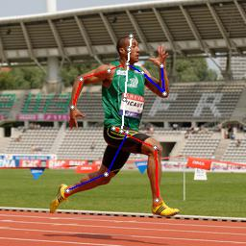
Fig. 1 Successful Pose Prediction
MargiPose works reasonably well for full body images of adults; results rendered to 2D and overlaid on the original image match well with the source, and tend to look reasonable from an alternative, fixed perspective, as presented in the original paper. Surprisingly, MargiPose successfully predicted results for amputees and others suffering from loss-of-limb disabilities. Missing limbs were successfully mapped to truncated stubs, or to the appropriate prostatic, although body shapes far outside the standard human variability produced the same results as out-of-frame humans (see “Full Body in Frame” below). Results appeared invariant to weight, race, and illumination, provided that the subject was centered and filled most of the frame.
However, qualitative analysis of the MargiPose output from a collection of real-world “in-the-wild” input identified a number of limitations and caveats.

Limitations and Caveats

Multiple People in Frame
If multiple people are in the image, only one is mapped by the algorithm, and which one is not selectable by the user. Multiple overlapping people may be confused, with some limbs from one being mapped with limbs from the other. While the issues relating to multiple subjects in the input image is touched upon in the paper, no suggested remedy is mentioned.

Subject Must be Centered
Even if a person is fully in the frame, but is close to the edge, the algorithm may completely miss them. The apparent expectation that the subject is in the center of the frame is not mentioned, but is likely due to the training sets, which focused on footage recorded in a laboratory environment – such footage typically has the subject fully in frame, centered in the image. This issue is particularly noticeable in video 000002.avi (available in the /output/ folder of our repository see footnote) – as the dancer moves out of the center of the frame, MargiPose repeatedly “loses” him, only to continue proper mapping once the dancer returns to the center. This limitation is not mentioned in the paper; all the images in the paper have the subject near the center, scaled or cropped to take up most of the frame.
(a)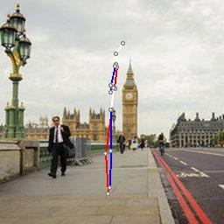(b)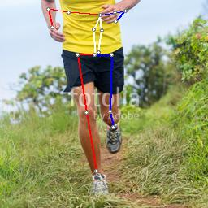(c)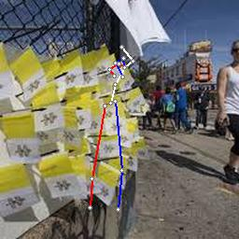
Fig. 2 Prediction subject not centered, or out-of-frame
(a) Subject is in frame, but not in the center
(b) Lower body is mapped correctly, but out-of-frame limbs are mapped incorrectly
(c) Mapping is attempted on non-human object

Full Body in Frame
In addition to the subject being centered, the majority of the subject’s body must be in the frame. Images showing only the lower body, or a single limb displayed significant discrepancies from ground truth. The output always generated a pose, even when no human was visible in the frame. If a portion of the body was out of frame, the model would map those portions to other objects within the frame, with a preference for the horizontal center.
(a)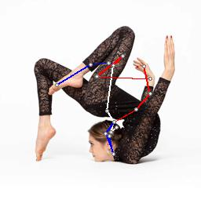(b)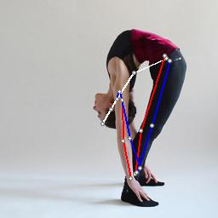(c)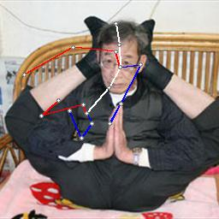
Fig. 3 Contortionist Pose Predictions
Note that (b) highlights limitations of a single spinal joint

Unnatural Poses
Poses outside the normal human range of motion, such as contortionist poses, tended to be only partially mapped, or completely incorrect. The contortionist poses also highlight the limitations of only using one spinal joint, versus the standard three for AAA games or production animation. Difficult yoga poses, while requiring high flexibility, but still within believable human range, tended to be well mapped – this may be due to the high incidence of yoga training videos available on YouTube, the source of the MPII Human Pose dataset included in both pretrained models.
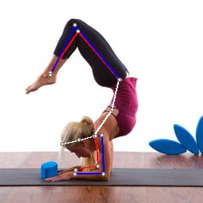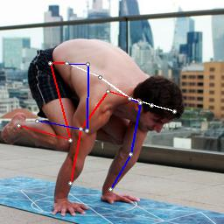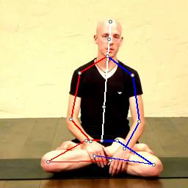
Fig. 4 Successful Yoga Pose Predictions

Depth and Scaling
Comparison of the output with the full 3D pose data highlighted a significant failing in the confusion of depth and scaling, resulting in a skewing along the Z (depth) axis. This effect was reduced in images taken from an angle, while more pronounced in profile or front-on perspectives. Images with children were particularly affected – the difference in proportions between children and adults likely conflicted with the constraints placed on the “universally-scaled” skeleton expected by the model.
(a)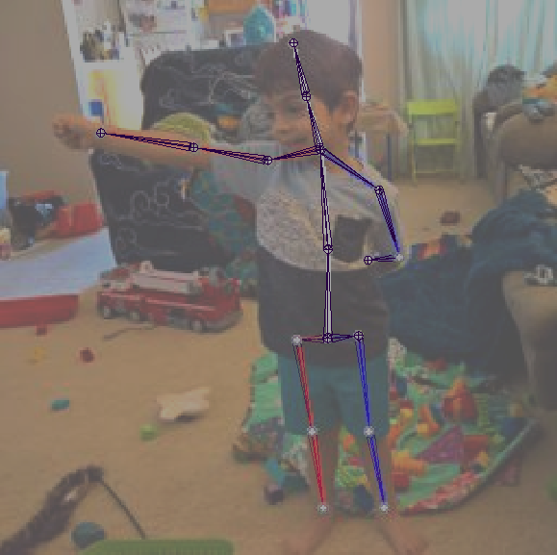(b)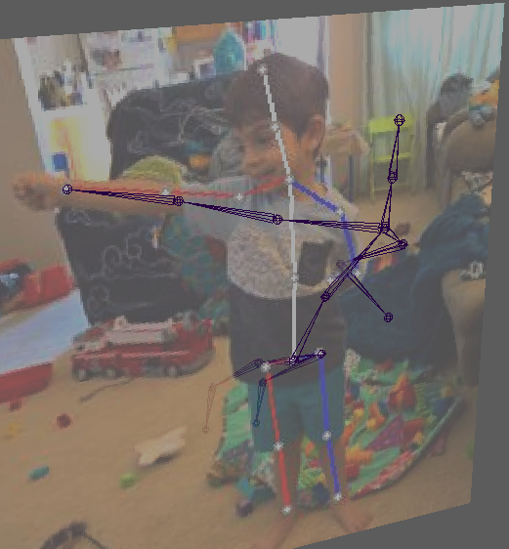(c)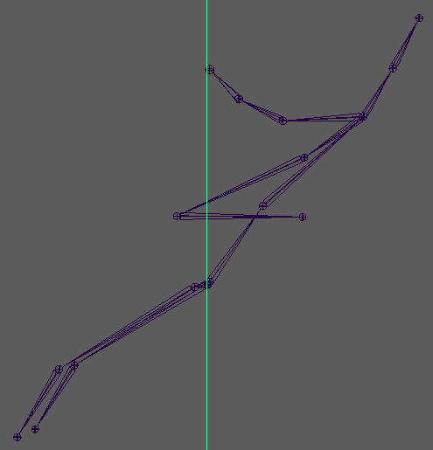
Fig. 5 Depth and Scale Issues with Children
(a) Exported skeleton in purple overlaid on output image
(b) Perspective rotated approx. 30°
(c) Perspective rotated 90° to image plane
The model trained with the MPI-INF-3DHP reliably produced these skewed poses, always with the joints lower in the image further (along the z-axis) away, with higher joints closer. For front-on standing poses, this tended to result in output reminiscent of Michael Jackson’s famous “Smooth Criminal” anti-gravity lean. The provided model trained on the Human3.6M dataset produced joints with unrealistic z coordinates, however the values and affected joints are more random. It should be noted that the 2D results in the plane of the image typically matched well with the image (Figure 4). Images taken from an angle, between front-on and profile, exhibited far fewer depth anomalies.
(a)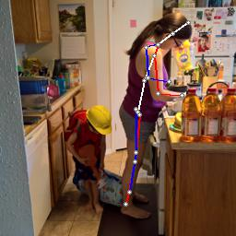(b)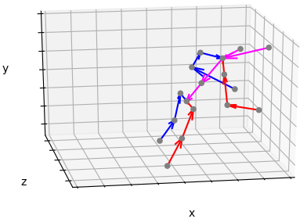
Fig. 6 Model Output
(a) Pose overlaid over cropped and scaled input image
(b) Perspective render of pose
(a)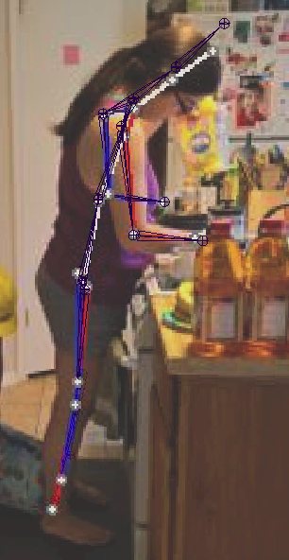(b)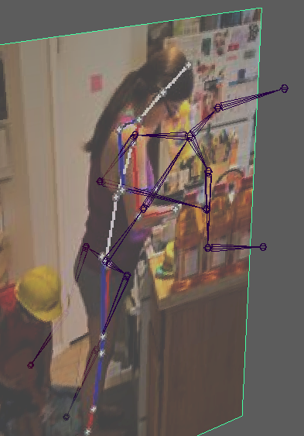(c)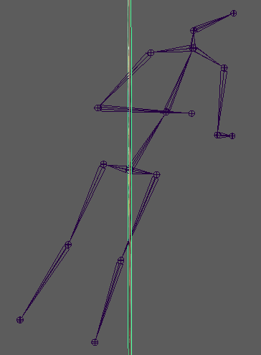
Fig. 7 Depth Issues - Exported skeleton in purple
(a) Orientation matched to model and image plane
(b) Orientation rotated approx. 30°
(c) Orientation rotated 90° to image plane
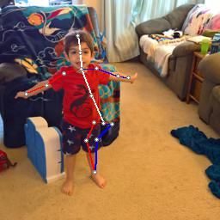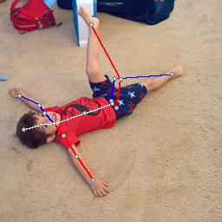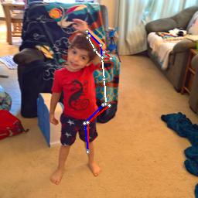
Fig. 8 Failed pose Predictions

Other Failures
At times, the model completely failed to determine an accurate pose, even for well lit subjects near the center of the frame, in poses within natural human range.

Applications of Resulting Output
To evaluate the usefulness of the MargiPose output, two direct application were explored: Motion capture data, to be applied as animation of a skinned mesh bound to an existing skeleton, and tracking of leg swing angles in videos to be used as a Gait Analysis tool. The purpose of this portion was to determine if the output of was useful beyond academic exercise, and in particular if the results were viable in 3D space.

Motion Capture and Animation
Building on the Maya exporter that allowed the resulting pose to be viewed and edited dynamically outside of MargiPose, an ATOM (Animation Transfer Object Model) exporter was developed. Using a base T-pose exported from MargiPose, a skeleton matching the 17 joints used by MargiPose was bound to an existing humanoid 3D mesh. Other poses were then exported from MargiPose in the ATOM format, then applied as key-frame transformations to the existing skeleton.
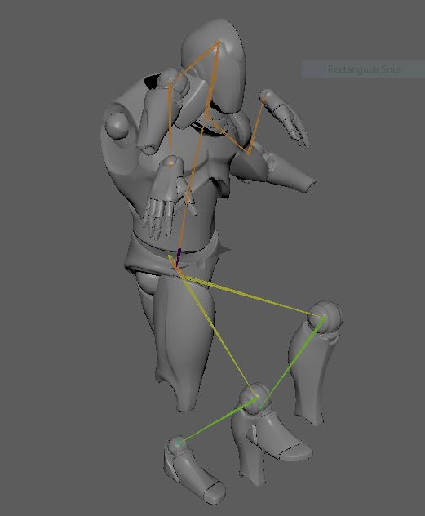
Fig.9 Motion Capture Fail
The use of inverse kinematics was explored, along with a combination of forward and inverse kinematics. The output of the model, while sufficient to overlay on the source image or to view in 3D, was not sufficient to capture motion data for an existing model, without significant additional processing. MargiPose provides per-frame positional data, without regard to joint orientation or rotation, both of which are necessary for meaningful animation of a skinned mesh bound to a skeleton.

Gait Analysis
Expanding MargiPose’s ability to analyze videos with inferred pose estimation allows for many potential clinical use cases. Image frames were extracted out of each video file as input into MargiPose. The output of MargiPose were recombined into a video file while maintaining the original input video’s framerate.
For this project, MargiPose was used to extract out features to gain insight into leg swing angles during the gait cycle. Three videos of different gait patterns were analyzed (Normal Gait, Parkison’s Gait, and Hemiplagic Gait). Angles between the (right hip, right ankle) and (left hip, left ankle) were used as features to determine flexion and extension angles of right and left legs (respectively) during their swing phase in the gait cycle. The results of the leg swing angles from each video were consistent with expected angles for all three types of gait pattern (Figure 8). Given the results, the addition of a video analysis feature provided by this project can be further explored as a potential tool to assist with clinical evaluations of gait patterns for various gait disabilities.

(a)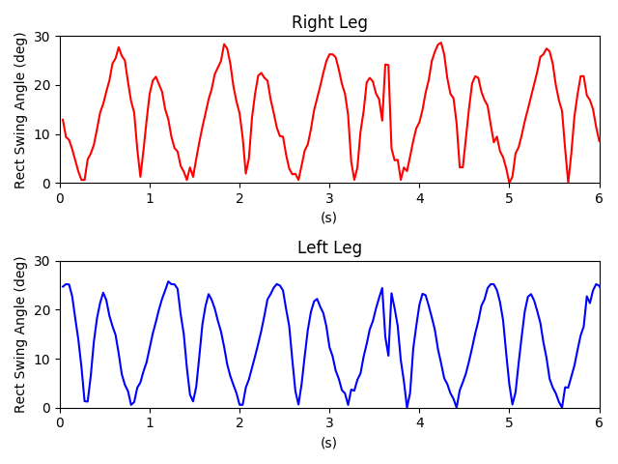(b)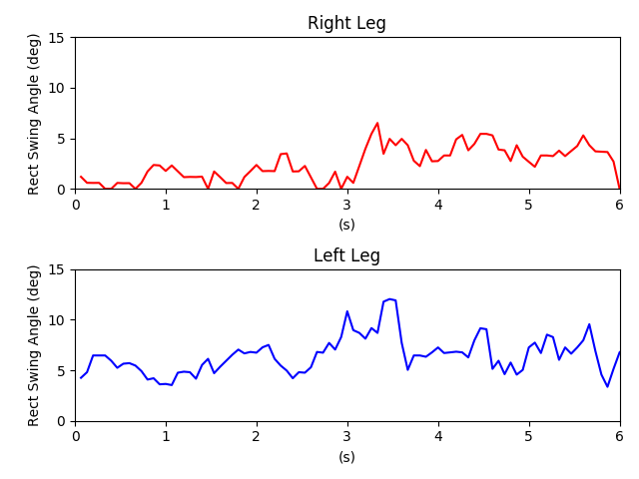(c)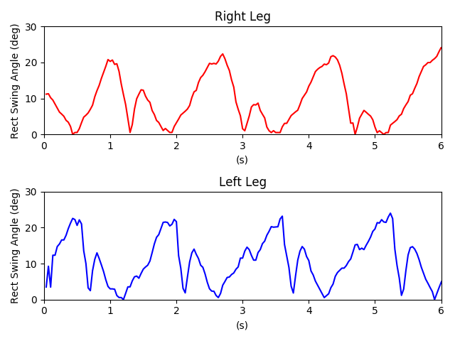
Fig. 10 Rectified Leg Swing Angle
- Normal Gait Pattern
- Parkinson’s Gait Pattern
- Hemiplagic Gait Pattern

User Manual
Please refer to repository README for user manual.

References
3D Human Pose Estimation with 2D Marginal Heatmaps
Aiden Nibali, Zhen He, Stuart Morgan, Luke Prendergast
La Trobe University, Australia
arXiv:1806.01484

