**Question 1**

Let x be 27 inch tv sets

Let y be 20 inch tv

Maximize z=120x+80y

x $≤$ 40

y $≤10$

20x+10y $≤$ 500

And x $≥$ 0, y $≥$ 0

b.

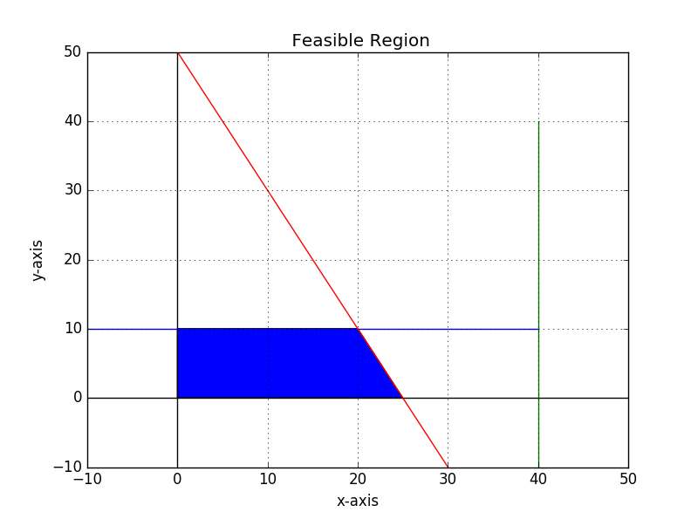

The maximux value is 3200 at point (20,10)

**Question 2a.**

# -*- coding: utf-8 -*-

import matplotlib.pyplot

from matplotlib.pyplot import *

import numpy

from numpy import arange

figure()

#ax = add_subplot(111)

x= arange(-1,10,1)

y= arange(-1,10,1)

y1= 27.0 - 3.0*x

y2= 12.0-1.0*x

y3=15.0 - 1.5*x

#y1= 12.0 - 2.0*x

#y2= 6.0 - 0.5*x

xlabel('x1-axis')

ylabel('x2-axis')

title (' Feasible Region')

plot(x,y1,color='b')

plot(x,y2,color='r')

plot(x,y3,color='g')

legend(['0.3x1 + 0.1x2=2.7','0.5x1 + 0.5x2=6', '0.6x1+0.4x2=6'])

xlim(-1,10)

ylim(-1,10)

grid(True)

x= [6.0,7.5,8.0]

y= [6.0,4.5, 3.0]

fill(x,y)

show()

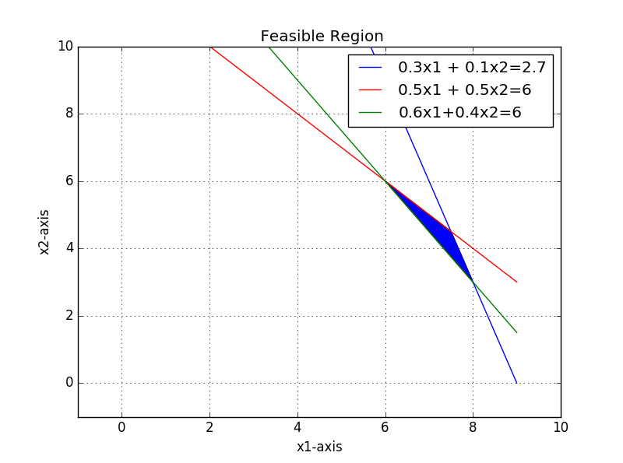

**Question 2b**

|  |  |  |
| --- | --- | --- |
| Corner Point | Value of z=0.4x1 +0.5x2 |  |
| (6,6) | 5.4 |  |
| (7.5,4.5) | 5.25 |  |
| (8,3) | 4.7 | Minimum |
|  |  |  |

The minimum dosage is 4.7 at point (8,3)

**Question 3**

$$\frac{P\left(x+h\right)-P(x)}{h}$$

$$\left(\frac{120}{x+h}+900\right)-\left(\frac{120}{x}+900\right)=$$

$\frac{120}{x+h}-\frac{120}{x}=\frac{120x-120(x+h)}{x(x+h)}$ = $\frac{-120h}{x\left(x+h\right)}$

$$\frac{P\left(x+h\right)-P(x)}{h}$$

$$\frac{\frac{-120h}{x(x+h)}}{h}=\frac{-120h}{x(x+h)}*\frac{1}{h}=\frac{-120}{x^{2}}=-30$$

Answer: When the demand is 2 the price drops by 30.

3b $$\frac{5}{{(2x-3)}^{4}}=5({\left(2x-3\right)}^{-4})$$

Let (2x-3) =u

5 $\frac{d}{du}\left(u^{-4}\right)\frac{d}{dx}\left(2x-3\right)=$

=5(- $-\frac{4}{u^{5}})*2$ = 5*(- $- \frac{4}{{(2x-3)}^{5}})*2$ = - - $\frac{40}{\left({(2x-3)}^{5}\right)}$

Answer = - - $\frac{40}{\left({(2x-3)}^{5}\right)}$

**Question 4.**

from math import *

# -*- coding: utf-8 -*-

#The population of students at Northwestern is given by the formula

#p(t)=(𝑡t^2+100)∗ln (t𝑡+2) , where t represents the time in years since 2000.

#Using Python, find the rate of change of the student population in both 2006 and 2016.

#p´(t)=2tln(t+2)+(t^2+100/x+2)

#number of years from 2000

def p(t):

return 2.0*t*log(t+2.0)+((t**2+100)/t+2)

print p(6)

print p(16)

Answer p(6)= 48.9532985002

P(16)= 116.491896253

**Question 7.**

G(x)= $=\left(\frac{12000}{1+19ee^{-1.2x} }\right)=$

G’(x)= 12000($\frac{1}{1+19e^{-1.2x}}$)=

=12000(($1+19e^{-1.2})-1)=$

= 12000($u^{-1})\left(1+19e^{-1.2x}\right)=$

= $12000\left(-\frac{1}{u^{2}}\right)\left({-22.8e}^{-1.2x}\right)=$

=1200(- $-\frac{1}{{(1+19e^{-1.2x })}^{2}}$)(-22.8 $e^{-1.2x} )$ =

= $\frac{273600e^{-1.2x}}{{(1+19e^{-1.2x})}^{2}}$

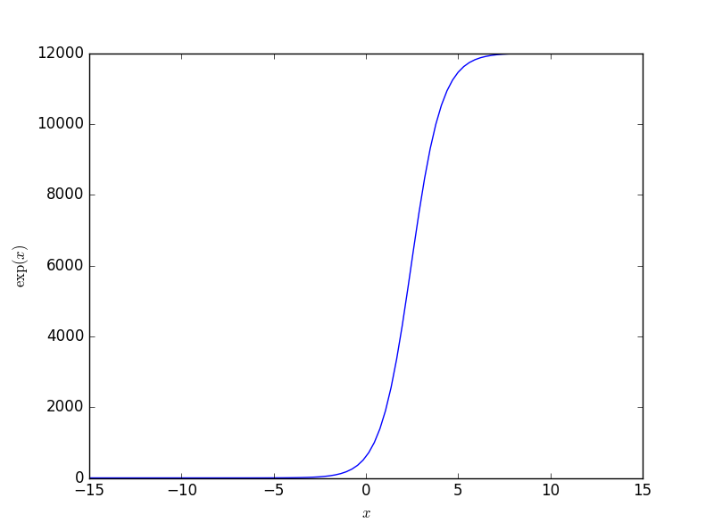

# -*- coding: utf-8 -*-

import numpy as np

import matplotlib.pyplot as plt

from math import *

x = np.linspace(-15, 15, 100)

y= 12000.0/(1.0+19.0*np.exp(-1.2*x))

plt.figure()

plt.plot(x, y)

plt.xlabel('$x$')

plt.ylabel('$\exp(x)$')

plt.show()

G’(t) will never be zero. Not sure I understand the question. The growth rate will never decline but at x=5 it will flatten out and become constant.

**Questions 8**

$$\int_{4}^{9}{x(\frac{1}{9}(1+\frac{2}{\sqrt{x)}dx}=\int{x\frac{1}{9}}}\left(1+\frac{2}{\sqrt{x}}\right)=$$

$$=\frac{1}{9}\left(\left(1+\frac{2}{\sqrt{x}}\right)\frac{x^{2}}{2}-\int{\left(-\frac{1}{x^{\frac{3}{2}}}\right)\frac{x^{2}}{2}}dx\right)=$$

= $\frac{1}{9}(\frac{1}{2}$ (2/ $\sqrt{x}+1)x^{2}-\int{- \frac{\sqrt{x}}{2}}dx$)=

= $\frac{1}{9}\left(\frac{1}{2}\left(\frac{2}{\sqrt{x}}+1\right)x^{2 }–\frac{1}{2}\int{\sqrt{x}} dx\right)=$

= $\frac{1}{9}$ ($\frac{1}{2}\left(\frac{2}{\sqrt{x}}+1\right)x^{2}-(-\frac{1}{2}\int{\sqrt{x}}dx$))=

= $\frac{1}{9}$ ($\frac{1}{2}\left(\frac{2}{\sqrt{x}}+1\right)x^{2}-(-\frac{1}{2}\frac{x^{\frac{1}{2}+1}}{\frac{1}{2}+1}))=$

= $\frac{1}{9}(\frac{x^{\frac{3}{2}}}{3}+\frac{1}{2}\left(\frac{2}{\sqrt{x}}+1\right)x^{2})$ =

= $\frac{17}{2}-\frac{56}{27}$ = $\frac{347}{54}=6.4259$

The mean life of this species of bird is $µ=6.4259$.

**Question9**

f(x)= $\frac{2}{109}x^{2}-\frac{2}{109}x+\frac{1}{654}$

f(0)=0.0015

f(6)=0.5520

Step one, f(x)>=0 is true.

$$\int_{0}^{6}{\frac{2}{109}}x^{2}-\frac{2}{109}x+\frac{1}{654}dx=$$

$$=\int{\frac{2}{109}x^{2}dx}-\int{\frac{2}{109}}xdx+\int{\frac{1}{654}}dx=$$

= $\frac{2}{109}*\frac{x^{2+1}}{2+1}-\frac{x^{2}}{109}+\frac{x}{654}$ = $\frac{2x^{3}}{327}-\frac{x^{2}}{109}+\frac{x}{654}$ =1-0=1

Second condition $\int_{0}^{6}{f\left(x\right)dx=1}$ is true.

Answer: Function is probability density function on the specified interval.

**Question10**

f(x)=-5x-(15/x)

f’(x)=-5+ $\frac{15}{x^{2}}$

Domain-The function is undefined when x=0 so 0 is not in domain of the function. It fails to exist when x=0..

f’(x)=0 when x=-1.7321 or x=1.7321.

The critical numbers of the function are -1.7321 and 1.7321. We can define following intervals:

($-∞,-1.7321),(-1.7321,0),(0,1.7321) and (1.7321,∞)$

f’(-5)=-4.4

f’(-1.5)=1.67

f’(1.5)=1.67

f’(-5)=-4.4

The function in interval ( $-∞,-1.7321) and (1.7321,∞)$ is decreasing.

The function in interval $(-1.7321,0)$ and $(0,1.7321)$ is increasing

f’’(x)= - $\frac{30}{x^{3}}$

The intervals of concavity are ( $-∞,0) and (0,∞)$ because for x=0 f’’(x) is undefined. This is the functions inflection point since f’’(x) does not exist for x=0.

f’’(-2)=3.75

f’’(2)=-3.75

The function is concave upward in ( $-∞,0)$ and concave downward in $(0,∞)$.

