One possible application of system of equations is comparing the prices offered by two cell phone companies.

Let’s assume that company A offers a plan that starts at 30$ for 200 minutes and charges $0.25 for every minute. Company B offers a plan that starts at $25 dollars for 200 minutes and charges $0.30 for every minute.

The question is which company is the best choice and why. In order to figure that out a system of equations can be used.

Both plans can be represented by following equations:

y=0.25x+30

y=0.30x+25

Solution Echelon method:

-0.25x+y=30 // \* -1 elimate y

-0.30x+y=25

-0.05x = -5// \ -0.05

x= 100

y=25+0.3\*100

y=55

The solution is x=100 and y=55

Solution Gauss-Jordan Method

-0.25 1 30//R1\*-4 -> R1

-0.3 1 25

1 -4 -120

-0.3 1 25 //R1\*0.3+R2->R2

1 - 4 -120

0 -0.2 -11 //R2\* -5->R2

1 - 4 -120 //R2\*4+R1->R1

0 1 55

1 0 100

0 1 55

The solution is x=100 and y=100.

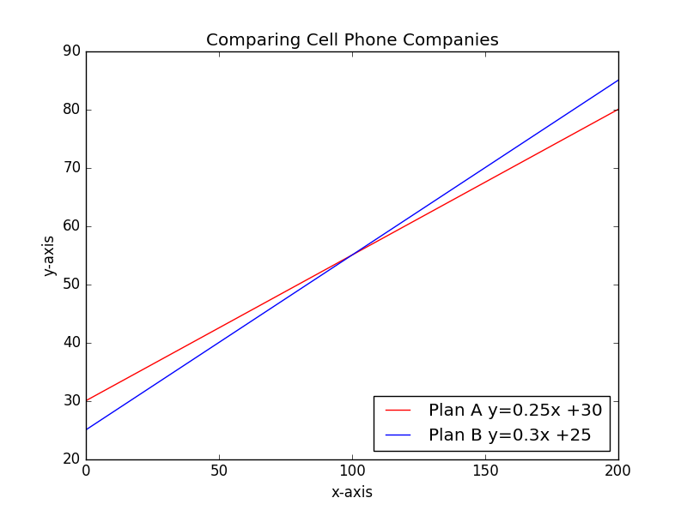

Plan A is less expansive if you talk more than 100 minutes, if you however talk less than 100 minutes than Plan B will be cheaper.

In this case I prefer Echelon method as it is much easier to calculate. Gauss-Jordan Method is much more complex to calculate but faster if you use technology.