1 a.

A =[[1, 0, 1], [4, 1, -2], [3, 1, -1]]

A= matrix(A)

IA= inv(A)

print IA

Inverse of A

[[ 0.5 0.5 -0.5]

[-1. -2. 3. ]

[ 0.5 -0.5 0.5]]

1b.

A =[[1, 2, 3], [3, 1, 2], [2, 0, 1]]

A= matrix(A)

xyz=[18,23,13]

xyz=matrix(xyz)

xyz=transpose(xyz)

IA=inv(A)

result=dot(IA,xyz)

print result

[[ 5.]

[ 2.]

[ 3.]]

**Answer:**  x1=5, x2=2, x3=3.

2.

x- num of transistors

y- num of resistors

z – num computer chips

Copper 3x + y+2z= 90000

Zinc 3x+2y+z = 50000

Glass 2x+y+2z = 61000

Using python to solve system of equations

B=[[3,1,2],[3,2,1],[2,1,2]]

B=matrix(B)

IB=inv(B)

result =dot(B,IB)

print result

[[ 1.00000000e+00 0.00000000e+00 0.00000000e+00]

[ 2.22044605e-16 1.00000000e+00 0.00000000e+00]

[ 2.22044605e-16 0.00000000e+00 1.00000000e+00]]

The matrix has no inverse so the system has to be solved by using Echelon och Gauss Jordan method. I’ll use Gauss-Jordan.

[3 1 2 | 90000] R1/3 -> R1

[3 2 1 | 50000] -3R1+R2 -> R2

[2 1 2 |61000] -2R1+R3 -> R3

[1 1/3 2/3 | 30000] R2/-3+R1-> R1

[0 1 -1 |- 40000]

[0 1/3 2/3 |1000] R2/-3+ R3->R3

[1 0 1 | 130000/3] –R3+R1->R1

[0 1 -1 | -40000] R3+R2->R2

[0 0 1 | 43000/3]

[1 0 0 | 29000]

[0 1 -1 | -77000/3]

[0 0 1 | 43000/3]

Since y needs to be >= 0 not the equation has no meaningful solution.

X=29000

Y=-77000/3

Z=43000/3

3

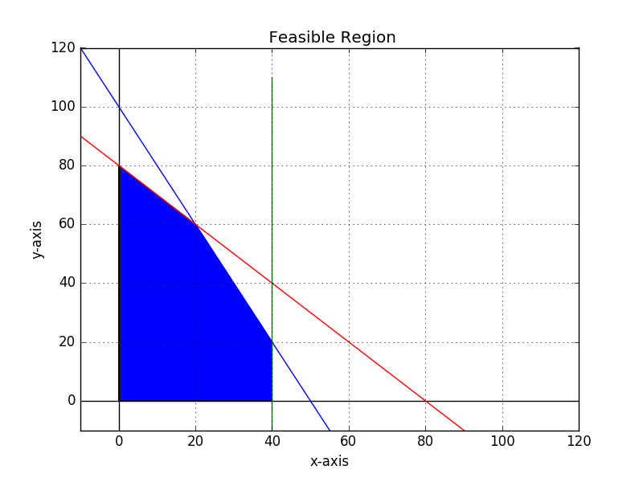

#PYTHON

import matplotlib.pyplot

from matplotlib.pyplot import *

import numpy

from numpy import arange

figure()

x= arange(-10,120,10)

y= arange(-10,120,10)

y1= 100.0-2.0*x

y2= 80.0-x

x1=40.0+0.0*y

xlabel('x-axis')

ylabel('y-axis')

title (' Feasible Region')

plot(x,y1,color='b')

plot(x,y2,color='r')

plot(x1,y,color='g')

xlim(-10,120)

ylim(-10,120)

hlines(0,-10,120,color='k')

vlines(0,-10,120,color='k')

grid(True)

x= [0.0,0.0, 20.0, 40.0,40.0]

y= [0.0,80.0, 60.0, 20.0,0.0]

fill(x,y)

show()

#PYTHON

4.

Let x be number of church groups

Let y be number of labor unions

Maximize z= 100x+150y subject to

2x+y<=20

2x+3y<=14

x>=0, y>=0, s1>=0, s2>=0

Tableau 1

|  |  |  |  |  |  |
| --- | --- | --- | --- | --- | --- |
| x | y | s1 | s2 | z |  |
| 2 | 1 | 1 | 0 | 0 | 20 |
| 2 | 3 | 0 | 1 | 0 | 14 |
| -100 | -175 | 0 | 0 | 1 | 0 |

The second column -175 is most negative indicator.

Pivot on row 2 since 14/3=4.6 is the lowest.

Tableau 2

|  |  |  |  |  |  |
| --- | --- | --- | --- | --- | --- |
| x | y | s1 | s2 | z |  |
| 1.333333 | 0 | 1 | -0.333333 | 0 | 15.3333 |
| 0.666667 | 1 | 0 | 0.333333 | 0 | 4.66667 |
| 16.6667 | 0 | 0 | 58.3333 | 1 | 816.667 |

R2/3->R2

R1+(-R2)->R1

175R2+R3->R3

x =0 y=4.66667 s1=15.3333, s2=0 z = 816.6667.

**Answer:** The maximum amount raised, given the existing constraint on letter writing and follow up, will be achieved by contacting 5 labour unions(4.6667). The 15 possible church groups should never be involved. The amount will be 817.

5.

Let x be securities

Let y be bonds

Let w be mutual fonds

Maximize z = 1.07x + 1.06y + 1.1w subject to

x + y + w <= 100000

x >= 40000

y + w >= 50000

0.2x + 0.01y + 0.03w <= 24000

Tableau #1

x y w s1 s2 s3 s4 z

1 1 1 1 0 0 0 0 100000 –R2 +R1->R1

1 0 0 0 -1 0 0 0 40000 Pivot on column 1

0 1 1 0 0 -1 0 0 50000

0.2 0.01 0.03 0 0 0 1 0 24000 -0.2R2 + R4 -> R4

-1.07 -1.06 -1.1 0 0 0 0 1 0 1.07R2 + R5 ->R5

Tableau #2

x y w s1 s2 s3 s4 z

0 1 1 1 1 0 0 0 60000 -R3 + R1->r1

1 0 0 0 -1 0 0 0 40000

0 1 1 0 0 -1 0 0 50000 Pivot on column 2

0 0.01 0.03 0 0.2 0 1 0 16000 -0.01R3 + R4 -> R4

0 -1.06 -1.1 0 -1.07 0 0 1 42800 1.06 R3 + R5 ->R5

Tableau #3

x y w s1 s2 s3 s4 z

0 0 0 1 1 1 0 0 10000 Pivot on column 5

1 0 0 0 -1 0 0 0 40000 R1 + R2 -> R2

0 1 1 0 0 -1 0 0 50000

0 0 0.02 0 0.2 0.01 1 0 15500 -0.2 R2 + R4 ->R4

0 0 -0.04 0 -1.07 -1.06 0 1 95800 1.07R2 + R5 -> R5

Tableau #4

x y w s1 s2 s3 s4 z

0 0 0 1 1 1 0 0 10000

1 0 0 1 0 1 0 0 50000

0 1 1 0 0 -1 0 0 50000 Pivot column 3

0 0 0.02 -0.2 0 -0.19 1 0 13500 -0.02R3 + R4 -> R4

0 0 -0.04 1.07 0 0.01 0 1 106500 0.04R3 + R5 ->R5

Tableau #5

x y w s1 s2 s3 s4 z

0 0 0 1 1 1 0 0 10000 Pivot column 6

1 0 0 1 0 1 0 0 50000 -1R1+ R2 -> R2

0 1 1 0 0 - 1 0 0 50000 R1 + R3 -> R3

0 -0.02 0 -0.2 0 -0.17 1 0 12500 0.17R1 + R4 ->R4

0 0.04 0 1.07 0 -0.03 0 1 108500 0.03R1 + R5 -> R5

Tableau #6

x y w s1 s2 s3 s4 z

0 0 0 1 1 1 0 0 10000

1 0 0 0 -1 0 0 0 40000

0 1 1 1 1 0 0 0 60000

0 -0.02 0 -0.03 0.17 0 1 0 14200

0 0.04 0 1.1 0.03 0 0 1 108800

x=40000, y=0, w=60000 z = 108800

**Answer:** The maximum interest of 108,800 will be earned by investing 40,000 in securities and 60,000 in mutual funds.

6.

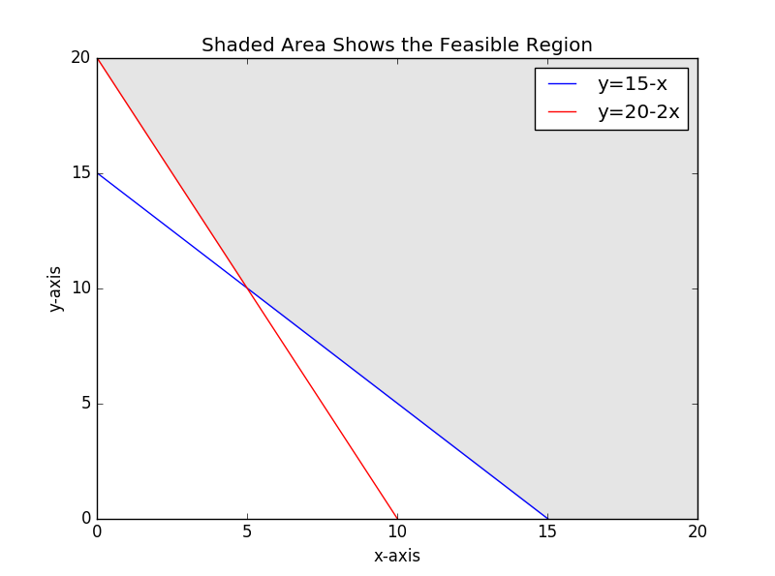

#PYTHON

import matplotlib.pyplot

from matplotlib.pyplot import *

import numpy

from numpy import *

x= arange(0,20.1,0.1)

y0= arange(0,20.1,0.1)

y1= 20.0-2.0*x

y2= 15.0-x

# The definition of y3 will allow filling the unbounded region in the plot.

y3= 20+0.0*x

# The filling will be between y3 and the maximum of y1 and y2. Need to define

# a new array y4 which will be that maximum.

y4=[0]*len(x)

for k in range(0,len(x)):

if y1[k] >= y2[k]:

y4[k]=y1[k]

if y2[k] > y1[k]:

y4[k]=y2[k]

# Plot limits must be set for the graph.

xlim(0,20)

ylim(0,20)

# Plot axes need to be labled,title specified and legend shown.

xlabel('x-axis')

ylabel('y-axis')

title('Shaded Area Shows the Feasible Region')

plot(x,y2,color='b')

plot(x,y1,color='r')

legend(['y=15-x','y=20-2x'])

#PYTHON

7.

Let x be small test tubes

Let y be large test tubes

Minimize 18x + 15y subject to

x >= 900

y >= 600

x+y >= 27000

2x –y >=0

Augmented matrix for this problem and transposed matrix for dual problem

[1 0 900]

[0 1 600]

[1 1 2700]

[2 -1 0]

[18 15 0]

Transpose

[1 0 1 2 |18]

[0 1 1 -1 |15]

[900 600 2700 0|0]

Maximize z = 900x + 600y + 2700p + 0w subject to

x + p + 2w <= 18

y + p - w <= 15

Tableau 1

Pivot on third column second row

[x y p w s1 s2 z | ]

[1 0 1 2 1 0 0 |18] -R2 + R1->R1

[0 1 1 -1 0 1 0 |15]

[-900 -600 -2700 0 0 0 1 |0] 2700R2 +R3->R3

Tableau2

[x y p w s1 s2 z | ]

[1 -1 0 3 1 -1 0 |3] R1/3->R1

[0 1 1 -1 0 1 0 |15] R2+R1->R2

[-900 2100 0 -2700 0 2700 1 |40500] 2700R1 + R3 -> R3

Pivot on w, first row fourth column.

15/-1 negative

3/3 =1

Tableau3

[x y p w s1 s2 z | ]

[0.33 - 0.33 0 1 0.33 -0.33 0 |1]

[0.33 0.667 1 0 0.333 0.667 0 | 16]

[0 1200 0 0 900 1800 1 |43200]

**Answer:** The minimum value z is 43200 cents = $ 432 when x = 900 small test tubes and y = 1800 large test tubes.

8.

Let x be running

Let y be swimming

Let w be playing drums

Maximize z = 388x + 518y + 345w subject to

x + y + w <= 10

-x + 2y - w <= 0

w <= 4

[x y w s1 s2 s3 z | ]

[1 1 1 1 0 0 0 | 10 ] -0.5R2 + R1 ->R1

[-1 2 -1 0 1 0 0 | 0] R2/2 -> R2 Pivot

[0 0 1 0 0 1 0 | 4]

[-388 -518 -345 0 0 0 1 |0 ] 259R2 + R4->R4

Pivot on second row second column

Tableau #2

[x y w s1 s2 s3 z | ]

[1.5 0 1.5 1 -0.5 0 0 | 10] 0.67R1->R1 Pivot

[-0.5 1 -0.5 0 0.5 0 0 | 0 ] 0.5R1 + R2 ->R2

[0 0 1 0 0 1 0 | 4 ]

[-647 0 -604 0 259 0 1 | 0 ] 647R1 + R4 -> R4

Tableau #3

[x y w s1 s2 s3 z ]

[1 0 1 0.667 -0.33 0 0 | 6.67]

[0 1 0 0.33 0.33 0 0 | 3.33]

[0 0 1 0 0 1 0 | 4 ]

[0 0 43 431.33 43.33 0 1 | 4313.33]

x=6.67, y=3.33, w=0

**Answer:** The maximum calories burnt is 4313 after 3.33h swimming and 6.67h running.

9.

Let A be event withdraw cash from ATM

Let B be event check account at ATM

P(A) = 0.93

P(B) = 0.32

P(B $∪$ A) = 0.96

P(B $∪$ A) = P(B) + P(A) – P(B $∩$ A)

0.96 = 0.32-0.93 - P(B $∩$ A)

P(B $∩$ A) = 0.29

P(A|B) = $\frac{P(B ∩ A)}{P(B)}$ = $\frac{0.29}{0.32}$ = 0.91

**Answer:** The probability that person will withdraw cash given that that person checks his or her balance is 0.91.

10.

P(H1|C1) = $\frac{0.8*0.9}{\left(0.8*0.9\right)+\left(0.12*0.4\right)+(0.08*0.1)}$ = 0.93

**Answer:** Probability that the patient has a normal heart given that the examination showed a normal stethoscope examination and a normal cardiogram is 0.93.