Assignment1.R

afuyo

Sun Apr 02 06:16:35 2017

#PREDICT 422  
#Programming Assignment 1  
#  
  
###################################  
#Excercise 8 (ISLR Section 2.4)  
  
#8(a)  
college=read.csv("C:\\playground\\Predict422\\R\\week1\\college.csv")  
summary(college)

## X Private Apps   
## Abilene Christian University: 1 No :212 Min. : 81   
## Adelphi University : 1 Yes:565 1st Qu.: 776   
## Adrian College : 1 Median : 1558   
## Agnes Scott College : 1 Mean : 3002   
## Alaska Pacific University : 1 3rd Qu.: 3624   
## Albertson College : 1 Max. :48094   
## (Other) :771   
## Accept Enroll Top10perc Top25perc   
## Min. : 72 Min. : 35 Min. : 1.00 Min. : 9.0   
## 1st Qu.: 604 1st Qu.: 242 1st Qu.:15.00 1st Qu.: 41.0   
## Median : 1110 Median : 434 Median :23.00 Median : 54.0   
## Mean : 2019 Mean : 780 Mean :27.56 Mean : 55.8   
## 3rd Qu.: 2424 3rd Qu.: 902 3rd Qu.:35.00 3rd Qu.: 69.0   
## Max. :26330 Max. :6392 Max. :96.00 Max. :100.0   
##   
## F.Undergrad P.Undergrad Outstate Room.Board   
## Min. : 139 Min. : 1.0 Min. : 2340 Min. :1780   
## 1st Qu.: 992 1st Qu.: 95.0 1st Qu.: 7320 1st Qu.:3597   
## Median : 1707 Median : 353.0 Median : 9990 Median :4200   
## Mean : 3700 Mean : 855.3 Mean :10441 Mean :4358   
## 3rd Qu.: 4005 3rd Qu.: 967.0 3rd Qu.:12925 3rd Qu.:5050   
## Max. :31643 Max. :21836.0 Max. :21700 Max. :8124   
##   
## Books Personal PhD Terminal   
## Min. : 96.0 Min. : 250 Min. : 8.00 Min. : 24.0   
## 1st Qu.: 470.0 1st Qu.: 850 1st Qu.: 62.00 1st Qu.: 71.0   
## Median : 500.0 Median :1200 Median : 75.00 Median : 82.0   
## Mean : 549.4 Mean :1341 Mean : 72.66 Mean : 79.7   
## 3rd Qu.: 600.0 3rd Qu.:1700 3rd Qu.: 85.00 3rd Qu.: 92.0   
## Max. :2340.0 Max. :6800 Max. :103.00 Max. :100.0   
##   
## S.F.Ratio perc.alumni Expend Grad.Rate   
## Min. : 2.50 Min. : 0.00 Min. : 3186 Min. : 10.00   
## 1st Qu.:11.50 1st Qu.:13.00 1st Qu.: 6751 1st Qu.: 53.00   
## Median :13.60 Median :21.00 Median : 8377 Median : 65.00   
## Mean :14.09 Mean :22.74 Mean : 9660 Mean : 65.46   
## 3rd Qu.:16.50 3rd Qu.:31.00 3rd Qu.:10830 3rd Qu.: 78.00   
## Max. :39.80 Max. :64.00 Max. :56233 Max. :118.00   
##

#8(b)  
fix(college)  
rownames(college) = college[,1]  
fix(college)  
college = college[,-1]  
fix(college)  
#8(c)  
# 8 (c) i.  
summary(college)

## Private Apps Accept Enroll Top10perc   
## No :212 Min. : 81 Min. : 72 Min. : 35 Min. : 1.00   
## Yes:565 1st Qu.: 776 1st Qu.: 604 1st Qu.: 242 1st Qu.:15.00   
## Median : 1558 Median : 1110 Median : 434 Median :23.00   
## Mean : 3002 Mean : 2019 Mean : 780 Mean :27.56   
## 3rd Qu.: 3624 3rd Qu.: 2424 3rd Qu.: 902 3rd Qu.:35.00   
## Max. :48094 Max. :26330 Max. :6392 Max. :96.00   
## Top25perc F.Undergrad P.Undergrad Outstate   
## Min. : 9.0 Min. : 139 Min. : 1.0 Min. : 2340   
## 1st Qu.: 41.0 1st Qu.: 992 1st Qu.: 95.0 1st Qu.: 7320   
## Median : 54.0 Median : 1707 Median : 353.0 Median : 9990   
## Mean : 55.8 Mean : 3700 Mean : 855.3 Mean :10441   
## 3rd Qu.: 69.0 3rd Qu.: 4005 3rd Qu.: 967.0 3rd Qu.:12925   
## Max. :100.0 Max. :31643 Max. :21836.0 Max. :21700   
## Room.Board Books Personal PhD   
## Min. :1780 Min. : 96.0 Min. : 250 Min. : 8.00   
## 1st Qu.:3597 1st Qu.: 470.0 1st Qu.: 850 1st Qu.: 62.00   
## Median :4200 Median : 500.0 Median :1200 Median : 75.00   
## Mean :4358 Mean : 549.4 Mean :1341 Mean : 72.66   
## 3rd Qu.:5050 3rd Qu.: 600.0 3rd Qu.:1700 3rd Qu.: 85.00   
## Max. :8124 Max. :2340.0 Max. :6800 Max. :103.00   
## Terminal S.F.Ratio perc.alumni Expend   
## Min. : 24.0 Min. : 2.50 Min. : 0.00 Min. : 3186   
## 1st Qu.: 71.0 1st Qu.:11.50 1st Qu.:13.00 1st Qu.: 6751   
## Median : 82.0 Median :13.60 Median :21.00 Median : 8377   
## Mean : 79.7 Mean :14.09 Mean :22.74 Mean : 9660   
## 3rd Qu.: 92.0 3rd Qu.:16.50 3rd Qu.:31.00 3rd Qu.:10830   
## Max. :100.0 Max. :39.80 Max. :64.00 Max. :56233   
## Grad.Rate   
## Min. : 10.00   
## 1st Qu.: 53.00   
## Median : 65.00   
## Mean : 65.46   
## 3rd Qu.: 78.00   
## Max. :118.00

# 8 (c) ii.  
pairs(college[,1:10])

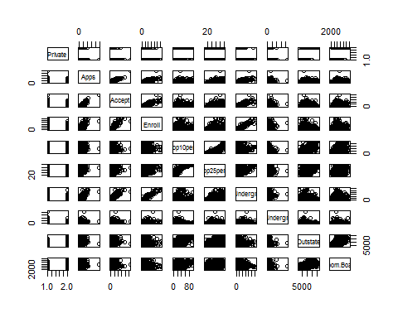

# 8 (c) iii.  
plot(college$Private,college$Outstate,xlab="Private",ylab="Outstate")

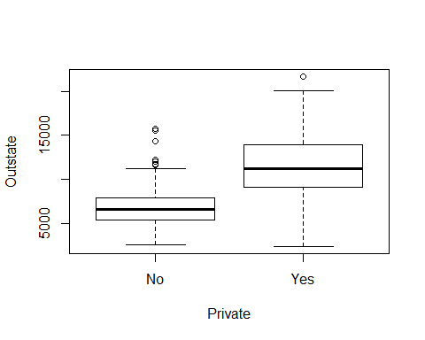

# 8 (c) iv.  
Elite = rep("No",nrow(college))  
Elite[college$Top10perc > 50] = "Yes"  
Elite = as.factor(Elite)  
college = data.frame(college,Elite)  
summary(college$Elite)

## No Yes   
## 699 78

plot(college$Elite,college$Outstate,xlab="Elite",ylab="Outstate")

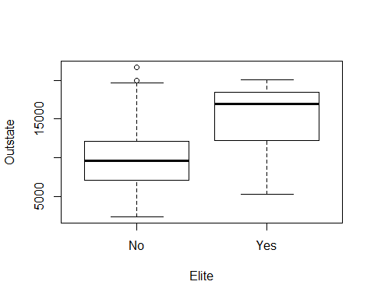

# 8 (c) v.  
par(mfrow=c(2,2))  
hist(college$Apps,breaks=50,col="gray",xlab="Apps",main="")  
hist(college$Accept,breaks=20,col="gray",xlab="Accept",main="")  
hist(college$Enroll,breaks=15,col="gray",xlab="Enroll",main="")  
# 8 (c) vi.  
# additional EDA  
  
########################################  
# Exercise 9 (ISLR Section 2.4)  
inPath = file.path("C:","playground","Predict422",  
 "R","week1")  
# Load data and remove missing values per the lab (Section 2.3.4)  
Auto = read.table(file.path(inPath,"Auto.data"),header=TRUE,na.strings="?")  
dim(Auto)

## [1] 397 9

Auto = na.omit(Auto)  
dim(Auto)

## [1] 392 9

# 9 (a)  
str(Auto)

## 'data.frame': 392 obs. of 9 variables:  
## $ mpg : num 18 15 18 16 17 15 14 14 14 15 ...  
## $ cylinders : int 8 8 8 8 8 8 8 8 8 8 ...  
## $ displacement: num 307 350 318 304 302 429 454 440 455 390 ...  
## $ horsepower : num 130 165 150 150 140 198 220 215 225 190 ...  
## $ weight : num 3504 3693 3436 3433 3449 ...  
## $ acceleration: num 12 11.5 11 12 10.5 10 9 8.5 10 8.5 ...  
## $ year : int 70 70 70 70 70 70 70 70 70 70 ...  
## $ origin : int 1 1 1 1 1 1 1 1 1 1 ...  
## $ name : Factor w/ 304 levels "amc ambassador brougham",..: 49 36 231 14 161 141 54 223 241 2 ...  
## - attr(*, "na.action")=Class 'omit' Named int [1:5] 33 127 331 337 355  
## .. ..- attr(*, "names")= chr [1:5] "33" "127" "331" "337" ...

summary(Auto)

## mpg cylinders displacement horsepower   
## Min. : 9.00 Min. :3.000 Min. : 68.0 Min. : 46.0   
## 1st Qu.:17.00 1st Qu.:4.000 1st Qu.:105.0 1st Qu.: 75.0   
## Median :22.75 Median :4.000 Median :151.0 Median : 93.5   
## Mean :23.45 Mean :5.472 Mean :194.4 Mean :104.5   
## 3rd Qu.:29.00 3rd Qu.:8.000 3rd Qu.:275.8 3rd Qu.:126.0   
## Max. :46.60 Max. :8.000 Max. :455.0 Max. :230.0   
##   
## weight acceleration year origin   
## Min. :1613 Min. : 8.00 Min. :70.00 Min. :1.000   
## 1st Qu.:2225 1st Qu.:13.78 1st Qu.:73.00 1st Qu.:1.000   
## Median :2804 Median :15.50 Median :76.00 Median :1.000   
## Mean :2978 Mean :15.54 Mean :75.98 Mean :1.577   
## 3rd Qu.:3615 3rd Qu.:17.02 3rd Qu.:79.00 3rd Qu.:2.000   
## Max. :5140 Max. :24.80 Max. :82.00 Max. :3.000   
##   
## name   
## amc matador : 5   
## ford pinto : 5   
## toyota corolla : 5   
## amc gremlin : 4   
## amc hornet : 4   
## chevrolet chevette: 4   
## (Other) :365

# 9 (b)  
#sapply(Auto[,1:7],range)  
for (ii in 1:7)  
{  
 rng = range(Auto[,ii])  
 print(paste(names(Auto)[ii],": ",rng[1]," to ",rng[2],sep=""))  
}

## [1] "mpg: 9 to 46.6"  
## [1] "cylinders: 3 to 8"  
## [1] "displacement: 68 to 455"  
## [1] "horsepower: 46 to 230"  
## [1] "weight: 1613 to 5140"  
## [1] "acceleration: 8 to 24.8"  
## [1] "year: 70 to 82"

# 9 (c)  
#apply(Auto[,1:7],2,mean)  
#apply(Auto[,1:7],2,sd)  
sapply(Auto[,1:7],mean)

## mpg cylinders displacement horsepower weight   
## 23.445918 5.471939 194.411990 104.469388 2977.584184   
## acceleration year   
## 15.541327 75.979592

sapply(Auto[,1:7],sd)

## mpg cylinders displacement horsepower weight   
## 7.805007 1.705783 104.644004 38.491160 849.402560   
## acceleration year   
## 2.758864 3.683737

# 9 (d) Now remove the 10th through 85th observations.  
AutoSubset = Auto[-(10:85),]  
sapply(AutoSubset[,1:7],range)

## mpg cylinders displacement horsepower weight acceleration year  
## [1,] 11.0 3 68 46 1649 8.5 70  
## [2,] 46.6 8 455 230 4997 24.8 82

sapply(AutoSubset[,1:7],mean)

## mpg cylinders displacement horsepower weight   
## 24.404430 5.373418 187.240506 100.721519 2935.971519   
## acceleration year   
## 15.726899 77.145570

sapply(AutoSubset[,1:7],sd)

## mpg cylinders displacement horsepower weight   
## 7.867283 1.654179 99.678367 35.708853 811.300208   
## acceleration year   
## 2.693721 3.106217

# 9 (e) Using the full data set, investigate the predictors graphically,  
# scatterplots or other tools of your choice. Create some plots  
#highlighting the relationships among the predictors. Comment  
#zon your findings.  
pairs(Auto[,1:8])

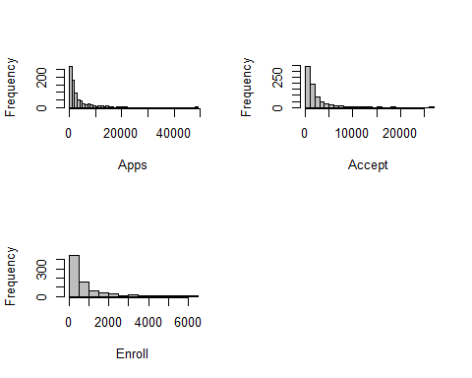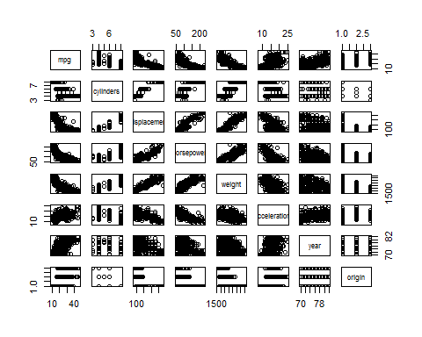

Auto$cylinders = as.factor(Auto$cylinders)  
Auto$origin = as.factor(Auto$origin)  
pairs(Auto[,c(1,3:7)])

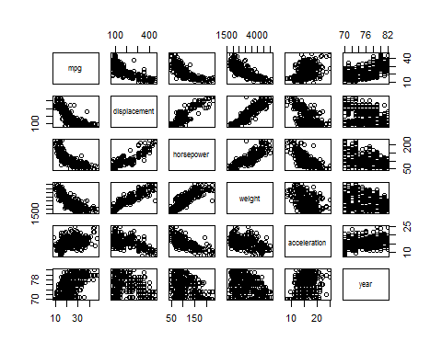

par(mfrow=c(1,2))  
barplot(table(Auto$cylinders),xlab="cylinders")  
barplot(table(Auto$origin),xlab="origin")

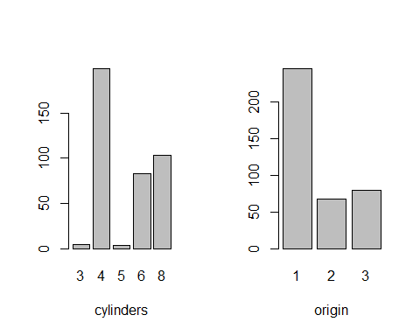

# 9 (f)Suppose that we wish to predict gas mileage (mpg) on the basis  
#of the other variables. Do your plots suggest that any of the  
#other variables might be useful in predicting mpg? Justify your  
#answer.  
par(mfrow=c(2,3))  
plot(Auto$displacement,Auto$mpg,xlab="displacement",ylab="mpg")  
# more horsepower correlates with lower mpg  
plot(Auto$horsepower,Auto$mpg,xlab="horsepower",ylab="mpg")  
#heavier weight correlates with lower mpg  
plot(Auto$weight,Auto$mpg,xlab="weight",ylab="mpg")  
plot(Auto$acceleration,Auto$mpg,xlab="acceleration",ylab="mpg")  
plot(Auto$year,Auto$mpg,xlab="year",ylab="mpg")  
#mpg increases over time  
  
par(mfrow=c(1,2))

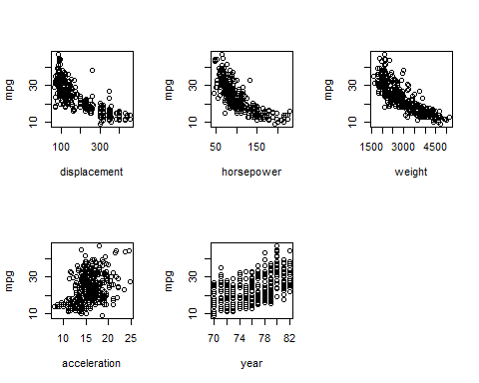

plot(Auto$cylinders,Auto$mpg,xlab="cylinders",ylab="mpg")  
plot(Auto$origin,Auto$mpg,xlab="origin",ylab="mpg")

