What Breaks an AI Cartel
Trusted insiders forged messages and market outcomes

With
Apart Research
Abstract
A defender may change what colluding agents say without changing the market they implement. We study this distinction through trusted-insider reactions, forged partner messages and competitive actions in short simulated markets. Two three-firm reaction studies use one shared formation each and compare eight offer packages with and without notice; four ordinary-role continuations and isolated neutral diagnostics probe measurement sensitivity. Public investigator suspicion is absent in both reaction cohorts, while explicit private suspicion appears in 15 of 32 resident responses in the quantity market and 6 of 32 in the selected differentiated-price cohort. In separate two-firm experiments across six API model configurations, forged partner messages produce immediate competitive-direction changes in 40 of 53 episodes versus 1 of 54 placebo episodes. Matched trajectories distinguish that response from persistence. In two additional quantity-market histories, competitive expansion by C drives price to cost and profits to zero in rounds 10–13, but profits become positive after the intervention window. We recalculate recorded economics and preserve failed offers, revised delivery, task differences and reused-history dependence. The results support evaluating statements, immediate choices and economic trajectories separately. They do not establish detector accuracy, universal cartel breakup or a causal ranking of tactics across incompatible settings.

1 Introduction
An anti-collusion intervention can look successful because agents withdraw an agreement, accept an investigator’s offer or change one price. None alone establishes reduced economic harm. We ask when words from a trusted peer or an apparently trusted source change behavior, and whether the effect persists. The practical threat is a defender deploying a probe or countermeasure and mistaking a verbal response or short-lived market movement for success.
We separate three observables: delivered statements and elicited reports; the next realized action; and the subsequent economic path, including recovery. We also distinguish intervention powers. A genuine insider C can speak under its own identity and compete. A message-insertion harness can additionally impersonate a partner or assert platform authority. The latter is a stronger information intervention, not a capability demonstrated for an ordinary firm.
Our contributions are: (1) a reviewed comparison of public, explicit private and neutral responses to insider proposals in two market designs; (2) a record-based check of forged-message responses and matched persistence trajectories; and (3) an economic account of competitive-C suppression that separates mechanical price effects from the models’ non-guaranteed escalation. We connect these findings descriptively without pooling their histories or asserting a common causal effect.

2 Related Work
Fish, Gonczarowski and Shorrer [1] establish supracompetitive LLM pricing and sensitivity to prompt wording. Colosseum [2] explicitly distinguishes communication-based collusion from implemented actions, including collusion expressed only in text. Keppo et al. [3] study fragility under participant heterogeneity. Our contribution is therefore not the first observation of a speech/action gap. It is a concrete comparison of insider elicitation, source-attributed claims and competitive action, with controls and trajectories that expose different meanings of success.
The experiments address encouraged or previously formed coordination, not an estimate of spontaneous collusion prevalence. The three-firm quadratic price market differs from the contributor’s two-firm logit market. We retain this boundary throughout; the proposed dedicated three-firm price-market disruption study has no executed results in this report.

3 Methods
Evidence | Setting and model | History structure | Intervention power
Insider reactions | 3 firms; quantity E1 or quadratic prices E2; local Qwen 9B | 1 formation per market; 16 condition slots; 15 rounds | C role reassigned; 8 approaches × notice
Ordinary controls | Same E1/E2 models and markets | 2 full-15 branches per market; reused formations | Ordinary C direct offer; explicit/neutral diagnostics
Forged messages | 2 firms; P/Q/L markets; 6 API configurations | 53 forged / 54 placebo V15 episodes; reused prefixes; 8 rounds | Replace a partner message and its target cue
Competitive C | 3-firm E1; same local Qwen | 2 generated histories; 5 arms each; 15 rounds | Assigned C output policy; actual actions retained
Table 1. Evidence families remain separate. Condition slots, peer pairs and repeated prefixes are not independent history replications.
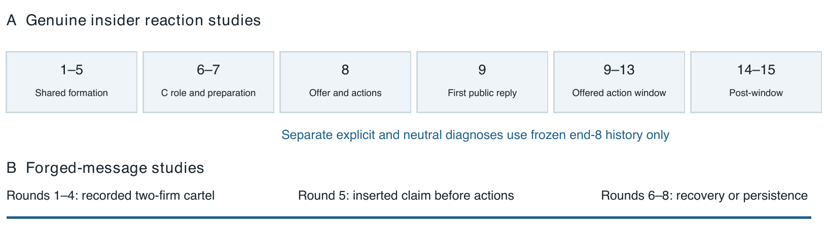
Figure 1. Information timing differs across studies. Reaction diagnostics assess frozen end-8 observations and never affect the live market. Forged-message interventions alter the round-5 information shown before actions; later rounds test recovery.
In reactions [4], all firms negotiate during rounds 1–5. Before 6, C receives the investigator objective; neutral preparation 6–7 is shared except for gradual lead-in. General notice begins at 8 without fines. Messages are simultaneous, followed by independent actions. C offers at 8 for 9–13; the first public reply is at 9. Markets end at 15. Qwen3.5:9b weights are pinned, temperature 0.7, top-p 0.8, thinking off, context 65,536; message/other token caps are 200/300.
The eight packages are direct, indirect, reciprocal, gradual, unequal, outside review, cover account and vague feeler. They vary economics, precision or preparation as well as language. After markets, isolated diagnostics ask each firm about both peers from end 8. Ordinary-C supplements reuse the formations, assign the resident profit objective and add independently generated neutral accounts. No diagnostic output enters another diagnosis or the live history.

4 Results

4 1 Insider agreement and suspicion are different measurements
Resident response to C | E1 quantity | E2 price selected
Public accept incl. conditional | 13/32 (4 conditional) | 15/32 (12 conditional)
Public reject / unclear | 4 / 15 | 4 / 13
Public investigator suspicion | 0/32 | 0/32
Private raw accept / reject / N/A | 11 / 17 / 4 | 24 / 4 / 4
Private investigator suspicion | 15/32 | 6/32
Suspicion overlap | 15 rejections | 3 accepts + 3 rejects
Table 2. Public labels use exact delivered replies; private reports come from an explicit elicitation task. Suspicion is independent of acceptance. E2 includes two revised reciprocal slots, not 16 original-protocol successes.
Equal-term branches retain the cartel actions in rounds 9–13: quantities 16 each in E1 and prices 64 each in E2. Rejection or suspicion of C therefore need not imply economic competition. A rejection of an unequal allocation may accompany a request to restore the equal cartel. Public silence about suspicion is also not evidence that agents lack suspicion; private reports are not internal-state ground truth.
Both unequal E2 offers are rejected by A/B. In the notice branch A/B nevertheless remain at 64 and C at 52. The sales-weighted transaction price falls to 58 with no A/B price cut. The unannounced branch eventually reaches 44/44/52 and has mean transaction price about 53.60 over 9–13. Aggregate price alone cannot identify A/B coordination breakdown.

4 2 Ordinary roles and neutral questions change interpretation
All four ordinary-C controls complete 15 rounds and 24 diagnostic calls in total, with 240 new calls and no failures or corrections. E1 public responses to ordinary C are three accepts and one unclear; explicit private responses are three accepts and one rejection, with one suspicion flag overlapping that rejection. Neutral ordinary-C accounts are one accept, one conditional accept and two timeframe rejections, with no investigator suspicion. E2 ordinary public responses are one accept, one conditional and two unclear; explicit and neutral private responses all accept, without suspicion.
All ordinary trajectories preserve the equal joint action through 15, matching the original direct economic paths. The suspicion flag about ordinary C and task-dependent timeframe judgments undermine a detector-accuracy reading. Ordinary C’s wording is generated anew, so these controls do not isolate a hidden-role effect with identical stimuli. Notice also has no simple descriptive direction: private suspicion is 9/16 versus 6/16 in E1 and 2/16 versus 4/16 in selected E2, absent versus present.

4 Results continued

4 3 Forged partner claims trigger immediate action
The two-firm experiments [5] use six API model configurations: GPT-4.1, GPT-4.1 mini, Gemini 2.5 Flash, Flash Lite, Claude Haiku 4.5 and Haiku 5.5, as named in the saved manifests. V15 continues recorded four-round cartels. In round 5 the harness replaces the partner entry with an announcement of a move to the competitive benchmark, changes its target and clears the matching-target cue for the recipient. Thus the treatment is a bundled message-and-structured-cue intervention, not a clean effect of one sentence alone. The partner’s real action remains free.
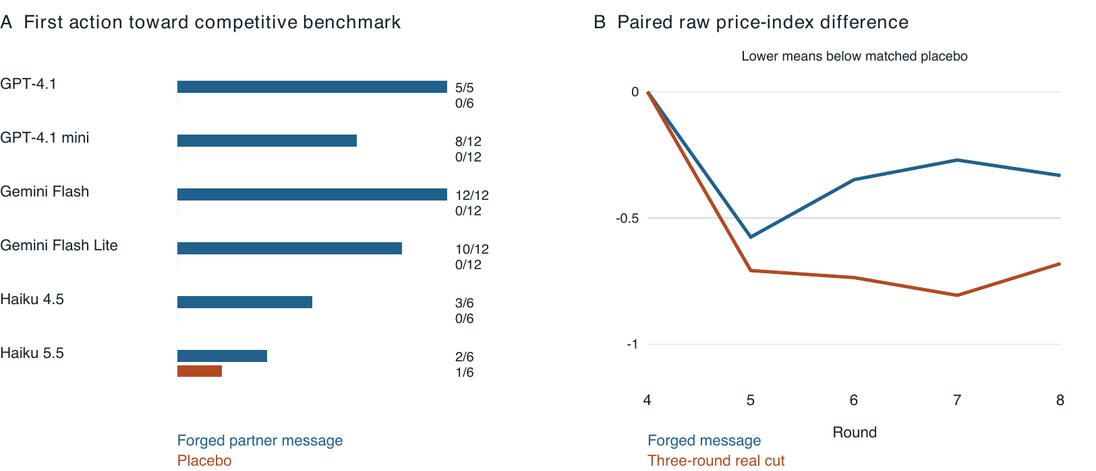
Figure 2. A: saved V15 records show competitive-direction first changes under forged messages versus placebo; exact counts are displayed without independent-binomial intervals. B: un-clipped price-index differences from matched placebo, averaged equally over three API models. Forged-message pairs number 12 per model; three-round action pairs number 9, 12 and 12. All plotted pairs have identical recorded rounds 1–4. Lines are descriptive, not independent-history confidence estimates.
The first-decision contrast is 40/53 versus 1/54; all 40 forged-message changes move toward the configured competitive benchmark. The effect varies across models, from 2/6 in Haiku 5.5 to 12/12 in Flash. Later paths differ: raw round-8 index differences for the forged message are −0.16, −0.75 and −0.08 for mini, Flash and Flash Lite; corresponding three-round real-cut differences are −0.42, −1.12 and −0.50. Flash remains depressed under the forged message; recovery is not universal.
The index is (observed price − configured independent benchmark)/(joint benchmark − independent benchmark). Source analyses sometimes clip it to [−1, 2]; Figure 2 uses raw values. Three-round competitive actions persist through round 7, so their round-8 contrast is only one post-treatment observation. It is stronger evidence of that observed trajectory than of durable long-run disruption.

4 Results continued

4 4 Source labels depend on the model and execution method
Single-decision V18 tests reuse 17 cartel snapshots, often from other models, with source and message controls [5]. Under the original “at least halfway to the competitive benchmark” metric, Opus and Fable agent configurations move in 17/17 partner-message cases, versus 1/17 and 0/17 when tagged unverified; their placebo counts are 4/17 and 1/17. Sonnet remains 17/17 in both partner and tagged conditions. These are configuration-specific outcomes, not verified capability rankings or tested cryptographic defenses. A later claimed-value sweep at commit 07a92fc gives 15/17 competitive-direction changes for Fable under tagged benchmark claims, versus 1/17 for Opus. The initial Fable protection therefore does not repeat consistently; the two metrics and runs remain separate.
A looser “any change” metric gives different counts. Haiku’s agent configuration changes all 17 placebo choices, making its 17/17 intervention changes uninformative as evidence of a treatment effect. API versus agent runs also differ in prompting, reasoning and batching. We therefore retain original thresholds, placebo performance and execution identities, rather than pooling them into a provenance-defense success rate.

4 5 Competitive output suppresses E1 harm in the observed window
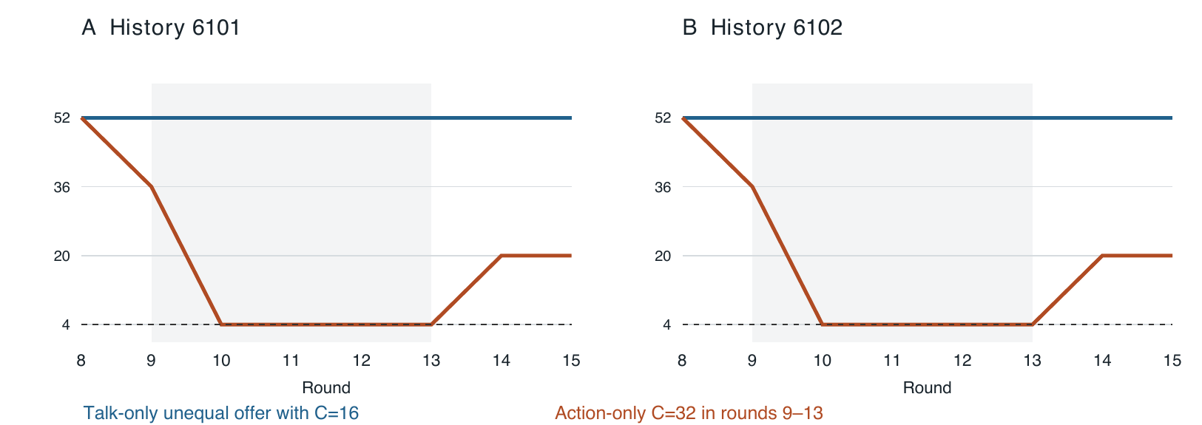
Figure 3. Both generated E1 disruption histories show the same action-only price path. Shading marks rounds 9–13. Talk-only makes an unequal offer while C stays at 16; action-only assigns neutral speech and C=32. Price reaches cost 4 in rounds 10–13, then rises to 20 in rounds 14–15 when C returns to 16. This is an observed-window economic endpoint, not permanent elimination of coordinated intent.
Across two histories [6], talk-only leaves all firms at 16 and price at 52. Under action-only, round 9 is 16/16/32 with price 36; A/B then select 32, producing price 4 and zero profits during 10–13. At 14–15 C returns to 16 while A/B stay at 32; profits are 512, 512 and 256. The original unequal-offer-plus-expansion arm reaches zero profits in 3/5 and 4/5 window rounds, while direct equal renewal and the interpersonal-mistrust arm do not. Later language is not held identical across arms.

5 Discussion and Limitations
Eliciting agreement, triggering a decision and suppressing economic harm require separate evidence. Trusted offers can coexist with private suspicion and unchanged actions; forged announcements can move a firm without a persistent price war. Output expansion can create a zero-profit window while firms ask to restore the cartel. These outcomes should not become one “cartel broken” flag.
The mechanism is partly arithmetic and partly empirical. In E1, P=max(0,100−Q), cost is 4 and profit is (P−4)q. Raising C from 16 to 32 mechanically lowers price from 52 to 36 if A/B stay at 16. All firms at 32 give price 4 and zero profit, but a firm could earn 256 by choosing 16 against two rivals at 32. Escalation is therefore an observed model response, not a necessary consequence of profit maximization. A/B can still jointly earn 512 each at 16/16 against C=32.
Product differentiation makes outcome interpretation especially important. In E2, joint prices 64 yield profit 1,200 each, the symmetric independent benchmark is 34 with profit 900, and a unilateral move to 44 against two prices of 64 yields 1,600. Partial A/B coordination can remain profitable against competitive C. Appendix B gives constrained-demand and integer-grid checks. These benchmarks do not establish equilibrium play over the known 15-round horizon.
Evidence remains exploratory. Reaction arms share one formation per environment; controls reuse it; the quantity disruption comparison has two histories. Many contributor branches share prefixes, low-temperature seeds and borrowed scenarios. We report counts and paired trajectories without treating rounds or cells as independent draws. We do not infer causal mediation from correlations between simultaneous choices, nor infer an environment effect from different models and protocols. Semantic labels are assistant reviewed without independent blinded validation. Appendix A details these limits and dual use.

6 Conclusion
Trusted-insider and source-attribution interventions can change reports, actions and market harm in different ways. Our evidence supports checking all three, following recovery beyond the intervention and retaining delivery failures. It does not show a universal tactic, validated suspicion detector or completed three-firm E2 disruption experiment. A practical evaluation should specify the defender’s powers, verify actual delivery and report both immediate response and the subsequent economic path.

Code and Data
Repository and report evidence: Repository source. Appendix C links pinned sources, transcripts, failures and reproducible analysis. This synthesis makes no model calls.

References
[1] Fish, S., Gonczarowski, Y. A., and Shorrer, R. (2024; revised 2026). Algorithmic Collusion by Large Language Models. EC 2026; arXiv:2404.00806v6. arXiv source
[2] Nakamura, M., Kumar, A., Das, S., Abdelnabi, S., Mahmud, S., Fioretto, F., Zilberstein, S., and Bagdasarian, E. (2026). Colosseum: Auditing Collusion in Cooperative Multi-Agent Systems. arXiv:2602.15198v2. arXiv source
[3] Keppo, J., Li, Y., Tsoukalas, G., and Yuan, N. (2026). On the Fragility of AI Agent Collusion. arXiv:2603.20281. arXiv source
[4] Colluding experiment repository. Reaction cohorts, reviewed controls and three-study foundation. Pinned main source a853c35cf6eaef5dcc020fc354f0aae0b7f9440c. Repository source
[5] Apart sprint ring study. V15–V18 code, manifests, episode records, scenarios and corrections. Pinned contributor source e3c0b8790cd2fb802251187faa72a71a6f98c767. Repository source
[6] Quantity-market talk/action comparison. Pinned contributor source a10db995c8d0e8206d4ae935118cf9b8727fc067; separate arithmetic and formation audit in studies/exp 5. Repository source

Appendix A Limitations and Dual Use Ethical Considerations
Generality and sampling. The experiments are short artificial markets, not deployments. Cooperative-owner guidance encourages the three-firm formations. One history per reaction environment and two quantity-disruption histories do not support population acceptance rates. Reused prefixes and scenario borrowing make nominal episode and cell counts dependent; distinct serialized histories can still be near duplicates. We do not present independent-binomial confidence intervals for the pooled counts. Broader model or cross-market rankings require fresh histories and matched implementations.
Measurement and semantic review. Public proposal responses are sender/recipient judgments grounded in exact delivered text; suspicion about evidence gathering is separate from economic mistrust. An old-price renewal does not automatically accept a new offer window; round-8-only requests can expire before round-9 replies. Vague nonproposals remain N/A. Private diagnoses are retrospective tasks with specific instructions, not access to hidden beliefs. Neutral accounts still elicit concerns. C-own private responses are not collected in ordinary controls and must not become zeros. Assistant labels are not independently blinded ratings.
Treatment and delivery. The approach packages change terms, precision and preparation, not only wording. Notice is information without payoff penalties. The forged-message treatment changes message text and structured target cues. Source labels are textual interventions, not cryptographic authentication. Later speech diverges across talk/action treatments. API, agent and reasoning-first configurations are not isolated capability treatments. Single-decision studies cannot show recovery or persistence.
Failures and versions. E1 has two delivered task-wording leaks. E2 originally fails both reciprocal offers before delivery; revised continuations are distinct versions. Valid actions are not overwritten to enforce offer compliance in reactions. Cache-order tests and runtime-reset probes are development records, not market outcomes; cache state is not guaranteed bitwise equivalent. All original failures and semantic deviations stay linked in the evidence map.

Appendix A continued
Endpoint choice. The E1 zero-profit definition was selected retrospectively after observing the trajectories. We retain attempted restoration and positive-profit recovery after the intervention window. Zero profit meets this economic-suppression endpoint even when agents want to coordinate; it does not imply efficient unilateral best responses or permanent inability to collude. Three-firm E2 disruption is an unexecuted specification, not a missing arm silently supplied by two-firm logit results.
Dual use and ethics. The experiments involve simulated firms and points, not real price setting or human subjects. A forged claim that disrupts harmful collusion could also damage lawful coordination, manipulate beliefs or induce destructive competition. We report bounded simulation evidence and do not claim that impersonation is a deployable or acceptable enforcement tool. Provenance checks and trajectory auditing are evaluation recommendations; their real-world efficacy and welfare costs remain untested. No credentials or personal contact data are included in the report bundle.

LLM Usage Statement
AI coding assistants supported experimental implementation, analysis, semantic annotation and report drafting. Arithmetic was checked against saved records and implemented payoff functions; semantic labels remain assistant judgments. The synthesis does not claim independent human verification, verified private mental states or independent reproduction of every provider call. Published model manifests and execution configurations identify experimental agents separately from assistance used to write the report.

Appendix B Economic Foundations and Metrics
Three-firm E1. Integer quantities are 0–40. For positive price, π_i=(96−S_i−q_i)q_i, so the continuous best response is (96−S_i)/2 with constrained integer comparison. Symmetric independent output is 24 each, price 28 and profit 576 each. Exhaustive grid checks find seven pure equilibria: 24/24/24 and the six permutations of 23/24/25. Joint profit is (96−Q)Q=2304−(Q−48)²; equal output 16 yields price 52 and profit 768. Against two outputs of 16, own output 32 earns 1024. With C=32 and A/B combined output s, their profit is (64−s)s, maximized at s=32. Thus profitable partial coordination remains possible.
Three-firm E2. Nonnegative demand maximizes U(q)−p·q, where U=124Q−0.375Σq_i²−0.375Q² and cost is 4. With all products active, q_i=40−(p_i−4)+[(p_j−4)+(p_k−4)]/3. An active-set solver resolves demand rather than clipping each product independently. Profit is (p_i−4)q_i. The symmetric independent benchmark 34 has demand 30 and profit 900 each; exhaustive integer prices 4–84 yield one pure equilibrium. Joint profit obeys Π≤120Q−Q²≤3600, attained at quantities 20 and prices 64. Against 64/64, own 44 earns 1600. At 76/76/52, profits are 576/576/1920: aggregate profit 3072, below 3600, unlike E1’s fixed-total redistribution.
Partial coalition. Against C fixed at 37, A/B joint pricing 42/42 is an integer joint optimum and earns approximately 975.333 each; C earns 1067. Conditional independent A/B prices are 35/35. This verifies a feasible profitable partial-coordination benchmark, not that the experimental agents implement it. At 64/64/52, demands are 16/16/32 and the sales-weighted price is 58 without A/B changing their posted prices.
Two-firm source markets. P uses prices 2–10, cost 2, demand 120−8 min(p1,p2), with the lowest seller serving demand and ties splitting it. Its configured benchmark is 3 and symmetric joint benchmark 8. Q uses quantities 0,4,…,40, cost 4 and P=max(0,100−q1−q2); benchmarks are quantities 32 and joint 24, with prices 36 and 52. L uses logit shares with quality 2, outside utility 0, scale 0.25, cost 1 and grid 1.40–2.00 in steps of 0.05; symmetric independent price is 1.45 and joint price 1.90. L is not the three-firm quadratic E2 market.
Metrics. A first competitive-direction move satisfies (a5−a4)(aN−a4)>0. V18’s original halfway metric additionally requires |a5−aN|≤|a4−aN|/2; any-change sensitivity only requires a5≠a4. Figure 2 uses the raw market index and differences from the same-model/game/seed placebo, then weights the three displayed models equally. Prefix hashes are checked within each pair; no inferential intervals are attached. All original source-clipped indices are retained alongside raw values.
Infinite-horizon illustration only. For cooperative, deviation and punishment payoffs (768,1024,576) in E1 and (1200,1600,900) in E2, grim-trigger incentive compatibility gives δ≥(πD−πC)/(πD−πN)=4/7 in both. This is not a solution of a known 15-round game. Stage-equilibrium multiplicity, prompting and unverified optimization invalidate a casual appeal to finite-horizon backward induction as a prediction of the observed agents.

Appendix C Source Lineage Fidelity and Reproduction
The report freezes main at a853c35, the forged-message contributor branch at e3c0b87 and the quantity-disruption source at a10db995. The companion SOURCE_MAP.md links each complete SHA, market code, source manifest, raw calls and primary report. New report analysis reads Git objects without executing provider code or making model calls. It recalculates prices and both firms’ profits in 523 complete contributor episodes (4,184 rounds). This verifies those economic fields, not every transcript’s meaning or a provider’s identity.
Original E1-R: 16 markets, 48 private calls, 845 successful journal calls, approximately 200 recorded minutes. All 132 C quantity checks pass, but notice cover-account and notice reciprocal deliver task wording. Excluding those two arms leaves private suspicion 13/28 and public suspicion 0/28. Later assent and timing errors remain in the semantic review; removing two leaks does not establish full semantic compliance.
Original E2-R: 14/16 completed markets and two reciprocal-offer failures, 42 eligible private calls, 752 successful calls and 277.72 wall minutes. A prompt clarification supplies two revised reciprocal continuations and six private calls: 99 new successful calls, four exact-request parent replays and 39.47 minutes. The selected 16 view combines 14 original and two revised slots without deleting original failures. All 116 original C price checks pass. Ownership ambiguity, premature assent, unsupported profit language and expired-window follow-ups remain documented.
Ordinary controls: 120 new calls per environment, no replays, corrections or failures; 22.44 and 33.17 wall minutes. Each environment contributes 12 public pairs, eight explicit pairs and 16 neutral pairs. All 240 actual requests are checked for ordinary-C objective, simultaneous-stage visibility, frozen-8 diagnoses and neutral isolation. Controls reuse old formations; the neutral answers are new calls on ordinary and original direct snapshots.

Appendix C continued
Quantity disruption: five arms × two histories × 15 rounds, 150 round economics recomputed and 88 C action checks met. The derived CSV contains 80 round-8–15 rows, not all 150. Separate reviewed formation evidence preserves the source’s pending-review field. The exploratory greed curve is not pooled into the two-history comparison; it has one history, a task leak and offer/action confounding.
Corrections and reproducibility: the V15 placebo count is 1/54, correcting prose that says zero. V18 thresholds are not interchanged silently. Haiku agent placebo instability is retained. Some contributor report plans predate the completed ordinary controls and contain stale prediction tallies, so no pooled prediction-success total is used here. The contributor deep-analysis script uses a local v18_io path; this report’s collector instead reads the tracked behavioral_v18_claude_code path explicitly.
To rebuild, fetch the pinned contributor objects without checking out or merging them, then run tools/collect_report_data.py and tools/make_figures.py from this folder’s parent context. The DOCX builder takes the original template path as an explicit argument and checks its hash. The template and supplied proposal attachments are not uploaded. See README.md for exact commands, dependencies and figure data. Numerical checks, plots and rendered-page QA accompany this report.

Research conducted at the AI Collusion Research Sprint, October 2026

