
WEBSITE MASTER BLUEPRINT
Antigravity Implementation Specification | 3-Phase Delivery

Approved direction: Mumbai-inspired skyline at dusk as a static, optimised hero image.
Premium • Mobile-first • Modular • Fast • Conversion-focused
Prepared from the supplied Dealestate brand assets, business profile, sales script and visual references.

1. Project brief and non-negotiable decisions
Build a premium, single-page Dealestate marketing website. The site should feel like a high-end real-estate technology brand: cinematic property photography, confident typography, a navy-and-gold identity, crisp service storytelling, convincing static product/dashboard previews and clear enquiry paths. The experience must be excellent on mobile first, then scale elegantly to desktop.
Decision | Specification
Website type | One long-scrolling landing page at the root route (/), with anchor navigation. No separate service routes in this release.
Primary business offer | Property-owner leads: Rental, Resale and Commercial.
Major differentiator | Human-led sales support. Give it strong visual and narrative prominence, not a minor feature-card position.
Technology positioning | AI-assisted verification and automation support human workflows; do not imply AI replaces people.
Buyer leads | Do not position buyer leads as a primary Dealestate service. Omit the buyer-lead section and buyer-lead CTAs.
Backend | No custom backend, database, authentication, admin panel or real CRM integration.
Contact | Use a hosted form endpoint/service and WhatsApp click-to-chat. Keep credentials/configuration outside source code.
Architecture | Strict modularity: reusable components, data-driven content, isolated sections, central design tokens and clear asset organisation.
Delivery | Three phases with working checkpoints, tests and acceptance criteria. Do not jump ahead or leave broken placeholders.

Core brand message
More Than Leads. A Complete Growth System. | Real Leads. Human Touch. AI-Powered Growth.

Primary conversion goal
Convert Indian real-estate brokers, independent agents, agency owners and commercial property consultants into qualified enquiries. The first conversion is an enquiry or WhatsApp conversation—not an online purchase or subscription checkout.

Audience
- Independent property brokers and agents.
- Real-estate agencies managing multiple agents, localities or property categories.
- Rental specialists, resale brokers and commercial property consultants.
- Small and growing property businesses that need a steadier owner-lead pipeline and disciplined follow-up.

Market framing
India-focused, with Lucknow as an initial focus market and expansion to other Indian cities only where supply and operational capacity support it. Avoid implying nationwide availability in every locality unless confirmed.

2. Source material and how to use it

Supplied brand and visual assets
Asset | Use in implementation
Dealestate logo image | Use as the primary brand mark. Do not redraw or replace with a generated approximation. Prepare transparent/clean variants only if the supplied source supports it; otherwise retain the original.
Dealestate reference website screenshot | Use as the strongest visual inspiration for the premium, long-page rhythm, dark visual treatment, cards, dashboard previews, CTA band and footer.
GharLeads website: https://gharleads.in/ | Study its information architecture and interaction patterns: navigation, service-led content, visual service demos, connected-workflow explanation, about/why-us, FAQ, CTA and footer. Rebuild original Dealestate content and visuals; do not copy source code, wording, branding or proprietary graphics.
Dealestate full business profile PDF | Source of truth for offer, audiences, lead categories, verification, exclusivity, pricing caveats, onboarding, operating standards and contact context.
Outbound calling script supplied in chat | Source for customer pain points, discovery questions, value proposition, objections and conversational sales language.
Generated Mumbai skyline hero image | Candidate hero artwork. Optimise and export responsive formats before production; do not ship the original multi-megabyte PNG as-is.
Generated full-page Dealestate mockup | Visual direction only. It is not a pixel-perfect specification and contains illustrative content; use the actual logo, approved copy and accurate claims.

Visual reference board
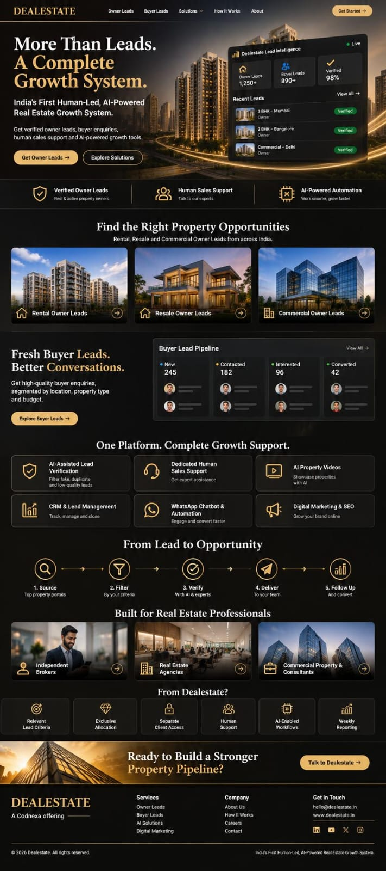
User-provided website inspiration screenshot: overall premium, dark real-estate landing-page rhythm.
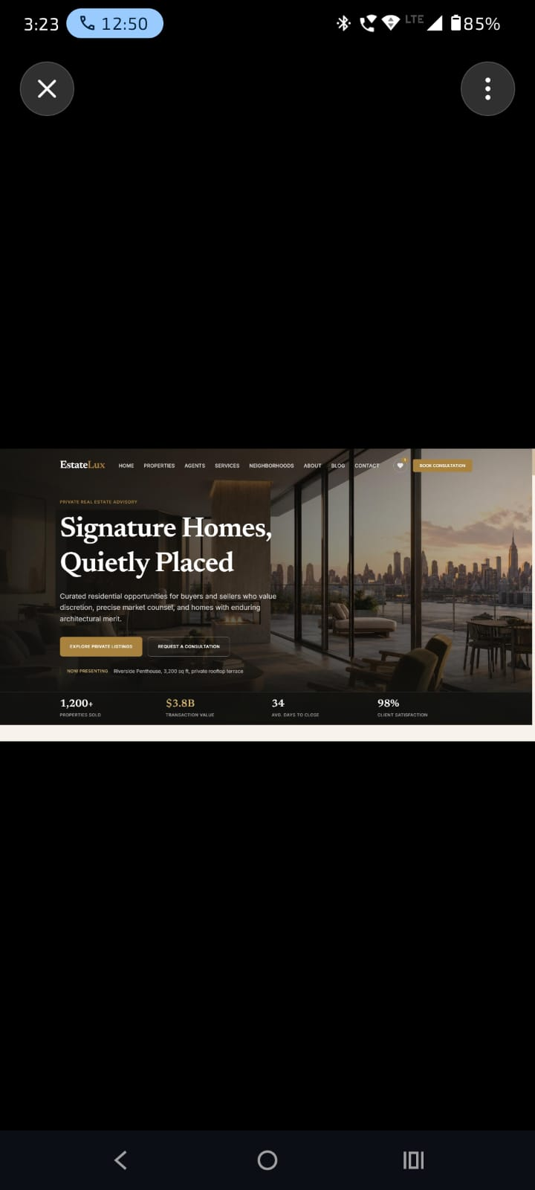
User-provided mobile reference: preserve cinematic hero imagery and responsive hierarchy.
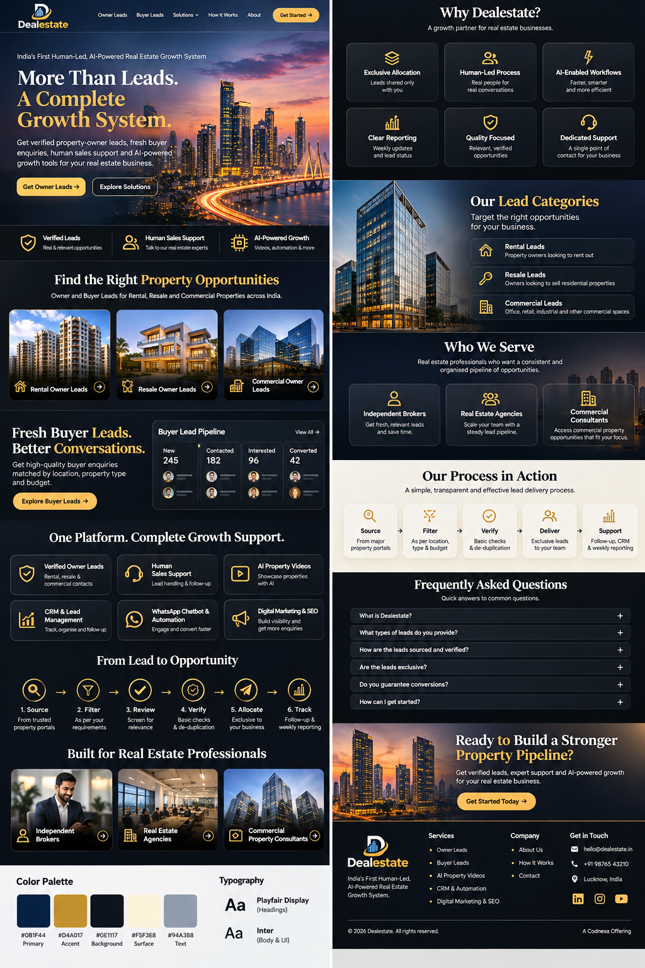
Generated Dealestate full-page concept: layout direction only; replace approximations with actual assets and approved copy.

GharLeads reference: patterns to adapt
- A compact top navigation with clear service anchors and a prominent primary CTA.
- A strong hero that explains the business in one glance and offers a discovery/enquiry action.
- Service-led storytelling with each offering paired with a relevant visual demonstration.
- A connected-system/process section that explains how the services work together.
- About/why-us credibility content, FAQ, a strong closing CTA and a complete footer.
- Responsive visual hierarchy and repeated contact opportunities.
Originality rule
Use GharLeads as a reference for page flow, content hierarchy and interaction ideas only. Do not copy its source code, exact text, proprietary illustrations, brand assets or distinctive compositions. Dealestate must have its own design system and original copy.

Source-of-truth rule
When a claim is not supported by the Dealestate profile or explicitly confirmed by the business owner, do not invent it. Use a clearly marked placeholder or omit it. Do not add fake customer testimonials, client logos, performance numbers, conversion rates, lead counts, office addresses, awards or guarantees.

3. Business facts and approved messaging
Topic | Approved content / guardrail
Positioning | India’s First Human-Led, AI-Powered Real Estate Growth System (brand positioning claim; not independently verified).
Supporting headline | More Than Leads. A Complete Growth System.
Brand promise | Real Leads. Human Touch. AI-Powered Growth.
Owner lead categories | Rental owner leads, resale owner leads and commercial owner leads.
Owner lead sourcing | Property portals such as Magicbricks and 99acres, plus other suitable sources where agreed. Describe sources accurately and avoid implying a formal partnership.
Verification | Relevance filtering, listing/contact review and AI-assisted screening plus human review. Never claim AI conclusively proves legal ownership.
Exclusivity | The agreed model is allocation to one Dealestate client, not resale to multiple Dealestate clients. Explain that the scope and access are agreed per client.
Human sales support | Human assistance for lead handling and follow-up workflows. Exact coverage hours, channels and service levels must be agreed before being promised.
AI property videos | AI-assisted promotional videos using supplied/approved property information and assets.
CRM | Lead capture/organisation and tracking by source, status, assigned agent, follow-up date and outcome where included.
WhatsApp | Automation can support first response, basic qualification, routing and reminders subject to approved workflow, WhatsApp rules and required consent.
Digital growth | Website, landing pages, social media, digital marketing and SEO through Codnexa capabilities; scope separately unless bundled.
Weekly reporting | Can summarise delivery, category, source, assignment and known follow-up outcomes.
Pricing reference | Starting reference of ₹100 per lead, subject to category, location, volume and qualification criteria. Not a universal fixed price. Decide whether public pricing is shown before launch.
Buyer leads | Not a primary Dealestate product for this website. Do not create a buyer-lead hero, buyer-lead category, buyer-lead pipeline or buyer-lead CTA.
Conversion guarantee | Never guarantee a sale, rental, commission or conversion. Dealestate provides leads and support; the client's response, pricing, property and market also affect outcomes.
Refund / replacement | Invalid-lead policy needs final written terms. Do not promise instant refunds until approved policy and operational process are confirmed.
Site visits | Dealestate does not conduct property site visits. Client's own team handles property visits and independently confirms property details, permissions and legal documents.

Approved copy direction
- Lead with the owner's business problem: irrelevant contacts, stale listings, wasted calls and fragmented follow-up.
- Position Dealestate as a system combining owner leads, people, process and technology—not merely a contact-list reseller.
- Make human support tangible: real people assist with lead handling and follow-up, with the exact scope agreed with each client.
- Keep copy confident, practical, clear, commercially focused and trustworthy.
- Use simple English for the website, with natural Indian business terminology where useful. Use Hinglish only in conversational examples/test copy if needed.

4. Final single-page information architecture
Order / anchor | Section | Purpose and required content
01 / #top | Sticky navigation | Logo; Owner Leads; Human Support; Solutions; How It Works; About; Contact; Get Started CTA. Mobile menu with accessible open/close states.
02 / #home | Hero | Mumbai-inspired skyline background; positioning line; large headline; concise value proposition; Get Owner Leads and Explore Solutions CTAs; restrained static lead-intelligence preview if it does not obstruct text.
03 | Trust strip | Three pillars: Verified Owner Leads; Human Sales Support; AI-Assisted Automation. Avoid unsubstantiated numeric stats.
04 / #owner-leads | Owner lead categories | Three image cards: Rental, Resale, Commercial. Each explains who the lead is for and invites an enquiry.
05 / #human-support | Human-led support spotlight | A dedicated, high-visibility section explaining real-person support, lead handling, follow-up workflows and human oversight. This must be a major differentiator.
06 / #solutions | Complete growth support | Service cards: AI-assisted verification; Human sales support; AI property videos; CRM & lead management; WhatsApp chatbot/automation; Digital marketing & SEO.
07 / #how-it-works | Lead-to-opportunity process | Source → Filter → Review → Verify → Allocate → Deliver → Track. Explain what happens at each stage.
08 / #audience | Built for real-estate professionals | Independent brokers; real-estate agencies; commercial property consultants. Rental/resale specialists may be mentioned in supporting copy.
09 / #why-dealestate | Why Dealestate | Relevant criteria; exclusive allocation; separate client access; human support; AI-enabled workflows; weekly reporting.
10 / #faq | FAQ | Lead categories, sourcing, verification, exclusivity, pricing, invalid leads, support scope, conversion guarantees, site visits and getting started.
11 / #contact | Final CTA + contact form | Clear invitation, enquiry form, WhatsApp action, business email/phone placeholders until verified.
12 | Footer | Logo; concise brand statement; service anchors; company/about; contact; social links only when verified; copyright; privacy notice/link.

Page length
Design for approximately 4–5 desktop viewport scrolls of meaningful content. Do not artificially inflate height. On mobile the same content will naturally require more vertical scrolling.

5. Visual design system

Brand palette
Token | Hex | Usage
Primary navy | #0B1F44 | Brand anchor, navigation, strong panels, deep overlays.
Gold accent | #D4A017 | Primary CTA, icons, small highlights, dividers and active states. Use sparingly.
Dark background | #0E1117 | Main dark sections, dashboard mockups and footer.
Warm surface | #F5F3E8 | Occasional light contrast panels and readable content surfaces.
Secondary text | #94A3B8 | Muted supporting copy on dark backgrounds.
Primary text | #F8FAFC | Headings and body copy on dark surfaces.

These are proposed web design tokens derived from the approved visual direction, not a claim that the supplied logo file contains exact sampled brand values. Validate contrast and refine after inspecting the logo in the actual browser.

Typography
- Headings: Playfair Display or a similarly refined editorial serif. Use for hero headline and major section headings only.
- Body/UI: Inter. Use for navigation, paragraphs, cards, labels, form controls and dashboards.
- Use a restrained type scale with clear hierarchy. Avoid tiny all-caps text for important information.
- Prefer locally hosted or carefully subsetted WOFF2 fonts. Use font-display: swap and sensible system fallbacks.

Visual language
- Premium, cinematic, modern real-estate technology; not a generic SaaS template.
- Large, authentic property and skyline photography with careful crops and dark overlays.
- Navy/charcoal panels, subtle borders, restrained glass effects and controlled gold highlights.
- Consistent card radii, spacing, icon stroke weight and alignment.
- Use real property photography or original generated visuals; avoid random stock-image mixing.
- Dashboard previews must be static, clearly illustrative UI compositions—not a fake working CRM.

Hero image specification
Generated Mumbai-inspired skyline candidate supplied for the hero.
- Use a static image, not an autoplay video or live stream. Static imagery is the preferred path for fast first paint.
- Prepare AVIF and WebP derivatives plus a JPEG fallback. Generate at least a wide desktop crop and a portrait/mobile crop.
- Use responsive <picture>/srcset/sizes with explicit width/height or aspect ratio to prevent layout shift.
- Preload only the exact hero asset used above the fold; set fetchpriority='high' and decoding='async'.
- Use a small blurred/low-quality placeholder only if it improves perceived loading without delaying the hero.
- Keep the original high-resolution source in the project assets; never make the browser download an 8K original if a visually equivalent compressed responsive asset is sufficient.
Performance reality
An 8K source image does not automatically render faster. The correct production approach is a high-quality master image plus carefully compressed AVIF/WebP derivatives, responsive sizes, preload and CDN caching. The visible hero should appear immediately without waiting for a video or large JavaScript bundle.

6. Interaction, motion and responsive behaviour

Motion principles
- Use motion to communicate hierarchy and state—not as decoration on every element.
- Hero: subtle background parallax or slow image drift only if it remains smooth and does not harm mobile performance. Default can be a static crop.
- Section entry: restrained opacity + 12–20px translate, triggered once when entering viewport.
- Cards: subtle lift (2–4px), border tint and restrained shadow on hover.
- Buttons: quick colour/brightness transition and a small arrow shift; avoid large scale/bounce effects.
- Navigation: smooth anchor scroll with sticky-header offset; active section indicator optional.
- Process: simple line/step reveal, with no heavy continuous animation.
- Cursor: a subtle gold halo or pointer accent on fine-pointer desktop only; disable on touch devices and do not replace the native cursor.
- Respect prefers-reduced-motion: reduce. All content and controls must remain fully usable without motion.

Timing and restraint
Interaction | Suggested duration / behaviour
Hover / focus transitions | 140–220ms, ease-out.
Button press | 80–140ms; no large scaling.
Section reveal | 350–550ms once, small movement.
Dropdown/mobile menu | 180–260ms, transform/opacity.
Background movement | Very slow and optional; never required to understand content.

Mobile-first requirements
- Design and implement at 360px width first; test 320px, 360px, 390px, 430px, tablet, 1366px and 1440px.
- No horizontal overflow, clipped CTA, overlapping text or undersized touch targets.
- Mobile navigation uses a clear menu button, accessible expanded state, focus handling and closes after selecting an anchor.
- Hero text comes before secondary visual elements on narrow screens. Keep the Mumbai skyline visible through deliberate object-position and overlay adjustments.
- Service cards stack or become a deliberate two-column grid only when space supports it. Avoid tiny cards.
- Use horizontal swipe only when it is discoverable, keyboard accessible and genuinely better than a stacked list.
- Buttons and form fields should have comfortable touch targets (aim for 44px minimum height).
- WhatsApp contact control must not cover form submit buttons, cookie/privacy controls or key content.

Loading, skeleton and empty states
- The hero and core copy are static HTML/CSS and must render without waiting for JavaScript-heavy widgets.
- Use skeletons only for components that genuinely wait for an asset or asynchronous third-party content; do not skeleton the entire page.
- Image placeholders should preserve exact aspect ratio to avoid layout shift. Use a blurred thumbnail or neutral shimmer, then fade in the loaded image.
- If a third-party form script is slow, keep a clear fallback contact link visible.
- If an image fails, show a deliberate branded fallback rather than a broken-image icon.
- Avoid fake loading spinners for content that is already static.

Accessibility
- Semantic landmarks: header, nav, main, section, footer; one H1; logical heading hierarchy.
- Visible keyboard focus, accessible names, form labels, validation messages and contrast.
- Mobile menu and FAQ accordions must work with keyboard and screen readers.
- Decorative images/icons should be hidden from assistive technology; meaningful images need useful alt text.
- Respect reduced motion and avoid hover-only information.

7. Technical architecture and modularity (strict)

Recommended stack
Layer | Recommendation | Notes
Framework | React + TypeScript + Vite | Fast static frontend build; no server rendering requirement for this single-page marketing site.
Styling | Tailwind CSS + CSS variables | Central tokens, reusable patterns and predictable responsive utilities. Avoid one giant stylesheet.
Motion | Framer Motion | Use selectively; CSS transitions are enough for simple hover/focus states.
Icons | Lucide React | Consistent outline icon set; do not mix random icon families.
Forms | Hosted form endpoint (e.g. Web3Forms/Formspree) | No custom API/backend. Configure endpoint via environment variable and document provider setup.
Hosting | Vercel or Netlify | Static deployment with HTTPS, compression, caching and redirects as needed.
Images | AVIF/WebP responsive assets | Use a CDN/static asset hosting path and lazy loading below the fold.

Suggested project structure
src/
app/
App.tsx
main.tsx
components/
layout/
SiteHeader.tsx
MobileNavigation.tsx
SiteFooter.tsx
SectionContainer.tsx
ui/
Button.tsx
Icon.tsx
SectionHeading.tsx
ServiceCard.tsx
ImageFrame.tsx
Skeleton.tsx
Accordion.tsx
WhatsAppButton.tsx
sections/
HeroSection/
HeroSection.tsx
HeroDashboardPreview.tsx
TrustStrip/
TrustStrip.tsx
OwnerLeads/
OwnerLeadsSection.tsx
OwnerLeadCard.tsx
HumanSupport/
HumanSupportSection.tsx
Solutions/
SolutionsSection.tsx
HowItWorks/
HowItWorksSection.tsx
Audience/
AudienceSection.tsx
WhyDealestate/
WhyDealestateSection.tsx
FAQ/
FAQSection.tsx
Contact/
ContactSection.tsx
data/
navigation.ts
services.ts
ownerLeadCategories.ts
processSteps.ts
faqs.ts
siteConfig.ts
hooks/
useActiveSection.ts
useReducedMotion.ts
lib/
contact.ts
analytics.ts
styles/
tokens.css
globals.css
assets/
images/
icons/
types/
content.ts
public/
favicon/
images/

Modularity rules
- Each page section is a self-contained component with a clear public interface. Do not build the entire page in App.tsx.
- Keep content/data separate from presentation. Service cards, FAQs, process steps and navigation should be data-driven.
- Create shared UI primitives for buttons, section headings, cards, containers, icons, accordions and image frames.
- Use central design tokens for colours, spacing, radii, shadows, typography and motion durations.
- Avoid duplicated markup, duplicated breakpoint logic, magic numbers and arbitrary one-off styles.
- Do not create a generic mega-component with dozens of boolean props. Compose smaller focused components.
- Use TypeScript types for data structures and component props. Avoid any unless there is a documented reason.
- Keep third-party integrations isolated in lib/contact.ts or a small adapter. Do not spread provider-specific code across components.
- Use semantic, descriptive filenames and predictable exports.
- Keep dependencies lean. Do not add libraries for effects that CSS can perform simply.

No-backend boundary
- No database, custom API, authentication, CMS, dashboard login or lead storage is in scope.
- Contact submissions go directly to a configured hosted form service. The service stores/sends submissions externally.
- WhatsApp CTA opens a prefilled wa.me link using a confirmed business number.
- If provider credentials, WhatsApp number, business email or social URLs are missing, use explicit configuration placeholders and report them as launch blockers.
- Never hardcode secret keys in client-side code. Use provider-supported public form keys only where documented.

8. Content and copy requirements

Hero copy draft
Eyebrow
INDIA’S HUMAN-LED, AI-POWERED REAL ESTATE GROWTH SYSTEM

More Than Leads. A Complete Growth System.
Get relevant property-owner leads, dedicated human sales support and AI-powered tools that help your real-estate business manage opportunities more effectively.
Primary CTA: Get Owner Leads | Secondary CTA: Explore Solutions
Avoid buyer lead claims, fake numeric proof and unsupported statements such as '100% verified', 'guaranteed deals' or 'instant refund'.

Owner leads cards
Category | Suggested short description
Rental Owner Leads | Connect with property owners offering residential or commercial spaces for rent.
Resale Owner Leads | Find relevant owner opportunities for residential resale requirements.
Commercial Owner Leads | Explore owner or authorised-contact opportunities across offices, retail, industrial and other commercial spaces.

Human-led support section
Suggested headline: Technology Helps. People Make the Difference.
Suggested body: Dealestate combines AI-assisted workflows with human sales support to help keep lead handling and follow-up organised. The support scope, channels and coverage are agreed around each client's requirements.

Solutions cards
Service | Description direction
AI-Assisted Lead Verification | Filter for relevance, review available listing/contact details and flag duplicates, invalid or suspicious records. Do not claim perfect accuracy.
Dedicated Human Sales Support | Human assistance for agreed lead handling and follow-up workflows.
AI Property Videos | Turn approved property information and media into promotional video content.
CRM & Lead Management | Organise leads by source, status, assigned agent, follow-up date and outcome where included.
WhatsApp Chatbot & Automation | Support first response, basic qualification, routing and reminders under approved consent-based workflows.
Digital Marketing & SEO | Optional website, landing page, social, campaign and search visibility support through Codnexa.

Process steps
Step | What to communicate
1. Source | Identify relevant owner listings or enquiries from agreed sources.
2. Filter | Apply location, property category and client criteria.
3. Review | Inspect listing details and available contact information for relevance and inconsistencies.
4. Verify | Use available checks and AI-assisted screening to flag suspicious or poor-quality records; ambiguous records should be labelled or excluded.
5. Allocate | Assign eligible leads to the agreed client under the exclusivity model.
6. Deliver | Share lead details and available source/context through the agreed channel.
7. Track | Record follow-up status and client feedback to improve subsequent filtering.

FAQ content to include
- What is Dealestate?
- What types of owner leads are available?
- Where do owner leads come from?
- How does the verification process work?
- Are leads exclusive?
- How is pricing decided?
- What happens if a number is invalid?
- What does human sales support include?
- Does Dealestate conduct property site visits?
- Does Dealestate guarantee a sale or rental?

Contact form fields
- Full name (required).
- Phone / WhatsApp number (required; validate India phone format without blocking legitimate international numbers if wider reach is needed).
- Business type (broker/agent, agency, commercial consultant, other).
- City / preferred locality (required).
- Lead category (rental owner, resale owner, commercial owner, not sure).
- Approximate requirement / message (optional).
- Consent checkbox with concise privacy wording (required if needed by the form workflow).
Form confirmation should state that the enquiry was submitted only after the hosted provider confirms success. Provide a fallback WhatsApp or email contact if the submission fails.

9. Three-phase implementation plan

PHASE 1 — Foundation, brand system and above-the-fold experience
Goal: establish a clean, production-ready foundation and deliver the most important first impression: header, mobile navigation and hero.

Step-by-step build
- Inspect the existing repository before changing anything. Identify framework, package manager, current routes, styling setup, lint/test commands and existing assets. Do not overwrite a working project blindly.
- Create a concise implementation plan and identify missing business configuration: WhatsApp number, email, form provider, social URLs and final policy links. Continue with safe placeholders where possible.
- Set up or clean the React + TypeScript + Vite foundation only if the repository does not already have a suitable setup. Keep dependencies minimal.
- Implement the folder structure, global styles, design tokens, typography, spacing scale, breakpoints, container widths and reusable button/section primitives.
- Prepare the supplied logo for web use. Do not substitute an AI-generated logo. Ensure correct aspect ratio, object-fit and crisp rendering.
- Optimise the skyline hero asset into responsive AVIF/WebP variants. Keep desktop and mobile crops/art direction separate if needed.
- Build sticky header, desktop navigation, mobile navigation, hero, dark overlay, CTA buttons and optional static dashboard preview.
- Add reduced-motion support, keyboard focus states, responsive typography and image loading behaviour.
- Run typecheck, lint, build and responsive visual checks. Fix issues before moving to Phase 2.

Phase 1 acceptance criteria
- Project starts and production build succeeds with no TypeScript errors.
- Header, logo, menu, hero copy and CTAs render correctly at 320px, 360px, 390px, 768px, 1280px and 1440px.
- Hero image is not a multi-megabyte unoptimised asset in production; responsive variants are used.
- Hero text is readable over the photograph and the primary CTA is immediately visible.
- Mobile navigation is accessible, closable and does not overflow.
- Reduced-motion preference is respected; no distracting cursor effect on touch devices.
- No placeholder buyer-lead messaging or fabricated business claims.

PHASE 2 — Complete page sections, content and conversion flow
Goal: implement the full long-scrolling landing page with reusable, data-driven sections and functioning enquiry paths.

Step-by-step build
- Implement the trust strip and three owner-lead category cards (Rental, Resale, Commercial).
- Implement a dedicated Human-Led Sales Support section with a distinct visual treatment and clear scope-safe copy.
- Implement the six solution cards using data-driven content and consistent iconography.
- Implement the seven-step lead workflow: Source, Filter, Review, Verify, Allocate, Deliver, Track.
- Implement audience cards for independent brokers, agencies and commercial property consultants.
- Implement Why Dealestate benefits: relevant criteria, exclusive allocation, separate client access, human support, AI-enabled workflows and weekly reporting.
- Implement FAQ accordion with accessible keyboard interactions and clear answer copy.
- Implement contact section, validation, loading/success/error states and fallback contact methods.
- Implement WhatsApp click-to-chat using a configurable number and concise prefilled message. Do not invent the number.
- Implement footer with verified business details only. Use placeholders for any missing information and list them in the handoff.
- Check every navigation anchor and CTA target. Add scroll-margin-top so sticky header does not cover section headings.

Phase 2 acceptance criteria
- Every section is a separate component and content is data-driven where appropriate.
- Owner leads and human support dominate the story; buyer leads are not represented as a core product.
- All buttons and navigation links perform their advertised action.
- Form has client-side validation and provider-backed submission handling; no false success state.
- FAQ is keyboard accessible and works on touch.
- All content is accurate against the business profile; unsupported claims are omitted or flagged.
- Page works without any custom backend, database or login.

PHASE 3 — Motion, performance, accessibility, SEO and release readiness
Goal: refine the experience, optimise real-world loading, test all breakpoints and prepare a deployable production build.

Step-by-step build
- Add restrained section reveal, card hover, button transitions, process-step motion and optional desktop-only cursor accent.
- Add prefers-reduced-motion handling and ensure no interaction depends on hover or animation.
- Audit images: convert to AVIF/WebP, responsive srcset, correct sizes, lazy-load below-fold images, explicit dimensions and meaningful alt text.
- Audit font loading: subset/local WOFF2 where possible, font-display: swap, avoid excessive weights and avoid render-blocking imports.
- Audit JavaScript bundle and dependencies. Remove unused packages, unnecessary animation logic and oversized icon imports.
- Set metadata: title, description, canonical URL placeholder, Open Graph image, theme colour and favicon using the supplied brand identity.
- Add semantic HTML, focus states, accessible labels, form errors, contrast checks and keyboard testing.
- Test Lighthouse/PageSpeed on mobile and desktop; fix layout shift, oversized images, render-blocking resources and unnecessary main-thread work.
- Test slow network and image failure states. Confirm the page remains understandable if external form/WhatsApp services are unavailable.
- Verify production environment variables and deployment settings. Deploy only after the owner supplies/approves the live contact details and final policy URLs.
- Provide a release report: changed files, architecture, commands run, test/build results, unresolved placeholders, asset sizes and deployment steps.

Phase 3 acceptance criteria
- Production build passes and there are no console errors or broken assets.
- No horizontal overflow at tested viewport widths.
- Hero image is prioritised; below-fold images are lazy-loaded.
- CLS is controlled through image dimensions/aspect ratios and stable skeletons.
- Keyboard-only navigation, focus visibility and reduced motion work.
- Mobile Lighthouse target: Performance 90+, Accessibility 95+, Best Practices 95+, SEO 95+ where measurable. Treat as targets, not guarantees; report actual results and explain any third-party limitations.
- Contact form success/error states are verified with the configured provider.
- Final handoff documents environment variables, deployment and remaining business approvals.

10. Production performance and quality standards
Area | Requirement / target
First render | Render semantic content and hero immediately; do not wait for animation library, analytics or form provider.
Hero image | Responsive AVIF/WebP, compressed to a sensible visual-quality/byte tradeoff. Suggested starting targets: desktop hero ≤350KB and mobile hero ≤220KB; adjust if visual quality requires it.
LCP | Aim for Largest Contentful Paint ≤2.5s on representative mobile testing. Preload the correct hero image and avoid lazy-loading the LCP image.
CLS | Aim for Cumulative Layout Shift ≤0.1. Reserve image/card/form dimensions.
INP | Aim for Interaction to Next Paint ≤200ms. Keep event handlers and animation work lightweight.
Below-fold images | loading='lazy', decoding='async', responsive sizes and fixed aspect ratio.
Fonts | Prefer WOFF2, subset where practical, preload only the primary critical font files.
Motion | Transform/opacity based; avoid expensive layout animation and continuous scroll listeners.
Third-party | Load form/analytics integrations only when needed; no blocking scripts in the critical path.
Caching | Use static asset caching and CDN delivery through the chosen host.
Error handling | Image fallback, form failure state, no dead CTAs and no unhandled promise errors.

Skeleton policy
Skeletons are for genuinely asynchronous content only. The hero, headings, service copy and static dashboard preview should be present immediately. Do not create a fake 2–3 second loading screen just to look sophisticated.

11. SEO, analytics, privacy and legal readiness

SEO
- One clear H1 containing the core Dealestate value proposition.
- Descriptive title and meta description focused on real-estate owner leads and human-led support.
- Semantic H2s for owner leads, human support, solutions, process, audience and FAQs.
- Descriptive image alt text; decorative imagery uses empty alt text.
- Open Graph/Twitter metadata and a suitable social sharing image.
- Local SEO claims must reflect actual service availability. Do not imply a physical branch in a city unless confirmed.
- Add Organization/LocalBusiness structured data only with verified details; do not fabricate address, rating or opening hours.

Analytics
Optional lightweight analytics may be added only after the owner chooses a provider and confirms the privacy approach. Track CTA clicks, WhatsApp clicks and successful form submissions without collecting unnecessary personal information. Do not add a heavyweight analytics bundle by default.

Privacy and consent
- Publish a privacy notice explaining what the enquiry form collects, why it is collected and how the business responds.
- Do not expose submitted lead information in client-side code or public dashboards.
- Ensure WhatsApp automation language accounts for consent and applicable platform rules.
- Cookie banner is only required if the selected analytics/marketing stack actually uses non-essential cookies or similar tracking; do not add a decorative banner without purpose.

Pre-launch approvals
Item | Status
Official WhatsApp number | OWNER TO CONFIRM
Business enquiry email | OWNER TO CONFIRM
Public phone number | OWNER TO CONFIRM
Social media profile URLs | OWNER TO CONFIRM
Form provider and endpoint | OWNER TO CONFIGURE
Pricing visibility (hide / 'starting at ₹100' / packages) | OWNER TO DECIDE
Invalid-lead refund/replacement policy wording | OWNER TO APPROVE
Human support scope and coverage hours | OWNER TO CONFIRM
Privacy policy URL/content | OWNER TO APPROVE
Final logo file (prefer transparent SVG/PNG if available) | OWNER TO PROVIDE IF AVAILABLE

12. QA test matrix
Test | Expected result
320px narrow phone | No horizontal scroll; headline wraps naturally; CTAs fit; menu usable.
360–390px phone | Hero and cards readable; no image/text collision; WhatsApp control does not cover actions.
430px phone | Spacing and card width remain balanced; no awkward stretched single card.
Tablet portrait/landscape | Navigation adapts; grid transitions are deliberate; no excessive empty space.
1366–1440px desktop | Hero composition balanced; text remains readable; max-width prevents overly wide copy.
Keyboard navigation | Logical tab order, visible focus, accessible menu, FAQ and form controls.
Reduced motion | No parallax/cursor/reveal motion that violates user preference.
Slow 3G / throttled network | Text renders immediately; hero uses optimised asset; no full-screen loader.
Image request failure | Fallback background or placeholder; layout dimensions remain stable.
Form success | Success message only after provider confirms submission.
Form failure | Clear retry/fallback message; values are not silently lost where feasible.
WhatsApp CTA | Opens correct configured number and prefilled message.
Anchor navigation | Correct section lands below sticky header; mobile menu closes.
Production build | No TypeScript/lint/build errors; no broken paths or missing environment configuration.

13. Master instruction to Antigravity
Execution mode
Treat this document as the single source of truth for the Dealestate marketing website. Work in three phases. Finish and validate each phase before starting the next. Do not skip acceptance criteria.

You are acting as a senior frontend architect, senior React/TypeScript engineer, performance engineer and premium web product designer.
Build the Dealestate single-page marketing website strictly according to this blueprint.
NON-NEGOTIABLES
- Mobile-first and production-quality responsive behaviour.
- Strict modularity: independent sections, reusable UI primitives, data-driven content, central design tokens and isolated integrations.
- Primary offer is property-owner leads: Rental, Resale and Commercial.
- Human-led sales support is a major differentiator and must be prominent.
- AI supports human workflows; do not imply it replaces the human team.
- Do not position buyer leads as a primary service.
- No custom backend, database, authentication, admin panel or real CRM.
- Use the supplied Dealestate logo. Never replace it with an AI-generated approximation.
- Follow the premium navy/gold cinematic visual direction and use the supplied Mumbai skyline image as the hero candidate after optimisation.
- Use GharLeads only as inspiration for information architecture and service storytelling. Do not copy code, text, branding or proprietary graphics.
- No fabricated statistics, testimonials, client logos, awards, guarantees, exact verification claims or instant-refund promises.
- Keep motion restrained, purposeful and fast. Respect prefers-reduced-motion.
- Skeletons only for genuinely asynchronous content. Static content must render immediately.
- Never claim a form was submitted unless the hosted provider confirms success.
WORKFLOW
1. Inspect the existing repository and assets before editing. Report the current stack, entry points, scripts and risks.
2. Create a file-by-file implementation plan. Preserve useful existing code.
3. Implement PHASE 1 only: foundation, design tokens, reusable primitives, logo handling, optimised hero asset, header, mobile nav and hero. Run typecheck/lint/build and viewport checks. Report results.
4. Implement PHASE 2 only after Phase 1 is validated: all page sections, content, FAQ, contact form, WhatsApp CTA and footer. Validate every interaction.
5. Implement PHASE 3 only after Phase 2 is validated: motion, performance, accessibility, SEO, QA and deployment readiness.
6. At each phase, list changed files, commands run, test results, unresolved issues and acceptance criteria status.
7. Do not silently invent missing business information. Keep clearly named configuration placeholders and report them as launch blockers.
8. Do not deploy, publish or push changes unless explicitly instructed by the owner.
DESIGN QUALITY BAR
The result must look art-directed, premium and intentional—not like a generic Tailwind starter or cheap template. Use consistent spacing, refined typography, real-estate imagery, restrained gold accents, carefully composed cards, strong mobile hierarchy and polished interaction states. Avoid excessive glassmorphism, glowing borders, giant gradients, random animations and crowded dashboards.
Begin with repository inspection and a concise Phase 1 plan. Do not implement all three phases in one uncontrolled pass.

14. Handoff checklist and definition of done
- ☐ Approved logo is used consistently in navbar and footer.
- ☐ Hero uses an optimised Mumbai skyline image with responsive crop and legible overlay.
- ☐ One-page anchor navigation works on desktop and mobile.
- ☐ Owner lead categories are the main commercial content.
- ☐ Human-led support has a dedicated, prominent section.
- ☐ AI-enabled services are described accurately and responsibly.
- ☐ No buyer-lead product positioning appears.
- ☐ All six supporting solutions are represented accurately.
- ☐ Lead workflow is presented in the correct seven-step sequence.
- ☐ FAQ, contact form, WhatsApp action and footer are complete.
- ☐ All missing business details are documented as owner approvals.
- ☐ Responsive QA is complete from 320px through large desktop.
- ☐ Loading, error, empty, focus and reduced-motion states are considered.
- ☐ Performance, accessibility and SEO checks are run and results recorded.
- ☐ Production build passes and deployment instructions are provided.
- ☐ Code remains modular, typed, documented where necessary and free of avoidable duplication.

15. Source references and provenance
Dealestate Business Profile PDF (user-supplied, 9 pages): used for positioning, audience, service scope, lead sourcing/verification, exclusivity, pricing caveats, onboarding, operating standards, performance metrics, FAQ and contact context. Key material appears on pages 2–9.
GharLeads reference website (user-supplied URL): https://gharleads.in/ — reviewed for the visible page structure and content flow: navigation, hero, services, visual CRM/service demonstrations, connected workflow, about/why-us, FAQ, CTA and footer. This is inspiration, not a source for Dealestate claims.
User-supplied Dealestate outbound calling script: used for broker pain points, owner-lead value proposition, qualifying questions, objections and WhatsApp follow-up direction. Claims from the script that conflict with the formal business profile or require a final policy (for example instant refund) are marked for owner confirmation rather than treated as guaranteed facts.
User-supplied assets: Dealestate logo, visual inspiration screenshot, mobile screenshot, generated Mumbai skyline hero candidate and generated full-page mockup. The mockup is illustrative and not a substitute for approved final copy or real product data.

