SOMALIA PREDICTORS
22/01/2024

Welcome to the data predictor documentation for Somalia. In this document, we provide a full description of the data sets used in the analysis. For a detailed overview of all available data sets and their respective sources, please refer to the Excel file "som_data_tracking.xlsx".
This document aims to provide an overview of the specific datasets used during the analysis study, giving readers a clear understanding of the data sources and their relevance to the research. For a more comprehensive view of the available datasets, including additional information and sources, we recommend consulting the accompanying Excel file.
To facilitate the analysis, we have provided an R script, "00_som_master_file.R," located in the "code" folder. Running this script will initiate the data cleaning, resulting in datasets essential for the analysis. But, before running the "00_som_master_file.R" script in the "code" folder, it is crucial to ensure that the datasets are up-to-date. After running the script, you will find the generated datasets saved in the "output" folder. Each dataset will include the following core elements: year, p_time, month, date, region, district, pcode, reg_code, and additional relevant information.
NB: The number of district/admin2 in Somalia is 74.
The beginning of the analysis is January 2015.

Contents
SOMALIA PREDICTORS 1
Health Datasets 2
Malaria Dataset 2
Measles Dataset 2
Cholera Dataset 2
Humanitarian Presence 2
Insecurity Events 2
Attacks Against Aid Workers 2
Food Datasets 2
SAM/MAM 2
Trades/Power Index 3
Water Price 3
Climate Datasets 3
Rainfall & CDI 3
Datasets Description 3
Overview of Datasets 3
Dataset Visualizations 5

Health Datasets

Malaria Dataset
Source: FSNAU Dashboard (directly from the website link, Fig.1)
Years: 2013 –> up-to-date
District: All
Malaria Incidence – Cases per 100,000 population

Measles Dataset
Source: FSNAU Dashboard (directly from the website, Fig.1)
Years: 2013 --> up-to-date
District: All
Measles Incidence – Cases per 100,000 population

Cholera Dataset
Source: FSNAU Dashboard (directly from the website, Fig.1)
Years: 2013 --> up-to-date
District: All
Cholera Incidence – Cases per 100,000 population

Humanitarian Presence

Insecurity Events
Source: https://acleddata.com/data-export-tool/ -- export the data + save it in the ‘data’ folder, Fig 2
Years: 2013 --> up-to-date
District: All
Saved as: acled_data_2023.csv
Incidence of insecurity events and fatalities – events of any typology per 100,000 population / fatalities per 100,000 population

Attacks Against Aid Workers
Source: https://aidworkersecurity.org – export the dataset and save it in the “data” folder, Fig.3
Years: 2013-2023
District: All
Saved as: security_incidents_2023.csv
Incidence of attacks against aid workers -- deaths/injuries per 100,000 population

Food Datasets
SAM/MAM
Source: https://drive.google.com/drive/folders/1Dl--uLDcgHhqhhe9qq5y0an9TelgKibe -- export the dataset and save it in the “data folder”
Years: 2013 --> up-to-date
District: All
Saved as: SOMALIA_NUTRITION_SERVICES_DATABASE_Sept_2023.xlsx
Malnutrition incidence -- cases of severe acute malnutrition admitted to treatment programmes per 100,000 population.

Trades/Power Index
Source: FSNAU Dashboard (directly from the website, Fig.1)
Years: 2013 --> up-to-date
District: All
Terms of trade purchasing power index -- Kcal equivalent of local cereals that an average local-quality goat (or daily labourer wage) can be exchanged for.

Water Price
Source: FSNAU Dashboard (directly from the website, Fig.1)
Years: 2013 --> up-to-date
District: All
Water price – price of 200L drum of water in Somali Shillings

Climate Datasets

Rainfall & CDI
Source: FSNAU Dashboard (directly from the website, Fig.1)
Years: 2013 --> up-to-date
District: All
Extent of drought conditions – Combined Drought Index
Rainfall – mean of Standard Precipitation Index

Datasets Description

Overview of Datasets

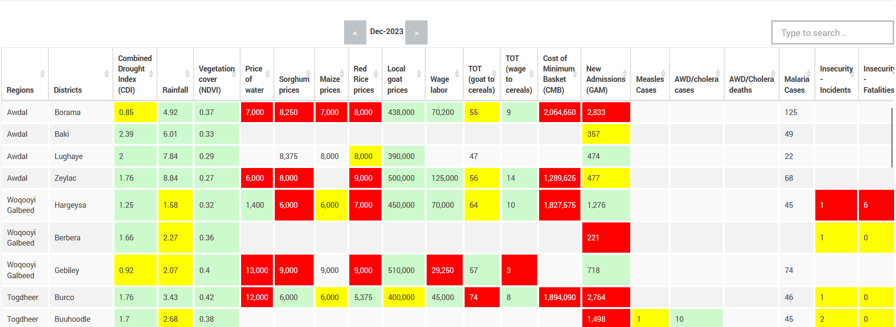
Figure 1 - FSNAU DashBoard (for the month of Dec. 2023) - https://dashboard.fsnau.org/dashboard/index

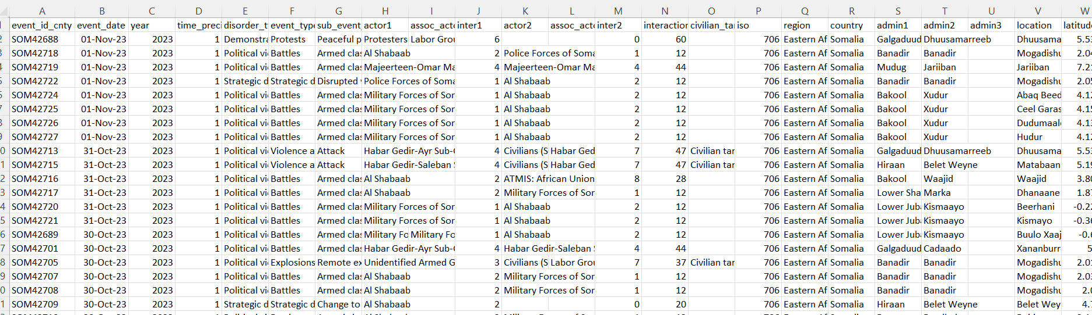
Figure 2- View of ACLED Datasets – Important columns: event_date, event_type, admin2 --
https://acleddata.com/data-export-tool/

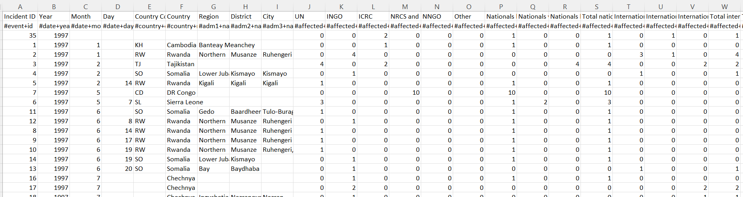
Figure 3 - View of the Aid workers datasets – Important columns: Incident ID, Year, Month, Country, District, Total killed, Total Wounded -- https://aidworkersecurity.org
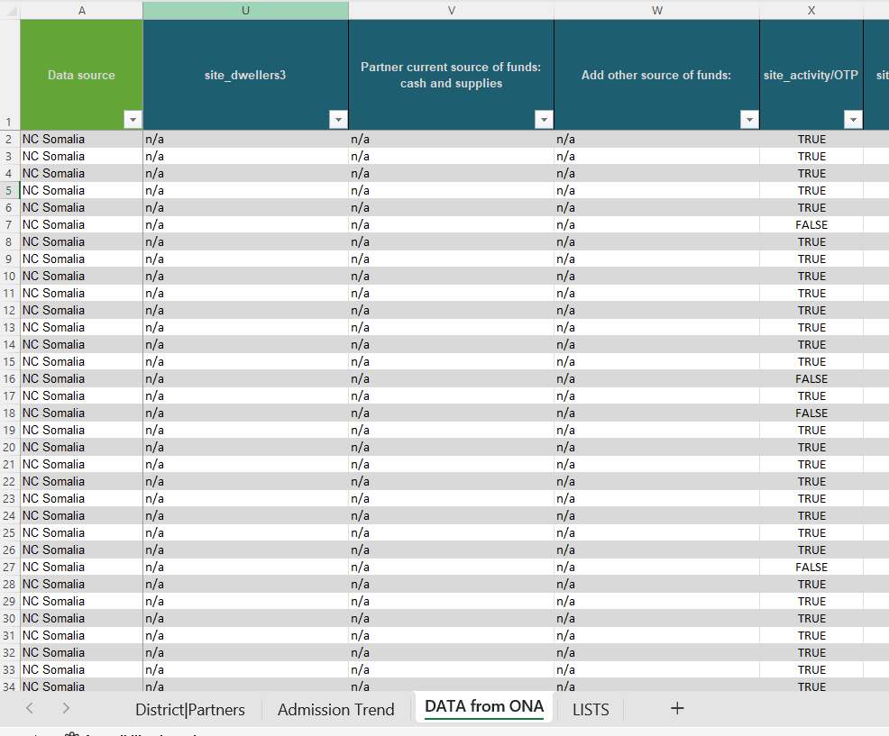
Figure 4 - View of the SAM Dataset -- Important sheet: DATA FROM ONA – Important columns: District, Year, Month, SAM#

Dataset Visualizations

Malaria Cases
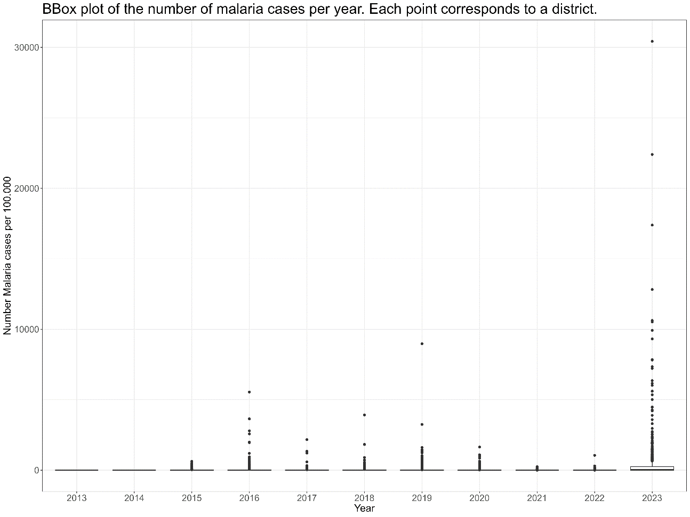
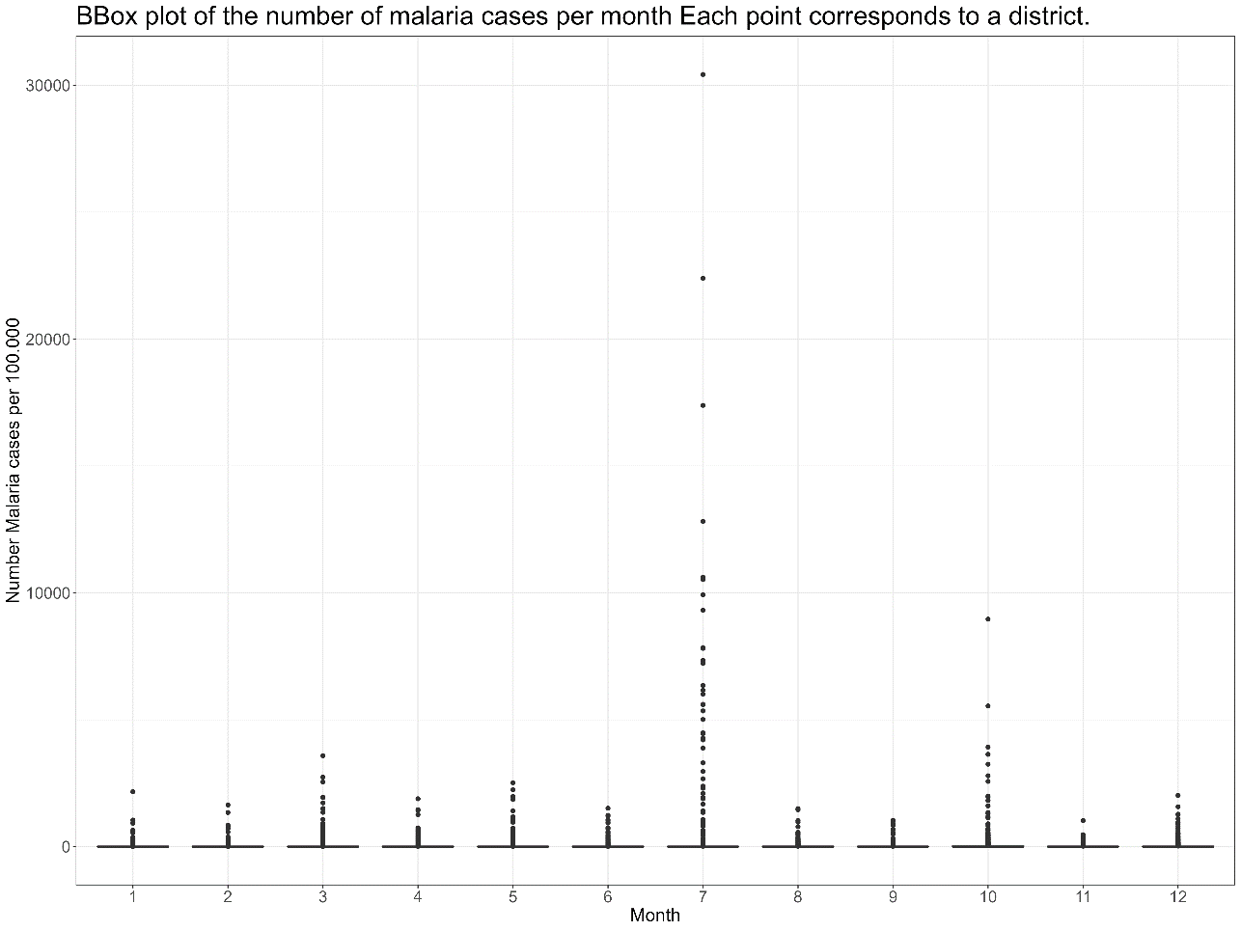

Measles Cases
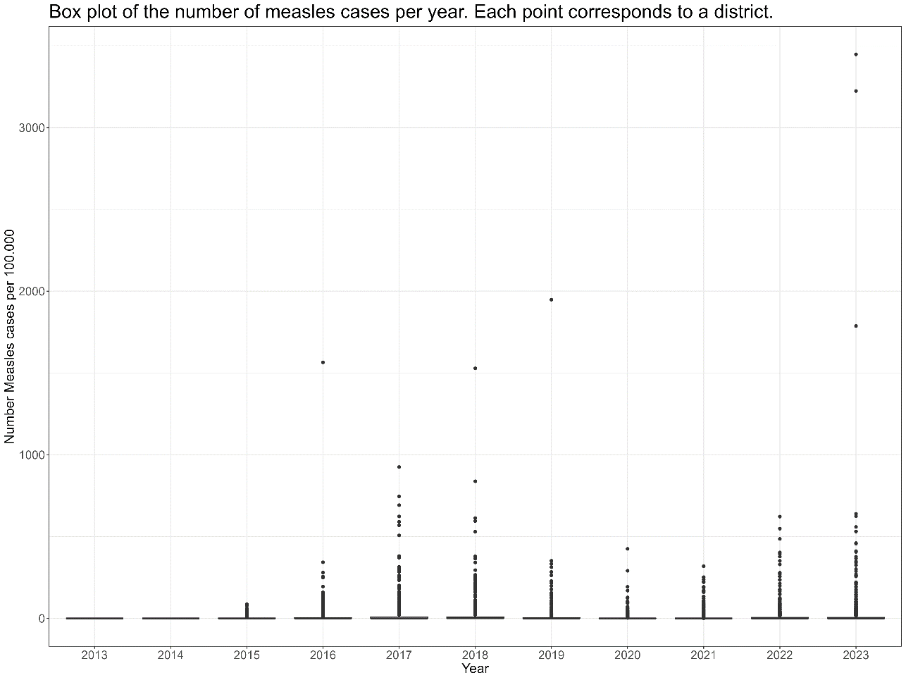

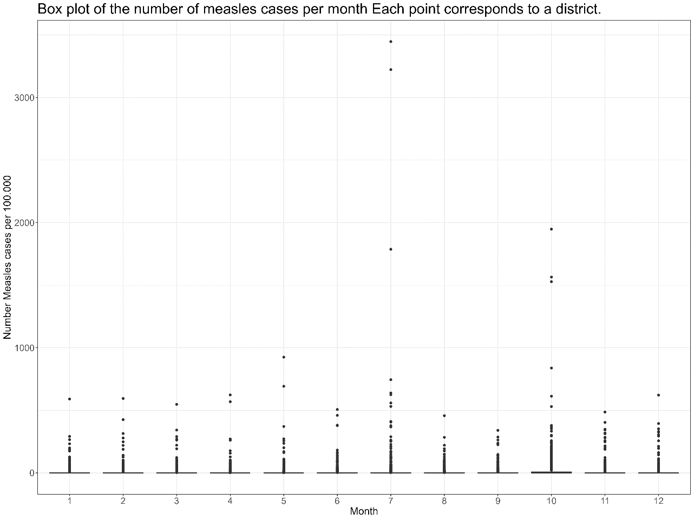

Cholera Cases
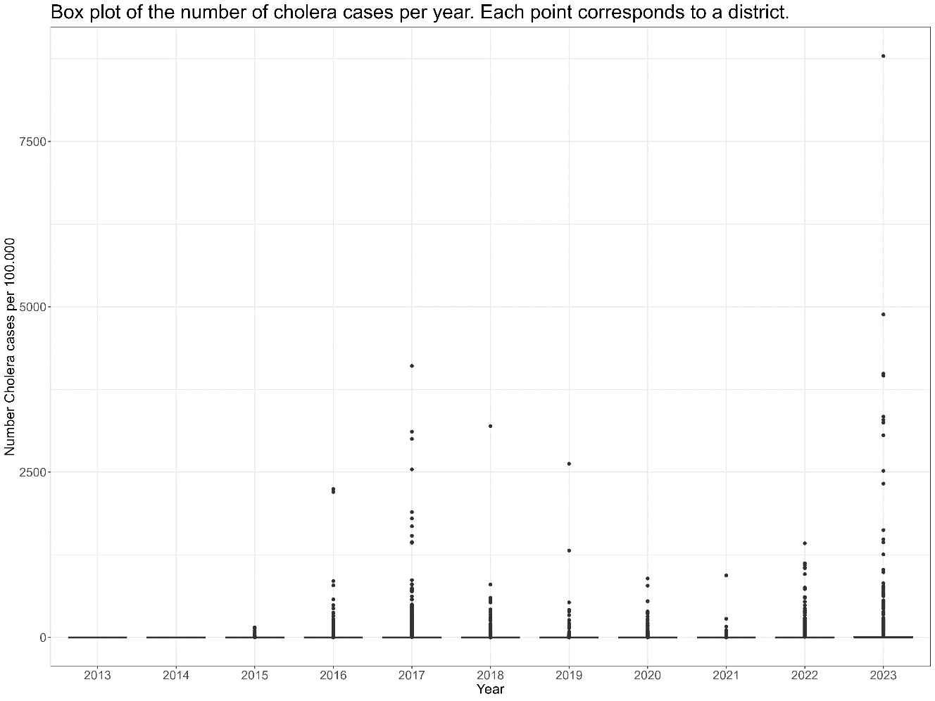

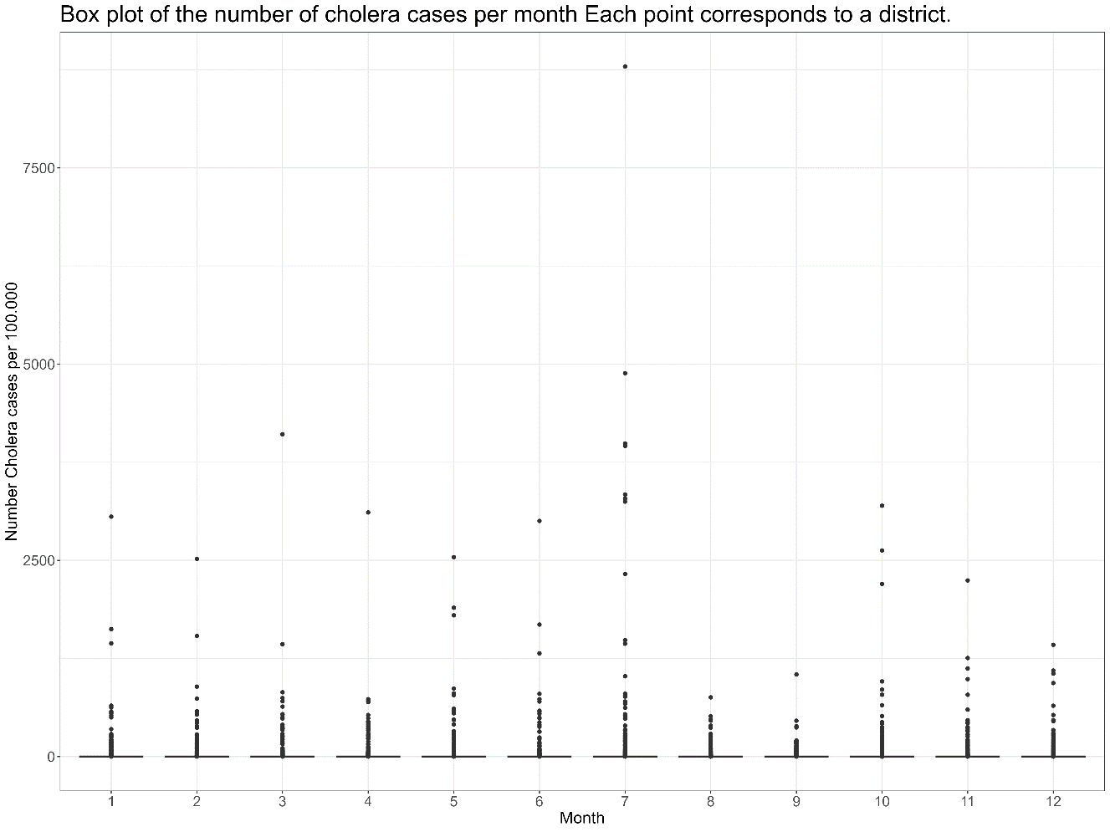

Insecurity Events
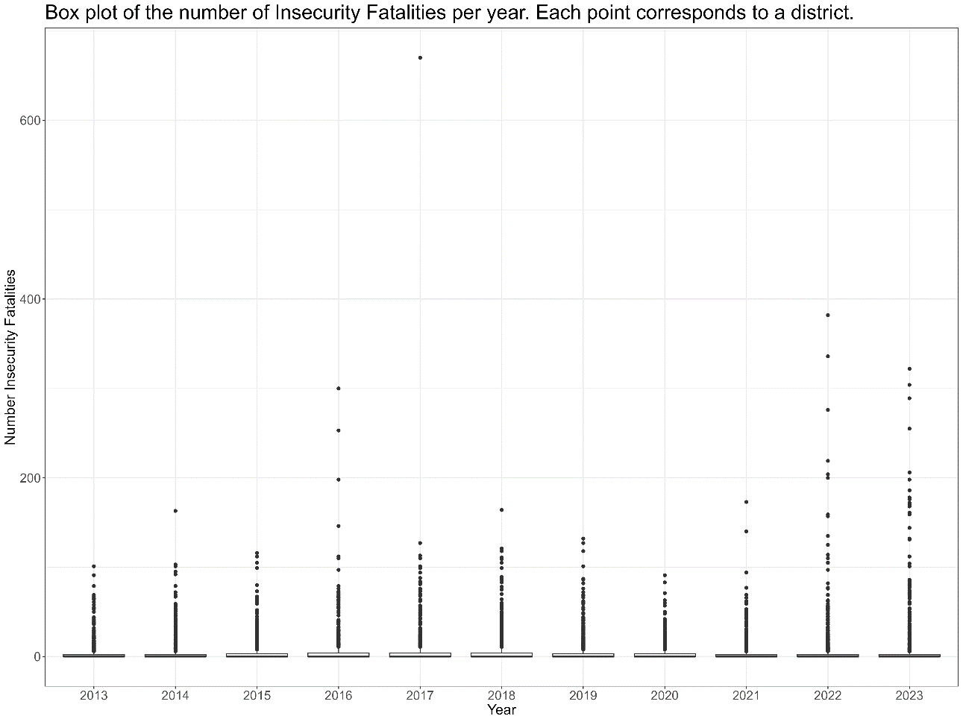

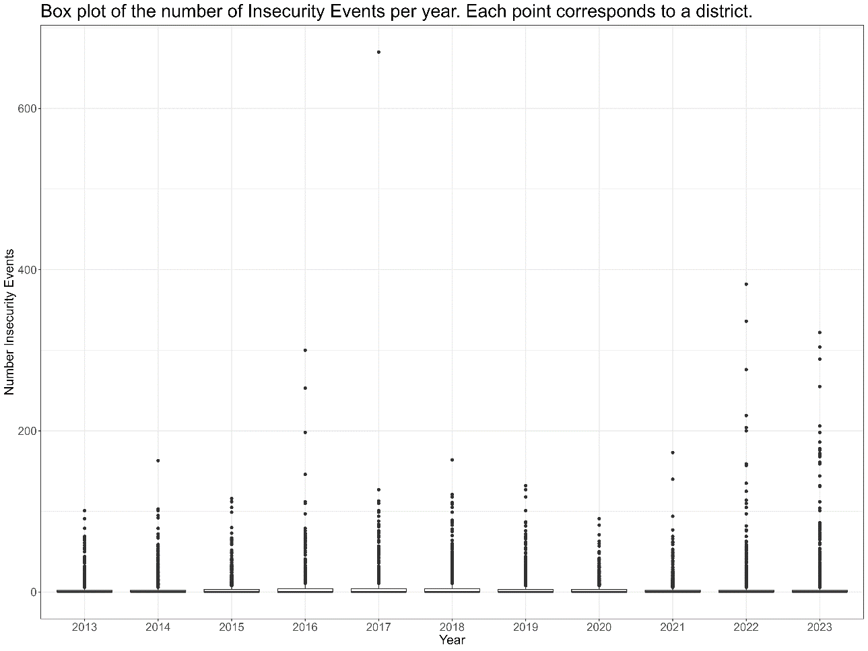

Attacks Against Aid Workers
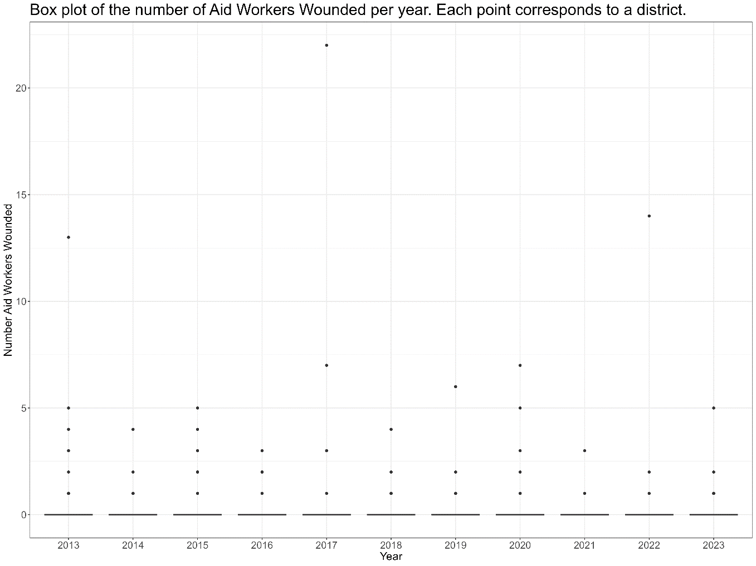
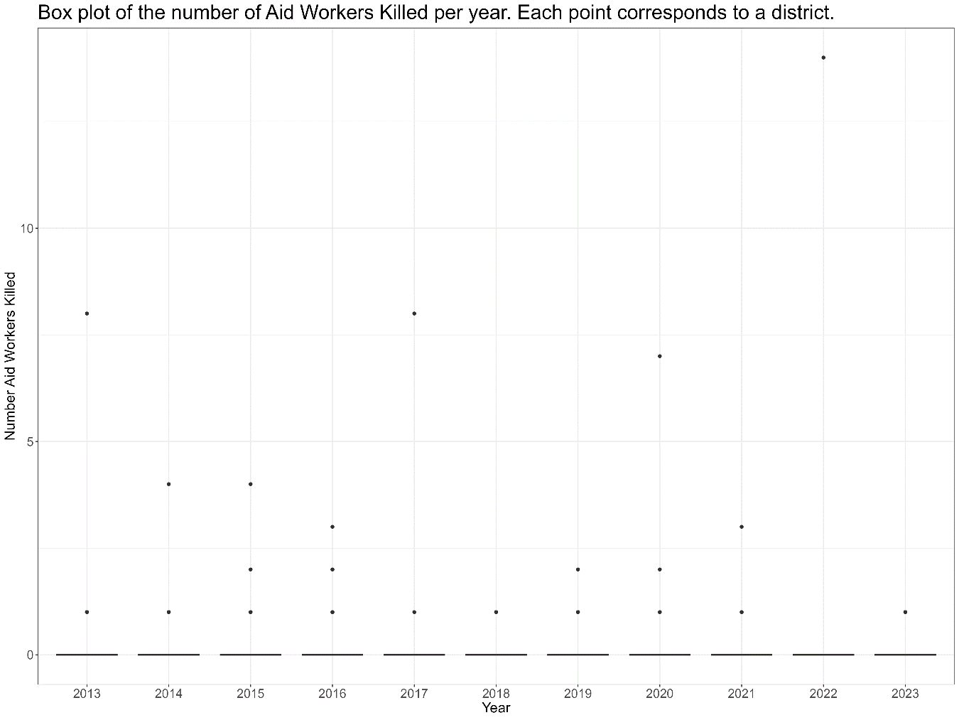

SAM
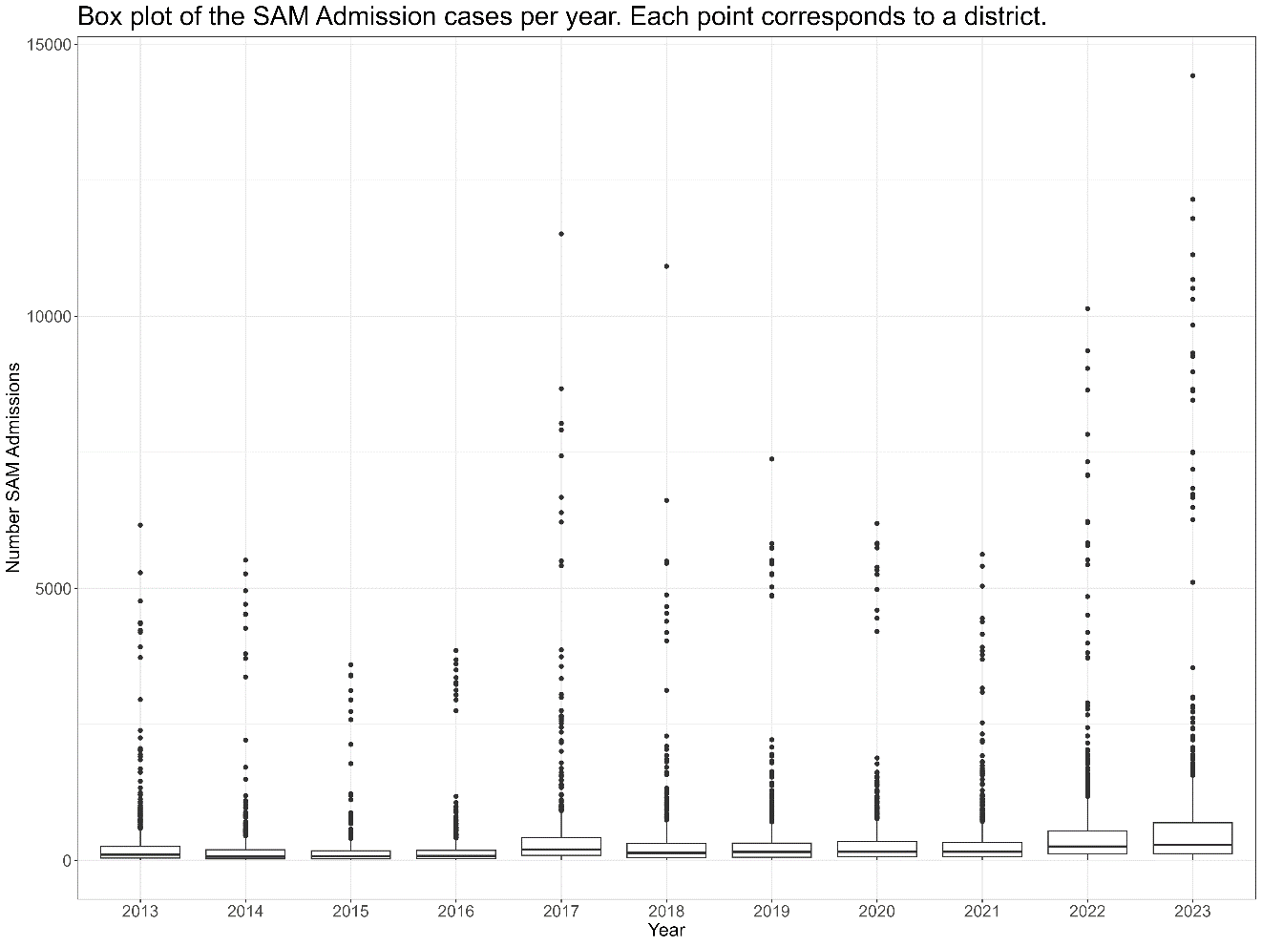

CDI
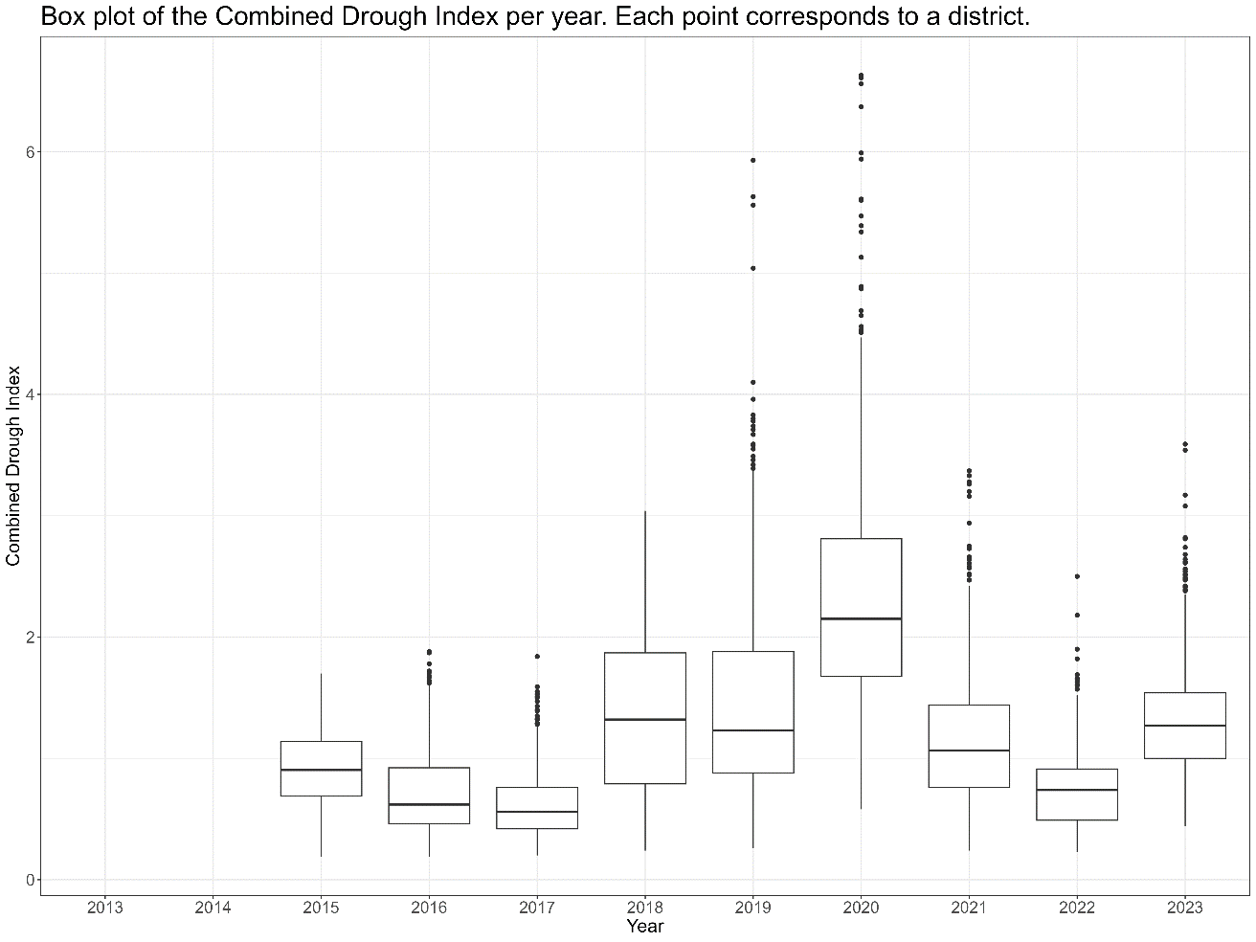

Trade/Power Index
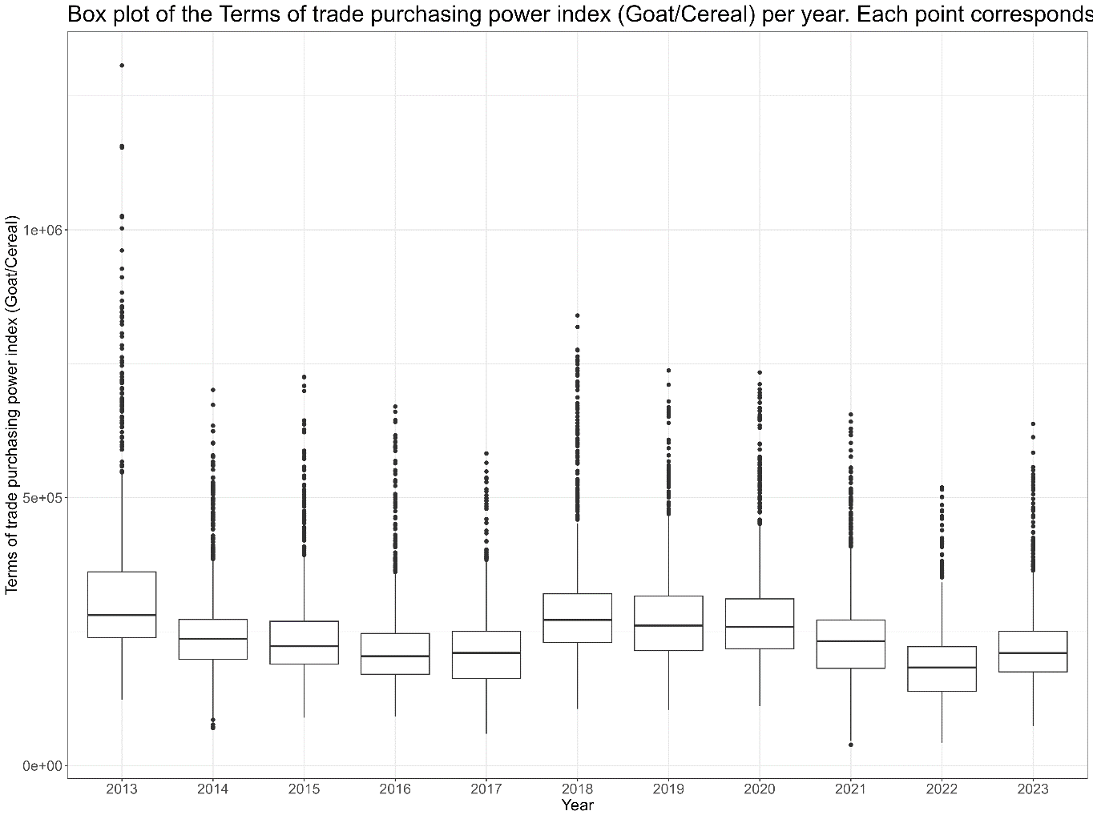
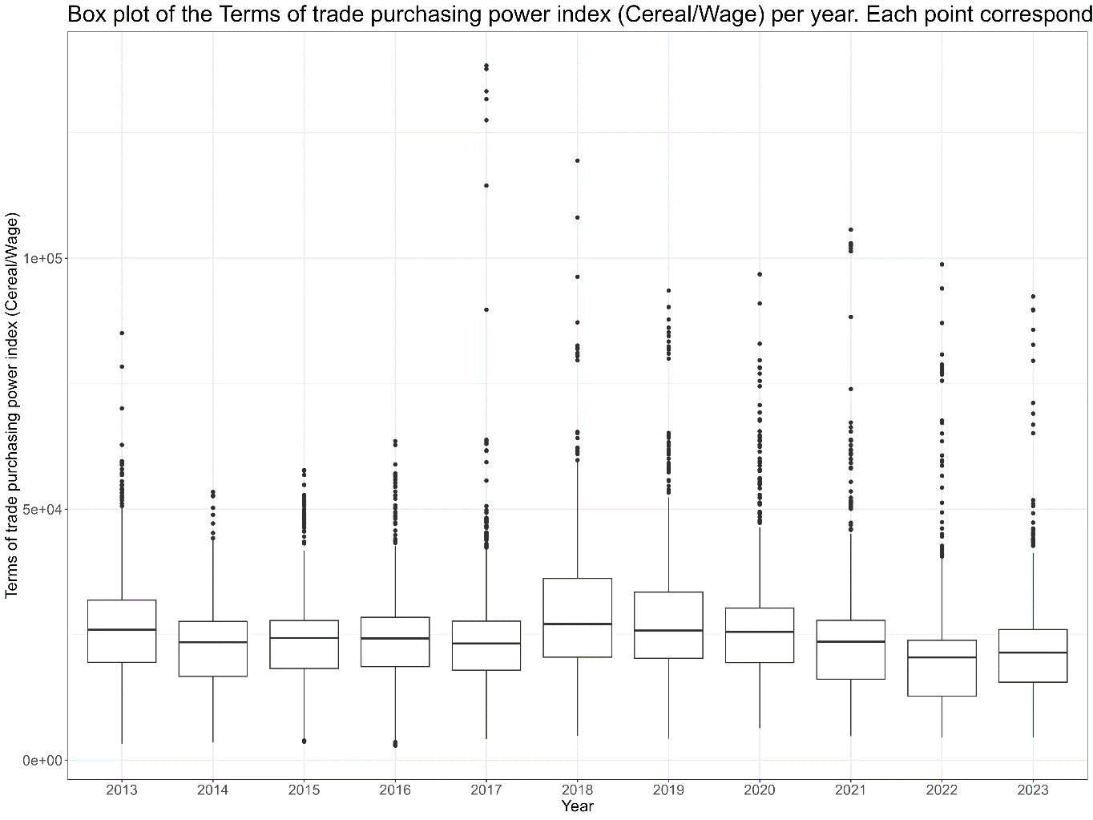

Water Price
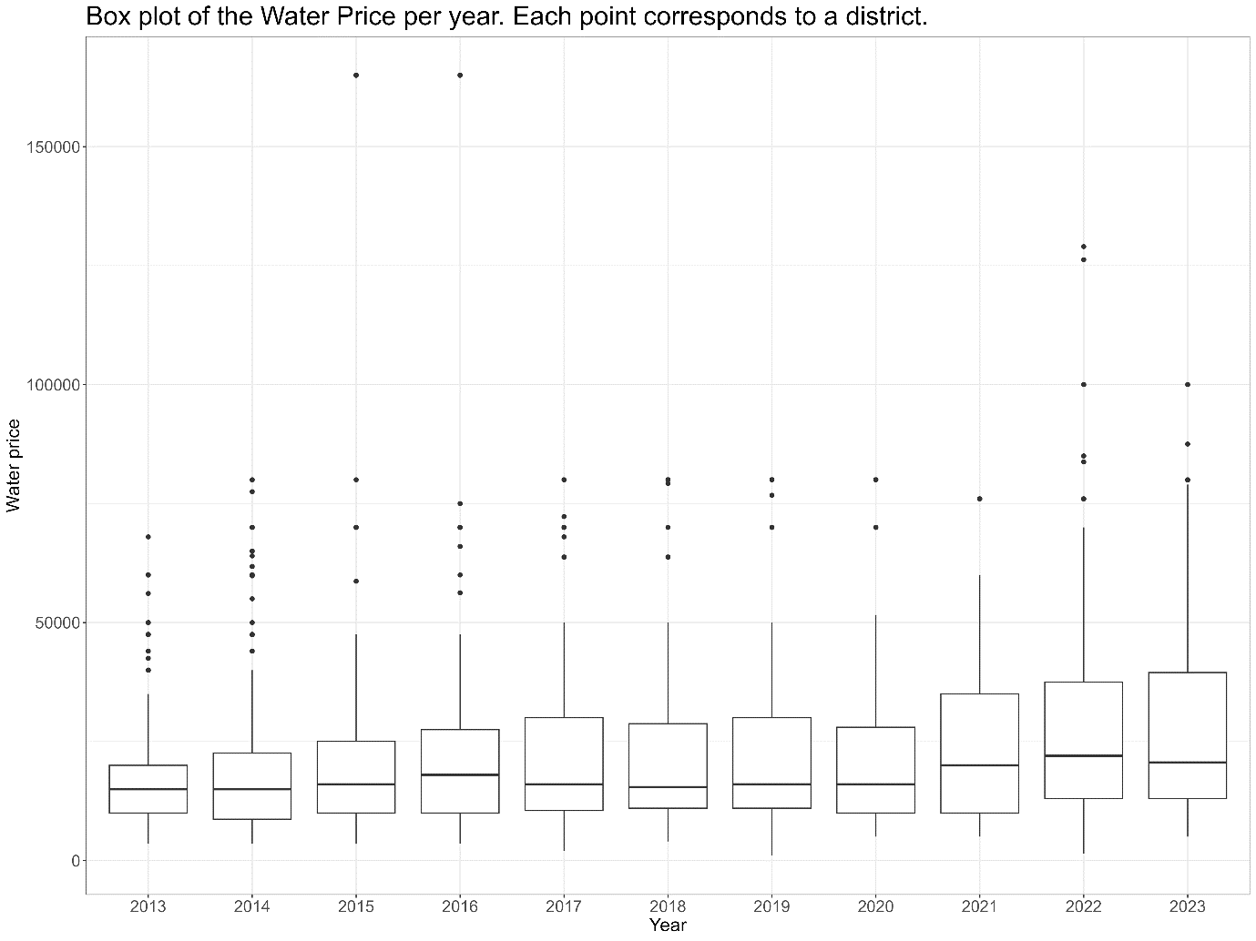

All Predictors Distribution
