SOMALIA PROCESS PREDICTORS
02/02/23

Welcome to the data process predictor documentation for Somalia. In this document, we provide a full description of the process transformation done on the Somalia predictors.

This document aims to provide an overview of the specific transformation made on the predictors used in the analysis study for the prediction of morality in Somalia. In order to better understand the values obtained in the further steps.

The transformations are done in the 04_process_predictor folder and an several R scripts are provided.

NB: The number of district/admin2 in Somalia is 74
The beginning of the analysis is January 2015.

Table des matières
Code Explanation 1
Transformation description: Predictor by predictor 1
Visualization 2

Code Explanation

Folder 04_process_predictor/code consists of three essential files, all of which use the mast package to perform transformations on predictors.
The first step to perform the predictor transformation is to modify the END_ANALYSIS_DATE in the ‘code/00_som_master_file’, then you can run this file. If you want to make any modifications, please check the two other R files: ‘code/01_complete_rate_predictors.R’ and ‘code/02_som_trans_norm_cat_predictors.R’.

Transformation description: Predictor by predictor

Predictor are modified differently according to its types, meaning and uses. Table 1 refers to the different transformations implemented on the different predictors.

Figure 1. Description of Predictor Transformation#

Visualization

To perform predictor transformation visualizations, go to the ‘visualization/code’ folder and run the ‘visualization/code/01_som_plot_predictors.R’. The output will be saved in the ‘visualization/output’ folder. An example of output can be seen in the Figure 2.
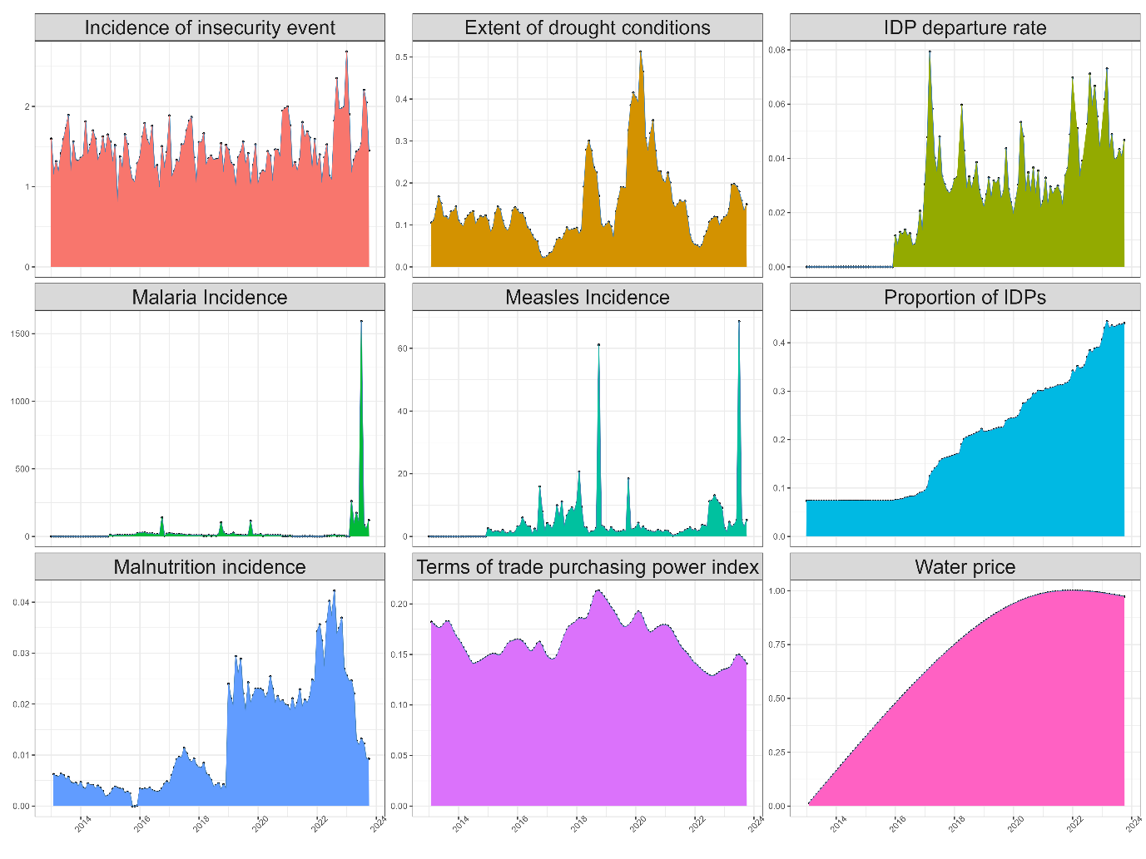
Figure 2. Visualization of the different predictors used in the Somalia mortality estimation

