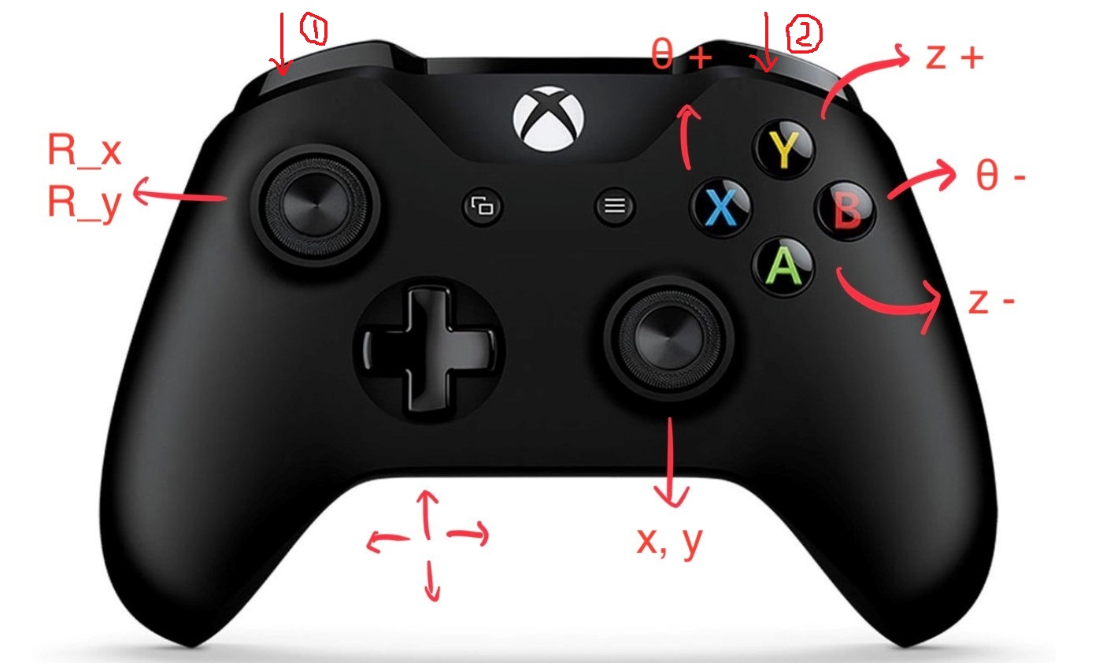

Left joystick: motion of x/y direction of rotation (sample) stage. (R_x, R_y)

Right joystick: motion of x/y direction of probe (x, y)

A/Y: height of probe (z+/z-)

X/B: rotation of sample ($θ$ +/ $θ$-)

Left shoulder(1): change the moving speed of all actuators

Right shoulder(2): disable(lock) x, y, R_x, R_y

Dpad: x,y MoveJog

Joystick control: move when the value exceeds a limit and stop when it returns to central position

Button control: move when the buttons are pressed and stop when they are released.

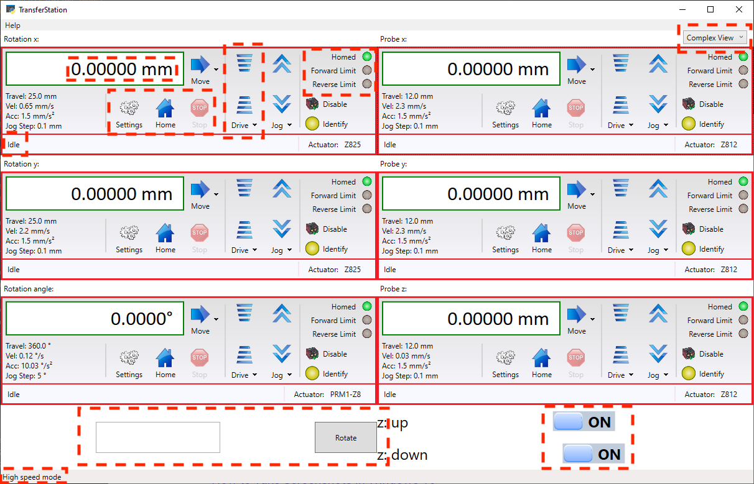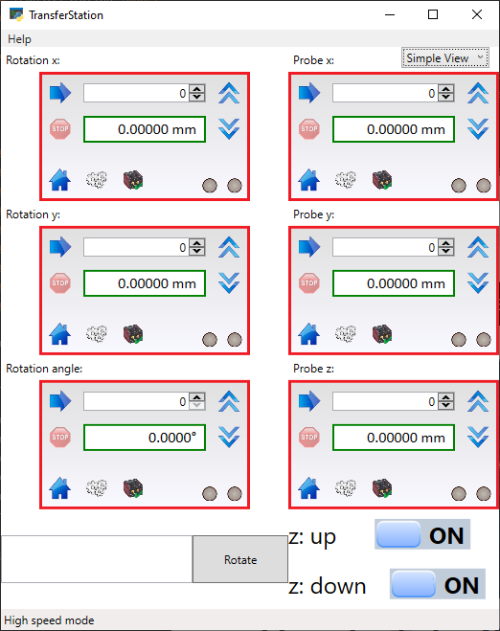

There are two different views of the GUI, which can be changed at the top right corner. At the bottom left, gives the current moving speed.

The program integrates the GUI provided by Thorlabs. There is a label at the top left of each panel, indicating which actuator it controls. You can control the actuators from the panel. At the bottom, there are two customized function:

1. Rotate the sample relatively at a given angle. Input the angle you want, for example 5 or -1.1 in the textbox and then press the button “Rotate”.

2. Height of the probe goes up/down at a slow speed. No need to hold A/Y for a long time. Turn on/off by the switch.

Notice:

1. The script is set to get the command from Xbox controller every 25ms, so it may not reacted to sudden change of the joystick.

2. The controller can gives many commands at a short time, but the motorized actuators are hard to react (all actuators stop not immediately), so **please be patient**.

3. In principle, once everything working normally and treated patiently, it will keep working well. So please check the moving speed and whether all actuators are homed at the beginning. If anything weird happens, just restart the program. If the problem is still not fixed, reboot the Thorlabs controller (a red switch).

Known issues and solutions:

1. The actuators may move at a very quick speed at the first time the program start. Change to the slow speed mode and move, and it should fix the problem. If not, reboot the program.

2. Sometimes the actuator stuck (it is not moving while the status on GUI says it is moving). Disable and then enable the actuator should fix. If not, the setting on GUI, reload the setting.

3. (A really rare case) Moving one actuator will cause moving of another one, which could be that the joystick is not at central position.

In conclusion, there might be some minor problems when using it, due to the unknown reasons. Whenever you start the program, just remember to **check if all actuators are homed and check the speed**, which should be fine in most case, and then you are good to go.

The rest is for the one who wants to modify the program.

GamingStation.py is the main() function, where I used WPF(Windows Presentation Foundation) model to create the window. The reason to do this is that the integrated GUI provided by Thorlabs is using .Net framework and they provide easy examples for C# platform. So by using pythonnet (Python for .Net) package I can directly use the .Net api.

TransferStation.py is the part for actuators. It gets the value from XboxController.py (a script I found on Github https://github.com/Zuzu-Typ/XInput-Python), and controls the actuators correspondingly. This part is straightforward.

More details about the GamingStation.py:

1. There are many tutorials on the Internet about wpf window design and using different component. Windows provide a website of all classes (<https://docs.microsoft.com/en-us/dotnet/api/system.windows.controls.checkbox?view=netframework-4.8>). In the Window.xaml you can design the window and the component you want. Here I used a design for “CheckBox” to make it look like a switch.

2. To add customized functions, you may do it in TransferStation.py. To control the actuators, you can find commands in the file (C:\Program File\Thorlabs\Kinesis\Thorlabs.MotionControl.DotNet_API) provided by Thorlabs. Although it is for C# platform, we can do it in the similar way, that is what pythonnet for.

3. For details of each function, see the memo in the code.

4. Website of Thorlabs tutorials: <https://www.thorlabs.com/newgrouppage9.cfm?objectgroup_id=10285>

5. If you have further question, contact me at [guo-yi@pku.edu.cn](mailto:guo-yi@pku.edu.cn) or guoyi1998@hotmail.com