ECS = Continer Orchesteration from AWS

EKS= Kubernetes o9n AWS

Fargat = limited time containers
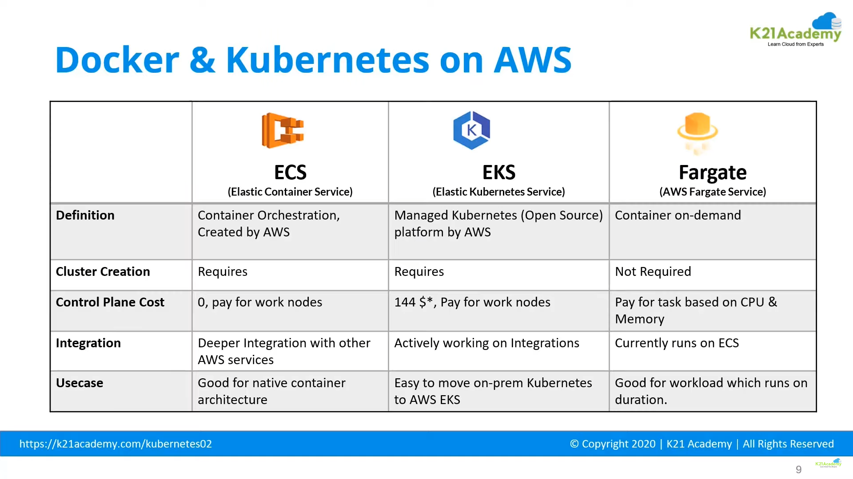

Node Group Role/Policies = EKS worker node Policy

