https://dev.to/lisahjung/beginner-s-guide-to-elasticsearch-4j2k

https://github.com/LisaHJung/Part-2-Understanding-the-relevance-of-your-search-with-Elasticsearch-and-Kibana-

https://github.com/LisaHJung/Part-3-Running-full-text-queries-and-combined-queries-with-Elasticsearch-and-Kibana

https://github.com/LisaHJung/Part-4-Running-Aggregations-with-Elasticsearch-and-Kibana

https://github.com/LisaHJung/Part-5-Understanding-Mapping-with-Elasticsearch-and-Kibana

https://github.com/LisaHJung/Part-6-Troubleshooting-beginner-level-Elasticsearch-Errors/blob/main/README.md

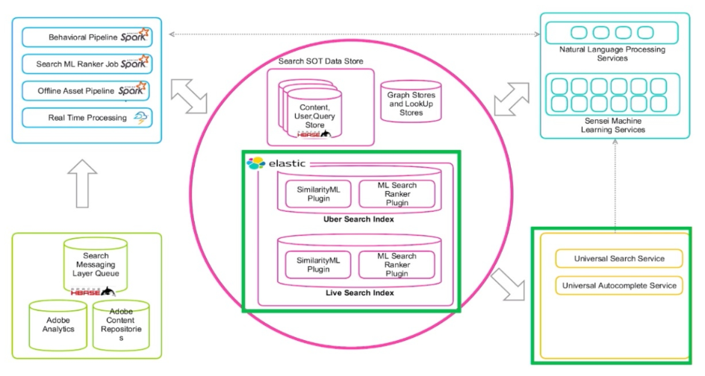



Elasticsearch is a free and open search and analytics engine for all types of data.

Uses Concept of Inverted Index and Fuzzy Distance

- Elastic Search is not a database

- stores documents

- search and analytics engine

- ELK is schema free

- Excel (Or make Fast) Full Text Searches

- Fine Tune the RELEVANCE Search Results For Ranking, Precision and Recall

- having shards => allows to perform searches in parallel

- Shards = Parallel Searches

- ELK Cluster Security = User Authentication & Encrypted Communication

APIs of Elastic search:

1.Node API
2. Cluster API

Elasticsearch is used for numerous use cases such as:
1. application search,
2. enterprise search,
3. application performance monitoring,
4. security analytics



Elasticsearch is known as the heart of the Elastic Stack, which consists of Beats, Logstash, Elasticsearch, and Kibana.

Together, the Elastic Stack allows you to take data from any source, in any format, then search, analyze, and visualize it in real time

understand how the components of Elastic Stack work together to search, analyze, and visualize data in real time
- install Elasticsearch and Kibana to run queries
- understand the basic architecture of Elasticsearch
- discuss how sharding and replication contributes to Elasticsearch's scalability and reliability
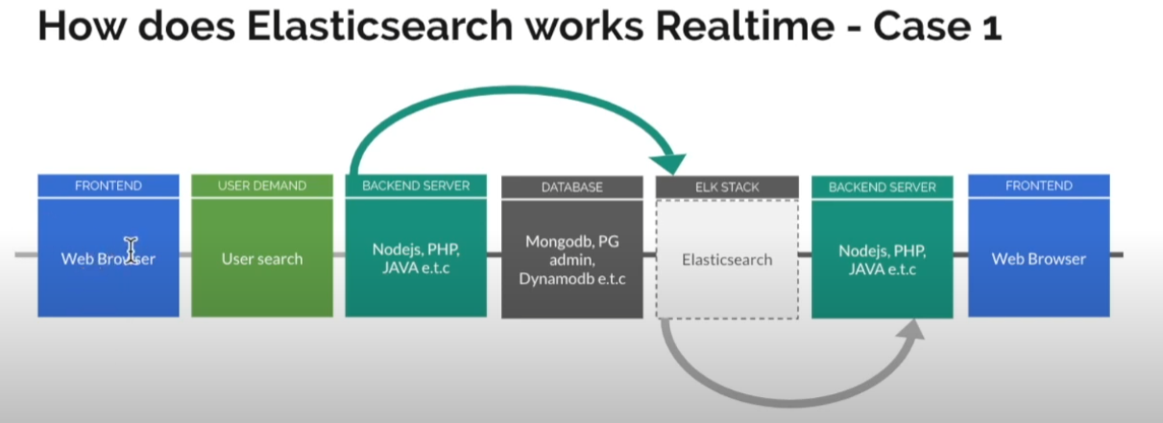
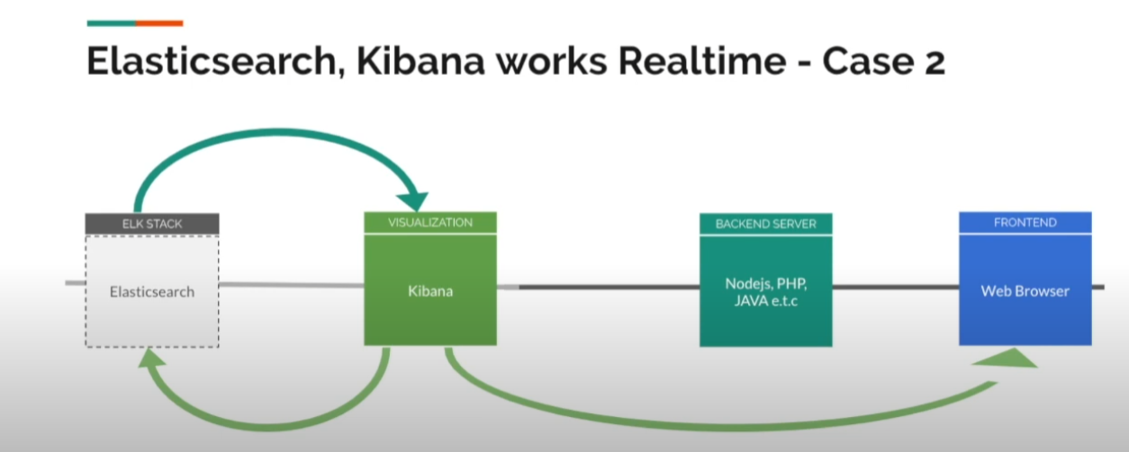
This is where Elasticsearch comes in.
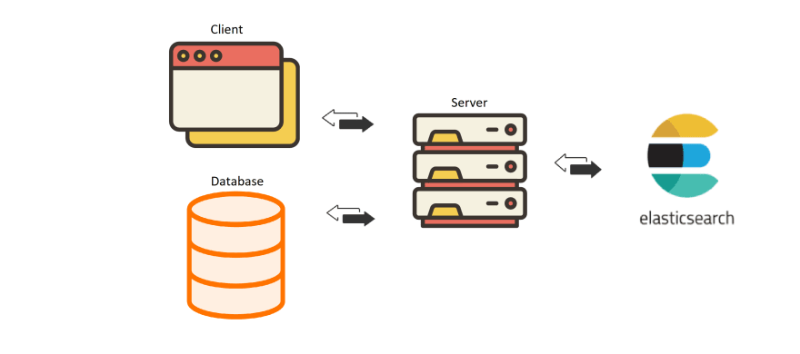

You would connect Elasticsearch to your app. When a user sends a search query on your website, the request is sent to the server. The server in turn, sends a search query to Elasticsearch.
Elasticsearch sends the search results back to the server, which processes the info and sends the result back to the browser.
At this point, you might be wondering how do we get data into Elasticsearch?
That is where Beats and Logstash come into play.
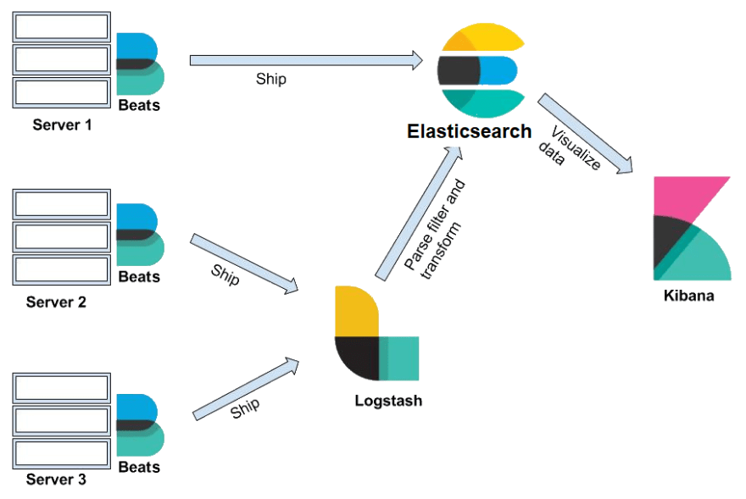

Beats is a collection of data shippers. When installed on your server, it collects and ships data to either Logstash or Elasticsearch.
Logstash is a data processing pipeline. Data that logstash receives(i.e. e-commerce orders & customer messages) are handled as events. These events are parsed, filtered , and transformed and are sent off to Elasticsearch where the data will be stored.
In Elasticsearch, data is stored as documents, a unit of info that is stored in JSON object. A REST API is used to query these documents.

Kibana provides a web interface to the data stored in Elasticsearch. It allows users to send queries to Elasticsearch using the same REST API. These queries can provide answers to questions such as "How many users visit our site daily?" or What was the revenue for last month?"
Through Kibana dashboard, users can visualize the query results and gain insights from the data as shown below!
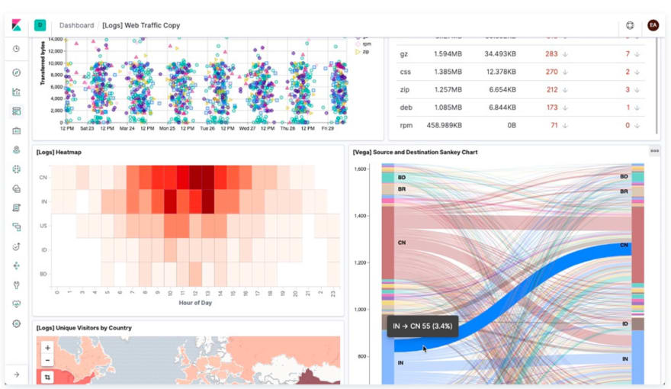

Installing Elasticsearch
To keep the blog brief, I will only be going over installation directions for Windows. But don't worry! The installation steps for macs/linux are shared in this blog.

Step 1: Download Elasticsearch
Go to the download link.
In the region highlighted with a green box, select the download option for your operating system.
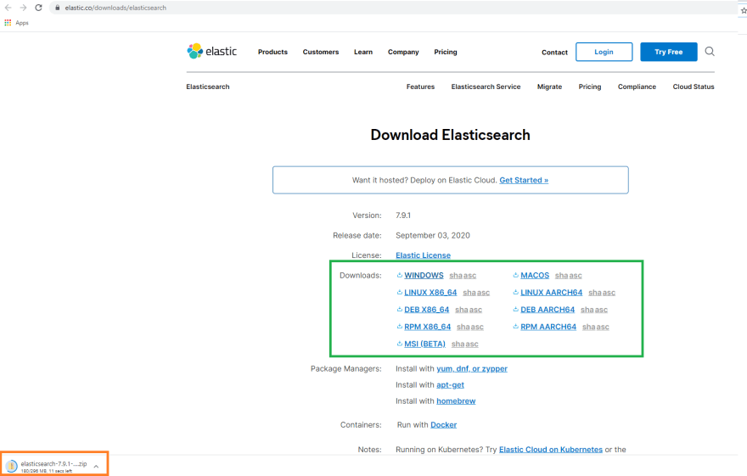
You will see that elasticsearch has been downloaded(orange box).
If you scroll down the page, you will see the installation steps. We will be using the commands specified in these steps to test whether Elasticsearch server is running smoothly.
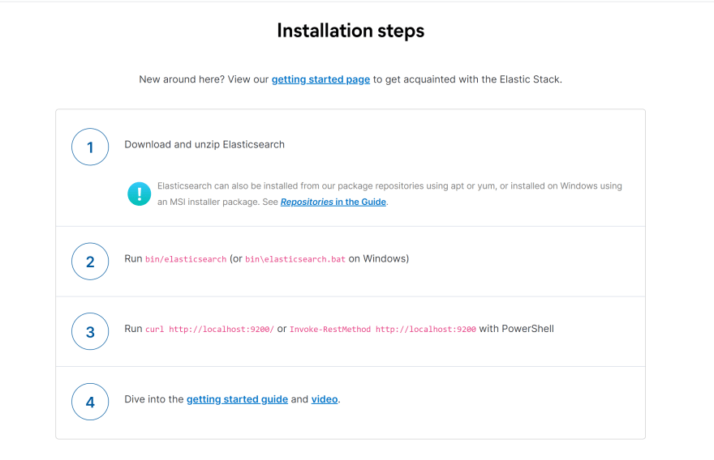

Step 2: Relocate downloaded Elasticsearch and unzip Elasticsearch
Where you relocate Elasticsearch is up to you but for this tutorial, I have created a folder called Elastic_Stack in my Windows(C:) drive.
Move the downloaded Elasticsearch to Elastic_Stack folder.
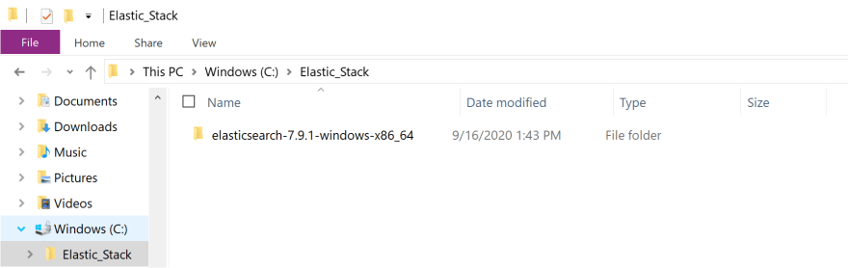
Right click on Elasticsearch to display pop up options and click on extract all option. Once the downloaded Elasticsearch has been extracted, double click on the folder. You will see the following displayed on your screen.
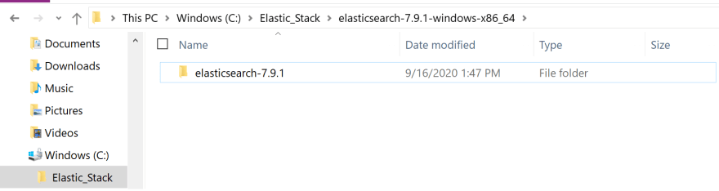
Double click on the folder.
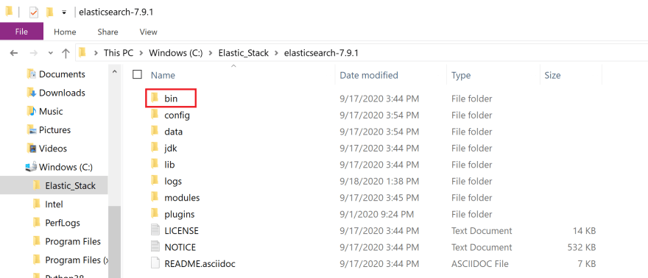
Click on bin folder(red box).
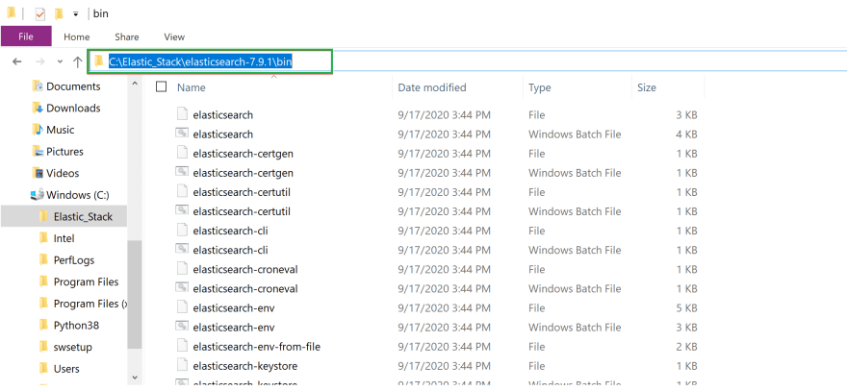
Click on the region highlighted with a green box. It should reveal the file path to the bin folder. Copy this address. We will be using it in the next step.

Step 3: Start the Elasticsearch server and ensure that everything is working properly
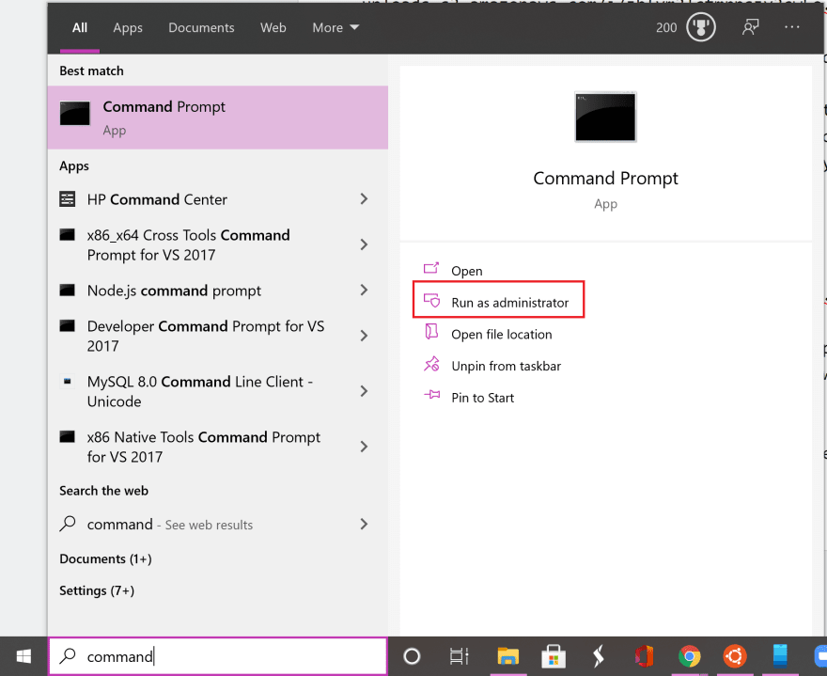
Search for the Command Prompt App on windows(purple box) and click on run as administrator option(red box).
In the Command Prompt App terminal, change into the bin directory(cd) by providing the file path to the bin folder. This is the file path you have copied in the previous step.
#In command prompt terminal
cd filepath to bin folder in Elasticsearch
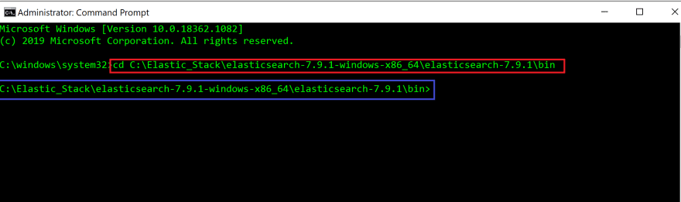
Red box highlights the command we have used to change to the bin directory.
When you press enter, you will see that you have changed into the bin directory(blue box).
In the terminal, run the following command. If you are running on a non-window OS, then run elasticsearch in the terminal instead.
#In command prompt terminal
elasticsearch.bat
You will see the cursor blinking for a while before you see Elasticsearch server running!
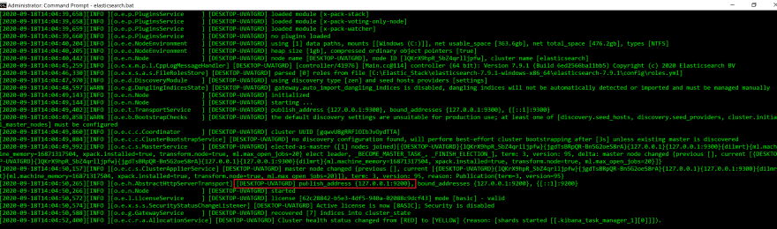
You will see that Elasticsearch server is running on localhost at port 9200(red box).
Let's recap real quick. When a user(client) sends a request to the server, the server sends a search query to the Elasticsearch server. A REST API is used to query the documents and this query is sent to the endpoint http://localhost:9200.
We will use cURL command line tool to check whether the request is received by Elasticsearch server.
Open up a new command prompt window(red box).
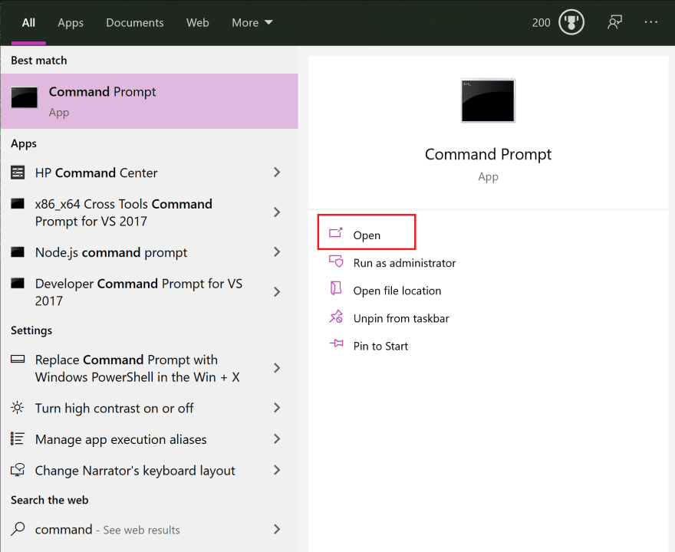
In the new terminal, run the following command.
#In new command prompt terminal
curl http://localhost:9200
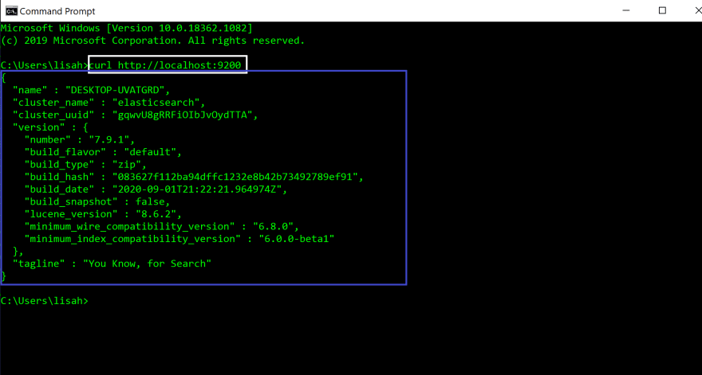
When you run the command(white box), you will see the following JSON object displayed in your terminal(blue box). That means everything is working correctly and Elasticsearch was successfully installed.
Leave these terminals open to keep the Elasticsearch server running.

Installing Kibana
Installing Kibana is very similar to installing Elasticsearch.

Step 1: Download Kibana
Kibana is a web interface for Elasticsearch. However, it ships with its backend server that communicates with Elasticsearch.
Go to the download link.
In the region highlighted with a red box, select the download option for your operating system.
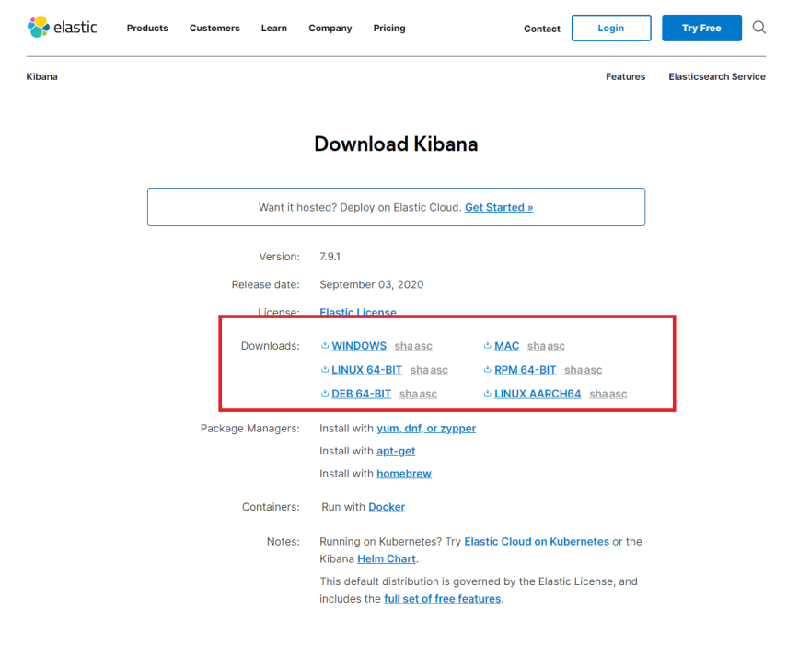
You will see that Kibana has been downloaded.
If you scroll down the page, you will see the installation steps. We will be using the commands specified in these steps to test whether Kibana server is running correctly.
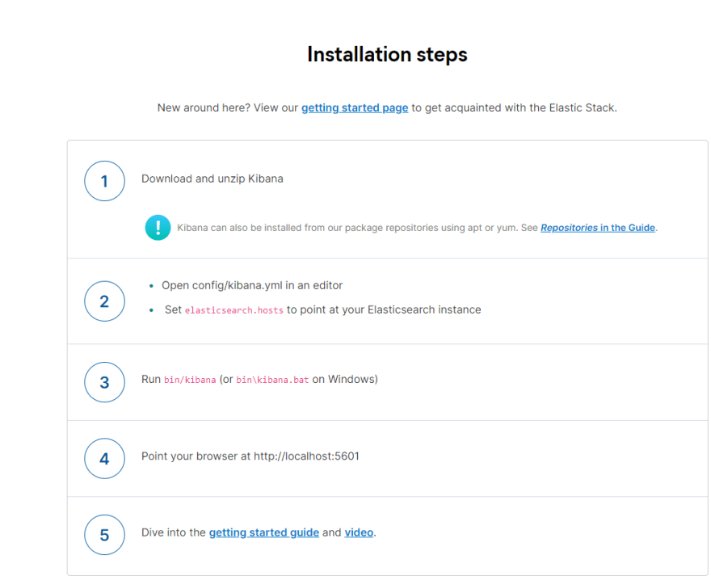

Step 2: Relocate downloaded Kibana and unzip Kibana
Move the downloaded Kibana to Elastic_Stack folder.
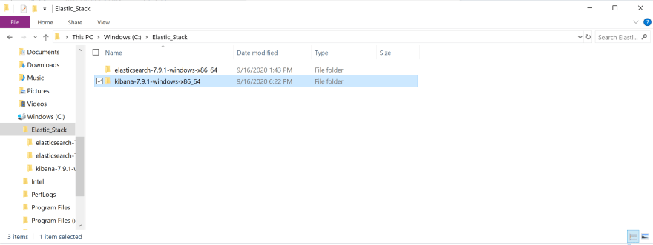
Right click on the Kibana to display options and click on extract all option. Once Kibana has been extracted, double click on the folder.
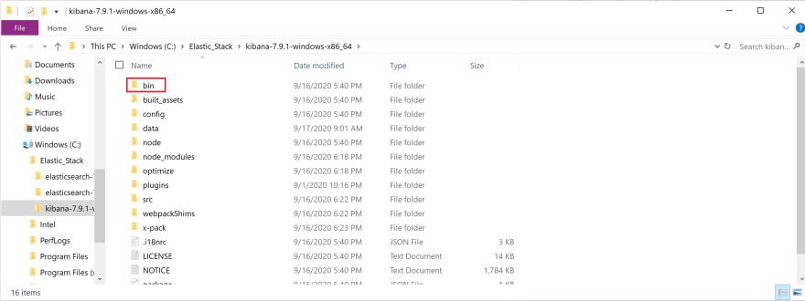
Click on bin folder(red box).
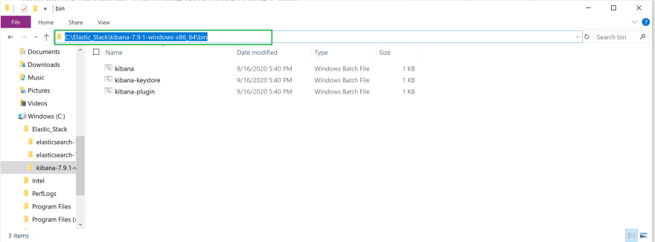
Click on the region highlighted with a green box. It should reveal the file path to the bin folder. Copy this address. We will be using it in the next step.

Step 3: Run Kibana and ensure that everything is working properly
First, go back to the command prompt window that is running the Elasticsearch server. Make sure it is still running and it is not displaying any error messages.
Open up a new command prompt window.
In the Command Prompt App terminal, change into the bin directory(cd) of Kibana by providing the file path to the bin folder. This is the path you have copied from the bin folder in the previous step.
#In command prompt terminal
cd filepath to bin folder in Kibana
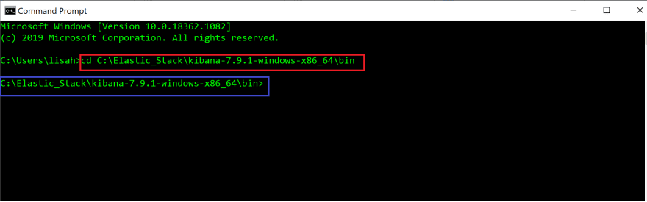
The command has been highlighted with a red box.
When you press enter, you will see that you have changed into the bin directory(blue box).
In the terminal, run the following command. If you are running on a non-window OS, then run kibana in the terminal instead.
#In command prompt terminal
kibana.bat
You will see the cursor blinking for a while before you see Kibana running!
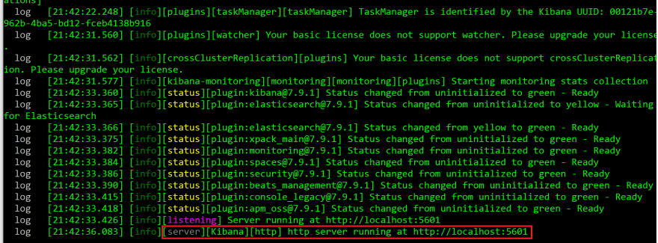
Open up a browser and go to http://localhost:5601.
You will see the following displayed on the browser.
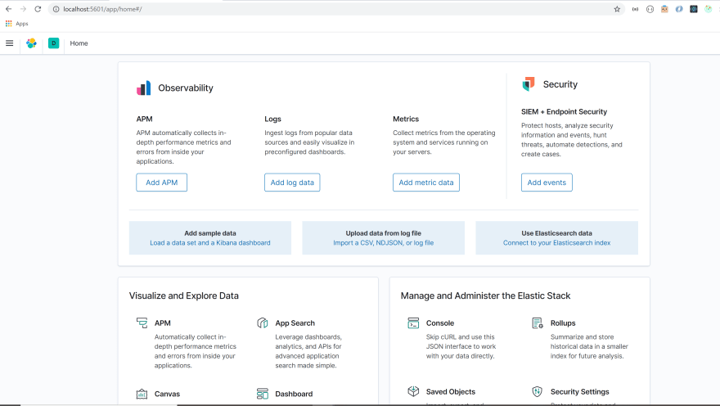
Troubleshooting
If you are having trouble getting Kibana to work, try restarting your Elasticsearch server. Go to the command prompt terminal used for your Elasticserach server. Press `control + c`. Then, run elasticsearch.bat in the same terminal.

Go back to your command prompt terminal for Kibana. Run `control + c` in the command prompt terminal. Then, run kibana.bat in the terminal. Go to http://localhost:5601 on your browser.
All right let's get back to the Kibana browser.
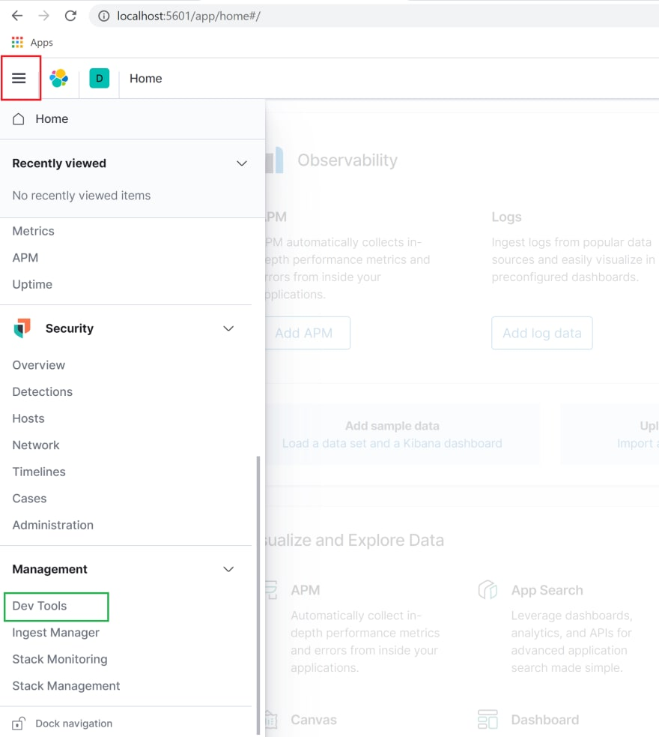
Click on the menu option(red box) to display a drop down menu. Scroll down to management section and click on Dev Tools option(green box).
This console allows us to easily send queries to Elasticsearch.
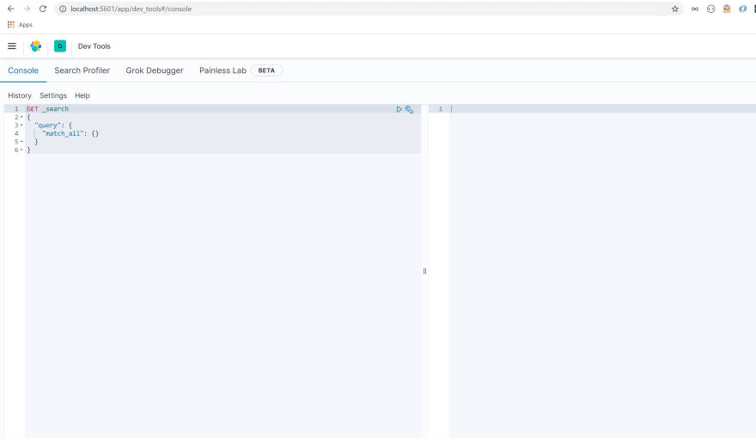
All right, now that we got installations out of the way, let's delve into the basic architecture of Elasticsearch! We will be using Kibana to look under the hood of Elasticsearch.

Basic architecture of Elasticsearch
Elasticsearch is a powerful search and analytics engine known for its distributed nature, speed, and scalability. This is due to its unique architecture.
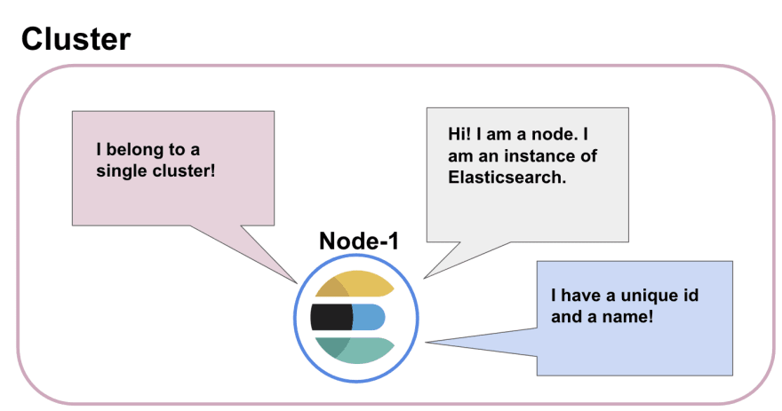
We have just downloaded and ran a Elasticsearch server. Little did we know we were starting up a node(blue circle)! A node is a running instance of Elasticsearch that stores data. It has a unique id and a name.
Each node belongs to a cluster, which is a collection of nodes that are connected together. When we started up a node, a cluster was formed automatically(pink box).
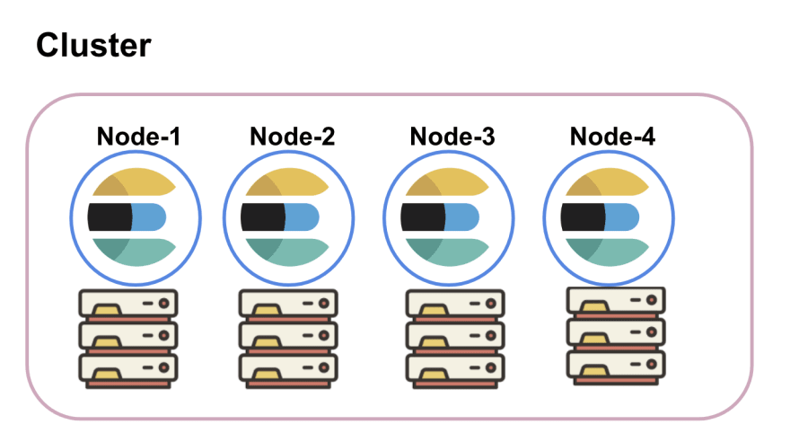
You can add one or many nodes in a cluster. These nodes are distributed across separate machines. A node, by default, are assigned all of the following roles: master-eligible, data, ingest, and machine learning(if available). You can configure these roles and give specific roles to certain nodes.
Each node in the cluster can handle HTTP request from client and communication between nodes. All nodes are aware of fellow nodes within the same cluster and can forward HTTP requests to the node designed to handle the request.
How is data stored within the node?
The basic unit of data stored in Elasticsearch is called a document. Document is a JSON object that contains whatever data you want to store in Elasticsearch.
For example, let's say you are building an app that helps users find the best food truck in their area. In order to build this app, you will need to store data about food trucks.
A document storing data about one food truck would look like the following.
{
"name": Pho King Rapidos,
"cuisine": Vietnamese and Mexican fusion
}
Imagine if we had data about millions of food trucks. How would we be able to quickly search through the data to find the one we are looking for?
Searching for data is very similar to searching for a food item at a grocery store. Your search will be way more efficient if all the food items in the store were organized into specific aisles(fresh produce, meat, dairy, condiments & etc).
Documents are organized in a similar way. Every document is grouped into an index. An index is a collection of documents that share similar traits and are logically related to each other, much like an aisle of a grocery store.
The cluster contains multiple nodes. Within nodes, relevant documents are grouped under indices.
As we would go to the produce aisle to find an apple, we would run search queries against the indices when searching for documents.
All right, let's look under the hood of Elasticsearch and see how we can get information about the node and cluster we have just created.
Elasticsearch cluster exposes a REST API which receives HTTP requests. We can access this REST API with any HTTP client such as Postman or cURL but we will be using the Kibana Dev Tool to do so.
Open up your Kibana Dev Tool. You should see the following on your screen.
We will start by checking the health status of our cluster.
Delete the content in the region highlighted in grey so we can write our own query.
The syntax of the query is very simple. You initiate the query by specifying an HTTP method(GET, POST, PUT, DELETE). Then, we specify the API we want to access and what we would like to accomplish(command).
In this case, we want to retrieve(GET) the health status of our cluster. We specify that we want to access the cluster API and we want information about its health.
So our query should look like this:
GET /_cluster/health
Copy and paste the query in the region highlighted with a red box.
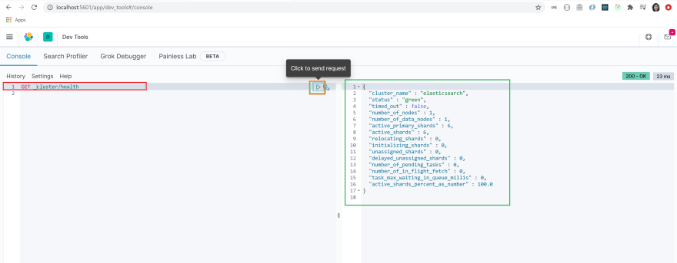
Make sure the query is selected by clicking on it. Run the query by clicking on the arrow highlighted with an orange box.
You will see that a JSON object has been returned to you(green box). You can see that the name of the cluster is set to elasticsearch by default and the status of the cluster is set to green.
This means that our cluster is healthy!
Let's get a list of nodes that are in our cluster.
In order to get this information, we use the _cat API. The query syntax is very similar to the query we have just sent.
We will send a GET request to the _cat API and we will use a command nodes?v to get the list of nodes in our cluster.
Your query will look like the following:
GET /_cat/nodes?v
Copy and paste the query into the dev tool. Select the query and send the query by clicking on the arrow.
You will see that basic info about the single node we have is displayed on the screen. It includes information about node's IP address, name, roles as well as some performance measures.
Great job! It looks like our node and cluster have been created successfully.
Let's create an index for food_trucks.
You can create an index by specifying the PUT method followed by the name of the index.
Run the following query in the dev tool.
PUT food_trucks
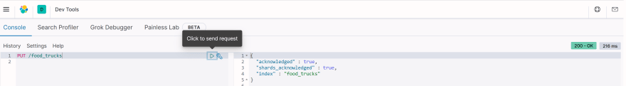
You will see a JSON object returned to you. It will specify that an index named food_trucks have been successfully created.
You will also see that the value of shards_acknowledged is set to true. We will cover this shortly!
Armed with the basic understanding of Elasticsearch architecture, we are now ready to understand what factors make Elasticsearch so scalable and reliable!

Understanding the factors behind Elasticsearch's scalability and reliability
What is sharding?
In the previous step, upon creating an index, we saw that shards_acknowledged value was set to true. What is a shard anyway?
Earlier I have mentioned that related documents are grouped into an index. Index is not actually storing documents. It is a virtual thing that keeps track of where documents are stored.
You can't find index on disk. What actually exists on disk is a shard! Shard is where data is stored in Elasticsearch. This is also where the search is ran!
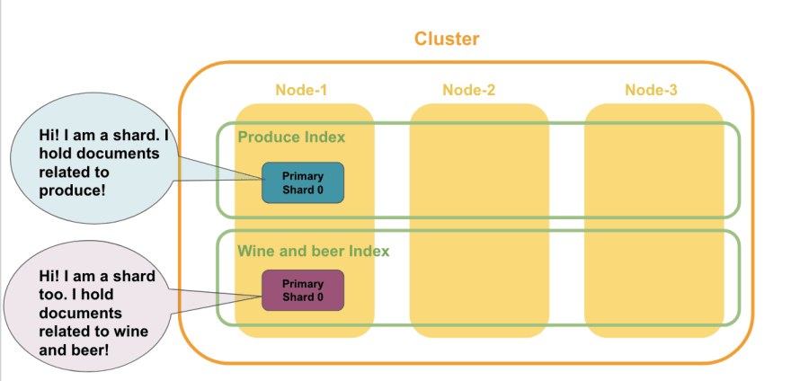
When you create an index, one shard comes with it by default. You can also configure it so that you can create an index with multiple shards that are distributed across nodes.
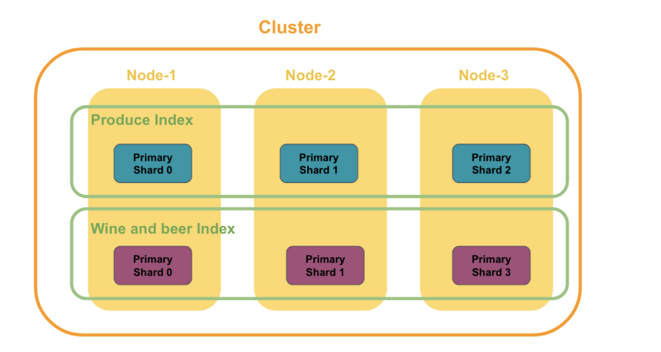
Let's say we want to store 600K documents about food trucks in an index called Food Truck Index.
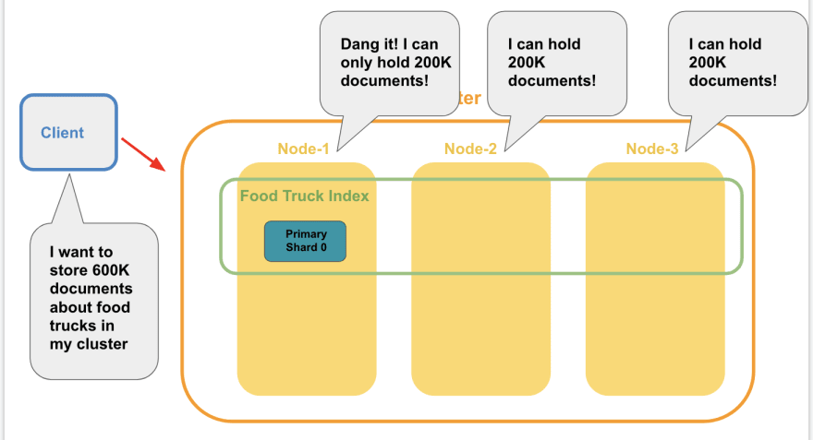
We have three nodes in our cluster, which can hold 200K documents each. When we create the Food Truck Index, one shard comes with it by default. This shard is assigned to Node-1.
Remember that shard is where data is stored. The number of documents a shard can hold depends on the capacity of the node.
We have three nodes that can only hold 200k documents each. But the entire index of 600K documents will not fit into any one of these nodes! If only we could divide these documents into smaller chunks and store them across these nodes...
Well, that is exactly what sharding is!
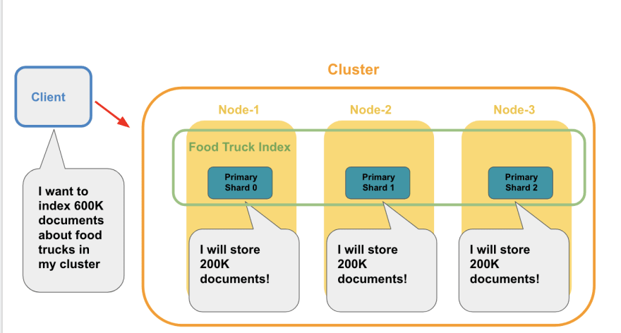
To make this possible, we add two additional shards to the index and distribute the shards across these nodes. Then, we store 200K documents per shard. Together, these shards are now able to store 600K food truck documents!
By dividing our documents into smaller chunks and storing these in shards that are distributed across nodes, we were able to store 600K documents. We accomplished all of this despite the fact that we do not have a single node that can store all that data! That is the beauty of sharding!
Sharding empowers Elasticsearch to adapt to support an increasing amount of data or demands placed on it.
So if our food truck app took off and we have a user base growing at a breakneck speed, we do not have to worry about increased data coming in. We can simply add more nodes and change the number of shards for whatever index you are working with!

What is replication?
Our food truck app is gaining some serious momentum. To our horror, one of the nodes goes down, taking its data down them into the dark abyss.

Can you imagine what a nightmare this would be if we had no back up mechanism to deal with something like this?
Thank goodness we have replication!

Replication creates copies of shards and keeps the copies in different nodes. If a node goes down, the copies stored in other nodes would step up to the plate and serve requests like nothing happened.
Elasticsearch automatically replicates shards without us having to configure anything. It creates a copy(replica shard) of each shard within the index.
Remember how we created an index called food_trucks earlier? Let's use Kibana to get more info about our index.
Go to the Dev Tool and run the following query.
GET /_cat/indices?v
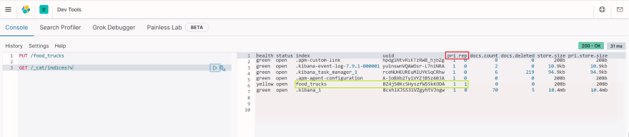
If you look at the column, you will column pri and rep(red box). These stand for primary shard(pri) and replica shard(rep).
Let's examine the index food_trucks highlighted with a green box. You will see that upon creating an index, a primary shard and replica shard have been automatically created!
Replica shard is an identical copy of the pimary shard. It functions exactly the same way as the primary shard.
As you should never put all of your eggs in one basket, Replica shards are never stored in the same node as the primary shard. The primary shards and replica shards are distributed across the nodes in a manner shown below.
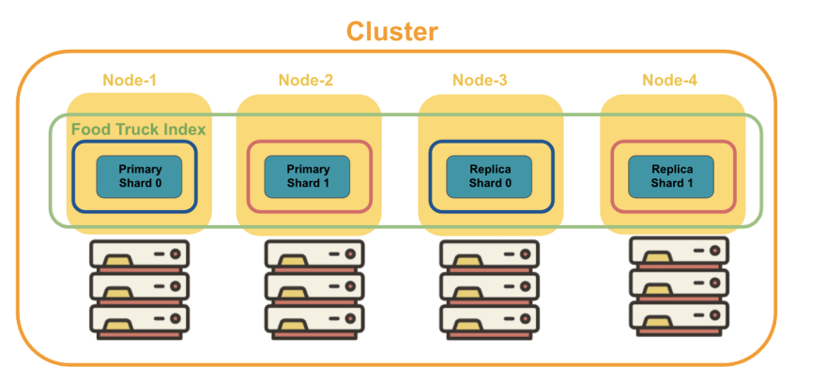
Even if a node goes down, you can rest easy knowing that replica shard stored in another node will pick up the slack as if nothing had happened!
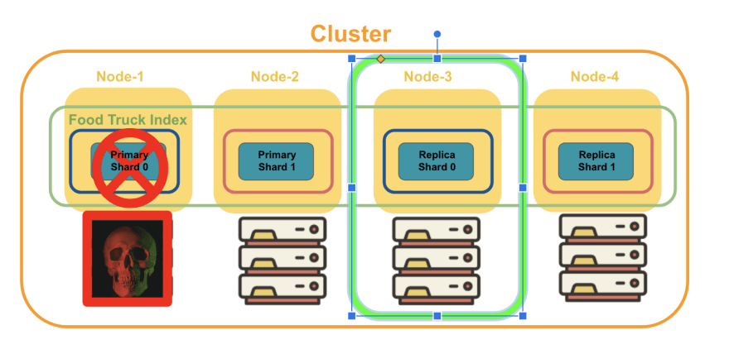
As you can see, sharding and replication contributes to Elasticsearch's scalability and reliability.
All right, we have achieved all of our end goals! You guys deserve an applause and a long break for getting this far.
Now that you have a solid grasp on important concepts of Elasticsearch, you are now ready to explore more advanced skills like CRUD operations, mapping, analysis, and advanced queries. Go explore and see what you can do with Elasticsearch on your own!
Elastic Stack offers Basic Auth, TLS Encryption, and User Management for free.
Link: elastic.co/blog/security-for-elast...

Tool to Bench Mark Elastic Search cluster Sizing:

tool called Rally and benchmark for the right numbers that you want your cluster to serve.

Security is free, starting in versions 6.8.0 and 7.1.0
For a change this important, we wanted to make sure that it was available to as many people as possible, so today we are releasing versions 6.8.0 and 7.1.0 of the Elastic Stack. These versions do not contain new features; they simply make the following core security features free in the default distribution of the Elastic Stack:
- TLS for encrypted communications
- File and native realm for creating and managing users
- Role-based access control for controlling user access to cluster APIs and indexes; also allows multi-tenancy for Kibana with security for Kibana Spaces
Previously, these core security features required a paid Gold subscription. Now they are free as a part of the Basic tier. Note that our advanced security features — from single sign-on and Active Directory/LDAP authentication to field- and document-level security — remain paid features. See the full feature matrix for details.

Data tiersedit
A data tier is a collection of nodes with the same data role that typically share the same hardware profile:
- Content tier nodes handle the indexing and query load for content such as a product catalog.
- Hot tier nodes handle the indexing load for time series data such as logs or metrics and hold your most recent, most-frequently-accessed data.
- Warm tier nodes hold time series data that is accessed less-frequently and rarely needs to be updated.
- Cold tier nodes hold time series data that is accessed infrequently and not normally updated. To save space, you can keep fully mounted indices of searchable snapshots on the cold tier. These fully mounted indices eliminate the need for replicas, reducing required disk space by approximately 50% compared to the regular indices.
- Frozen tier nodes hold time series data that is accessed rarely and never updated. The frozen tier stores partially mounted indices of searchable snapshots exclusively. This extends the storage capacity even further — by up to 20 times compared to the warm tier.
When you index documents directly to a specific index, they remain on content tier nodes indefinitely.
When you index documents to a data stream, they initially reside on hot tier nodes. You can configure index lifecycle management (ILM) policies to automatically transition your time series data through the hot, warm, and cold tiers according to your performance, resiliency and data retention requirements.

Content tieredit
Data stored in the content tier is generally a collection of items such as a product catalog or article archive. Unlike time series data, the value of the content remains relatively constant over time, so it doesn’t make sense to move it to a tier with different performance characteristics as it ages. Content data typically has long data retention requirements, and you want to be able to retrieve items quickly regardless of how old they are.
Content tier nodes are usually optimized for query performance—​they prioritize processing power over IO throughput so they can process complex searches and aggregations and return results quickly. While they are also responsible for indexing, content data is generally not ingested at as high a rate as time series data such as logs and metrics. From a resiliency perspective the indices in this tier should be configured to use one or more replicas.
The content tier is required. System indices and other indices that aren’t part of a data stream are automatically allocated to the content tier.

Hot tieredit
The hot tier is the Elasticsearch entry point for time series data and holds your most-recent, most-frequently-searched time series data. Nodes in the hot tier need to be fast for both reads and writes, which requires more hardware resources and faster storage (SSDs). For resiliency, indices in the hot tier should be configured to use one or more replicas.
The hot tier is required. New indices that are part of a data stream are automatically allocated to the hot tier.

Warm tieredit
Time series data can move to the warm tier once it is being queried less frequently than the recently-indexed data in the hot tier. The warm tier typically holds data from recent weeks. Updates are still allowed, but likely infrequent. Nodes in the warm tier generally don’t need to be as fast as those in the hot tier. For resiliency, indices in the warm tier should be configured to use one or more replicas.

Cold tieredit
When you no longer need to search time series data regularly, it can move from the warm tier to the cold tier. While still searchable, this tier is typically optimized for lower storage costs rather than search speed.
For better storage savings, you can keep fully mounted indices of searchable snapshots on the cold tier. Unlike regular indices, these fully mounted indices don’t require replicas for reliability. In the event of a failure, they can recover data from the underlying snapshot instead. This potentially halves the local storage needed for the data. A snapshot repository is required to use fully mounted indices in the cold tier. Fully mounted indices are read-only.
Alternatively, you can use the cold tier to store regular indices with replicas instead of using searchable snapshots. This lets you store older data on less expensive hardware but doesn’t reduce required disk space compared to the warm tier.

Frozen tieredit
Once data is no longer being queried, or being queried rarely, it may move from the cold tier to the frozen tier where it stays for the rest of its life.
The frozen tier requires a snapshot repository. The frozen tier uses partially mounted indices to store and load data from a snapshot repository. This reduces local storage and operating costs while still letting you search frozen data. Because Elasticsearch must sometimes fetch frozen data from the snapshot repository, searches on the frozen tier are typically slower than on the cold tier.

Configure data tiers on Elasticsearch Service or Elastic Cloud Enterpriseedit
The default configuration for an Elastic Cloud deployment includes a shared tier for hot and content data. This tier is required and can’t be removed.
To add a warm, cold, or frozen tier when you create a deployment:
- On the Create deployment page, click Advanced Settings.
- Click + Add capacity for any data tiers to add.
- Click Create deployment at the bottom of the page to save your changes.
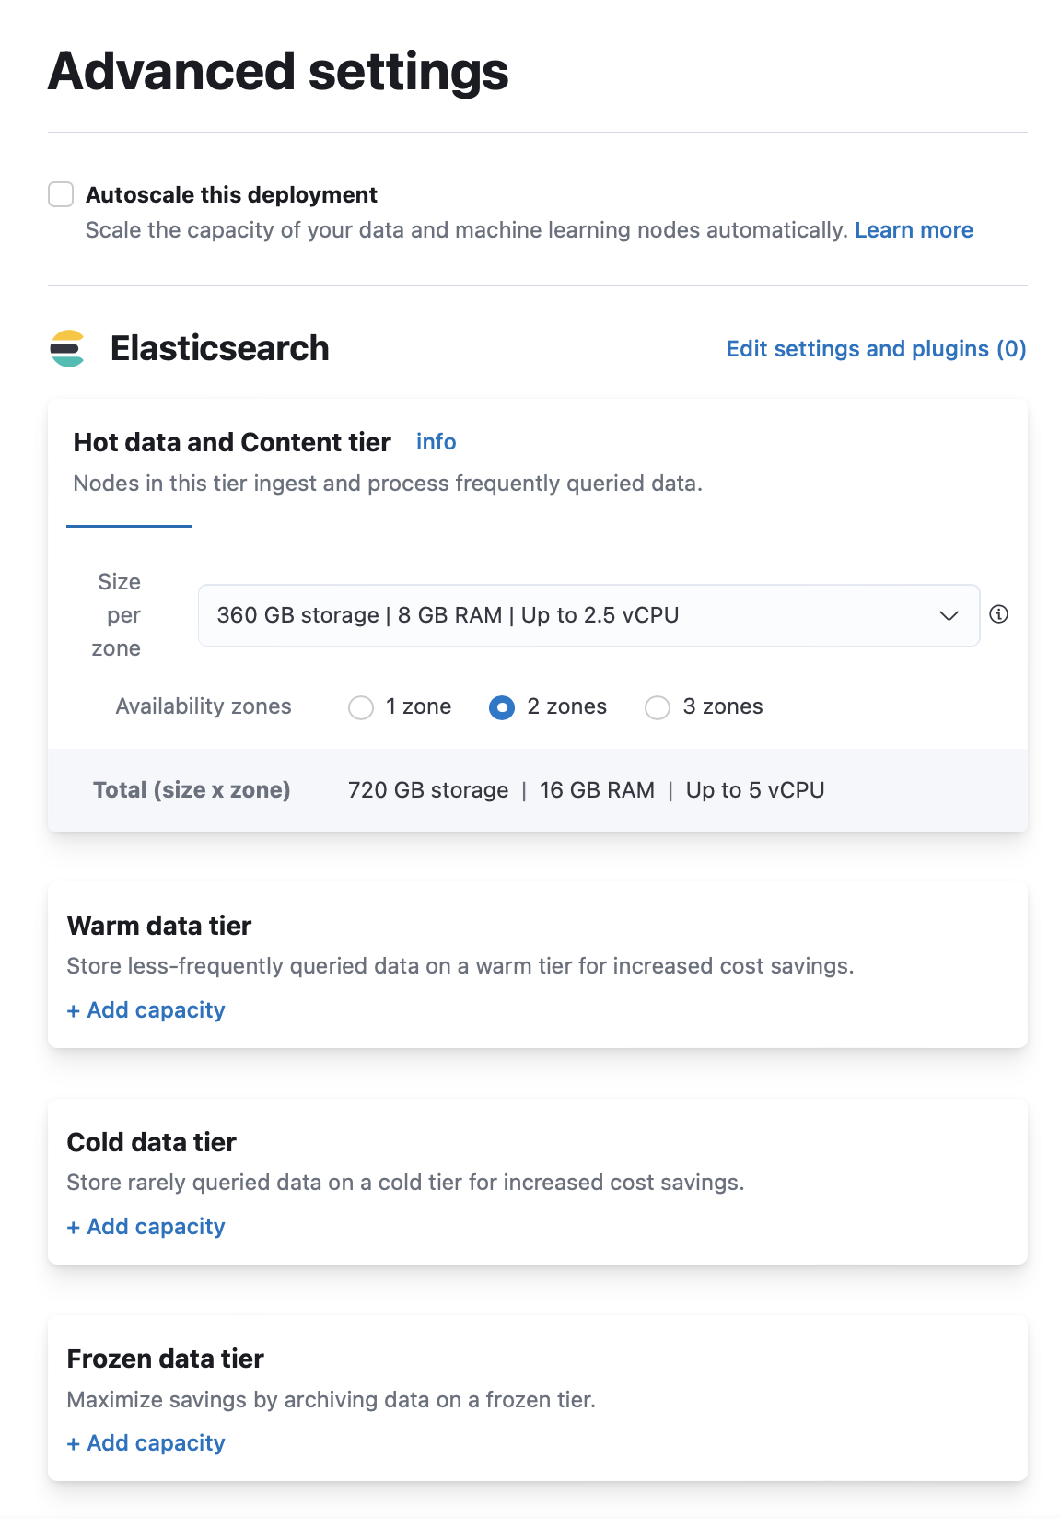
To add a data tier to an existing deployment:
- Log in to the Elastic Cloud console.
- On the Deployments page, select your deployment.
- In your deployment menu, select Edit.
- Click + Add capacity for any data tiers to add.
- Click Save at the bottom of the page to save your changes.
To remove a data tier, refer to Disable a data tier.

Configure data tiers for self-managed deploymentsedit
For self-managed deployments, each node’s data role is configured in elasticsearch.yml. For example, the highest-performance nodes in a cluster might be assigned to both the hot and content tiers:
node.roles: ["data_hot", "data_content"]
We recommend you use dedicated nodes in the frozen tier.

Data tier index allocationedit
When you create an index, by default Elasticsearch sets index.routing.allocation.include._tier_preferenceto data_content to automatically allocate the index shards to the content tier.
When Elasticsearch creates an index as part of a data stream, by default Elasticsearch sets index.routing.allocation.include._tier_preference to data_hot to automatically allocate the index shards to the hot tier.
You can explicitly set index.routing.allocation.include._tier_preference to opt out of the default tier-based allocation.

Automatic data tier migrationedit
ILM automatically transitions managed indices through the available data tiers using the migrate action. By default, this action is automatically injected in every phase. You can explicitly specify the migrate action with "enabled": false to disable automatic migration, for example, if you’re using the allocate action to manually specify allocation rules.

