RIGA TECHNICAL UNIVERSITY
Faculty of Engineering Economics and Management

AFZAL MOHMOOD ANAT SAKKEER

Assessment of Volatility Forecasting Models in Financial Markets

Master Thesis

Scientific Supervisor
RTU assoc. professor, Dr. oec.
Konstantins Kozlovskis

Riga 2025
Anotācija
Noslēguma darba autors: Afzal Mohmood Anat Sakkeer
Noslēguma darba zinātniskais vadītājs: RTU assoc. professor, Dr. oec. Konstantins Kozlovskis
Noslēguma darba temats: Svārstīguma prognozēšanas modeļu novērtējums finanšu tirgos
Noslēguma darbs rakstīts: Diplomdarbs ir uzrakstīts angļu valodā, tas sastāv no ievada, teorētiskā ietvara, metodoloģijas, secinājumiem un ieteikumiem. Darba apjoms 101 lpp., tajā iekļauti 23 attēli, 21 tabula, 11 formulas. Bibliogrāfija un avotu saraksts satur 57 avotus, visi angļu valodā. Darbam ir pielikums ar 5 pielikumiem iekšā.
Noslēguma darba galvenie rezultāti: Empīriskie rezultāti liecina, ka gan tradicionālajos akciju tirgos, gan kriptovalūtās pastāv liela nepastāvība un klasterizācijas modeļi. Starp GARCH modeļiem T-GARCH un E-GARCH uzrāda labākus rezultātus nekā bāzes modeļi, jo T-GARCH efektīvi novērtē fondu tirgus nesimetrisko svārstīgumu, savukārt E-GARCH nodrošina labāku kriptovalūtu lielākas svārstības un pastāvīgu nepastāvību. . Attiecībā uz svārstīguma noturību un klasterizāciju ir konstatēts, ka tradicionālie akciju tirgi ir mēreni, un kriptovalūtu tirgi, īpaši BTC, ETH un XRP, ir jutīgāki un riskantāki straujāku svārstību dēļ. Attiecībā uz EWMA ir skaidrs, ka prognozes laika gaitā samazina nepastāvību. Tomēr tas darbojas labāk, fiksējot vienmērīgas tendences tirgos salīdzinājumā ar GARCH, un labāk prognozēt īstermiņa 15 periodus. Tam arī ir nepieciešams pareizi izvēlēties pareizos prognozēšanas modeļus atkarībā no aktīvu klases nepastāvības modeļa.
Noslēguma darba bibliogrāfiskais apraksts: Anat Sakkeer A. M. (2025). Svārstīguma prognozēšanas modeļu novērtējums finanšu tirgos. Maģistra darbs/ A. M. Anat Sakkeer, K. Kozlovskis. - Rīga: RTU, FEEM, Studiju programma “Uzņēmējdarbības finanses”, 2025, 101.

Abstract
Thesis author: Afzal Mohmood Anat Sakkeer
Thesis scientific supervisor: RTU assoc. professor, Dr. oec. Konstantins Kozlovskis
Title of thesis: Assessment of Volatility Forecasting Models in Financial Markets
Thesis written: The thesis is written in English language, it consists of introduction, theoretical framework, methodology, conclusions and recommendations. Amount of work is 101 p., it includes 23 pictures, 21 tables, 11 formulas. Bibliography and source list contains 57 sources, all in English language. Work has annexure with 5 appendices inside.
The most important results: The empirical results shows that high volatility and clustering patterns exist in both the conventional stock markets and cryptocurrencies. Among GARCH models, T-GARCH and E-GARCH show better results than the baseline models, as T-GARCH effectively estimates the non-symmetrical volatility of the stock market, while E-GARCH provides better estimation of higher volatility and persistent volatility in cryptocurrencies. As to the persistence and clustering of volatility, it has been found that the traditional stock markets are moderate, and the crypto markets, especially BTC, ETH, and XRP, are more sensitive and riskier due to sharper fluctuation. For EWMA it is evident that forecasts reduce volatility over time. However, it performs better in capturing smooth trends in markets relative to GARCH and performed better in forecasting short-term of 15 periods. It also necessitates proper choice of the right forecasting models depending on the volatility pattern of the asset class.
Bibliographic description of the thesis: Anat Sakkeer A. M. (2025). Assessment of Volatility Forecasting Models in Financial Markets. Master Thesis/ A. M. Anat Sakkeer, K. Kozlovskis. - Riga: RTU, FEEM, the Study programme “Uzņēmējdarbības finanses (Business Finance)”, 2025, 101.

Table of Contents
Introduction 6
1. Theoretical Framework Of The Research 12
1.1 Key Concepts and Theoretical Background 12
1.2 Review of Key Studies 16
1.2.1 Volatility in Financial Markets: Definition and Importance 16
1.2.2 Volatility Patterns in Traditional US Stock Markets 17
1.2.3 Volatility in Cryptocurrency Markets 18
1.2.4 Comparative Analysis Studies 20
1.3 Discussion on Volatility Forecasting Models 22
1.4 Limitations of Traditional Volatility Forecasting Models 26
1.5 Impact of External Factors on Volatility and Forecasting 28
1.6 Comparative Analysis of Volatility Patterns and Models 29
1.7 Identification of Gaps in the Literature 30
1.7 Conclusion of the Literature Review 31
2. Methodology of the Research 34
2.1 Research Design 34
2.2 Sample Selection and Data Collection 36
2.3 Data Processing 39
2.4 Volatility Modelling Framework 44
2.5 Tools and Techniques 49
2.6 Model Performance Metrics 52
2.7 Model Validation Techniques 55
2.8 Limitations of the Methodology 57
3. Empirical Part of the Research 59
3.1 Descriptive Statistics 59
3.2 Stationarity testing 64
3.3 Volatility Clustering and ARCH Effects 65
3.3.1 Visual Evidence of Volatility Clustering 65
3.3.2 Statistical Evidence of ARCH Effects 69
3.3.3 Autocorrelation Function (ACF) Analysis of Squared Log Returns 70
3.4 GARCH Model Specification and Selection 73
3.5 Forecasting with GARCH Model 78
3.6 Forecasting with EWMA Model 82
3.7 Comparative Analysis of Model Performance 86
Conclusion And Proposals 92
List of References 98
APPENDIXES 102

Introduction
The financial sector is rapidly evolving, innovating and growing in the recent years with its development digitally and technologically. Cryptocurrency is one of the financial assets in this era that has shown spiking trends and attracted a large section of participants with its unique characteristics. Cryptocurrency uses cryptography technology to facilitate direct and highly secured financial transactions between people. It does not operate under the auspices of central monetary authorities or national bank regulators and rather it employs an open-source code for disbarring decentralized transactions. This approach combined with decentralization is unique feature that distinguishes cryptocurrencies from traditional form of currencies.
Cryptocurrencies have gained popularity because to recent advancements in digital banking and digital contracts, which have also attracted significant interest from the present financial markets. In this regard, this new asset provides a variety of viewpoints and new opportunities regarding its risks and rewards (Obeng, 2021). Bitcoin was found by Satoshi Nakamoto in 2009 and has since grown to be the most well-known of all digital cryptocurrencies. In contrast to conventional financial markets, the markets for cryptocurrency are new and have a substantial market capitalization. Bitcoin's market capitalization reached 820 billion dollars at the end of February 2021, and by December 2024, it had grown to 2 trillion dollars. Despite this, the fast growth of these digital assets has also drawn attention to the extreme volatility seen in cryptocurrency markets notably compared with traditional financial markets including U.S. stock exchanges. Most of the literature has focused on the volatility (Blau, 2017; Conrad et al., 2018) and the secure features and capacity of Cryptocurrencies to hedge (Bouri et al., 2020; Klein et al., 2018).
First introduced nearly two decades ago, cryptocurrencies, such as Bitcoin, have now become a form of money that is different than the traditional forms of money. The question of whether cryptocurrencies fulfil the three fundamental purposes of money - as an instrument of transaction, a unit of account for measuring financial worth, and an inventory of value - remains unanswered despite the increase of companies accepting Bitcoin payments (Polasik et al., 2015). Of such digital currencies, Bitcoin is the oldest and the most popular. Concentrating such a significant amount of value within a single asset, as Bitcoin did in April 2021 with a market share of about 50% of the overall cryptocurrency market value (Gopane, 2022), generates considerable academic and financial community attention.
The market of cryptocurrencies is exploring fast and trending higher during volatile economic times. According to Gopane (2022), the cryptocurrency sector is already among the biggest financial markets where investors seek higher returns, especially during volatile instances like the COVID-19 pandemic. But market participants have been concerned by Bitcoin's extreme volatility. They have opened constant volatility and large and frequent changes in prices that, of course, have concerned investors (Bouoiyour & Selmi, 2015b). Bitcoin needs to be considered significant due to the massive increase the cryptocurrency has experienced in value. Currently the market of cryptocurrencies is quickly developing. This culminated with Bitcoin reaching 820 billion U.S. dollars’ worth of market capitalization by the end of February 2021, more specifically, supplying an imperative impetus to academics in particular (Liu & Serletis, 2024). This considerable evolution has placed cryptocurrencies at the core of all monetary conversations revolving around volatility and risks.
Nevertheless, Bitcoin has been from time to time used as a medium of exchange. Bitcoin has received acceptance as a medium of exchange since 2013 primarily because of low transaction charges, quick processing, and cross-border payment acceptance (Nguyen & Oh, 2018). It has not, however, been frequently utilized as a storage of value, an instrument of transaction, or a metric of financial worth because of its exceptionally high degree of volatility (Jimoh et al., 2020). Nevertheless, as per Zimmermann and Weber, (2014) analysed user's intention on bitcoins and the study points that the bitcoin holders use it as an investment tool rather than using it for transactional purposes. The alternative cryptocurrencies also called altcoins have grown to a considerable number with over the market being flooded with over 5000 altcoins. As per Harb et al., (2024), together, Bitcoin(BTC) and Ethereum(ETH) account for 60% of the value of all cryptocurrencies in the market.
One of the primary focuses of attention in the finance industry is the stability of cryptocurrencies, particularly considering significant developing market catastrophes like COVID-19. Thus, the empirical results asserted that in COVID -19 period, there was volatility persistence, and the returns were high, and the crypto markets’ returns competed higher skewness, fat-tailed distribution and leverage effect (Khan & Khan, 2021). As such there is growing interest on how external influences or financial crises affect cryptocurrencies as opposed to traditional financial assets.
Some of the studies have also explored the association relating to cryptocurrencies and conventional stock markets. Numerous studies have investigated the relationship among share prices, currency pairs, and cryptocurrencies. For instance, (Nguyen & Oh, 2018) explained how cryptocurrencies affect exchange rates by incorporating them into the money supply equation. This work has explained the causes and effects of volatility spillover between cryptos and conventional financial assets; suggesting those new markets influence to lead change in global trends.
Therefore, as cryptocurrencies gain prominence and their features are well distinguished coupled with the high volatility marked in their markets, the need to establish the volatility patterns and its relationship with other financial markets has attracted increasing academic attention. This research will focus on these patterns by comparing the traditional US stock market with new markets like cryptocurrency markets and then assessing the predictive ability of the forecasting models applied in these different market environments.
Volatility is the key indicator of financial risks which measures the degree of variation of asset prices with relation to time. This is a crucial indicator of risks for its participants including investors, traders and policymakers. In traditional US stock markets, volatility has been extensively studied, using existing models used to forecast price fluctuations. However, cryptocurrency markets, which are relatively new and often known for its extreme volatility showcases high risks for both investors and forecasters. This study aims to assess the volatility patterns of both traditional US stock market and cryptocurrency market and assess the effectiveness of volatility forecasting models in each context.
The aim of this master’s thesis is to assess the volatility forecasting models in financial markets with the goal to aid investors, analysts, and policymakers improve their risk management strategies by providing insights into the strengths and limitations of these forecasting models in both traditional and emerging financial environments.
The object of this master’s thesis is the volatility patterns in financial markets, mainly focussing on US stock market and cryptocurrency market and the subject is to analyse volatility patterns and the effectiveness of traditional forecasting models in US stock and cryptocurrency markets.
The research questions are:
- How do volatility patterns in traditional US stock markets compare to those in cryptocurrency markets, and how effective are traditional volatility forecasting models in predicting these patterns?
- What are the key differences characteristics of volatility between these two financial markets?
- How do advanced volatility forecasting models of GARCH perform in comparison with baseline models?
- How do volatility forecasting models perform differently in stock markets compared to cryptocurrency markets?
The research objectives are as follows:
- To compare volatility patterns in traditional US stock markets and cryptocurrency markets.
- To identify key volatility characteristics in both markets.
- To assess the effectiveness of advanced volatility forecasting models of GARCH in comparison with baseline models.
- To evaluate the effectiveness of volatility forecasting models such as GARCH, EWMA and other hybrid GARCH models.
Limitations of the research is that the study will be limited to analyse and compare volatility patterns in traditional US stock markets and cryptocurrency markets, and evaluating the effectiveness of traditional volatility forecasting models, such as GARCH family models and EWMA, in forecasting the volatility. Also, the sample for this research includes only major US stock indices (S&P 500, NASDAQ, and Dow Jones Industrial Average) and stock (Nvidia and Apple) and selected cryptocurrencies (Bitcoin, Ethereum, Binance, Tron and Ripple), chosen based on their market significance and distinct volatility characteristics for period from 2020 till 2023. The study will provide insights into the applicability of these models and to identify key differences in characteristics of volatility on these two market contexts.
This topic is relevant for understanding volatility in each market and how effectively forecasting models work and also is efficient for risk management, investment strategies, and policymaking. This comparison helps to understand how the traditional volatility forecasting methods adapt to the new cryptocurrency markets. The outcomes of this research could assist in determining common characterization of volatility and differences between traditional and cryptocurrency markets and determining the suitability of traditional forecasting models in the detection of these behaviors.
This can serve as a sort of starting point for the construction of higher-precision models of new financial markets. This research involves evaluating the effectiveness of conventional procedures of volatility forecasting like GARCH family models and EWMA, with a view of establishing the need for modification for volatility forecasting for cryptocurrency markets. The work enlightens the strategies by which investors, analysts, and financial institutions can mitigate risk and enhance their investment decisions in mature and emerging financial markets, especially when market volatility or uncertainties prevail. The findings may prove useful internationally by providing insights into how existing traditional forecasting models can be effectively utilized in the current fast-changing global financial environment, thereby aiding enhanced risk evaluation and policies for world financial markets.
However, the findings of the study have some drawbacks, such as it is based only on GARCH and EWMA models; they can be insufficient for capturing the extreme values of volatility and nonlinearities that characterise cryptocurrencies. Furthermore, there are limitations of data available and its quality especially in situation of high volatility in newly emerged cryptocurrency which in turn influence the precision and transferability of the findings. Finally, the study does not look into the possibilities of future or more complicated models perhaps machine learning models that could yield better performance in such volatile financial systems.
The hypothesis statements of the research are:
- H1: Cryptocurrency markets exhibit more volatile behaviour compared to traditional US stock markets.
- H2: Traditional volatility forecasting models (e.g. GARCH, EWMA) perform differently across stock and cryptocurrency markets.
The approach used in this study is a quantitative approach where past data on stock market price and cryptocurrency market price are gathered and compared for Volatility pattern. Financial data will be collected based on stocks and market data from Yahoo Finance, Finviz, and Quandl, or for cryptocurrencies, data will be obtained from CoinMarketCap and Yahoo Finance. The market trends and volatility measures data will be collected over a period of three years, from the year 2020 to the year 2023.
To capture and simulate the changes in volatility, the study relies on the traditional forecasting models such as the GARCH family of models and the EWMA model. These models will also be useful in predicting the volatility behaviour in both classical US security markets and crypto-currencies markets. The data sources consist of US stock market platforms including Finviz, Yahoo Finance, Quandl and cryptocurrency market platforms including CoinMarketCap. Some new sources like FRED, Kaggle Datasets, Investing.com, Forex Factory, Trading View will be used to obtain more general economic and market data. Quantitative analysis will be done in R programming and MS excel to gain statistical relevance and better understand the volatility patterns and effectiveness of the model in changing markets.
The thesis comprises several essential sections: it includes an introduction, various sections under theoretical framework, methodology, a conclusion and proposal for the future, sources, and appendices. The background of the study gives an understanding of the study, a clear statement of the research objectives and the justification for studying volatility in the financial markets. It describes the study questions, hypothesis, and key issues for debate. Theoretical framework of the research specifies the general and specific concepts and models of the subject area, with particular emphasis on the areas of concern, such as volatility in the conventional stock markets of USA and the cryptocurrency market. In this chapter, the author aims to compare volatility patterns between these markets and the underlying theory of using models such as GARCH and EWMA for volatility forecasting.
On the second chapter named Methodology of the Research, the procedures used in the research are explained with an emphasis on the data collection and analysis procedures. The daily stock prices of the US indices, Bitcoin, Ethereum, Litecoin, Ripple, and other related indices are collected from trustworthy sources like Yahoo Finance, CoinMarketCap, and FinViz for 2020-2023. The chapter also describes the GARCH and its modifications together with EWMA models that are used for volatility forecasting. Categorically, data analysis is conducted using R programming and MS excel to investigate volatility patterns and evaluate the models.
Empirical Part of the Research section shares the research conclusion from the empirical part and discusses the data obtained. The software properties of the statistical models are also reviewed in order to establish how well traditional volatility models perform in future volatility determinations in the various market conditions as well as the effects of the external environmental forces. These empirical findings are then discussed bearing in mind the hypotheses postulated.
The Conclusions and Proposals Chapter is to draw general conclusions on the findings of the study to reveal the relevance of the results for investors, market analysts, and policymakers. It provides suggestions for enhancing the existing conventional approaches to forecast variation in the impending digital currencies market and it contain recommendations for mitigating the risks. Further, it points out the direction for future research to study the enhanced model or an alternative way of prognostication of volatility in other financial markets.
The thesis also ends with reference list to which all the sources used and checked in the current work are cited. The appendices simply include more materials needed to support the analysis and which have been used when constructing the thesis.

1 Theoretical Framework of The Research
The literature review section of this study focuses on examining the different publications, papers and journals related to volatility in traditional US stock markets and cryptocurrency markets, and the effectiveness of forecasting models like GARCH and EWMA. This section aims to collect and analyse ideas and various insights from academic and industry-related research to create an understanding of volatility patterns and forecasting models. Theoretical review examines through theory and existing literature on market volatility, defining this characteristic in terms of clustering, persistence and spiking, and studying its interaction with exogenous factors including macroeconomic shocks and sentiment. Furthermore, the literature review segment of the present literature, the relationship between traditional financial and crypto-financial Markets Volatility, will also explore other empirical studies that have compared the patterns of volatility in these financial markets, as well as the testing of the suitability of models applied to conventional financial markets in cryptocurrency and vice versa. This part of the research will also identify existing gaps in the literature, aiding to conducting the present study and testing the research hypotheses.

1.1 Key Concepts and Theoretical Background
Digital currencies on average are gaining momentum at tremendous speed as the newest type of financial instruments across world markets. One of the most commonly known cryptocurrencies, Bitcoin is defined by Harb et al., (2024) as "A digital currency with broad recognition as a means of connecting users by cryptographic methods and carrying out transactions without intermediaries" Unlike traditional financial systems and regulatory frameworks, like central banks and government authorities, cryptocurrencies like Bitcoin work completely independently of one another. In these cases, they make use of blockchain technology, a distributed and immutable digital ledger that secures, transparently, and trustworthily the transactions (Nakamoto, 2008). The growing adoption and popularity of cryptocurrencies is grounded on the blockchain’s inherent features such as cryptographic security and resistance to censorship as well as their decentralization.
Thus, the fact that cryptocurrencies are decentralized has attracted a myriad stakeholders, ranging from retail investors to institutional entities and technology enthusiasts looking to them as a financial instrument alternative. For instance, Bitcoin has been praised for its potential to allow peer to peer transactions globally without the high fees and in very short spaces of time and with a level of anonymity that doesn’t exist with fiat (Antonopoulos, 2014). It is also on the reliance on Blockchain technology that Bitcoin and other cryptocurrencies come with the special property of borderless financial tools immune to the pressing influence of monetary policies, though these tell on inflation.
Yet cryptocurrencies have their drawbacks. The absence of regulation, and by implication, their speculative nature, have shifted passengers to a large price volatility risk, and at the same time to a risk for the respective investors and policymakers. For assessing the role for cryptocurrencies within financial markets we must first understand its fundamental characteristics. Table 1.1 gives a superficial summary of definitions for cryptocurrency which are provided by scholars and authoritative sources and their different opinions and different role in the global financial ecosystem.
Table 1.1
Key Definitions of Cryptocurrency (created by author)
Source | Definition
Nakamoto, (2008) | Cryptocurrency is a decentralized digital currency that uses cryptographic techniques to secure transactions and control the creation of new units. It operates on a peer-to-peer network without reliance on a central authority or financial institution
(Buterin, 2013) | Cryptocurrencies are digital representations of value that enable peer-to-peer transactions and are programmable, meaning they can incorporate smart contracts, automating processes based on predefined rules
World Economic Forum, (2018) | Cryptocurrency refers to digital or virtual currencies that leverage blockchain technology to gain decentralization, transparency, and immutability. They utilize distributed ledger systems and cryptographic methods to validate and secure transactions
Antonopoulos, (2014) | Cryptocurrency is a digital form of currency built on cryptographic protocols that ensure the security and verification of transactions. Its decentralized nature enables direct transfers between parties without requiring an intermediary
Kuo Chuen et al., (2017) | Cryptocurrencies are digital financial assets that rely on blockchain technologies for operational functionality, providing a secure method of transaction and value storage while ensuring immutability and transparency

Fixed by a transparent algorithm accounting for the current hash rate, demand for Bitcoin comes into play based on expectations of price changes. They opined in their paper ‘the behaviour of Bitcoin and other cryptocurrencies market price: an empirical analysis’, that “like each other commodity, the process of supply and demand determines the price of cryptocurrencies like Bitcoin.”, Bitcoin has emerged as a medium of exchange from 2013 because of reduced transaction costs, immediacy and efficient cross border payments (Nguyen & Oh, 2018). However, due to the high volatility, it is ineffective as an instrument of account and for storing value thereby creating problems for performing other function of money.
Despite its very high variability in value, the demand for Bitcoin is on the rise. But the most important factor motivating this demand is that is provides anonymity. Bitcoin has demand in the last years due to its highly volatile currency.” The increasing need may be explained by the anonymous Bitcoin transaction” (Harb et al., 2024). This anonymity protects the identities of the users and enables operation beyond normal legal boundaries including probably unlawful. Therefore, the media was filled with news on acceptability of this virtual currency, Price Volatility and Regulatory actions in various nations including China where Bitcoin has been banned for usage as currency.
The cryptocurrency market becomes more global and accepted, it is bridging its characteristics with the main financial markets thus eradicating it from being a safe-haven asset (Bouri et al., 2020). Several linkages have been established by scholars analysing cryptocurrencies’ association with other conventional financial measures. For instance, using the money supply equation, Nguyen & Oh (2018) explained that integration of cryptocurrencies increases the monetary base and affects exchange rates. In addition, it constructed a one-way correlational relationship between the price of Bitcoin and Standard & Poor’s (S&P) 500 index by using the method proposed by Levent and Caglar, (2018).
The analysis of volatilities is rather important to investigate financial markets, particularly in the time of crisis. As Harb et al., (2024) pointed out: “Volatility modelling is the most important move in the examination of financial time series data during the period of crisis”. This focus is supported by the Modern Portfolio Theory (MPT) introduced by Markowitz (1952), which underscored diversification as the ideal way to strive between risk and return. It is impossible to diversify a portfolio without knowing the interdependence or otherwise of the assets, and this is where MPT fails to deliver a clear perspective, which is why in considering the relative valuation of cryptocurrencies to traditional assets it is crucial to examine their correlation coefficient.
Even though the popularity of Bitcoin is growing continuously, efforts to pinpoint the reasons for its value change failed to apply the principles of classical economics. Kristoufek, (2013) pointed that “because certain demand and supply characteristics of currency market are likely to be missing in Bitcoin markets, we cannot apply economic theories of pricing to the price of Bitcoin”. This demonstrated the depth, and the volume involved in valuing cryptocurrencies and why new approaches are required.
To overcome these difficulties Liu and Serletis (2024) use a “a semi-parametric GARCH-in-Mean copula model with flexible dependence structure specification is used to reflect the dependence structure and uncertainty effect relating to cryptocurrencies and other financial markets.” Such innovative models enable less biased assessment of volatility and relationships between cryptocurrencies and conventional financial markets – information that is critical for risk mitigation and investment planning.
There have been numerous studies conducted based on volatility forecasting and the network map generated by VOSviewer (see Fig. 1.1) highlights key trends in volatility forecasting research, focusing on the central theme of "forecasts" and "volatility forecasting". The main issue addressed in literature is accuracy of forecasts, with a special focus placed on increasing the reliability of volatility prediction models.
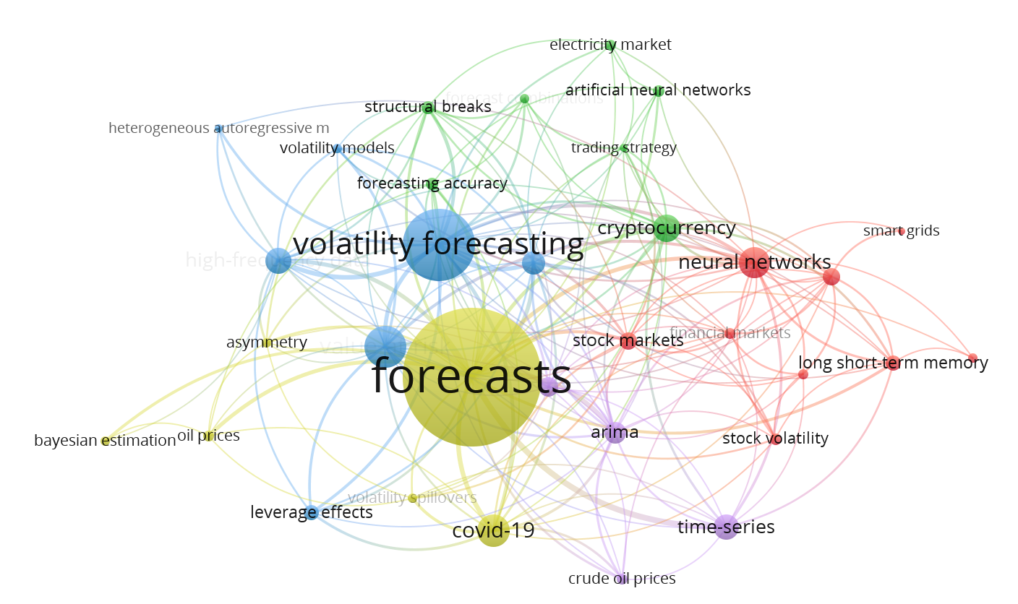
Figure 1.1 Co-occurrence map of keywords from VOS Viewer (Created by author).

A large part of the research effort has been directed towards constructing volatility models that can accommodate “asymmetry” and “leverage effects”. Further research has been dedicated to models that model market behaviour that is not symmetrical – negative movements are followed by much greater volatility as compared to positive ones. This implies that in order to improve on the forecasts more sophisticated models that are able to capture the non-linear stochastic volatility behaviour are required.
Another clear trend is a tendency towards the growing usage of various machine learning algorithms, especially ‘‘neural networks’’ and ‘‘artificial neural networks.’’ These models are emerging as the preferred methods in volatility analysis because of their capacity to work with high degrees of data and variable volatilities that other methods are likely to ignore. But this has changed to use of advanced methods due to the shortcoming of classical models in predicting the volatilities and dynamic behaviours of the markets.
Furthermore, the map points to a rising concern with matching up the irregularities of fluctuation between various markets, or between this “crypto currency” and the more conventional “stock exchange.” This is suggestive of a desire to gain insights on the kind of volatility that is typical of newer markets such as cryptocurrencies. Externals like “COVID-19” and “oil prices” are also pointed out as such ways to address such influences when building predictive models.
Indeed, the presence of terms such as the LSTMs and time-series points to the fact that temporal dynamics are becoming core issues in volatility modelling. For instance, LSTM networks are becoming more popular due to the feature they have of capturing non-stationary variance dynamics. Last but not the least, the map shows that volatility forecasting is increasingly being applied to newer asset classes like cryptocurrencies and encoding new problems due to market shocks as well as structural breaks.
All in all, this analysis focuses on the development of volatility forecasting stressing on the subsequent improvements, the role of outside factors, and the recent concerns with coins as well as the time-collection data analysis.

1.2 Review of Key Studies

1.2.1 Volatility in Financial Markets: Definition and Importance
The term Volatility is used to describe changes in the financial markets and more specifically the changes in the value of assets in a particular time period and is used for evaluating risk in business. This concept is considered to be a primary one in finance as it enters investment operation, management of risks, and sound development of financial systems. Different aspects of financial market volatility include Volatility clustering, leptokurtosis, Asymmetric volatility and the leverage effect, and these phenomena are evident in the stock returns in particular financial time series (Nishad et al., 2024).
Volatility clustering is a characteristic whereby large price movements are succeeded by further large movements, and small movements followed by further small movements pointing to success in activities characterized by elevated and depressed variations. This clustering effect coupled with leptokurtosis, (fatter tails in the return distribution) signal that financial time series may be non-normal at least to some extend as represented by traditional models. Asymmetric volatility means that negative change in volatility is more than double the positive change in volatility with the same magnitude on average leading to the vicious leverage effect in financial markets.
Recent development has also demonstrated that volatility is a more nuanced phenomenon especially for emergent assets like cryptocurrency. For instance, findings of various research show that while volatility significantly impacts its (Bitcoin) returns negatively; it has no significant impact on the returns of cryptocurrencies generally (Liu & Serletis, 2024). This implies that whereas for Bitcoin- the global market leader and the most traded cryptocurrency, there is a specific phenomenon where the interplay between volatility and average returns has, the same cannot be said for other cryptocurrencies.
Furthermore, this paper finds that prior studies on the correlation between cryptocurrency movements and financial markets have been done primarily in the context (Liu & Serletis, 2024). This means that previous works have simply used common correlations to analyse the relationship between traditional financial assets and new cryptos. However, these approaches do not necessarily reveal those aspects that conform non-linear and intricate relations characterising a market situation in a crisis or in a period of market shift.
The knowledge of these characteristics and their meaning should be useful for investors, financial analysts and policy makers. Improved understanding of volatility and relationship dynamics can refine existing risk mitigation and prediction, provide better guidance in investment decision-making to value-added, and provide greater relevance to both conventional and innovative markets.

1.2.2 Volatility Patterns in Traditional US Stock Markets
Depictions of volatilities in traditional US staple stock markets display distinctive behaviours and interactions governing their functioning and investing therein. These trends include phenomena like feedback mechanisms, the correlation between conditional volatility and asset returns, and volatility clustering. Research on traditional markets, such as the U.S. stock markets, consistently shows these characteristics of volatility, i.e., clustering (volatility breeds volatility), persistence (shock lasts a long time), and mean reversion. Engle (1982) studies introduced ARCH models, which were later extended into GARCH models of Bollerslev (1986) which effectively capture such patterns and form a basis for modern volatility forecasts in structured financial markets.
Among all models employed for studying these patterns, GARCH (Generalized Autoregressive Conditional Heteroskedasticity) model is employed most often. The bare bones of the model are used with the mean stock return as a constant; nonetheless, the model fails to explain the mechanics of volatility feedback ((Nishad et al., 2024)). Volatility feedback means that changes in future asset returns depend on current volatility feedback in which there is a reciprocation between price changes and current volatility levels. In traditional GARCH models, conditional variance clustering is in the form such that high value of variance is followed by high value, and vice versa, though feedback effects may not be well modelled.
Studies using the GARCH-M model have provided additional insight into these trends. As an illustration, the GARCH-in-Mean coefficients are positive and statistically significant for Ethereum, interest rate, and stock returns, demonstrating that conditional volatility has a positive and statistically significant effect on these returns (Liu & Serletis, 2024). This relationship establishes that higher turbulence is generally accompanied by the predicted premiums for stock gain in the US stock exchange market. Besides, such being the case it becomes important to have such findings to assess the investors’ behaviour and market sentiment especially in conditions of uncertainty or disruption of the market.
In general, the regularities highlighted in conventional America stock markets are Persistency in volatility, and the positive correlation in the conditional volatility and the assets prices. Although original GARCH model has been useful in modelling such patterns, it is crucial to look at advanced modifications that incorporate feedback mechanisms for a better market description. These inputs are also used in risk assessment, in investment decisions and in framing policies in conventional financial markets.

1.2.3 Volatility in Cryptocurrency Markets
This study examined data from cryptocurrencies and discovered that, due to their unique characteristics and factors, they exhibit a remarkable high degree of volatility when compared to conventional investments. Cryptocurrencies have different patterns of volatility to exhibit aspects such as volatility asymmetry, leptokurtosis, and nonlinear nature. Such characteristics aggravate fluctuations in the activity of cryptos and create difficulties for expectations based on classical modelling approaches.
One significant finding from the cryptocurrency market analysis was volatility spillovers, which occur when a shift in the value of one cryptocurrency has a substantial effect on the price of other cryptocurrencies. In return and volatility spillover analysis between Bitcoin and 17 large cryptocurrencies, Koutmos (2018) also established that the magnitude of correlation varies with time, and they demonstrate that Tether, Ripple, Ethereum, and Bitcoin are all to some extent impacted by their own shocks of return. This issue, however, also affects Litecoin and shocks that come from it, in addition to other cryptocurrencies. Furthermore, he describes Litecoin as the shock absorber for volatility and Bitcoin as the main shock transmitter.
On the other hand, Corbet et al. (2018) explore cross connectivity of volatile behaviour and returns of Ripple, Litecoin and mainly Bitcoin, however, the studies upheld that return shocks of Bitcoin impacts return from Litecoin and Ripple, respectively; further, high and significant connectedness of return and volatility between Ripple and Litecoin. Their study also shows that ripple and Litecoin cross adversely and positively affect market volatility of Bitcoin, showing that there exists bilateral causality between such cryptocurrencies. It puts emphasis on the nature of volatility and the relative relationships of the interactions within the cryptocurrency market.
This means that volatility in the price of cryptocurrencies depend on several factors such as Speculative trading as well as outside news events. In line with this speculation, Cheah and Fry (2015) and other related works (Corbet et al., 2018; Dyhrberg, 2016) pointed out that spearheaded by its use by the speculative crowd, Bitcoin shows high average volatility and fat tail behaviour. Also, news, especially geopolitical ones as well as the government regulations have remained key sources of volatility for Bitcoin (Chinazzo & Jeleskovic, 2024). Legal measures for instance in 2015, when the US Commodity Futures Trading Commission classified Bitcoin as a commodity and events that cause market alarms such as are insta-pump events that dramatically transform the volatility rate. Such news-driven shocks can have a dual impact: Whereas negative news undermines investors’ confidence and creates presale conditions, it decreases the offer of Bitcoin while increasing demand because of asset scarcity.
Another cause of cryptocurrency fluctuation is closely related to investors and the sentiment in the market. Smales (2022) proved that investor attention is positively related to returns in the twenty largest cryptocurrencies. However, more attention to investors and demand for securities is tightly connected with higher fluctuations and lower liquidity level. As in the previous studies (Garcia et al., 2014), correlation exists between buzz and price of Bitcoin: further popularity and concern about cyber impact can lead to fluctuation dramatically.
There are other aspects of volatility in cryptocurrencies that are equally worth refreshing: asymmetry and leverage effects. Nishad et al. (2024) established that the conditional variance of cryptocurrencies has more response to negative news or shocks than the similar positive news. This was made clear through the realization of leverage effects by using EGARCH and TGARCH models that were in circulation.
In distributional characteristics, the same can be said with regards to the cryptocurrencies which show off-skewed, leptokurtic, and fat-tailed returns. Hence, Liu & Serletis (2019) demonstrate that returns of cryptocurrency are skew, leptokurtic, and fat - tailed that is these returns are far from normally distributed. Further, Liu & Serletis (2024) emphasized that other correlations between cryptocurrency and financial markets exist in higher conditional moments more than the first two to suggest that there are more profound interactions beyond correlation.
Altogether, presented evidence suggests that there are both endogenous and exogenous factors that influence cryptocurrency market volatility – speculative trading, investor attention, changes in legislation and their reactions to the news. Correlations between leading cryptocurrencies, asymmetric adjustment to shocks, and non-Gaussian characteristics of the returns make cryptocurrency market highly volatile and uncertain. Knowledge of these volatility patterns may help investors and analyst to create proper risk management techniques and forecast models for this ever-growing market.

1.2.4 Comparative Analysis Studies
The interconnection and correlation between cryptocurrencies and the conventional financial markets have become a more prominent neoteric research focus. In the previous literature, studies have attempted to explain how cryptocurrencies and different financial instruments including stocks, bonds, and fiat currencies relate to each other. Comparative studies reveal substantial differences in volatility pattern between the two markets. While traditional stock markets have relatively predictable volatility dynamics correlated with macroeconomic factors, cryptocurrency markets exhibit high frequency, sharp spikes driven by sentiment-based behaviour (Katsiampa, 2017). The distinction in these factors underlines the need to develop fitting forecasting models to specific markets. Such research is intended to identify the relationships and interactions between these relatively new types of digital assets and conventional markets.
Some scholars have observed the links and relationships between cryptocurrency itself to another cryptocurrency. Aslanidis et al. (2019) studied interdependencies between BTC(Bitcoin), DASH(Dash-Coin), XMR(Monero) and XRP(Ripple) using a generalized dynamic conditional correlation model and they observed that the correlation among them is positive and but its time-varying. This finding implies that although there are general connections in most cases, the degree of these relations may fluctuate at different time opportunities perhaps due to factors such as market forces or regulations amongst others. In the same way, Shi et al. (2020) employed the MFSVM (Multivariate Factor Stochastic Volatility Model) combined with the BE (Bayesian Estimation) technique to find the crash risk and correlation between BTC(Bitcoin), DASH(Dash-Coin), ETH (Ethereum), LTC(Litecoin), XRP(Ripple), and XLM(Stellar). The study identified a positive correlation of volatility in the following pairs: BTC-LTC, ETH-XRP, ETH-XLM, and XRP-DASH pairs. Additionally, the authors discuss the market connections between the cryptocurrencies: Ethereum(ETH) is associated with Ripple(XRP), Dash(DASH), and Stellar(XLM), whereas Bitcoin(BTC) is associated mostly with Litecoin(LTC) to various degrees.
Concerning market dominance, several authors indicated on the presence of bitcoin dominance on other cryptocurrencies. In the same regard, analysing the data, S Kumar & Ajaz, (2019) have found that Bitcoin remains the most influential cryptocurrency as far as price fluctuations are concerned. Likewise, Qiao et al. (2020) obtain positive Granger causality at the medium and high frequencies for Bitcoin and other digital currencies but establish causality from Bitcoin to other cryptos at the low frequency. This implies that although, Bitcoin has a first-significant dominance over rest of the digital currencies; the kind of its dominance differs from conditions of the market.
The outcomes become somewhat less conclusive when the usage of cryptocurrencies such as Bitcoins, Litecoin, etc., with more conventional financial instruments like bonds and stocks is under consideration. Harb et al. (2024) posited that the US stock has limited exposure to cryptocurrencies and presents investors with the hedging and safe haven utilisation opportunities. This detachment suggests that due to some level of risk diversification cryptocurrencies could be used for stock market investment during instabilities, but the relationship needs further empirical evidence.
Finally, there is information on benefits and drawbacks for different markets. For example, Jimoh et al. (2020) learns that market price in Nigeria is more sensitive to volatility in the prices of Bitcoin and Ethereum than exchange rates. Though, there is often not always a direct correlation between the cryptocurrencies and financial markets. Consequently, Liu and Serletis (2024) note that whereas there is no statistically significant tail dependence between the financial market and cryptocurrency market, there is relatively lower tail dependence between Bitcoin and returns on stock. This implies that instead of positing of constant flow of information and other relevant content during robust relationships between companies and their investors, there may be random contacts only during especially turbulent market conditions.
Therefore, the comparative analysis studies show that cryptocurrencies are of a different level of dependability on each other and on the traditional financial assets, and that such influences and dependability constantly evolve. Bitcoin seems to play a key role within the cryptocurrency system dominating both the amount of return and the volatilities’ cross-over. Nonetheless, given the relatively low level of correlations between the cryptocurrencies and more conventional assets, investors may be potentially protected from portfolio losses by diversifying portfolios with cryptocurrencies, to varying degrees depending on current market conditions and other factors.

1.3 Discussion on Volatility Forecasting Models
The important issues include accurate volatility modelling and volatility forecasting because of the challenges associated with the movements of asset prices in the given financial markets. Forecasting volatilities is successful attractive being applied for the purpose of realizing the risks which exists in the market and for planning how to minimize these risks among the professional investors, industrial analysts and even policymakers. Many volatility forecasting models has been created and enhanced over years with simplest and mostly used models being based on GARCH. The existence of volatility forecasting models has changed since Engle (1982) proposed the autoregressive conditional heteroscedasticity or ARCH model followed by the generalized autoregressive conditional heteroscedasticity model proposed by Bollerslev (1986). Several papers have extended the GARCH framework to accommodate certain characteristics of the market as shown in Table 1.2.
Table 1.2
GARCH Models suggested in various papers (created by author)
Author (Year) | Financial Asset Researched | Models Suggested
Bollerslev (1986) | U.S. Stock Market | GARCH
Chu et al. (2017) | Cryptocurrencies | IGARCH, GJRGARCH
Katsiampa (2017) | Bitcoin | AR-CGARCH
Dyhrberg (2016) | Bitcoin, Gold, U.S. Dollar | GARCH, EGARCH
Peng et al. (2018) | Cryptocurrencies and Currencies | SVR-GARCH, EGARCH, GJRGARCH
Naimy et al. (2021) | Monero and Cryptocurrencies | IGARCH (Monero), GJR-GARCH (Other Cryptocurrencies)
Teker & Teker (2020) | Bitcoin | GARCH (1,1)
Obeng (2021) | Cryptocurrency Index | ARMA-SGARCH, EGARCH
Nishad et al. (2024) | Stock Market and Cryptocurrencies | EGARCH, TGARCH
Liu & Serletis (2024) | Cryptocurrencies and Financial Markets | ARMA-GARCH-in-Mean, Copula-Based Models

The existence of volatility forecasting models has changed since Engle (1982) proposed the autoregressive conditional heteroscedasticity or ARCH model followed by the generalized autoregressive conditional heteroscedasticity model proposed by Bollerslev (1986). Several papers have extended the GARCH framework to accommodate certain characteristics of the market as shown in Table 1.2. The existence of volatility forecasting models has changed since Engle (1982) proposed the autoregressive conditional heteroscedasticity or ARCH model followed by the generalized autoregressive conditional heteroscedasticity model proposed by Bollerslev (1986). Several papers have extended the GARCH framework to accommodate certain characteristics of the market as shown in Table 1.2.
GARCH and Its Extensions
The GARCH model developed by Bollerslev in 1986 with the full form name of the Generalized Autoregressive Conditional Heteroscedasticity model, has remained a popular model, throughout the years for modelling volatility of financial markets. Thus, GARCH models are most appropriate in capturing most of the standard features of financial returns data, such as clustering of volatility, fat-tails, leverage effect and leptokurtosis. However, like most other GARCH models, it does not allow for asymmetry in the reaction of the volatilities to positive and negative shocks.
To overcome these limitations, several modifications of the GARCH model have been made, although the most frequently used models are Exponential GARCH (EGARCH), Threshold GARCH (TGARCH), and GJR-GARCH. For example, EGARCH is an improvement of the basic GARCH (1, 1) approach and allows for better evaluation of the asymmetry because it eliminates the symmetry constraint. Such models are valid for cases when the effect of negative information dominates at increasing the market’s volatility, whereas positive information does not significantly reduce volatility.
Using the performance of models that were derived, a comparative analysis can be made with previous models. Empirical research works have been carried out to examine and compare various models based on GARCH to analyse the level of effectiveness of the given approaches to forecast the volatility in the routine and cryptocurrency trading markets. In their comparative study of the performance of the models, (Peng et al., 2018) work under the assumption of symmetric and asymmetric distributions through the use of Gaussian and student-t distributions in SVRGARCH, EGARCH and GJRGARCH model. They do conclude that support vector regression GARCH, followed by GJRGARCH, was the best for volatility forecast on the Bitcoin market. In the same way, (Teker & Teker, 2020) analysed several GARCH models, which are ARCH, GARCH, TGARCH, EGARCH, and found that GARCH (1,1) model is the most suitable for explaining the movements of the return volatility of Bitcoin.
Expanding these analyses to other financial assets, research like Dyhrberg (2016) and Bouoiyour & Selmi (2015b) looked at the volatility of bitcoin to gold and US dollar through GARCH and asymmetric EGARCH analysis. These studies discovered direction similar same fluctuation track of Bitcoin as well as orthodox financial investment belonging to risky asset class and therefore, they concluded that Bitcoin can, in fact, act as a hedge for risk-averse investors. Dyhrberg (2016) also pointed out that Bitcoin may be highly effective for risk management favourable for investors who mainly respond to the negative occurrences.
Modelling Volatility in Cryptocurrencies
Given the peculiarities of cryptocurrencies, several research works have intended to establish appropriate models to provide the volatilities. From the studies carried out by Katsiampa (2017) reveal that among all proposed models, the AR-CGARCH model can best explain the volatility of Bitcoin. Other research has generalized the idea to encompass different particular cryptocurrencies. For example, Chu et al. (2017) used twelve various GARCH-type models to analyse seven most popular cryptocurrencies and determined that IGARCH and GJRGARCH were the most appropriate models for analysing the crypto market’s volatility. This was supported by Naimy et al., (2021) whereby it was found that IGARCH best suited modelling volatility for Monero while GJR-GARCH provided the best way of modelling of other cryptocurrencies in-sample volatility.
In a similar tradition, Obeng (2021) also aimed at comparing the performances of various volatility models in constructing VaR (Value at Risk) for the Cryptocurrency Index. This study has also established that there were negligible differences between the models and that ARMA (1, 2) - SGARCH and EGARCH models were more appropriate for measurement and estimation of volatility when normal and student-t distributions were applied. Moreover, since the absolute values of the coefficients for the logarithm of absolute daily returns and negative daily returns in EGARCH model were significantly larger than those for the positive daily returns, the results confirmed that the leverage effect exist in the cryptocurrency market.
Advanced Models is a Copula-Based Model.
Although there are conventional GARCH models and their variants which enjoys the maximum applications, the advanced model to capture the conditional heteroscedasticity have been under scrutiny in the recent times to capture the interdependencies among the tiles in the financial market. For example, the evaluation of the drawbacks of the standard multiple GARCH analysis can be facilitated by employing GARCH-in-Mean models based on the Copula. These models offer greater flexibility in modelling the dependence structure between financial assets especially with regard to nonlinear and tail dependencies. This is important for cryptocurrencies, where they experience regular and large volatility to change, causing increased investor anxiety (Bouoiyour & Selmi, 2015a).
The below mentioned Table 1.3 summarizes the key GARCH models and other models used for volatility forecasting. It helps in analysing their performance in traditional stock markets and cryptocurrency markets.
Table 1.3
Overview of Forecasting Models
Forecasting Model | Definition
ARCH (Autoregressive Conditional Heteroskedasticity) | A foundational model that explains volatility clustering by making variance dependent on past squared residuals (Engle, 1982).
GARCH (Generalized Autoregressive Conditional Heteroskedasticity) | Extends ARCH by including lagged variances and residuals to better capture volatility persistence (Bollerslev, 1986).
E-GARCH (Exponential GARCH) | Models’ volatility asymmetry by expressing conditional variance in logarithmic form, ensuring positive values (Nelson, 1991).
T-GARCH (Threshold GARCH) | Incorporates threshold effects to account for the differing impacts of positive and negative shocks on volatility (Zakoian, 1994).
GARCH-M (GARCH-in-Mean) | Extends GARCH by allowing variance to directly influence the mean return, linking risk to expected returns (Engle et al., 1987).
I-GARCH (Integrated GARCH) | A model assuming that shocks to variance have a persistent effect, making volatility changes long-lasting (Engle & Bollerslev, 1986).
A-GARCH (Asymmetric GARCH) | Accounts for the unequal effects of positive and negative shocks on conditional volatility (GLOSTEN et al., 1993).
F-GARCH (Flexible GARCH) | A generalization of GARCH that includes non-linear transformations and various distributional assumptions (Ding et al., 1993).
P-GARCH (Power GARCH) | Extends GARCH by raising conditional variance to a power, offering flexible modelling for extreme variations (Ding & Granger, 1996).
COPULA GARCH (Copula-Based GARCH) | Combines GARCH with copula functions to model dependencies between multiple assets, preserving marginal distributions (Patton, 2006).
EWMA (Exponentially Weighted Moving Average) | A simpler volatility model that gives greater weight to more recent observations to better capture changing conditions (RiskMetrics Group, 1996).

Issues and Prospects
However, there are still critical issues associated with the forecast of volatility, even though there have been significant improvements in this area. For example, although the standard GARCH (1,1) model produces satisfactory results using AIC, and BIC criteria, it fails to portray the nonlinear effects and sudden movement behaviour of extreme markets (Chinazzo & Jeleskovic, 2024). To address these accessibility issues, more flexible distribution and effects, such as EGARCH and copula are being investigated by numerous studies.
In conclusion, GARCH-based volatility forecasting models highlight certain qualities of financial returns useful in traditional and cryptocurrency-based trading markets. Nonetheless, new research findings are required to further enhance these models and generate new models for better capturing the quickly shifting behaviour of these markets, asymmetrical distributions, tail risks, and non-linear interdependencies.

1.4 Limitations of Traditional Volatility Forecasting Models
However, despite the widespread use of traditional volatility forecasting models such as the ARCH (Autoregressive Conditional Heteroskedasticity) and GARCH (Generalized Autoregressive Conditional Heteroskedasticity) models there are some limitations to their effectiveness in fully representing complexities of financial markets, particularly in extreme market conditions where cryptocurrencies are being traded.
One major drawback of the standard GARCH model is that it cannot explain asymmetries to market shocks. "Asymmetry in the impact of positive and negative shocks is not accounted for by the standard GARCH model." As such, Harb et al. (2024) assumes that positive and negative shocks have same effect on conditional volatility. A drawback of this approach is that it is likely to be problematic in real world financial markets where negative shocks tend to have a more pronounced impact than positive shocks of the same magnitude, a phenomenon known as leverage effect.
“It is also shown that ARCH and GARCH models fail to capture the leverage effect, as their distribution is symmetric” (Nishad et al., 2024). The importance of more advanced models that take into account asymmetries and discriminate the effect of positive and negative shocks on market volatility is underscored by this limitation. To overcome these, for example models like the Exponential GARCH (EGARCH) and Threshold GARCH (TGARCH) have been introduced that account for asymmetry in the volatility estimation.
In addition, traditional GARCH models tend to impose constraints on model parameters to ensure model parameters are non-negative and stationary. It is then showed that the GARCH and the ARCH parameters satisfy the non-negative condition. In particular, the ARCH parameter is significant and indicates that the past volatility shock in the cryptocurrency market affects the present volatility of the exchange rate market" (Jimoh et al., 2020). The first group of constraints is necessary for the stability of the model but its extension to financial markets such as that of the cryptocurrencies and emerging assets, may not cover the intricacies of the nonlinear and interdependent spaces.
Traditional GARCH models have shortcomings that become much more evident during times of market crises like the COVID 19 pandemic. "In fact, this study findings suggested that the crypto market returns series exhibited volatility persistence, fat tail phenomena, and leverage effects in the period of the COVID-19 pandemic" (Khan & Khan, 2021). However, persistence, fat tails and leverage effects lead to models that are more complex than can handle nonnormal distributions or several of the extreme events that frequently happen in volatile markets.
Moreover, the multivariate GARCH models that are used to assess multiple assets at the same time frequently assume the distribution constancy. However, the multivariate GARCH model is typically based on quite strong assumptions in order to have a positive semidefinite covariance matrix. Liu and Serletis (2024) first assumes, that the stochastic term follows an elliptical (Gaussian or Student’s t-) distribution with linear dependence." However, assumptions like ellipticity, or that relationships between assets are nonlinear, may not hold, restricting the use of these models in cases where dependencies between assets are complicated.
A second limitation is that the way in which traditional models fail to consistently forecast future patterns of volatility. However, the "current findings can be useful to determine the short- and long-term relationship between the cryptocurrency index and stock indices; however, we cannot assure future recurrence of the pattern" (Nishad et al., 2024). The challenge these models pose for investors and analysts is their unpredictability: the models are used for forecasting and risk management, and if these turn out to be inaccurate, the model does not always generate the desired outcomes.
Thus, traditional volatility forecasting models, such as ARCH and GARCH, are able to explain the volatility phenomena, but are lacking in many dimensions. However, these approaches are symmetric, restrictive, and incapable of encompassing leverage effects and extreme market changes. As research and practice move forward, we need to continue to explore alternative models that can provide better predictions of these shortcomings in both traditional and new financial markets.

1.5 Impact of External Factors on Volatility and Forecasting
Volatility in financial market is influenced by external factors: economic crises, market sentiment and news events. These factors may cause sudden changes in the market condition and concomitant shifts in investor behavioural response and distorting the accuracy of volatility forecasting models.
Negative news is one of the main external factors that determine volatility, since the negative news may provoke exaggerated market reactions. As Obeng (2021) points out, returns tend to be negative and bad news distorts markets to "increase volatility strongly". This is a negative news result, called the leverage effect, which increases the market volatility and worsens investor uncertainty. Under these conditions, traditional forecasting models, such as GARCH, sometimes fail to accurately predict market behaviour because they cannot account for the full range of asymmetric responses to negative and positive shocks.
COVID 19 pandemic is a prominent example of any factors except internal factors which can drive and worsen market volatility. Market fluctuations were sharp and came during the experienced of the pandemic, when investors panicked. “The increased volatilities in the financial markets make panicked investors in the COVID-19 pandemic” (Khan & Khan, 2021). Traditionally, such crises pose challenges to such models that are typically calibrated to typical market conditions like normal times and sometimes do not consider extreme events or crisis periods very well.
For cryptocurrencies, the off ramps have certainly been external factors like economic recessions and regulatory developments. It found that during the initial stage of the COVID-19 imposed recession," the cryptocurrency index and the major cryptocurrency prices fell down at the onset of the recession but had been rising afterwards" (Liu & Serletis, 2024). In this sense, this clearly shows the dependence of cryptocurrencies to macroeconomic conditions and the recovery opportunity given that the market sentiment changes. These volatility patterns reflect that economic setting and market sentiment to take in consideration in forecasts are therefore required.
Overall, the volatility in the both the traditional and cryptocurrency markets are overall decisions due to the external factors which include some of the negative news, economic crisis and market sentiment. These external events are dynamic and unpredictable and traditional forecasting models fall short of capturing their effect as well as capturing the impact of external shocks with enough accuracy.

1.6 Comparative Analysis of Volatility Patterns and Models
The behaviour of traditional stock markets and cryptocurrency markets is compared by looking at volatility patterns and forecasting models across the two asset classes. With varying external influences and interdependencies, the dynamic nature of both markets calls for a closer analysis of how the performance of the traditional and emerging forecasting models varies across different market conditions.
Volatility Patterns and Interdependencies
Recent studies about the relationship of stock markets and cryptocurrencies show various levels of interdependencies. As an example, Nishad et al. (2024) reports a 'good correlation between stock index and cryptocurrency prices in India' to show a growing link between these two markets. The finding here is that stock index changes may be correlating with changes in cryptocurrency prices, and vice versa, due to the strengthening of the crypto into broader financial systems.
Although there are correlations and interdependencies across all financial variables, they are not the same. Liu and Serletis (2024) holds that, using the semiparametric GARCH-in-mean copula model, cryptocurrency returns are not statistically dependent upon the effective exchange rate of the U.S. dollar or returns of cryptocurrency and the interest rates, but there is lower tail dependence between Bitcoin and stock markets. Based on this finding, though, Bitcoin might enjoy some insulation, at least to some extent, from financial variables other than exchange rates and interest rates.
Comparative Performance of Forecasting Models
Volatility forecasting models exhibit high sensitivity to the presence of the market context and the choice of the model specifications. Standard GARCH models have been commonly used in traditional financial markets since their effectiveness at capturing volatility clustering and other stylized fact of financial returns. Nevertheless, in the world of cryptocurrencies, typically more sophisticated models are needed to handle their peculiar traits and excessive volatility.
Liu and Serletis (2024) discovered that "the ARMA(2,2)-GARCH(1,1)-in-Mean model with a Student’s t-distribution as the error term has the best fit to the returns" because they require appropriate model specifications to capture the persistent non-normal distributions and high volatility in cryptocurrency returns. Student’s t distribution is used to account for the fat tails often found in cryptocurrency price movements and to help the model to be more predictive.
Moreover, a number of other studies made efforts to circumvent the drawback of standard multivariate GARCH models that fail to take advantage of rich interdependencies and tail risks. Liu & Serletis (2024) finds that while traditional GARCH models are effective at capturing individual asset return dynamics, sophisticated models such as the semiparametric GARCH-in-mean copula model are necessary to characterize the intricate intermarket and tail dependencies between cryptocurrencies and other financial assets.
Insights and Implications
Using a comparative analysis of volatility patterns and volatility models, we find that traditional stock markets and cryptocurrency markets follow a similar volatility behaviour, with important differences. Since cryptocurrencies are associated with higher volatility and lower tail dependencies with some financial variables, they impose higher demands of more flexible and robust forecasting models. While traditional GARCH models are successful in capturing the more general behaviour of the market, they do not capture the peculiar nature of the cryptocurrency market sufficiently and may accrue deviations, where emphases on the deviation and its resultant effects may not be novel.
Finally, the implications for investors, analysts, and policymakers of volatility patterns and comparative forecasting model performance can be used to inform the most appropriate strategies for risk management and investment in these markets. It will become crucial to identify the right models and capture essential interdependencies in an evolving landscape of traditional and emerging financial markets.

1.7 Identification of Gaps in the Literature
Although extensive empirical literature exists on spillover effects of cryptocurrency markets on traditional financial markets, sparse evidence on the tail and nonlinear dependence exists between cryptocurrencies and financial markets (Liu & Serletis, 2024). In particular, there is lack of comprehensive studies investigating the asymmetric effects and the volatility clustering effects in the crypto markets in comparison to the traditional financial markets. The prediction of extreme tail risks present in the cryptocurrency markets is further complicated by the fact that traditional econometric models, for example GARCH, do not accurately predict them. This gap shows need for more comprehensive studies exploring the intersection of extreme market conditions and complex interdependencies, both in terms of risk management, forecasting, etc. In addition, the impact of the macroeconomic events, like geopolitical instability and regulatory statements, that disproportionately affects cryptocurrency markets is often not taken into account by existing models. These kinds of comparative analyses can inform improvements in the predictive accuracy of volatility forecasting methods by examining model adaptability in these external conditions.
Emerging machine learning techniques, even though promising, have yet to be rigorously tested in these extreme market environments. In addition, these relationships should be further studied to evaluate the performance of traditional and advanced models in modelling the same relationships over different market settings.

1.7 Conclusion of the Literature Review
The literature review offers the academic analysis of volatility patterns and modelling in the conventional financial markets and the relatively new burgeoning cryptocurrency markets. This study reveals that although both markets share some level of normality, the cryptocurrencies market is marked by high level of volatility, fat tailed distribution and other market irregularities due to speculative activities and external shocks such as news and policies.
The literature also illustrates that traditional volatility forecasting models, especially those derived from the GARCH family, have been widely used in modelling key behaviours of the market. Nevertheless, the weaknesses of these models are outlined in one study or another that analyses them. For example, the standard GARCH model cannot capture the leverage effect thus cannot be very helpful in volatility forecasting during distressed periods. However, GARCH types satisfy essential conditions such as non-negativity, but generally fail to capture extreme events and nonlinear relationships, which are always present in both stock and cryptocurrencies markets.
Comparing these models in the context of cryptocurrencies, it emerges that extensions like EGARCH, TGARCH and GJRGARCH are required for asymmetry and leverage effects. This paper has also ascertained those models with flexible distributions and semiparametric methodologies, which have adopted the GARCH-in-mean copula models, outperform traditional models in capturing the inter-market dependencies and risks at the tails. However, these models also suffer from limitations in capturing dynamic market behaviour and the changing nature of interactions between digital assets and the corresponding conventional financial measures.
Geopolitical news, regulatory changes and outcomes, macroeconomic changes also affect the volatility greatly. For example, the emergence of COVID-19 pandemic clearly illustrated how shocks can act as a trigger to entice persistence, fat tails or impacts of leverage effects in both markets. Hence, extension of the traditional business forecast models to account for the effects of external shocks and market sentiment is appropriate.
The findings from the reviewed contributions provide a vital understanding key to the hypotheses, and more fundamentally, provide a deeper understanding for the subsequent empirical consideration. This section summarizes the main heading to address the stated hypotheses relative to the literature review.
H1: Cryptocurrency markets exhibit more volatile behaviour compared to traditional US stock markets.
The literature strongly supports the claim that cryptocurrency markets are inherently more volatile than the US stock markets. As has been demonstrated in studies, cryptocurrencies, including Bitcoin and Ethereum, demonstrate frequent price fluctuations and exhibit greater volatility clustering in price compared with such stock indices as the S&P 500 (Harb et al., 2024; Liu & Serletis, 2019). These factors (e.g. speculative trading, low market maturity, high sensitivity to macro-economic shocks and regulatory developments) also explain this heightened volatility (Katsiampa, 2017). More specifically, cryptocurrencies exhibit intense price behaviour characterized by fat tails and leptokurtosis (Liu & Serletis, 2024), they are subject to larger and more frequent deviations from normal expected price movements.
However, US stock markets though is not resistant to volatility, but exhibits more stable and predictable patterns. Institutional regulations, greater market liquidity, standardized trading norms all mean a reduced degree of volatility in these markets as opposed to the emerging and speculative nature of the crypto market. The distinction highlights the special problems of volatility forecasting for cryptocurrency markets that often have sharp spikes generated by news and market sentiment (Kristoufek, 2013).
H2: Traditional volatility forecasting models (e.g., GARCH, EWMA) perform differently across stock and cryptocurrency markets.
When traditional volatility forecasting models are applied to stock and cryptocurrency markets, it is clear to the literature that performance between models is significant. However, it has been found that models such as GARCH and EWMA are effective at stock markets, but not necessarily so for cryptocurrencies owing to the asymmetric reaction to shocks and the nonlinear dependencies exhibited in the later (Peng et al., 2018). For example, GARCH models, which are assumed symmetric, struggle to capture those extreme volatility and fat tail considerations of cryptocurrencies (Chu et al., 2017).
In the cryptocurrency market however, advanced models such as E-GARCH and T-GARCH that consider asymmetry and leverage effects had a better performance (Katsiampa, 2017). These models overcome the weaknesses of some standard frameworks by taking into consideration such characteristics as cryptocurrencies’ extreme volatility persistence and on news of negative market behaviour (Bouoiyour & Selmi, 2015a).
While these advancements exist, the same level of accuracy in cryptocurrencies as markets are seen in traditional markets is not yet achieved. They argue that the factors behind the failure, which include the absence of historical data, market fragmentation, and the unpredictable external influence of shocks such as regulatory announcements, are the underlying ones (Harb et al., 2024). For this reason, the demand for hybrid or even machine learning models that are able to cope with the peculiar volatility of cryptocurrencies has been increasing.
The conclusions emphasize the difficulties, and potential opportunities, to forecasting volatility in traditional as well as cryptocurrency markets. The insights from the literature add commitment to the empirical analysis by informing the empirical investigation and also contributing further to the understanding of these hypotheses.
However, the current literature does lack empirical research on the nonlinear and tail dependencies between cryptocurrencies and traditional financial markets. Although more and more research works address the issues of spillover effects and correlations, the existing literature lacks effective and systemic works to discuss the issues during severe market conditions and the relations cross sectors. Filled these gaps will be critical for enhance the forecast models and the improving of the risk management policies.
Therefore, the imperative for more research to fill the existing gaps and enhance the existing models is clearly identified in the literature review sections. Due to expanded forms and the increasing role of digital assets in global financial markets, the authors and practitioners observe shifts in overall patterns as well as characteristics of both conventional and cryptocurrency markets. Through helping to refine the current analysis of the structure and connections of volatility over time, future research can contribute to enhancing the accuracy of volatility forecast and risk management and thus offering more fruitful decision-making in the international financial context.

2 Methodology of the Research
The methodology in this thesis outlines the systematic approaches that are undertaken to achieve the research objectives, including data collection, selection of financial instruments, model implementation, and the comparative analysis of volatility patterns across traditional US stock markets and cryptocurrency markets. By employing quantitative research methods, this study examines volatility characteristics and evaluates the effectiveness of forecasting models like GARCH, other models in GARCH family and EWMA in these two distinct financial ecosystems.
The study focuses on collection of historical price data over a three-year period (2020–2023) from reliable financial sources such as Yahoo Finance, CoinMarketCap, and Quandl. Both markets were analysed using established and advanced GARCH family models to capture volatility patterns and their implications. The statistical computations and graphical presentations have been carried out with software, R programming and MS Excel, which ensures that the results obtained are robust and addressable.
The focus of the methodology is to compare volatility patterns as well as the out of sample predictive accuracy of forecasting models between these markets. The effects of external factors (macroeconomics and market sentiment) on volatility and the accuracy of forecasts are placed in the spotlight. The findings are designed to further understand the constraints of the use of traditional volatility forecasting models in contexts such as emerging markets for which increased volatility is the norm, such as indexed, and how these constraints manifest in high volatility environments.

2.1 Research Design
For this study, a quantitative, descriptive and comparative research design is applied to analyse patterns of volatility and assess the performance of forecasting models in the universe of US overall stock markets and cryptocurrency markets. We choose this design for its promise to offer robust, data driven insights while allowing for a structured comparison of two distinct financial ecosystems.
This is a quantitative approach that the study must hang on to because it greatly deals with the number of numerical analysis of historical price series. The application of this method permits us to apply advanced statistical models such as GARCH, E-GARCH, TGARCH, IGARCH, GARCH-M and EWMA for investigation of volatility characteristics like clustering, persistence and asymmetry. These models help the study investigate sophisticated monetary market behaviours of the traditional and cryptocurrency markets simultaneously.
The addition of this descriptive aspect supplements the quantitative approach by adding detail to the nature of volatility in the selected markets. To that end, this also includes studying how volatility responds to varying conditions within the market, what volatility does to macroeconomic events and how volatility changes over time. Descriptive analysis is used to inform key volatility patterns so that comparative analysis and model evaluation are possible.
The research design emphasizes the comparative dimension that allows a systematic assessment of differences and similarities between traditional and cryptocurrency markets. The study creates consistency and reliability in its results by using identical statistical models and evaluation metrics for the two markets. Using this approach, we also demonstrate the differences in volatility patterns and model effectiveness for the stable, regulated environment of US stock markets as compared to the speculative and high volatility of the cryptocurrency markets.
The design also considers the effect of external factors, namely macroeconomic events and market sentiment, on volatility, and on the error of the forecast. These considerations are not central, but they contribute depth to the analysis by making explicit how they affect market dynamics and predict performance.
This combination of the elements provides the research design with a rigorous systematic approach of his addressing study goals. The design adopted allows to ascertain different volatility characteristics, to assess forecasting model performance and to test research hypothesis. Not only does this comprehensive framework fit the criteria of the thesis, but it also helps to further explore the way financial market dynamics and risk assessment.
A direct alignment with the particular objectives of this thesis, the research design offers a structured basis for exploring volatility patterns and assessing the forecasting models’ performance in traditional US stock markets and cryptocurrency markets. The study employs a mixture of descriptive and comparison methods to examine some key volatility characteristics, such as clustering, asymmetry, and persistence, and provides insights particular to how each market works.
The application of multiple models is done systematically using GARCH, E–GARCH, TGARCH, IGARCH, GARCH–M and EWMA to assess their performance in predicting volatility in the market. The research applies these models across a diverse range of financial environments to show their strengths and limitations and contributes to a more general understanding of their usefulness in traditional and emerging markets.
In addition, the research design is suitable for the testing of the study’s hypotheses and support for obtaining empirical results in terms of the differences in the volatility behaviour and the effectiveness of forecasting models between the two markets. Beyond addressing the defined objectives, this framework also fills the gaps in the current literature on volatility forecasting and risk assessment for various financial environments.

2.2 Sample Selection and Data Collection
For this study, we select the sample in a way that yields a comprehensive dataset that is consistent with the research goal of comparing volatility patterns and forecasting models between traditional US stock markets and cryptocurrency markets. Samples on the chosen stock market have been selected and everything goes from major indices to companies in US stock market and the leading cryptocurrencies in terms of market capitalization. The selection is based on their significance in market, availability of historical data, and also their unique characteristics in reflecting volatility.
US Stock Market
The sample selection of US Stock Market is further widened into 3 major indices in the market as well as 2 large-cap stocks showing diverse patterns in volatility. The indices selected are listed below:
- S&P 500 (SPX): The 500 companies listed here are large US companies which represent different sectors. It is seen as a benchmark for US stock market in general and for market wide volatility patterns and sectoral diversity. This inclusion provides a broad view of traditional market volatility.
- NASDAQ (IXIC): The NASDAQ Composite is a known concentration in technology and growth-oriented companies that has high volatility from innovation-based industries. Being dynamic, it is best suited to detect volatility clustering and asymmetrical response to market shocks.
- Dow Jones Industrial Average (DJI): The DJI is made up of 30 of the major large-cap companies, who represent the stability and performance of blue-chip stocks. It's a behaviour of mature companies and a counterweight against the more volatile NASDAQ.
The stocks for the sample are selected based on the top 2 companies with largest market capitalisation (as on December 2024) and the same is listed below:
- NVIDIA (NVDA): NVIDIA as a leading technology company has an outstanding market volatility due to innovation cycles, semiconductor trends and macroeconomic factors. The presence of sector specific volatility is represented in its inclusion.
- Apple Inc. (AAPL): Apple is a company known from all over world as the largest one and the greatest influence in consumer electronics. Because its stock is stable but sensitive to market changes, its stock serves as a representative sample of large cap stocks in the sector.
To obtain a complete picture of volatility patterns, the US stock market sample includes broad cross-section of indices and individual stocks. Indices, such as S&P 500, NASDAQ Composite and Dow Jones Industrial Average (DJI), include index value that gives the macro level market status across all the sector and industries. The first set of these indices is an aggregate measure of how well many companies have performed, and they are used so that the study can measure market wide volatility trends as both the aggregate and as a sectoral variation.
However, in contrast, the selected individual stocks such as NVIDIA (NVDA) and Apple Inc. (AAPL) provide a micro view in terms of a particular company. The device sector is represented by NVIDIA, a technology company and a good representative of the increased volatility that comes from innovation cycles and market speculation. For mature, well-established companies, Apple offers interesting insights into the volatility patterns experienced by large cap, stable companies.
Its diversification between indices and stocks allows for both market level and firm specific volatility behaviours to be captured in the study. The research combines these perspectives to offer a more nuanced view of volatility in traditional financial markets and offers a robust comparative analysis with cryptocurrency markets.
Cryptocurrency Market
The cryptocurrency market sample consists of five leading cryptocurrencies designed to capture the scope and diverge of this emerging financial marketplace. Overall, cryptocurrencies are inherently more volatile than traditional financial assets due to speculative trading, regulatory developments, and changes in market sentiment. The selected assets on the other hand are of established leaders and among the disparate players that happened in the crypto space.
- Bitcoin (BTC-USD): As the first and the biggest crypto coin, bitcoin has the largest share in the crypto market. Existence of high volatility caused by speculative trading, regulatory news and macroeconomic events. Often, its market behaviour is a proxy for the cryptocurrency market.
- Ethereum (ETH-USD): Decentralized finance (DeFi) is a vast and community-built ecosystem that utilizes Ethereum as the second largest cryptocurrency. Its volatility is a result of technological innovations or even market trends and needs analysis.
- Ripple (XRP-USD): Ripple is unique for their cross-border payment software and partners with financial institutions. Regulatory developments and institutional adoption tend to affect its market value as well as make it volatile.
- Binance Coin (BNB-USD): BNB is the native token of Binance exchange which is a very important crypto element. Market sentiment and the operational success of Binance are considered both in defining its price dynamics which make it a unique addition to the sample.
- Tron (TRX-USD): In contrast, Tron is one such blockchain based platform with a differentiation in much regard such as decentralized applications (DApps). Adding it to the sample provides diversity, as it’s another manifestation of market behaviour beyond cryptocurrency mainstream.
The two largest cryptocurrencies by market capitalization, Bitcoin (BTC) and Ethereum (ETH), serve are used as foundational to the analysis of the market and are used as broad trends and major developments. The third additions in this list are Ripple (XRP), Binance Coin (BNB), and Tron (TRX), each providing their own diversified use cases, trading behaviours and market impulses. It covers a comprehensive view of the cryptocurrency market, taking into consideration both high market capitalization and trading volume of cryptocurrencies, all with distinctive attributes. The study focuses on these assets to have robust volatility patterns analysis as well as meaningful comparison with traditional US stock markets.
The chosen assets let you maintain a dynamic equilibrium between stable, mature markets (US stock indices and companies) and speculative, high volatility markets (crypto currencies). Datasets here contain enough historical observations – 1,006 US stock and 1,461 cryptocurrency combinations – spread over 2020 to 2023 period. This enables us to perform robust analysis of volatility patterns across both markets in various economic settings, such as the COVID-19 pandemic and market recovery.
The study focuses on these assets to provide a complete foundation for evaluation of variance forecasting models and summary of market behaviour. The research objectives are supported by this diverse sample and allows important distinction to be made between traditional and emerging financial markets.

2.3 Data Processing
It is critical with regard to the preprocessing of data when studying volatility modelling, as well as in financial analysis. Financial datasets like real time stock indices and cryptocurrency prices contain irregularities, missing values, outliers and non-stationary trends. If these concerns are not addressed, they can distort model results in a way that gives unreliable conclusions. Preprocessing is necessary to have clean, consistent data that is also statistically suitable for more advanced analytical methods like GARCH family models and EWMA, as these methods are very sensitive to quality of input.
Preprocessing is necessary for achieving research objectives of the study, including comparing volatility patterns and forecasting models in two different financial markets. Raw price data is transformed into meaningful daily returns, variance stabilizing, and the resultant data will satisfy statistical assumption requirements of chosen models. Such steps as dealing with missing values, dealing with outliers, and testing for stationarity are absolutely essential in preparing the data for serious analysis.
All pre-processing tasks are done using R programming in order to maintain precision and reproducibility. Because of R’s large number of specialized libraries and functions, it’s particularly good for financial time series analysis. R with the automation minimized the human errors and standardised approach when we are to deal with high volume of datasets. This study ensures the datasets from US stock markets and cryptocurrency markets are comparable, clean and can be passed into the advanced modelling techniques through careful preprocessing. This step of which lays the groundwork for discovering useful volatility patterns and testing the forecasting models on different markets.
Calculating Daily Averages
In preparing this data for the rest of this study, daily average price for each asset was computed to standardize the data for different assets from both US stock markets and cryptocurrency markets. With the format of the raw data being the content of columns such as 'Open', 'High', 'Low', and 'Price,', the daily average was calculated as an arithmetic mean of the four values. This approach guarantees achieving all necessary price metrics and providing a balanced view on the asset’s price movement throughout the day. The formula (2.1) used to calculate the daily average price is as follows:
$Daily Average Price=\frac{Open+High+Low+Price}{4}.$ (2.1)

This is because in this method, it captures the intraday extremes (High and Low) and the day’s opening and closing price (Price), thus providing an overall view of day’s price dynamics. The study averages these values, sacrificing the impact of individual deviances or outliers while retaining the crucial features of the daily price range.
In Microsoft Excel we calculated the daily average prices for all selected assets, as well as US stock indices (S&P 500, NASDAQ Composite, Dow Jones Industrial Average), individual stocks (NVIDIA, Apple Inc.) and cryptocurrencies (Bitcoin, Ethereum, Ripple, Binance Coin, Tron). By using this standardized measure, we enable consistency and comparability across all assets and make it possible for robust analysis in the following steps.
This is an important preprocessing step which sets the data base for time series modelling and volatility analysis, hence its significance to analysis for removing outliers or errors should be stressed. The results thereafter should be accurate and reliable. Using a common method to represent daily prices gives the study a method for eliminating differences in adopting specific price metrics, such as the closing price, and presenting a more balanced view of market behaviour. The plot of average prices of all the tickers in sample is provided in Appendix 1.
Stationarity Testing
Stationarity testing is an important step in preparing financial time series data for volatility modelling. Time series data is considered stationary if the statistical properties of a data set, mean and variance as well as autocovariance, are fixed with respect to time. A stable statistical structure over the carbon balance is a requisite to apply models like GARCH and its extensions because these models rely on a hypothesised constant statistical structure to obtain the correct representation of the volatility (Brooks, 2019)
To ensure compatibility with the chosen models, the stationarity of the time-series data is tested in this study. Financial time series, like stock indices and cryptocurrency prices, often display trends, cycles, or non-constant variance, therefore they are typically transformed into something stable like logarithmic returns to provide stability in the variance. Even after such transformations, you are required to establish the data is stationary (Tsay, 2010).
Statistical tests of Augmented Dickey Fuller (ADF) and Kwiatkowski Phillips Schmidt Shin (KPSS) are carried out to test for stationarity. The ADF test (see Fig. 2.1) tests for presence of unit root on a series with the null hypothesis that the series is nonstationary. If a null hypothesis is rejected (p-value < 0.05) then the series is stationary.

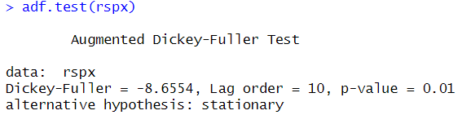
Figure 2.1 Augmented Dickey Fuller (ADF) test in R programming.

On the contrary, with KPSS test (see Fig. 2.2) in turns, the null hypothesis is that the series is stationary. If there is a significant p-value (p-value > 0.1) then the null hypothesis cannot be rejected, and the observation is said to be stationary.

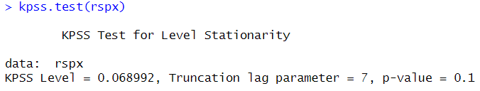
Figure 2.2 Kwiatkowski Phillips Schmidt Shin (KPSS) test in R programming.

In addition to the ADF and KPSS tests, the Phillips-Perron (PP) test is also conducted for stationarity testing in this study with the null hypothesis that the series is nonstationary. If a null hypothesis is rejected (p-value < 0.05) then the series is stationary.
A series is assumed stationary when, at least, any two among the three tests(ADF, KPSS and PP) confirms stationarity. It helps to achieve better robustness in the results since the presence of unit roots is investigated by using various approaches and stationarity of the time series required for further analysis is examined.
In this research, stationarity tests are carried out on the obtained logarithmic returns of both the US stock market data and the cryptocurrency data (see Fig. 2.3). If several results of the series are obtained and are found not stationary, first-order differencing or second transformations are employed to make it meet the stationary test. It is essential to make this assumption because it would enable the selected volatility models to capture time dependency structure from data properly.

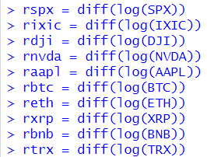
Figure 2.3 Computing Log returns of sample in R programming.

Due to the stationarity testing done in this study, the time series data is made reliable for volatility modelling and comparative analysis on the forecasting models. This step enhances the methodological reliability of the study and affirms its validity and interpretability of the results.
Visualizing Volatility Clustering: Log Returns Plot
Volatility clustering is evident in most financial time series data because periods of high volatility will be succeeded by other periods of high volatility, and similar to low volatility will be succeeded by other periods of low volatility. This pattern suggests that volatility displays temporal dependence and is not an irregular phenomenon. Volatility clustering is the main concept this study focuses on as it determines the evaluation and choice of GARCH-family models.
To detect the presence of volatility clustering, it initially processes the time series data by taking the log of the returns. Log returns plot is a convenient tool to illustrate variations in the price of an asset in a given period. Even though this is the simplest of all the steps mentioned above it is very important because it introduces knowledge about temporal dependencies in the data. It also constitutes an initial diagnostic test as to why one might want to employ models such as GARCH, which incorporate heteroskedasticity into their equation.
Autocorrelation Function (ACF) Analysis
The next step is that the ACF of the squared log returns is calculated on the respective stocks. As a feature extraction approach, the ACF computes how a time series is related to its prior values at various lags. In relation to the volatility, the means of testing for autocorrelations in the squared returns means that we can identify volatility clustering. The importance of ACF analysis lies in its ability to:
- Detect Temporal Dependencies: High and significant autocorrelations at several lag orders provide further support for the persistence of volatility.
- Guide Model Selection: The ACF pattern assists in confirming the applicability of GARCH-family models, which were developed to incorporate such dependencies.
- Assess Model Performance: As its final step, the ACF of the residuals obtained after the use of GARCH or any of its modified forms can be examined to check whether temporal structure has been accounted for.
Statistical Test for ARCH Effects
To determine the presence of volatility clustering and ARCH (Autoregressive Conditional Heteroskedasticity) effects in the financial time series, the ARCH-LM test is employed (See Fig. 2.4). This statistical test checks if the squared residuals of a time series have significant autocorrelation which signifies volatility clustering. It must also be noted that statistical significance was assessed based on the p–value at a significance level of 0.05.
The null hypothesis of the ARCH-LM test therefore asserts that no ARCH effect is present hence the squared residuals are non-auto correlated. When the null hypothesis is rejected evidence of ARCH effects exist which makes the application of volatility models like GARCH appropriate.

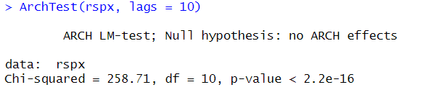
Figure 2.4 ARCH LM-Test in R programming.

Estimation of GARCH Model Parameters
A systematic testing process was performed by using different ARMA (Autoregressive Moving Average), GARCH (Generalized Autoregressive Conditional Heteroskedasticity) orders and different error distributions in order to identify best volatility forecasting model. According to statistical criteria such as Akaike Information Criterion (AIC) and Bayesian Information Criterion (BIC), allows that the most efficient model (that is, the one capturing the volatility patterns of the data) is selected.
The autoregressive (AR) and moving average (MA) part of the mean equation was varied in the orders of ARMA. Consequently, we considered the specific combinations as ARMA(0,0),ARMA (1,0), ARMA(0,1), and ARMA (1,1). The purpose here is to test how far past values and past errors in mean equation contribute to an accounting of a given volatility.
At the same time different GARCH orders were tested to fit the conditional variance dynamics. I tested GARCH models of orders (1,1), (1,2), (2,1), and (2,2). While the first parameter (p) constitutes the lagged conditional variance terms (GARCH effects), and the second parameter (q) denoted the lagged squared error terms (ARCH effects). We run the tests on the different GARCH orders to check the level of persistence and clustering of volatility in the financial time series.
The assumption for the residuals were also examined on this and five error distributions were considered to determine which was closest to ARMA and GARCH specifications. The types of these included the normal distribution ("norm"), Student's t-distribution ("std"), skewed Student's t-distribution ("sstd"), Generalized Error Distribution ("ged"), and skewed Generalized Error Distribution ("sged"). Moreover, financial data very often displays fat tails and skewness, and hence the inclusion of non-normal error distribution is particularly relevant.
The rugarch package in R was used to execute the testing process in an automated loop. A model was specified and fitted to the data for every ARMA order, GARCH order, and error distribution. The parameters of a conditional variance model (GARCH) were then estimated. Error handling mechanisms were incorporated to get around models that didn’t converge or produced unreliable results, to ensure robustness.
After modelling was completed for all models, AIC and BIC were used as key model selection criteria. Both the AIC and the BIC balance model complexity and goodness of fit with model complexity penalizing; the BIC adds an even greater ontology based on the parameter size in relation to the sample size. AIC and BIC values of the models were obtained to rank the models, and the model of minimum AIC was decided to be the most fitted model.
This process produced a detailed table of ARMA order, GARCH order, error distribution, AIC, BIC and log likelihood values for each model. AIC value was used to identify the best model parameters, which were then applied for subsequent volatility analysis and forecasting. As expected from any rigorous model selection process, the model we selected properly captures the statistical properties of the financial data, such as clustering of volatility, persistence, and asymmetric effects that are often found in both traditional stock markets and the cryptocurrency markets.

2.4 Volatility Modelling Framework
The specification of volatility models is particularly important for modelling the dynamic features of the time-series data, the elements of which are log returns of US stock market and cryptocurrencies. This work utilizes six documented forecasting models comprising of GARCH-family members which include GARCH, E-GARCH, T-GARCH, IGARCH, GARCH-M, and EWMA models enabling the comprehensive comparison of volatility characteristics and forecast performance in developed and EMEs.
GARCH (Generalized Autoregressive Conditional Heteroskedasticity)
The GARCH model was proposed Bollerslev (1986) based on ARCH model of Engle (1982) where GARCH refer to generalized autoregressive conditional heteroscedasticity which may be classified among the most popular models in the modelling and forecasting of financial time series with clustered volatility. The standard GARCH(1,1) model is defined as below in Formula (2.2) (Engle, 1982).
$σ_{t}^{2}=α_{0}+α_{1}ϵ_{t-1}^{2}+β_{1}σ_{t-1}^{2}$, (2.2)
where $σ_{t}^{2}$ is Conditional variance at time 𝑡;
$α_{0}$ is constant term (long-run variance);
$ϵ_{t-1}^{2}$ is squared error term from the previous period (ARCH term);
$σ_{t-1}^{2}$ is conditional variance from the previous period (GARCH term);
$α_{1}$ is weight of the ARCH term;
$β_{1}$ is weight of the GARCH term.

The parameters of the GARCH model are specially built to allow it to correctly capture the dynamic properties of financial market risk. The intercept term ($α_{0}$) called long-run variance – estimate of the variance we expect in the absence of recent movements. This lays a background on which the natural variability in the market can be explained from. The ARCH term covering ($α_{1}$) show the effect of recent shocks in terms of squared residuals to the current volatility. This term is quite useful for expressing how a change in new information or market events contributes to a change in volatility. Moreover, the GARCH term which is $β_{1}$, capture the volatility persistence by factoring the past variances into the present volatility. Combined, these terms continuously change the dependent variance in real-time, making the model responsive to shifting market scenarios.
Finally, the sum of the coefficients on the ARCH and GARCH terms ($α_{1+ }β_{1}$) gives information regarding the degree of volatility persistence. When this sum is less than one, volatility is stationary, and the variance is deteriorated over time to reveal mean-reversion. However, when the sum is one, persistence of volatility is high which is also seen in IGARCH models. These features make the GARCH model very flexible to movements of market risk.
The reason for using GARCH is comprised on the fact that it captures important features in financial markets. One of its most significant advantages is the identification of volatility clustering that means that large price movements are followed by other large movements, while small movements are followed with small ones. This is a common occurrence in financial markets, and if used correctly, GARCH will be able to capture all of it. Moreover, GARCH expands the variability conditionality; this means that the variance is capable of changing with time, in contrast to models with fixed variability, which does not give real life situations.
The high degree of flexibility is the next advantage GARCH model also holds. This paper demonstrates that it is ideal for modelling stable low-volatile markets such as S&P 500 and highly volatile markets such as the Cryptocurrency markets. This makes the model flexible in a way that the manipulation and application of different trends is feasible in other financial environments. Furthermore, GARCH models present high forecasting capability of future volatilities. This capability is particularly important for risk management, pricing of derivative securities, and portfolio selection and rebalancing, sectors where knowledge of the characteristics and behaviour of volatility is paramount. These features support the conclusion about the applicability and effectiveness of the GARCH model in the financial studies.
E-GARCH (Exponential GARCH)
The Exponential GARCH (E-GARCH) model is developed by Nelson (1991) with the intention of modelling the asymmetric volatility characteristics of financial markets. One difference between this form of GARCH model and the standard GARCH model is that while they treat positive and negative shocks of equal magnitude as having the same impact this particular model can include asymmetry. This characteristic makes E-GARCH particularly appropriate in markets where negative shocks have even a stronger effect on volatility than positive one, which can be valid for most of the financial data sets and, especially, cryptocurrencies data. Mathematically, the E-GARCH(1,1) model is represented as in Formula (2.3) (Nelson, 1991):
$\log\left(σ_{t}^{2}\right)=ω+β\log\left(σ_{t-1}^{2}\right)+α\frac{ϵ_{t-1}}{σ_{t-1}}+γ\left(\left|\frac{ϵ_{t-1}}{σ_{t-1}}\right|-\sqrt{\frac{2}{π}}\right)$, (2.3)
where $\log\left(σ_{t}^{2}\right)$ is Logarithm of the conditional variance at time 𝑡;
$ω$ is the constant term;
$β$ is the persistence parameter of the past volatility;
$α$ shows the impact of past standardised shocks on current volatility;
$γ$ is the asymmetry parameter that shows the differential impact of shocks;
$ϵ_{t-1}$ is the resuidual or error term from previous time step;
$σ_{t-1}$ is the conditional standard deviation from the previous time step.

Another advantage of the E-GARCH model is that it works directly with the logarithm of variance so that the variance is always greater than zero, though without fixing the parameters of the model non-negative. This makes E-GARCH to be more generalized to capture the nature of the fluctuating financial time series. The E-GARCH model is nobly suited in modelling the cryptocurrency markets since adverse news have a more profound impact on volatilities than favourable news events. This asymmetry is one of contour of markets to understand the risk dynamics of such markets. Also, E-GARCH models can capture fat-tailed distributions, which are in close proximity to those prevailing in traditional stock indices and cryptocurrencies.
Thus, the E-GARCH model, incorporating of which asymmetric responses, can give better understanding of the volatility and give more accurate forecast. It is thus very useful in assessing and planning for risks, and overall strategic management of money in the situation where great risk and unpredictability is the norm in a financial market.
T-GARCH (Threshold GARCH)
The T-GARCH model is developed to capture asymmetry in volatility because positive and negative shocks may not necessarily change the conditional variance in the same manner. The model extends use of an indicator function that separates these shocks. Mathematically, the T-GARCH(1,1) model can be expressed as in Formula (2.4) (Zakoian, 1994):
$σ_{t}^{2}=α_{0}+α_{1}⋅ϵ_{t-1}^{2}+γI_{t-1}ϵ_{t-1}^{2}+β_{1}σ_{t-1}^{2}$ (2.4)
where $σ_{t}^{2}$ is Conditional Variance at time $t$;
$α_{0}$ is Constant term;
$α_{1}$ is impact of positive shocks on volatility;
$γ$ is impact of negative shocks on volatility (asymmetric term);
$I_{t-1}$ is indicator function, which is 1 if $ϵ_{t-1}$ < 0 (negative shock), 0 otherwise;
$β_{1}$ is weight of the previous period's conditional variance.

The T-GARCH model is especially appropriate when applied to the emergent financial markets where leverage effects are observed; negative innovations or, bad news evoke larger volatility jumps as opposed to the positive ones. This makes it appropriate for capturing the asymmetry volatility characterised in most equity and cryptocurrency markets.

IGARCH (Integrated GARCH)
Integrated GARCH or IGARCH is a specific form of the GARCH that ensures the value behaves like a unit root, as the addition of the ARCH and GARCH parameters is one. This feature makes sure that shocks in volatility are persistent in the system. The IGARCH(1,1) model is defined as in Formula (2.5) (Engle & Bollerslev, 1986):
$σ_{t}^{2}=α_{0}+α_{1}ϵ_{t-1}^{2}+\left(1-α_{1}\right)σ_{t-1}^{2}$, (2.5)
where $σ_{t}^{2}$ is Conditional variance at time 𝑡;
$α_{0}$ is constant term (long-run variance);
$ϵ_{t-1}^{2}$ is squared error term from the previous period (ARCH term);
$σ_{t-1}^{2}$ is conditional variance from the previous period (GARCH term);
$α_{1}$ is weight of the ARCH term;
$β_{1}$ is weight of the GARCH term, but the constraint $α_{1}+β_{1}=1$ is applied.

IGARCH has its application in the study of long memory in financial volatility, especially in circumstances where shocks to volatility are long standing, as in periods of crises.
GARCH-M (GARCH-in-Mean)
The GARCH-in-Mean (GARCH-M) model is an enhanced form of GARCH since it takes the conditional variance (𝜎𝑡2σ ) as an additional variable in the conditional mean specification. This makes it possible to capture the association between risk (measured by the volatility) and return. The GARCH-M(1,1) model is expressed as in Formula (2.6) (Engle et al., 1987):
$r_{t}=μ+λσ_{t}^{2}+ϵ_{t}$,
$σ_{t}^{2}=α_{0}+α_{1}ϵ_{t-1}^{2}+β_{1}σ_{t-1}^{2}$, (2.6)
where $r_{t}$ is asset return at time;
$μ$ is the constant term;
$λ$ is the risk-return parameter;
$σ_{t}^{2}$ is Conditional variance at time 𝑡;
$α_{0}$ is constant term (long-run variance);
$ϵ_{t-1}^{2}$ is squared error term from the previous period (ARCH term);
$σ_{t-1}^{2}$ is conditional variance from the previous period (GARCH term);
$α_{1}$ is weight of the ARCH term;
$β_{1}$ is weight of the GARCH term.

GARCH-M is most useful for testing if increased variability is related to increased returns of financial assets. This model is useful in understanding risk-return processes in the stock and the cryptocurrency markets.
EWMA (Exponentially Weighted Moving Average)
One of the simplest model of volatility forecasting is the Exponentially Weighted Moving Average (EWMA). This work assigns exponentially decreasing weight to older observation, hence greater importance is given to recent observations. The formula (2.7) for EWMA is mentioned below (RiskMetrics Group, 1996):
$σ_{t}^{2}=\left(1-λ\right)ϵ_{t}^{2}+λσ_{t-1}^{2}$, (2.7)
where $λ$ is the smoothing parameter;
$σ_{t}^{2}$ is the conditional variance at time $t$;
$ϵ_{t}^{2}$ is the error term at time $t$.

Even more, the EWMA model is especially useful when applying the analysis on high- frequency financial data since it offers a fast method for estimating the volatility while having comparatively low needs when it comes to parameter estimation. This makes it easy to use as a first-round volatility analysis in volatile markets such as cryptocurrencies.

2.5 Tools and Techniques
Two primary software tools R Programming and Microsoft Excel were used for conducting analysis and achieving the research objectives. That first step to preprocess raw data, aggregate values and calculate daily price average across some of the selected assets were done on Microsoft Excel platform, including stock indices (S&P 500, NASDAQ, DJI) and cryptocurrencies (Bitcoin, Ethereum, Ripple, Binance Coin, Tron). Data manipulation, computation, and visual validation of aggregated data was done efficiently in Excel's intuitive interface.
R Programming was used as the core software for advanced statistical modelling and time series analysis, after this. Financial modelling and econometric analysis lend themselves very well to R, not only does it have an extremely broad library ecosystem, but there is also quite a lot of flexibility in terms of scripting available in the language. The analytical tasks carried on in R included stationarity testing, volatility clustering detection, ARCH effects testing as well as fitting and forecasting from GARCH family models.
In model testing, R’s programmability to automate complex computations and run iterative processes (multiple ARMA-GARCH combinations) meant robustness and reproducibility. Additionally, by integrating specialized packages in R, the execution of statistical tests, error distribution assumptions, and volatility forecasting models’ performance evaluation were precisely carried out.
Libraries and Packages
The following libraries and packages in R were employed to facilitate various steps in the analysis:
- readxl: In the R environment, Excel files containing the pre-processed time series data for stock indices and cryptocurrencies were imported using this package. This allowed flowing data through pipelines easily, and even allowed seamless integration with further analytical workflows.
- tseries: An essential instrument in detecting whether the financial data series possesses unit root behaviour is the Augmented Dickey-Fuller (ADF) test, which is offered by the tseries package.
- rugarch: The rugarch package is a recommended tool for specifying, estimating and simulating GARCH-family models. The model supports advanced volatility models like GARCH, E-GARCH, T-GARCH, I-GARCH and GARCH-M and different error distributional assumptions (e.g., normal, Student t, skewed Student t). This allowed for the systematic testing of several ARMA GARCH combinations to establish the best combination model using AIC (Akaike Information Criterion) and BIC (Bayesian Information Criterion).
- FinTS: The ARCH-LM test is a diagnostic tool to test for the presence of heteroskedasticity (ARCH effects) of a financial time series using the FinTS package. Indeed, ARCH effects have to be confirmed to justify the use of GARCH type models for forecasting volatility (Engle, 1982).
- e1071: In particular, the e1071 package was used to compute higher moments of financial time series, e.g. skewness and kurtosis to identify fat tailed distributions. Financial data often exhibits fat tails; therefore, alternative error distributions (Student’s t distribution) is more appropriate to be used than normal distributions.
- dplyr: Efficient data wrangling and transformations, e.g., daily log returns for stock indices and cryptocurrencies were made possible through the dplyr package.
These libraries were integrated to create an integration of these libraries to form a methodical, replicable analysis pipeline that had statistical rigour and computational efficiency.
Visualization
Data visualization was used to identify volatility patterns, diagnose statistical properties, and interpret results from the fitted models. Meaningful graphical representations for the processed data and model outputs were generated by employing the visualization functions of R programming.
- Time Series Plots: Daily log returns of stock indices and cryptocurrencies were observed and generated time series plots. Through these plots, volatility clustering was shown—whereas large variations are accompanied by other large variations, a trait which motivates the use of GARCH family models.
- Autocorrelation Function (ACF) plot: The Autocorrelation Function (ACF) plots were very useful in showing the behaviour of financial time series data. Log returns were characterized by no significant autocorrelation in either the log returns or the squared log returns which indicated the volatility clustering was present. The observations all corroborated the fact that such advanced volatility models as GARCH and its extensions (E-GARCH, T-GARCH, IGARCH) are needed in order to be able to capture adequately and to forecast time varying volatility in stock and cryptocurrency markets.
- Model Performance Visualization: After we fitted the GARCH family models, we finally plot the forecasted volatility series to see the volatility trends in the future. They plotted the model’s ability to respond to changes in market conditions and highlight periods of high and low volatility.
In R Programming and its libraries, a comprehensive and reproducible volatility analysis was possible. Iterative model testing, combined with advanced tooling and robust visualization, ensured that the study achieved the core objectives of identifying volatility patterns, evaluating model performance and future volatility in traditional stocks and cryptocurrency markets, respectively.
A structured and empirical approach to volatility modelling is presented through an implementation of stationarity testing, ARCH effect diagnosis, model specification and validation in a step-by-step format. The methodology followed conforms to conventional procedures in financial econometrics, assuring reliability and rigour of the analysis and transparency of the analytical process.

2.6 Model Performance Metrics
Volatility forecasting models are evaluated to see whether they’re robust, reliable and able to generalize to unseen data. A set of quantitative metrics was then used to systematically evaluate the performance of the selected GARCH family and EWMA models. Some of these metrics included, Akaike Information Criterion (AIC), Bayesian Information Criterion (BIC), Mean Squared Error (MSE) and Mean Absolute Error (MAE). Furthermore, in sample and out of sample validation techniques were applied to forecast the models. In this section, evaluation metric and comparison framework are detailed on both US traditional stock markets and cryptocurrency markets.
Akaike Information Criterion (AIC)
The Akaike Information Criterion (AIC) is a relatively popular way of model selection, but especially in time series forecasting. It would allow to choose among model fits complexity (to penalize unnecessary parameters), so it’s used in order to evaluate the trade-off between model fit and complexity. A more optimal balance between goodness of fit and model simplicity) is achieved by a lower AIC (Akaike, 1974)
The AIC for a model is calculated as in formula (2.8) (Akaike, 1974):
$AIC=-2∙loglikelihood+2∙k$, (2.8)
where $loglikelihood$ represents the likelihood of the model given the data;
$k$ is the number of parameters in the model.

The AIC has been shown to be particularly valuable in choosing the best ARMA order and GARCH order from several competing models. An additional penalty is included for model complexity, but this helps to avoid overfitting. On that basis, for this research the AIC was used to compare the various models and determine which model was the best performing for each time series.
Bayesian Information Criterion (BIC)
As with the AIC, the Bayesian Information Criterion (BIC) is an alternative model selection criterion, that balances the trade-off between model fit and complexity. However, the BIC exhibits a huge penalty for extra parameters, resulting in a method which is quite effective at preventing overfitting.
The BIC is calculated as in Formula (2.9) (Schwarz, 1978):
$BIC=-2∙loglikelihood+k∙\log\left(n\right),$ (2.9)
where $loglikelihood$ is the model’s likelihood function;
$k$ is the number of parameters in the model;
$n$ is the number of observations.

As sample size increases, the penalty term in the BIC as well as the AIC increases, but with the BIC the emphasis is more toward simpler models than with the AIC. This provides a criterion, specifically suitable for large datasets when we are interested in model generalizability. The BIC gave us one more layer of evaluation for helping to decide the robustness of the selected models for this thesis.
Both AIC and BIC were used to evaluate model performance, with results showing that the penalty for complexity in the two diagnostics results in slightly different rankings of models. Moreover, to balance between these two metrics was made by the final selection.
Mean Squared Error (MSE)
Mean Squared Error (MSE) is the widely used performance metric to assess the accuracy of forecasts of volatility. It calculates the average squared difference of the observed actual of volatility vs forecasted volatility.
The equation for calculating MSE is mentioned below as in Formula (2.10) (Willmott & Matsuura, 2005):
$MSE=\frac{1}{n}\sum_{t-1}^{n}{{\left(y_{t}-{\hat{y}}_{t}\right)}^{2}}$ , (2.10)
where $y_{t}$ is the observed value at time $t$;
${\hat{y}}_{t}$ is the forecasted value at time $t$;
$n$ is the total number of observations.

While squaring residuals make MSE sensitive to outliers, MSE penalizes large errors more than small errors. The specificity is also very important because accuracy in predicting volatility is important. MSE was applied in this thesis to determine how each (GARCH-family) model or EWMA carried out the task of following the actual volatility (observed in the financial time series data).
Mean Absolute Error (MAE)
A Mean Absolute Error (MAE) is another error metric used to find the average of absolute differences between observed and forecasted volatility. The equation to calculate MAE is given below in Formula (2.11) (Willmott & Matsuura, 2005):
$MAE=\frac{1}{n}\sum_{t-1}^{n}{\left|y_{t}-{\hat{y}}_{t}\right|}$ (2.11)
where $y_{t}$ is the observed value at time $t$;
${\hat{y}}_{t}$ is the forecasted value at time $t$;
$n$ is the total number of observations.

As a result, MSE is less sensitive to outliers than MAE because it squares the residuals. Most important, it yields a clear, interpretable measure of the average forecast error. This resulted in a more comprehensive evaluation of model performance which combines both MSE and MAE. By performing a dual analysis of errors, models were evaluated for the overall error magnitude and for sensitivity to extreme deviations.
Conservatism in Volatility Forecasting: Analysis of Underestimation Instances
The conservatism of volatility forecasting models is assessed by analysing the number of underestimations in their predictions. Specifically, the number of instances where the forecasted volatility was lower than the actual volatility is recorded for each model—GARCH and EWMA—across the different tickers. This is an important metric when deciding whether the model has a tendency to understate volatility, which is a feature of conservative models. This approach aims at counting these underestimations in an attempt of determining which model is more likely to present underestimated volatility forecasts because of the cautious nature of the methodology.
It is most appropriate when dealing with comparisons of high frequency movements where the failure to estimate volatility may reveal the model’s conservative behavioural tendencies which may be important in preventing over reaction to market dynamics. Thus, the focus on the underestimation cases clarifies how GARCH and EWMA perform in different market environments, which contributes to the identification of their conservatism in the forecast.
Mean and Standard Deviation of Forecast Error
The Mean Forecast Error (MFE) and Standard Deviation of Forecast Error (SDFE) are used to further analyse the conservatism of volatility forecasting models. The mean forecast error measures the average difference between the forecasted and actual volatility. A small mean error is an indication that the model is conservative of the volatility or is located closer to the actual volatility.
The standard deviation of forecast error determines the level of variation of the model in its forecasts. Therefore, a high value of standard deviation means increased variations and less reliability with the forecasts while a low value of the standard deviation denotes increased reliability with the forecasts. The mean forecast error and standard deviation of forecast error is calculated as in figure 2.5.

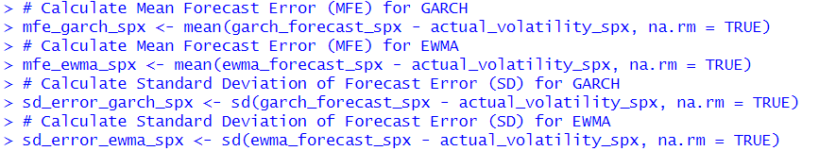
Figure 2.5 Calculating MFE and SDFE in R programming.

This analysis is crucial in establishing whether a model responds competitively to market changes or if the prediction is steady and unruptured. The mean error and standard deviation of forecast error are calculated for both GARCH and EWMA models across different tickers to assess their forecasting conservatism. In the context of the thesis, this methodology helps understand how each model handles volatility forecasting under various market conditions and how their forecasting stability can be aligned with the goals of accurate and conservative predictions.

2.7 Model Validation Techniques
Validation is a critical component of the accomplishment of tried and tested methods that sustains accurateness of the prediction models. It entails determining the performance of the model when dealing with data that has not been trained and testing its adaptability. In turn, the comparative analysis of different GARCH-family models and EWMA is carried out using in-sample and out-of-sample validation techniques in both US stock markets and cryptocurrency markets. These techniques guarantee that only qualified models are chosen, and these models can in fact be employed in real financial decision making.
In-Sample Validation
In sample validation involves evaluating the model base on the data that was used in the training of the model. The primary target is to assess the degree, to which the model describes the patterns and inter-relations reflected in the data. For example, for log of returns for the S&P 500 first, a GARCH (1,1) model is fitted, and the parameters are re-estimated to minimize the AIC and BIC. Given these considerations, the model’s performance in fitting, reproducing the observed data and addressing the issue of volatility clustering directly reflects its in-sample performance.
This step is useful for the model to describe past data volatility in patterns, factors like mean reverting and volatility clustering are measured accurately. Nevertheless, great sensitivity to variation within a dataset is good but not enough to ensure that the model will perform well with new numbers being fed into the model.
Out-of-Sample Validation
Using out of sample data helps to analyse the model predictive capacity since the data applied to testing was not used in the model calibration process. Information is generated in a manner that replicates future market data therefore future results from this model can be easily tested by researchers as the model is tested with data it has never encountered before. In the current study, around fifteen observations time series data is set aside as out-of-sample data to test the model in as real-world manner as possible.
For instance, when working with GARCH model to achieve the database, the model is tested by its ability to predict the volatility of the fifteen observations in out-of-sample. The Mean Squared Error (MSE), and the Mean Absolute Error (MAE) are utilized to evaluate the prediction of volatility and real observed values. The high level of accuracy presented in out-of-sample testing shows that the model’s ability to predict other samples is good; thereby making it a worthwhile tool in risk management and portfolio construction.
In-sample validation still protects against the risk of overfitting, and variance reduction is assured by out-of-sample validation. In sample-evaluation ensures that the model is correctly specified and consistent with the theoretical works while the out of sample-evaluation reveals ability of the model under changing market environment. This is apparent where one needs to compare the performance of different models across normal stock markets and the cryptocurrencies’ complicated and unpredictable markets.
Cryptocurrencies are volatile themselves as they exhibit large and sharp price swings – the features which make forecasting volatility a challenging task. These complexities are resolved to understand whether the traditional models, including GARCH and its versions, can address these issues or not by using out-of-sample validation techniques. With a view of achieving these objectives, this study proposes to adopt these validation techniques systematically so as to offer sound evidence on the efficiency of volatility forecasting models which can in turn be of great help to financial practitioners in the selection of appropriate forecasting models.
Besides, other quantitative measures consist of AIC, BIC, MSE, and MAE are incorporated into the calibration procedure. The idea of such ratings is to have an accurate reference point to evaluate the models and define which approaches are to be considered the most trustworthy for each market. For instance, only models with small AIC and BIC values in the in-sample validation are tested again for out-of-sample predictive accuracy, to avoid being overly greedy when choosing a model.
This paper not only validates the methods for forecasting by use of in-sample and out-of-sample validation techniques, but further makes practical the methods in different financial settings. Such methodological approach is crucial for making generalizable conclusions and providing relevant research to the existing literature on volatility forecasting in traditional and emerging markets.

2.8 Limitations of the Methodology
The method used in this study although credible and systematic comes with some methodological limitations. These limitations need to be acknowledged in order to better situate the study consequences and realistic practical applications of the outcomes.
The two are the primary concerns of this study; one of which is the issue of data availability and reliability especially for cryptocurrencies. While stock market data is well documented and normalized comparable to cryptocurrency data that can be gotten from different sources may not easily agree. For instance, problems with data formatting include variation in price trends or data sequence, absence of data, and problem related to time zones and/or time formats. Also, the amount of time series is not very deep because cryptocurrencies have a very short history in contrast to popular stock shares such as S&P 500, Dow Jones etc. These limitations could cause volatility modelling to be imprecise, including in respect to long-term trends.
Also, the GARCH-family models employed in this research make use of several assumptions, which may not always be consistent with the actual market behaviour, as in the case of:
- Stationarity: These models also have the assumption that the fundamental data is stationary, where changes such as log returns or differencing are applied. But in many financial markets, there are structural changes or regime switches or trends that break this assumption.
- Symmetry and Error Distributions: It is widely known that many of the standard GARCH models impose the assumption of symmetry of volatility to shocks, though this condition cannot effectively model the asymmetrical behaviour in return volatilities to shocks. Although models like E-GARCH do this in part, an additional bias is introduced by the choice of error distribution (normal, Student’s t etc.) because real world returns often have heavy tails and are skewed.
- Parameter Sensitivity: Sensitivity of the results was observed when using these models and this depended on the parameter estimations of the models together with the order of the ARMA and GARCH models to be used. Small variation in any of these specifications may enhance the variations in the respective results, hence lowering the robustness.

However, due to the above limitations, the proposed methodology can be useful for developing an adaptive threshold for predicting market volatility, not only in traditional but also in cryptocurrency markets. These limitations suggest that there are externalities and acknowledging these constrain helps strike a good balance during the interpretation of the findings and identify some of the future research directions. By acknowledging these issues in a transparent manner, this research advances the much-needed scholarship in understanding the nature and patterns of volatility and offers insights into practical application of financial volatility risk analysis and management.

3 Empirical Part of the Research
To compare the performance of the models and to test the proposed hypotheses, this empirical analysis investigates categories of traditional US stock indices (S&P 500, NASDAQ, DJI) and stocks (NVDA and AAPL) with cryptocurrencies (Bitcoin, Ethereum, Ripple, Binance and Tron). Thus, the objectives are to compare the volatility characteristics of the markets, to evaluate GARCH-family and EWMA for the forecasting, and to check whether cryptocurrency markets have higher volatility and different forecasting pattern. This section divides the layout of the segment to comprise the descriptive statistics to testing and detecting stationarity, volatility clustering and then model specification, assessment and forecasting. The research findings will offer a better understanding of the specific characteristics of these markets to possibly assess forecasting volatility models then improving risk management across the different financial domains.

3.1 Descriptive Statistics
In the descriptive statistics section, the statistical properties of the log returns of US stock indices and cryptocurrency markets is analysed. A summary of the descriptive statistics of log returns for the selected US stock indices (SPX, IXIC, DJI), individual stocks (NVDA, AAPL) and major cryptocurrencies (BTC ETH, XRP, BNB, TRX) are mentioned in Table 3.1 below, which includes mean, distribution asymmetry (skewness) and fat tails (kurtosis) as well as the volatility (standard deviation).
Table 3.1
Descriptive Statistics of Log Returns (Stocks and Cryptocurrencies) (Created by author)
TICKER | MEAN | STANDARD DEVIATION | SKEWNESS | KURTOSIS
SPX | 0.0003828 | 0.0106578 | -0.841818 | 10.593037
IXIC | 0.0005047 | 0.0131736 | -0.5166071 | 6.90256
DJI | 0.0002689 | 0.0104563 | -1.0890269 | 18.622167
NVDA | 0.0021047 | 0.0273257 | 0.5160807 | 9.432024
AAPL | 0.0009475 | 0.0169673 | -0.15907 | 6.80515
BTC | 0.0012122 | 0.0257778 | -0.9909103 | 12.222205
ETH | 0.0019626 | 0.0328973 | -0.9182669 | 10.164855
XRP | 0.0007957 | 0.0419694 | 0.4937158 | 16.666777
BNB | 0.0021466 | 0.0358261 | 0.5207505 | 23.087715
TRX | 0.0014302 | 0.0337351 | -0.4490653 | 12.002935

Mean-Returns Analysis
All assets exhibited mean of log returns that are positive (see Fig. 3.1), indicating that the observed period was characterized by small upward trends. The highest mean of return among stock indices is NASDAQ Composite (IXIC), at 0.0005047 and the second highest mean of return is S&P 500 (SPX) at 0.0003828. Such a strong performance cannot be ignored, and its emphasis is on technology heavy indices such as the NASDAQ. Dow Jones Industrial Average (DJI) also shows a smaller mean return of 0.0002689, implying the index is calmly performing compared to growth focused indices.

Figure 3.1 Mean of Log Returns of the sample data (Created by author).

NVIDIA (NVDA) is unique in individual stocks with NVDA as the mean of return of 0.0021047 over the observed period can be attributed to its significant growth. In comparison, other more mature company, Apple (AAPL) has a mean return of 0.0009475.
Binance Coin (BNB) particularly as well as Ethereum (ETH) especially, show remarkably greater mean of 0.0021466 and 0.0019626, respectively. Other cryptocurrencies were also positive, at 0.0012122, although Bitcoin showed less growth than the others. Moderate results are seen in TRX (0.0014302) and XRP (0.0007957), and this is consistent with what we have noticed before in that cryptocurrencies exhibit more variance in returns.
Volatility Analysis
The standard deviation (volatility) shows that there are many differences between traditional financial markets and cryptocurrency markets (See Fig. 3.2). SPX (0.0106578), IXIC (0.0131736) and DJI (0.0104563) are low in volatility stock indices which suggest that the traditional markets are stable. This finding is consistent with the behaviour for known financial indices that track broader economic trends.

Figure 3.2 Standard Deviation of Log Returns of the sample data (Created by author).

However, we find that NVDA exhibits a much higher standard deviation (0.0273257), representing the higher price fluctuations as seen in growth stocks. For one, AAPL is less volatile than 0.0169673, as AAPL is a large cap technology company and should be less volatile.
Cryptocurrencies are much more volatile than traditional assets. For example, if we take standard deviation from above, we can see how the BNB is having higher standard deviation of 0.0358261 followed by TRX 0.0337351, and last but not the least XRP with 0.0419694. Just as Bitcoin (BTC) and Ethereum (ETH) which are both viewed as an established cryptocurrency record some deviances of 0.0257778 and 0.0328973, respectively. This heightened volatility indicates the very dangerous nature of cryptocurrency markets that experience sudden changes in prices time and again caused by the changing sentiment in the market, development in the technology and regulatory changes.
Skewness Analysis
Skewness studies the degree of asymmetry in the distributions of returns and the negative skewness of returns it depicts how prone it is to generate steep negative returns (see Fig. 3.3). Stock indices skewness values for SPX (-0.841818), IXIC (-0.5166071), DJI (-1.0890269) are primarily negative. These values imply that although returns are stable, the probability of sharp downward moves is heightened with economic downturns or market shocks.

Figure 3.3 Skewness of Log Returns of the sample data (Created by author).

NVDA has positive skewness for individual stocks at (0.5160807), which means that although large occurrences of large positive returns are common, they are never quite as large as what was observed for the indices. On the contrary, AAPL has a slight negative skewness of -0.15907, which means that the amplitude distribution is nearly symmetrical.
The skewness of cryptocurrencies is mixed. Bitcoin (BTC) (-0.9909103) and Ethereum (ETH) (-0.9182669) clearly show considerable negative skewness indicating that both coins have high levels of volatility with sharp downward potential. But BNB is still positive skewness at 0.5207505 indicating that more upward movements have happened against other cryptocurrencies. In both cases (TRX and XRP) the skewness values have crossed the zero point at 0.4490653 for TRX and 0.4937158 for XRP making them exhibit near zero skewness value which shows that both the distribution is closely balanced and less extreme outlier.
Kurtosis Analysis
The Kurtosis values show how "tailed" the return distributions are, the larger, the more likely of fat tails and extreme price movements (see Fig. 3.4). Kurtosis values of stock indices are very high and especially high for DJI (18.622167) and SPX (10.593037) which show high occurrence of extreme returns. This is consistent with historical periods of economic volatility, during which periods of sharp upward or downward movement tend to be more frequent. One way we can indicate how diversified index funds with respect to individual stocks is to observe kurtosis of individual stocks with respect to indices; NVDA has kurtosis of 9.432024, indicating moderate kurtosis, while AAPL has 6.80515 indicating lower kurtosis which means fewer extreme returns.

Figure 3.4 Kurtosis of Log Returns of the sample data (Created by author).

Cryptocurrencies do show much higher kurtosis, making them easy targets for extreme price behaviour. XRP (16.666777), TRX (12.002935) and BNB (23.087715) have the highest kurtosis values. Even Bitcoin and Ethereum (which are themselves considered relatively mature) have kurtosis values of 12.222205 and 10.164855, respectively. This validation of heavy tailed nature in cryptocurrency returns distributions, indeed, confirms the need for managing the uncertainty surrounding their prediction of extreme events, especially in these markets.
In the analysis, distinctions between the normal financial markets and the cryptocurrency markets become vivid. Cryptocurrencies, especially BNB and ETH, have greater average returns than stock market indexes yet are excited compared to diversified portfolios. For that reason, stocks such as NVIDIA Corporation (NVDA) perform better than more conventional indices because of investor focus on growth, although they are far less stable and have smaller returns than large capital stocks, such as Apple Inc (AAPL).
The cryptocurrencies are observed to have much higher volatility than the stock indices and large-cap stocks, as the standard deviations suggest. Skewness indicates that there are steep falls in most of the assets; it is negative for stocks, cryptocurrencies, whereas BNB and NVDA occasionally register some rise occasionally. The analysis further shows that cryptocurrencies have a high Kurtosis of mean returns; this figure suggests that there are many extreme returns confirming the speculation of fat-tailed distribution.
In general, the evidence produced emphasizes the greater volatility, non-symmetric, and fat-tailed return distribution of cryptocurrencies compared to conventional stocks. The fact that cryptocurrencies have such a unique risk-return characteristic indicates the importance of accurate volatility forecasting techniques, including models from the GARCH family.

3.2 Stationarity testing
The empirical results confirm the importance of stationarity for reliable time-series modelling in volatility forecasting. Initially, the Augmented Dickey-Fuller (ADF) test and Kwiatkowski-Phillips-Schmidt-Shin (KPSS) test were conducted on the original price series of both stock indices and cryptocurrencies. The ADF test results (presented in table 3.2) reveal that all series—including SPX, IXIC, DJI (stock indices), NVDA, AAPL (individual stocks), and BTC, ETH, XRP, BNB, TRX (cryptocurrencies)—exhibited non-stationarity. The null hypothesis of non-stationarity in the ADF test could not be rejected, because the p-values for all the assets checked exceeded the 0.05 threshold. This suggests that the raw price series contained trends and did not meet the stationarity requirement necessary for GARCH-family models.
Table 3.2
Results of Augmented Dickey-Fuller (ADF) test of sample data (Created by author)
Ticker | P-Value (<0.05 for Stationary) | Interpretation
SPX | 0.5914 | Non-Stationary
IXIC | 0.6967 | Non-Stationary
DJI | 0.4168 | Non-Stationary
NVDA | 0.8638 | Non-Stationary
AAPL | 0.3611 | Non-Stationary
BTC | 0.6898 | Non-Stationary
ETH | 0.7007 | Non-Stationary
XRP | 0.3856 | Non-Stationary
BNB | 0.5889 | Non-Stationary
TRX | 0.2315 | Non-Stationary

To address non-stationarity, the logarithmic returns of each series were first computed, and then the first-order difference of the log returns was applied, and this is denoted as R followed by the ticker name (e.g., RSPX for the logarithmic returns of SPX). This transformation has effectively removed the trends in it and made the series mean-reverting. The differenced log returns were then re-tested for stationarity using the Augmented Dickey-Fuller (ADF), Kwiatkowski Phillips Schmidt Shin (KPSS) and Phillips-Perron (PP) tests.
As illustrated in table 3.3, all series reached stationarity after the transformation. ADF results produced p-value of less than 0.05 in all the assets hence rejecting the null hypothesis of non-stationary. At the same time, the KPSS test revealed that there is stationarity in most variables which was supported by the p-value greater than 0.1. However, some differences in p-values were identified regarding particular cryptocurrencies like ETH and BNB but identified ranged within acceptable margins.
Table 3.3
Results of ADF, KPSS and PP tests of logarithmic returns of each series (Created by author)
Ticker | Augmented Dickey-Fuller (ADF) test |  | Kwiatkowski Phillips Schmidt Shin (KPSS) test |  | Phillips-Perron (PP) test
 | P-Value (<0.05 for Stationary) | Interpretation | P-Value (>0.1 for Stationary) | Interpretation | P-Value (<0.05 for Stationary) | Interpretation
RSPX | 0.01 | Stationary | 0.1 | Stationary | 0.01 | Stationary
RIXIC | 0.01 | Stationary | 0.1 | Stationary | 0.01 | Stationary
RDJI | 0.01 | Stationary | 0.1 | Stationary | 0.01 | Stationary
RNVDA | 0.01 | Stationary | 0.1 | Stationary | 0.01 | Stationary
RAAPL | 0.01 | Stationary | 0.1 | Stationary | 0.01 | Stationary
RBTC | 0.01 | Stationary | 0.1 | Stationary | 0.01 | Stationary
RETH | 0.01 | Stationary | 0.06659 | Non-Stationary | 0.01 | Stationary
RXRP | 0.01 | Stationary | 0.1 | Stationary | 0.01 | Stationary
RBNB | 0.01 | Stationary | 0.07456 | Non-Stationary | 0.01 | Stationary
RTRX | 0.01 | Stationary | 0.1 | Stationary | 0.01 | Stationary

Since two of the three tests confirm stationarity, the sample data is now confirmed as stationary. The results of stationarity testing are a crucial step in the empirical analysis, as stationarity is a fundamental prerequisite for GARCH-family models. These results ensure that the data is now appropriate for subsequent analysis of volatility clustering, model specification, and forecasting.
Hence the first-order differenced logarithmic returns of each series will be used for further calculations in the empirical analysis of this thesis, and for simplicity, the ticker names will be used (e.g., SPX will refer to the first-order differenced logarithmic returns of SPX, and so on) in subsequent empirical analysis.

3.3 Volatility Clustering and ARCH Effects

3.3.1 Visual Evidence of Volatility Clustering
For the stock indices, cryptocurrencies, and technology stocks, the visual inspection of their first-order differenced log returns and square log returns shows clear indication of volatility clustering, as is a defining statistical feature of financial time series.

Traditional Stock Indices (SPX, IXIC, DJI)
The plot of the logarithmic returns for SPX, IXIC and DJI shows that there are always long periods of low fluctuations with occasional high fluctuations during market shocks or major economic occurrences. For instance, in the SPX series (see Fig. 3.5) we observe a sharp rise in the variability in the initial observations which indicate an extreme market event.

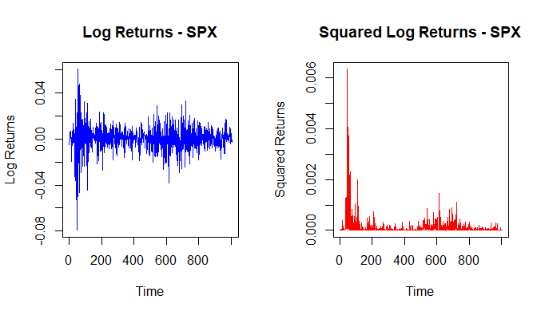
Figure 3.5 Log returns and squared log returns of S&P 500 (SPX) (Created by author).

The squared log return plots also accentuate this feature and depict sharper oscillations that are related to turbulence. These outcomes provide evidence for the presence of volatility clustering in classic stock markets and testify that its frequency and intensity are lower in cryptocurrencies.
Technology Stocks (NVDA and AAPL):
NVDA being a growth-driven stock is showing periods of extreme upward and downward movements in log returns, particularly during innovation-driven events (see Fig. 3.6). The squared log returns confirm volatility clustering, although less intense compared to other US stock market samples and cryptocurrencies.

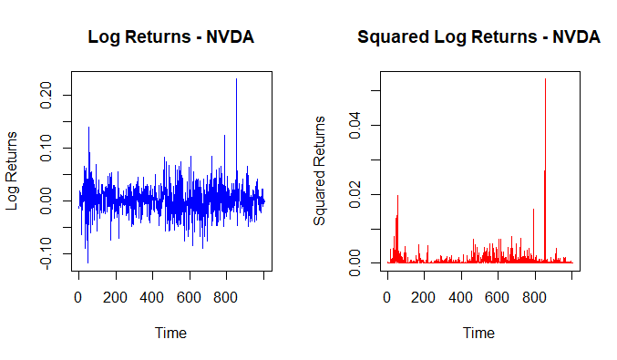
Figure 3.6 Log returns and squared log returns of Nvidia Corp (NVDA) (Created by author).
AAPL shows comparatively more and but stable volatility clustering patterns. It is evident that the stock is also consistent with its large-cap and stable market characteristics. The squared returns plot confirms that volatility episodes are less frequent and relatively subdued. The stock indices SPX, IXIX and DJI are showing similar patterns of clustering.
Cryptocurrencies (BTC, ETH, XRP, BNB, TRX):
Both BTC and ETH display persistent and pronounced volatility clustering with long periods of large fluctuations. Other aspects of cryptocurrency markets — such as their speculative nature and sensitivity — are also on display here. However, as seen with BTC in particular, volatility is extremely spikey, demonstrating the Bitcoin's great susceptibility to market shocks (see Fig. 3.7).

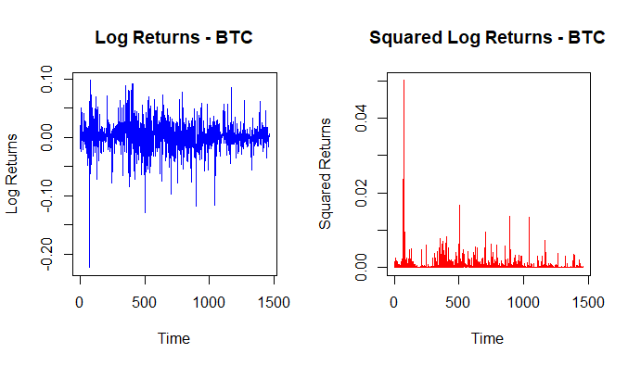
Figure 3.7 Log returns and squared log returns of Bitcoin (BTC) (Created by author).

Similar patterns are seen for BNB, TRX and XRP, with varying spike magnitudes. TRX and XRP tend to exhibit smaller, but frequent spikes characterized with greater volatility persistence as opposed to traditional markets, while BNB has shown very volatile episodes.
Plots of log returns and squared log returns of the remaining sample has been attached in Appendix 2. The plots can be summarised based on thresholds of log returns and squared log returns can be defined as in table 3.4.

Table 3.4
Thresholds Based on Plot Analysis for log returns and squared log returns (Created by author)
Volatility Clustering | Log Returns Plot | Squared Log Returns Plot
Low | Random fluctuations, no clustering. | No sustained large returns.
Moderate | Some large spikes followed by others. | Clusters of large returns but interrupted.
High | Persistent large movements. | Persistent clusters of large returns.
Very High | Consistently large movements. | Long periods of high volatility.

A concise table summarizing the Visual Evidence of Volatility Clustering across different financial assets, based on the thresholds of the provided plots and observations is mentioned below (See Tab. 3.5).
Table 3.5
Summary of Visual Evidence of Volatility Clustering (Created by author)
Ticker | Log Returns Characteristics | Squared Log Returns Characteristics | Volatility Clustering Intensity
SPX | Stable returns with occasional volatility spikes | Pronounced peaks in early periods | Moderate
IXIC | Moderate fluctuations with sudden volatility | Noticeable peaks during downturns | Moderate
DJI | High initial fluctuations, stabilizing over time | Clusters of spikes in the early period | Moderate
NVDA | Relatively stable with occasional volatility | Smaller and fewer spikes | Low
AAPL | Significant volatility during specific periods | Large peaks, indicating extreme movements | High
BTC | Persistent, frequent large fluctuations | Extreme peaks, highly volatile | Very High
ETH | Substantial, frequent volatility clustering | Pronounced peaks across time | Very High
XRP | Frequent large fluctuations in early periods | Spikes in volatility, though smaller | High
BNB | Extreme fluctuations, particularly mid-series | Large, persistent peaks in volatility | Very High
TRX | Moderate and frequent fluctuations | Significant peaks in volatility | High

Cryptocurrencies exhibit the most significant and persistent volatility clustering across all analysed assets. BTC, ETH, and BNB show frequent and extreme spikes in volatility, which shows their speculative and nature of high risk. Traditional Stock Indices (SPX, IXIC, DJI) display clear volatility clustering, but less extreme when compared to cryptocurrencies. Technology Stocks (NVDA, AAPL) show heterogeneity in volatility clustering. NVDA seems to exhibit significant clustering due to its nature of growth-driven price movements. But AAPL displays more stability and lower volatility clustering when compared.

3.3.2 Statistical Evidence of ARCH Effects
The ARCH-LM test was applied to all log return series to statistically validate the presence of volatility clustering. The results are summarized below (see Tab. 3.6).
Table 3.6
Summary of ARCH-LM test results (Created by author)
Ticker | Chi-Squared Statistic | Degrees of Freedom (df) | p-value | ARCH Effects
SPX | 258.75 | 10 | < 2.2e-16 | Present (p < 0.05)
IXIC | 184 | 10 | < 2.2e-16 | Present (p < 0.05)
DJI | 272.15 | 10 | < 2.2e-16 | Present (p < 0.05)
NVDA | 15.574 | 10 | 0.1125 | Absent (p > 0.05)
AAPL | 201.12 | 10 | < 2.2e-16 | Present (p < 0.05)
BTC | 414.99 | 10 | < 2.2e-16 | Present (p < 0.05)
ETH | 355.05 | 10 | < 2.2e-16 | Present (p < 0.05)
XRP | 154.84 | 10 | < 2.2e-16 | Present (p < 0.05)
BNB | 304.41 | 10 | < 2.2e-16 | Present (p < 0.05)
TRX | 216.39 | 10 | < 2.2e-16 | Present (p < 0.05)

P values for all three variables; SPX, IXIC and DJI are less than 0.05 so there is presence of ARCH effects. This also shows us that there is a great variance in these indices that is not evenly spread out across time but rather is present in spikes at certain times. Comparing all three indices, it has been established that the DJI index exhibits even higher Chi-squared statistic than SPX and IXIC and therefore will be characterized by even higher ARCH effects.
Substantial evidence of ARCH effects is found for AAPL (p < 0.05) signifying clustered volatility but less profound as shown by cryptocurrency data. NVDA is an exception to this observation having a p-value of 0.1125. This clearly rules out the presence of higher order ARCH effects, which suggests that the volatility of NVDA is less variable over time than that of other assets.
When using the ARCH test all p-values are less than 0.05 and all Chi-squared statistics are relatively high among all cryptocurrencies. For instance, BTC’s Chi-squared statistic equals 414.99, which confirms its most variable characteristic. In the same regard, BNB and ETH constantly exhibit a volatility clustering pattern. These outcomes support the hypothesis of increased market volatility of cryptocurrencies in comparison with the conventional financial markets, as well as the phenomenon of segregation of volatility into clusters.
The combination of visual and statistical evidence confirms that volatility clustering is a pervasive characteristic across all analysed series, particularly in cryptocurrency markets. The following key insights are drawn:
- Volatility clustering is more extreme and persistent in cryptocurrencies than in stock indices or technology stocks. This behaviour is showing the speculative nature and lower market maturity of cryptocurrencies.
- The strong presence of ARCH effects in most series (validated statistically) reinforces the need for volatility models that account for heteroskedasticity, such as the GARCH-family models. Traditional time series models that assume constant variance are inadequate for such datasets.
- Although stock indices like SPX, IXIC, DJI demonstrate high volatility and concentration within some certain timeframes, such as the crisis, their amplitudes and time frames are not as high as with cryptocurrencies.
- The ARCH tests also show that NVDA has low statistical significance in the ARCH tests, which means that not all high-efficient stocks exhibit clustering behaviour that suggest heteroscedasticity in volatility structures amongst different securities.

3.3.3 Autocorrelation Function (ACF) Analysis of Squared Log Returns
The ACF plots of the squared log returns of various stock indices, individual scripts, along with cryptocurrencies are used to make headway into the understanding of the phenomenon of volatility clustering. Time-varying volatility is evidenced by volatility clustering where large changes in returns are followed by other large changes whether positive or negative. Consequently, ACF results are useful for defining the need of GARCH-family models to capture behavioural feature.
US Stock Market
The ACF plots for the S&P 500 (SPX), NASDAQ (IXIC), and Dow Jones Industrial Average (DJI) reveal strong autocorrelation at initial lags. However, for SPX, autocorrelation decreases slowly but persistently, indicating significant short term volatility clustering (See Fig. 3.8). Similar type of spikes at the first few lags can also be seen in IXIC reflecting its dynamic nature and the presence of ARCH effects. The DJI exhibits more persistent autocorrelation up to the 10th lag before tapering off, reinforcing the earlier statistical test results.
The ACF plots for individual stocks such as Apple (AAPL) and Nvidia (NVDA) are quite variable as it relates to volatility clustering. Initially lags, AAPL has moderate autocorrelation, reflections of its relatively stable returns. But in the ACF plot of NVDA, it's showing less autocorrelation signifying lesser significance of clustering. But the application of GARCH model assuming clustering will provide valuable insights by comparing with other models in the sample.

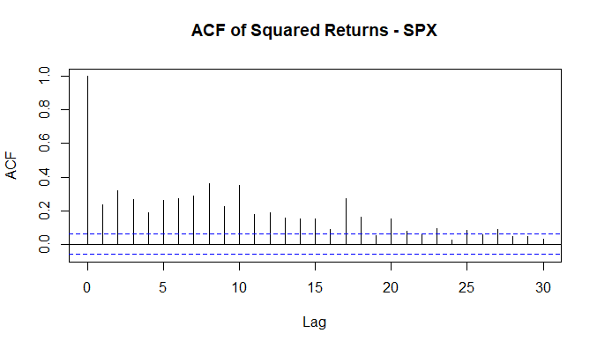
Figure 3.8 ACF Plot of S&P 500 (SPX) (Created by author).

Cryptocurrency Market
It can be observed that ACF plots of cryptocurrencies likes Bitcoin (BTC), Ethereum (ETH), Binance Coin (BNB), Ripple (XRP) and Tron (TRX) also exhibit large autocorrelation in squared returns at early lags. The initial sharp spikes in BTC (see Fig. 3.9) and ETH reflect speculative and volatile cryptocurrency market characteristics and persistence in autocorrelation. We find evidence of persistent volatility clustering for BNB and XRP, which show similar patterns. It shows large and noticeable spikes at early lags, indicating that it is vulnerable to volatility when compared with traditional financial assets.

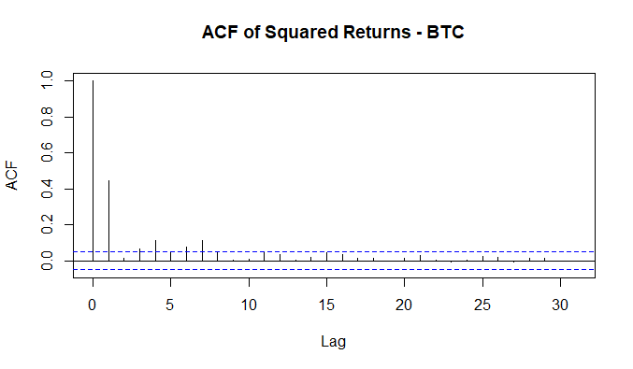
Figure 3.9 ACF Plot of Bitcoin (BTC) (Created by author).
ACF Plots US Stock sample (IXIC, DJI, NVDA and AAPL) and cryptocurrency sample (ETH, XRP, BNB and TRX) has been provided in Appendix 3. The observation of ACF plots is summarised based on the thresholds of ACF values as in Table 3.7.
Table 3.7
Thresholds for based on ACF plots (Created by author)
Volatility Clustering | ACF Value at Lag 1 | ACF Value at Lag 2, 3 and further
Low | 0 | No significant persistence further
Moderate | 0.1 - 0.2 | Persist for a short period (until lag 3)
Strong | 0.2 - 0.4 | Stronger persistence (until lag 5)
Very Strong | > 0.4 | Strongest persistence and gradual decay (more than lag 5)

The summary of ACF plots which signifies volatility clustering based on the thresholds are mentioned below in table 3.8.
Table 3.8
Summary of ACF plots (Created by author)
Ticker | Autocorrelation Behaviour | Volatility Clustering
SPX | High autocorrelation at initial lags and gradual decay | Strong
IXIC | Prominent spikes at initial lags | Strong
DJI | Gradual decay up to the 10th lag | Strong
NVDA | Less significant spikes of autocorrelation | Low
AAPL | Moderate spikes at initial lags | Moderate
BTC | High correlation at initial spike and decayed | Strong
ETH | High correlation at initial spike and gradual decayed | Very Strong
XRP | Sharp spikes followed by gradual decay | Strong
BNB | Significant autocorrelation at initial lags | Strong
TRX | Noticeable spikes at early lags and gradual lag | Strong

It is revealed by ACF analysis, first, that volatility clustering is intense for all explored assets except NVDA and second, that the observed cross correlations are statistically significant. However, even though stock indices and individual stocks like AAPL are clustered, cryptocurrencies (e.g. BTC, ETH, and BNB), on the other hand, show higher and more persistent clustering. It fits with their speculative nature and higher risk. While less volatile, stock indices demonstrate clearly visible volatility clustering in SPX, IXIC and DJI.
The autocorrelation in squared returns further supports the need for GARCH family models (and this is confirmed by the observations). Such volatility is absent from traditional models that would fail to capture the time varying nature of volatility especially in cryptocurrencies where extreme returns are more frequent and persistent.

3.4 GARCH Model Specification and Selection
Baseline Models
The analysis begins with the specification and estimation of baseline ARMA-GARCH models for both US stock indices and cryptocurrencies. The models utilize combinations of ARMA (Autoregressive Moving Average) terms for the mean equation and GARCH (Generalized Autoregressive Conditional Heteroskedasticity) terms for the variance equation. The purpose is to account for autocorrelations in returns (mean dynamics) and volatility clustering (variance dynamics).
For each asset series, various combinations of ARMA orders, such as ARMA (0,0),ARMA (1,0), ARMA(0,1), and ARMA (1,1), were tested with GARCH orders of (1,1), (1,2), (2,1) and (2,2). The models were evaluated using different error distributions:
- Normal (Gaussian) Distribution (norm): Generally, assumes symmetric, bell-shaped errors and without outliers, often observed under stable environment.
- Student's t-distribution (std): Similar to normal but with heavier tails and captures outliers.
- Skewed Student's t-distribution (sstd): It adds skewness to sstd and is useful for asymmetrical data with long tails.
- Generalized Error Distribution (ged): Flexible distribution for heavy tails and non-normality, without assuming symmetry.
- Skewed Generalized Error Distribution (sged): Extends GED to model for both skewness and heavy tails. It is ideal for asymmetric and extreme data.
The specifications of these baseline models make it possible to capture the heavy tails and asymmetry that are very common in financial time series. Three key metrics in selecting the best performing baseline model are:
- Akaike Information Criterion (AIC): Lower AIC values indicate better fit of the model.
- Bayesian Information Criterion (BIC): BIC penalizes complexity of the model stronger when compared to AIC.
- Log-Likelihood: Higher log-likelihood indicates a better fit to the data.
The summary of the baseline model results in terms of ARMA-GARCH orders, selected distributions, and corresponding AIC, BIC and log likelihood scores are mentioned below (See Tab. 3.9).

Table 3.9
Summary of selected baseline models (Created by author)
Ticker | ARMA Order | GARCH Order | Distribution | AIC | BIC | LogLikelihood
SPX | 0,1 | 1,2 | sstd | -6803.981 | -6764.679 | 3409.99
IXIC | 0,1 | 1,2 | sged | -6183.664 | -6144.362 | 3099.832
DJI | 0,1 | 1,1 | std | -7041.318 | -7011.841 | 3526.659
NVDA | 0,1 | 1,1 | std | -4624.394 | -4594.918 | 2318.197
AAPL | 0,1 | 1,2 | std | -5648.716 | -5614.327 | 2831.358
BTC | 1,1 | 1,2 | std | -7465.739 | -7423.45 | 3740.87
ETH | 1,1 | 1,1 | std | -6775.035 | -6738.032 | 3394.517
XRP | 1,1 | 1,2 | std | -6445.323 | -6403.033 | 3230.661
BNB | 1,1 | 1,2 | std | -6875.404 | -6833.114 | 3445.702
TRX | 1,1 | 1,2 | std | -6964.057 | -6921.768 | 3490.029

The combination ARMA(0,1)-GARCH(1,2) with sstd distribution yields lower AIC (-6803.981) and BIC (-6764.679) than other suitable distributions, suggesting a better fit for SPX. Similarly, for IXIC, the best model is ARMA(0,1)-GARCH(1,2) with the Skewed GED (sged) distribution, reflecting the presence of heavy tails in the returns. The DJI index shows strong performance under the ARMA(0,1)-GARCH(1,1) model with the standard t-distribution, highlighting that volatility clustering can be effectively captured with simple GARCH models.
For NVDA and AAPL, the baseline models indicate that ARMA(0,1)-GARCH(1,1) and ARMA(0,1)-GARCH(1,2), respectively, with the standard t-distribution are sufficient to capture volatility behaviour. The results with AAPL return a slightly larger log likelihood score (2831.358) which indicates a better model fit relative to NVDA.
Higher volatility and persistence of cryptocurrencies can be seen through ARMA(1,1)-GARCH(1,2) and GARCH(1,1) models with a standard t-distribution. Thus, the results of analysing the BTC show the lowest AIC (-7465.739) and the highest log-likelihood (3740.87) for all instruments, which means a high degree of volatility clustering and the subsequent need to consider long memory effects. The results for BNB and TRX also show that the ARMA(1,1)-GARCH(1,2) models are stable and reveal again the applicability of effective models for cryptocurrency markets analysis.
The student’s t-distribution (std) appears most frequently as the optimal error distribution, emphasizing the heavy-tailed nature of financial returns. Thus, GARCH(1,2) model performs better than the basic GARCH(1,1) models for most series, especially in the cryptocurrency markets having higher and persistent volatility and large fluctuations.
The baseline models detail bears some fundamental features like volatility clustering and fat tails and should therefore be used as a foundation for volatility modelling. Nevertheless, the existence of the asymmetric effects and higher-order persistence raise the need to consider improving the GARCH-family models, which are more capable of managing them.
Advanced Models
To enhance the performance of volatility modelling, advanced GARCH-family models were tested, including E-GARCH (Exponential GARCH), T-GARCH (Threshold GARCH), I-GARCH (Integrated GARCH) and GARCH-M (GARCH-in-Mean). Each advanced model was fitted to the same datasets, using the best ARMA-GARCH combinations identified in the baseline models. Specific distributions (e.g., std, sstd) were retained to address the heavy-tailed nature of financial returns. The summary of the results for advanced models, highlighting the performance of each model is mentioned below (see Tab. 3.10). The detailed results computed in R programming has been attached in Appendix 4.
Table 3.10
Summary of advanced models and performance (Created by author)
Ticker | ARMA Order | GARCH Order | Distribution | Model | AIC | BIC | Log-Likelihood
1 | 2 | 3 | 4 | 5 | 6 | 7 | 8
SPX | 0,1 | 1,2 | sstd | sGARCH | -6803.981 | -6764.679 | 3409.99
 |  |  |  | E-GARCH | -6845.735 | -6801.52 | 3431.867
 |  |  |  | T-GARCH | -6856.018 | -6811.804 | 3437.009
 |  |  |  | I-GARCH | -6803.981 | -6764.679 | 3409.99
 |  |  |  | GARCH-M | -6802.698 | -6758.483 | 3410.349
IXIC | 0,1 | 1,2 | sged | sGARCH | -6183.664 | -6144.362 | 3099.832
 |  |  |  | E-GARCH | -6212.791 | -6168.577 | 3115.396
 |  |  |  | T-GARCH | -6217.369 | -6173.155 | 3117.685
 |  |  |  | I-GARCH | -6182.279 | -6142.977 | 3099.139
 |  |  |  | GARCH-M | -6181.676 | -6137.462 | 3099.838
DJI | 0,1 | 1,1 | std | sGARCH | -7041.318 | -7011.841 | 3526.659
 |  |  |  | E-GARCH | -7072.643 | -7038.254 | 3543.321
 |  |  |  | T-GARCH | -7081.019 | -7046.63 | 3547.509
 |  |  |  | I-GARCH | -7041.121 | -7011.645 | 3526.561
 |  |  |  | GARCH-M | -7040.787 | -7006.398 | 3527.393
NVDA | 0,1 | 1,1 | std | sGARCH | -4624.394 | -4594.918 | 2318.197
 |  |  |  | E-GARCH | -4638.515 | -4604.126 | 2326.257
 |  |  |  | T-GARCH | -4641.487 | -4607.097 | 2327.743
 |  |  |  | I-GARCH | -4622.098 | -4592.621 | 2317.049
 |  |  |  | GARCH-M | -4622.714 | -4588.324 | 2318.357

Table 3.10 Continued
1 | 2 | 3 | 4 | 5 | 6 | 7 | 8
AAPL | 0,1 | 1,2 | std | sGARCH | -5648.716 | -5614.327 | 2831.358
 |  |  |  | E-GARCH | -5663.757 | -5624.455 | 2839.878
 |  |  |  | T-GARCH | -5666.879 | -5627.577 | 2841.44
 |  |  |  | I-GARCH | -5647.821 | -5613.432 | 2830.911
 |  |  |  | GARCH-M | -5647.096 | -5607.794 | 2831.548
BTC | 1,1 | 1,2 | std | sGARCH | -7465.739 | -7423.45 | 3740.87
 |  |  |  | E-GARCH | -7473.559 | -7425.983 | 3745.779
 |  |  |  | T-GARCH | -7469.333 | -7421.757 | 3743.666
 |  |  |  | I-GARCH | -7465.805 | -7423.515 | 3740.902
 |  |  |  | GARCH-M | -7463.945 | -7416.37 | 3740.973
ETH | 1,1 | 1,1 | std | sGARCH | -6775.035 | -6738.032 | 3394.517
 |  |  |  | E-GARCH | -6774.955 | -6732.666 | 3395.478
 |  |  |  | T-GARCH | -6771.964 | -6729.674 | 3393.982
 |  |  |  | I-GARCH | -6775.207 | -6738.204 | 3394.603
 |  |  |  | GARCH-M | -6773.949 | -6731.66 | 3394.975
XRP | 1,1 | 1,2 | std | sGARCH | -6445.323 | -6403.033 | 3230.661
 |  |  |  | E-GARCH | -6435.771 | -6388.195 | 3226.885
 |  |  |  | T-GARCH | -6455.815 | -6408.24 | 3236.908
 |  |  |  | I-GARCH | -6445.327 | -6403.037 | 3230.663
 |  |  |  | GARCH-M | -6443.476 | -6395.9 | 3230.738
BNB | 1,1 | 1,2 | std | sGARCH | -6875.404 | -6833.114 | 3445.702
 |  |  |  | E-GARCH | -6879.368 | -6831.792 | 3448.684
 |  |  |  | T-GARCH | -6874.446 | -6826.87 | 3446.223
 |  |  |  | I-GARCH | -6875.444 | -6833.155 | 3445.722
 |  |  |  | GARCH-M | -6873.615 | -6826.04 | 3445.808
TRX | 1,1 | 1,2 | std | sGARCH | -6964.057 | -6921.768 | 3490.029
 |  |  |  | E-GARCH | -6974.218 | -6926.643 | 3496.109
 |  |  |  | T-GARCH | -6967.84 | -6920.264 | 3492.92
 |  |  |  | I-GARCH | -6964.208 | -6921.919 | 3490.104
 |  |  |  | GARCH-M | -6962.964 | -6915.388 | 3490.482

The table summarizes the results for advanced models, highlighting the following key insights:
- T-GARCH was proven to enhance model efficiency for all the US stocks and indices as indicated by the smaller AIC and BIC values than in the baseline models pointing out leverage effect present in the market.
- E-GARCH demonstrated competitive results for cryptocurrencies like BTC, BNB and ETH, suggesting that volatility persistence and asymmetric effects are critical in crypto markets.
- In ETH, the I-GARCH had the lowest AIC (-7463.945) establishing long-term influence and persistence in the volatility.
The summarised table of the top-performing models across all instruments is mentioned below (see Tab, 3.11).
Table 3.11
Summary of advanced models and performance (Created by author)
Ticker | ARMA Order | GARCH Order | Distribution | Model | AIC | BIC | Log-Likelihood
SPX | 0,1 | 1,2 | sstd | T-GARCH | -6856.018 | -6811.804 | 3437.009
IXIC | 0,1 | 1,2 | sged | T-GARCH | -6217.369 | -6173.155 | 3117.685
DJI | 0,1 | 1,1 | std | T-GARCH | -7081.019 | -7046.63 | 3547.509
NVDA | 0,1 | 1,1 | std | T-GARCH | -4641.487 | -4607.097 | 2327.743
AAPL | 0,1 | 1,2 | std | T-GARCH | -5666.879 | -5627.577 | 2841.44
BTC | 1,1 | 1,2 | std | E-GARCH | -7473.559 | -7425.983 | 3745.779
ETH | 1,1 | 1,1 | std | I-GARCH | -6775.207 | -6738.204 | 3394.603
XRP | 1,1 | 1,2 | std | T-GARCH | -6455.815 | -6408.24 | 3236.908
BNB | 1,1 | 1,2 | std | E-GARCH | -6879.368 | -6831.792 | 3448.684
TRX | 1,1 | 1,2 | std | E-GARCH | -6974.218 | -6926.643 | 3496.109

Volatility models across U.S. stock markets and cryptocurrency markets are compared based on model performance and volatility behaviour in a table. T-GARCH model always leads with the best results for all tickers in the U.S. stock market, which indicates that symmetric volatility models well characterize market fluctuations in conventional equities. On the contrary, on some tickers such as rbtc, rtrx, E-GARCH models were preferred to, due to the fact that asymmetric volatility can be found on these tickers, as negative shocks have a larger effect on market volatility. Lower AIC and BIC values for cryptocurrency tickers shows a better fit on the model than for stocks, suggesting the higher complexity and volatile dynamics of crypto markets. However, in general, stock market volatility seems to be more stable and to be symmetric, while cryptocurrencies are more sensitive to shocks, and, thus, require more advanced asymmetric models for forecasting.
The findings show better fit of the data by the advanced GARCH-family models compared with baseline GARCH models for all the assets based on AIC, BIC, and log-likelihood values (see Fig 3.10).

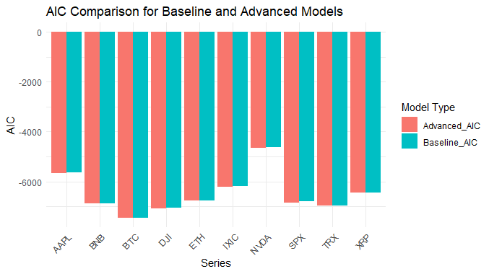
Figure 3.10 Comparison of AIC and BIC values for different tickers (Created by author).

Among the models considered, both E-GARCH and T-GARCH deliver the better fits to US stocks data mainly owing to its ability to model the volatility that is asymmetric in nature. Of all cryptocurrency models, I-GARCH models produce the smallest AIC values, evidenced by high volatility shocks characteristic of emergent crypto markets.

3.5 Forecasting with GARCH Model
In this section, the results of the 15-step-ahead volatility forecasts for selected US stock indices and major cryptocurrencies are presented. The volatility forecasts are generated using advanced GARCH family models and the Exponentially Weighted Moving Average (EWMA) model based on the sample selected. These forecast aims to capture and compare volatility trends in traditional US Stock market, and highly volatile cryptocurrency markets. The analysis considers the volatility forecasts for each asset based on the best-performing models and visualization of volatility trends to examine differences in forecast behaviour.
The table 3.12 below shows the 15-step-ahead forecasts of volatility for five major US stock indices and companies including SPX (S&P 500), IXIC (NASDAQ Composite), DJI (Dow Jones Industrial Average), NVDA (NVIDIA), and AAPL (Apple Inc.). These forecasts are generated using the advanced model selected, which is majorly T-GARCH model, with varying ARMA and GARCH orders as determined by the best-fitting model specifications. Majority of the forecasts involves the use of the following distributions, namely the standardized Students’ t- distribution (sstd), skewed generalized error distribution (sged), and standard distribution (std).
Table 3.12
Volatility forecasted for US stock market assets in sample using GARCH (Created by author)
Ticker | SPX | IXIC | DJI | NVDA | AAPL
ARMA Order | 0,1 | 0,1 | 0,1 | 0,1 | 0,1
GARCH Order | 1,2 | 1,2 | 1,1 | 1,1 | 1,2
Distribution | sstd | sged | std | std | std
Model | T-GARCH | T-GARCH | T-GARCH | T-GARCH | T-GARCH
T+1 | 0.004522 | 0.006741 | 0.003384 | 0.013773 | 0.010663
T+2 | 0.004363 | 0.006278 | 0.003535 | 0.014341 | 0.010279
T+3 | 0.004614 | 0.006817 | 0.003681 | 0.014883 | 0.010854
T+4 | 0.004696 | 0.006779 | 0.003822 | 0.015398 | 0.010782
T+5 | 0.004840 | 0.007060 | 0.003958 | 0.015888 | 0.011125
T+6 | 0.004954 | 0.007151 | 0.004090 | 0.016356 | 0.011182
T+7 | 0.005075 | 0.007342 | 0.004217 | 0.016801 | 0.011417
T+8 | 0.005188 | 0.007468 | 0.004340 | 0.017224 | 0.011523
T+9 | 0.005299 | 0.007623 | 0.004458 | 0.017628 | 0.011704
T+10 | 0.005407 | 0.007755 | 0.004572 | 0.018012 | 0.011825
T+11 | 0.005512 | 0.007892 | 0.004683 | 0.018377 | 0.011976
T+12 | 0.005613 | 0.008020 | 0.004789 | 0.018726 | 0.012098
T+13 | 0.005712 | 0.008146 | 0.004892 | 0.019057 | 0.012230
T+14 | 0.005807 | 0.008267 | 0.004992 | 0.019373 | 0.012347
T+15 | 0.005900 | 0.008384 | 0.005088 | 0.019674 | 0.012466

The volatility forecasts exhibit a general upward trend for all assets, particularly noticeable on IXIC and NVDA. IXIC starts at 0.006741 (T+1) and increases steadily to 0.008384 (T+15), which is indicating increasing uncertainty and risk in the returns in NASDAQ (see Fig. 3.11). But, SPX (S&P 500) shows lower volatility levels throughout the forecast period, which starts at 0.004522 and gradually rising to 0.005900 by T+15 (see Fig. 3.11). This relates to the stable nature of this broader market index than other assets in the US stock market.

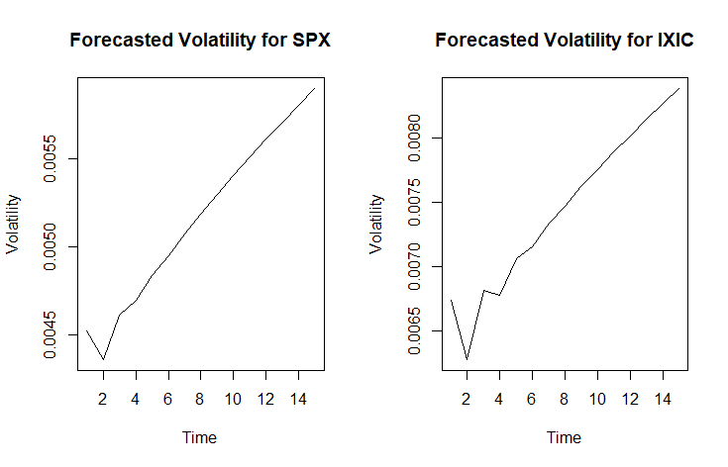
Figure 3.11 Volatility forecasted for S&P 500 (SPX) and NASDAQ Composite (IXIC) using GARCH (Created by author).
We can also observe that DJI has the least value of volatility compared to other indices starting from 0.003384 (T+1) to 0.005088 (T+15). This is in line with its makeup of large well-established blue-chip organisations that do not experience as much price volatility. Conversely, as seen in the figures below, the technology-oriented stocks such as NVDA and AAPL have much higher forecasted volatility on average and especially in the last forecast horizons. For example, we observe a transformation of NVDA from 0.013773 to 0.019674; it is evident that with increase in the volatility, especially in technology stocks, investors face a higher degree of risk.
For all assets, short-term volatility forecasts (T+1 to T+5) display moderate increases. However, from T+6 onward, the volatility trends become more pronounced, reflecting the persistence of volatility clustering captured by the GARCH models. This clustering effect suggests that high volatility in the near term tends to propagate into subsequent periods, particularly for NVDA and IXIC.
These volatility forecasts US stock indices and companies predict higher volatility for technology-based assets and have compared IXIC and NVDA with SPX and DJI. This is especially important for investors and risk managers, and it shows that the exposure of risk differs from one market segment to another. While the forecasts demonstrate upward trends, they also underline the ability of T-GARCH models to capture volatility persistence and clustering in financial markets.
The following table 3.13 shows the forecast of the 15-step-ahead volatilities in the major cryptocurrencies namely BTC (Bitcoin), ETH (Ethereum), XRP (Ripple), BNB (Binance Coin), and TRX (Tron). These forecasts are estimated by fitting E-GARCH, I-GARCH, T-GARCH, ARMA and GARCH orders that are specific to each of the assets. The models make use the standard distribution (std), which is well suited for capturing volatility patterns of highly speculative instruments such as bitcoins.
Table 3.13
Volatility forecasted for cryptocurrencies in sample using GARCH (Created by author)
Ticker | BTC | ETH | XRP | BNB | TRX
1 | 2 | 3 | 4 | 5 | 6
ARMA Order | 1,1 | 1,1 | 1,1 | 1,1 | 1,1
GARCH Order | 1,2 | 1,1 | 1,2 | 1,2 | 1,2
Distribution | std | std | std | std | std
Model | E-GARCH | I-GARCH | T-GARCH | E-GARCH | E-GARCH
T+1 | 0.012451 | 0.017286 | 0.019834 | 0.033629 | 0.012685
T+2 | 0.012603 | 0.017441 | 0.020023 | 0.033745 | 0.012806
T+3 | 0.012654 | 0.017595 | 0.020570 | 0.033306 | 0.012992
Table 3.13 Continued
1 | 2 | 3 | 4 | 5 | 6
T+4 | 0.012756 | 0.017748 | 0.020946 | 0.033039 | 0.013145
T+5 | 0.012831 | 0.017899 | 0.021373 | 0.032739 | 0.013312
T+6 | 0.012919 | 0.018049 | 0.021759 | 0.032463 | 0.013471
T+7 | 0.012999 | 0.018197 | 0.022144 | 0.032195 | 0.013632
T+8 | 0.013082 | 0.018345 | 0.022511 | 0.031937 | 0.013790
T+9 | 0.013163 | 0.018491 | 0.022869 | 0.031689 | 0.013948
T+10 | 0.013243 | 0.018636 | 0.023213 | 0.031450 | 0.014105
T+11 | 0.013323 | 0.018780 | 0.023546 | 0.031220 | 0.014260
T+12 | 0.013402 | 0.018923 | 0.023869 | 0.030999 | 0.014414
T+13 | 0.013480 | 0.019065 | 0.024180 | 0.030786 | 0.014567
T+14 | 0.013557 | 0.019206 | 0.024481 | 0.030581 | 0.014719
T+15 | 0.013634 | 0.019346 | 0.024772 | 0.030383 | 0.014869

These results show that forecasted volatility of cryptocurrencies is substantially higher than of the US stock market, which may be attributed to the speculative nature of cryptocurrencies. BTC (Bitcoin) begins from 0.012451 (T+1) and volatility goes higher and touches 0.013634 by the end of forecast horizon T+15. Ripple/ XRP has the highest level of volatility out of the analysed cryptocurrencies with figures beginning from 0.019834 (T+1) and escalating to 0.024772 (T+15), showing a much higher degree of price fluctuation (see Fig. 3.12).

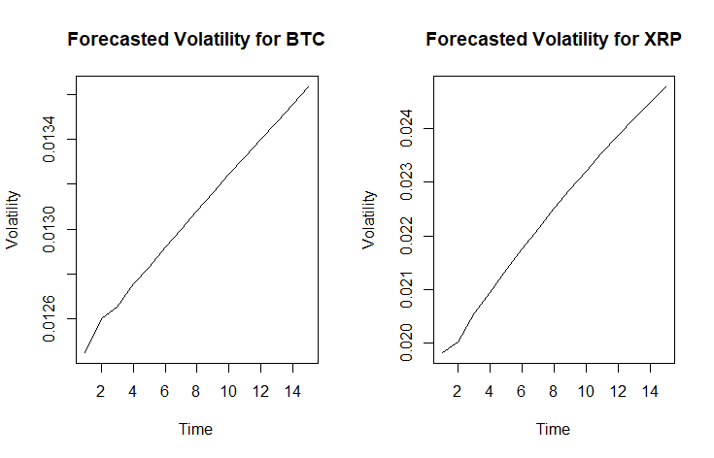
Figure 3.12 Volatility forecasted for Bitcoin (BTC) and Ripple (XRP) using GARCH (Created by author).

The forecasts show clustering in volatility, meaning the actual data in terms of short-term volatility is passed onto other future periods. This has been more evident in XRP and BNB which show an upward trend throughout the forecast period. BNB starts a bit higher at 0.033629 (T+1) and remains quite elevated until the last spot at 0.030833 (T+15). This supports the sustained fluctuation even as there are slight dips in the later periods.
ETH (Ethereum) is less volatile than XRP and BNB, its values start from 0.017286 at T+1 and rise to 0.019346 at T+15. This correlates well with Ethereum being a more established crypto with comparatively less amounts of less speculation in trading activity. Tron, which is traded under the symbol TRX, presents the lowest volatility projections at 0.012685 first and then attaining 0.014869 at T+ 15. Although they are showing higher variations, they are relatively lower than that of BTC or XRP, and thus it is understandable that their price dynamics would be slightly more stable over the forecast period.
Volatility forecasts in the short term (T+1 to T+5) show rapid increases for most cryptocurrencies. For example, XRP increases from 0.019834 to 0.021373 within five steps. As seen in BNB and BTC, over longer periods (T+6 to T+15) the volatility trends stabilize or decline slightly. Hence, this is an indication of a decreasing market risk over time.
E-GARCH analysis on BTC, BNB, and TRX shows the structure of volatility has an asymmetric distribution. E-GARCH models successfully estimate the leverage effect which displays that negative price shocks cause larger volatility than positive shocks. For ETH, the I-GARCH model is used, this is due to the fact that volatility has a lasting impact on the market and any shocks that are witnessed in the market impacts the entire ETH throughout the duration. T-GARCH, when used on XRP, focuses on the excess kurtosis and the fact of the asymmetric distribution of volatility that characterizes the dynamics of Ripple’s rate.

3.6 Forecasting with EWMA Model
The study uses US stock indices, and cryptocurrency to analyse the volatility using the Exponentially Weighted Moving Average (EWMA) and the forecast is for 15 periods. In this model, we set the smoothing parameter 𝜆 at 0.94, which gives relatively higher weights to recent return observations and less weightage to historical data, thereby providing the model with the ability to respond adequately to the issue of volatility clustering.
The forecasted volatilities for the US stock market indices (SPX, IXIC, DJI, NVDA, AAPL) using EWMA is mentioned below in table 3.14.

Table 3.14
Volatility forecasted for US stock market assets in sample using EWMA (Created by author)
FORECAST | SPX | IXIC | DJI | NVDA | AAPL
T+1 | 0.004852 | 0.005992 | 0.004516 | 0.012971 | 0.007452
T+2 | 0.004704 | 0.005810 | 0.004378 | 0.012576 | 0.007225
T+3 | 0.004561 | 0.005633 | 0.004245 | 0.012193 | 0.007005
T+4 | 0.004422 | 0.005461 | 0.004115 | 0.011822 | 0.006792
T+5 | 0.004287 | 0.005295 | 0.003990 | 0.011462 | 0.006585
T+6 | 0.004157 | 0.005133 | 0.003868 | 0.011112 | 0.006384
T+7 | 0.004030 | 0.004977 | 0.003751 | 0.010774 | 0.006190
T+8 | 0.003907 | 0.004825 | 0.003636 | 0.010446 | 0.006001
T+9 | 0.003788 | 0.004678 | 0.003525 | 0.010127 | 0.005819
T+10 | 0.003673 | 0.004536 | 0.003418 | 0.009819 | 0.005641
T+11 | 0.003561 | 0.004398 | 0.003314 | 0.009520 | 0.005469
T+12 | 0.003452 | 0.004264 | 0.003213 | 0.009230 | 0.005303
T+13 | 0.003347 | 0.004134 | 0.003115 | 0.008949 | 0.005141
T+14 | 0.003245 | 0.004008 | 0.003020 | 0.008676 | 0.004985
T+15 | 0.003146 | 0.003886 | 0.002928 | 0.008412 | 0.004833

For the SPX (S&P 500), starting value of volatility is 0.00485 in T+1 and this decreases to 0.00315 in T+15 (see Fig. 3.13). This suggests fairly, consistent or predictable volatility for this broad market index which is appropriate for the index’s role as a benchmark for US equities. The same trend is marked in the case of DJI (Dow Jones Industrial Average), which begins at 0.00452 and declines to 0.00292 at T+15 because it is less sensitive to shocks owing to its summary of blue-chip stocks.

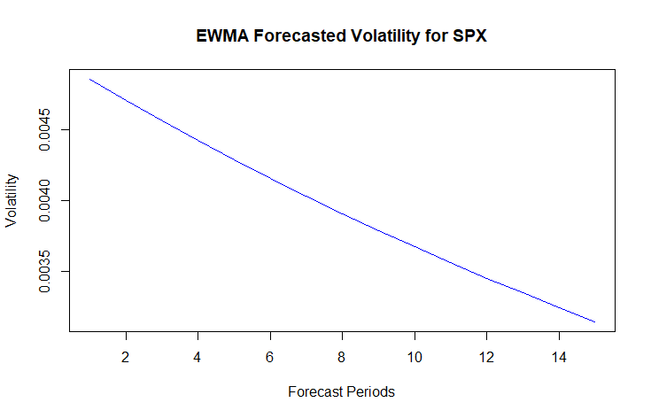
Figure 3.13 Volatility forecasted for S&P 500 using EWMA (Created by author).

The NASDAQ (IXIC), which specialises in technology and growth stocks, has initially higher volatility level at 0.00599 reducing to 0.00388 at the end of the forecast period. This pattern represents the general tendency to be more unpredictable which can be observed in the tech-dominated index but also showcases stabilizing over time.
If equities are considered, higher initial volatility is observed in NVDA (NVIDIA) starting from 0.01297 because it shows more susceptibility to market risk and technology sector risk. The volatility decreases to 0.00841 at T+15 and is still higher than broader indices given that it has reduced considerably. Similar, but less fluctuating, AAPL (Apple) starts at 0.00745 and drops to 0.00483 which shows investors’ trust and the company’s stability on the market.
These outcomes validate the assumption that although the SPX and DJI are characterized smooth and predictable movements in volatility, the IXIC, NVDA, and other technology-related stock and indices show higher volatility. Nevertheless, the persistent decrease over all asset’s points to the fact that the EWMA accurately depicts and estimates the volatility’s consistent falling, which is useful for risk analysis and portfolio management under stable processes.
The empirical results of the 15-step-ahead EWMA model forecasts for cryptocurrencies (BTC, ETH, XRP, BNB, TRX) is mentioned in table 3.15. They establish notably elevated values of fluctuation compared with the conventional stock market indicators.
Table 3.15
Volatility forecasted for cryptocurrency assets in sample using EWMA (Created by author)
FORECAST | BTC | ETH | XRP | BNB | TRX
T+1 | 0.013390 | 0.017998 | 0.015025 | 0.032070 | 0.012343
T+2 | 0.012982 | 0.017449 | 0.014568 | 0.031093 | 0.011967
T+3 | 0.012587 | 0.016918 | 0.014124 | 0.030146 | 0.011602
T+4 | 0.012203 | 0.016402 | 0.013694 | 0.029227 | 0.011249
T+5 | 0.011831 | 0.015903 | 0.013277 | 0.028337 | 0.010906
T+6 | 0.011471 | 0.015418 | 0.012872 | 0.027474 | 0.010574
T+7 | 0.011122 | 0.014949 | 0.012480 | 0.026637 | 0.010252
T+8 | 0.010783 | 0.014493 | 0.012100 | 0.025825 | 0.009940
T+9 | 0.010454 | 0.014052 | 0.011731 | 0.025039 | 0.009637
T+10 | 0.010136 | 0.013624 | 0.011374 | 0.024276 | 0.009343
T+11 | 0.009827 | 0.013209 | 0.011027 | 0.023536 | 0.009059
T+12 | 0.009528 | 0.012806 | 0.010691 | 0.022819 | 0.008783
T+13 | 0.009237 | 0.012416 | 0.010366 | 0.022124 | 0.008515
T+14 | 0.008956 | 0.012038 | 0.010050 | 0.021450 | 0.008256
T+15 | 0.008683 | 0.011671 | 0.009744 | 0.020797 | 0.008004

Volatility for BTC (Bitcoin) ranges from 0.01339 in T+1 to 0.00868 in T+15 (see Fig. 3.14). While this was achieved, the forecasted values stay at levels that are still quite high, suggesting BTC’s sensitivity to crypto and macroeconomic sentiment. In the same way, the initial volatility of ETH (Ethereum) is 0.01799, goes down to 0.01167 by T+15, indicating that while the volatility decreases over time, ETH remains higher than BTC because it is platform for decentralized applications and the changing market.

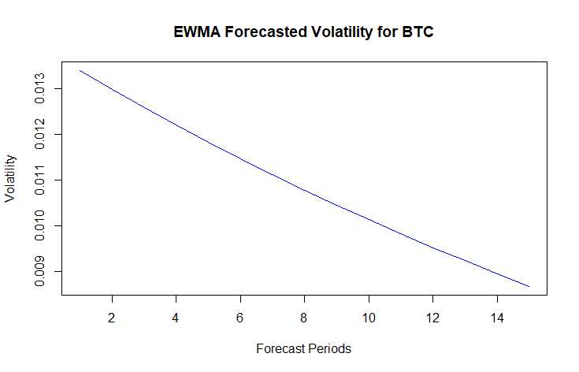
Figure 3.14 Volatility forecasted for Bitcoin (BTC) using EWMA (Created by author).

The trend for volatility forecasts for XRP is identical from the beginning at 0.01502 to the end at 0.00974. This is a sign of trend now stabilizing but the initial levels remain significant as they are by traditionally wild XRP price fluctuations and enormous regulatory uncertainty. On the other hand, compared to other observed cryptocurrencies, BNB (Binance Coin) starts with the highest initial volatility of 0.03207. TRX (Tron) has slightly lower volatility which starts at 0.01234 and declines to 0.00800. This trend indicates relatively stable behaviour than other cryptocurrencies, but it is well beyond institutional financial asset volatility.
In general, cryptocurrency markets do indeed exhibit decreasing volatility over time, which means that the EWMA forecasts, while declining, remain orders of magnitude higher than observed for stock indices. The volatility of digital assets is clearly highlighted by these two developments, which makes investing in or managing risk in these markets quite challenging. With the heterogeneity within cryptocurrency market, the differences between BTC and altcoins like ETH, XRP, BNB, and TRX are distinct.

3.7 Comparative Analysis of Model Performance
Using advanced GARCH-family models (T-GARCH, E-GARCH, I-GARCH) and the EWMA model, the empirical results demonstrate key differences in volatility behaviour, persistence, and model performance. Both stock indices and cryptocurrency markets exhibit volatility clustering (the same higher volatility period is followed by a higher volatility period). But in cryptocurrencies, its intensity is even more pronounced and also more persistent. For example, volatility in BTC and BNB, respectively, decays slower in the T-GARCH and E-GARCH models, capturing instances of market uncertainty lasting for quite a bit. In contrast, stock indices like SPX, DJI & IXIC exhibit less volatile clustering, and the forecast implies smoother and faster stabilization over time.
In cryptocurrency markets, traditional GARCH models tend to be quite successful at forecasting volatility in the stock markets but come with a number of limitations. For example, stock index forecasts from the T-GARCH model such as SPX and DJI can exhibit their consistent and declining forecasts of the asymmetric effects of volatility shocks. Models such as E-GARCH and I-GARCH perform better in cryptocurrencies than in standard portfolios, since they do manage to capture the high volatility and skewness in assets like BTC, ETH and XRP. In both markets the EWMA model, with its exponential style of weighting recent returns, does quite well. In particular, it yields more smooth forecasts of stock indices where the changes of volatility are not abrupt. EWMA now captures the immediate response to volatility shocks, while it underestimates the persistence seen in GARCH family models.
In the GARCH model volatility forecast (see Fig.3.15) for stock indices SPX continuously rises upward, while it is forecast to decay slowly in the EWMA model. This pattern suggests that GARCH forecasts respond more strongly to recent spikes in volatility and forecast an ongoing increase during the period covered. On the other hand, EWMA smooths past volatility, making the downward estimate more conservative over time.

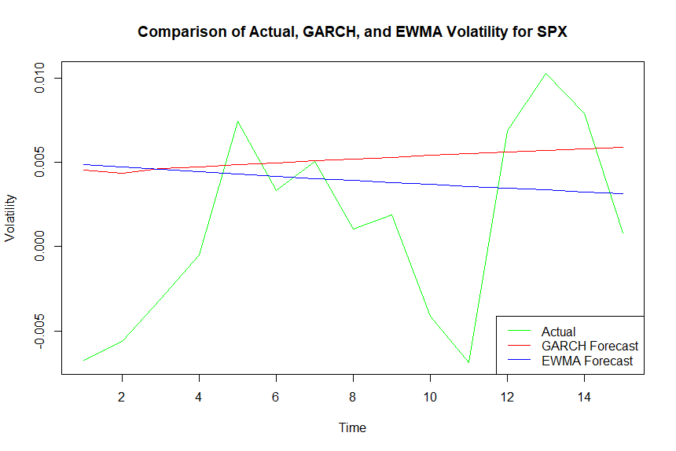
Figure 3.15 Comparing volatility forecast for S&P 500 (SPX) using GARCH and EWMA models (Created by author).

For cryptocurrency markets, BTC shows a divergent pattern, as well (see Fig. 3.16). EWMA forecasts have a constant declining volatility whereas GARCH forecasts show a gradual rise. Bitcoin markets are only more pronounced, as they inherently show greater volatility as well as sensitivity to external shocks. Persistence of volatility fluctuations is well captured by GARCH models, while EWMA forecasts adjust to sudden volatility shocks more slowly.

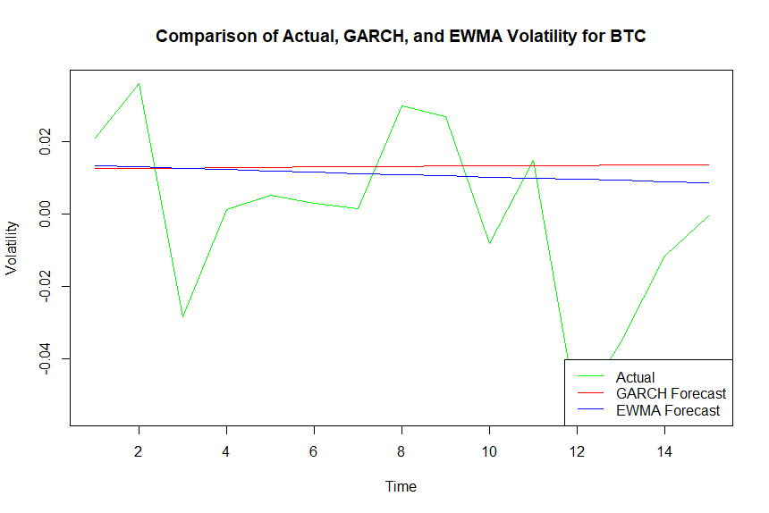
Figure 3.16 Comparing volatility forecast for Bitcoin (BTC) using GARCH and EWMA models (Created by author).

The forecasts of the two models show clearly differing behaviours. Both markets show that EWMA forecasts are always tending down, reflecting their reliance on historical smoothing, and GARCH forecasts are tending up, indicating their volatility sensitivity and their persistence over time (see Appendix 5 for more plots).
Mean Absolute Error (MAE) and Mean Squared Error (MSE)
The comparison of GARCH and EWMA models based on Mean Absolute Error (MAE) and Mean Squared Error (MSE) highlights key differences in the accuracy of volatility forecasts across stock indices and cryptocurrencies (see Tab 3.16).
Table 3.16
MAE and MSE Metrics of Volatility forecasts (Created by author)
Ticker | Model | MAE | MSE
SPX | GARCH | 0.00538446 | 0.00004312
 | EWMA | 0.00531442 | 0.00004015
IXIC | GARCH | 0.00840541 | 0.00011063
 | EWMA | 0.00819372 | 0.00009956
DJI | GARCH | 0.00479477 | 0.00003015
 | EWMA | 0.00466334 | 0.00002831
NVDA | GARCH | 0.01374022 | 0.00031531
 | EWMA | 0.01519257 | 0.00032584
AAPL | GARCH | 0.01436534 | 0.00034643
 | EWMA | 0.01274614 | 0.00028621
BTC | GARCH | 0.02157117 | 0.00076898
 | EWMA | 0.02033535 | 0.00068209
ETH | GARCH | 0.02478864 | 0.00087578
 | EWMA | 0.02338261 | 0.00081322
XRP | GARCH | 0.02819794 | 0.00128007
 | EWMA | 0.02127342 | 0.00086710
BNB | GARCH | 0.03340470 | 0.00134283
 | EWMA | 0.02787373 | 0.00100608
TRX | GARCH | 0.01636841 | 0.00039211
 | EWMA | 0.01497821 | 0.00033912

The accuracy of both models is fairly similar for conventional indices like SPX, IXIC and DJI, albeit slightly higher for the EWMA technique. For SPX, the MAE of GARCH is 0.00538446 and that of EWMA of 0.00531442, the MSE of GARCH is 0.00004312 and that of EWMA is 0.00004015. Likewise, with reference to IXIC, EWMA proves to offer a lower MAE and MSE hence pointing to a efficient forecasting methods all aimed at lowering the squared errors. The results for DJI also support this relationship where EWMA performs slightly better than GARCH in both MAE (0.00466334 to 0.00479477) and MSE (0.00003015 to 0.00002831).

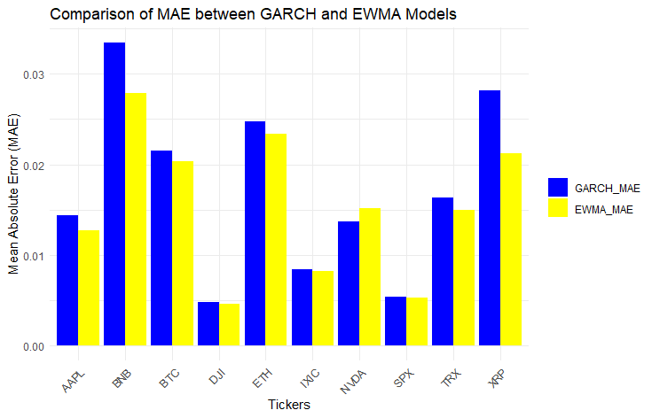
Figure 3.17 Comparison of Mean Absolute Error for GARCH and EWMA models (Created by author).

When operating at the stock level (i.e., NVDA and AAPL), there is a small discrepancy between the models’ results. On the other hand, GARCH yields NVDA’s better MSE estimation than EWMA with a figure of 0.00031531 against 0.00032584, hence reflecting the general fluctuations. Nevertheless, the MAE for NVDA is significantly higher when using EWMA, a signal of the algorithm’s inability to handle small deviations well; the EWMA MAE stood at 0.01519257 and the GARCH at 0.01374022. However, for AAPL, EWMA performs much better than GARCH in terms of lower MAE (0.01274614 and 0.01436534) and MSE (0.00028621 and 0.00034643). This implies that EWMA is more responsive to volatility characteristics of Apple by focusing on its stability in assets with irregular fluctuations.
Thus, in the cryptocurrency market, the EWMA model is superior to the GARCH in all indicators observed. For the EWMA for Bitcoin (BTC), we have MAE of 0.02033535 while for GARCH the MAE is 0.02157117 and for MSE, it is 0.00068209 for EWMA and 0.00076898 for GARCH. The same result occurs with Ethereum (ETH) where EWMA also gives lower MAE (0.02338261 vs. 0.02478864) and MSE (0.00081322 vs. 0.00087578). The better performance of EWMA can be attributed to its exponential weighting factor which gives higher importance to the most recent data thus making it more responsive to sudden price movements typified in cryptocurrencies.
For fluctuating digital currencies such as XRP or BNB, EWMA shows great stability once again. Furthermore, the MAE for XRP under EWMA is lower at 0.02127342 than under GARCH at 0.02819794. Likewise, the MSE obtained for XRP in EWMA is 0.00086710 which is more efficient to that of 0.00128007 in GARCH. In Binance Coin (BNB) prospects EWMA is once again proven giving greater efficiency, where MAE (0.02787373 versus 0.03340470) and MSE (0.00100608 versus 0.00134283) disclose less error compared to GARCH. These results confirm that EWMA is suitable for extreme and erratic values of assets.
This implies that EWMA is more efficient for short-term volatility prediction, especially for high fluctuating assets like cryptocurrencies. GARCH, however, remains solid in stable environments and might contain extra evidence for longer-term mean reversion. The relative differences observed stress the need for using the right models consistent with the distribution of the data under analysis. Although EWMA contains fluctuations in markets that are volatile, GARCH may still prove useful in stable or the less sensitive markets.
Conservatism - Analysis of Underestimation in Forecast
The table 3.17 shows the number of underestimations in the volatility forecasts produced by the GARCH and EWMA models for each ticker over 15 periods. The number of underestimations gives the corresponding measure of how many times the model underestimated the volatility by assuming lower value than the actual market volatility. Both models show relatively conservative behaviour, however, more often EWMA underestimates volatility than GARCH.
Table 3.17
Number of underestimation in the volatility forecasts (Created by author)
Ticker | Number of underestimation in GARCH forecast | Number of underestimation in EWMA forecast
SPX | 4 | 5
IXIC | 5 | 6
DJI | 2 | 2
NVDA | 8 | 8
AAPL | 3 | 5
BTC | 3 | 4
ETH | 3 | 5
XRP | 1 | 1
BNB | 0 | 1
TRX | 3 | 3

The NVDA ticker shows the highest number of underestimations for both models, with 8 underestimations for GARCH and 8 for EWMA. This suggests that in high-volatility environments or when market behaviour is more unpredictable, both models tended to predict lower volatility than actually occurred. This can be supported by the low clustering effect in the ticker. Conversely, the XRP and BNB tickers demonstrated the least number of underestimations, with XRP having only 1 underestimation for both models, while BNB saw no underestimation in GARCH forecasts. These results suggest that for more stable or less volatile assets, the models provided more accurate volatility forecasts.
For SPX, IXIC, and AAPL, the number of underestimations for GARCH and EWMA are relatively similar, but GARCH showing slightly less underestimation of volatility in these tickers compared to EWMA. This behavior indicates that EWMA tends to smooth out the volatility predictions and thus leading to a slightly higher number of underestimations when compared to GARCH forecasts. The difference in the number of underestimation between the two models suggests that GARCH model is more reactive and sensitive to market changes, whereas EWMA producing a more cautious forecast.
For BTC, ETH, and TRX, the underestimations are lower than compared to volatile assets like NVDA, wherein GARCH and EWMA underestimated volatility lesser times. This implies that for more volatile assets, both models tend to provide lower forecasts. However, for other more stable assets and assets with higher numbers of clustering effects, they are likely to give closer estimations to the actual values and less of underestimations.
These patterns illustrate the fact that GARCH and EWMA give different volatility forecasts depending on the conditions in the market, while GARCH is more reactive and responsive to changes in and EWMA is more conservative in its volatility estimates.
Conservatism – Mean and Standard Deviation of Forecast Error
Mean forecast error measures the mean of the difference between the predicted volatility and the actual volatility and standard deviation of forecast error measures the variability of the forecast. This is summarized in table 3.18, for both GARCH and EWMA models across all the tickers to establish the level of forecasting accuracy and variability attained by the models.
Table 3.18
Mean forecast errors and Standard Deviations of forecast errors (Created by author)
Ticker | GARCH Mean Error | EWMA Mean Error | GARCH SD Error | EWMA SD Error
SPX | 0.003993008 | 0.002768454 | 0.005396075 | 0.005899633
IXIC | 0.005904647 | 0.00332508 | 0.009009724 | 0.009737839
DJI | 0.00387602 | 0.003244773 | 0.004025893 | 0.004364973
NVDA | 0.004813657 | -0.001681134 | 0.017691974 | 0.018603515
AAPL | 0.010877968 | 0.005434936 | 0.015633077 | 0.01658339
BTC | 0.013048686 | 0.010854859 | 0.025327446 | 0.02458802
ETH | 0.012399754 | 0.008688988 | 0.027813575 | 0.02811442
XRP | 0.026900509 | 0.016702502 | 0.024416723 | 0.025102464
xBNB | 0.033404702 | 0.027450546 | 0.015593984 | 0.016449508
TRX | 0.01165264 | 0.007900124 | 0.016571995 | 0.017218443

The mean error of GARCH for SPX is 0.00399, which is slightly greater than EWMA mean error of 0.00277 meaning that GARCH provides a slight overestimate of volatility when compared to EWMA. Looking at the standard deviation of forecast error of both GARCH (0.00539) and EWMA (0.00589), we can see that GARCH has a greater amount of variation, which makes it more sensitive to market change.
In the case of IXIC, mean error of GARCH (0.00590) is greater than that of EWMA (0.00333) suggesting that GARCH overestimates volatility more than EWMA does. Likewise, the standard deviation of error also fits this pattern where GARCH has higher variability (0.00900) than EWMA has (0.00973), thus supporting the more volatile GARCH forecasts.
For GARCH, mean error is 0.00481 showing that it overestimates the volatility while EWMA underestimates with mean error of -0.00168. This trend of overestimation in GARCH and under estimation in EWMA is in conformity with the observation that GARCH models are more responsive to markets data compared to EWMA models. On the other hand, the GARCH model has a higher standard deviation of forecast error (0.0177), which is larger than EWMA (0.0186), meaning fluctuation in the prediction.
For other tickers like AAPL and BTC, EWMA consistently shows smaller mean forecast errors when compared to GARCH. This shows that EWMA forecasts tends to provide more conservative and stable predictions. The standard deviation of error for EWMA forecasts is also generally smaller when compared with GARCH. This implies that EWMA is the less volatile model, and it offer smoother forecasting and less fluctuation within the period.
In summary, the GARCH model is more reactive than other models and exhibits higher mean errors, and more variable forecast errors. While EWMA has a lower mean absolute error and lower mean standard deviation of the forecast errors, suggesting that the approach is smoother and more stable. Based on these results, it can be inferred that GARCH model is better used for modelling sharp volatility changes, and, on the contrary, EWMA model is more suitable for modelling constant and conservative volatility.

Conclusions And Proposals
The primary objective of this research is to analyse and compare volatility patterns in traditional US stock markets, represented by indices like SPX, IXIC, and DJI and stocks like NVDA and AAPL, with those observed in cryptocurrency markets, including BTC, ETH, XRP, BNB and TRX. Thus, based on these patterns, the study has sought to evaluate the accuracy of the forecasting models like the GARCH family of models and EWMA model in predicting market volatility. This investigation addresses key questions on the differences in volatility behaviour between stable and highly volatile markets and evaluates the performance of traditional models in adapting to the unique characteristics of each. The study provides important implications for investors, policymakers, and researchers in improving the knowledge and mitigating the risk in financial markets.
The literature review set the premise for analysing volatility patterns as well as forecast methods for more conventional stock markets and the volatile cryptocurrency markets. Liquidity driven global stock markets under institutional framework show less erratic and more controlled volatility. On the other hand, cryptocurrency markets are affected by speculation, macro-economic factors, changes in regulation, and these are directional, display fatter tails and are irregular. These classical publications such as GARCH have been very popular in stock markets but do not satisfy higher order conditions for non-linear dependencies and do not handle well extreme values and leverage effects especially in market distressed periods. Some of these draw backs are however addressed by advanced variants that include EGARCH and TGARCH that seem to perform better in cryptocurrency markets as they allow for asymmetry and leverage effects.
The review also draws on how factors as geopolitics and macroeconomic environment affects the market fluctuations. Since stock markets have clear trading rules and regulatory systems in place, they reflect relatively stability during shocks while, on the other hand, cryptocurrencies react extremely sensitively to those shocks making the process of regarding of the trends. There are still openings in applying volatility modelling, such as nonlinearity, spillover effects, and extreme market settings despite substantial growth in the field. As the literature shows, there is recognition of more complex hybrid models with synthesis of external factors and processing of machine learning techniques to improve accuracy of estimation of risks and optimization of results in financial contexts.
The empirical results highlight significant volatility patterns in both traditional stock markets and cryptocurrencies. While the stock market represented by SPX, IXIC and DJI presents slightly less volatile returns in general, the cryptos comprised of BTC, ETH and XRP present a high variability having higher standard deviations and higher kurtosis. The ARCH-LM test results confirm the presence of significant ARCH effects in most series, indicating the appropriateness of GARCH-family models for modelling volatility. Cryptocurrencies, specifically, present a higher level of ARCH effects, meaning the asymmetry and fluctuation of cryptocurrencies must be predicted by more complex models.
Evaluating the GARCH model performance analysis, it is evident that T-GARCH and E-GARCH models have better performance than baseline models for not only stock markets composed of traditional indices but also emerging cryptocurrencies markets. This superiority is better illustrated by lower AIC and BIC and higher log likelihood for the advanced models to depict improved identification and analysis of the trend in volatility. In the case of stock indices, including SPX, IXIC, and DJI, T-GARCH became prevalent as the most efficient model to illustrate the model’s potential to resolve the issue of asymmetrical volatility. Evidence among cryptocurrencies, for instance, the E-GARCH model exhibited promising performance in explaining elevated volatility and persistence present in BTCs and ETHs. These results also show how the use of advanced models is essential for volatility forecasting, something especially relevant in high-volatile assets such as cryptocurrencies.
The GARCH forecast results highlight distinct patterns in volatility across both US stock and cryptocurrency markets. In the US stock market, the volatility forecasts (e.g., for SPX, IXIC, DJI, etc.) show relatively stable growth over the 15 forecast periods, reflecting moderate persistence and clustering, indicative of steady volatility dynamics. In the case of the cryptocurrency markets (BTC, ETH, XRP), observations show higher volatility during the initial periods of the forecast period and even a sharper spike during the subsequent periods for both ETH and XRP. Such behaviour corresponds with the fact that the cryptocurrency market is more risky and more sensitive in comparison with the traditional stock market. The GARCH variations (e.g., T-GARCH, E-GARCH, and I-GARCH) are suitable for the differing volatility characteristics which are present in both types of markets, illustrating the flexibility of the models for these two classes of assets.
The EWMA forecasts predict a continuous reduction in volatility up to the 15th period of both the US stock market and cryptocurrency markets, which characterizes the used model as an exponential smoothing model. Specifically, in the US-stock market (S&P500, Nasdaq composite, Dow Jones Industrial Avg.), expected return still displays mean-reverting patterns and relatively small impact of shocking events. In the cryptocurrency markets, such as BTC, ETH, XRP, the initial volatility is significantly higher compared to stocks but the forecast displays the decrease in its growth and it is indicated that the model strongly reacts on the recent prices. But the fact that the rate of decline in volatility for such cryptocurrencies as ETH and BNT is lower compared to other assets indicates the persistent risk of these cryptocurrencies and their specific characteristics within the market. In general, EWMA forecasts place greater emphasis on the decay of volatility over time than does the actual data, although they are less accurate in identifying structural changes or sharp movement compared to more complex models such as GARCH.
In the stock market, EWMA was comparatively better than GARCH with lower MSE and MAE for stable tickers like SPX, IXIC, and DJI as it works well in capturing smoother trends of variability. But when it comes to high volatile stocks such as NVDA, it can be seen that GARCH performs better in terms of MSE, as it is better equipped to handle big fluctuations. Similarly, the cryptocurrency market analysis reveals that EWMA has significantly lower MSE than GARCH for all selected assets – BTC, ETH, XRP, and BNB which implies that EWMA is better suited to model smoother average trends. However, looking at the results in terms of MAE, it is seen that GARCH has a potential to deal with problems related to clustering and high volatility better than the other models, at the same time it may produce relatively bigger errors in forecasts on the average. The results of the simulations indicate that for choosing the model it is necessary to consider the volatility characteristic of the asset, since each model possesses the corresponding advantages at the conditions of different volatility.
The evaluation of the number of underestimations and forecast errors for GARCH and EWMA models shows that GARCH is more sensitive to market changes, and has fewer underestimations than EWMA that indicates that volatility is forecasted higher in GARCH model compared to EWMA model. As such, GARCH yields larger variance of forecast errors and can respond to abrupt changes in volatility patterns. In contrast, EWMA is found to underestimate volatility more often because it produces less volatile and more stable forecasts with lower forecast error variance. Based on this analysis, GARCH is more sensitive, and yields better results in high volatility situation whereas EWMA is better for stable markets since it comprises more conservative or stable precipitations.
In conclusion, based on presented GARCH and EWMA models comparison, it is critical to discuss that the choice of the volatility forecasting technique should be based on characteristics of the respective market. The simple structure and efficiency of EWMA in averaging smoother trends make it ideal for stable assets, whilst GARCH’s feature for modelling volatility clustering and accommodating for outliers and extreme values, makes it essential for volatile areas such as cryptocurrencies. Comparing the two models, it is seen that generally, one model is not superior to another, and the selection of a particular model requires the consideration of certain factors relating to the market and the goals of forecasting. This research contributes to existing knowledge in the field and serves as a useful reference for financial practitioners and academics by enhancing understanding and forecast differentiation and adaptation for various global financial services markets.
However, following the results of the empirical research of the current master thesis, it is possible to conclude:
- Hypothesis 1 stating that cryptocurrency markets exhibit more volatile behaviour compared to traditional US stock markets is confirmed. Cryptocurrency markets showed significantly higher volatility levels, persistence, and clustering than US stock indices. The GARCH models could capture such behaviours while underestimations were observed in the case of EWMA.
- Hypothesis 2 stating traditional volatility forecasting models (e.g. GARCH, EWMA) perform differently across stock and cryptocurrency markets is confirmed. The results show that EWMA generally outperforms GARCH in stock markets, with lower MSE and MAE for stable tickers like SPX, IXIC, and DJI, where smoother volatility trends dominate. However, in the evaluation of cryptocurrency markets, EWMA has lower MSE than GARCH, but the latter exhibits higher efficacy when dealing with irregular and clustered outliers indicating that it is more well-suited for highly volatile assets like BTC and ETH as notable from the above graphs. This variation defines the efficiency of those models in the context of the volatility and features of the respective markets.
Based on the conclusions above following recommendation can be developed and applied by the investors and market participants:
- Use complex GARCH models like T-GARCH, E-GARCH and I-GARCH with appropriate value of ARMA with specific distributions to forecast volatility efficiently. These models are sensitive to the recent market conditions and are better than the baseline models, particularly in unstable assets such as cryptocurrencies.
- In stable market like SPX an DJI, EWMA models should be used in volatility forecasting since they yield smooth volatility estimates. GARCH family models T-GARCH, E-GARCH are more suitable for intrinsically high volatility markets such as NVDA and cryptocurrencies due to volatility clustering and sudden spikes.
- Diversify portfolios across cryptocurrencies and traditional assets to mitigate risks. GARCH-based forecasts can help in short-term decisions, while EWMA can guide long-term asset allocation.

Considering the limitations of the current research, for further researches it is recommended:
- Inclusion of external factors by incorporating macroeconomic indicators, market sentiment, and regulatory changes to improve accuracy of the model and forecast.
- Testing alternative models using advanced models like Stochastic Volatility, Machine Learning, and hybrid approaches to enhance accuracy in forecasting.
- Broader asset coverage by expand the study to include commodities, emerging market indices, and alternative cryptocurrencies for a comprehensive and deeper analysis.
- Longer time horizons by using longer timeframes and real-time data to capture evolving volatility trends and intraday market movements.
- Market phase analysis by analysing volatility patterns during bull, bear, and crisis periods to assess model performance under different market conditions.
- Enhanced evaluation metrics by Incorporating metrics like RMSE and Theil’s U-statistic for more robust model comparisons and validation.

List of References
- Akaike, H. (1974). A new look at the statistical model identification. IEEE Transactions on Automatic Control, 19(6), 716–723. https://doi.org/10.1109/tac.1974.1100705
- Antonopoulos, A. M. (2014). Mastering Bitcoin: Unlocking Digital Crypto-currencies. O'Reilly Media, Inc, 1-29p. ISBN: 9781449374044
- Aslanidis, N., Bariviera, A. F., & Martínez-Ibañez, O. (2019). An analysis of cryptocurrencies conditional cross correlations. Finance Research Letters, 31, 130–137. https://doi.org/10.1016/j.frl.2019.04.019
- Blau, B. M. (2017). Price dynamics and speculative trading in bitcoin. Research in International Business and Finance, 41, 493–499. https://doi.org/10.1016/j.ribaf.2017.05.010
- Bollerslev, T. (1986). Generalized autoregressive conditional heteroskedasticity. Journal of Econometrics, 31(3), 307–327. https://doi.org/10.1016/0304-4076(86)90063-1
- Bouoiyour, J., & Selmi, R. (2015a). Bitcoin Price: Is it really that New Round of Volatility can be on way?[online]. CATT, University of Pau, France, ESC, Tunis Business School of Tunis, Tunisia [accessed on 24 December 2024]. Available at https://mpra.ub.uni-muenchen.de/65580/
- Bouoiyour, J., & Selmi, R. (2015b). What Does Bitcoin Look Like?. Annals of economics and finance, 16(2), 449-492.
- Bouri, E., Lucey, B., & Roubaud, D. (2020). Cryptocurrencies and the downside risk in equity investments. Finance Research Letters, 33, 101211. https://doi.org/10.1016/j.frl.2019.06.009
- Brooks, C. (2019). Introductory Econometrics for Finance (4th ed.). Cambridge University Press, 411p. https://doi.org/10.1017/9781108524872
- Cheah, E. T., & Fry, J. (2015). Speculative bubbles in Bitcoin markets? An empirical investigation into the fundamental value of Bitcoin. Economics Letters, 130, 32–36. https://doi.org/10.1016/j.econlet.2015.02.029
- Chinazzo, C., & Jeleskovic, V. (2024). Evaluating Bitcoin Price Volatility Forecasting Models: A Comparative Analysis. Journal of Research, Innovation and Technologies, Vol. 3 Iss. 1(5), pp. 7-29. https://doi.org/10.57017/jorit.v3.1(5).01
- Chu, J., Chan, S., Nadarajah, S., & Osterrieder, J. (2017). GARCH Modelling of Cryptocurrencies. Journal of Risk and Financial Management, 10(4), 17. https://doi.org/10.3390/jrfm10040017
- Conrad, C., Custovic, A., & Ghysels, E. (2018). Long- and Short-Term Cryptocurrency Volatility Components: A GARCH-MIDAS Analysis. Journal of Risk and Financial Management, 11(2), 23. https://doi.org/10.3390/jrfm11020023
- Corbet, S., Meegan, A., Larkin, C., Lucey, B., & Yarovaya, L. (2018). Exploring the dynamic relationships between cryptocurrencies and other financial assets. Economics Letters, 165, 28–34. https://doi.org/10.1016/j.econlet.2018.01.004
- Ding, Z., & Granger, C. W. J. (1996). Modeling volatility persistence of speculative returns: A new approach. Journal of Econometrics, 73(1), 185–215. https://doi.org/10.1016/0304-4076(95)01737-2
- Ding, Z., Granger, C. W. J., & Engle, R. F. (1993). A long memory property of stock market returns and a new model. Journal of Empirical Finance, 1(1), 83–106. https://doi.org/10.1016/0927-5398(93)90006-D
- Dyhrberg, A. H. (2016). Bitcoin, gold and the dollar - A GARCH volatility analysis. Finance Research Letters, 16, 85–92. https://doi.org/10.1016/j.frl.2015.10.008
- Engle, R. F. (1982). Autoregressive Conditional Heteroscedasticity with Estimates of the Variance of United Kingdom Inflation. Econometrica, 50(4), 987-1007. https://doi.org/10.2307/1912773
- Engle, R. F., & Bollerslev, T. (1986). Modelling the persistence of conditional variances. Econometric Reviews, 5(1), 1–50. https://doi.org/10.1080/07474938608800095
- Engle, R. F., Lilien, D. M., & Robins, R. P. (1987). Estimating Time Varying Risk Premia in the Term Structure: The Arch-M Model. Econometrica, 55(2), 391-407. https://doi.org/10.2307/1913242
- European Central Bank. (2012, October 26). Virtual Currency Schemes [online]. European Central Bank [accessed on 26 December 2024]. Available at https://www.ecb.europa.eu/pub/pdf/other/virtualcurrencyschemes201210en.pdf?941883c8460133b7758f498192a3ed9e
- Garcia, D., Tessone, C. J., Mavrodiev, P., & Perony, N. (2014). The digital traces of bubbles: Feedback cycles between socio-economic signals in the Bitcoin economy. Journal of the Royal Society Interface, 11(99). https://doi.org/10.1098/rsif.2014.0623
- Glosten, L. R., Jagannathan, R., & Runkle, D. E. (1993). On the Relation between the Expected Value and the Volatility of the Nominal Excess Return on Stocks. The Journal of Finance, 48(5), 1779–1801. https://doi.org/10.1111/j.1540-6261.1993.tb05128.x
- Gopane, T. J. (2022). Volatility Behaviour of Bitcoin as a Digital Asset. Journal of Telecommunications and the Digital Economy, 10(2), 195–213. https://doi.org/10.18080/jtde.v10n2.510
- Harb, E., Bassil, C., Kassamany, T., & Baz, R. (2024). Volatility Interdependence Between Cryptocurrencies, Equity, and Bond Markets. Computational Economics, 63(3), 951–981. https://doi.org/10.1007/s10614-022-10318-7
- Jimoh, S. O., Benjamin, O. O., & Causality, G. (2020). The Effect of Cryptocurrency Returns Volatility on Stock Prices and Exchange Rate Returns Volatility in Nigeria. Acta Universitatis Danubius. OEconomica, 16(3), pages 200-213.
- Katsiampa, P. (2017). Volatility estimation for Bitcoin: A comparison of GARCH models. Economics Letters, 158, 3–6p. https://doi.org/10.1016/j.econlet.2017.06.023
- Khan, M., & Khan, M. (2021). Cryptomarket Volatility in Times of COVID-19 Pandemic: Application of GARCH Models. The Economic Research Guardian , 11(2), 170–181.
- Klein, T., Pham Thu, H., & Walther, T. (2018). Bitcoin is not the New Gold – A comparison of volatility, correlation, and portfolio performance. International Review of Financial Analysis, 59, 105–116. https://doi.org/10.1016/J.IRFA.2018.07.010
- Koutmos, D. (2018). Return and volatility spillovers among cryptocurrencies. Economics Letters, 173, 122–127. https://doi.org/10.1016/j.econlet.2018.10.004
- Kristoufek, L. (2013). BitCoin meets Google Trends and Wikipedia: Quantifying the relationship between phenomena of the Internet era. Scientific Reports, 3(1), 2-5. https://doi.org/10.1038/srep03415
- Kuo Chuen, D. L., Guo, L., & Wang, Y. (2017). Cryptocurrency: A New Investment Opportunity? The Journal of Alternative Investments, 20(3), 16–40p. https://doi.org/10.3905/jai.2018.20.3.016
- Levent, M., & Caglar, A. E. (2018). Analysis of the relationships between Bitcoin and exchange rate, commodities and global indexes by asymmetric causality test. Eastern Journal Of European Studies, 9(2), 27-45.
- Liu, J., & Serletis, A. (2019). Volatility in the Cryptocurrency Market. Open Economies Review, 30(4), 779–811. https://doi.org/10.1007/S11079-019-09547-5/METRICS
- Liu, J., & Serletis, A. (2024). Volatility and dependence in cryptocurrency and financial markets: a copula approach. Studies in Nonlinear Dynamics and Econometrics, 28(1), 119–149. https://doi.org/10.1515/snde-2022-0029
- Markowitz, H. (1952). PORTFOLIO SELECTION*. The Journal of Finance, 7(1), 77–91. https://doi.org/10.1111/j.1540-6261.1952.tb01525.x
- Naimy, V., Haddad, O., Fernández-Avilés, G., & El Khoury, R. (2021). The predictive capacity of GARCH-type models in measuring the volatility of crypto and world currencies. Plos One, 16(1), e0245904. https://doi.org/10.1371/journal.pone.0245904
- Nakamoto, S. (2008). Bitcoin: A Peer-to-Peer Electronic Cash System [online], Bitcoin website [accessed on 24 December 2024]. Available at https://bitcoin.org/bitcoin.pdf
- Nelson, D. B. (1991). Conditional Heteroskedasticity in Asset Returns: A New Approach. Econometrica, 59(2), 347. https://doi.org/10.2307/2938260
- Nguyen, K., & Oh, J. H. (2018). The Growing Role of Cryptocurrency: What Does It Mean for Central Banks and Governments?. International Telecommunications Policy Review, 25(1), 33-55.
- Nishad, M., Noufal, K. M., & C, N. (2024). Modelling Asymmetric Volatility in the Crypto Currency And Its Dynamic Relationship With Stock Market. The Review of Finance and Banking, 16(1). https://doi.org/10.24818/rfb.24.16.01.01
- Obeng, C. (2021). Measuring Value at Risk Using Garch Model - Evidence From The Cryptocurrency Market. International Journal of Entrepreneurial Knowledge, 9(2), pp 63–84. https://doi.org/10.37335/ijek.v9i2.133
- Patton, A. J. (2006). Modelling Asymmetric Exchange Rate Dependence*. International Economic Review, 47(2), 527–556. https://doi.org/10.1111/j.1468-2354.2006.00387.x
- Peng, Y., Albuquerque, P. H. M., Camboim de Sá, J. M., Padula, A. J. A., & Montenegro, M. R. (2018). The best of two worlds: Forecasting high frequency volatility for cryptocurrencies and traditional currencies with Support Vector Regression. Expert Systems with Applications, 97, 177–192. https://doi.org/10.1016/j.eswa.2017.12.004
- Polasik, M., Piotrowska, A. I., Wisniewski, T. P., Kotkowski, R., & Lightfoot, G. (2015). Price fluctuations and the use of bitcoin: An empirical inquiry. International Journal of Electronic Commerce, 20(1), 9–49. https://doi.org/10.1080/10864415.2016.1061413
- Qiao, X., Zhu, H., & Hau, L. (2020). Time-frequency co-movement of cryptocurrency return and volatility: Evidence from wavelet coherence analysis. International Review of Financial Analysis, Vol. 71. https://doi.org/10.1016/j.irfa.2020.101541
- RiskMetrics Group. (1996). Morgan Guaranty Trust Technical Document [online], MSCI Website [accessed on 12 December 2024]. Available at https://www.msci.com/documents/10199/5915b101-4206-4ba0-aee2-3449d5c7e95a
- S Kumar, A., & Ajaz, T. (2019). Co-movement in crypto-currency markets: evidences from wavelet analysis. Financial Innovation, 5(1), 1–17. https://doi.org/10.1186/S40854-019-0143-3/FIGURES/8
- Schwarz, G. (1978). Estimating the Dimension of a Model. The Annals of Statistics, 6(2). https://doi.org/10.1214/aos/1176344136
- Shi, Y., Tiwari, A. K., Gozgor, G., & Lu, Z. (2020). Correlations among cryptocurrencies: Evidence from multivariate factor stochastic volatility model. Research in International Business and Finance, 53. https://doi.org/10.1016/j.ribaf.2020.101231
- Smales, L. A. (2022). Investor attention in cryptocurrency markets. International Review of Financial Analysis, 79, 101972. https://doi.org/10.1016/j.irfa.2021.101972
- Teker, D., & Teker, S. (2020). Estimation of Bitcoin Volatility: GARCH Implementation. International Journal of Economics and Management Studies, 7(1), 169–173. https://doi.org/10.14445/23939125/ijems-v7i1p120
- Tsay, R. S. (2010). Analysis of financial time series. Wiley series in probability and statistics. 3rd edition. New York: John Wiley & Sons, Inc. 457 p. https://doi.org/10.1002/9780470644560
- Willmott, C., & Matsuura, K. (2005). Advantages of the mean absolute error (MAE) over the root mean square error (RMSE) in assessing average model performance. Climate Research, 30, 79–82p. https://doi.org/10.3354/cr030079
- Buterin, V. (2013). Ethereum white paper: A next-generation smart contract and decentralized application platform [online]. Ethereum website [accessed on 10 December 2024]. Available at https://ethereum.org/en/whitepaper/
- Zakoian, J.-M. (1994). Threshold heteroskedastic models. Journal of Economic Dynamics and Control, 18(5), 931–955. https://doi.org/10.1016/0165-1889(94)90039-6
- Zimmermann, K., & Weber. (2014). Bitcoin-asset or currency? Revealing users’ hidden intentions [online]. Twenty Second European Conference on Information Systems [accessed on 10 December 2024]. Available at http://ssrn.com/abstract=2425247

APPENDIXES
APPENDIX 1. Plot of Average Price of Sample data
APPENDIX 2. Plot of Log-Returns and Squared Log return of Sample data
APPENDIX 3. Plot of Autocorrelation Function (ACF) Analysis of Squared Log Returns
APPENDIX 4. Results of Advanced Model selection in R Programming
APPENDIX 5. Plots comparing forecast of advanced GARCH models and EWMA with actual volatility

Appendix 1.
Plot of Average Price of Sample data
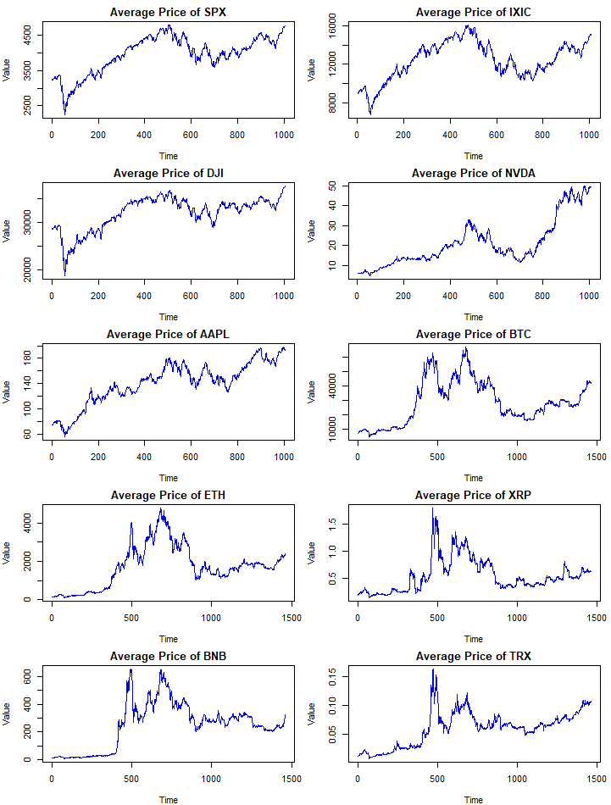

Appendix 2.
Plot of Log-Returns and Squared Log return of Sample data
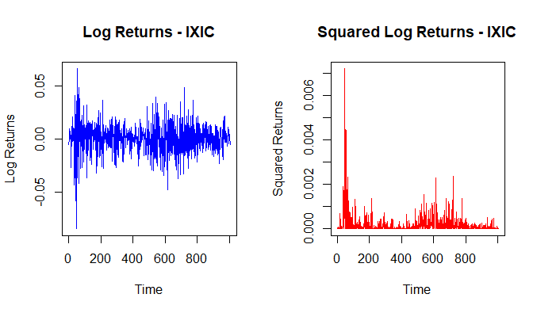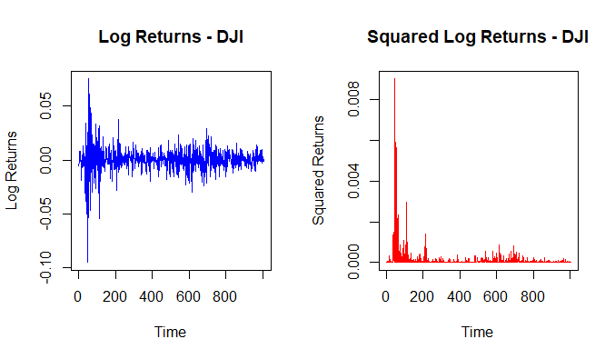
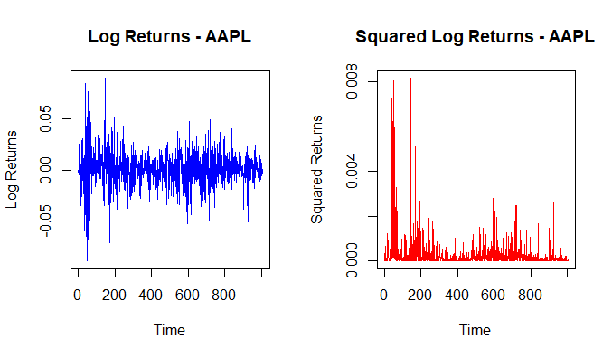

Appendix 2. Continued
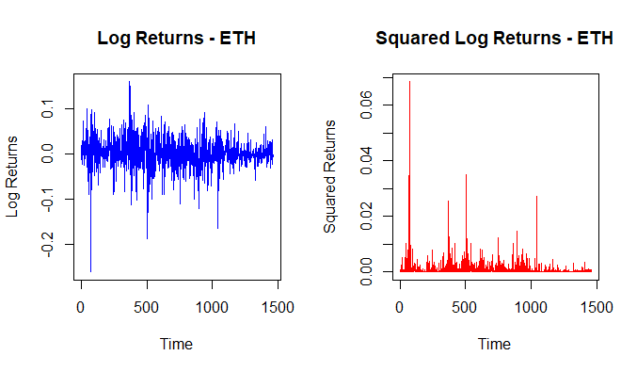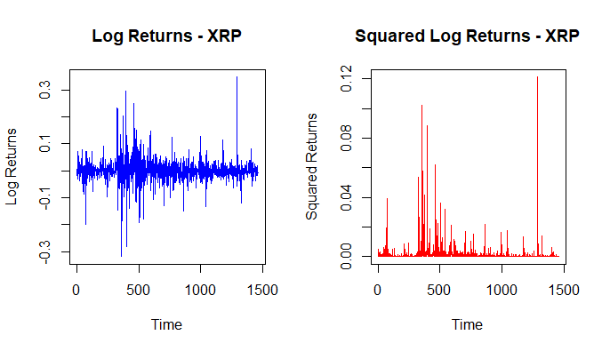
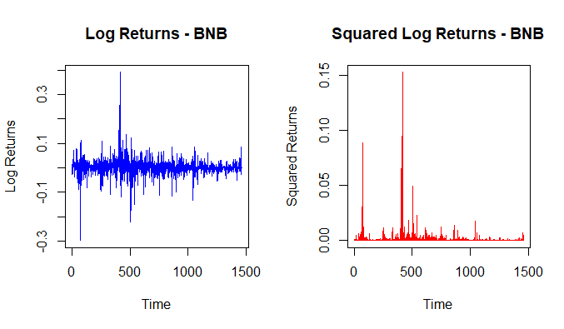
Appendix 2. Continued
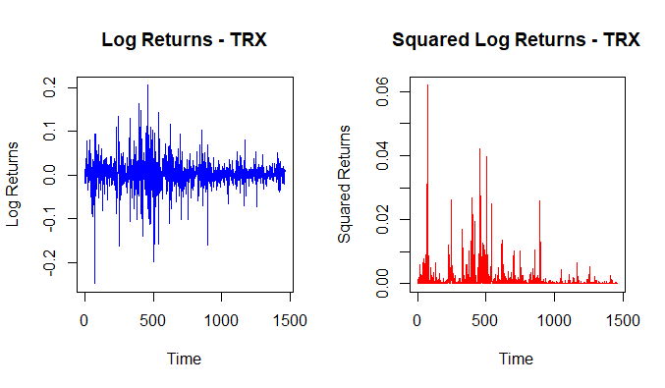

Appendix 3.
Plot of Autocorrelation Function (ACF) Analysis of Squared Log Returns

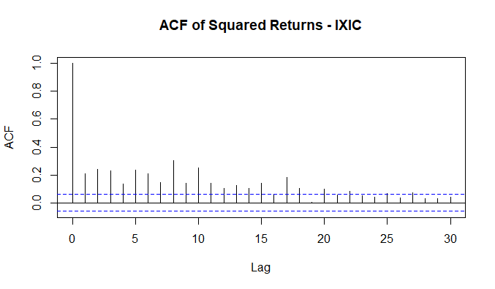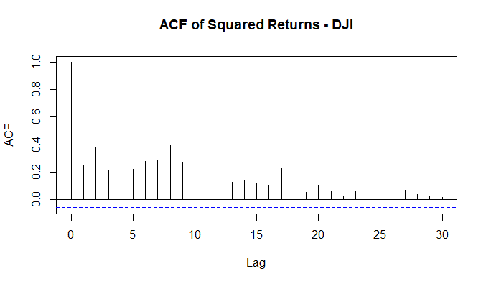
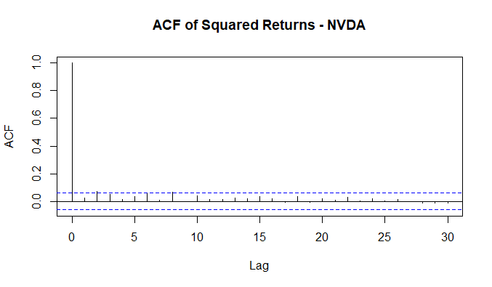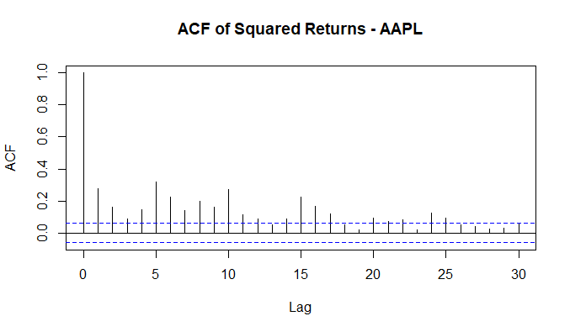
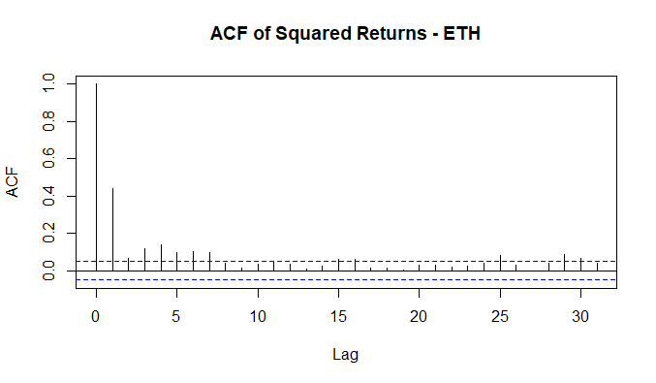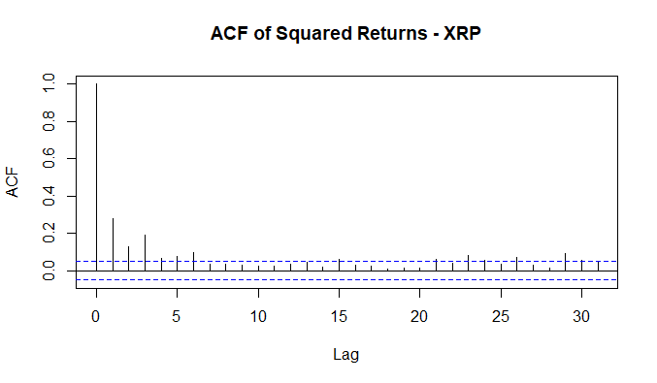
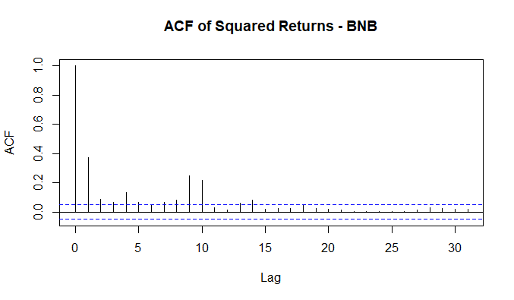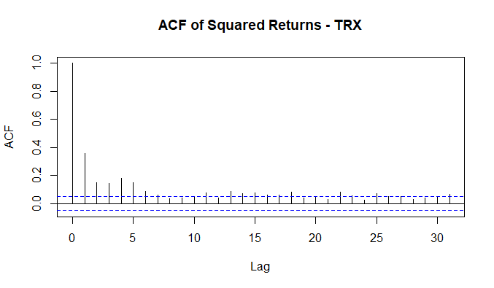

Appendix 4.
Results of Advanced Model selection in R Programming

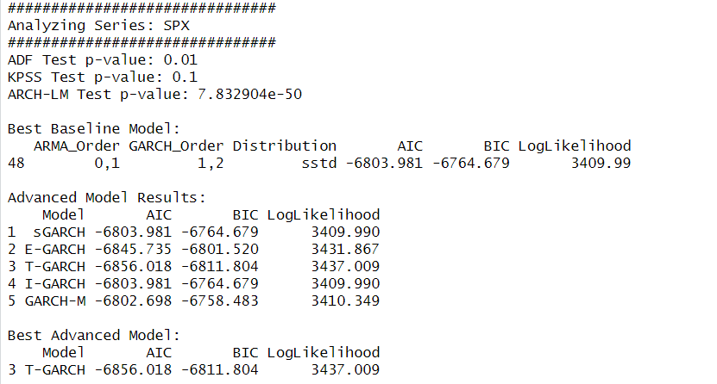
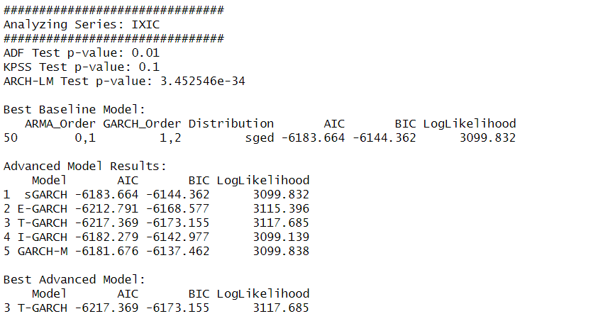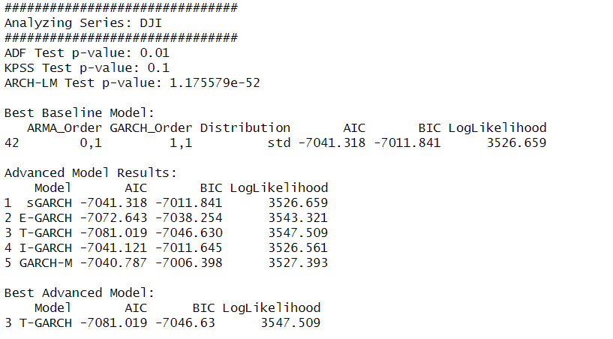
Appendix 4. Continued

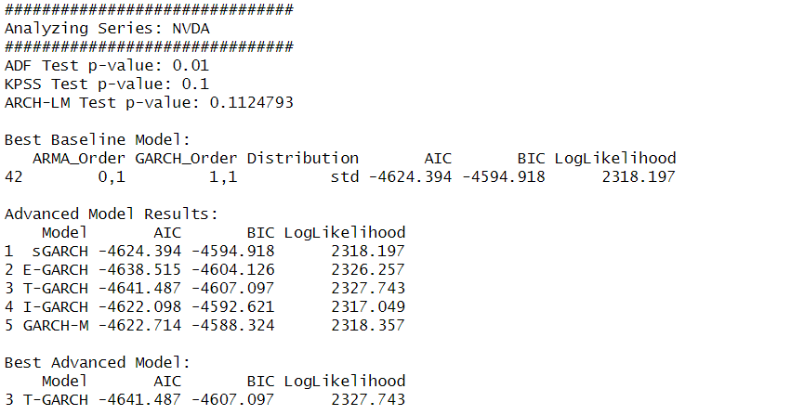
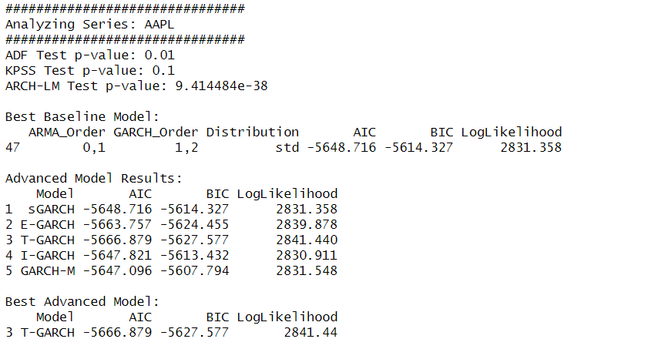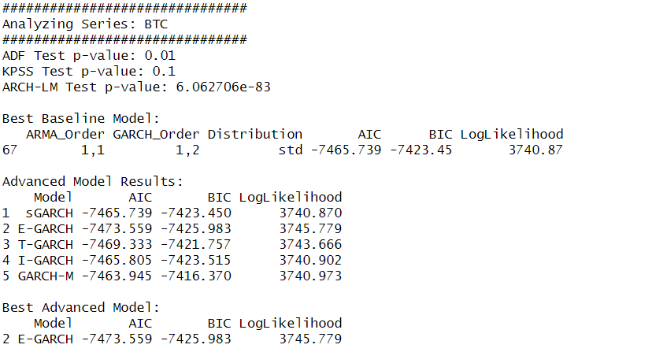
Appendix 4. Continued

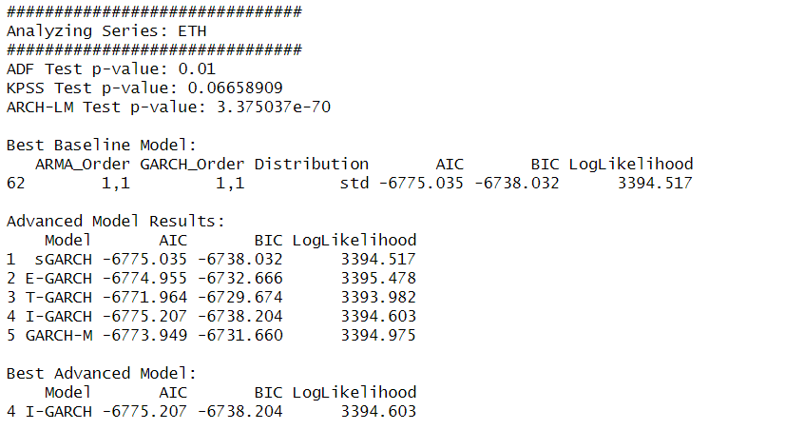
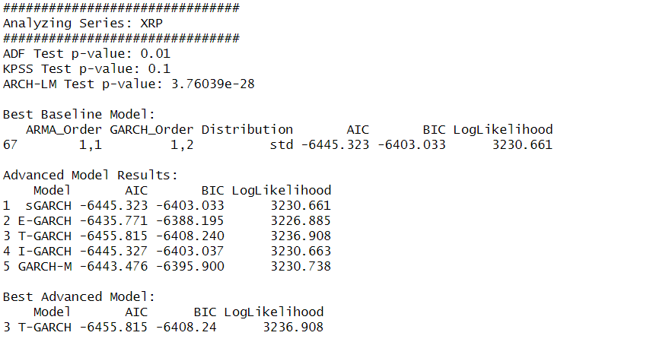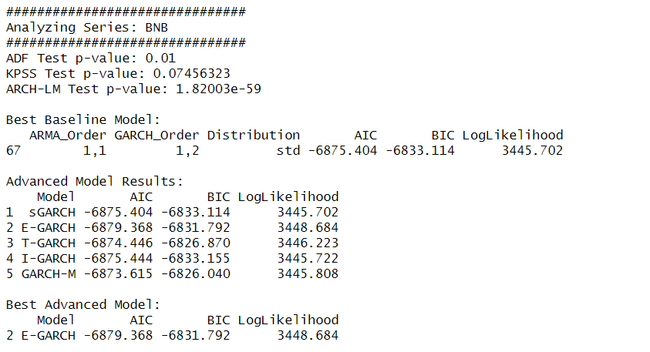
Appendix 4. Continued

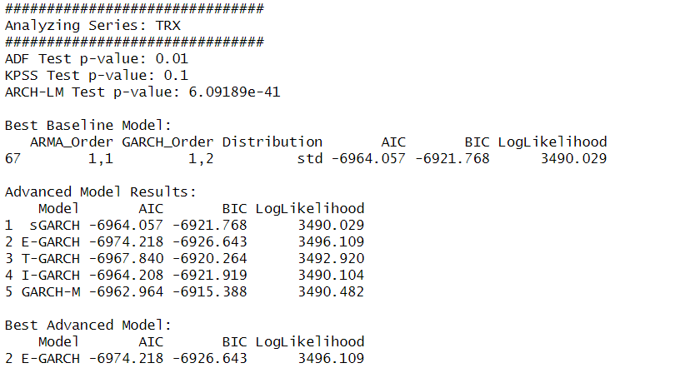

Appendix 5.
Plots comparing forecast of advanced GARCH models and EWMA with actual volatility 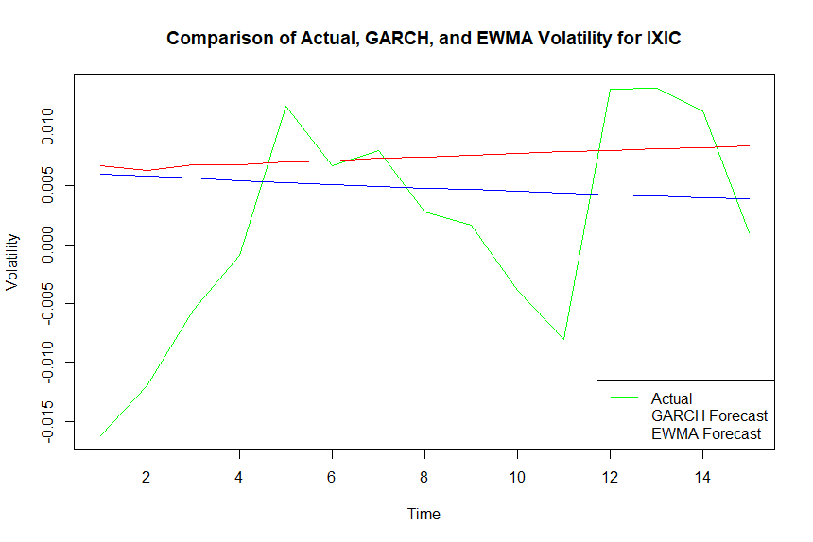 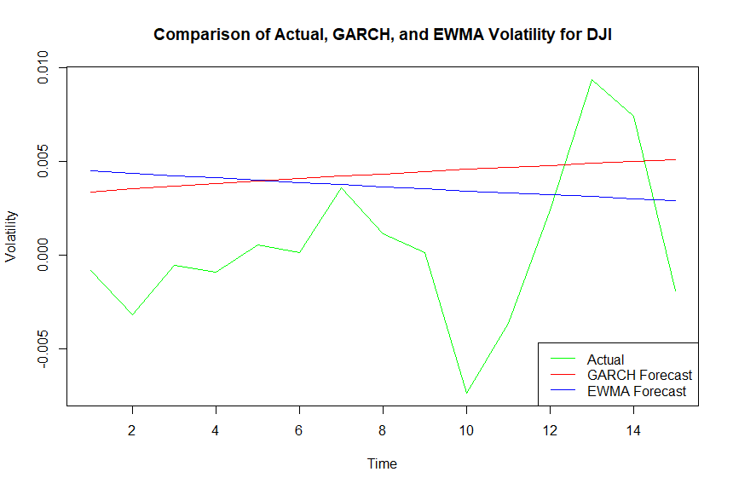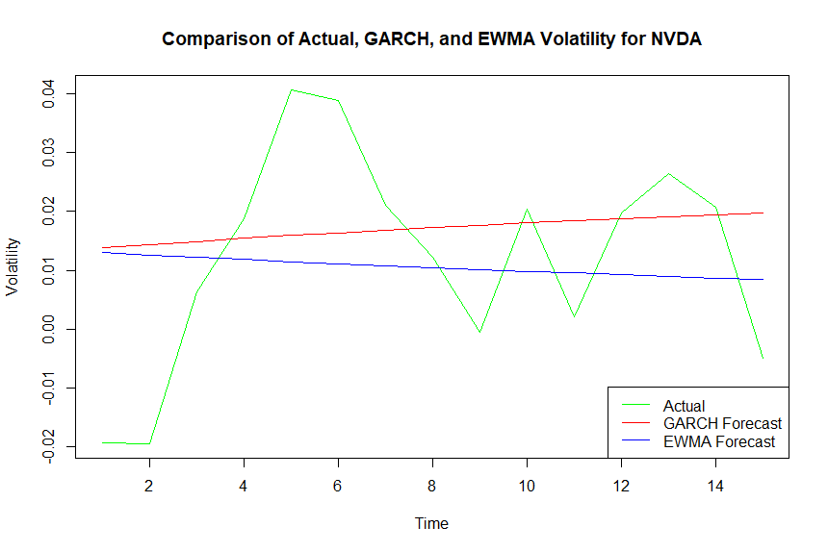

Appendix 5. Continued
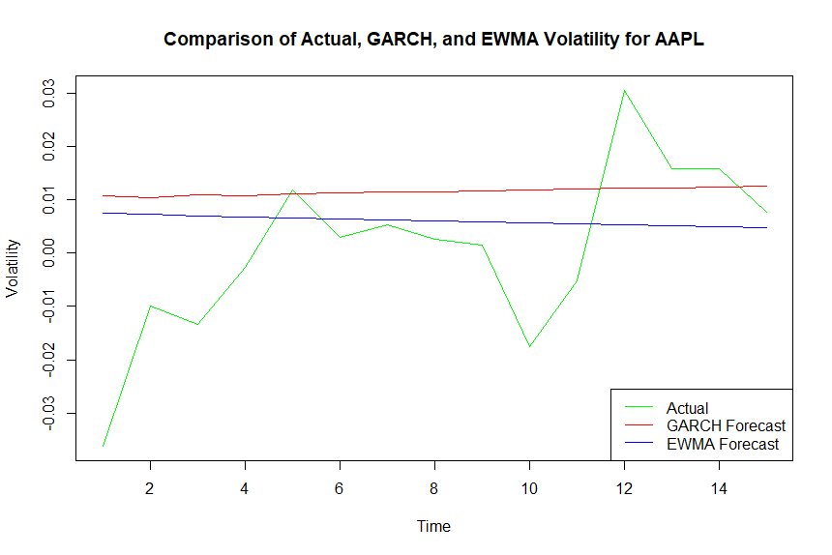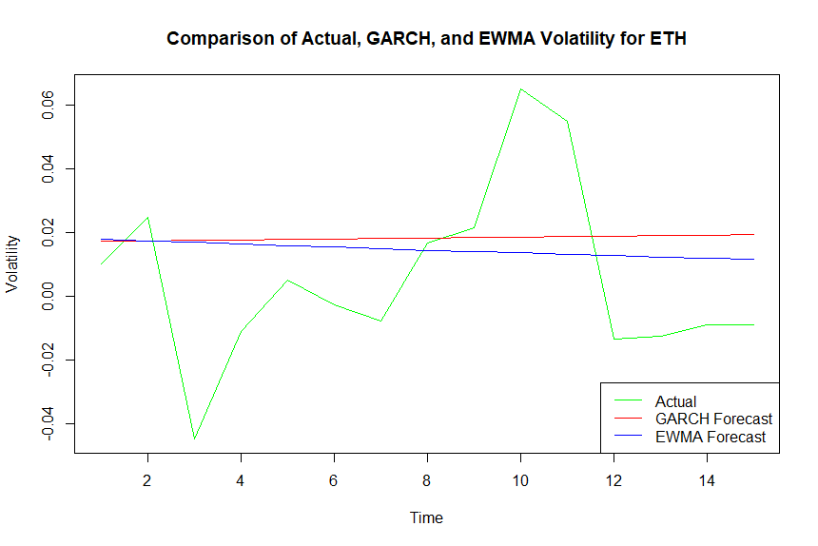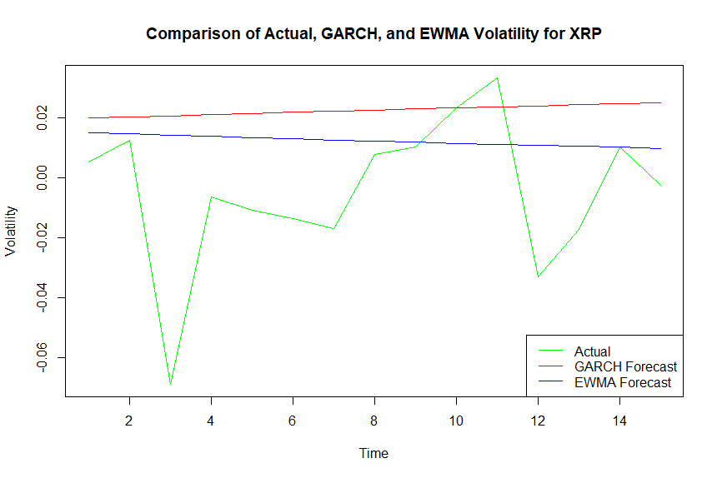
Appendix 5. Continued
