**Using GitHub for Labs Submissions**

**Step#1:** Create a GitHub Account

**Step#2:** Create a Repository

1. Click the “+” on the top-right corner.

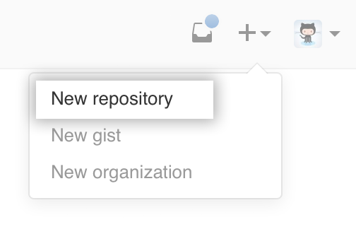

1. Give your repository a name. Select Public, check “Initialize this repository with a README” and click on the **Create Repository** button.

**Note:** The name of the repository should contain your roll number and name.

**Example: fa19becse0001-YourName**

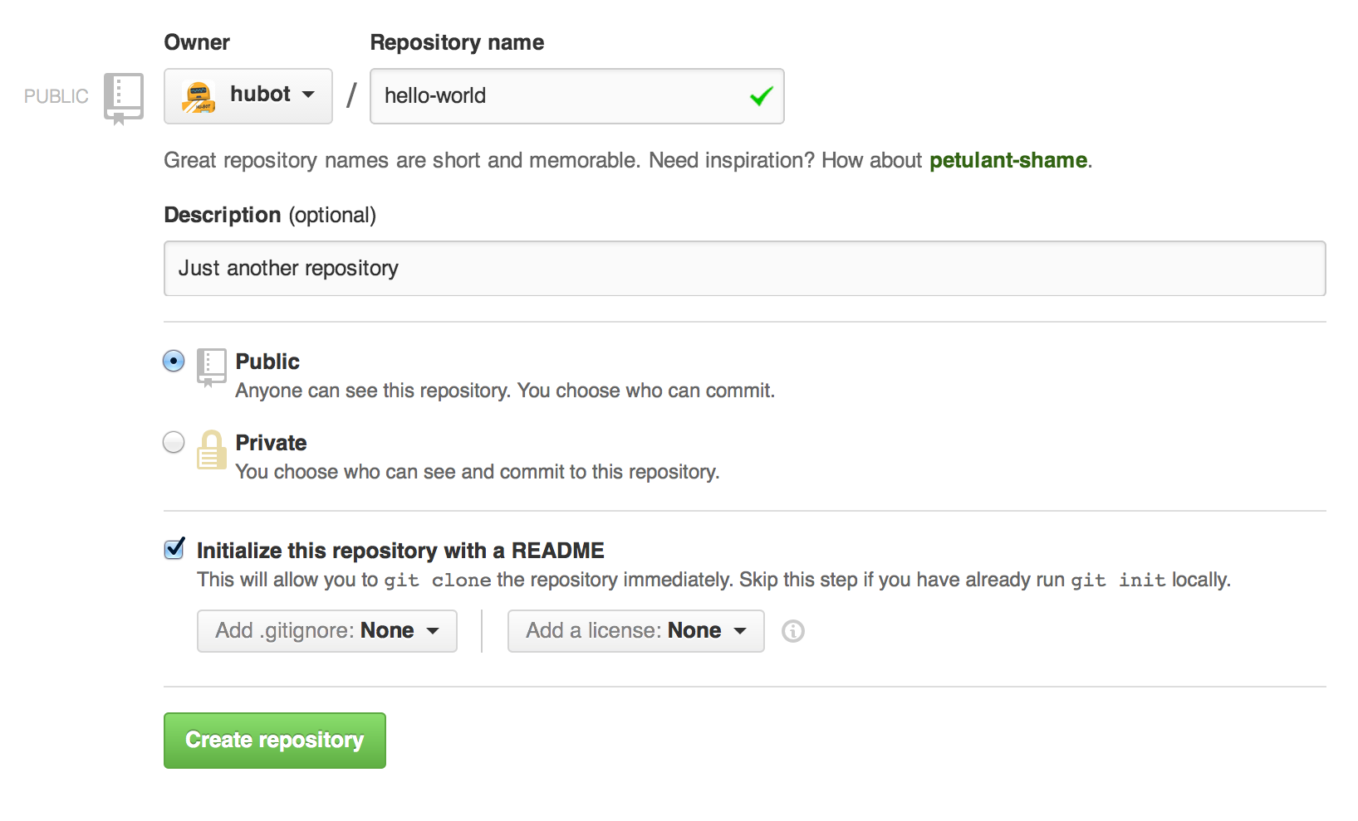

**Step#3:** Click the **upload files** button

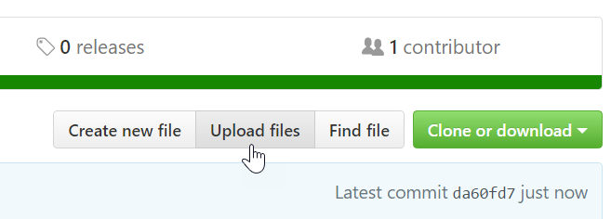

**Step#4:** Drag and drop the folder that contains your lab task and after the upload completes, click on the “**commit changes”** button

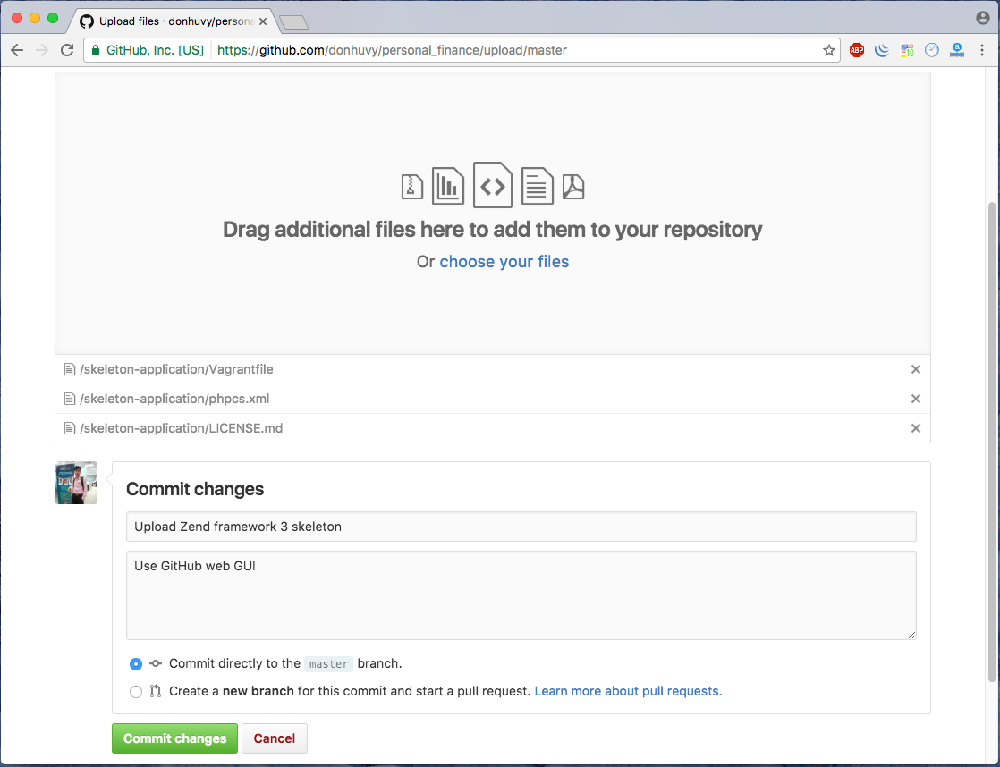

**Step#5:** Sharethe link of your repository on the contact section of rafia.shaikh@jinnah.edu

**For the folder that you will upload on GitHub**

**Step#1:** Create a folder for each Lab separately.

**Example: OS-Lab1**

**Step#2:** Keep all the task files in that folder. If any task requires you to create multiple files. Inside the lab folder, create a subfolder with the name Task1 or whatever number the task represents and put all your files of that task in it.