FitMap – SizeStream Detailed Project Report

1. Project Overview
This document provides a detailed analysis of the FitMap–SizeStream pipeline, including measurement extraction, AWS infra, KPIs, SQL samples, and data diagrams.

2. Data Flow Diagram
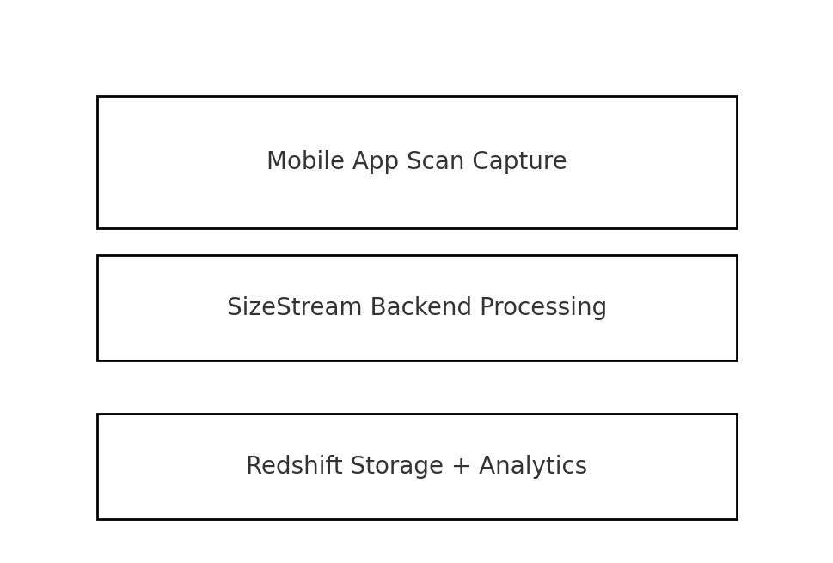

3. User Measurement Data
FitMap extracts over 120 body measurements categorized into primary, secondary, and derived metrics.

4. AWS Architecture Summary
AWS components include Redshift, S3, Glue, Lambda, QuickSight and IAM. These support ingestion, transformation, analytics, BI, and secure access.

5. Key KPIs
- Scan Completion Rate
- Measurement Confidence Levels
- User Funnel Drop-off Points
- Average Scan Duration
- Failed Scan Reasons Distribution

6. SQL Samples
Example SQL to compute scan success metrics:
SELECT
scan_log_reason_1,
COUNT(*) AS total_scans,
ROUND(100.0 * COUNT(CASE WHEN scan_log_reason_1 ILIKE '%scanCompleted%' THEN 1 END)::DECIMAL
/ NULLIF(COUNT(*),0),2) AS success_pct
FROM size_scans_metadata
GROUP BY 1;

