**UDYAM-UP-64-0025148 UPSA-1715473.**

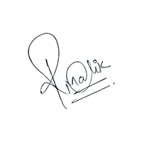

**C E R T I F I C A T E**

**WCEI**

Of Completion

WCEI certifies that

{{full_name}}

Has successfully passed the requirements for

{{course_name}}

Certification Date: {{date}} Certification ID: {{id}}

Founder & CEO