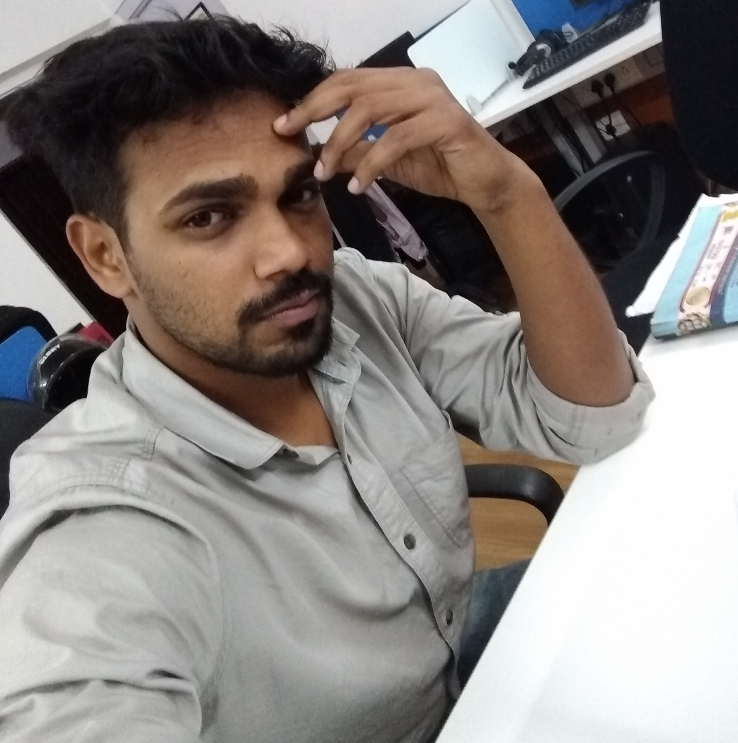
Curriculum Vitae
Mohammad Afzal

Personal Information

Address : 271, Sai Vihar, Rishikesh (249201)
Uttarakhand, India
Phone : (+91) 7222876247
Email : contact@afzalex.tech
Date of Birth : 05.10.1993 in Uttarakhand, India

Summary

Currently working in Nagarro as Senior Associate in Technology. I have more than 4 years of experience in Full-stack development with expertise in Java.

Have strong understanding of Data Structure, Algorithms and Design Patterns. Have worked on Spring, Angular, ReactJS, docker, mongodb, postgresql. Have experience in the field of System Adminstration of linux servers. I have contributed in key decision making and in the selection of technologies to develop projects in my current organization.

Apart from these technical skills I am a hobbyist Guitarist.

Professional Career

2017 – 2019 Senior Software Developer in Enbraun
Code Review, Software Architecting, System Administration, Recruitment of new software developers and Training of junior employees are some of core task apart from development during this period for Enbraun.

2015 – 2017 Software Developer in Enbraun
Worked on a web-application eResource Scheduler, a specialised collaborative (multi-user) and configurable web application that lets organisations schedule, plan and manage employees, equipment and other resources on projects. Development and Testing was core job during this period.

2014 – 2015 Freelance Projects
CQuiz, Desktop application, written in java Swing, developed to organize a quiz competition in ‘Graphic Era University’, Uttarakhand.

Educational Details

2015 Bachelors in Computer Science from
Uttarakhand Technical University with 66% aggregates

2011 Intermediate from CISCE board with 87% aggregates

2010 High school from ICSE board with 70% aggregates

Skills

- Java8, JavaEE - Git - npm - Restful Services
- Spring - Maven - nodejs - ReactJS
- Struts - Wildfly - AWS (EC2, RDS) - Java Swing
- RDBMS (Postgresql) - Mongodb - Stripe - Oauth 2.0

To know more please visit https://about.afzalex.tech Last updated on 1st January, 2020

