**M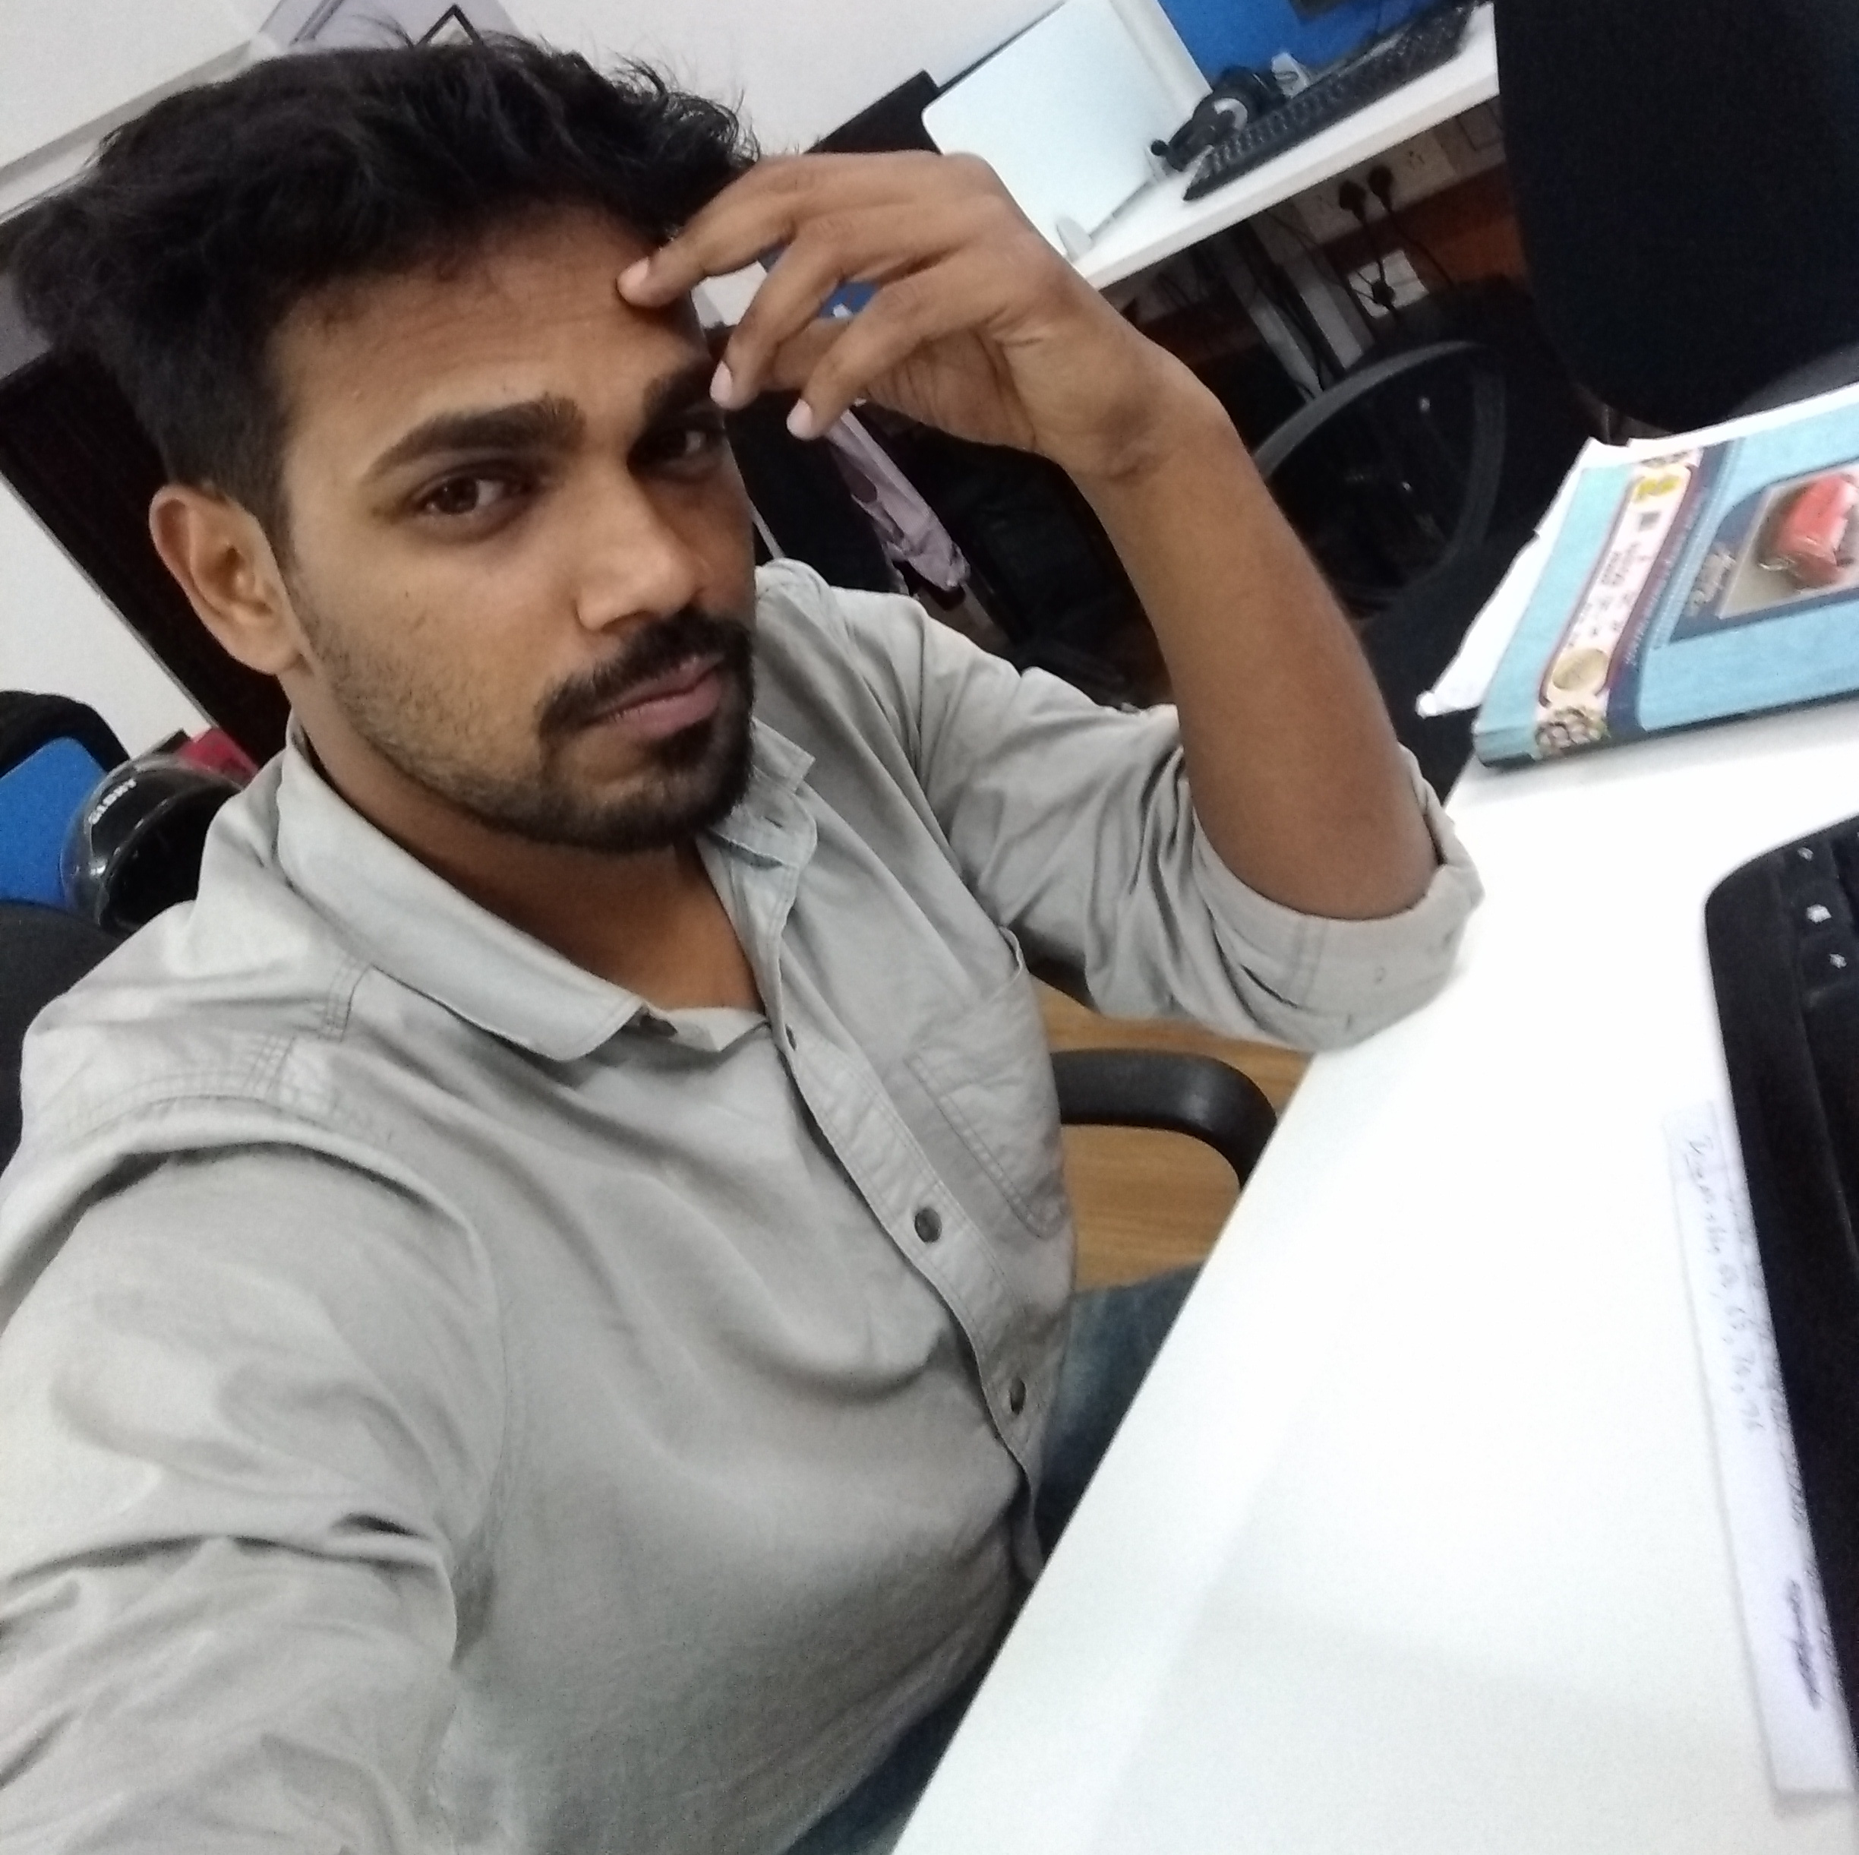ohammad Afzal**

Currently working in Enbraun as a Senior Software Developer.

I have more than 3 years of experience in Web Application

Development in current Company.

I am also active in stackoverflow.com and have more than 7000

reputation points there. Apart from these technical stuff I am a

hobbyist guitarist.

**PERSONAL DETAILS**

Email : [c](mailto:mohammad.afzal.cs@gmail.com)ontact@afzalex.tech

Date of Birth : 5th October, 1993

Permanent Residence: 271, Sai Vihar colony, Veerbhadra road, Rishikesh (249201), Uttarakhand

Citizenship : **Indian**

Marital Status: Unmarried

**PROFESSIONAL CAREER**

**2015 – 2017 Software Developer** in Enbraun

Worked on a web-application eResource Scheduler, a specialised collaborative (multi-user) and configurable web application that lets organisations schedule, plan and manage employees, equipment and other resources on projects. **Development** and **Testing** was core job during this period.

**2017 – 2019** **Senior Software Developer** in **Enbraun**

**System Administration**, **Recruitment** of new software developers and **Training** of junior employees are some of core task apart from development during this period for Enbraun.

**2014 – 2015** **Freelance Projects**

**CQuiz, Desktop application,** written in java Swing, developed to organize a quiz competition in ‘Graphic Era University’, Uttarakhand.

**EDUCATIONAL DETAILS**

2011 – 2015 Uttarakhand Technical University, Btech in Computer Science with 66% aggregates

2010 – 2011 Modern School Rishikesh, Intermediate from CISCE board with 87% aggregates

2010 Modern School Rishikesh, High school from ICSE board with 70% aggregates

**SKILLS**

- Java8, JavaEE - Git - npm - Restful Services

- Spring - Maven - nodejs - jQuery

- Struts - Wildfly - AWS (EC2, RDS) - Java Swing

- RDBMS (Postgresql) - Mongodb - Stripe - Oauth 2.0

For more information visit [https://about.afzalex.tech](https://about.afzalex.tech/) Last updated on 9th April, 2019