Image Processing and Computer Vision
Subtask 1 : The Viola-Jones Object Detector
The objective of the first subtask is to test the performance of the face detection system and the provided classifier. The resulting images are shown below:
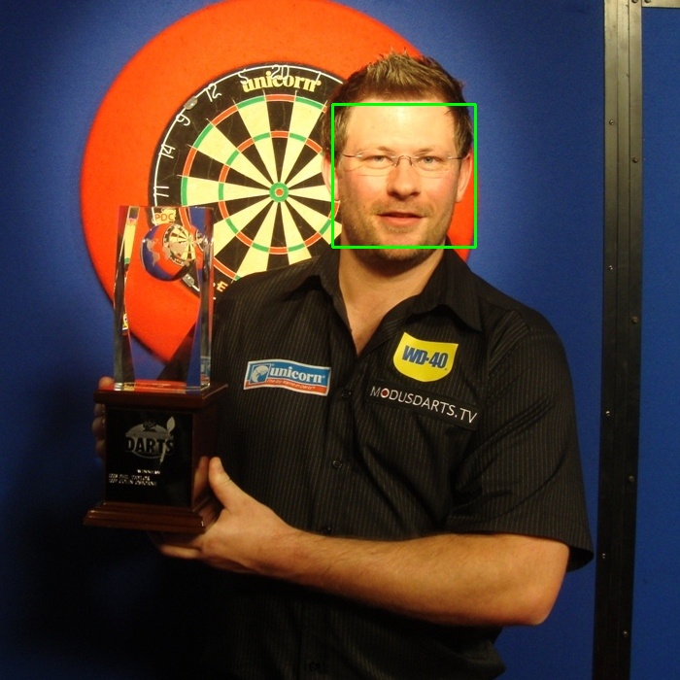
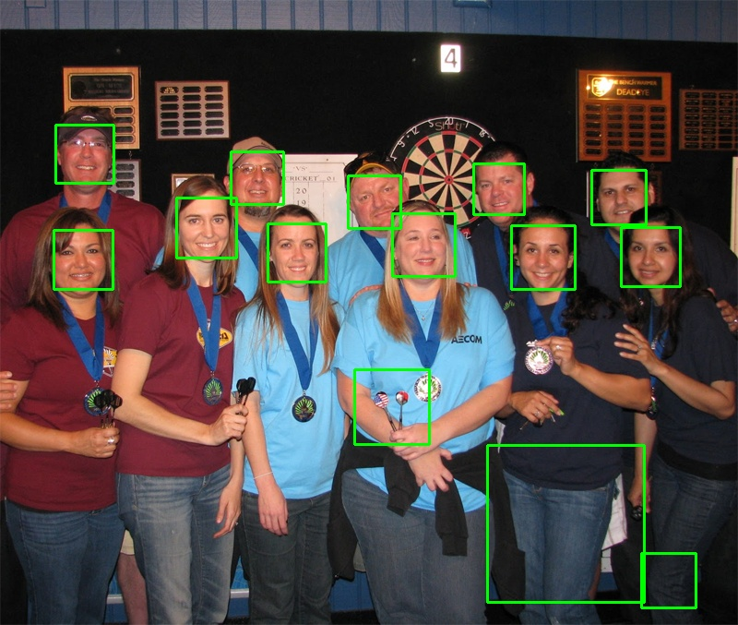
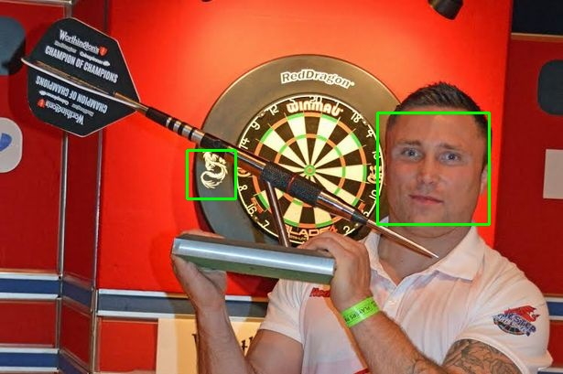
dart4.jpg
dart5.jpg
dart13.jpg
dart14.jpg
dart15.jpg

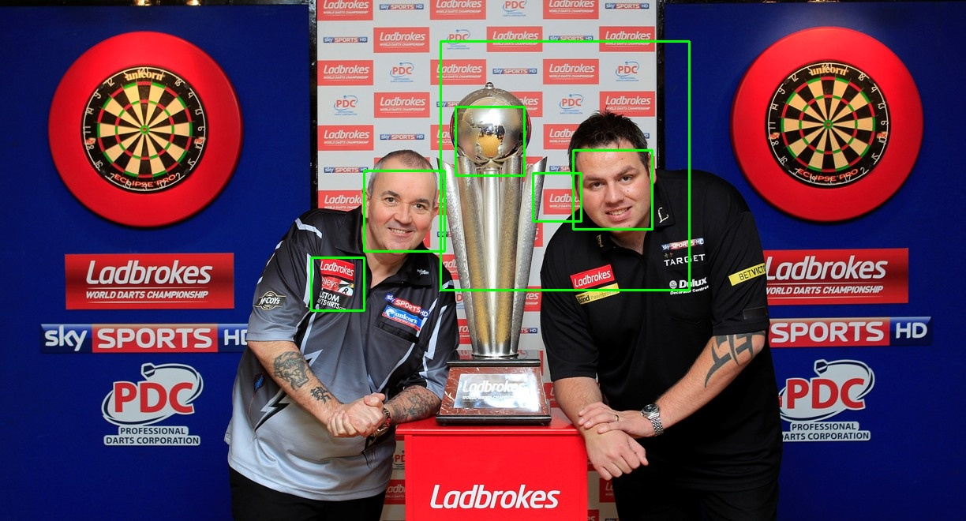
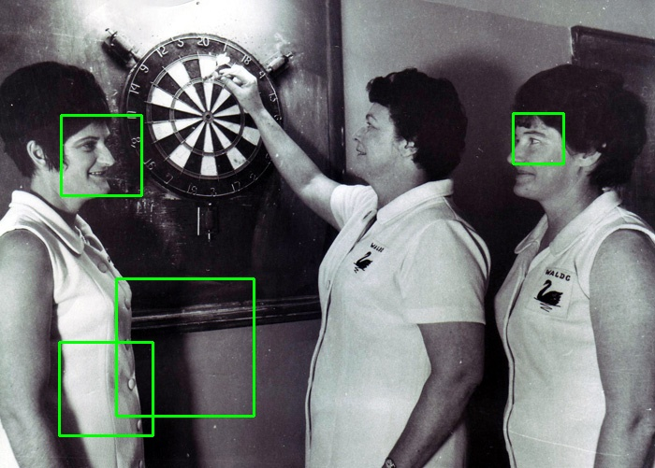

A possible way of measuring the performance of a binary classifier such as our face detection system is by calculating the true positive rate(TPR). This is defined mathematically as TPR=TP/(TP + FN) where TP and FN stand for “true positive” and “false negative” respectively. In simple terms, it is the number of detected faces(true positives) divided by the total number of faces(true positives and false negatives).
This metric, which is also known as recall or sensitivity of the detector, can sometimes be difficult to measure accurately due to the fact that a large sample is required for this to be a true estimate of the probability that an arbitrary member of a class is detected correctly. For example, in the first picture(dart4.jpg), since there is only one face which was correctly detected(i.e. no false negatives/undetected faces), we have a TPR=1/1=100%. For pictures dart5.jpg and dart15.jpg, TPR is equal to 11/11=100% and 2/3=66.67% respectively. In addition, depending on the picture and the object being detected, false negatives can sometimes be difficult to measure just by observation and hence it can be impossible to calculate TPR.
The true positive rate is not the only metric by which the performance of a detection system can be estimated. Since TPR does not take into account the number of objects that were falsely classified as faces(i.e. false positives or FP), we can always increase TPR by increasing the sensitivity of a system. In fact, a system that classifies every possible object in an image as a face, would still have a TPR of 100% but of course that would not be a very useful classifier because it would have very low precision. This suggests that another metric is needed which would also take into account the false positives. That is the F1-score and it is defined as F1=2TP/(2TP+FN+FP). For example, for dart15.jpg this is F1=2*2/(2*2+1+2) = 4/7 = 57.14%. To calculate this, we have written a function that attempts to match each rectangle returned by our system with a defined set of rectangles indicating where each face truly is in a picture(ground truth). A pair of rectangles are matched when the ratio of their overlap to the total(union) of their areas is greater than 0.3[I/(A1+A2-I)]. The number of matched pairs of rectangles is our true positive value. The number of unmatched rectangles in our ground truth array is our false negative values and the number of unmatched rectangles from those that were returned by our system is the false positive value.
Subtask 2 : Building & Testing our own Detector
The objective of the second subtask is to use two OpenCV tools, one that will produce a set of 1000 positive train dartboard sample images from a given dart image and another for training the classifier in order to detect dartboards in images, instead of faces, through the boosting procedure. During the different training stages, the boosting provides updates about the machine learning aspect of each stage, TPR and FPR. Here are the results we obtained when running the training procedure:
INSERT GRAPH HERE

Observing the values obtained we can see that, initially, there exists a high sensitivity threshold, meaning a high TPR as well as a high FPR. As the training procedure proceeds to the next training stage, it increases the number of features to be used for classifying, which, in turn, will discard false positives without altering the amount of the true positives. This is similar to the constraint optimization problem, where a large set of objects is initially detected and we optimize this set by getting rid of false positives. The next step of this subtask required that we run the dartboard detector using the cascade, storing all of the features obtained from the training procedure, to check on its current performance and visualize the results. Below is a list of the F1 scores for all the exmple images plus four example outputs with bounding boxes around detected objects:

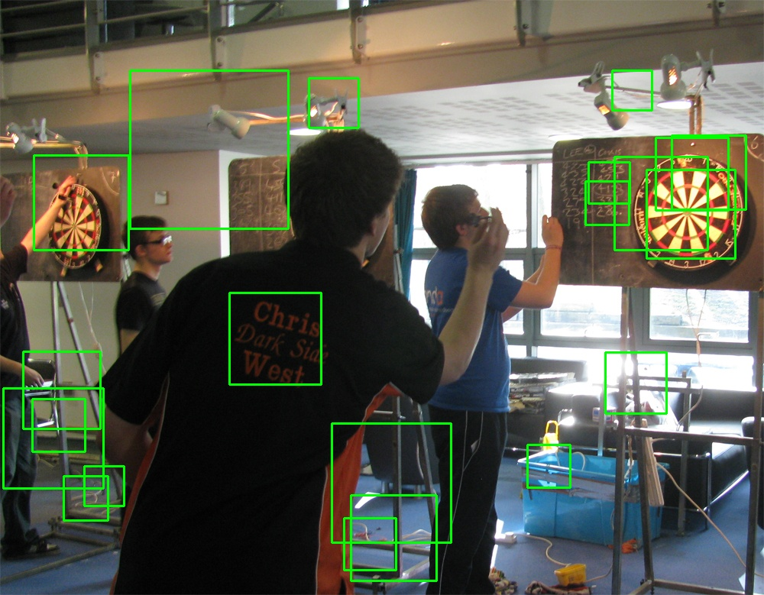
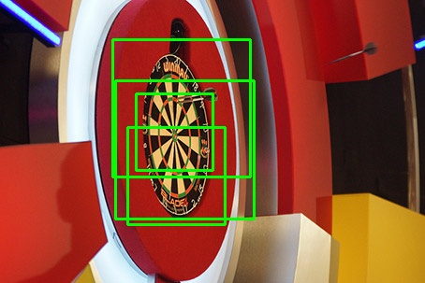
F1=2TP/(2TP+FN+FP) (TP) (FN)
dart0: 1/7 (1) (0)
dart1: 2/11 (1) (0)
dart2: 1/3 (2) (0)
dart3: 2/13 (1) (0)
dart4: 1/6 (1) (0)
dart5: 2/19 (1) (0)
dart6: 2/15 (1) (0)
dart7: 2/29 (1) (0)
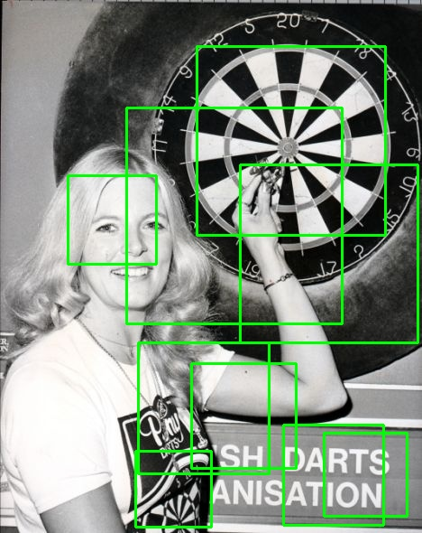
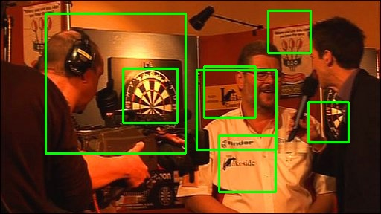
dart8: 4/23 (2) (0)
dart9: 4/11 (2) (0)
dart10: 6/35 (3) (1)
dart11: 2/5 (2) (1)
dart12: 2/5 (1) (0)
dart13: 1/8 (1) (0)
dart14: 4/39 (2) (0)
dart15: 2/9 (1) (0)

As we can observe from the output images, all of the dartboards were correctly detected, TP, but there exist a lot of FP detections as well. So given the graph above, we can now say for certain that all of the output have a TPR=1 correctly. We run the training procedure for another stage and we got better results with decreased number of FP detected, but moving on to a further fifth step would result to over-fitting, as in some of the TP were, wrongfully not detected. That is also the reason we prefer using a plot like the one done above, so that we can know when training is leading to over-fitting which can then lead to false results. As soon as the value of TPR falls below 1, then we can know that the training procedure has gone to far and will not detect dartboards that should be detected, just because they are slightly rotated or parts of the are obscured by another object.

