NVIDIA Merlin
A GPU-Accelerated Recommender Systems Framework
What it is · why it is used · how it works · and use cases for a media company like Dow Jones
Research briefing
Prepared 26 June 2026
Compiled from NVIDIA primary documentation and peer-reviewed sources (see References).

Contents

1. Executive summary
NVIDIA Merlin is an open-source, end-to-end framework for building large-scale recommender systems that run on NVIDIA GPUs. A recommender system is the engine that decides “what to show this user next” — the articles, products, videos, or ads ranked specifically for one person. Merlin packages the whole pipeline — data preparation, feature engineering, model training, and real-time serving — into interoperable libraries that keep the data on the GPU from start to finish.
Companies adopt Merlin for one core reason: recommendation at scale is bottlenecked by data movement and tabular processing, not just model maths. When you have hundreds of millions of interactions and thousands of categorical features, the data-preparation and training steps can take days on CPU clusters. Merlin’s GPU-native design compresses those steps dramatically and lets a small team iterate on models that would otherwise require a large distributed CPU fleet.
For a media and financial-information company like Dow Jones — publisher of The Wall Street Journal, Barron’s, MarketWatch, Factiva and Dow Jones Newswires — Merlin is relevant wherever personalization drives engagement and subscription revenue: ranking the article feed, recommending the “next read,” powering session-based recommendations for anonymous visitors, improving search and content discovery across the Factiva archive, retaining subscribers by surfacing relevant content, and targeting first-party advertising. These applications are inferential — there is no public confirmation that Dow Jones uses Merlin — but they map directly onto the framework’s documented capabilities.
A note on the evidence: the technical claims below are drawn from NVIDIA’s own primary documentation and a small set of peer-reviewed and industry sources. Performance figures (e.g. “up to 10× faster ETL”) are NVIDIA self-reported benchmarks and should be treated as vendor claims. Merlin is also a comparatively lower-activity project as of 2024–2025, which is discussed in Section 7.

2. What is NVIDIA Merlin?
NVIDIA Merlin is an open-source collection of libraries, models, and tools designed to make every stage of a deep-learning recommender system fast and reproducible on GPUs. Rather than a single monolithic product, it is a family of components that share data formats and can be composed into a single pipeline:
- NVTabular — GPU-accelerated feature engineering and ETL (extract, transform, load) for large tabular datasets.
- HugeCTR — a high-performance, C++/CUDA training engine for click-through-rate (CTR) and deep recommendation models, built to scale across many GPUs and nodes.
- Merlin Models — a library of standard, ready-to-use recommender architectures (DLRM, DCN, Wide & Deep, Two-Tower retrieval, and more) with TensorFlow and PyTorch APIs.
- Transformers4Rec — a library that brings Transformer (NLP-style) architectures to session-based and sequential recommendation, bridging Hugging Face Transformers and recommender use cases.
- Merlin Systems — tooling that assembles trained components into a production inference pipeline served by the NVIDIA Triton Inference Server.
- Merlin Core / Dataloader — shared utilities and high-throughput GPU data loaders that feed TensorFlow/PyTorch training without the CPU becoming a bottleneck.
Underneath, Merlin sits on the NVIDIA RAPIDS ecosystem (cuDF for GPU dataframes, Dask for scale-out) and CUDA. The design goal stated in NVIDIA’s documentation is an end-to-end pipeline that keeps data on the GPU — avoiding the repeated, expensive copies between CPU and GPU memory that dominate traditional recommender workflows.

3. Why is Merlin used? The problem it solves
Industrial recommender systems have a distinctive performance profile that general deep-learning tooling handles poorly. Merlin exists to address four specific pain points:

3.1 Massive, wide tabular data
Recommendation data is tabular and high-cardinality: millions of users, millions of items, and categorical features (article IDs, topics, authors, device types) that can each take millions of distinct values. Preparing this data — encoding categories, filling missing values, normalizing, computing target statistics — is computationally heavy. On CPU it can take hours to days for the largest datasets. NVTabular performs this on the GPU; NVIDIA reports ETL speed-ups of up to roughly 10× versus optimized CPU pipelines (a vendor benchmark).

3.2 Training throughput and data loading
Deep recommender models are often not compute-bound in the GPU’s tensor cores — they are data-loading bound. Standard framework data loaders feed batches too slowly to keep a GPU busy when each row has thousands of sparse features. Merlin’s dataloaders and HugeCTR’s embedding handling are engineered to keep GPUs saturated, and HugeCTR scales the very large embedding tables (which can exceed a single GPU’s memory) across multiple GPUs and nodes.

3.3 Huge embedding tables
The embedding tables that map each user/item ID to a learned vector can run into hundreds of gigabytes to terabytes — far larger than one GPU’s memory. HugeCTR’s model-parallel embeddings and its Hierarchical Parameter Server (which tiers parameters across GPU, CPU, and SSD) are purpose-built for this, which is the main reason large-scale CTR teams choose it over general-purpose frameworks.

3.4 A consistent path from research to production
Re-implementing feature transforms for serving that were prototyped for training is a classic source of training–serving skew (subtle bugs where the live system computes features differently from training). Merlin Systems exports the same NVTabular transformation graph into the serving pipeline on Triton, so the identical feature logic runs in production. This end-to-end consistency — not just raw speed — is a major reason teams adopt the whole framework rather than individual pieces.
In one sentence: Merlin is used because it turns a slow, multi-tool, CPU-heavy recommender workflow into a single GPU-accelerated pipeline that is faster to iterate on and consistent from training through to real-time serving.

4. How Merlin works: architecture
Merlin organizes a recommender into four stages — data → feature engineering → training → inference serving — with a feedback loop where new user interactions become tomorrow’s training data. The diagram below shows the components and how data flows between them.
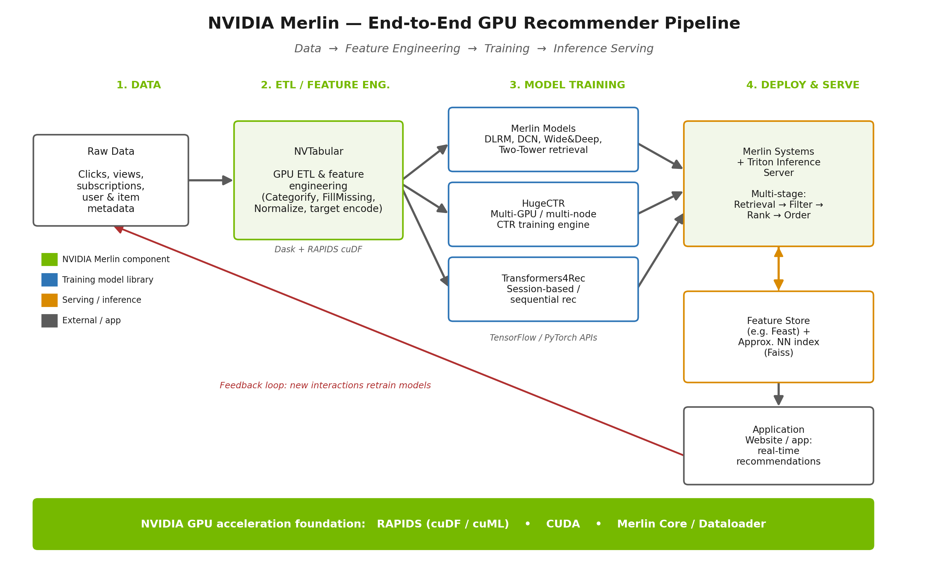
Figure 1. NVIDIA Merlin end-to-end recommender pipeline.

4.1 The components, stage by stage
Stage | Component | What it does
1 · Data | Raw event & metadata stores | Clicks, page views, dwell time, subscriptions, plus user and item (article) metadata land in data storage.
2 · Feature engineering | NVTabular | GPU ETL: encodes categories (Categorify), fills missing values, normalizes numerics, and builds target/count features. Outputs a saved transformation “workflow” that is reused at serving time.
3 · Training | Merlin Models | Ready-made architectures (DLRM, DCN, Wide & Deep, Two-Tower) via TensorFlow/PyTorch APIs — the fast on-ramp for standard models.
3 · Training | HugeCTR | C++/CUDA engine for very large CTR models; scales massive embedding tables across multiple GPUs/nodes with a Hierarchical Parameter Server.
3 · Training | Transformers4Rec | Transformer architectures for session-based / sequential recommendation; integrates with Hugging Face Transformers.
4 · Serving | Merlin Systems + Triton | Assembles feature transform + retrieval + ranking into a single Triton inference graph for low-latency, real-time recommendations.
Foundation | RAPIDS / CUDA / Merlin Core | GPU dataframes (cuDF), scale-out (Dask), data loaders, and shared utilities that keep data on the GPU end-to-end.

4.2 How a recommendation request flows: the multi-stage pattern
Production recommenders rarely score every item for every user — with millions of articles that would be far too slow. Merlin Systems implements the standard multi-stage pattern, where each stage narrows the candidate set:
- Retrieval — a fast model (typically a Two-Tower architecture) plus an approximate-nearest-neighbour index (e.g. Faiss) pulls a few hundred or thousand plausible candidates from the full catalogue in milliseconds.
- Filtering — business rules remove ineligible items (already-read articles, region-locked content, paywall constraints).
- Ranking — a heavier, more accurate model (e.g. DLRM/DCN) scores the surviving candidates precisely, using rich features pulled from a feature store.
- Ordering — final re-ordering applies diversity, freshness, and editorial business logic before the list is returned to the app.
A feature store (such as Feast) supplies up-to-date user and item features at request time, and NVIDIA documents an offline-to-online pattern where features computed in batch are pushed to a low-latency online store for serving. Because the same NVTabular workflow runs in this serving graph, the features the model sees in production match those it was trained on.

4.3 The feedback loop
Every recommendation generates new signals — what was shown, clicked, read, or ignored. These flow back into the data layer and become training data for the next model refresh, so the system continuously adapts to changing user interests and freshly published content. For a news publisher this loop is especially important because the item catalogue (today’s stories) turns over constantly.

5. Use cases for a media company like Dow Jones
Dow Jones operates subscription news and data products — The Wall Street Journal, Barron’s, MarketWatch, Investor’s Business Daily, Factiva, and Dow Jones Newswires. Its commercial model depends on acquiring subscribers, keeping them engaged, and reducing churn, plus monetizing a vast professional content archive. The following use cases map Merlin’s capabilities onto that business. (These are illustrative applications, not confirmed deployments.)

5.1 Article feed personalization & “next read”
Rank each reader’s home feed and “recommended for you” modules using a Merlin Models ranking model (DLRM/DCN) over features like reading history, topics followed, recency, and section affinity. This is the highest-value, most direct fit — more relevant feeds increase articles-per-visit and time spent, the leading indicators of subscriber retention.

5.2 Session-based recommendation for anonymous & new visitors
A large share of a news site’s traffic is logged-out or first-time visitors arriving from search or social, for whom there is little or no history. Transformers4Rec is purpose-built for exactly this: it predicts the next item from the current session’s clicks alone. This directly supports converting anonymous readers toward registration and subscription by showing a compelling next article in real time.

5.3 Subscriber retention & churn reduction
Engagement is the strongest predictor of renewal. A Merlin-powered system that reliably surfaces relevant content — newsletters, “while you were away,” topic digests — raises habitual usage. The same feature pipeline can feed a churn-propensity model so that at-risk subscribers receive re-engagement recommendations before they lapse.

5.4 Content discovery & search ranking across Factiva
Factiva is a professional research archive of thousands of sources. Personalized ranking and retrieval can improve how professionals discover relevant articles, companies, and topics — the Two-Tower retrieval + ranking pattern applies to surfacing the most relevant documents for a query or a user’s research profile, complementing keyword search with behaviour-aware relevance.

5.5 Cross-property & cross-format recommendation
Recommend across the portfolio — a WSJ markets reader nudged toward a relevant Barron’s analysis, a MarketWatch ticker follower toward a Newswires alert, or an article reader toward a podcast or newsletter. Shared user embeddings learned by Merlin let signals from one property inform recommendations on another, increasing portfolio-wide engagement and cross-sell.

5.6 First-party advertising & sponsored-content targeting
Merlin’s lineage is in click-through-rate prediction — the core of digital advertising. With first-party, consented data, Dow Jones could rank house ads, sponsored content, and subscription-upsell offers using the same CTR models (DLRM/HugeCTR) the framework was designed for, improving yield on premium inventory without third-party tracking.

5.7 Newsletter & notification optimization
Decide which stories go to which subscriber and when, framing email/push as a recommendation-and-ranking problem. Personalized newsletters typically lift open and click rates, reinforcing the daily habit loop that underpins retention.
Summary: fit and priority
Use case | Merlin component(s) | Primary business value | Fit
Feed personalization / next-read | Merlin Models (ranking) | Engagement, time-on-site | Strong
Session-based rec (anonymous) | Transformers4Rec | Conversion of new visitors | Strong
Subscriber retention / churn | Full pipeline + feature store | Renewal, LTV | Strong
Factiva discovery / search | Two-Tower retrieval + ranking | Product value, B2B stickiness | Moderate
Cross-property recommendation | Shared embeddings | Cross-sell, portfolio engagement | Moderate
First-party ad / upsell targeting | HugeCTR / DLRM (CTR) | Ad yield, upsell revenue | Moderate
Newsletter / notification timing | Ranking models | Habit formation, open rates | Moderate

6. Why the GPU-native design matters for a publisher
- Freshness: news catalogues churn hourly. Faster ETL and training (NVTabular + HugeCTR) mean models can be refreshed frequently so today’s stories are recommendable quickly — a real constraint that slow CPU pipelines struggle with.
- Scale at lower fleet cost: GPU acceleration can replace large CPU clusters for the ETL and training stages, which NVIDIA positions as a total-cost advantage (a vendor claim worth validating against your own workloads).
- Real-time serving: Triton-based serving targets the low latency needed to personalize a page as it loads.
- Consistency: reusing the NVTabular workflow at serving time reduces training–serving skew — fewer silent bugs in a revenue-critical system.

7. Limitations & considerations
A balanced assessment should weigh the following:
- Vendor benchmarks: performance figures (10× ETL, training-speed records) are NVIDIA self-reported and measured on NVIDIA hardware. Validate against your own data before forecasting savings.
- NVIDIA hardware lock-in: the speed comes from GPUs and CUDA. The benefits assume an investment in NVIDIA GPU infrastructure (on-prem or cloud).
- Project momentum: Merlin is a comparatively lower-activity open-source project as of 2024–2025. Some teams instead use TensorFlow Recommenders, PyTorch-based stacks (e.g. TorchRec), or managed cloud recommendation services. Assess maintenance and community support for a multi-year commitment.
- Engineering investment: an end-to-end Merlin deployment (feature store, ANN index, Triton serving, MLOps) is a substantial build. The largest payoff is at large scale; smaller catalogues may not need GPU-class tooling.
- Dow Jones specifics are inferential: there is no public confirmation that Dow Jones uses Merlin. The use cases above are derived from the framework’s documented capabilities and standard publishing recommendation patterns.

References
Technical claims are grounded in the following primary and secondary sources, collected and verified during research. Performance and adoption figures from NVIDIA blogs are vendor-reported.
- NVIDIA Merlin — Official Documentation (Overview & README) — https://nvidia-merlin.github.io/Merlin/stable/README.html
- NVIDIA Merlin product page — https://developer.nvidia.com/merlin
- NVTabular product page — https://developer.nvidia.com/nvidia-merlin/nvtabular
- NVIDIA-Merlin GitHub (main repository) — https://github.com/NVIDIA-Merlin/Merlin
- Merlin: A GPU Accelerated Recommendation Framework (RecSys / arXiv) — https://arxiv.org/pdf/2210.08803
- Transformers4Rec — Getting Started — https://nvidia-merlin.github.io/Transformers4Rec/main/getting_started.html
- Announcing NVIDIA Merlin (NVIDIA Developer Blog) — https://developer.nvidia.com/blog/announcing-nvidia-merlin-application-framework-for-deep-recommender-systems/
- Transformers4Rec: Building Session-Based Recommendations (NVIDIA Blog) — https://developer.nvidia.com/blog/transformers4rec-building-session-based-recommendations-with-an-nvidia-merlin-library/
- Merlin Systems — GitHub — https://github.com/NVIDIA-Merlin/systems
- Deploying Multi-Stage RecSys with Merlin Systems — https://nvidia-merlin.github.io/Merlin/stable/examples/Building-and-deploying-multi-stage-RecSys/02-Deploying-multi-stage-RecSys-with-Merlin-Systems.html
- Offline-to-Online Feature Storage for Real-Time Recommenders (NVIDIA Blog) — https://developer.nvidia.com/blog/offline-to-online-feature-storage-for-real-time-recommendation-systems-with-nvidia-merlin/
- Building Recommender Systems with Merlin (example) — https://nvidia-merlin.github.io/Merlin/stable/examples/Building-and-deploying-multi-stage-RecSys/01-Building-Recommender-Systems-with-Merlin.html
- NVIDIA Merlin Helps Fuel Clicks for Online Giants (NVIDIA Blog) — https://blogs.nvidia.com/blog/2022/01/18/nvidia-merlin-helps-fuel-clicks-for-online-giants/
- NVIDIA Merlin Powers Fastest Commercially Available RecSys Training (Blog) — https://developer.nvidia.com/blog/nvidia-merlin-powers-fastest-commercially-available-solution-for-recommender-systems-training/
- Session-Based Recommenders (NVIDIA Merlin) — https://developer.nvidia.com/merlin/session-based-recommenders
- News recommender systems — research review (Tandfonline, 2024) — https://www.tandfonline.com/doi/full/10.1080/16522354.2024.2343638

