Decoding Huffman codes

In 1952 David Huffman discovered an optimal compression algorithm for data. The algorithm assigns binary codes to items of data and generates a unique coding scheme based on that data. After transmittal, the binary code and its coding scheme are decoded to get back the original message. Today's zip files and .jpegs use variants of the Huffman compression scheme.

In this lab you will only decode a Huffman message. As an example, suppose the message is

0010010111010100

and its Huffman coding scheme is
T | 00
S | 01
<space> | 101
H | 11
J | 100

Then the decoded message is: ____ ____ ____ ____ ____ ____ ____

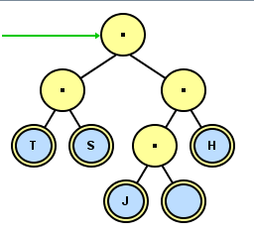
In a computer, the Huffman coding scheme arrives as a text file from which you must construct a binary tree. The zeroes and ones describe the path to get to the leaf, where a "0" means a left branch and a "1" means a right branch. The tree's nodes all have values of null, except for each leaf, which has the value of the letter. The scheme above turns into a tree looking like this:

After the Huffman tree is built, the binary text is decoded by following the zeroes and ones to each leaf. As you can see for yourself, each path is unique, i.e., no character's code is a prefix of any other character's code.

Assignment
Write the program deHuffman that prompts the user to read two files, the binary message and the Huffman coding scheme. Then decode and output the message. At the beginning, use the two files message.tj.txt and scheme.tj.txt . There are also several pairs of test files in the folder, with more available at http://academics.tjhsst.edu/compsci/parallel/huffman/index.php

