Lab16
Mouse Input
Objective
To modify the “Get the Prize” lab (Lab 12) to include mouse input.

Background
Not all listeners are ActionListeners registered with Timers. You can also register a MouseListener with the JPanel itself, as on Line 32.
16 public PrizePanel()
17 {
. . .
30 t = new Timer(0, new Listener());
31 t.start();
32 addMouseListener(new Mouse());
33 }
. . .
37 private class Mouse extends MouseAdapter
38 {
39 public void mousePressed( MouseEvent e )
40 {
41 ball.setX( e.getX() );
42 ball.setY( e.getY() );
43 }
44 }

The Listener object on Line 30 is the same Listener from Lab12, which implements the ActionListener interface, which controls the motion of the objects.

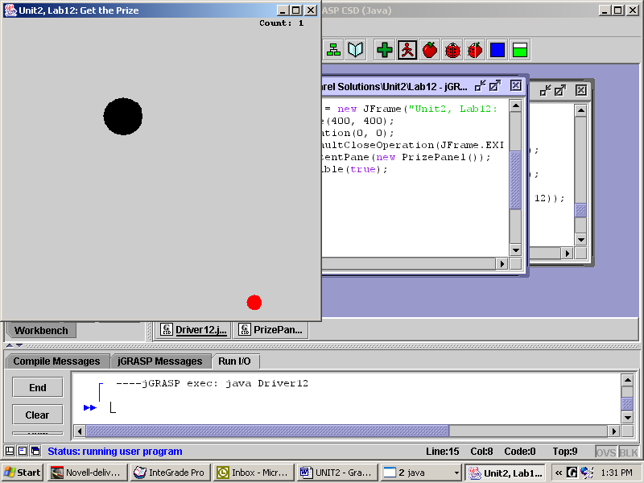
The Mouse object on Line 32 could either implement the MouseListener interface or extend the MouseAdapter class. If you implement MouseListener you’ll need to define five methods, even if you only use one of them. On the other hand, as a convenience, the MouseAdapter class provides default (empty) definitions for these methods, so only the methods that you override need to be defined.

Notice that e.getX() calls an instance method of a mysterious MouseEvent object named “e”. This object e is no doubt instantiated somewhere up in the MouseAdapter hierarchy. Whenever you click, this e object is automatically passed to the mousePressed method. The e object has its own set of methods. Thus, e.getX() returns the x location of the click, and similarly for e.getY(). Study Lines 41 and 42, which move the ball to the spot where you click.

Specification
Copy all files from Lab12. Set the JFrame's size to (408, 438), which makes the mouse's location in the JFrame correspond to its location in the JPanel. Then modify the mousePressed method to get three different behaviors from e:
button | Boolean method | desired behaviors
left click | <none> | moves the polkadot to where you clicked
right click | e.isMetaDown() | moves the ball to where you clicked
Shift + left click | e.isShiftDown() | randomly changes the speed and direction of the ball

Test Data
Go to www.tjhsst.edu/compsci.

Extension
Implement an interesting behavior that is allowed by the MouseMotionListener interface. MouseMotionListener objects are registered with the addMouseMotionListener method.

