Digital Forensic Investigation Report
Forensic Analysis of the M57 Jean Disk Image

Case ID: DFIR-001
Case Name: M57 Jean Forensic Examination
Investigator: Gabara Agata
Organization: Personal Digital Forensics Portfolio
Tool Used: Autopsy 4.23.1
Evidence Source: M57 Jean Disk Image (Digital Corpora)
Evidence Format: EnCase E01
Report Date: 26 June 2026

Confidentiality Notice
This report was prepared for educational purposes using a publicly available forensic training image provided by Digital Corpora. All findings relate exclusively to the training dataset.

1.Executive Summary
The purpose of this investigation was to perform a forensic examination of the M57 Jean disk image using Autopsy 4.23.1. The analyzed evidence is part of the publicly available Digital Corpora forensic training dataset and was examined in a controlled laboratory environment.
The objective of the investigation was to identify and analyze digital artifacts that could be used to reconstruct user activity on the examined system. The analysis focused on operating system information, user accounts, installed software, browser artifacts, recently accessed documents, downloaded files, email artifacts, USB device history, and deleted files.
During the examination, multiple user accounts were identified, including the primary user account jean. The forensic analysis revealed evidence of web browsing activity, downloaded software, email-related artifacts, recently opened documents, and several connected USB devices. The operating system was identified as Microsoft Windows XP Service Pack 3, and the recovered artifacts provided valuable insight into the workstation's configuration and user activity.
All findings presented in this report were obtained using standard forensic procedures. The original evidence was examined in a read-only environment, ensuring that its integrity remained preserved throughout the investigation.

2. Case Background
The purpose of this investigation was to conduct a comprehensive forensic examination of the M57 Jean disk image using Autopsy 4.23.1. The evidence analyzed during this investigation is part of the publicly available M57 Patents Scenario, developed by Digital Corpora as a forensic training dataset.
The M57 dataset simulates a realistic corporate workstation environment and is widely used for digital forensic education and professional training. It contains a variety of operating system artifacts, user-generated content, application data, and system metadata that enable investigators to practice evidence identification, artifact correlation, and forensic reporting.
This investigation was performed in a controlled laboratory environment using a forensic copy of the original evidence. No modifications were made to the source image during the examination, ensuring that the integrity of the evidence was preserved throughout the analysis.
The examination focused on identifying artifacts that could assist in reconstructing user activity and understanding how the workstation was used. Particular attention was given to browser activity, user accounts, installed software, document access, removable storage devices, email artifacts, and deleted files.

3. Investigation Objectives
The primary objectives of this forensic examination were:
- Identify the operating system and workstation configuration.
- Enumerate all local user accounts.
- Examine installed software and applications.
- Analyze recently accessed documents.
- Review browser history, downloads, and bookmarks.
- Identify email-related artifacts.
- Detect removable USB storage devices connected to the system.
- Examine deleted files and recover available evidence.
- Review image metadata where available.
- Correlate recovered artifacts to reconstruct user activity.
- Document findings in accordance with digital forensic best practices.

4. Evidence Description
4.1 Evidence Source
The forensic examination was conducted using the M57 Jean training disk image obtained from the Digital Corpora repository. The dataset is intended for educational and research purposes and simulates a realistic Windows workstation used in a corporate environment.
The evidence was provided in the EnCase Evidence File Format (E01) and consisted of two segmented files:
Evidence ID | File Name | Format
E-001 | nps-2008-jean.E01 | EnCase Evidence File
E-002 | nps-2008-jean.E02 | EnCase Evidence File (Segment 2)
The evidence image was imported directly into Autopsy for analysis without any modification to the original files.

4.2 Examination Environment
The forensic examination was performed in a controlled laboratory environment using the following software:
Component | Description
Operating System | Windows 11
Forensic Tool | Autopsy 4.23.1
Evidence Format | EnCase (E01)
Investigation Type | Static Disk Image Analysis
The investigation was conducted using a read-only forensic image to ensure that the integrity of the original evidence was preserved throughout the examination.

4.3 Enabled Ingest Modules
The following Autopsy ingest modules were enabled during the examination:
- Recent Activity
- File Type Identification
- Extension Mismatch Detector
- Embedded File Extractor
- Picture Analyzer
- Email Parser
- Encryption Detection
- Interesting Files Identifier
- Keyword Search
- Hash Lookup
These modules were used to automatically identify and extract relevant forensic artifacts from the disk image.

5. Examination Findings
5.1 Operating System Information
The initial phase of the investigation focused on identifying the operating system and basic workstation configuration. System information recovered by Autopsy confirmed that the examined image originated from a Microsoft Windows XP workstation.
The recovered operating system details provide important contextual information and establish the foundation for further forensic analysis. Knowledge of the operating system version is essential for interpreting system artifacts, registry structures, file locations, and user activity.
The following information was recovered during the examination:
Property | Value
Operating System | Microsoft Windows XP Service Pack 3
Architecture | x86 (32-bit)
Computer Name | JEAN-13FBF038A3
Windows Directory | C:\WINDOWS
The recovered operating system information confirms that the workstation was running Windows XP Service Pack 3. This information is consistent with the remaining forensic artifacts identified during the examination.

Evidence
Figure 2. Operating System Information
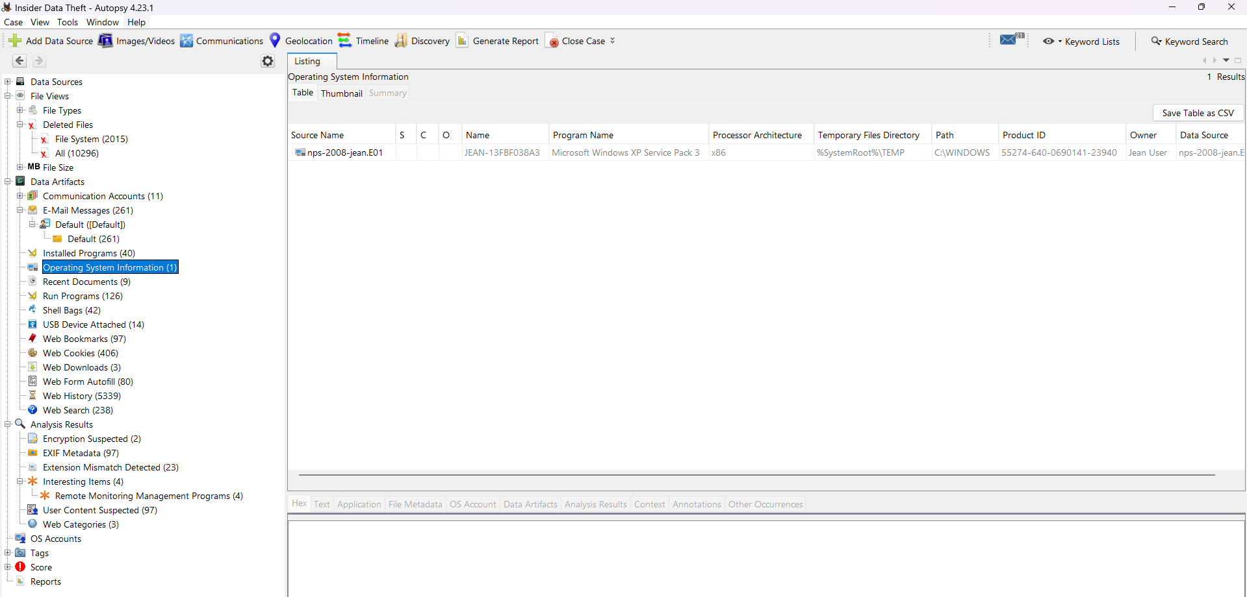

5.2 User Accounts
User account analysis was performed to identify individuals who had access to the examined workstation. Local user accounts provide valuable information during forensic investigations, as they help attribute system activity, document access, browser usage, and application execution to specific users.
Autopsy identified six local accounts within the examined Windows installation. These included two standard user accounts, one administrative account, and three default Windows service accounts.
The following accounts were identified:

Account | Description
Administrator | Built-in Windows administrative account.
jean | Primary user account associated with the workstation.
devon | Secondary local user account.
SYSTEM | Default Windows system account.
LOCAL SERVICE | Built-in service account used by Windows services.
NETWORK SERVICE | Built-in service account with limited network privileges.
Among the identified accounts, jean appears to be the primary workstation user. This conclusion is supported by the correlation of multiple forensic artifacts recovered during the examination, including recently accessed documents, browser activity, downloaded files, and email artifacts associated with this account.
The remaining built-in accounts (SYSTEM, LOCAL SERVICE, and NETWORK SERVICE) are standard Windows service accounts and do not indicate direct user interaction.
Identifying the primary user account is an important step in forensic investigations because it allows subsequent artifacts to be associated with a specific user profile and provides context for reconstructing user activity.
Evidence
Figure 3. Local User Accounts Identified by Autopsy
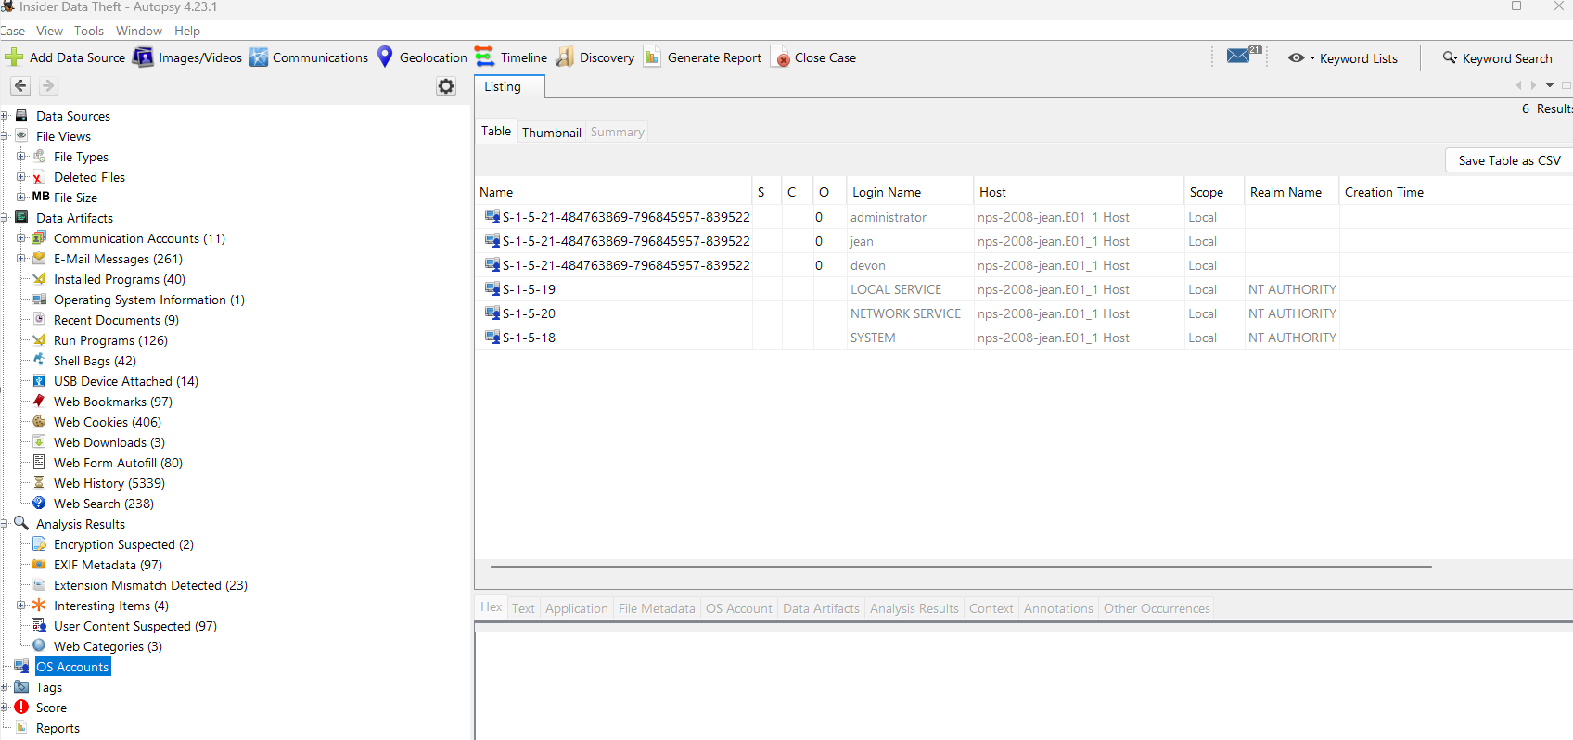

5.3 Installed Programs
The analysis of installed software was conducted to identify applications available on the examined workstation. Installed applications provide valuable context regarding the system's intended use, user activities, and the types of artifacts that may be present during a forensic examination.
Autopsy recovered information indicating that the workstation contained a combination of operating system components, productivity software, web browsers, communication tools, and virtualization software.
The following applications were identified during the examination:
Application | Purpose
Mozilla Firefox | Web browser
Microsoft Office 2000 | Office productivity suite
AIM Messenger | Instant messaging client
Adobe Flash Player | Browser multimedia plugin
VMware Tools | Virtual machine integration software
The presence of Mozilla Firefox is particularly significant, as it explains the browser-related artifacts recovered during the investigation, including browsing history, downloads, bookmarks, cookies, and cached web content.
The installation of Microsoft Office 2000 indicates that the workstation was capable of creating and editing business documents such as spreadsheets, presentations, and word processing files. This finding is consistent with the recently accessed documents identified later in the investigation.
The presence of AIM Messenger suggests that the workstation was used for instant messaging. Although no conclusions regarding user communications can be drawn solely from installed software, messaging applications may contain valuable forensic artifacts depending on the available evidence.
The recovered software inventory provides important context for understanding the overall environment in which the examined workstation was operated and supports the interpretation of subsequent forensic artifacts.
Evidence
Figure 4. Installed Programs
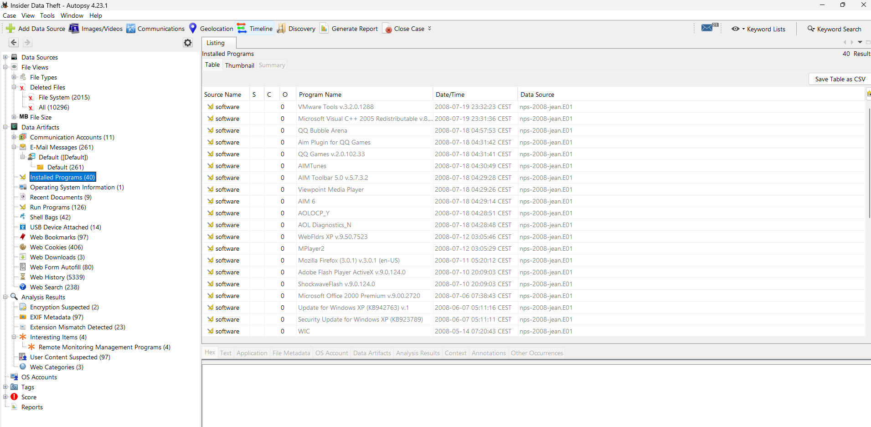

5.4 Recent Documents
The Recent Documents artifact was examined to identify files that had been accessed by the primary user prior to the acquisition of the forensic image. This artifact is generated by the Windows operating system and records shortcuts to files that were recently opened by users. Although the presence of a shortcut does not confirm that a file was modified, it provides strong evidence that the document was accessed at a specific point in time.
The examination identified several recently accessed files associated with the jean user profile. The recovered artifacts included Microsoft Excel spreadsheets, image files, and Windows shortcut files.
Examples of recently accessed documents include:
File Name | File Type
m57biz.xls | Microsoft Excel Spreadsheet
tag-cloud.jpg | JPEG Image
LightBlueTop.gif | GIF Image
11soft.flipflops.jpg | JPEG Image
The presence of m57biz.xls indicates that spreadsheet documents were accessed on the workstation. Since Microsoft Office 2000 was identified during the software inventory, this finding is consistent with the installed applications and supports the conclusion that the workstation was used for office-related activities.
Several image files were also identified among the recently accessed documents. While these files do not independently indicate suspicious activity, they contribute to reconstructing normal user behavior and help establish a broader timeline of workstation usage.
Recent Documents artifacts are valuable because they enable investigators to correlate user activity with other evidence sources such as browser history, email artifacts, and file system metadata. When analyzed together, these artifacts provide a more complete picture of user interactions with the operating system.
Evidence
Figure 5. Recent Documents Recovered by Autopsy
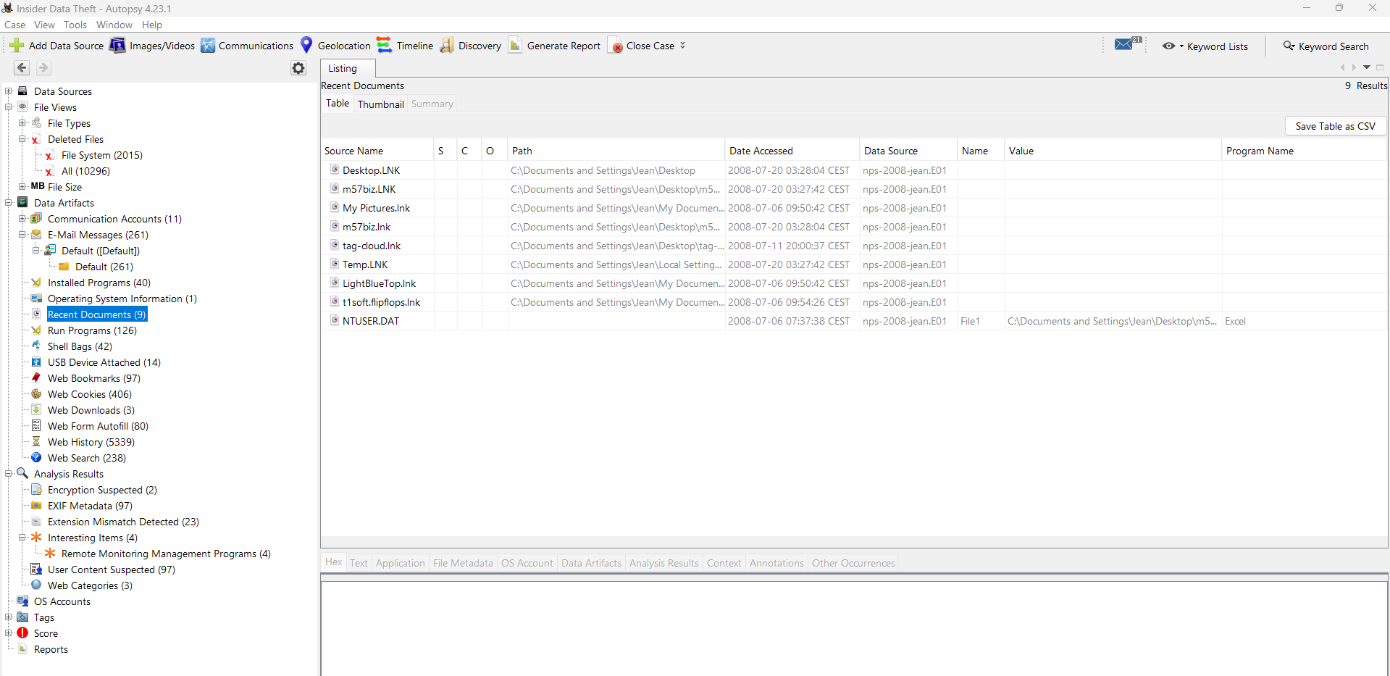
5.5 Browser Activity
Browser artifacts were examined to reconstruct the user's online activity and identify websites accessed prior to the acquisition of the forensic image. Web browsing history is one of the most valuable sources of forensic evidence, as it provides insight into user behavior, search activity, downloaded content, and interactions with online services.
Autopsy recovered a substantial number of browser artifacts from the examined system, including browsing history, cookies, bookmarks, and cached web content. The recovered data indicates that Mozilla Firefox was the primary web browser used on the workstation, which is consistent with the installed software identified earlier in the investigation.
The browsing history contained over 5,300 recorded entries, representing visits to various websites over an extended period. Among the recovered records were visits to search engines, software-related websites, news portals, and informational resources.
Examples of recovered browsing activity included:
- Google Search
- Mozilla websites
- CNN
- Centers for Disease Control and Prevention (CDC)
The browser history also contained search queries and page titles associated with publicly available information. These records provide evidence of websites accessed by the user but should always be interpreted within the broader context of the investigation. The presence of a visited webpage alone does not indicate malicious intent or unauthorized activity.
Browser artifacts are particularly valuable because they can be correlated with other forensic evidence such as downloaded files, recently accessed documents, email communications, and timeline events. This correlation enables investigators to reconstruct user activity with greater accuracy and establish relationships between different sources of evidence.
Evidence
Figure 6. Browser History Recovered by Autopsy
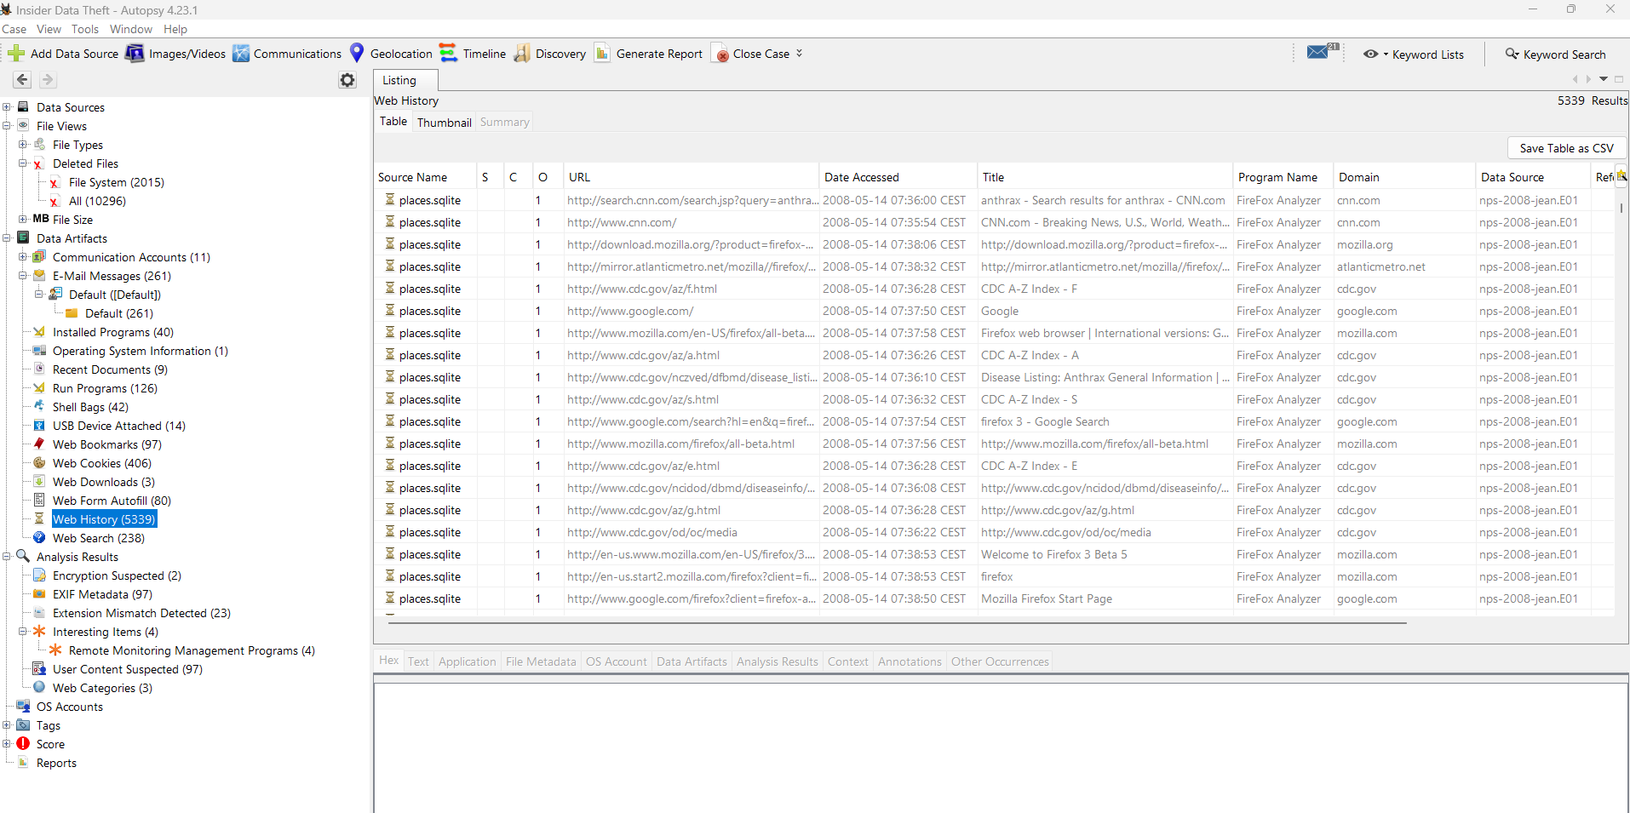

5.6 Downloaded Files
The analysis of browser download artifacts was performed to identify files obtained from the Internet and to better understand user activity on the examined workstation. Download records are valuable during forensic investigations because they provide evidence of software installations, document acquisition, and other files intentionally retrieved by the user.
Autopsy recovered multiple download records from the Mozilla Firefox browser. The recovered artifacts indicate that the user downloaded several software installation packages from trusted online sources.
Examples of recovered downloads include:
Downloaded File | Description
Firefox Setup 3.0 Beta 5.exe | Mozilla Firefox installer
install_aim.exe | AIM Instant Messenger installer
install_flash_player.exe | Adobe Flash Player installer
The recovered download history is consistent with the software inventory identified during the examination. Applications such as Mozilla Firefox, AIM Messenger, and Adobe Flash Player were present on the system, suggesting that at least some of the downloaded files were subsequently installed.
The correlation between browser download records and installed applications increases confidence in the forensic findings and helps reconstruct the sequence of user actions performed on the workstation.
No evidence of malicious software or unauthorized executable files was identified within the reviewed download records. However, download artifacts remain an important source of evidence, as they document user-initiated file acquisition and may assist investigators in reconstructing system activity.

Evidence
Figure 7. Browser Download History
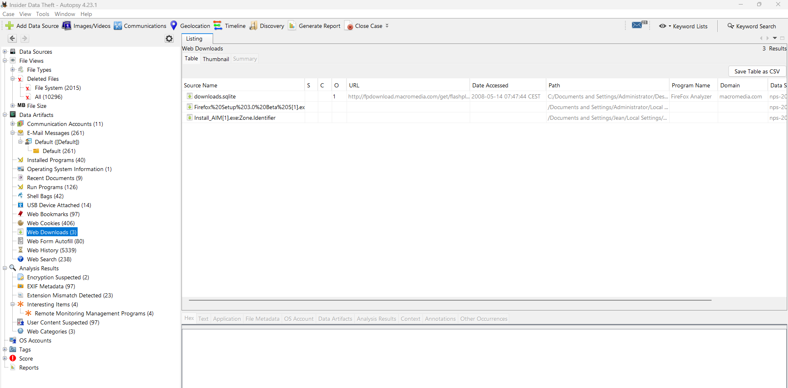

5.7 Email Artifacts
Email artifacts were examined to identify evidence of electronic communications stored within the forensic image. Email data is frequently considered a valuable source of digital evidence, as it may provide information regarding user interactions, document exchange, account activity, and communication timelines.
Autopsy identified a total of 261 email artifacts associated with the examined workstation. The recovered data indicates that email-related information was successfully extracted from the forensic image and indexed for further analysis.
Although the objective of this examination was not to perform a detailed content analysis of individual messages, the recovered artifacts confirm that email activity formed part of the user's normal workstation usage. The existence of these records provides investigators with an additional source of evidence that can be correlated with browser history, downloaded files, recently accessed documents, and timeline events.
Email artifacts are particularly valuable because they preserve metadata such as message timestamps, sender and recipient information, subject lines, and attachment references. When examined alongside other forensic artifacts, this information can assist in reconstructing user activity and establishing relationships between events.
During this investigation, the identified email artifacts were documented as available evidence for further examination if required. No conclusions regarding the content or intent of individual communications were made without additional analysis.

Evidence
Figure 8. Email Artifacts Identified by Autopsy
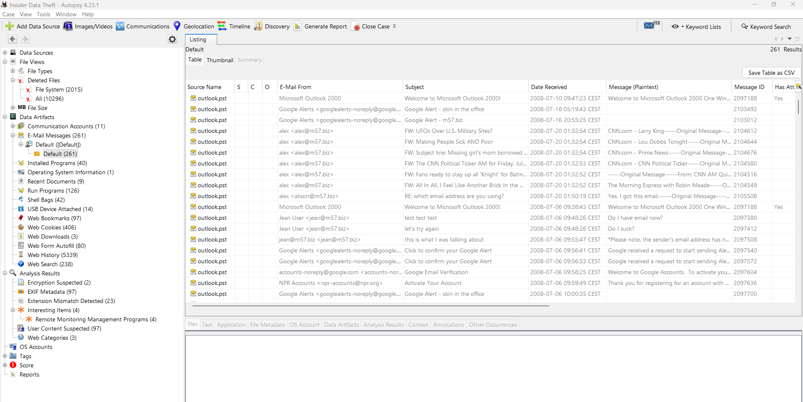

5.8 USB Device Analysis
The examination included an analysis of USB device artifacts to identify external storage devices that had been connected to the examined workstation. USB forensic artifacts are particularly important because removable media is frequently used to transfer, copy, or exfiltrate data.
Autopsy recovered records indicating that several USB devices had been connected to the system during its operational lifetime. The identified devices included both removable storage media and peripheral hardware.
The following devices were identified during the examination:
Device | Description
Apple iPhone | Mobile device
Flash Disk 256 MB | Removable USB storage device
CBM2080 / CBM2090 Flash Drive Controller | USB flash drive controller
VMware Virtual USB Hub | Virtual USB device
VMware Virtual HID Mouse | Virtual input device
The presence of removable USB storage devices confirms that the workstation interacted with external media. While the recovered artifacts demonstrate that these devices were connected to the system, they do not independently establish that files were copied or transferred. Additional analysis of file system metadata, shellbags, link files, registry artifacts, or timeline data would be required to determine whether data movement occurred.
The identification of an Apple iPhone further indicates that a mobile device was connected to the workstation. Such connections may be associated with charging, synchronization, backup operations, or file transfers; however, the available artifacts do not provide sufficient evidence to determine the specific purpose of the connection.
From a forensic perspective, USB device artifacts provide valuable contextual information and can support investigations involving data exfiltration, intellectual property theft, or unauthorized use of removable media.

Evidence
Figure 9. USB Device History Recovered by Autopsy
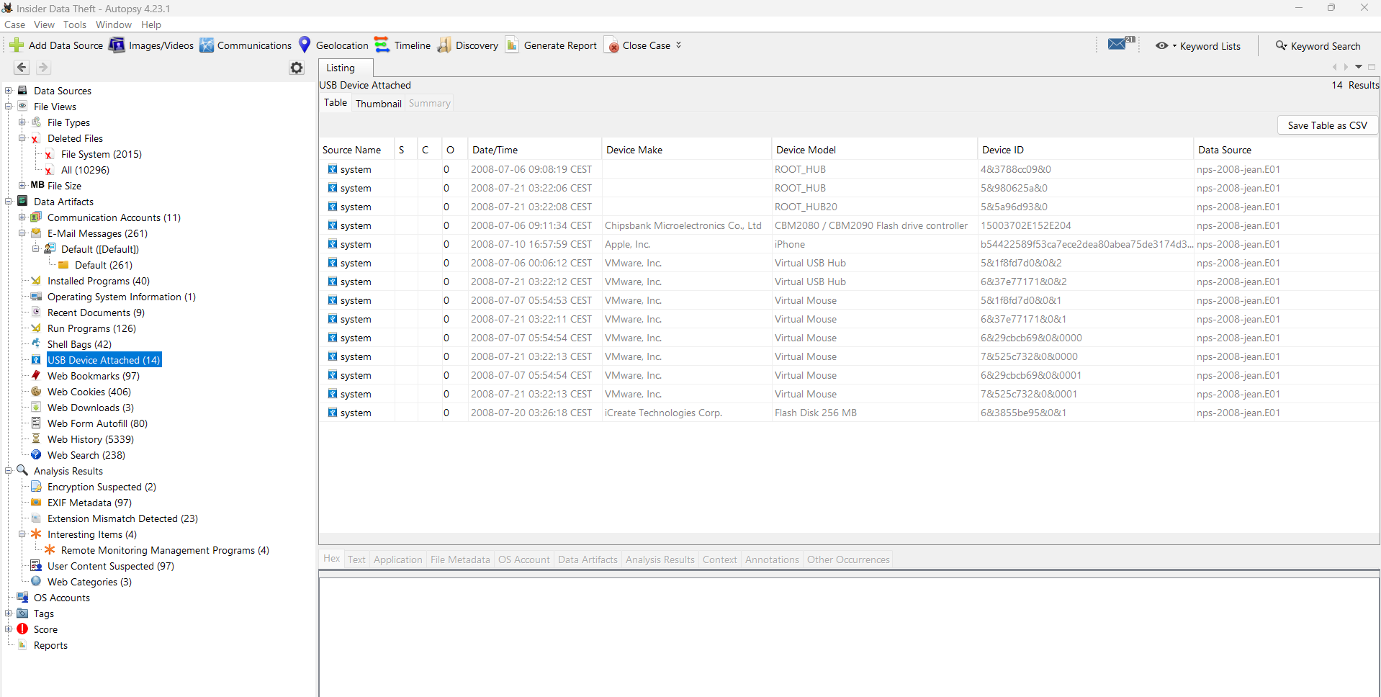

5.9 Deleted Files
The examination included an analysis of deleted file artifacts to determine whether recoverable evidence remained on the disk image. Deleted files are of particular forensic interest because removing a file through the operating system does not immediately erase its contents from the storage media. Instead, the file system typically marks the associated disk space as available for reuse, allowing forensic tools to recover deleted data until it is overwritten.
Autopsy identified deleted file artifacts within the examined image and categorized them separately from active files. These artifacts were reviewed to determine whether they contained information relevant to the investigation.
The presence of recoverable deleted files demonstrates that remnants of previously stored data remained accessible despite user deletion. Such artifacts may provide valuable insight into historical user activity, document handling, and file lifecycle events.
Deleted file analysis is an important component of digital forensic investigations because it can reveal evidence that users intentionally or unintentionally attempted to remove. When correlated with other artifacts, such as browser history, recently accessed documents, and timeline events, deleted files contribute to a more complete reconstruction of workstation activity.
During this examination, deleted file artifacts were documented and preserved as part of the overall evidence set. No evidence was modified or restored to the original storage media during the recovery process.

Evidence
Figure 10. Deleted Files Identified by Autopsy
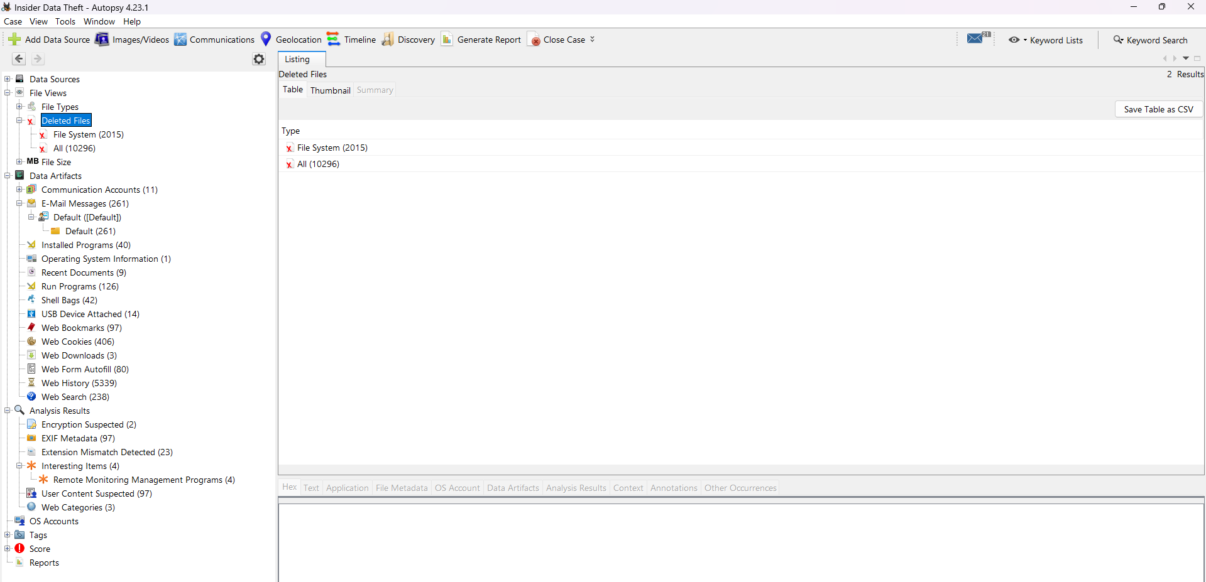

5.10 Timeline Analysis
Timeline analysis was performed to reconstruct the chronological sequence of events recorded within the forensic image. By correlating timestamps from multiple artifact sources, investigators can establish when specific activities occurred and identify relationships between user actions and system events.
Autopsy automatically generated a timeline by combining metadata from the file system, browser artifacts, recently accessed documents, email records, and other operating system artifacts. This consolidated view enables investigators to analyze user activity in chronological order rather than examining individual artifacts in isolation.
The timeline provides a structured overview of workstation usage and assists in identifying periods of increased user activity, document access, software execution, browser sessions, and file operations. Correlating these events with additional forensic artifacts improves the reliability of investigative findings and supports the reconstruction of user behavior.
Although the timeline identified numerous events throughout the lifetime of the examined system, no conclusions were drawn based solely on timestamp information. Timeline analysis was used in conjunction with supporting artifacts to ensure that findings were based on multiple independent sources of evidence.
The chronological reconstruction of events demonstrated the effectiveness of timeline analysis as a method for understanding system usage and validating relationships between recovered forensic artifacts.

Evidence
Figure 11. Timeline Analysis Generated by Autopsy
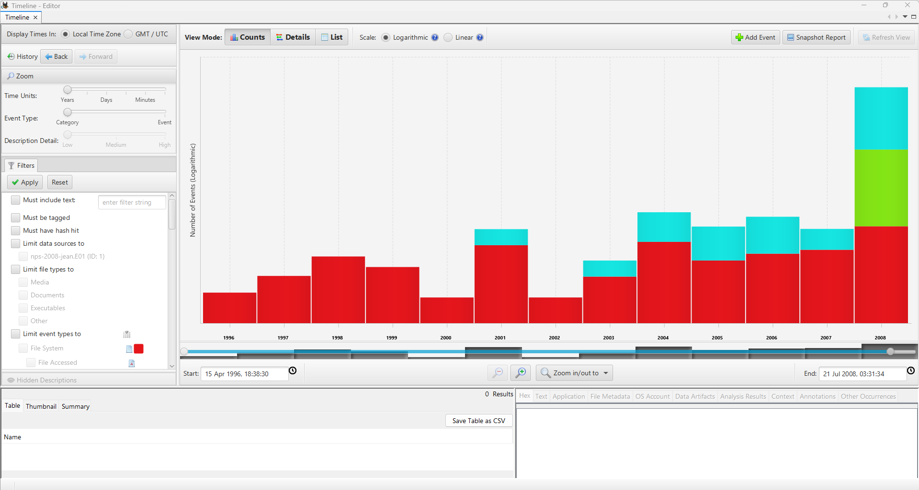

6. Conclusion
The forensic examination of the M57 Jean disk image was successfully completed using Autopsy 4.23.1. The investigation achieved its primary objective of identifying and documenting digital artifacts that provide insight into the configuration of the examined system and the activities performed by its users.
Throughout the analysis, a wide range of forensic artifacts was recovered and examined, including operating system information, local user accounts, installed software, recently accessed documents, browser history, downloaded files, email artifacts, USB device records, and deleted files. The correlation of these artifacts enabled the reconstruction of user activity and provided a comprehensive understanding of how the workstation was used.
The examination demonstrated the value of forensic artifact correlation. Individual artifacts, while informative on their own, become significantly more valuable when analyzed together. Browser history, recent document records, installed applications, and removable device artifacts collectively contributed to a more accurate reconstruction of workstation usage.
No modifications were made to the original evidence during the examination. All analysis was performed on a forensic image within a controlled laboratory environment, following fundamental principles of digital forensic methodology and evidence preservation.
This investigation demonstrates the effectiveness of Autopsy as a digital forensic platform for the identification, recovery, and analysis of artifacts stored within Windows-based systems. The recovered evidence illustrates how forensic tools can assist investigators in reconstructing user activity while maintaining the integrity of digital evidence.
Although this examination was conducted using a publicly available training dataset, the investigative methodology and analytical process reflect techniques commonly applied during real-world digital forensic investigations.

7. Limitations
The findings presented in this report are based exclusively on the forensic artifacts recovered from the M57 Jean disk image. No live system acquisition, volatile memory analysis, network traffic analysis, or external log sources were available during the examination.
The investigation was limited to the artifacts successfully extracted by Autopsy from the acquired evidence image. Consequently, activities that did not leave persistent artifacts on the storage media could not be evaluated.
Additionally, the absence of a forensic artifact should not be interpreted as evidence that a particular activity did not occur. Digital artifacts may be altered, deleted, overwritten, or unavailable due to normal operating system behavior.
All conclusions presented in this report are supported by the evidence available at the time of the examination.

8. Recommendations
Based on the findings of this examination, the following additional forensic activities are recommended to further enhance the investigation:
- Perform Windows Registry analysis to identify additional user activity and system configuration changes.
- Analyze Windows Event Logs to reconstruct authentication events and system activity.
- Conduct memory analysis using Volatility to identify running processes, injected code, and network connections.
- Perform hash verification of recovered files using known hash databases.
- Examine shellbags, jump lists, prefetch files, and link files for additional user activity.
- Correlate forensic artifacts with external log sources where available.
- Preserve all recovered evidence in accordance with digital evidence handling procedures.
These additional activities would provide greater visibility into system usage and further strengthen the overall forensic investigation.

9. References
- Carrier, B. File System Forensic Analysis. Addison-Wesley, 2005.
- Casey, E. Digital Evidence and Computer Crime. Academic Press, 2011.
- NIST Special Publication 800-86 – Guide to Integrating Forensic Techniques into Incident Response.
- Autopsy User Documentation.
- Digital Corpora – M57 Training Dataset.
- NIST Computer Forensics Tool Testing Program (CFTT).

10.Appendix
Appendix A – Screenshots
Figure | Description
Figure 1 | Autopsy Case Overview
Figure 2 | Operating System Information
Figure 3 | User Accounts
Figure 4 | Installed Programs
Figure 5 | Recent Documents
Figure 6 | Browser History
Figure 7 | Browser Downloads
Figure 8 | Email Artifacts
Figure 9 | USB Device History
Figure 10 | Deleted Files
Figure 11 | Timeline Analysis

Appendix B – Tool Information
Component | Version
Autopsy | 4.23.1
Operating System | Windows 11
Evidence Format | EnCase E01
Dataset | Digital Corpora – M57 Jean

