3.1 Cellular composition changes during NSCLC progression
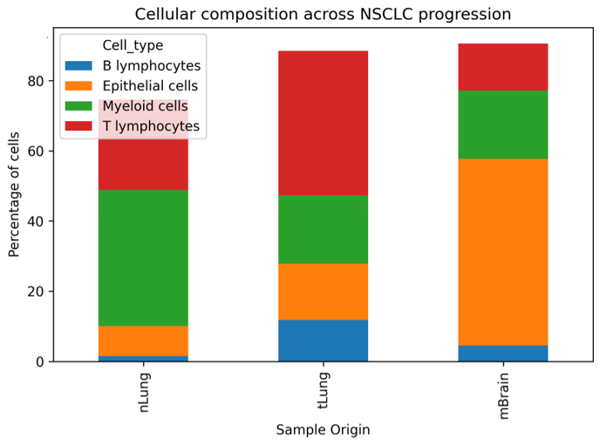
Single-cell transcriptomic analysis of 208,506 cells revealed substantial remodeling of the tumor microenvironment during NSCLC progression (Figure 1). Normal lung tissue (nLung) was enriched in immune populations, including myeloid cells (38.8%), T lymphocytes (25.8%), and NK cells (15.9%). In contrast, primary tumors (tLung) and brain metastases (mBrain) displayed a marked increase in epithelial cells, representing 16.1% and 53.2% of all cells, respectively.
Concurrently, the proportion of NK cells decreased from 15.9% in normal lung tissue to 5.2% in primary tumors and 3.0% in brain metastases. T lymphocytes also declined from 25.8% in normal lung tissue to 13.5% in brain metastases. These findings indicate progressive immune depletion and enrichment of malignant epithelial populations during metastatic progression.
3.2 T-cell remodeling reveals progressive immune dysfunction
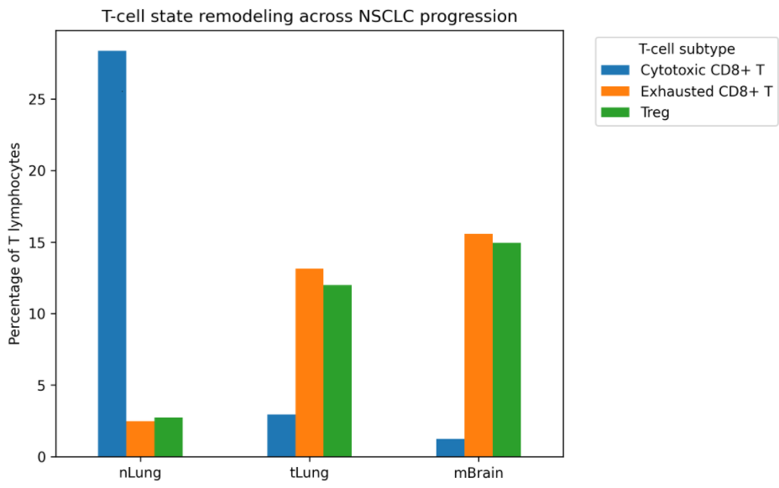
Analysis of T-cell subpopulations demonstrated profound alterations in T-cell states during disease progression (Figure 2). Cytotoxic CD8+ T cells represented the dominant T-cell population in normal lung tissue (28.4%) but decreased dramatically in primary tumors (2.9%) and brain metastases (1.2%).
In contrast, exhausted CD8+ T cells increased from 2.5% in normal lung tissue to 13.1% in primary tumors and 15.6% in brain metastases. Similarly, regulatory T cells (Tregs) increased from 2.7% in normal lung tissue to 12.0% and 14.9% in primary tumors and brain metastases, respectively. These observations suggest progressive impairment of anti-tumor immunity and accumulation of immunosuppressive T-cell populations during NSCLC progression.
3.3 Macrophage remodeling accompanies metastatic dissemination
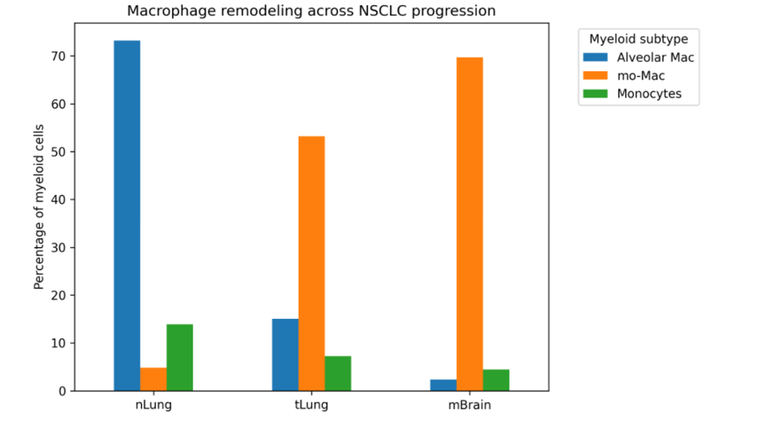
Significant remodeling of the myeloid compartment was observed during disease progression (Figure 3). Alveolar macrophages constituted the dominant myeloid population in normal lung tissue (73.2%). However, their abundance decreased markedly in primary tumors (15.1%) and brain metastases (2.4%).
Conversely, monocyte-derived macrophages (mo-Macs) expanded substantially during progression, increasing from 4.8% in normal lung tissue to 53.2% in primary tumors and 69.7% in brain metastases. These findings indicate replacement of tissue-resident macrophages by inflammatory macrophage populations associated with tumor progression and metastatic dissemination.

3.4 Exhaustion markers are elevated in metastatic lesions
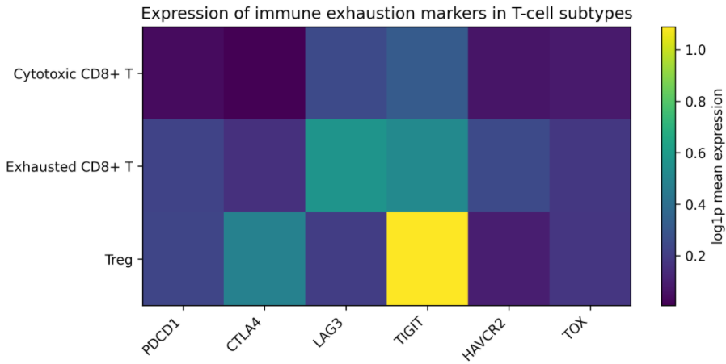
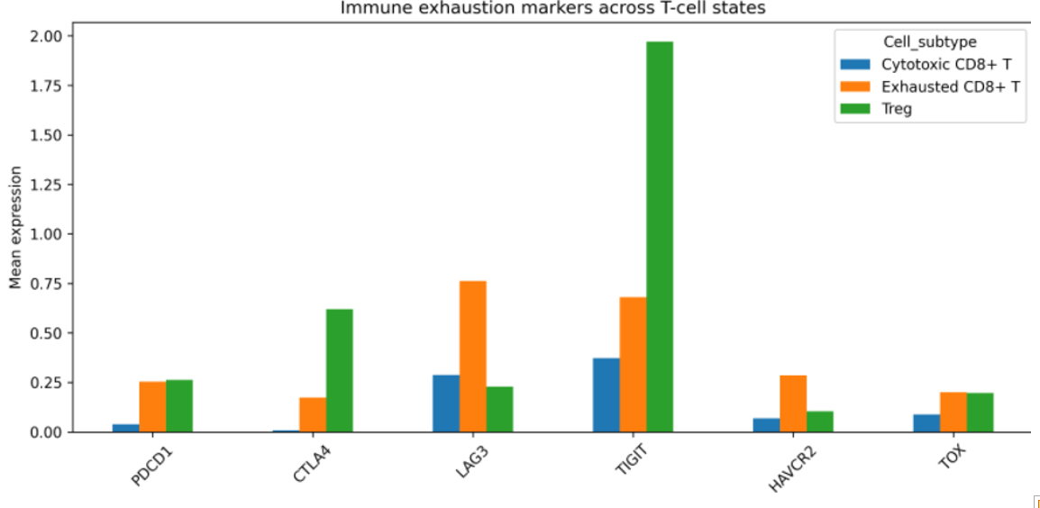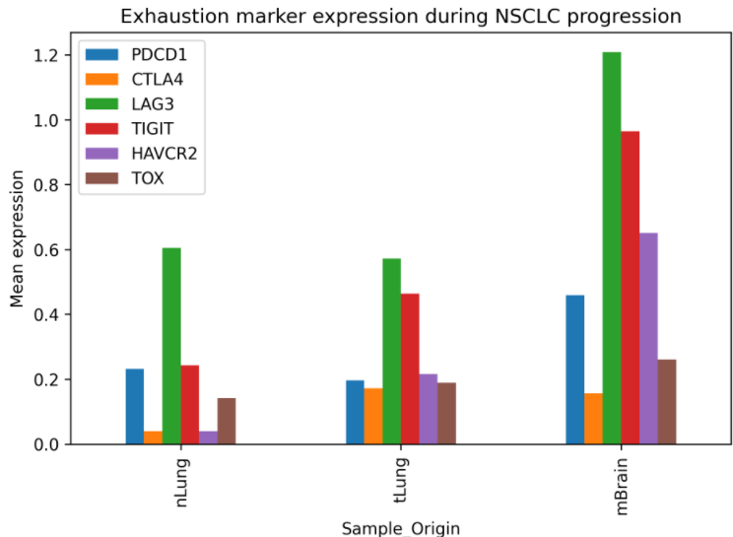
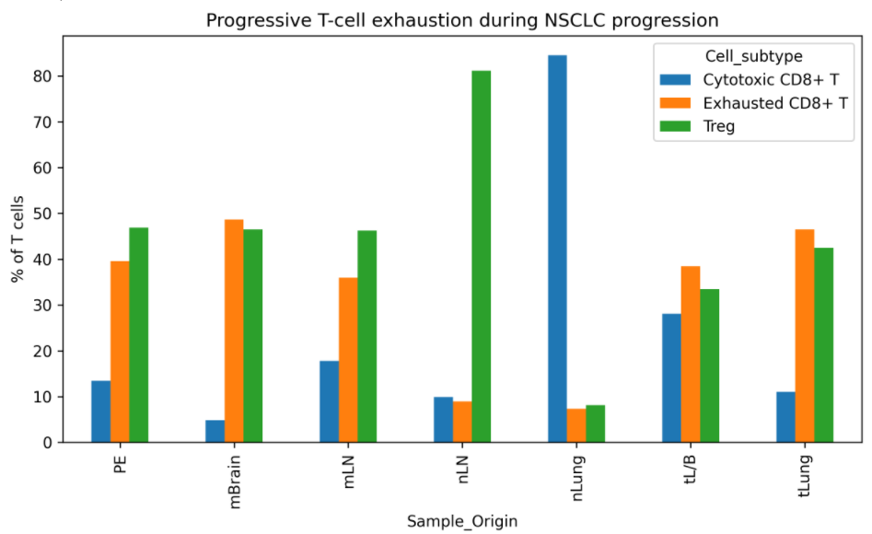

To investigate the molecular basis of T-cell dysfunction, expression of established immune exhaustion markers was examined (Figures 4–6). Exhausted CD8+ T cells displayed consistently higher expression of PDCD1, CTLA4, LAG3, TIGIT, HAVCR2, and TOX compared with cytotoxic CD8+ T cells.
Brain metastases exhibited the highest expression of multiple exhaustion-associated genes. In exhausted CD8+ T cells, PDCD1 expression increased from 0.232 in normal lung tissue to 0.459 in brain metastases. Similarly, LAG3 expression increased from 0.605 to 1.209, TIGIT increased from 0.243 to 0.964, and HAVCR2 increased from 0.040 to 0.651. These findings demonstrate progressive activation of immune checkpoint pathways during NSCLC progression.

3.5 Exhaustion score identifies profound immune dysfunction in brain metastases
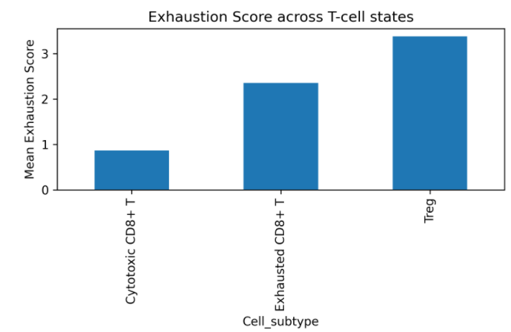
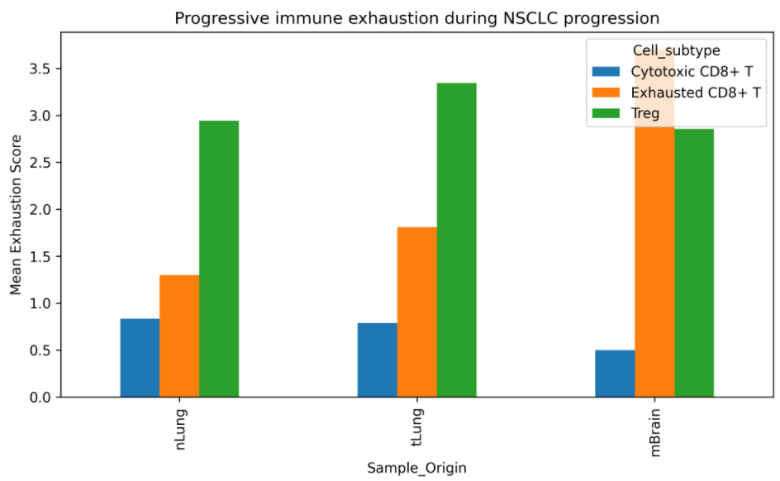

To quantify T-cell dysfunction, an exhaustion score was calculated based on the combined expression of PDCD1, CTLA4, LAG3, TIGIT, HAVCR2, and TOX (Figures 7–8). Exhausted CD8+ T cells exhibited substantially higher exhaustion scores than cytotoxic CD8+ T cells (2.355 vs. 0.865), while Tregs demonstrated the highest overall exhaustion scores (3.381).
Importantly, exhaustion scores in exhausted CD8+ T cells increased progressively during disease progression, rising from 1.299 in normal lung tissue to 1.809 in primary tumors and 3.701 in brain metastases. Statistical analysis confirmed significant differences between normal lung tissue and primary tumors (p = 0.004), primary tumors and brain metastases (p = 1.23 × 10^-12), and normal lung tissue and brain metastases (p = 1.15 × 10^-10). These findings indicate that brain metastases are characterized by profound T-cell dysfunction and enhanced immune exhaustion.

