Lumma Stealer Network Traffic Analysis Report
Author: Agata Gabara

Table of Contents
- Executive Summary
- Objectives
- Environment
- Tools Used
- Attack Flow
- Network Traffic Analysis
  - Protocol Hierarchy
  - IPv4 Endpoints
  - IPv4 Conversations
  - DNS Analysis
  - TLS Handshake
  - Command-and-Control Communication
  - Follow TCP Stream
  - I/O Graph
  - Protocol Hierarchy (TLS)
  - TCP Sequence Graph
- Exported Objects
- Expert Information
- Indicators of Compromise
- MITRE ATT&CK Mapping
- Detection Opportunities
- Infection Timeline
- Conclusion
- References

1. Executive Summary
This report documents the forensic analysis of a Lumma Stealer malware infection using Wireshark. The objective was to reconstruct the malware's network behavior, identify malicious infrastructure, recover indicators of compromise (IoCs), and document the attack chain observed in the provided packet capture.

2. Objectives
- Identify malicious DNS activity.
- Detect Command-and-Control communication.
- Analyze encrypted TLS traffic.
- Recover downloaded malware payloads.
- Extract Indicators of Compromise.
- Map observations to MITRE ATT&CK.

3. Environment
- Operating System: Windows
- Analysis Tool: Wireshark
- Sample: Lumma Stealer PCAP
- Analyst: Agata Gabara

4. Tools Used
- Wireshark
- VirusTotal
- Any.Run
- Hybrid Analysis

5. Attack Flow
(Insert attack flow diagram)
The infection begins with DNS resolution of the malicious domain, followed by encrypted TLS communication with the Command-and-Control server. During the session, the malware retrieves an additional executable payload over HTTP.

6. Network Traffic Analysis
Protocol Hierarchy
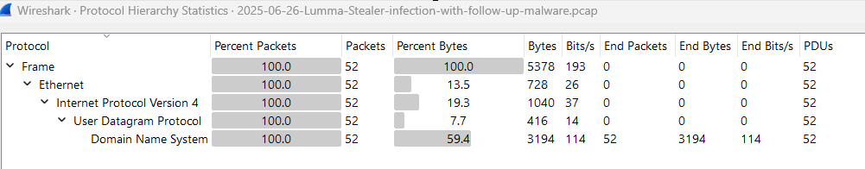
The Protocol Hierarchy view confirms that the filtered capture contains exclusively DNS traffic encapsulated within UDP over IPv4. DNS accounts for all 52 packets and approximately 59.4% of the transmitted bytes, indicating that the applied filter successfully isolates the domain resolution phase of the malware communication.

IPv4 Endpoints
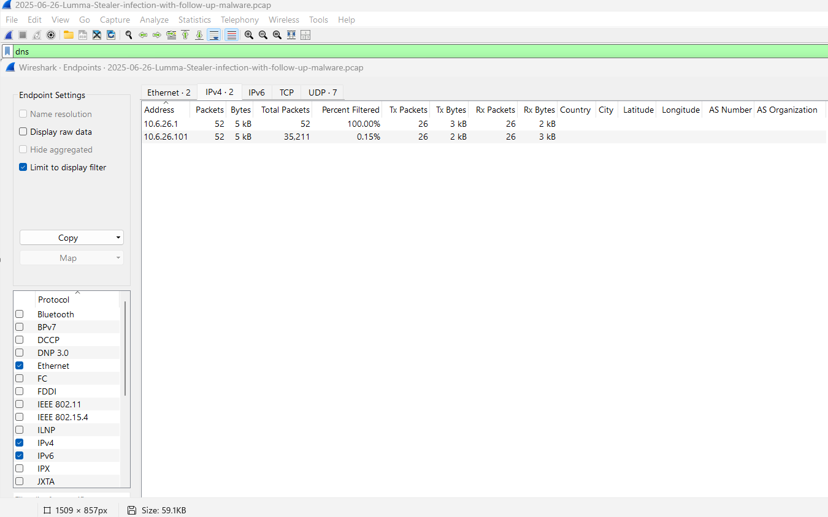
The IPv4 Endpoints view confirms that the DNS traffic is limited to communication between the infected host (10.6.26.101) and the local DNS resolver (10.6.26.1). The workstation transmitted 26 DNS queries and received 26 responses, resulting in 52 packets exchanged. This represents the domain resolution phase that precedes communication with the malware's external infrastructure.

IPv4 Conversations
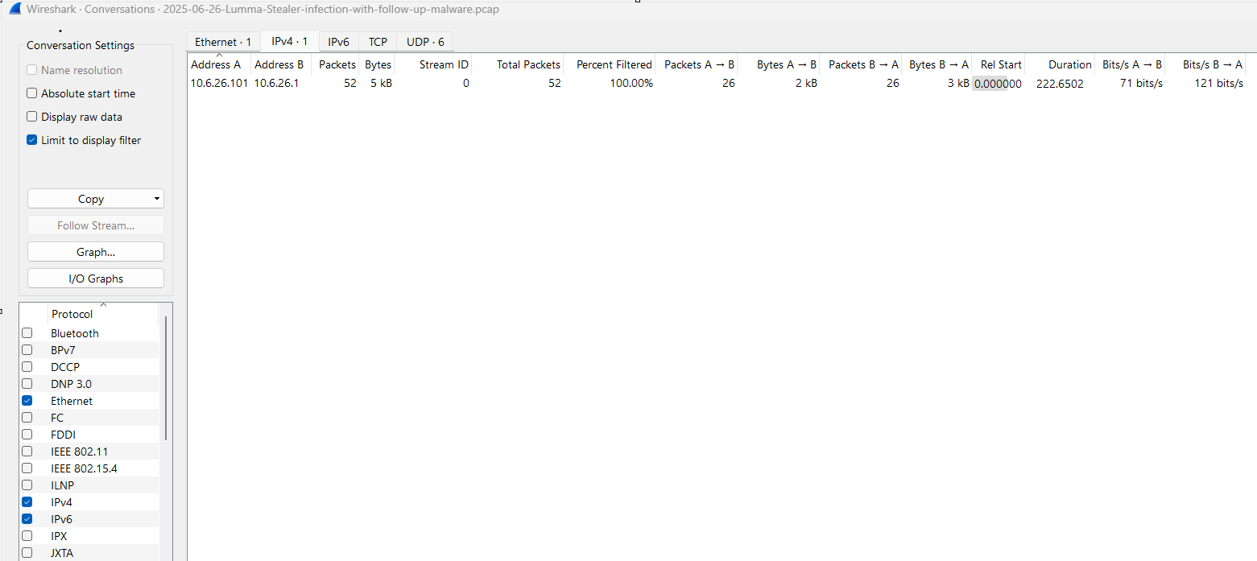
The IPv4 Conversations statistics show a single DNS conversation between the infected workstation (10.6.26.101) and the local DNS resolver (10.6.26.1). The session consists of 52 packets exchanged over approximately 223 seconds, with an equal number of DNS queries and responses. This communication represents the initial stage of the infection, where the malware resolves external domains before establishing encrypted Command-and-Control (C2) connections.

Command-and-Control Communication
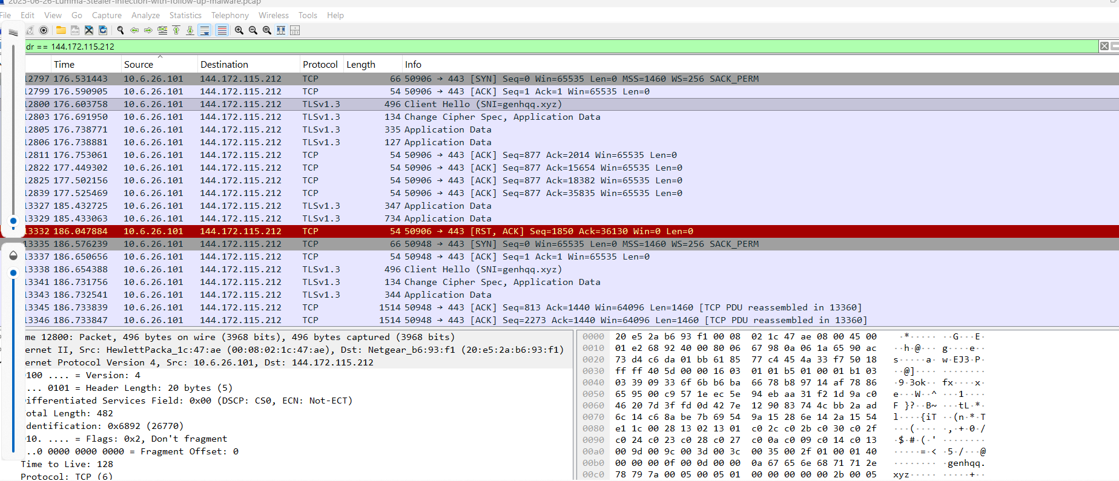
This filtered view captures the malware's communication with its Command-and-Control (C2) infrastructure. The infected workstation (10.6.26.101) establishes a TCP connection to 144.172.115.212 on port 443, followed by a TLS Client Hello exposing the Server Name Indication (SNI) genhqq.xyz. The subsequent TLS Application Data packets confirm encrypted data exchange with the remote server. After the session is reset (RST), the malware immediately initiates a new TLS connection, demonstrating persistent communication attempts with the C2 infrastructure.

TLS Handshake
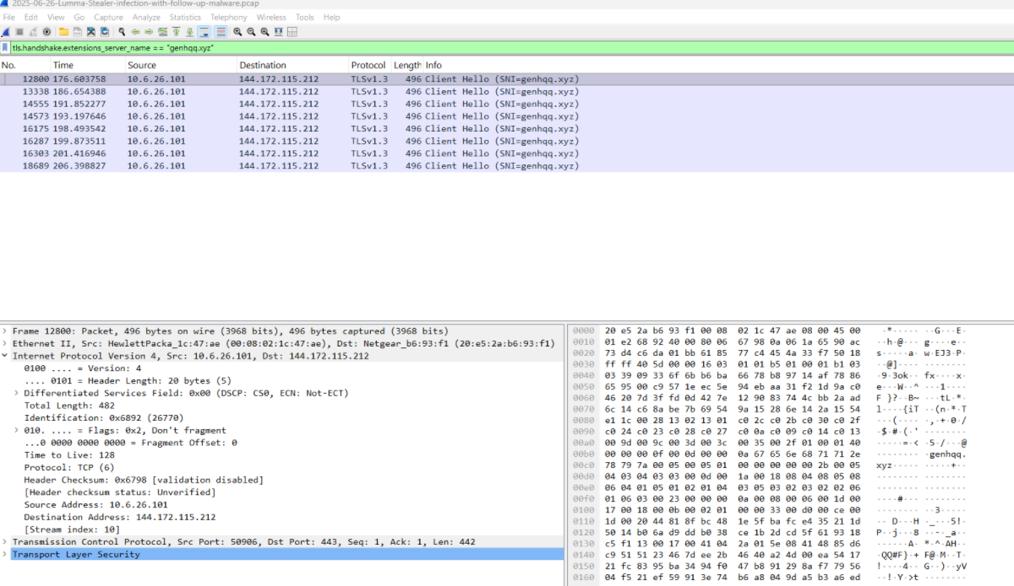
This view isolates all TLS Client Hello packets containing the Server Name Indication (SNI) genhqq.xyz. The repeated appearance of the same hostname throughout the capture indicates that the malware persistently attempted to establish encrypted connections with its Command-and-Control (C2) infrastructure. While the TLS payload remains encrypted, the SNI extension exposes the destination domain, making it a valuable Indicator of Compromise (IoC) for network detection and threat hunting.

Follow TCP Stream
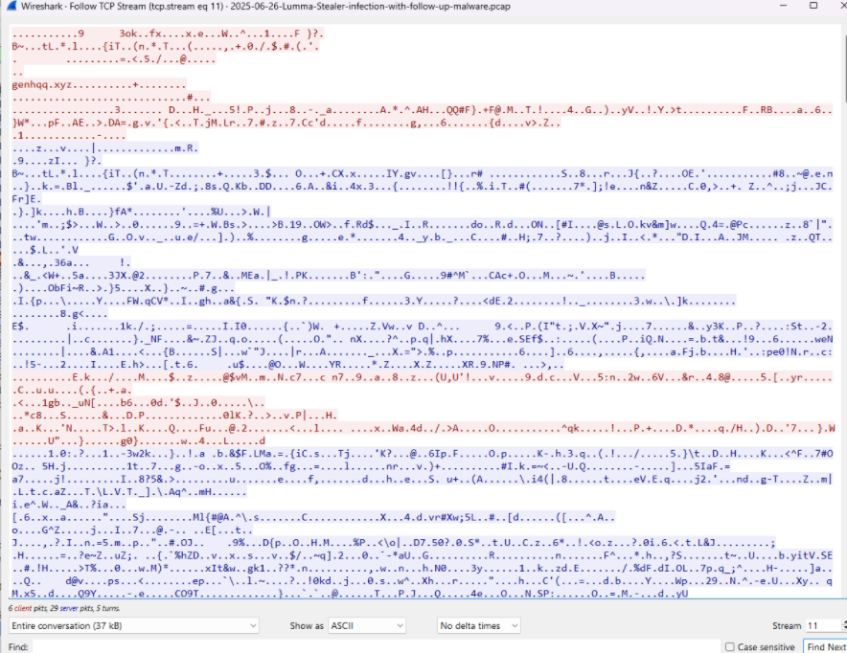
The reconstructed TCP stream contains the complete bidirectional communication exchanged during the TLS session. The visible plaintext hostname genhqq.xyz originates from the TLS Client Hello message, where the Server Name Indication (SNI) extension specifies the intended destination. Following the handshake, all subsequent application data is encrypted, preventing direct analysis of the malware payload while confirming the establishment of a secure communication channel with the C2 server.

I/O Graph
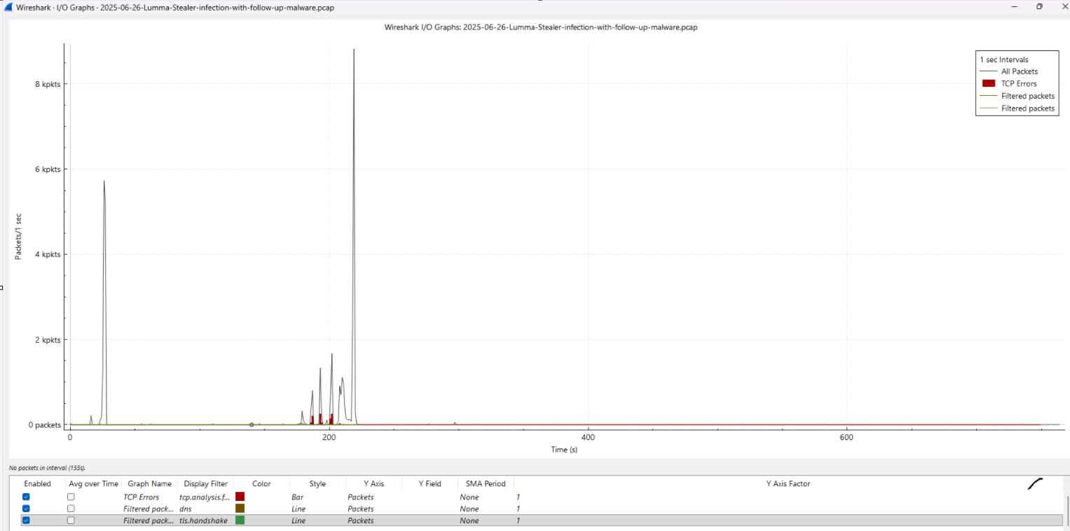
The I/O Graph illustrates packet rates over time during the captured malware infection. Short bursts of network activity are visible during the initial DNS lookup, TLS handshake, and encrypted data exchange with the Command-and-Control (C2) infrastructure. The absence of sustained high-volume traffic suggests periodic beaconing and encrypted communication rather than continuous data transfer.

Protocol Hierarchy (TLS)
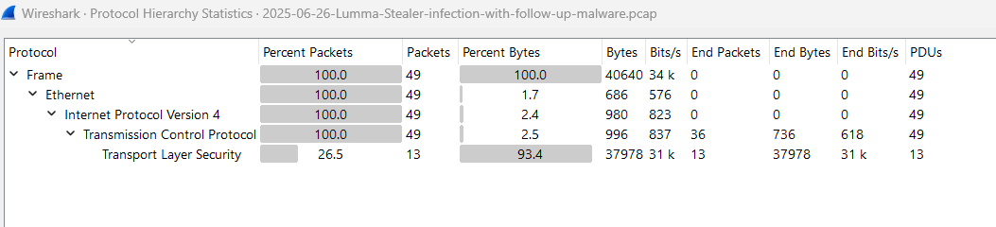
The filtered Protocol Hierarchy confirms that the analyzed traffic consists primarily of encrypted TLS communication carried over TCP/IPv4. Although TLS packets represent only 13 of the 49 captured packets (26.5%), they account for approximately 93.4% of the total transferred bytes, indicating that nearly all exchanged data is encrypted. This behavior is consistent with Lumma Stealer communicating with its Command-and-Control (C2) infrastructure over HTTPS.

TLS Handshake Details
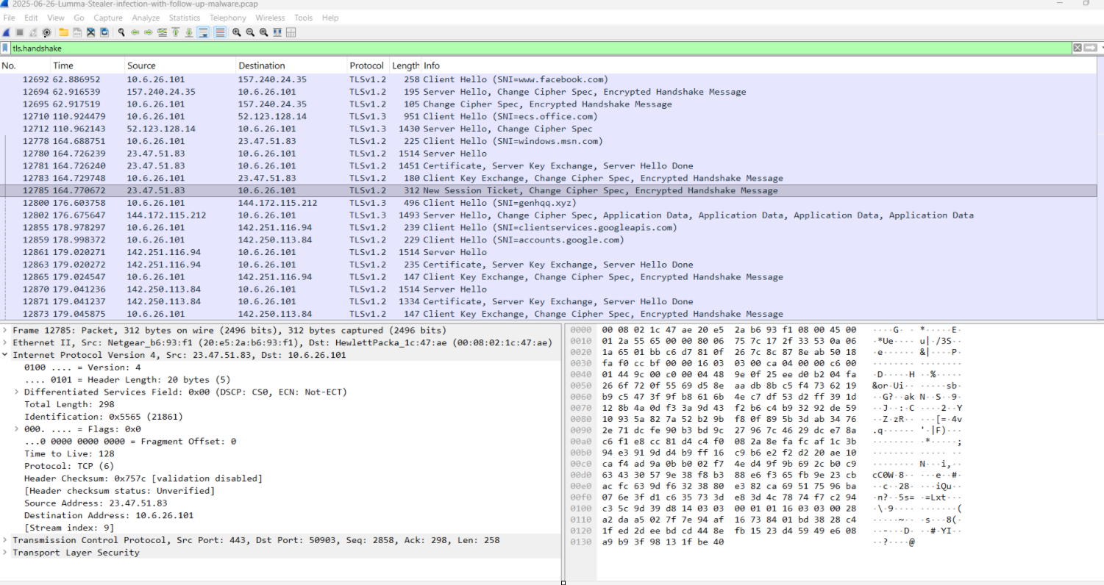
The TLS Handshake view displays all TLS Client Hello and Server Hello messages observed during the packet capture. In addition to legitimate encrypted connections (e.g., Facebook, Microsoft, and Google services), the infected workstation initiates a TLS Client Hello toward the malicious domain genhqq.xyz. The Server Name Indication (SNI) field exposes the destination hostname before encryption is established, making it possible to identify the Command-and-Control (C2) infrastructure despite the encrypted communication.

TCP Sequence Graph
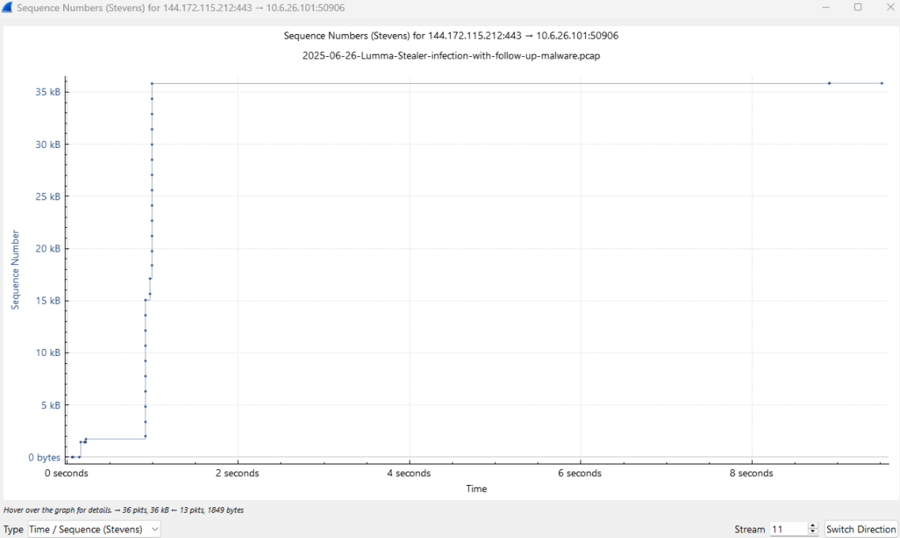
The initial spike in sequence numbers is consistent with the exchange of encrypted TLS application data between the infected host and the C2 server. No packet retransmissions or abnormal TCP behavior are visible, indicating a stable and successful communication session.
The TCP Time-Sequence (Stevens) graph illustrates the progression of sequence numbers during the communication between the infected workstation (10.6.26.101) and the Command-and-Control (C2) server (144.172.115.212). The rapid increase in sequence numbers during the first second indicates a burst of encrypted TLS data transmission. After the initial exchange, the sequence numbers stabilize, suggesting that the malware completed the primary data transfer and maintained the TCP session with minimal additional traffic.

7. Exported Objects
HTTP Objects
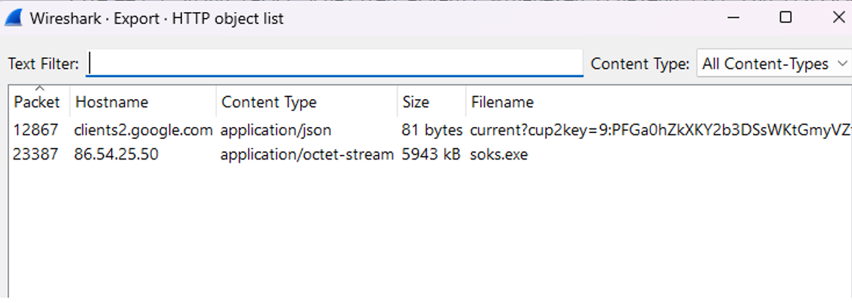
The HTTP Object List reveals two downloadable objects captured during the network session. The most significant artifact is the executable file **soks.exe** (approximately **5.9 MB**) downloaded from the host **86.54.25.50** with the content type **application/octet-stream**. This confirms the malware delivery stage of the attack and demonstrates that the payload can be recovered directly from the packet capture for further static or dynamic malware analysis.
Recovered executable:
- soks.exe

SMB Objects
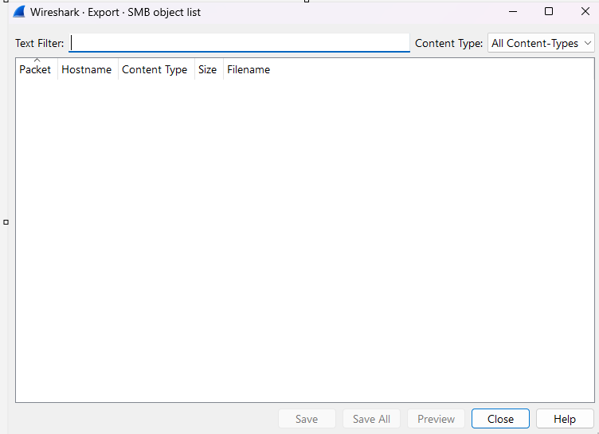
No exported SMB objects detected.

DICOM Objects
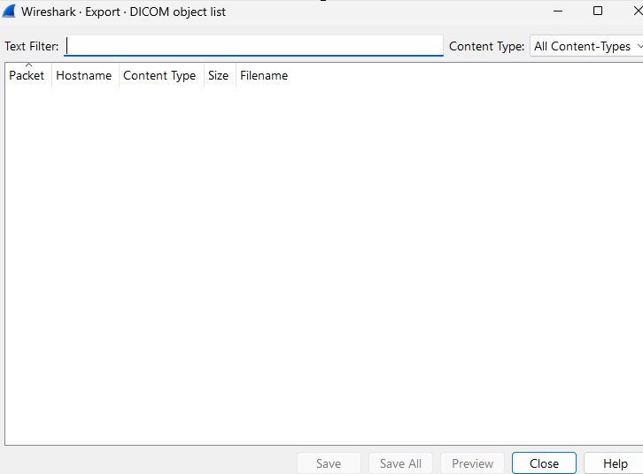
No exported DICOM objects detected.

TFTP Objects
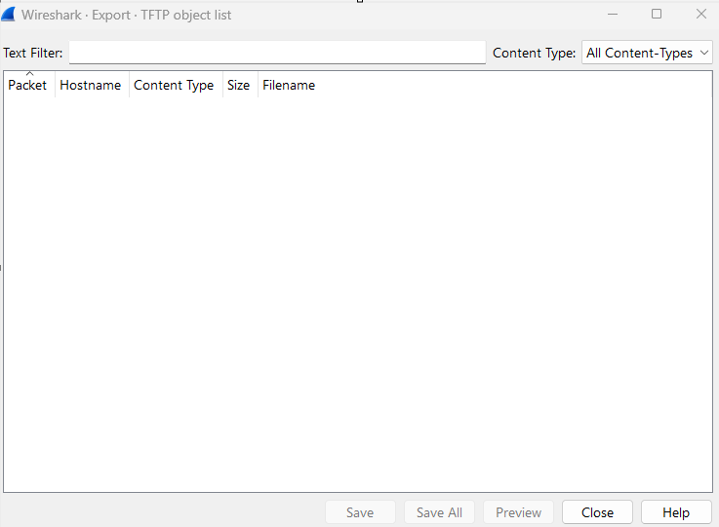
No exported TFTP objects detected.

8. Expert Information
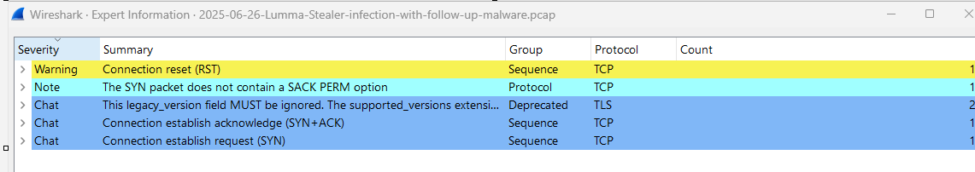Minor TCP warnings were observed during the communication. No critical protocol errors affected the investigation.

9. Indicators of Compromise
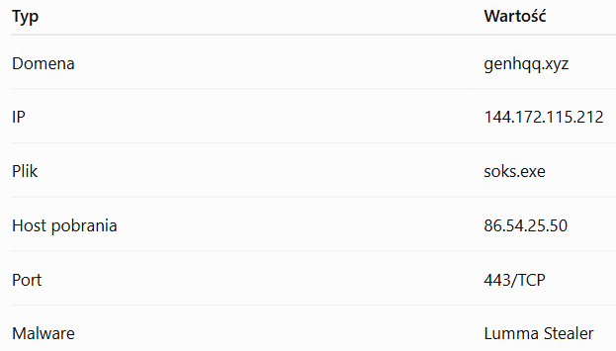

10. MITRE ATT&CK Mapping
Tactic | Technique
Command and Control | T1071.001
Command and Control | T1573
Command and Control | T1105

11. Detection Opportunities
- Monitor DNS queries for malicious domains.
- Inspect TLS Server Name Indication (SNI).
- Detect outbound HTTPS connections to rare destinations.
- Monitor executable downloads over HTTP.
12. Infection Timeline
- DNS query for genhqq.xyz
- TCP three-way handshake
- TLS Client Hello
- Encrypted communication established
- Malware payload retrieved
- Persistent C2 communication

13. Conclusion
The investigation confirmed communication with the Lumma Stealer Command-and-Control infrastructure using encrypted TLS sessions. Network metadata, DNS activity, exported HTTP objects, and protocol statistics were sufficient to reconstruct the attack timeline and identify the malware infrastructure despite encrypted application traffic.

14. References
- Wireshark Documentation
- MITRE ATT&CK
- Malware-Traffic-Analysis.net
- VirusTotal

