Project outcome:

The project contains a web application for students, admin and supervisors. Every user can access the application after successfully completing their login process. Each has different views to use the application. Views on the application include

* Login redirection page (For all the users)
* Login page (For all the users)
* Submit preference page (Only for students)
* Admin dashboard
  + Add topics page (For admin and supervisors)
  + View and publish topics page (Only for admin)
  + View preferences page (Only for admin)
  + View allocations page (Only for admin)
* Supervisor dashboard
  + Add topics page (For admin and supervisors)
  + Supervising group page (Only for supervisors)

Login redirection page:

This is first page where every user can see when they open the web application. In our case where we have 3 different type of users, we need to know which user wants to login. This page has 3 buttons each for admin, student and supervisor which redirects them to their required login pages.

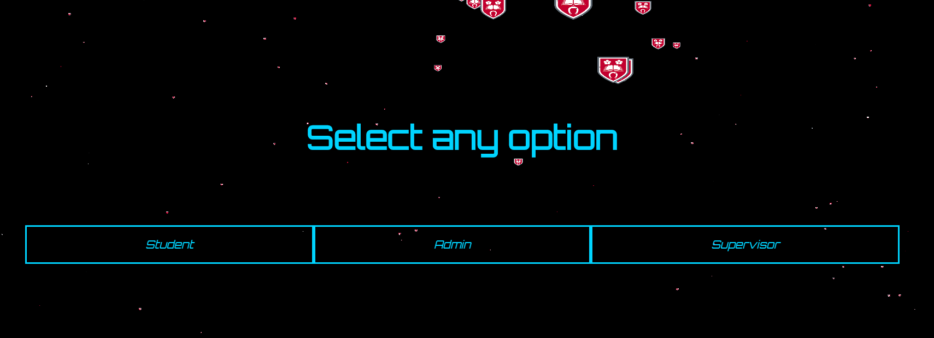

Login page:

This page is also available for all the users. This page allows all users to login into the web application. Every user can login with their username/email and their password and submit them to complete their login process. Based on the type of user, further pages are shown to them.

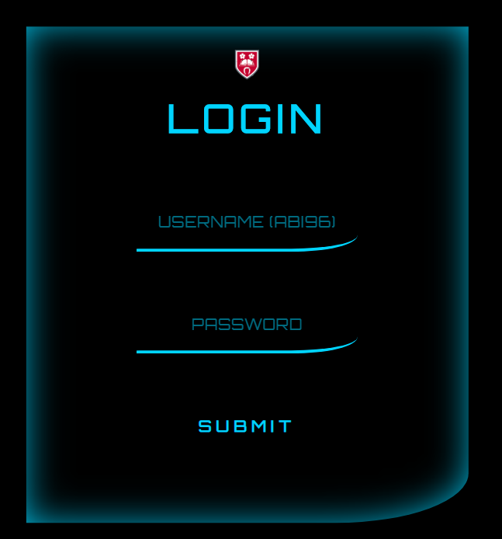

Submit preference page:

This page is only available for students to submit their preferences. This page contains all the available topics once the approved topics are published by the admin. Students need to submit their top 5 preferred topics by dragging and dropping them in the required order. A video popup which shows how to submit preferences in required order is also added after each login so that students can submit them without any doubts and also avoids submitting of wrong preferences. For further understanding of their priority colours from green to red are allocated for their preferences so students can know their top preferred topic while submitting. If the student submits the topics without selecting them in their preferred order, then default topics which are from 1 to 5 are submitted as their top 5 preferred topics. If the student has changed their mind and want to reorder the preferences after submitting them, he/she can login and submit their preferences again to update them in the database. Here we are not showing their previous preferences when they login back to submit again.

Topic link is added for every topics so student when on clicking it opens a new tab in the browser which redirects them to the topic’s webpage where students can find more about the topic before selecting it as one of their preference.

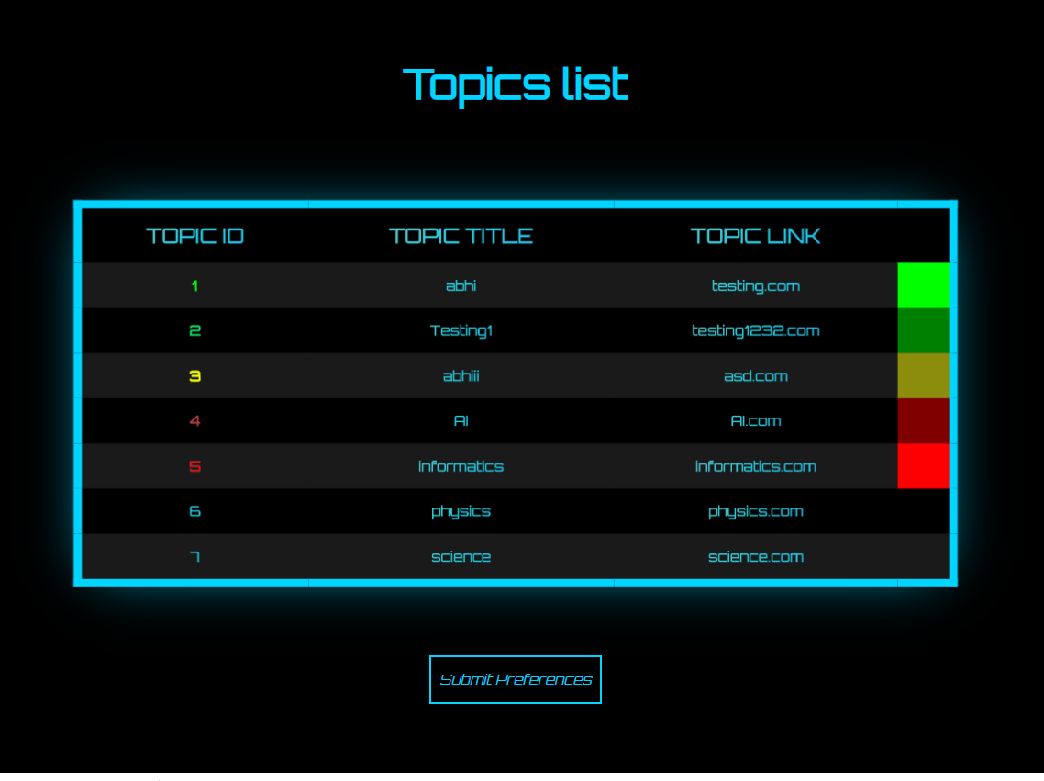



Five colours on the page which shows students each of their preferences in following order:

* Green as preference 1
* Light green as preference 2
* Yellow as preference 3
* Light red as preference 4
* Red as preference 5

If the students logs in before admin publishing the topics, then is shows them that there are no topics published and submit button is disabled with its href attribute value as javascript:void(0).

**IMAGE OF NO TOPICS NEED TO BE ADDED HERE**

On every page, at left bottom we have a anchor tag which redirects them to send mail to the admin in case they are unable to login to the application or unable to submit their preferences etc.

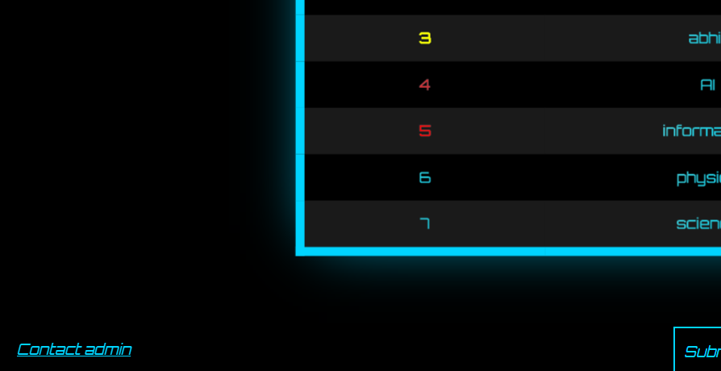

**Admin Dashboard:**

Admin dashboards has 4 buttons which redirects them to pages which include

* Add topics
* View topics
* View preferences
* View allocations



Add topics page:

This page is available for admin and supervisors to add a topic.

To add a topic, admin or supervisor needs to click add topic button on top of the page, which shows them a form with two input fields. One for topic title and other for topic URL. After submitting the form by clicking add topic, topic gets added into the database and it’ll be updated on view topics page so admin can later publish them once they are approved. An alert message showing ‘topics added’ will be shown after each successful submission of the topic.

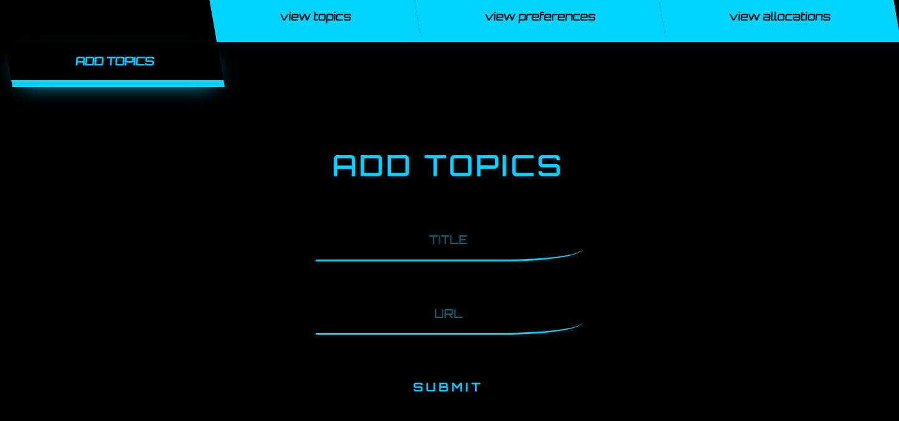

View topics page:

This page is available only for admin. Here admin can view the topics which are in the database and publish the topics to students.

We also have an option for deleting the topics and also hide them from students so only selected topics are shown to students. To delete a topic, admin can simply click the x button which is added beside every topic and to temporarily hide the topic from the student, there is a checkbox added for each topic which on clicked hides them from the students.

After deleting or hiding the topics, admin needs to click “publish topics button” to submit them into the database and to also show them for students.

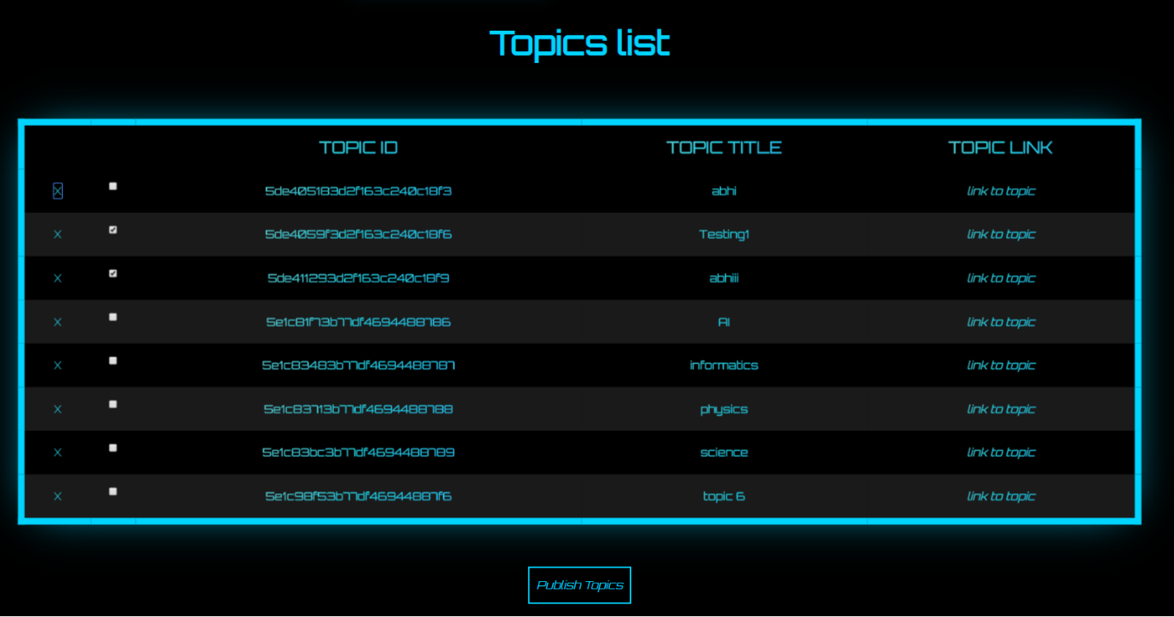

View preferences page:

After publishing the topics, all the students need to submit their top 5 preferred topics then on this page admin can view all the preferences of all the students. If everything is fine, then admin clicks the run algorithm button which is at bottom of the page. This runs the algorithm and allocates students into group of 5 students with their top preferred topic as the group topic.

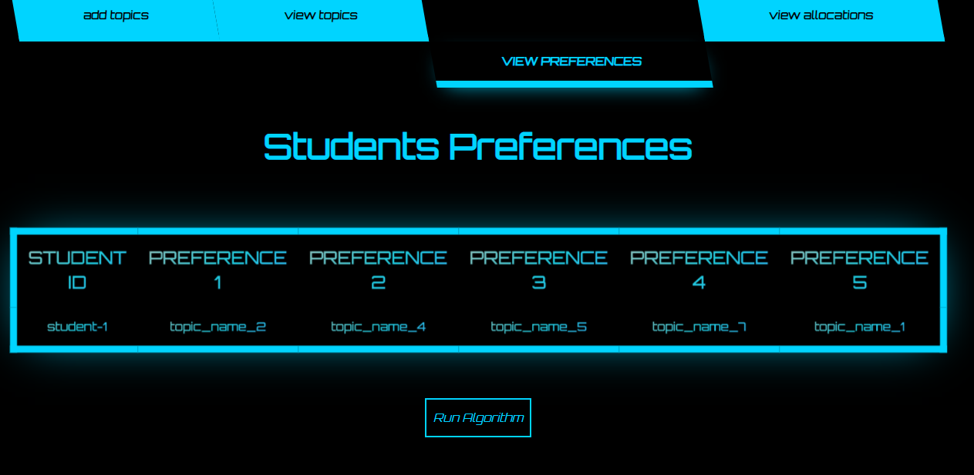

View allocations page:

Once the preferences are submitted by the students and implementing the algorithm, all the allocated groups can be seen by the admin and he can publish them so supervisors can see them and select a topic for which they want to supervise.

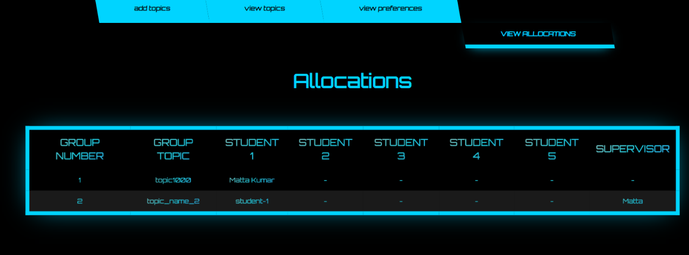

Supervisor dashboard:

Here supervisor has 2 buttons which redirects them to pages which include

* Add topics page
* Submit supervising topic page (available only for supervisor)

Add topics page:

This page is same for both admin and supervisor.

To add a topic, admin or supervisor needs to click add topic button on top of the page, which shows them a form with two input fields. One for topic title and other for topic URL. After submitting the form by clicking add topic, topic gets added into the database and it’ll be updated on view topics page so admin can later publish them once they are approved. An alert message showing ‘topics added’ will be shown after each successful submission of the topic.



Submit supervising topic page:

This page is only available for supervisor. By clicking the allocations button on supervisors dashboard, supervisor can access this page.

Once admin runs algorithm and groups are allocated, supervisor can see those allocated groups on this page.

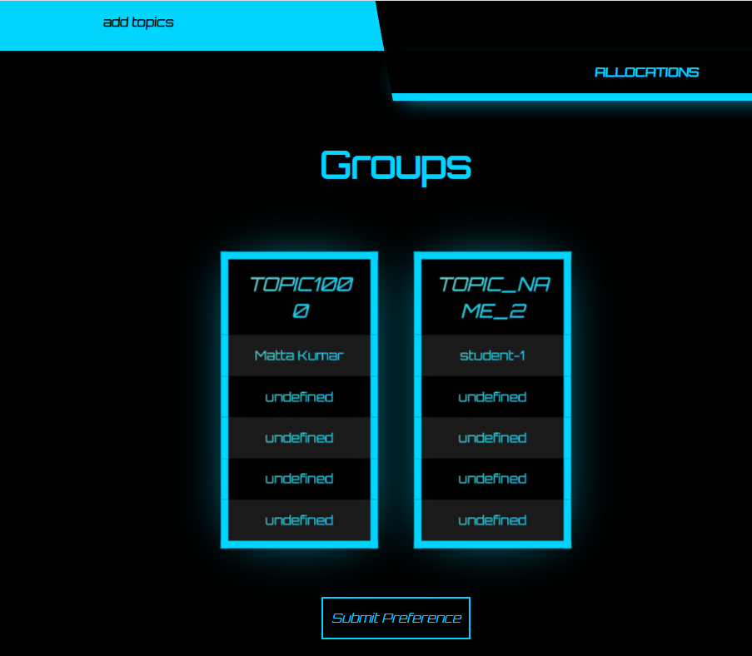

Supervisor can select one topic from the list of groups and submit it by clicking submit preference button on bottom of the page. After selecting the preferred group, the group colour changes from blue top green and a smiley is shown as a cursor showing the supervisor that the group he wants to supervise is selected.

