Testing:

There are many types of testing but some of the main steps in testing phase include:

* Functionality testing
* Usability testing
* Interface testing
* Compatibility testing
* Performance testing
* Security testing

Functionality testing:

In this phase, we need to check the functioning of every module, database connection, etc. In our project, we tested this phase by checking whether or not all the data is getting submitted into the database correctly and all the data is showing exactly how it should be shown from the database. This process tests the working on Front-end views, DB and API.

Testing with Postman tool:

By submitting different inputs manually to the database and checking them on the postman,” A collaboration platform for API development” [https://www.getpostman.com/].

In this, we need to open the postman tool and add the endpoint of our API and run it. We can view all the responses of users on our page if everything in the code works fine.

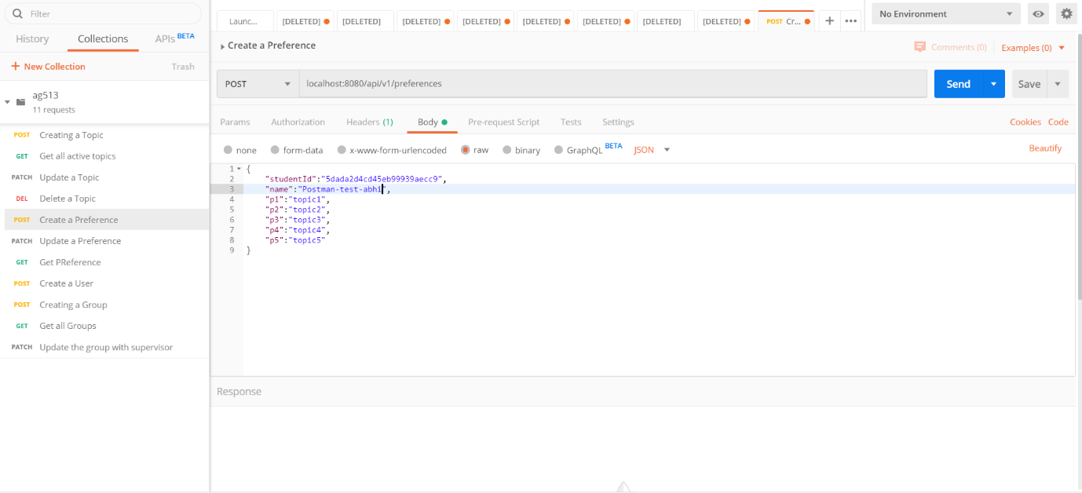

On the left side, we can see all out APIs and their methods.

In the body section, we can see student ID, name and five preferences, This is the body of API for submitting the student's preferences into the database.

Usability testing:

“Usability testing refers to evaluating a product or service by testing it with representative users. Typically, during a test, participants will try to complete typical tasks while observers watch, listen and takes notes. The goal is to identify any usability problems, collect qualitative and quantitative data and determine the participant's satisfaction with the product.” [https://www.usability.gov/how-to-and-tools/methods/usability-testing.html]

In this phase, I have asked some of my fellow students to test the site while running it on my desktop as it is not hosted anywhere. I’ve taken their feedback and most of them where optional requirements of the project.

Testing algorithm and its efficiency:

Developing an algorithm is not a hard task, but making if making it work more efficiently is the main problem. In our case efficiency means the allocation of the top preferred topic to all the students. So, to test the efficiency of the algorithm I have used many test cases with different student’s preferences. The algorithm in this project works with data that it receives from the database but we don’t have all student’s preferences in our database and its waste of time adding preferences manually from the web application into our database. So, I have created test data in JSON format and sent it to the algorithm to test the data. The first version of the algorithm allocated students' preferences in such a way that its efficiency was nearly 75 -80%, after modifying the algorithm many times and ended up with this algorithm which has nearly 95% efficiency when tested with sample data. (efficiency is calculated by Testing data containing 35 students with 6 different data. In all cases 30-32 students are allocated with their first preferred topic, 2-4 students are allocated with their second preferred topic and 1-2 students are allocated with the fourth or fifth preferred topic).