
NAME:
Ahmad Raza (53302)
Atia Rahat (57325)
Zain Zaheer(53812)

PROGRAM:
BSSE-6

COURSE:
SPM

PROJECT:
Sales Point

DOCUMENT:
Lab 7

SUBMITTED TO:
Sir Waqar Mehmood

Scenario 1: Hospital Management System
System Overview: A hospital requires a digital system to manage patients, doctors, billing, pharmacy, and administrative operations.
- Tree Structure (Text-Based WBS)
Hospital Management System (Level 0)
├── Patient Management (Level 1)
│ ├── Registration
│ ├── Medical History Management
│ ├── Appointment Booking
│ └── Patient Records
├── Doctor Management (Level 1)
│ ├── Doctor Profiles
│ ├── Scheduling & Availability
│ └── Consultation Management
├── Billing & Payment (Level 1)
│ ├── Invoice Generation
│ ├── Payment Processing
│ └── Insurance Claims
├── Pharmacy Management (Level 1)
│ ├── Inventory Control
│ ├── Prescription Handling
│ └── Medicine Dispensing
└── Administrative Operations (Level 1)
├── Staff Management
├── Reports & Analytics
└── System Security
- Hierarchical Diagram
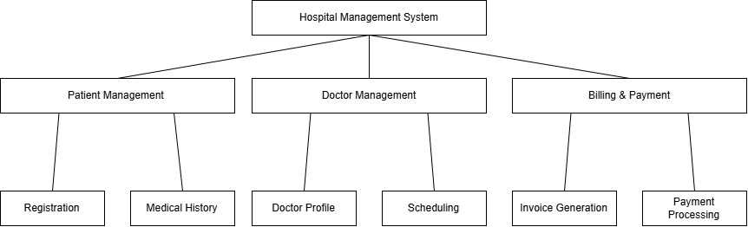

- Draw.io (Digital WBS)

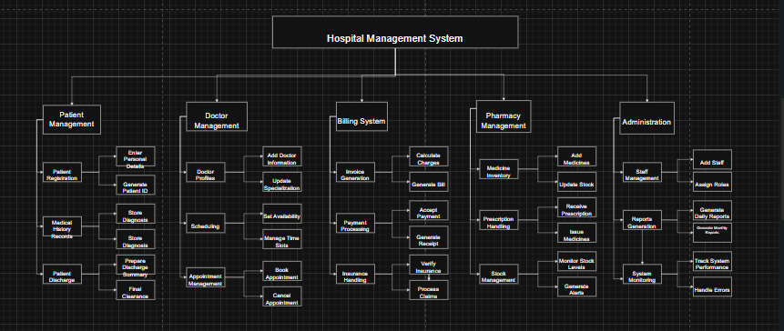

Scenario 2: University Management System
System Overview: A university requires a system for managing students, courses, exams, attendance, and fee processing.
- Tree Structure (Text-Based WBS)
University Management System (Level 0)
├── Student Management (Level 1)
│ ├── Student Registration & Enrollment
│ ├── Profile & Academic Records
│ └── Student Portal
├── Course Management (Level 1)
│ ├── Course Catalog
│ ├── Timetable Scheduling
│ └── Course Assignment
├── Examination System (Level 1)
│ ├── Exam Scheduling
│ ├── Result Processing
│ └── Grading System
├── Attendance System (Level 1)
│ ├── Daily Attendance Marking
│ ├── Reports Generation
│ └── Biometric Integration
└── Fee Management (Level 1)
├── Fee Structure & Invoicing
├── Payment Processing
└── Scholarship Management

- Hierarchical Diagram
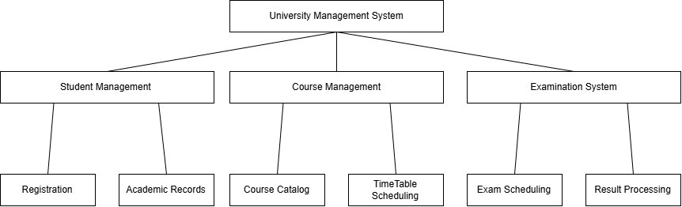

- Draw.io (Digital WBS)
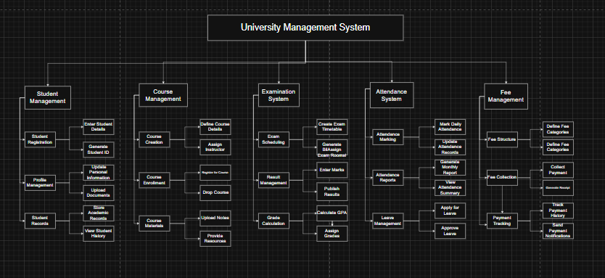

Scenario 3: Online Food Delivery System
System Overview: A food delivery platform similar to FoodPanda or Uber Eats, including customers, restaurants, orders, delivery, and payments.
- Tree Structure (Text-Based WBS)
Online Food Delivery System (Level 0)
├── Customer Module (Level 1)
│ ├── User Registration & Login
│ ├── Restaurant Browsing & Search
│ ├── Order Placement
│ └── Order Tracking
├── Restaurant Module (Level 1)
│ ├── Restaurant Onboarding
│ ├── Menu Management
│ └── Order Reception
├── Order Management (Level 1)
│ ├── Order Processing
│ ├── Status Updates
│ └── Notifications

├── Delivery System (Level 1)
│ ├── Delivery Partner Assignment
│ ├── Real-time Tracking
│ └── Delivery Confirmation
└── Payment System (Level 1)
├── Payment Gateway Integration
├── Transaction Processing
└── Refund Handling
- Hierarchical Diagram
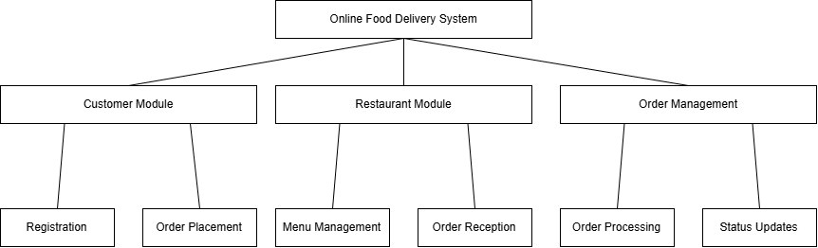
- Draw.io (Digital WBS)

